Food and Beverage Operation
BMIH4002 - LEVEL 4

Assignment 2: Menu Engineering

Student ID:2246360
Student Name: Mihaela Costache
Course name: Food and Beverage Operation (BMIH4002)
Submission Deadline: 10.11.2023
Table of Contents
PART 1: Restaurant Concept 3
Restaurant concept (fushion of Japanese and Italian fine dining) 3
Target audience 3
Reasoning for menu choices 3
PART 2: Menu Design 4
Conceptualization 4
Menu Items 5
Pricing Strategy 7
Menu Design 9
Menu Description 10
Sustainability and Seasonality 11
References 12

PART 1: Restaurant Concept

Restaurant concept (fusion of Japanese and Italian fine dining)
The contemporary notion of the cafeteria is the fusion of Chinese-Italian fine dining. The classification of food that will be conformed in the restaurant is a mixture and fusion of Chinese and Italian cookeries as well as the food items of both nations. The menu will present both vegetarian, non-vegetarian and vegan alternatives to the clients. Moreover, standing in a fine-dining cafeteria the price issue at which the cost of the meals commodities will be negligibly on the pricey side. However, in order to appreciate the delicious food, the customers will be instructed to reserve the tables so that their uneasiness can be commemorated and confirmed. Apart from this, the restaurant will have a comprehensive satisfying ambience with music in the background to institute a vibe within the decorum.

Target audience
This section of the study is very significant for evaluation. This is because, without a target audience, not even a single business can work and operate. Considering the same aspect, the target audience will be people who choose and desire to participate in sufficient dining with reinvigorated experiences in the context of food preferences. The targeted age group that the restaurant will be functioning expert and household that have family earning of approximately 110,000 pounds on an annual basis. The reasoning behind the selection of the target audience is that the restaurant strives to market all the classifications of meals which implicate vegetarian, non-vegetarian and vegan targeting the audience in the people that like either of the mentioned classifications.

Reasoning for menu choices
This section of the study focuses on providing reasoning for the choice of menu. The menu that has been designated for the food that will be offered is a fusion of Chinese and Italian food. This is because it has been encountered that in a nation like the UK, Italian meals outperform the checklist of favoured cuisines which is 51% observed by Chinese with approximately 46% (YouGov, 2022). Apart from that, it has also been found that over one in Brits consume Chinese meals at least one time a week (Mintel, 2016). This indicates that the food items that will be offered by the restaurant will flourish and become famous in the market of the United Kingdom.
The fortune of Chinese cafeterias will thrive in the forthcoming times. The Chinese takeout market is predicted to have a prosperous CAGR of approximately 7.2% during the time of 2022 to 2032. Moreover, the Chinese market is envisioned to acquire almost US$107 billion by the year 2032 from roughly US$62 billion in the year 2022 (Future Market Insights, 2023).
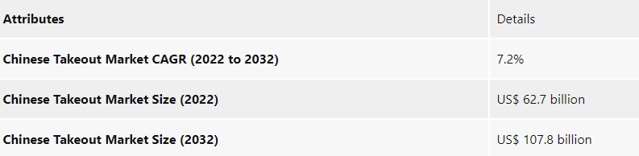
Figure 1: UK Chinese Food Market
(Source - Future Market Insights, 2023)

PART 2: Menu Design

Conceptualization
This segment of the section discusses the menu design of the restaurant business.
For the same, conceptualisation creates an utmost importance (Brown et al., 2013). For the same, the aspect of conceptualisation has been taken into consideration. The concept that has been taken into deliberation for the new restaurant lays a comprehensive focus on the demand. Since both the food cuisines, Chinese and Italian have been preferred by the people of the UK, the demand is greater. To cater to that demand, the restaurant will offer Italian and Chinese fusion items that have been offered to both nations. Moving further, the type of service that will be offered to the consumers and the guests is the fine dining restaurants. As per the viewpoint of Yam (2023), fine-dining cafeterias usually arrive with the most complicated menus and costly prices. The astonishments of such restaurants desire to suggest an environment of classiness and elegance. Moreover, as stated by Chandra (2022), they engage chefs who ministered in culinary academies and enclose many years of understanding. Most clients do not care about disbursing the costly prices because of the perceived value they acquire from consuming at fine dining restaurants. Reckoning upon the same facets, the menu prices will be slightly higher compared to other offerings.
Moreover, the components of cleanliness, consumer service, culinary grade and cohesiveness are some of the satisfactory dining experiences that will be presented to the clients and guests. It will construct an impactful foremost appearance and present incomparable service to the people. Furthermore, the conduct of staff, rate of the food, menu creation and worth for money will be some distinctive elements that will enhance the overall experience of the consumers of the restaurants. The rationale behind the selection of the service style and unique elements is because of the preferences the people choose nowadays. This will improve the chances of the restaurant to succeed and create its own identity in a very short period of time.

Menu Items
A menu is a collection and list of dishes that sufficed for a meal or that can be composed in a restaurant (Foskett et al., 2021). For any restaurant company, the menu items create the utmost importance because they lay a basis for which the service is offered to the customers. This section of the study presents the menu items that have been proposed below:
Appetizers or Starters
Vegetarian | Non-Vegetarian | Vegan
Bruschetta of Spring Vegetables | Sticky Baked Chinese Chicken Wings | Bruschetta with roasted bell peppers
Potato Focaccia Rolls | Okra Salad with Black Vinegar | Braised artichokes with caponata
Favorite Mediterranean Salad | Salami & Cream Cheese Roll | Roasted zucchini with Italian herbs and Italian flatbread
Four-Cheese Stuffed Shells | Spicy chicken rolls | Fennel orange salad with confit tomatoes and focaccia
Crispy Fried Vegetables with Burnt Garlic |  | Farinata
Table 1: Appetizer Menu Items
(Source - Created by the learner)
Entrees or Main Course
Vegetarian | Non-Vegetarian | Vegan
Pizza Quesadillas | Chicken Dopiyaza with creamy sauce | Creamy mushroom risotto with pitta pizzas
Chinese broccoli with white sauce and cucumber salad | Chicken Jalfeezi with Tandoori Murgh | Vegan Tofu Bolognese
Herb-laminated pasta with soffrito | Pizza Quesadillas | Creamy Pumpkin Pasta with creamy cashew sauce
Aubergine parmigiana sandwich with burrata tagliatelle |  | Pasta Arrabiata with balsamic eggplant steaks
Table 2: Entrees Menu Items
(Source - Created by the learner)
Side Dishes
Vegetarian | Non-Vegetarian | Vegan
Balsamic Roasted Carrots | Broccoli and Mushroom Stir Fry | Chinese Scallion Shanghai Noodles
Mashed Potatoes with Cornbread Dressing | Chinese Zucchini Stir Fry | Chinese Pickled Smashed Cucumbers
Broccoli Apple Salad with  Pita Bread | Easy Chinese Egg Drop Soup
 | Chinese Flower Roll dipped in a creamy sauce
Table 3: Side Dishes Menu Items
(Source - Created by the learner)
Deserts
Vegetarian | Non-Vegetarian | Vegan
Tiramisù | Tiramisù | Eight Treasure Rice Pudding
Strawberry Gelato | Tres Leches Cake | Chinese Sweet Rice Cake
Tres Leches Cake | Zabaglione trifle slice | Chinese Almond Cookies
Mixed-Nut-Milk Panna Cotta | Strawberry Gelato | Sesame Seed Balls
Table 4: Deserts Menu Items
(Source - Created by the learner)
Beverages
Italian Red Wines, Campari, Aperol Spritz, Prosecco, Bellini, Tieguanyin, Yunnan Coffee, Jiuniang and Suanmeitang

Pricing Strategy
The pricing strategy is an essential part of revenue management and the Trinity Hotel is required to determine a specific pricing strategy to ensure higher revenue generation to efficiently manage all the operational and business management aspects profitably (Kimes, 2010). Since the Trinity is a star-rated hotel and aims to offer a fusion fine experience to the target customers such as corporates and single businesses the hotel might dynamic pricing strategy along with value-added pricing options, for instance, a range of vegetarian, non-vegetarian and vegan options will be available for the customers and this will cost the hotel significantly in terms of its preparation cost including raw materials, monthly salary of experienced and professional chefs and effective customer services design. As opined by Cho et al., (2018), a dynamic pricing strategy will allow making necessary changes to structure the princess of different products and services to maintain the cash flow and supply-demand equilibrium since the hospitality industry is dynamic as well as the contemporary market. An example of possible pricing for different menu options is given below.
Food options | Appetisers or Starters | Entrees or Main Course | Side Dishes | Deserts & Beverages | Add-ons | Pricing per dish (£)
Vegetarian | Bruschetta of Spring Vegetables | Pizza Quesadillas | Balsamic Roasted Carrots | Tiramisù | Italian Red Wines | 50-150
Non-Vegetarian | Sticky Baked Chinese Chicken Wings | Chicken Jalfrezi with Tandoori Murgh | Broccoli and Mushroom Stir Fry | Tres Leches Cake | Campari | 100-250
Vegan | Bruschetta with roasted bell peppers | Creamy mushroom risotto with pitta pizzas | Chinese Scallion Shanghai Noodles | Eight Treasure Rice Pudding | Aperol Spritz | 150-200
Table 4: Example of probable prices of different products
(Source - Created by the learner)

Menu Design
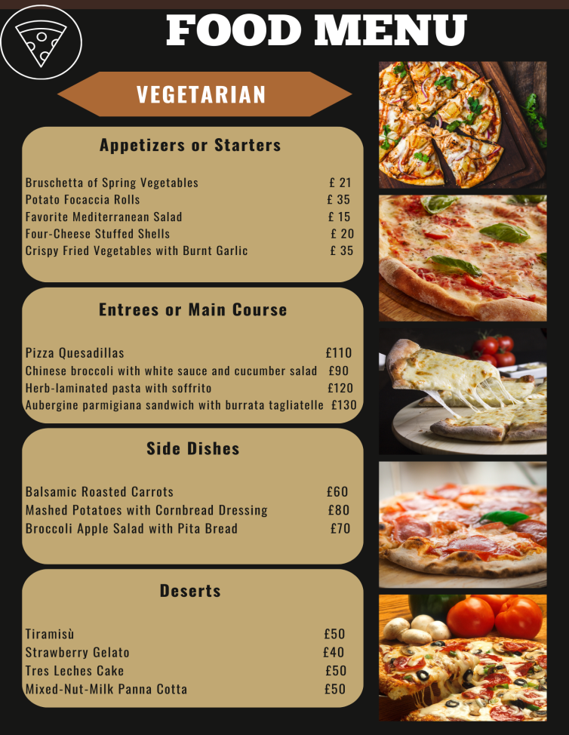
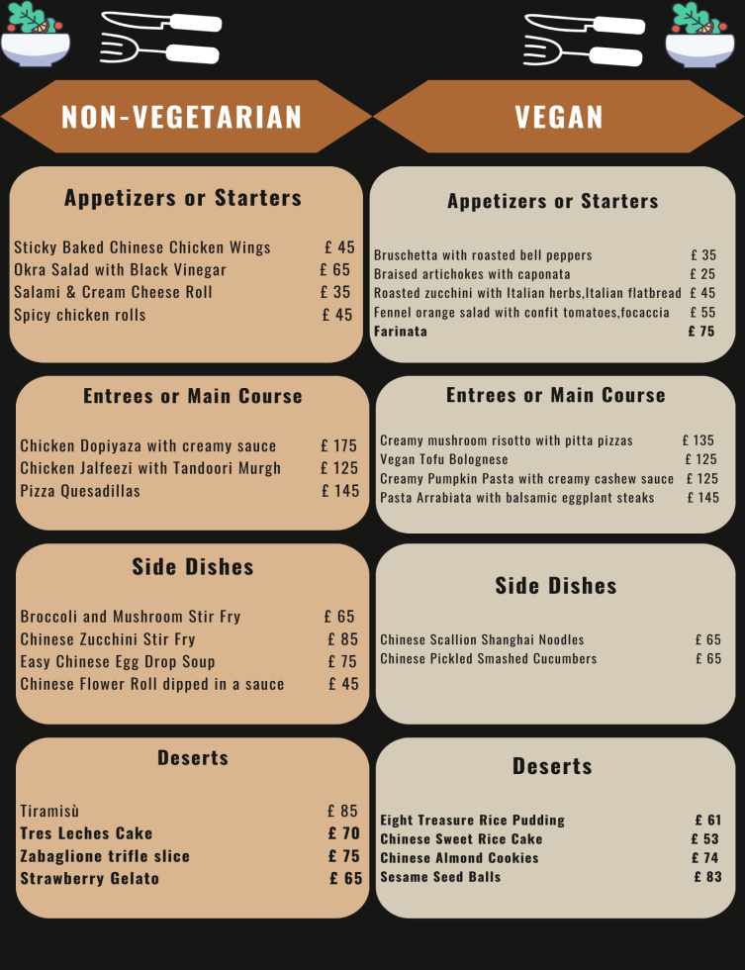
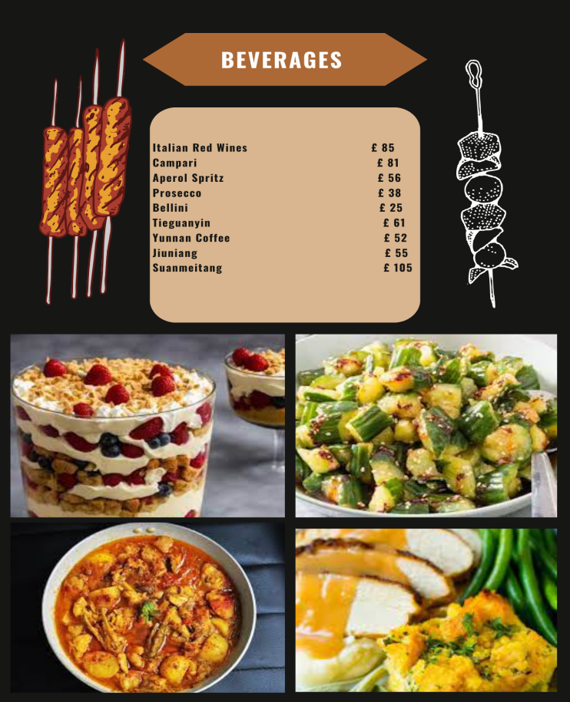

Menu Description
This part of the segment demonstrates and elucidates the description of the menu that has been presented above.
Non-Vegetarian Menu: The necessary components that will be utilised in preparing non-vegetarian Chinese and Italian dishes are soy sauce, frozen meat, chicken, cornflour, sesame oil, noodles, beansprouts, vegetables, mushrooms, scallops, fish, cheeses, sausages, pasta and pork. Apart from these, herbs and spices will be employed for enhanced taste and flavours.
Vegetarian Menu: The essential elements that will be utilised in the preparation of vegetarian Italian and Chinese dishes are sauces, vegetables, cheese, pasta, basil, olive oil, beansprouts, and cornflour. As already discussed, considerable herbs and spices will also be used for the improvement of the taste and flavours.
Vegan Menu: The fundamental ingredients that will be operated in the preparation of vegan Italian and Chinese dishes are seaweed, nutritional yeast, hemp, flax, chia seeds, nuts, legumes, tofu, sprouted and fermented plant foods, dairy products, oils and vinegar, sauces, pasta and noodles and fungi. Moreover, numerous herbs, spices and leaves will be used to enrich the flavours and taste.

Sustainability and Seasonality
Sustainability is one of the significant considerations for modern businesses especially for the hospitality sector. A significant amount of food waste, supply chain operations and the use of raw materials, water and energy resources are required for a hotel on a regular basis. For that reason, Trinity Hotel will use sustainable and organic materials along with seasonal ingredients as well as ensure sustainable operations across the customer service lifecycle following current trends and regulations (Ivanovic et al., 2022). For instance, the use of sustainable energy sources for interior and exterior decoration and lightning as well as for cooking operations. On the other hand, a strict eye will be maintained to ensure that neither any food is wasted nor waste materials during food preparations are managed vulnerably (Mijatov et al., 2018). Additionally, green operations for utilisation of organic food preparation, water-efficient hotel management, purchasing material from sustainable suppliers, and use of eco-friendly cleaning products will be acknowledged. Additionally, biodegradable and reusable materials will be used for food packaging in case of takeaways (Mijatov et al., 2018). Recycling is one of the popular and widespread ways of being environmentally conscious and this will help the business become more energy-efficient and cost-effective. Furthermore, the hotel will improve its composting practices by creating a composting barrel where all the food waste will be dumped for conversion into compost materials to feed the soil.

References
Brown, D. R., TotalBoox and TBX (2013) The Restaurant Manager’s Handbook : How to Set Up, Operate, and Manage a Financially Successful Food Service Operation. 4th Edition. Atlantic Publishing Group*
Chandra, G. 2022. Is Culinary School Still Worth It? Four Chefs Weigh In. Available at: <https://www.foodandwine.com/lifestyle/culinary-school-worth-it-four-chefs-weigh-in> [Accessed on November 9 2023]
Cho, S., Lee, G., Rust, J. and Yu, M., 2018, April. Optimal dynamic hotel pricing. In 2018 Meeting Papers (Vol. 179).
Foskett, D. et al. (2021) The Theory of Hospitality and Catering. 14th Edition. London: Hodder Education Group.*
Future Market Insights. 2023. Chinese Takeout Market Outlook (2022-2032). Available at: <https://www.futuremarketinsights.com/reports/chinese-takeout-market> [Accessed on November 9 2023]
Ivanovic, S., Ivankovic, Z. and Klimoska, A.M., 2022. Aspects of Seasonality in the Hotel Business. TIEM 2022, p.16.
Kimes, S.E., 2010. Strategic pricing through revenue management.
Mijatov, M., Pantelić, M., Dragin, A., Perić, M. and Marković, S., 2018. Application of sustainable development principles in hotel business. Journal of the Geographical Institute “Jovan Cvijić” SASA, 68(1), pp.101-117.
Mintel. 2016. Chinese New Year: Over one in 10 Brits eat Chinese food at least once a week. Available at: <https://www.mintel.com/press-centre/chinese-new-year-over-one-in-10-brits-eat-chinese-food-at-least-once-a-week/> [Accessed on November 9 2023]
Yam, G. 2023. Fine Dining Is Going Out of Fashion. As an Ex-Chef, I’m Relieved. Available at: <https://www.bonappetit.com/story/end-of-fine-dining-opinion> [Accessed on November 9 2023]
YouGov. 2022. Part Three: Favourite cuisines and junk food. Available at: <https://yougov.co.uk/society/articles/41659-part-three-favourite-cuisines-and-junk-food?redirect_from=%2Ftopics%2Fsociety%2Farticlesreports%2F2022%2F04%2F20%2Fpart-three-favourite-cuisines-and-junk-food> [Accessed on November 9 2023]

