Academic and employability skills

Student name ……………….. Maxim Babin
Student number ………………… 1909116
Lecturer name ……………….. Rita Ukachi-Lois
Module title ………………… Academic and
Employability skills
Module code ………………… BMSW4001_LON

Table of contents
Introduction 3
Academic abilities 3
“Reflecting writing” 3
“Reflective Practitioner” 3
“Self-awareness” 3
“Direction for change 4
PPDP framework 4
Effective Literature Research 4
Justifying own research 4
Demonstrating your expertise 4
Joining the conversation 4
Models of Reflection 4
Boud Triangular Representation 5
Gibbs Reflective Cycle 5
Atkins and Murphy Model 6
Model of Reflection Usefulness 6
Decision Making 7
Communication 7
References 7
Learning undertakes outside the classroom 7
Analyze published literature CV and Cover Letter 7
Conclusion 8
References: 9

Introduction
Academic abilities are extremely vital for a human being to extract information on how to expand your knowledge and access information throughout what media shows us. The working department is on a fast run therefore, developing inner skills will facilitate own prosperous life. The purpose of this report is to identify inner strengths and weaknesses compulsory to successes in the professional life and to reflect on my learning in this module. Employment abilities and employability skills are bonded together and without one there is a high chance of being rejected or not fully integrated in the professional life. (McGrew, 2020)
The structure of this report will expand designed framework and working upon achieving an expansion on information gathering criteria. To reflect on inner skills, it is important to research. Researching in every department, business, academic, self-teaching helps by enlarging own vision. On the internet there is useful information but compared to the reviews and opinions which large corporation paid the writers to publish, the unedited information comes in when you really dig the internet. Therefore, researching becomes a difficult task but on the other hand scientific papers, Universities publications and well-known editors. Revising the internet influenced my report structuring therefore, the report will consist of reliable literature research study, individual research abilities, recognition of core academic abilities and reviewing individual audit attributes.

“Reflecting writing” it’s a basic introduction where when deeply explored it reveals detailed information about inner skills. A possible structure for reflective writing can be utilized in order to structure your work better. There are few crucial questions which every trainee must answer. Reflecting thinking requires the ability to speak publicly because the academic thinking must spread throughout the environment and usually listeners are coming back with challenging situation which deeper research must be conducted. Therefore, examining an assignment question with academic colleagues can be viewed from different angles. Everyone carries a different life path, different background therefore its vision will express using own filters. (Reflective Writing Guide ,2020)
“Reflective Practitioner” – working on self-improvement helps identifying strengths and weaknesses. In the business environment, running scheduled audits help the organisation solve their issues. Same treatment can be applied in the educational environment. Kolb`s learning cycle (1984) utilises four main elements to describe its learning cycle. The concrete experience it`s based on previous background activities, Reflective observation investigates your own work to determine future improvements, Abstract Conceptualisation is the final conclusion of previous work and to end up with Active experimentation to plan and try what have you learned as a practitioner and investigate further improvements. (learning to teach, 2020)

“Self-awareness” – PPDP exposes this attribute as being used as a strength but when not used correctly the outcome can turn on the negative side. When the student receives a specific feedback from lecturer, the activity must be confidential as the activity supported by staff can only be used by a specific student.
“Direction for change” – when reflecting your work, finding the negatives will automatically turn your work/project into a different phase. Direction for change can be worked on as soon as the student reviews its work with the lecturer. Feedbacks are a characteristic of changing directions of work attributes.
PPDP framework has been utilised to undermine a student-lecturer awareness. When reviewing your own work, as a student, it’s vital to determine the current position. To achieve this task successfully, the practitioner must dig more information, re-vitalise its own research against previous work. Once the research phase has been completely achieved, the next stage is to identify what is going well. Asking yourself “what are you good at?” can boot confidence and determine the time you can work on the weaknesses. The last phase relies on the personal SWOT analysis which will be described in the next slide. (faculty londondeanery,2020)

Effective Literature Research
As Olivia Valdes published to achieve an effective literature research it involved different stages where the academic person must accomplish three main activities. Spending time to achieve, review and write about research which has already been published must bring new ideas into the game.

Justifying own research
A preliminary literature review helps the academic person to achieve a high level of expanding on the previous research development. Knowing why and how to justify your own work against a multitude of questions it’s an important asset. With the internet populating our life, everyone can register online and start writing about their personal experiences on business or academic strategies. On the other hand, there are business professionals which publish their own work to help academicians expand their knowledge. When researching for own project, as an academic person, you must bring something new into the game, a new question which have not been tackled.

Demonstrating your expertise
By the time you write a specific paper, the internet already saved hundreds of similar projects into their servers, therefore it’s crucial to produce a literature review to engage with the prior scholar who examined similar topic and continue the cycle. Most of the publication are outdated, therefore refreshing scientific papers it’s quite an expertise.

Joining the conversation
When a research it’s based on scientific papers, joining the conversation from a different perspective brings onto the table various situations which academics must explore. An ongoing dialogue among scholars and researchers can re-vitalize own vision.

Models of Reflection
Individuals, groups and institutions worked throughout the years to design close representation from their own vision towards model of reflection. This report will focus on Bouds’s triangular representation, Gibbs’ reflective cycle and Atkins and Murphy’s cyclical model.

Boud Triangular Representation
Known as the simplest form of model of reflection, Boud has represented a model to solve the basic issue regarding this question. Boud focused on experience, reflection and learning. Important assets when it comes to self-resolution. Translated into self-learning techniques, Boud’s experiment was interpreted as the pioneer of Academic and employability inner skills.
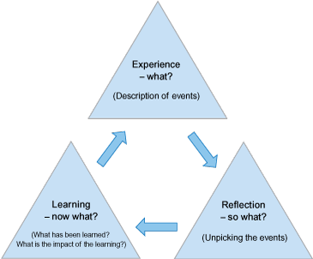

[Figure 1: Bouds’s triangular representation of “model of reflection”]

Gibbs Reflective Cycle
Based on Boud’s triangle of model of reflection, using a similar cyclical pattern, the reflective cycle designed by Gibbs improved on what the previous pioneer published. With time, innovations such as technology and media change how we are getting the information from. This cycle reflects more on the human aspect and addresses feelings in a high manner. When experimenting a new challenge, humans usually tend to reflect on their feelings, “What were you feeling?” more than on the actual outcome. On the other hand, Gibbs does not extend on critical thinking or other aspects which can produce a higher impact on the individual.

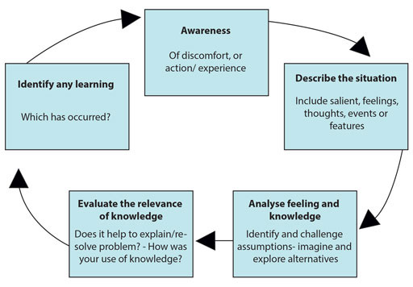

[Figure 2, illustrates Gibbs Reflective Cycle]

Atkins and Murphy Model
Compared to previous pioneers of self-reflecting cycle, Gibbs and Bound, Atking and Murphy model does not touch the “feelings” part. Concentrating on the critical part, where the other representation failed to observe, the last cycle evaluates the situation awareness, and relevant knowledge. Being a cycle, the process never ends, but each stage must be well identified and applied to contextual intervention.
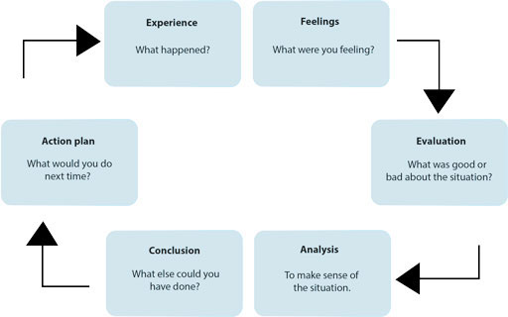

[Figure 3, representing Atkins & Murphy vision towards reflecting cycle]

Model of Reflection Usefulness

Each representation of reflecting cycle has their own unique selling points (USP), Boud on his simplicity, Gibbs extended towards the emotional aspect and Atkings & Murphy model by advancing the cycle into reaching criticism level.
In my academic life, I have encountered multiple tasks, essays and other forms of examination, therefore, interacting with my lecturers and receiving feedbacks it is a part of it, so all these things helped me discover my strengths that I can rely on all my life. My recent tasks involved developing a curriculum vitae and cover letter for a specific job pattern.
The CV involved multiple stages. The lecturer presented us, in the classroom, a form of a CV and standard guidelines (attached in the appendix section). Extracting vital information from the lecturer helped my learning skills and inner strengths as well as exposing the weaknesses. To remedy key weaknesses and explore other CV tips, in my own time researching captured a major portion of it. Applying the Atking & Murphy reflective cycle, helped me to achieve a better grade and overall understanding of the subject. Evaluating my work against professionals and other colleges, asking the teacher to verify the content helped me to develop an action plan and tract my evolution.
Cover Letter, the critical phase from the Atkin and Murphy reflective cycled pushed me into the right direction of researching and successfully modify my own cover letter. Applying the reflective cycles into own experience helped me as an academic individual to express my skills professionally.
Of course, previous experienced added to my skill bag characteristics such as researching, effective communication and critical thinking. Researching, many different types of academic source such as: scholar books, PDF, journals and scientific reports are a credible and trustfully source which depends on the published data. Usually, Universities publish well-documented papers and their availability lasts a long time but it’s vital to ensure the publisher and writer has been acknowledged or its vision corresponds.
I learned a lot of effective things last semester about skills that are really important and matter for me.

Decision Making
It’s a skill which bounces up the chances on interacting with professional and give the opportunity to illustrate how working under pressure affects you as an academic. In student’s life, essential is to make decisions based on solid and trustfully papers (scientific or University based) whereas in the professional life it’s based more on the previous experience and background. Assimilating information eliminated the doubt you have and proceeds with a decision based on inner skills. Decision-making it’s a vital task because it can change the course of your life. Decisions can escalate from what you want to eat for breakfast until what to study.

Communication
Presenting facts, pursuing information are important tasks which every academic must face, the communication factor becomes incredibly important when you approach a business professional and try to elaborate on your experience. The ability to sell and explain facts based on your research goes down to communication skills.

References
Referencing an academic and professional work must be within the policies used by the institution. Therefore, Harvard, APA, MLA are the most used referencing systems throughout the UK. On the other hand, the importance of proper referencing can distinguish between a plagiarism and factual context.

Learning undertakes outside the classroom

Reading everything my hands and eyes are focused on it’s an incredibly important assets because self-teaching is a process where you get to know yourself from the academic perspective and expand on your own hobbies at your own pace. Online resources and groups such as “Khan Academy” and “Udemy” are great places to start learning new skills.

Analyze published literature CV and Cover Letter

Published journals, topics and forums regarding the CV and Cover letter, mainly fixed ideas which the lecturer illustrated in the classroom. To advance and create a unique document, it’s important to use your own unique selling points. The online journals are broadly explaining how a resume and CV should present yourself but on the other hand it’s crucial to exercise own best practices and use your lecturers and professional academics to review your work.
Alison Doyle wrote “Curriculum Vitae samples and writing tips” journal to expose the main characteristics of the undertaking subject. The “what not to include” section has some outdated interpretation as the writer focuses more on the US type of CV, in Europe and the United Kingdom, depending on the position you apply for they require a photo attached to your CV and references. The author indicates a CV should be between 2-3 pages, whereas including the critical parts for a specific job will not take more than 2 pages length. On the other hand, Alison Doyle presents other factors perfectly, therefore it’s important to know what job you apply for and previous experience.

Conclusion
Self-teaching and self-reflection are two key attributes which will create new paths towards professional and academic life. The ability to craft your skills and future has been aided by technology and the upcoming innovations. Standards and frameworks designed to help you achieve a better yourself are useful, but it is vital to measure your skills and capacity. Academic writing and speaking will improve day to day activities and help you reach a better life quality. When interpreted correctly, self-teaching and self-reflection can adjust and craft new paths. When you want to be more creative and professional things that you already know do not matter so much like things that you need to learn.

References:
Doyle, A. (2020) Curriculum Vitae (CV) Samples and Writing Tips. The Balance Careers. [Online] Available at: https://www.thebalancecareers.com/cv-samples-and-writing-tips-2060349 (Accessed, 3 April 2020).
Faculty.londondeanery.ac.uk. (2020) [Online] Available at: https://faculty.londondeanery.ac.uk/professional-development-framework-for-supervisors/Professional%20Development%20Framework%202012 (Accessed, 1 April 2020).
Figure 1,2,3 Reference: Adobe Spark. (2020) Models of Reflective Practice. [Online] Available at: https://spark.adobe.com/page/rKyBx/ (Accessed, 22 March 2020).
McGrew, K. (2020) Academic Ability Conception.Iapsych.com. [O
nline] Available at: http://www.iapsych.com/acmcewok/Academicabilityconception.html (Accessed, 2 April 2020).
Open.edu. (2020) Learning To Teach: Becoming A Reflective Practitioner: View As Single Page. [Online] Available at: https://www.open.edu/openlearn/ocw/mod/oucontent/view.php?printable=1&id=14520 (Accessed, 1 April 2020).
Open Learn. (2020) Succeeding in Postgraduate Study. [Online] Available at: https://www.open.edu/openlearn/ocw/mod/oucontent/view.php?id=51386&section=4 (Accessed, 21 March 2020).
Student.unsw.edu.au. (2020) Reflective Writing Guide | UNSW Current Students. [Online] Available at: https://student.unsw.edu.au/reflective-writing (Accessed, 1 April 2020).
Valdes, O. (2020) What You Need to Know About Writing A Literature Review ThoughtCo [Online] Available at: https://www.thoughtco.com/literature-review-research-1691252 (Accessed, 23 March 2020).



