Innovation, Function and Sustainability of Wool.

By: Rhian Gould (P151179)
Supervisor: Ainsley Hillard
Surface Pattern Design: Textiles for Fashion (M6X01791)
Word count: 6000


Contents
1.0 List of Illustrations Page 3
2.0 Introduction Page 4
3.0 Chapter 1: Wool Unravelled – Process and Sustainability Page 5
4.0 Chapter 2: Traditional and Innovative Designers Through a
Sustainable Practice Page 12
5.0 Chapter 3: Changing the Face of Wool Through Innovative
Practices Page 17
6.0 Conclusion Page 23
7.0 Bibliography Page 25

- List of Illustrations
Figure 1: Damaged wool and their prices Page 5
Figure 2: Wool and their prices Page 5
Figure 3: Traditional Welsh costume Page 6
Figure 4: Needled felt Page 7
Figure 5: Pressed felt Page 7
Figure 6: Woven felt Page 7
Figure 7: Knit Page 8
Figure 8: Woven felt rugs Page 8
Figure 9: Riccabona’s work Page 12
Figure 10: Felted green diagonal twist panel Page 13
Figure 11: Felted earrings Page 15
Figure 12: Kogire Zukushi fabric Page 17
Figure 13: Solidwool chair Page 19
Figure 14: Jewellery by Dr Kathy Vones Page 20
Figure 15: Dashing Tweeds cloth Page 21
2.0 Introduction

Due to the versatility of wool, it is widely used from clothing to upholstery. “Wool is the product for which sheep are best known” (Schoenian, n.d.). In recent years wool has appeared strongly in giftware and diverse products e.g. photo albums, notebooks, keyrings, memorabilia objects, tennis ball covers and so much more we are yet to discover due to its unique qualities and ability to lend itself to be used in creating such of a variety of things.
This paper discusses the uses and processes involved with wool, as well as a few designers and companies who are giving wool a different perception to what’s known. The significance of this related to the increasing popularity of wool in the fashion and interior industry after man-made fibres have taken over the industry for more than 40 years. Figures show that the woollen industry soared to a market value of £1.25 billion from 2008 to 2010, along with a 50% increase in sales (Warren, 2013). Constant efforts are being implied by designers and companies to bring wool back into fashion.
Due to increased knowledge and technology, more innovative companies are emerging, producing products out of wool that wouldn’t have existed ten years ago. Companies such as Solidwool and Nuno have turned the way wool is perceived on its head through giving it a new face. Not only changing the face of wool but accomplishing this in a sustainable manner throughout the process of creating.

3.0 Chapter 1: Wool Unravelled – Process and Sustainability
Different breeds of sheep produce different types and quality of wool and the fleece of the sheep itself varies in quality (Williams-Davies, 1981, p.67). “It is a high maintenance fabric” (Evelegh, 2013, p.30) the fleece quality can vary due to the environment of its surroundings, age and health that have a huge part in creating a strong, good quality fleece (Robson and Ekarius, 2013, p.8). The upper area of the sheep produces the best quality fleece e.g. sides, shoulders, back and upper back legs. The fine wool is used to create fine tweeds and soft furnishings. The lower area of the sheep e.g. belly, tail, lower back legs and chest/neck produces a coarser and rougher quality fleece as it’s exposed to dirt and various elements causing the wool fibres to be stiff and weak (Williams-Davies, 1981, p.67/68).
When it comes to dyeing wool, the white fleece is the greatest quality of fibre due to the variety of colours it can be dyed to, but on the other hand, dyeing wool which has a natural colour to it can create beautiful shades of subtle colours. Wool from different breeds of sheep take to dye in different ways which gives endless possibilities of colours created (Robson and Ekarius, 2013, p.8). But not every fleece can take to dye with the darkest shade being tones of grey along with the white fleece that can be used for the dyeing process (Robson and Ekarius, 2013, p.18). From this information it gives black wool a disadvantage when it comes to the dyeing process making it not seem as valuable as white wool.
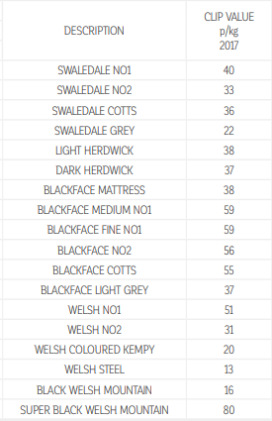
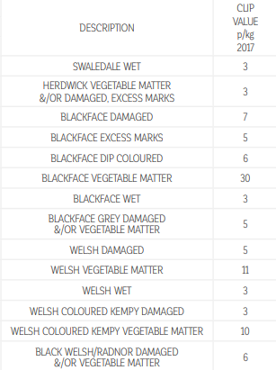

Figure 2: Wool and their prices, (Britishwool, 2018).
Figure 1: Damaged wool and their prices, (Britishwool, 2018).
As seen in the tables above the price of wool varies between breeds from white to black wool, in figure 1 it’s showing the prices of damaged wool from a selection of breeds. The damage to wool can be caused by vegetable matter such as leaves or twigs from trees tangled in the wool, other faults includes wetness and stains.
The most expensive faulty wool is the Blackface sheep with vegetable matter at a price of 30 p/kg and the lowest price is Welsh, Herdwick and Blackface with wet wool at a measly 3 p/kg. Figure 2 shows the price of wool at its best quality. Breeds such as the Super Black Welsh Mountain sheep retailing at 80 p/kg but can also be worthless due to the inability to dye. The Super Black Welsh Mountain sheep wool is more expensive than the Black Welsh Mountain sheep due to the softness of the wool. Welsh Steel wool is considered the cheapest quality wool at 13 p/kg (Britishwool, 2018). As seen in this table, Herdwick wool retails relatively cheap due to its coarseness. The wool from Herdwick sheep can’t be used in clothing, therefore, a company called Solidwool have created a composite material using Herdwick wool as a reinforcement for the resin (Solidwool, n.d.).
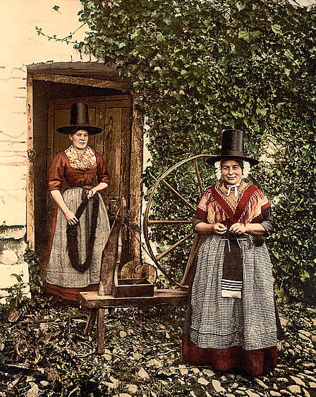

Figure 3: Traditional Welsh costume, (Radeska, 2016)

The traditional welsh costume of the 19th century was often worn in North Wales, using the fleece from black sheep. They would especially rear black fleece sheep as their wool was used for making stockings, which was extremely suitable due to its natural ‘smoky-black’ colour. There was no need to dye the wool and no dye loss would be experienced from frequent washing (Etheridge, 1977, p.54). As seen in the image on the right, this is a traditional Welsh costume. The costume was made from wool, woven to create a stripped or chequered pattern. The traditional Welsh costumes primarily known to us incorporate the colour red that was dyed from cockles which was commonly known nearer the coast (Etheridge, 1977, p.50).

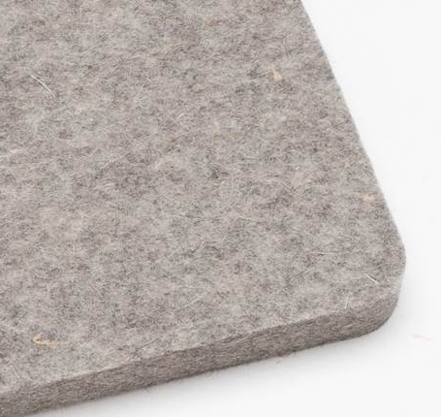
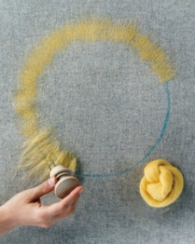
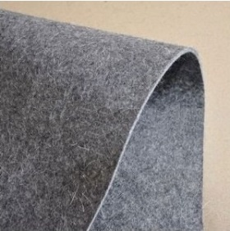
Figure 5: Pressed felt, (Suntherlandfelt, n.d.)
Figure 4: Needled felt, (marthastewart, n.d.)
Figure 6: Woven felt, (Southeasternfelt, n.d.)

Wool can be used in many different forms such as felt, weave and knit which are used to make clothing and furnishings. Melody Grossman states “This is the only form of felt that is known to man, it even predates knitting and weaving techniques” (Grossman, 2017). There are a few different processes to create felt; pressed, needled and woven. The process of needled felt includes the interlocking of fibres this technique is referred to as the ‘dry technique’, through using a needle to stab in to the fibre creating your own fabric with various colours (Fouchier, 2009, p.15). When creating the felted piece, it is a combination of wool and a synthetic fibre or usually 100% wool (Grossman, 2017). Synthetic fibres came about in the 19th century with felt being one of the processes, as you were able to create felt out of synthetic fibres. Producing felt on an industrial scale they would combine synthetic and wool to create a more of a sturdy fabric (Fouchier, 2009, p.15). Pressed felt is another method to create this fabric, it uses heat and moisture to create the interlocking relation in the fibres. Woven felt is a blend of wool woven into fabric and then moisture and pressure are applied. Unlike wool for clothing or furnishing, felt has a very coarse texture and minimal elasticity due to the fibres being pressed and not interlocked. The advantage of this process of felt is that it’s extremely durable and is ideal for lining cases for musical instruments but doesn’t have the same thickness as felt made by needling or pressing says Melody Grossman (Grossman, 2017). Felt is advantageous due to its ability to be dense and very thick which can be particularly useful for padding and lining, and a felt called baize is used to line snooker tables. Felt has many uses as it’s very versatile and can be inexpensive (Grossman, 2017).

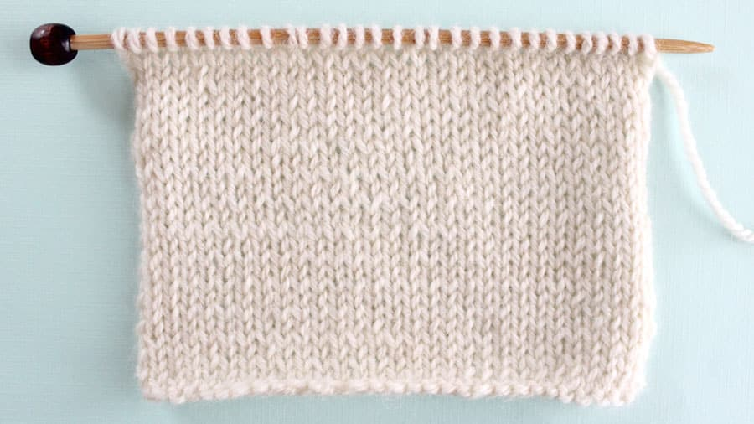
Figure 7: Knit, (Studioknit, n.d.)

Wool is most commonly known for its two different processes, knit and weave. Due to the different way the processes are manufactured, these two processes have great need in the market today (textilefashionstudy, 2012). To create a piece of knitwear, a single continuous thread is used along with long needles, which creates a series of knots connecting to one another to create a piece of textile (Przybylek, n.d.) that does not require specific sizing when made into a garment (textilefashionstudy, 2012). This method is considered sustainable due to lack of waste material. From creating this you end up with a soft textured fabric with great flexibility and comfort. Whilst wearing knitwear, there is no feeling of restriction, yet it hugs the human body (Ailige Textile, n.d.). Knitwear surprisingly is quite inexpensive material, due to its reputation of the composition of the fabric being less stable giving it a worn appearance after a short period of time, but also begins to shrink and stretch due to change in temperature when laundering (Cox, 2008).
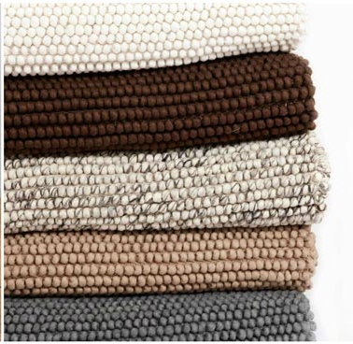

Figure 8: Woven felt rugs, (Sukhirugs, n.d.)

The process of weave is the interlocking of yarn to form a piece of textile. Weaving is a process whereby two sets of yarn, called the warp and weft are interlaced, crossing each other at a right angle. A weave is created on a loom where the warp threads are held under strain whilst the weft intersects each warp thread (Shields, 2015). Compared to knitting, the production cost is considerably more due to the machinery and time involved when creating. This process contributes to approximately 48% of fabrics in the textile section. The elasticity of a woven fabric is noticeably less than that of a knitted fabric, yet its dimensional stability is remarkably higher than that of a knitted material (Textilefashionstudy, 2012). Woven fabrics tend to have a sharp look to their patterns as the threads tend to be more tightly compacted, which provides a smarter, more luxurious appearance. Woven clothing tends to provide a more fitted appearance due to its uncompromising fabric formation. Due to the uncompromising fabric, woven fabrics tend not to be as soft as knitted fabrics and don’t stretch making the fabric feel rather restrictive. Woven fabrics are used over knitted fabrics for bottoms due to the structure they create (Cox, 2008).
In the fashion industry our well known and as much-loved designer Vivienne Westwood who has always felt strongly regarding the idea of creating unique fine knitwear, in comparison to how wool clothing is being perceived. Describing wool as a versatile fabric and uses this fibre in her own designs (Dhillon, 2015).
As Westwood states,
Every kind of cloth was woven for a purpose, to be useful in certain situations where a uniform was necessary, for example hunting foxes, going to the North Pole, opening Parliament, and going to school (Dhillon, 2015).
This is due to the perceived warmth of the fabric that can withstand the harsh conditions of the North Pole, but also seen as a luxurious fabric as it’s suitable for the most prestigious of occasions.
Wool has become effectively the most natural form of fibre suitable to protect the human from all possible weather known to the human race. The demand for this luxurious fibre has increased and the trend from fleece to fashion is continuing, down to its outstanding performance whilst maintaining its sustainable properties (Dhillon, 2015). Apart from creating stylish and unique hats Gabrielle Chanel began her famous career at the beginning of the 20th century using a wool jersey fabric in women’s wear. Gabrielle Chanel revolutionised women’s clothing by utilizing this “humble of materials” (Chaney, 2011, p.123). Chanel was able to create clothes of simplicity, comfort and neatness which was sought for as world war one broke out (Chaney, 2011, p.116). In 1916, vogue described her salon as “the jersey house” (Chaney, 2011, p.124). The wool industry therefore continues to develop the fabric and to meet commercial demand and forever changing as trends are continuously challenged by new and unique styles of clothing (Dhillon, 2015).
According to Amica Dall and Giles Smith from BBC Radio 4, we should discuss the closeness of things to our body, as the issue of maintaining quality is becoming ethically sought for. Due to manufacturers today becoming very clever, apart from clothing, it’s impossible for us to know how materials and objects are made and what from (Dall and Smith, 2018). As far back as the 18th century, before the Industrial revolution began, people became dependant on the craft of others creating small volumes of handmade products from the home. Wool became the most common fabric made, with the demand of people wanting woollen based products such as clothing and bed linen. Therefore, this process of making wool turned it into a machine operated factory creating a mass amount of fabric at one time at a faster pace. Unfortunately, cotton has become a more popular fabric to use, as wool isn’t being used to its full potential as such anymore (Braungart and McDonough, 2009, p.19).
Through watching ‘BBC Stacey Dooley investigates fashions dirty secrets’, Lucy Siegle, a journalist on environmental issues states “cotton is responsible for one of the biggest environmental catastrophes we’ve seen to date on planet earth” (Fashions Dirty Secrets, 2018). As cotton is seen as a very natural, eco-friendly and clean fibre. Due to these false claims, cotton remains to be Britain’s most popular fabric. As one pair of jeans will use 15,523 litres of water to make, but not only the high usage of water is a huge risk but also the harmful toxic chemicals in the water that is left behind from the process of making cotton harms our environment (Fashions Dirty Secrets, 2018). “Always check the label. Man-made fibres pollute our oceans and water supply” (WoolOvers, 2018, p.36) not only mass manufactured cotton harms our environment but also man-made fibres adding to the crisis.
The knowledge and skill that people have developed is ever increasing, it’s making the world worse and not for the better due to the throw-away attitude of today (Dall and Smith, 2018). Described by Michael Braungart and William McDonough, a landfill would typically have clothing, plastic, electronics, furniture but also including organic waste such as food and wood. All these products have been made from expensive materials with the effort to produce these products too, creating money’s worth of objects (Braungart and McDonough, 2009, p.27). Looking back on history, it’s almost like the handmade crafts are better quality and organically of a higher standard, but this is potentially an historical accident, which has developed into creating mass produced products by machinery (Dall and Smith, 2018).

4.0 Chapter 2: Traditional and Innovative Designers Through a Sustainable Practice
New and unique designer brands from China have emerged along with customers taste of clothing becoming more sophisticated. By using Merino wool this reflected the sophistication for mainstream brands and designer brands. The demand for this natural fibre in China increased as the years went on, with designers including Uma Wang, Vmajor, Ms Min and Banxiaoxue using this luxurious fabric in their work (Smith, n.d.).
Merino sheep has great quality wool, with 40% of our wool production coming from merino sheep globally, as they are most known to be farmed in New Zealand, Australia and South Africa (Fouchier, 2009, p.9). The fibres valuable appearance is its naturally crimped quality, that gives a soft and springy texture to the cloth (Ian, Spearman, 1973, p.130). Wool fibre is defined by its various qualities through strength, curl, length, resilience and fineness, Merino wool being ultra-fine along with all the other wool advantages. Merino wool is a lightweight and thin fabric with great “insulating power”, through washing this fabric it stays soft (Fouchier, 2009, p.9). “A few other mammals have been domesticated for their wool, but none has achieved the economic importance of the sheep” (Ian, Spearman, 1973, p.131). Today not only wool from sheep is being used but also from alpacas and llamas that have similar qualities to wool.
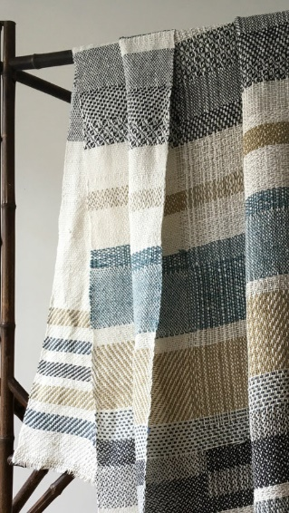

Figure 9: Riccabona’s work, (CatarinaRiccabona, n.d.)

Catarina Riccabona incorporates environmental beliefs in to her practice. Creating her own woven blankets and throws using sheep wool, recycled yarns and alpaca wool. As she weaves every throw and blanket by hand through setting the loom up takes many days before the creating process begins with the end results being a 1m x 1.8m size throw (Catarinariccabona, n.d.). The image above is one of Riccabona’s throws, which is recycled waste warp woven by hand. The warp is the waste you’re left with after cutting your piece of work off the loom, usually measuring 1m in length, by attaching the coloured yarns together you’re able to use the strings in the weft (theholbornmag, n.d.)
Riccabona describes herself by being quite spontaneous when creating her products and is inspired by the fabrics she works with. As a designer Riccabona tries to keep her work as eco-friendly and sustainable as possible by using second-hand or recycled fabric such as cotton. Also, undyed yarn to assist in the reduction of toxic chemicals and water waste. To add colour to the designs she uses plant-dyed wool fabric, when using this method of dyeing the results of the colour will not always be the same on each fabric as Catarina Riccabona states “...I just love these subtle nuances!” (theholbornmag, n.d.). Another way she uses colour is through collecting “waste warp” from other weavers, as the warp will go to waste if not used (theholbornmag, n.d.). Catarina Riccabona takes sustainability quite seriously and this reflects through her designs by the quality of the fabric and carefully taken her time to hand make the throws, reflecting a great care towards how she treats her pieces of fabric.
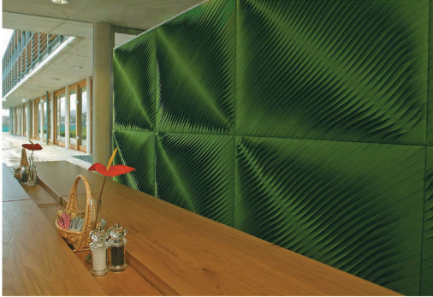

Figure 10: Felted green diagonal twist panel, (Tanner, 2010, p.81)

Anne Kyyro Quinn who began working with textile interior creating soft furnishings such as cushions and throws is today more known for her bold wall panels made from felt. She first became well known in 2001 for creating a felt pleated lamp which was the first ever product she made from felt. Quinn finds inspiration everywhere and the materials she works with inspire her but loves the challenge and experimentation of creating a three-dimensional product whilst without it losing its function. When creating a product Anne Kyyro Quinn experiments with fabrics to see how versatile the fabric is and how to push the boundaries and challenge the felt through twists, pleats, curves, folds and joining together. Through looking at these elements it adds depth to her designs and a different approach to surface design through pattern. Quinn is inspired by the structural elements she creates from her textile piece, but also, how can it be used from an architectural point of view to create installations and through working large scale how many techniques and ideas can develop through this scale of working (Tanner, 2010, p.80).
To Anne Kyyro Quinn it’s important for her that the production of her designs stays in the UK, where she has a small workshop in Yorkshire full of makers who create her designs (Tanner, 2010, p.80). Through designers like Quinn using felt for installations, this fabric has grown over the years in architecture as its properties are flame and water resistant, due to it being a natural fibre it’s become an alternative to mand-made synthetic fabrics. FilzFelt who are a company based on creating 100% wool felt are also creating a new face for felt in the interior market as felt is being known as a very versatile fabric and can be used for any surface in interiors (Schneiderman and Winton, 2016, p.41).
Lisa Klakulak the creator of Strongfelt company, creates her art sculptures and accessories using traditional craft using organic resources from plants and animal fibres. Where she’s inspired by different materials used for traditional craft, she also sees how these materials have been used in different cultures across the world (Klakulak, n.d.). Looking at objects and natural material which are not produced by humans creating synthetic fibres, but through looking at pattern or texture from animals that have a repeat form, such as snakeskin, shell of a lobster or crab, acorn and stone walls (Chelli, 2015). Klakulak grew a strong interest in natural dyes, that she created from using minerals, insects and plants (Klakulak, n.d.). Through felting she began dyeing using natural dyes, but through experimentation of using this process on fine wool fibres became quite unpleasant and time consuming as the wool fibres would mat together. But wool caught her eye due to its great characteristics in absorbing colour clearly and brightly using a process called mordanting (Chelli, 2015). The process of mordanting is a chemical that permanently fixes the dye on the fibre, with certain salts and metallic oxides that are used for fixing the dye; wool is commonly used for mordanting (Krohn, 1980, p. 23). Stated by Tessa Evelegh wool takes to dye well and creates subtle lovely colours (Evelegh et al, 2013, p.30). Not only does Lisa Klakulak dye wool but also has begun incorporating silks and cellulose fabrics into her felting as they would bring out the colour differently, using her felted pieces to create accessories and handbags. The pieces reflect a visual narration that are based on surface pattern, imagery and forms (Chelli, 2015).
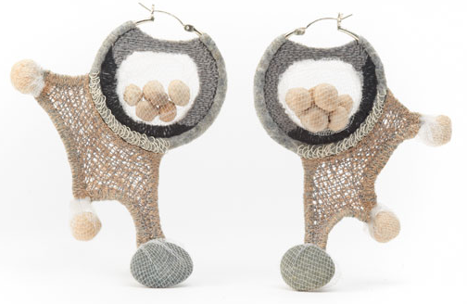

Figure 11: Felted earrings, (Klakulak, n.d.)

“I sculpt through contraction, a relationship between space and mass, or what is unknown and known” (Klakulak, n.d.). On the other hand, her sculptures are based on her human experiences and perspectives, as the beautiful art pieces don’t have a function just a reflection of her thoughts. Not only does Lisa Klakulak associate wool with comfort and warmth, but also uses wool as her work is about the human concepts of security and comfort, from both emotionally and physically (Chelli, 2015). Lisa Klakulak has “instigated a visual battle between fibre and metal” through creating earrings, by trying to keep the balance between two very different materials and finding a way of making them work together. The felted earrings are made from merino wool using the process of needle felting and incorporating small stones (Klakulak, n.d.) reflecting a contrast between hard and soft through using wool and stones.
As Kam Dhillon states
Using wool in informed and educated ways is a move to champion your own potential to redefine the DNA of textile production (Dhillon, 2015).
A company called ‘Unmade’ founded in 2013, is a digital software company that are creating a solution to waste and a new way of producing items of clothing to the fashion industry. Working with big brands in fashion, sportswear and lifestyle industry, the company can customise products such as knitwear and is able to interact directly by creating a product that does not exists on the market and manufacturing process. Customers are free to click and drag the pattern of the jumper and the colour to how they’d like it with a choice of fabrics to pick from, which are merino wool, cashmere or cotton (marketingweek, n.d.). Through working this way, the fashion industry will only make what is sold which results in less waste. As for the customer, this experience feels unique and exciting, creating customised products (somersethouse, n.d.). Unmade are aiming to change the fashion industry through creating a sustainable way of manufacturing clothing to help the economy (somersethouse, n.d.). The video link below shows perfectly how this process is created from its digitally form to a physical item.
https://player.vimeo.com/external/239795439.hd.mp4?s=f4e589084418f35249106e8980062e39928a88ed&profile_id=174 (Unmade, n.d.)

5.0 Chapter 3: Changing Face of Wool Through Innovative Practices
Many designers use wool in various path ways from print to makers, creating various looks using wool from traditional to contemporary. “At Nuno - which is Japanese for fabric - we blend the traditional and the contemporary” (Nuno, n.d.). Nuno’s work is recognised by leading clothing brands, creating current styles using traditional techniques from Japan where she grew up. The techniques being weaving and dyeing fabric, by working with craftsmen creating newly developed textiles, she continues to create a visual of the 21st century with modern art technologies. Nuno’s work reflects a link between traditional crafts and modern textile art, whilst also being supported by local craftsmen, this is a great way of enticing customers from all around the world. Nuno states that it’s important to create your own identity through using cultural elements and the natural habitat of your surroundings where you’ve been brought up in creating originality to your work. (Millar, 2005, p.8/9).
Reiko Sudo states,
The first image that comes to my mind is the feel and touch of the material, its texture. Before considering its use, I always begin with how coarse or smooth it feels (Millar, 2005, p.11).
Sudo is pushing the boundaries of textiles, testing the properties of fabrics to create something new that people haven’t yet seen before with her great knowledge and skills in textiles (Millar, 2005, p.14). But how Sudo does her experimentation is unique through what organic fibres to use and carefully use less waste as possible in the process of experimenting (Quinn, 2013, p.181). Therefore, Sudo is seen as a sustainable designer.
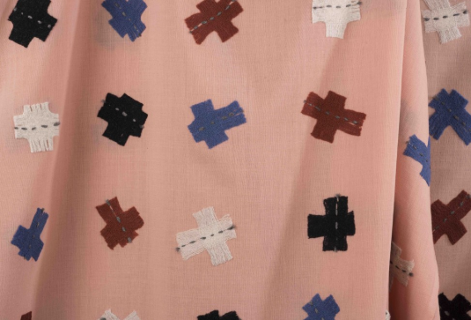

Figure 12: Kogire Zukushi fabric, (Nuno, n.d.)

The Kogire Zukushi piece is 100% wool using the process of needle punching, unusually not using the traditional method of weave. From using this method, the outcome of the design gives wool quite a different view as it has a contemporary look to it. As it hasn’t been traditionally woven, it gives the pattern a lovely random look rather than a perfectly geometric woven design as wool cloth is traditionally known for. As the shapes themselves aren’t cut out perfectly geometric either, this adds to the randomness quite nicely.
The designs created don’t have a correct front or back to them, as she wants us to have a relationship with the fabric and to choose how we position it, as the fabric almost becomes dependant on the owner (Millar, 2005, p.12) “It also relates to the two-sided ‘between-ness’ of textiles” (Millar, 2005, p.21). Interviewed by Millar, Sudo was asked about fabric waste as she has great interest in using threads and fibres from leftover waste to create new fabric. Sudo finds the life of the fibre a lot more interesting than the textile and would like the customer to appreciate the fabric just as much as Reiko Sudo does (Millar, 2005, p.18). “Reiko Sudo breaks convention in her processes as well as her manufacture of woven fabric to manually insert feathers” (Hemmings, 2012, p.30). Millar asked Sudo about one of her most special developments, her answer being about creating fabric with motion in it, from this idea she thought of feathers and flight which is known as the feather fabric (Millar, 2005, p.20). At the end of the interview Sudo was asked about the future of Nuno, which she replied saying that Nuno will forever take inspiration from the atmosphere and the fabric would reflect this (Millar, 2005, p.23).
A company called Solidwool have an innovative way of using wool to create lifestyle items for everyday for the home or creative area called the Hembury Collection. This company use a certain breed of sheep called the Herdwick sheep. They have wiry, hard wool that can’t be used for soft furnishings and clothing due to the quality of the wool. Historically this wool was used in the carpet industry, the demand for carpets made from this wool was declining, because of this the wool is now worth almost nothing. Solidwool has found use for it and to revive this hard-wearing wool and to bring value to it once more. Their aim is “To turn the way we have always worked with wool on its head” where they take the unwanted and turn it in to something beautiful (Solidwool, n.d.). Solidwool have created a unique composite material that incorporates the unused wool with resin to create strong, rigid items of furniture. As they believe in creating beautiful items that are made to be appreciated and designed to last a long time.
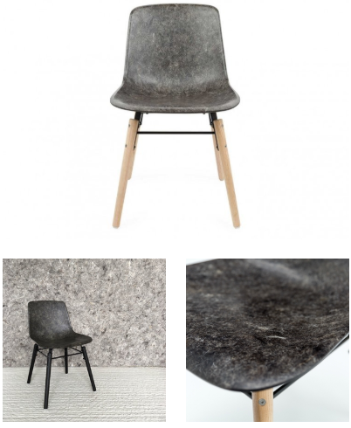

Figure 13: Solidwool chair, (Solidwool, n.d.)

This product created portrays an unusual view on wool as we know it. The product gives wool a more masculine and hard-wearing image, which changes the face of wool as it’s been proven it can be used to create hard material just as much as fabric. Wool’s properties have now expanded even further as not only it can be used to keep us warm but also create lifestyle products for the home of higher quality material. Also, it’s an excellent way to replace plastic that is ruining the environment and to use wool, our natural fibre.
For Solidwool it all began with wool and their home town with the woollen industry declining, as they described the market town once a booming part of the wool industry that had grown very quiet as mass manufacturing began and thrived, taking the local woollen industry with it. Solidwool found a new way to work with wool which will help to bring the industry back to their hometown. The planet only has limited resources; therefore, wool is seen as a very important fibre due to its sustainability, if sheep are still farmed there will be fleeces made every year. (Solidwool, n.d.).
Today Edinburgh Napier University has undertaken a project on design and leading materials. This project was funded by Textiles Future Forum that have collaborated with four Scottish based textile companies that provided the ‘waste’ from the textile industry using specifically Scottish made fabric. The waste collected was mainly wool, leather and cashmere fabric which were all fluff and scraps found underneath the machinery. The scraps mainly come from looms and knit machinery due to being caused by “selvedge waste” (Forster, 2017, p.138/139). Through taking the scraps they create “3D printable materials” which were created into products for example jewellery from cashmere wool made by Dr Kathy Vones, almost giving the object an unusual contrast between the softness yet reflecting a hard material such as metal.
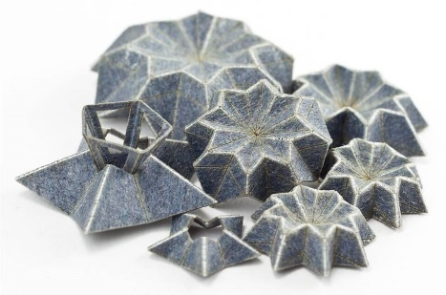

Figure 14: Jewellery by Dr Kathy Vones, (Forster, 2017, p.151.)

Over the years there has been an increase in 3D printing objects made from this process, as Textile Future Forum believes that there is a possibility 3D printed material could be the future of recycling scraps of fabric and could may well be mass manufactured, as this reflects the new way of creating ‘shoddy’ material (Forster, 2017, p.139). The ‘shoddy’ textile began when the industrial revolution hit Britain, beforehand fabrics were created through a process that involved “spinning and weaving” with the leftover fabric being used for other lifestyle essentials. The term ‘shoddy’ means fabric that’s been spun created from recycled fibres of wool, sourced from old wool rags and places such as tailors for offcuts (Forster, 2017, p.143). Tailors value wool very much as it doesn’t crease very easily but also can be sculpted and manipulated in to shape effortlessly (Evelegh, 2013, p.30). This new way of creating “3D printable materials” has the same aspects as ‘shoddy’ but with a contemporary attitude towards sustainability and recycling. As of this the contrast between ‘shoddy’ fabric and the new way of creating recycled wool textile in “3D printable material” form is seen as quite luxurious (Forster, 2017, p.150/152).
The diverse process of 3D printing is known as “maker movement” as this incredible digital machinery has its own mind set which can create any product bringing together people from different creative backgrounds to create their own unique design (Forster, 2017, p.141). But most importantly its sustainability, as less waste will be created through using recycled wool (Forster, 2017, p.140). Through using this process, it will also use less energy when creating, because of this it will cause a change towards digital and “supply chains” (Forster, 2017, p.142/143). In the project it’s not only about new ways of creating materials but also about challenging the perception of Scottish traditions and textiles (Forster, 2017, p.154).
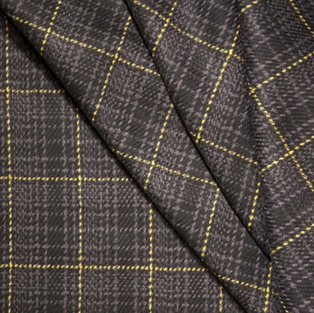

Figure 15: Dashing Tweeds cloth, (dashingtweeds, n.d.)

A weaver called Kirsty McDougall and photographer called Guy Hills started a business called Dashing Tweeds, creating reflective woven garments for men made from Merino wool. Their first ever design was the reflective ‘scooter coat’, this design was developed as McDougall and Hills felt there was a gap in the market for this new idea of woven fabrics, to take it a step further and to give it more of a purpose (Hemmings, 2012, p.32). They’ve uniquely developed a weave using wool and reflective yarn which they’ve called ‘Lumatwills’, during the day seen as a combination of colours but by night the reflective yarn is revealed through brightness (DeLong and Martinson, 2013, p.29). Not only to give it more of a purpose but to also keep up with the demands of the twenty-first-century, taking great interest and inspiration from the urban life surrounding them through looking at colour and the city and changing the look of tweed from the traditional to contemporary (DeLong and Martinson, 2013, p.29). The urban life is a continuing challenging study through looking at the function of clothing, technology and travel in the city (Hopkins, 2017, p.30). Dashing Tweeds are inspired by colours found in London, from “wet pavements of Piccadilly to the green parks of St. James” to create innovative designs (DeLong and Martinson, 2013, p.29).
Since the creation of the ‘scooter coat’ they have developed the business further by creating jackets, flat caps, trousers and even more coats that are woven in the UK. Dashing Tweed have collaborated with many various brands, Fred Perry particularly due to it being the iconic Sportswear brand for Britain. Fred Perry also looking at the change in culture, looking particularly at youth movements. To create more of a contemporary look, Dashing Tweed have created a modern and intricate fabric which also reflects the heritage of ‘British tweed sportswear’ for Fred Perry, developing the cloth into Harrington jackets, bags and caps (Hopkins, 2017, p.30). This way of collaborating with other brands is a good way to get wool noticed from all age groups, showing again how versatile wool is and can be used for any sort of style of clothing from tailor to casual.

6.0 Conclusion

Many believed that wool couldn’t be used in any other form other than fabric. Through researching designers and companies, specialising in wool, it’s been discovered that wool is a very versatile material that can be used for anything from clothing to accessories to home-wear products.
Prior to research, it was believed that black wool was priced inferior to that of white wool but as seen in figure 1 and 2, the Welsh Black Mountain wool is the dearest considering the inability to dye this wool, with the exceptions of grey shades.
Many items as of today are created out of a hard, unsustainable material; plastic being the main contributor to the damaged environment. Many companies should follow in the footsteps of Solidwool, creating a sustainable composite material to replace many plastic items. Research has been undertaken by designers and companies to expand the capabilities wool has to offer. New technology and knowledge are allowing designers such as Anne Kyyro Quinn to expand the horizons of wool to areas that wouldn’t have been imaginable ten years ago. The fashion industry should start looking more in to wool and start using this great fibre that is on our door step rather than mass producing tonnes of cotton that is harming the environment and a danger to all life surrounding the cotton factories.
Wool has been perceived as a traditional and old-fashioned material over the years, but designers such as Dashing Tweed are changing this through bringing wool to the 21st century, creating a more contemporary look. As generations pass, society are appreciating wool’s properties and luxuriousness less due to wool not being ‘fashionable’. A great way of bringing wool to the 21st century is by collaborating with high end brands. Dashing Tweed have collaborated with Fred Perry creating a collection that totally gave wool another face of luxuriousness and style. It has been proven that wool can be stylish, and companies are expanding this further and pushing the boundaries of wool and what we perceive wool as. Wool is a versatile fabric and over the centuries has been shown how it’s been developed, as wool is mainly perceived to keep people warm not fashionable but now becoming a fashionable and contemporary item. In the upcoming years wool will change its look again and again, being developed maybe through combining with other fabrics to create new fabric replacing cotton. Reiko Sudo is a fine example of this process but who knows what the next exciting step for wool will be.

7.0 Bibliography
Anon (n.d.). About — Solidwool. [online] Solidwool. Available at: http://www.solidwool.com/about/. [Accessed 15 Oct. 2018].
Anon (2012). What Is Knitting And Weaving | Difference Between Knitting And Weaving | Textile Fashion Study. [online] Textilefashionstudy.com. Available at: http://textilefashionstudy.com/what-is-knitting-and-weaving-difference-between-knitting-and-weaving/. [Accessed 24 Oct. 2018].
Anon (n.d.). Advantages and disadvantages of knitted fabrics-Ailige Textile. [online] Ailige-fabric.com. Available at: http://www.ailige-fabric.com/html/Advantages-and-disadvantages-of-knitted-fabrics-1319.html. [Accessed 1 Oct. 2018].
Anon (n.d.). Unmade. [online] Somerset House. Available at: https://www.somersethouse.org.uk/residents/unmade-0. [Accessed 19 Sep. 2018].
Anon (n.d.). Unmade. [online] Marketing Week. Available at: https://www.marketingweek.com/disruptive-brands/unmade/. [Accessed 18 Nov. 2018].
Anon (2018). Producer Information and Wool Values. [ebook] p.17, 23. Available at: https://www.britishwool.org.uk/ksupload/userfiles/Farmer/Information%20&%20wool%20values.pdf. [Accessed 19 Oct. 2018].
Anon (2018). Woolovers (Catalogue), p.36.
Anon (2018). Work — Catarina Riccabona. [online] Catarina Riccabona. Available at: https://www.catarinariccabona.com/work-1/ [Accessed 19 Oct. 2018].
Anon (n.d.). Q&A with Catarina Riccabona hand weaver. [online] theholbornmag. Available at: https://theholbornmag.com/2016/07/13/qa-with-catarina-riccabona-hand-weaver/ [Accessed 14 Oct. 2018].
Anon (n.d.). NUNO - About. [online] NUNO. Available at: https://www.nuno.com/en/about/ [Accessed 9 Nov. 2018].
Chaney, L. (2011). Coco Chanel an intimate life. p.116, 117, 123, 124.
Chelli, A. (2015). An interview with Lisa Klakulak. [online] Dyeing house gallery. Available at: http://www.dyeinghousegallery.com/en/an-interview-with-lisa-klakulak/. [Accessed 1 Nov. 2018].
Ching, V. (1980). Hawaii dye plants and dye recipes. Univ Of Hawai'i Press.
Cox, A. (2008). The pros and cons of knits and wovens. [online] Youlookfab.com. Available at: https://youlookfab.com/2008/08/27/the-pros-and-cons-of-knits-and-wovens/. [Accessed 1 Dec. 2018].
Daily Motion (2018). BBC Stacey Dooley Investigates Fashions Dirty Secrets. [video] Available at: https://www.dailymotion.com/video/x6wbmip [Accessed 1 Dec. 2018].
Dall A., Smith G. (2018). BBC Radio 4: The Sympathy of Things Part 1, 1 November. Available at: https://www.bbc.co.uk/sounds/play/m0000xqs [Accessed 29 Sep. 2018].
Davies, J W. (1981). Welsh sheep and their wool. Gomer, p.67, 68.
DeLong, M. and Martinson, B. (2013). Color and design. p.29.
Dhillon, K. (2015). Why Should You Work with Wool?. [online] Notjustalabel.com. Available at: https://www.notjustalabel.com/editorial/why-should-you-work-wool. [Accessed 30 Sep. 2018].
Ekarius, C. and Robson, D. (2013). The Field Guide to Fleece: 100 sheep breeds and how to use their fibres. Storey Publishing, p.8, 18.
Etheridge, K. (1977). Welsh costume in the 18th & 19th century. Ammanford: Dinefwr press, p.54, 50.
Evelegh, T., Grant, P., Martin, M. and Mumford, T. (2013). The great British sewing bee. p.30.
Fouchier, S. (2009). Felt (Textile handbook). A & C Black Publishers Ltd, p.9, 15.
Forster, S. (2017). Textile Design Research and Practice. 5(2), pp.138, 139, 140, 141, 142, 143, 151, 154.
Grossman, M. (2017). What is Felt, and why has it been one of the most popular textiles for over 5000 years?. [online] Contrado. Available at: https://www.contrado.co.uk/blog/what-is-felt/. [Accessed 10 Oct. 2018].
Hemmings, J. (2012). Warp & weft. London: Bloomsbury, p.30, 32.
Ian, R. and Spearman, C. (1973). The Integument – A textbook of skin biology. p. 131.
Klakulak, L. (n.d.). Artist Statement. [online] Strongfelt. Available at: http://strongfelt.com/artist-statement/. [Accessed 11 Oct. 2018].
Mcdonough, W. and Braungart, M. (2009). Cradle to cradle. London: Vintage, p.19, 27.
Millar, L. and Kawashima, K. (2005). 2121: The Textile Vision of Reiko Sudo and Nuno. Canterbury: University College for the Creative Arts, p.8, 9, 11, 12, 14, 18, 20, 21, 23.
Przybylek, S. (n.d.). The Textile Knitting Process. [online] Study.com. Available at: https://study.com/academy/lesson/the-textile-knitting-process.html. [Accessed 17 Nov. 2018].
Quinn, B. (2013). Textile visionaries. London: Laurence King, p.181.
Schneiderman, D. and Winton, A. (2016). Textile Technology and Design: From Interior Space to outer Space. p.41.
Schoenian, S. (n.d.). Sheep 101: About wool. [online] Sheep101.info. Available at: http://www.sheep101.info/warmwool.html. [Accessed 20 Nov. 2018].
Shields, H. (2015). Guide to weaving. [online] Make Works. Available at: https://make.works/blog/guide-to-weaving. [Accessed 29 Sep. 2018].
Smith, M. (n.d.). New World Wool. [online] Woolmark.com. Available at: https://www.woolmark.com/collaboration/fashion/new-world-wool/. [Accessed 17 Oct. 2018].
Tanner, A. (2010). Batch; Craft, design and product. London: A & C Black, p.80, 81.
Unmade (2018). Customizeable design through industrial manufacturing. [Video] Available at: https://gcs-vimeo.akamaized.net/exp=1544592483~acl=%2A%2F866505924.mp4%2A~hmac=741bc53c4c2f32d20717cd994de9d2dcf5e37176f272732eb1fbfa4a49f33513/vimeo-prod-skyfire-std-us/01/2959/9/239795439/866505924.mp4 [Accessed 4 Dec. 2018].
Warren, J. (2013). Why wool is spinning back into fashion. [online] Express.co.uk. Available at: https://www.express.co.uk/life-style/style/386791/Why-wool-is-spinning-back-into-fashion [Accessed 18 Nov. 2018].

Pictures
Figure 1: British Wool (2018). Damaged wool and their prices. [image] Available at: https://www.britishwool.org.uk/information--wool-values [Accessed 8 Nov. 2018].
Figure 2: British Wool (2018). Wool and their prices. [image] Available at: https://www.britishwool.org.uk/information--wool-values [Accessed 8 Nov. 2018].
Figure 3: Radeska, T. (2016). Traditional Welsh costume. [image] Available at: https://www.thevintagenews.com/2016/12/31/the-welsh-traditional-costume-saved-the-nation-from-the-last-invasion-of-britain/ [Accessed 3 Dec. 2018].
Figure 4: Stewart, M. (n.d.). Needled felt. [image] Available at: https://www.marthastewart.com/907975/needle-felt-felt-cutouts-roving-and-yarn [Accessed 3 Nov. 2018].
Figure 5: Sutherland (n.d.). Pressed Felt. [image] Available at: http://www.sutherlandfelt.com/felt/pressed-wool-felt/ [Accessed 14 Nov. 2018].
Figure 6: Southeastern felt & supply corp (n.d.). Woven felt. [image] Available at: http://www.sefelt.com/woven.html [Accessed 6 Nov. 2018].
Figure 7: Studio Knits (n.d.). Knit. [image] Available at: https://www.studioknitsf.com/stitch-patterns-beginner/ [Accessed 28 Nov. 2018].
Figure 8: Sukhi Rugs (n.d.). Woven felt rugs. [image] Available at: https://www.sukhirugs.com/about-wool-and-felt-rugs [Accessed 25 Nov. 2018].
Figure 9: Catarina Riccabona (n.d.). Riccabona’s work. [image] Available at: https://www.catarinariccabona.com/work-1/ [Accessed 27 Nov. 2018].
Figure 10: Tanner, A. (2010). Batch; Craft, design and product. London: A & C Black, p.81.
Figure 11: Klakulak, L. (n.d.). Artist Statement. [online] Strongfelt. Available at: http://strongfelt.com/artist-statement/.
Figure 12: Nuno (n.d.). Kogire Zukushi fabric. [image] Available at: Anon (n.d.). NUNO | Kogire Zukushi. [online] NUNO. Available at: https://www.nuno.com/en/textile/kogire-zukushi/ [Accessed 5 Dec. 2018].
Figure 13: Anon (n.d.). About — Solidwool. [online] Solidwool. Available at: http://www.solidwool.com/about/
Figure 14: Forster, S. (2017). Textile Design Research and Practice. 5(2), p.151
Figure 15: Dashing Tweeds (n.d.). Dashing Tweeds cloth. [image] Available at: https://www.dashingtweeds.co.uk/product/black-urban-shadow-2/ [Accessed 6 Dec. 2018].

