Seren Trodden
2201099

1. Art shouldn’t be commodified by a particular ideology
2. Art should have the same value as other subjects in education - Is the education system diminishing the creativity in art?
3. How much freedom should be in art?
4. Does art need limitations?
5. Should there be limitations for art to be used in different movements?
6. What is art worth to the human mind?
7. What does art give to society?
8. Art should be experienced by different peoples perception, allowing freedom of creativity
a. Art shouldn’t be commodified by a particular ideology
b. Art should have the same value as other subjects in education
c. Art should be experienced by different peoples perception, allowing freedom of creativity
a. Art is a powerful tool, and many political movements use artwork to convey messages to the population. But does using art to manipulate opinion create suspicion, giving people negative views of all public art?
‘’Advertisers have used models of behaviour to frame their messages since the inter-war years. They have sought to define and understand their target market.’’. (Brierley, 1995 p.152)
We are familiar with advertising campaigns using artwork, as well as seeing old propaganda posters dating from the First and Second World Wars. Strong images were accompanied with powerful messages on World War 2 posters to target particular people. This showed that the poster commissioners understood how to use artwork to catch public attention not only through words but strong images too. Some posters had positive messages to encourage the population, while others made fun of opposing nations, using impactful images with heavy graphics. Using painted images in this way could lead to mistrust of all artwork, with people viewing it as primarily a tool for political propaganda to this day.

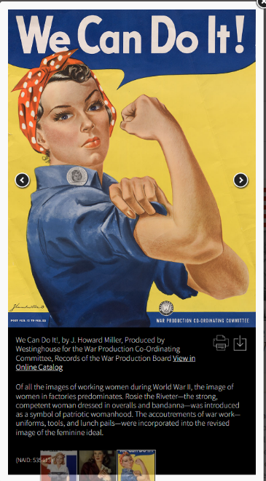

Fig.1: It’s a Woman’s War Too!

b. While art and design at college and university level are exciting fields of study across many different media, my personal experience of studying art at school was that it was not taught to the same standard of education as other subjects. Studying GCSE and A level art, I felt a lack of exploration, absence of equipment and materials enabling forms of art other than drawing and painting. This did not stop my own love of the subject, but could the school education system be putting off future artists?
‘’…this is an excellent work which should be studied by everyone concerned with the future of the arts in our society.’’(Stevas, 1989)
Though art is not a mainstream choice for secondary pupils, the limitations for teaching this subject, whether due to poor funding, restrictive curriculum, staff or other factors, can affect the students’ view of the subject. If the school does not appear to value art as a subject then why should the students? There are so many different forms of art and yet many schools can't even explore past the basics.

c. Art allows the maker to express and share whatever they want but also means that each viewer experiences something different from a work of art. For example, one person may find meaning in an abstract painting while another finds nothing. Some look for a message, others respond instinctively to an artwork.
‘’we recognize and respect many art forms of the past, like tragedy - although our context for experiencing them may be different.’’ (Freeland, 2001)
A good example is religious art. Someone who shares the religion depicted may respond differently to another person of different faith, or no religion. This does not mean that people from outside that religion cannot objectively experience the quality of the artwork itself, or be inspired by viewing the piece of work with an outside perspective. It is just that the religious experience will not affect them the same way. Across the world each one of us is affected uniquely by different artworks.

Bibliography
Brierley, S. (1995) The advertising handbook. London: Routledge.
Stevas, N, St J. (1989) The arts in school. UK: Calouste Gulbenkian Foundations.
Freeland, C. (2001) But is it art?. Oxford: Oxford University Press.
List of illustrations
Figure 1: NATIONAL ARCHIVES (2019) It’s a Woman’s War Too! [Poster campaign]. Available at: https://www.archives.gov/exhibits/powers-of-persuasion (Accessed: 27th October 2023).

