Reflective report
Contents
Learning 1
Engagement 1
Motivation 2
Environment 2
Managing problems 2
Researching 2
Presentation 2
Writing 2
Soft Skills 3
Teamwork 3
Employability and Career Development 3
Conclusion 3
References 3

during this year, I had the opportunity to broaden my academic horizon and my skills as a professional. Not only for my coursework, but also for using these skills for other different times. I am writing this report to make an analysis of how I have adapted these techniques during this course to improve what I’m doing right now. I will also talk about how it will contribute to my leanings and how it will shape my future career as I finish this course in time. I talk about and what I’ve learnt what skills I have done.

Learning
According to David Kolb [1] One of the most important leaning aspects is that there were three learning styles. Visual, auditory and kinesthetics. was of my learning style. I have found out that I was an auditory and visual learner, which means I am able to learn easier by watching and listening. This helped me to broaden myself so that I can focus more during lessons and lectures. And it would help me during activities such as group discussions. I always try to learn even at home, to make myself a much smarter person than I was before.

Engagement
During my coursework, I try to maintain a straight-forward feeling towards working for this course. I always think what benefit that I would get, a higher diploma and a grant of £1000. I always try to motivate myself into working and try my best to keep focusing although it sometimes doesn’t work. I do this so that I would make myself a much more focused and professional person. I feel as if these points would help me during teamwork courses and future work.

Motivation
An aspect of my learning I would say was mandatory was the goals I will achieve once I finish this course. I like to finish my work as soon as possible so that at the end of the day, I wouldn’t have to worry about the deadline. I also want to make everyone around me impressed by what I’m doing, so that I try to be professional about it and make people proud.

Environment
One key lesson I have learnt this year was the fact that having a good study environment is important. I organise my workspace and using a schedule so that I can make focusing on my work easier. During my studies in my house, I tend to have breaks every 20 minutes before I put myself in the workspace again. I use a timer so that is helps me when it’s time to work and when it’s time to rest.
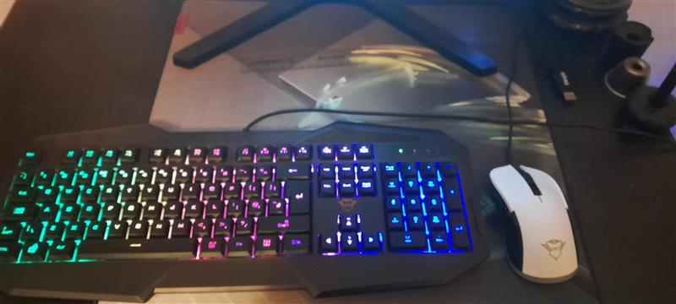
This is my work desk at home. I keep it look nice and tidied so that I don’t have any distractions towards workings.

Managing problems
During the course, I have met several problems. Whereas to do with the work, deadline or it could be somewhat of a family problem. However, I always try to work my fullest and try to worry about the problems later. As such, I ask my teachers if there are any problems I can discuss with them, and my parents as well if there are any personal problems that I can’t discuss with anyone else.
Whenever I must deal with problems during an assignment or other work, I try to think what I could do to solve the problem in the first place by cutting the problems into smaller and more manageable pieces, or that I try to think outside the box if I get stuck trying to solve the problem. If I can’t do handle them by myself, I ask my teachers for help or advice and check and see what they have given me or what they have said to me that would lead my problems solved and so that I can continue with what I was doing.
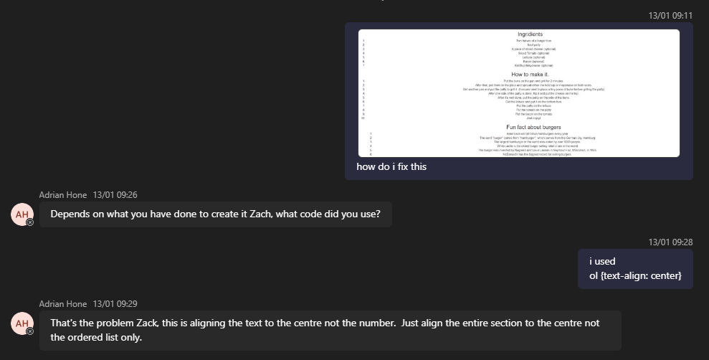
This is an example of me getting stuck on an assignment. I didn’t know what to do and I was clueless. So I thought the best way to solve this is by asking a teacher.

Researching
I usually apply research methods in my coursework, which can be very useful sometimes. This involves me in gathering information from valuable sources by going to online websites that are considered valid. I always try to find what would fit perfectly in my coursework so that it would make my work much more effective by using context. I find researching useful because it can help explain efficiently in what the information I made is talking about
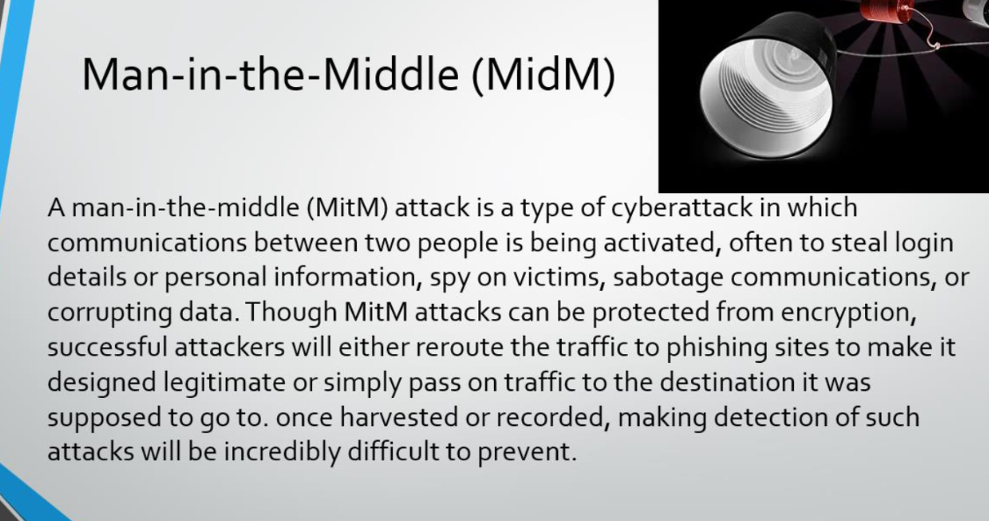
This is an example of how I research. I get information about the man-in-the-middle attack by going on a website that stated what information I need, then I use that information and put it in the presentation that I would be working on.

Presentation
A topic which I think I am quite struggling on is the presentation work. During presentation a presentation, you’re suppose to use many types of skills such as eye contact, hand gestures, and clear voice. What I think I struggle with is the fact I don’t practice doing the presentation before the main presentation starts. With that in mind, I’ve made an agreement to myself, that I should try to practice at least once a day.
Although presenting isn’t that good, I feel as if working on the presentation slides are beneficial. I use editing for example, animation, shapes, text sizing and colouring. I think this is one of my strengths when I do the presentation slides.
Writing
Another topic that I feel would be useful in the report is my professional writing. I have been structuring my reports efficiently setting which information goes where and to make it easier for the viewers to read. For example, I use the table of context so that if the viewer is lost and has forgotten what to read, the table is context is there to help them. These points make the report easy to follow and proves that my ideas were on point.
Soft Skills
During the course, I have developed some soft skills that would be helpful during my future career, examples such as communicating with colleagues and using time-management. The ability to analyse with what useful skills that I have and what I usually go wrong with have led me to believe that if I can make more skills by training myself, I could have an easier horizon that I can continue to work on.

Teamwork
My experiences during this year were that fact that I have asked for help with my teachers so that I can be more confident next time while working. This made me think that maybe in my future career, when I see my co-worker struggling, I could also help them as well so that I could learn how people’s strengths and weaknesses were used in a way which would help me from understanding and make teamwork a lot let difficult.
And, I have a friend that sits next to me during class. We usually help each other.

Employability and Career Development
The aspects during this course that I have developed, such as professional writing, listening skills and problem solving is very crucial when I look forward towards my future career. I believe that looking back to this course in a few years’ time would help me become much clear and more confident while working on my job. Moreover, whilst using the information that I got, I think I will have a better chance of being more proactive during my career

Conclusion
This report has provided what I believed I have applied the academic and employability skills and what I have learned for myself during this course. the techniques and strategies I have studied have not only improved my knowledge but have also prepped me with useful skills for my next future career. From problem solving to teamwork communication, I have made a wide range of skills that I would believe would work for my next career; However, I don’t think I am ready just yet, I still feel as if I’m in need of more practice and also need to focus more whilst working as I do get distracted sometimes. Never less, I am confident of expanding my academic knowledge and developing skills so that in the future, I can continue to work more naturally as I grow older

References
[1] Kolb explains that different people naturally prefer a certain single different learning style. Various factors influence a person's preferred style: notably in his experiential learning theory model (ELT) Kolb defined three stages of a person's development

