

An Investigation and Evaluation of Social Media Promotion Strategies for Organisations

by
Lloyd Pennington

Supervisor: James Williams
Second Marker: Beverley Holland

Project submitted as part of the requirements for the award of
BSc (Hons) Business Information Technologies

May 2019

DECLARATION

I, Lloyd Thomas Pennington declare that I am the sole author of this Project; that all references cited have been consulted; that I have conducted all work of which this is a record, and that the finished work lies within the prescribed word limits.

This work has not previously been accepted as part of any other degree submission.

Signed : Lloyd Thomas Pennington

Date : 01/05/2019

FORM OF CONSENT

I, Lloyd Thomas Pennington hereby consent that my Project, submitted in candidature for the B.Sc.(Hons) Business Information Technologies degree, if successful, may be made available for inter-library loan or photocopying (subject to the law of copyright), and that the title and abstract may be made available to outside organisations.

Signed : Lloyd Thomas Pennington

Date : 01/05/2019

Contents
Chapter 1: Introduction 6
1.1 Literature Review Introduction 6
1.2. Aims and Objectives 6
Chapter 2: Research and Review of Current Literature 7
2.1: Social Media – What is it? 7
2.1.1 Definition: Social Media 7
2.1.2 Introduction to Social Media 7
2.2 Social Media: Categories 8
2.3 Social Media: The Big Three 8
2.3.1 Facebook 8
2.3.2 YouTube 9
2.2.3 Instagram 9
2.4 Business Orientated 10
2.4.1 LinkedIn 10
2.5 Video/Image Sharing 11
2.5.1 Vimeo 11
2.5.2 YouTube 11
2.5.3 Facebook Space 11
2.5.4 Twitch 11
2.6 Social Media: Promotion Strategies 11
2.6.1 Advertisements 11
2.6.2 Posts 12
2.6.3 Graphics 13
2.7 Social Media Management 13
2.7.1 What is Social Media Management? 13
2.7.2 Analytical Tools 14
2.7.3 Social Media Analytical Tools 14
Chapter 3: Research Methodology 15
3.1 Introduction 15
3.2 Research Philosophies 15
3.2.1 Positivism 15
3.2.2 Phenomenology 15
3.3 Research Strategies 16
3.4 Data Collection Methods 16
3.4.1 Survey 16
3.4.2 Research Implementation 16
Chapter 4: Research: Implementation 18
4.1 Introduction 18
4.2 Plan 18
4.2.1 Social Media 18
4.2.2 Posting Strategy 18
4.2.3 Monitoring 18
4.2.4 Digital Branding 18
Chapter 5: Implementation: Analysis of Results 19
5.1 Instagram 19
5.2 Facebook 20
5.2.1 Overview 20
5.2.2 Posts 20
5.3 Survey Analysis 22
5.3.1 Question 1 22
5.3.2 Question 2 22
5.3.3 Question 3 22
5.3.4 Question 4 23
5.3.5 Question 5 24
5.3.6 Question 6 25
5.3.7 Question 7 26
5.3.8 Question 8 27
5.3.9 Question 9 28
5.3.10 Question 10 29
5.3.11 Question 11 30
5.4 Conclusion 31
5.4.1 Instagram 31
6. Evaluation 31
Bibliography 32
Appendix 35

Chapter 1: Introduction
The project that has been undertaken has been a survey-based project that focusses on the effectiveness of social media promotion strategies on new and emerging businesses. This will focus on asking the new businesses how they put themselves on social media and how older businesses used social media when they first started.

1.1 Literature Review Introduction
The literature review begins with the overview of the methodology that has been used within the literature review. This includes the different people and the company that has been collaborating with the research and practical aspect of this literature review.
Following this, the second section will be a look into the operational understand and the technical definition of social media, there will also information regarding the different types of social media, this is taking into consideration the “Big Three”, business oriented and video sharing social media, this section also shows the main social media, explaining how they work and why social media is popular with the users.
The third section investigates the information regarding social media promotion strategies, this includes an overview of the definition of a social media promotion strategy and how a business can boost on a social media with the use of the different features that are available on that specific social media.
The fifth section will include the research, this includes the premise of the research and how the research will fit into the current field of social media.
The sixth section will show the implementation of the research and will show the information in the literature review in a practical setting. The final section for the literature review is the conclusion and will feature the research and the implementation of the research in an analytical setting.

1.2. Aims and Objectives
The aim of this project is to investigate social media promotion strategies and identify current best practises.
The objectives of this literature review are these;
- Analyse current social media strategies
- Design, test and implement new social media promotion strategies
- Evaluate the effectiveness of the social media promotion strategies and recommend best practices.

Chapter 2: Research and Review of Current Literature

2.1: Social Media – What is it?
The following sections, within the current chapter, will give an introduction about social media. This chapter will explain, and discuss, the current social media: included will be how to market a business on social media and will explain the advantages and the disadvantages of utilising social media for a new business in a time where everything is constantly evolving and changing.

2.1.1 Definition: Social Media
The definition of a social media promotion strategy is straight forward, although the definitions do differ from source to source. The reasoning behind this is that defining the term “social media promotion strategy” is simple to define so no one really needs to define the term. In the academic journal Business Horizons [1] a social media promotion strategy is loosely defined as;
“Consumers become involved in the promotion or demotion of brands through self-created advertising videos.”
This basically means that the user will be a part of the advertising process through the various posting stratagems that the company employ onto the social media platform.

2.1.2 Introduction to Social Media
Social media is a recent phenomenon that has taken the world by storm, in the UK alone there is an estimated 42 million users daily [2]. Depending on who is asked, the first type of social media was made in either the late 1970s [3] or the late 1990s [4]. The “first social media” was called Six Degrees [5], this can be thought of as a basic version of Facebook, as it allowed the users to chat with each other and add each other as friends. Either way, no one can argue that social media has been on the rise since, mainly with the younger generation e.g. “Generation Z” or “Millennials” – but businesses are also utilising the evolving platform to gain new customers and for a global reach.
Social media has become a main staple in people’s lives and an essential part of their personal life. The main reasoning for this is that it allows the person to be completely “up-to-date” with what’s going on around them, as the user is constantly viewing and/or interacting with posts from people around the globe. Social media is communication on an unprecedented level, when considering that not even one hundred years ago the main method people used to communicate was via a letter, while the smaller businesses could only communicate themselves via poster and/or word-of-mouth.
Social media is always evolving and changing, as any type of technology from around the world. The fact that there are people constantly generating data, with the likes of updating statuses, uploading images and/or videos. Social media is not only for the personal use but is also utilised by different businesses in different ways to promote their business globally. The reason for this is quite evident, if there are millions upon millions of people of social media around the world then the best method for businesses to reach out and gain an influx of customers would be to utilise social media to amplify their presence.

2.2 Social Media: Categories
There are different categories when it comes to social media, depending on the source of the information there can either be around ten [6], while a different source would say that there are around four. Most sources, however, would say that the main three social media for business promotions would be Facebook, YouTube and Instagram [7].
The main categories for social media, as defined by many different sources, would be the “social networks”, media sharing, shopping, blogging and discussion forums [8], in this case the main categories are defined by Hootsuite – with many more categories being defined each day.

2.3 Social Media: The Big Three
As with any type of medium, there are the main variants of social media. The main three social media are, according to Entrata [9], Facebook, YouTube and Instagram. This is based off the user data, i.e. how many people visit the social media daily and the amount of interaction the users have with the social media.

2.3.1 Facebook
Whenever somebody thinks about social media, that person will more than likely think about Facebook. This may be due to the fact that Facebook is the largest social media on the internet and boasts over 2 billion active users [10] Facebook, as a social media, is catered towards every type of user, this is ranging from the average person to a multi-million-pound business [11].
A typical Facebook page will contain the following; the feed, the chat and advertisements. Each of these features can help a business, whether small or large, in many important ways. Let’s take the feed. The feed is the main way of communicating, with a large audience, on Facebook. Taking this into consideration a business can implement different methods of promoting themselves via text, images and video. There are, of course, other features on Facebook but none of them apply to the business setting, as they apply more to the casual Facebook user.
Moving on to the chat tab, this is mainly used for either one-on-one conversations or small groups. While this is mainly used casually, it can be utilised in a business setting for communicating with the customer when they have an issue.
Lastly, the final feature on the main Facebook page will be the advertisements. The can be used by businesses, both big and small, to promote themselves with an audience. There are many ways of implementing an advertisement on Facebook, and this will be covered later.
In terms of social media promotion strategy Facebook mainly relies on advertisements as its main form of targeting an audience, as said by Facebook [12]. The posts would then be used to further get the user interested, this would be done by the language used in the post and how relevant the text is to the over advertisement. The wording would differ from one advertisement to another, as the demographics and overall topic would be different. An example of this would be if there was a specific advert targeted towards Teenagers then the language would be different from an advertisement targeted towards the elderly generation. [13]
A successful case study for Facebook marketing would be Birds Eye. [14] With their use of targeting the correct audience, mixed with the use of videos and correct use of social media posts. This allowed the Birds Eye campaign to drive 10% overall incremental reach and huge incremental reach among its target audience: 26% of those exposed to Facebook were not exposed to the TV campaign. The results of the Facebook marketing strategy include a 26% incremental reach from Facebook on top of TV amongst target audience. This also includes a 6 million unique users reached amongst target audience, while 10% of those exposed to the Facebook campaign were not exposed to the TV campaign.

2.3.2 YouTube
YouTube has over 1 billion users each month and is the second largest search engine, processing more than 3 billion searches a month. People are consuming video more than ever and allocating funds for video advertising shouldn’t be an afterthought anymore. YouTube advertising is relatively cheap, and, in some cases, you may only spend a few cents per view [15] .
YouTube is a video sharing and video streaming social media, this makes it different when comparing it to the other members of the Big Three [16] .The fact that YouTube is a video sharing social media means that it will have a different layout and format when comparing Facebook and Instagram. This type of social media will have drastic differences when comparing the social media marketing strategies when comparing it to either Facebook or Instagram [17].
On YouTube the main format involves a search bar, recommended videos and a task bar for the user. YouTube’s search bar is the area where the user would go to search for a video and/or channel that they might be interested in, this also brings up similar searches when the user is searching [18] .
The second part of the YouTube interface is the recommended videos. The recommended videos are the videos that are either popular globally, I.e. trending, or have a similar format/topic to the types of video that the user has been searching and watching previously.
The final feature would be the notifications tab. This is the area where the user can properly interact with the YouTube interface. This section allows the user to see their channel analytics and allows the user to modify their videos and channel data [19]. The modifications would include the uploading and/or deleting of videos and the use of scheduling any videos for to be uploaded at a later time and/or date. There are a more casual set of features on the YouTube interface for the more casual user of YouTube, but these do not apply to the more technical user of YouTube.

2.2.3 Instagram
Instagram is a social networking app made for sharing photos and videos from a smartphone. Instagram has a different interface, but the features are like Facebook and/or Twitter, everyone who creates an Instagram account has a profile and a news feed [20].
When you post a photo or video on Instagram, it will be displayed on your profile. Other users who follow you will see your posts in their own feed. Likewise, you'll see posts from other users whom you choose to follow.
Within a six-month period in 2016, Instagram grew its daily user count by 100 million users. Now with more than 600 million active users on Instagram, it’s no wonder why the image and video social sharing app can’t stay out of the news. The introduction of Instagram advertising made it even more of a critical space to be for businesses.
Instagram demographics have veered toward younger generations since its inception. However, new statistics from the Pew social media report show older generations are starting to embrace the app a bit more, the statistics would be [21];
- 59% of 18–29 year olds use Instagram.
- 33% of 30–49 year olds use Instagram.
- 18% of 50–64 year olds use Instagram.
- 8% of people 65+ use Instagram.
Also, of all of those age groups, the dominant gender on the photo-sharing site is still women. These statistics would be [21];
- 38% of online women use Instagram.
- 28% of online men use Instagram.

2.4 Business Orientated
Social media is not just for the casual user, for example the type of person who will come home after school/work and browse for an hour or so. Social media can also be used for businesses and by businesses. Businesses would do this to get their information across a wide audience of people as quickly and efficiently as possible [22].

2.4.1 LinkedIn
LinkedIn is a social networking site designed specifically for the business community. The goal of the site is to allow registered members to establish and document networks of people they know and trust professionally [23].
LinkedIn works a little differently when compared to the more casual Facebook and/or Twitter because there are different types of memberships that a LinkedIn user can buy. There are also different features of the website, as the social media is more catered towards businesses and business users.
There is the Home page on LinkedIn. The home feed is your news feed, showing recent posts from your connections with other professionals and company pages you're following.
There is also the users profile page, which shows your name, your photo, your location, your occupation and more right at the top. Below that, you have the ability to customize various different sections like a short summary, work experience, education and other sections similarly to how you might create a traditional resume or CV.
Following on from that there is the “My Network” section. In this section you'll find a list of all the professionals you're currently connected with on LinkedIn. If you hover your mouse over this option in the top menu, you'll also be able to see several other options that will allow you to add contacts, find people you may know and find alumni.
In the Jobs section there are all sorts of jobs listings are posted on LinkedIn everyday by employers, and LinkedIn will recommend specific jobs to you based on your current information, including your location and optional job preferences that you can fill out to get better-tailored job listings.
There are a lot more features to the website, but these are all unanimous with other social media pages, for example there is a search bar that allows the user to search and filter the results that they want to reach. There is also a tab for messages and notifications, this works exactly how it sounds and works pretty much in an identical manner as Facebook and Twitter.

2.5 Video/Image Sharing

2.5.1 Vimeo
Vimeo operates much like YouTube as they are both video hosting platforms. This basically means that they allow users to upload videos to the website and they will allow users to host the video on their servers.

2.5.2 YouTube
YouTube is a convenient way for absolutely anyone to upload quick videos of everything from tutoring to home videos to music performances. Although the user base is much more amateurish, YouTube comes with the advantage of having a much larger viewership. YouTube has a reputation for lower quality videos and a higher percentage of videos that are unprofessional or pointless.
Vimeo has nearly 20 million members and receives 100 million unique visitors each month. And although Vimeo’s viewership is dwarfed by YouTube’s numbers, the site attracts the elite and a niche crowd that appreciates the higher quality videos

2.5.3 Facebook Space
Facebook Space is the social media company's virtual reality (VR) application that allows users to interact in a virtual environment as if they were in the same room. It effectively would be more ‘social’ than the social media, as you can physically talk to the people instead of typing to them or posting on the recipients Facebook wall etc.
Facebook Spaces is generally just a VR form of Facebook. This is in the sense that you can do everything that you can do on Facebook but in VR. Of course, there are differences between Facebook and Facebook Spaces, an example would be that Facebook Spaces allows the user to draw in 3D and allowing the user to “transport” to different areas of the website by ‘eating an orb’ – this will be a form of user interaction that progresses the functionality of the livestream.
There are going to be more additions to the Facebook Spaces platform, in the sense that third party developers will be allowed to make their own spaces, this could be anything from games such as Farmville to businesses making meetings.

2.5.4 Twitch
Twitch is an online streaming platform designed for streaming video-games. The streaming service boasts over 2 million unique streamers every month and more than 17 thousand of these are actual streamers – the colloquial term for someone who live streams a game/talk show/show for an audience [24].

2.6 Social Media: Promotion Strategies
A social media promotion strategy is the planning involved to make a successful business promotion within various social media [25] – this is how Kotler defines a social media promotion strategy. The general outcome of a well-planned social media promotion strategy would include a higher click rate, a higher view rate and a higher interaction rate between the business and the consumer [26].

2.6.1 Advertisements
Digital advertising is seen across the internet, whether it be on a search engine like Google or on a social media such as YouTube. This is done because of the high amount of traffic coming through these search engines [27]. Social media advertising is done the same way, and for the same purpose as the Google Advertisements.
Social media advertisements are usually catered towards a specific audience, for example if an advert were about video gaming then the advert would be catered and shown towards people who have “liked” video-gaming related pages, rather than people who have not “liked” video game pages [28]. The example of “liking” is done for the purpose of an example for Facebook, as each social media has a different method of “liking”/users interacting with pages/profiles - Twitter has following, for example [29].
There are different methods of advertisements for a new and upcoming business. These types of advertisements can be categorised into two different types – paid and unpaid. The two methods both achieve the same goal, although if the user pays for the option for a boost then that users business will be seen faster and by more people than if the user decides on not paying for a boost.

2.6.1.1 Paid
https://www.socialmediaexaminer.com/facebook-boost-posts-promoted-posts/
Businesses are allowed to have the option to promote themselves on social media in different formats. The different formats being either a partnership with the social media or for the user to manually pay for the advertisement.
A paid advertisement can be defined in different ways, the definition varies from source to source. Kotler, however, defines paid advertising as ““...Any paid form of non-personal presentation and promotion of ideas, goods or services by an identified sponsor” [30].
As the social media chosen for the implementation, the social media advertisements being discussed will be situated around Facebook and Instagram. Both, Facebook and Instagram, have their own methods of a paid social media advertisement post.
Facebook allows the user to make an advertisement, for their business, by allowing the customisation of the advertisements – this includes who will be able to view the advertisements (the target audience), the overall cost of the payment and, finally, the actual content of the advertisement. When it comes to the payment methods, the user can choose between either paying a one-time fee and/or paying a recurring bill each month.
Instagram allows the user to make an advertisement, for their business, by allowing the user to customise the advertisement. The customisation in the form of Instagram allows the user to choose different criteria for the audience, i.e. the location of the users and the age of the users – these are just two examples of the choice that the user has when making an Instagram paid advertisement. The method of payment for the advertisement is, relatively, the same as Facebook’s, in the sense that there is an option for a onetime fee or a recurring bill every month.
Both Facebooks and Instagram’s paid promotions work the same way as each other’s paid promotion. There are however some stark differences, for example Instagram’s paid promotions will be more focussed on a image and/or video form than Facebooks text/post based form. Both Instagram’s and Facebook’s paid advertisements will appear within the target audiences social networking feed – this means that the user will not even need to search the business up to see their advertisement(s).

2.6.2 Posts
A social media post is defined as, by Hootsuite Blog as [31];
“Social media engagement refers to the acts of talking to, messaging or otherwise interacting with other people on social networks.”
With this definition there are multiple ways that a company can post on social media. Post is a generic term and is mainly used for Facebook, other social media use different terms, for example Twitter uses “Tweet”, while YouTube uses “Upload” - the term post will cover these terms but are not social media specific [32].
The number of posts is also a massive deal when it comes to different social media. CoSchedule is a company that has done research on the amount of posts that are recommended for each type of social media [31] and according to the company's research, here how often you should be publishing on each of the major social media platforms daily:
- Facebook: 1 post per day
- Twitter: 15 Tweets per day
- Pinterest: 11 Pins per day
- LinkedIn: 1 post per day
- Instagram: 1-2 posts per day

2.6.3 Graphics
In IT, the term graphics generally refers to images generated by a computer or similar tech device. In the most fundamental sense, graphics are images. Over time, there have been radical changes in computer graphics and the ways they are generated and utilised. An example of this would be to use them on different websites and, more recently, to use them on social media as a method of gaining more views and understanding of the given topic. [33]
Using graphics on social media can be beneficial to both the user and the designer. The reasoning for this is that graphics can convey more information that words ever could, an example of this would be from Canva. Canva is a business that helps businesses make graphical designs for their various social media feeds and social media platforms. Canva released this statistic [34];
“We utilised a graphic design to promote my content upgrade freebie, which was a bundle of Pinterest templates. The result was 74 email sign-ups.”
Using this as an example would suggest that graphics help the designer to draw in customers and/or clients and allow them to understand what is happening, without the use of a wall of text. Comparing this to a company that has not utilised an image would be pretty irrelevant, as it would be easy to understand how the two will compare – Canva would get more views and more signups than the company that has not used an image, as the image will be more likely to draw in a higher volume of customers. This would be mainly to do with that the image is bright and colourful when compared to a wall of black and white text.
Utilising graphics could also be considered a form of “digital branding”. Digital branding can be defined as [35] “Digital branding is a brand management technique that uses a combination of internet branding and digital marketing to develop a brand over a range of digital venues…”

2.7 Social Media Management

2.7.1 What is Social Media Management?
There are methods of monitoring and managing social media, this could be anything from posting strategies to monitoring the number of clicks on a page. Most social media have some form of monitoring built into them. Facebook, as an example, has this feature built into it.
Users earn money through the Twitch Partner program, a service that provides streamers with added features such as paid subscriptions and ad placements, and this is where the business aspect comes into play. The main reason why Twitch is categorised as a social media would be that the views and the streamers can communicate in real time – Twitch is basically a live streaming website for video gaming. Compare Twitch to Facebook Live for a higher understanding – Twitch is the video game equivalent of Facebook Live.
The people who stream the video-games on Twitch are called “Streamers” and they can make a fair amount of money doing so, this could be from either advertisements or sponsorships. They are also a very ingenious way of sharing business ideas, especially businesses like SMCoaching, as this is where the main clients could potentially come from.
One of the main reasons why people go on Twitch is to communicate with the streamer and their fellow viewers, enjoying the opportunity to influence the stream and check out the content with a “room” of like-minded people. Common ways to grant some control to viewers include hosting votes/straw polls to make gaming decisions, inviting viewers to play with you online, and holding live giveaways and competitions. All of these examples could be commandeered by marketers to introduce interactivity into online video advertising.

2.7.2 Analytical Tools
There are analytical tools built into different social media, an example of this would be the Facebook, Twitter and YouTube analytics tool. While the tools do the same function, they all analyse differently compared to one another. There are, however, third party analytical tools that can do more analysing and will also be more in depth when compared to the built in, free, options on the social media accounts.

2.7.3 Social Media Analytical Tools
To see Facebooks analytical tool please visit Chapter 5 section 5.2. Comparing Facebooks analytical tool to Twitters; they do exactly the same functionality with just a little more emphasis on trending and hashtags – as hashtags are what Twitter are known for.
For example, YouTube when a video is uploaded allows the user to see how many people have watched the video and how much money the video has made. This allows the uploader to make more videos like that one if it did well, or not to make another video like that if it went poorly.

Chapter 3: Research Methodology

3.1 Introduction
This part of the project looked at the application of a select research methodology. This section also looked at the overall justification of the methods that have been implemented within the project. The different items that have been considered are the various strategies and approaches towards the research, while also taking into consideration the methods that have been used for the collection of the data and/or information. This part has also considered the methods of the data analysis and who and what the sample is for the data collection.
This part of the project has been focussed on the various details of the research. This has included the overall validity of the research and the reliability of the various sources that have been utilised in gathering the information.
The research that has taken place has mainly affected the first objective that is within the project, while also helping to complete the second and third objective. The first objective is self-explanatory, as research is needed to complete the objective, however, the second and third objectives will be utilising the information gathered in a more passive method to help complete said objectives.
- Analyse current social media strategies
- Design, test and implement new social media promotion strategies
- Evaluate the effectiveness of the social media promotion strategies and recommend best practices.

3.2 Research Philosophies
There are two main types of research philosophy [36], this is according to Michael Armstrong. The two main research philosophies are called Positivism and Phenomenology. Each being different methods of gathering data and/or information and allow different types of results.

3.2.1 Positivism
Positivism is the understanding of the real world. The type of research that would come from this type of methodology would be items such as questionnaires, surveys and experiments etc. All these types of research would be collected first hand by the user, therefore making the research primary and not secondary. [37]

3.2.2 Phenomenology
Phenomenology is the understanding of gathered data. The type of research that would come from this type of methodology would be the items such as case studies, one-on-one interviews and ethnographic research etc. All these types of research would be collected first hand by the user and would also make this type of methodology primary instead of secondary. This does depend on if the case studies have already been made. [38]
During this case study there will be the use of both positivism and phenomenology. The reasoning behind this is there has been the implementation of a survey, which has been proposed by the author as a method of data gathering, and surveys, if completed first hand, fall under positivism. However, phenomenology has been utilised during the entirety of Chapter 2 – this is evident by the amount of case study examples and the fact that all the data used within Chapter 2 is secondary, and not primary, therefore making it phenomenology.

3.3 Research Strategies
This section of the research methodology focusses on the proposed research strategies that have been implemented within the project to gain the relevant information needed to complete the various objectives.
As discussed, there will be two main types of research strategies in order to collect first-hand data and second-hand data. The first type of research strategy that has been used will have been the use of case studies. The reasoning behind using a case study would be to achieve the first objective. The second type of research strategy that has been utilised has been the use of a survey in the form of questionnaire. The use of the survey will be done to achieve the third objective.

3.4 Data Collection Methods
Data collection would be used, as defined by Polkinghorne [39] as
“The purpose of data gathering in qualitative research is to provide evidence for the experience it is investigating. The evidence is in the form of accounts people have given of the experience.”
Also, data collection methods can also be defined as, by Dudovskiy, [40] “Data collection is a process of collecting information from all the relevant sources to find answers to the research problem, then to test the hypothesis and evaluate the outcomes.”

3.4.1 Survey
The purpose of the survey is to gain a further understanding of a how a business operates with their social media.

3.4.2 Research Implementation

3.4.2.1 Advantages and Disadvantages
This case study, or research implementation, was chosen as a method of testing all the data gathered in chapter 2. The case study will be used as a first-hand experience to show the user how social media affects a small and growing business. This will also show how the social media will need to be maintained and analysed to gain the proper understanding of the evolving technology.
On the other hand, there will be disadvantages for using this case study as a resource. The main disadvantage being the time constraints of both Mr. McCann and the student – this is due to the fact that this business is not Mr. McCann’s main source of income and, is truly, on a hobby. This means that external factors will affect the uploading of social media posts and analysing the results; these factors would be issues like the student and Mr. McCann going to work and being unable to communicate the posting strategies in full. Another disadvantage would be the student having time constraints in relation to the University course and needing to complete other assignments while working on the dissertation.

3.4.2.2 Reliability and Validity
This research implementation has been considered when it comes to the reliability and the validity of the implementation of the research. This being considered, there should be no problems when it comes to the overall reliability and validity of the implementation of the research.
What makes the implementation reliable is more to do with the fact that Mr. McCann was present in the creation of the social media pages and has been present to, not only, design and upload some of the posts but has present if a consultation would have needed to happen.
The validity of the implementation is valid because Mr. McCann did not have a social media presence before the making of this implementation of the research. If, for instance, Mr. McCann had a social media presence, for the business beforehand, then the research implementation would not be valid as there could be a potential cross contamination of the various social media when it comes to gaining followers or post interactions.
The validity of the implementation is valid because Mr. McCann had the social media beforehand, but only for a short amount of time – this being the Facebook option. The Instagram option was made for the implementation and is, therefore, the more valid option: this is another reason why the Instagram was chosen to mainly be implemented when compared to the Facebook option.

Chapter 4: Research: Implementation

4.1 Introduction
SMCoaching will be a small coaching business for video-gaming, primarily featuring the game Counter Strike: Global Offensive, however SMCoaching will expand into other popular video-games such as League of Legends and Overwatch. The business is owned by Mr. McCann, who is a personal friend of the author and who proposed that his business could be a case study for the implementation of the research.

4.2 Plan

4.2.1 Social Media
The coaching will be done by one person, the owner of the business. This means that there is little need to go into every type of social media. The main types of social media that would fall under the category of “social media” and image sharing based social media sites. As defined by biteable, these types of social media would be social media such as Facebook and Instagram, respectively.
The reasoning for using Facebook and Instagram was that they encompass all the features needed with a large audience within them. Facebook would be used to get more of the posting side of the implementation, this would follow the idea that the audience will want to communicate with the business so that they can work out a coaching plan.
The reasoning for using Instagram would be that as this is a coaching service then the users may want to see previous examples of previous clients and how much they have improved at the game since being initially coached.

4.2.2 Posting Strategy
The posting strategy was, originally, the owner of the business: Mr. McCann would have made a post on Facebook and Instagram each day – the posts would differ sometimes, but yet also be the same, e.g. sometimes Facebook would get unique posts, while other times Instagram would get unique posts.
Mr. McCann did not want to spend any money on boosting posts or a third party analytical tool, so the methods used encompass his ideology – even if spending money might have made a post better or made the social media more prominent for a new, and upcoming, client.
Different types of posts have been utilised during the month-long timeframe. An example of the different types of posts would be giveaways and shout-outs. Appendix D shows the example of a giveaway on both the social media, while Appendix E shows the shout-out on both social media.

4.2.3 Monitoring
To make sure that Mr. McCann’s Facebook and Instagram pages, and posts, are doing well then there will have to be the use of a social media analytical and monitoring tool. The monitoring methods used by Mr. McCann were the Facebook Analytical tool and the Instagram Insights. There was a proposition for a third party social media monitoring application, but Mr. McCann thought it would be easier, for him, to use the service on the various social media.

4.2.4 Digital Branding
As Mr. McCann’s business was not around there, evidently, was no digital branding available or to go off for a design, graphically anyways. However, there were images that were made to make Mr. McCann’s business stand out compared to any competition. Appendix A shows the image created as a profile picture – this image does not look like any other image from any competitor. Appendix B shows the image used as the Facebook header – this image was not created but was, instead, implemented as the image in a well-known rank within the game and therefore will be known to potential clients, it is all about familiarity and using well known images to draw in new clientele.
The digital branding on Mr. McCann’s Instagram page is fairly similar, as to not confuse potential clientele. Appendix C shows the profile picture for the Instagram page, the reason that the Instagram profile picture is different to the Facebook profile picture is mainly due to the mode of viewing for Instagram compared to Facebook – Instagram is mainly viewed on the phone and is better to be viewed on the phone as the interface is mainly suited towards a phone-sized layout.

Chapter 5: Implementation: Analysis of Results
This section will focus on the results of the social media posting strategies. This will include tables containing the relevant posting information and the overall impact of the posts on the social media pages.

5.1 Instagram
The table from Figure 1 will encompass all the data related to the posts from the Instagram account.
Each column has a different functionality. For instance the “Impressions” column includes all the data surrounding where the people viewed the post from – this includes from the home page of Instagram, by searching the hashtags/trends, from their profile or from a different source. The “Reach” column will contain all the data relating to how many individual accounts saw the post. Finally, the “New Followers” heading contains the information in relation to how many new accounts started following the page from that post.
Date | Reach | Impressions | New Followers | Profile Visits | Posting Strategy | Appendix
30/03/2019 | 54 | 87 | 0 | 6 | Availability of Coaching | F
01/04/2019 | 77 | 110 | 0 | 0 | Availability of Coaching | G
02/04/2019 | 89 | 133 | 0 | 0 | Customer communication | H
04/04/2019 | 89 | 128 | 0 | 4 | Customer communication | I
06/04/2019 | 50 | 84 | 0 | 1 | Giveaway | J
08/04/2019 | 67 | 97 | 0 | 0 | Giveaway and Availability of Coaching | K
22/04/2019 | 71 | 124 | 1 | 1 | Giveaway and Availability of Coaching | L
01/05/2019* | 14 | 17 | 0 | 2 | Giveaway | M
Figure 1: Instagram Analysis Table
*this post was around an hour old at the time of the recording. The reasoning for this was to gain a larger understanding of how the businesses posts did within a smaller timeframe, at least when compared to the other posts that have been there for weeks, up to a month.
When it comes to Instagram, most of the clientele were private messaging the business asking for coaching. This is more likely the reason why there are little comments on the posts and yet the reach rate has increased.

5.2 Facebook

5.2.1 Overview
The image from Figure 2 shows the entirety of the performance of the Facebook business page over the previous 28 days – this was the time of the postings. As is evident, the Facebook page performed very well when it came to every category, apart from Posts Engagements – the reasoning for this was to do with the fact that nobody was commenting on the posts, so therefore making the post engagements go down because there was no one to engage with.
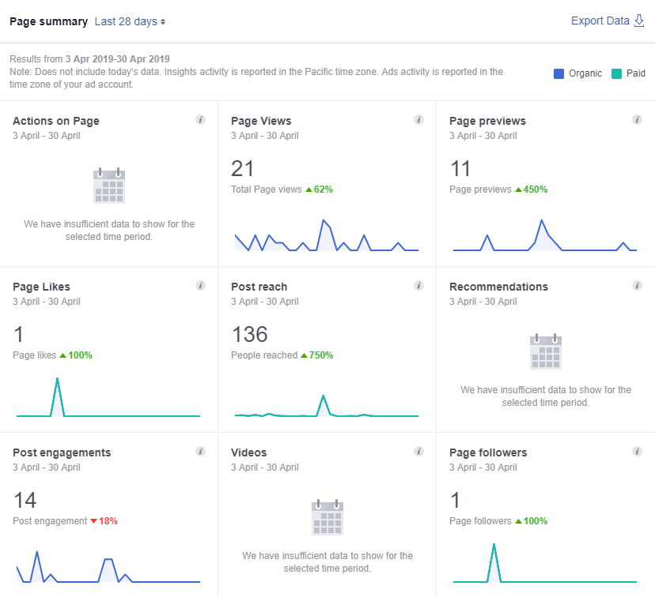
Figure 2: Facebook Overview

5.2.2 Posts
The follow image, figure 3, shows how effective each post was when it comes to different criteria. For example the following criteria were the overall reach and the overall engagement of each post.
As is shown, the best types of posts were the types of posts where there was a question; in this case the best post was on 02/04/2019. This type of post makes it so the clientele see the business as more of a human than a business, as there is the use of informal language and, as there is a question, in inviting for the clientele to communicate with the business.
The student and Mr. McCann theorised that the giveaway type posts were going to perform the best out of all the other types of posts – the reasoning for this is that they invite the clientele to engage with the posts, as they will have something to gain out of the engagement.
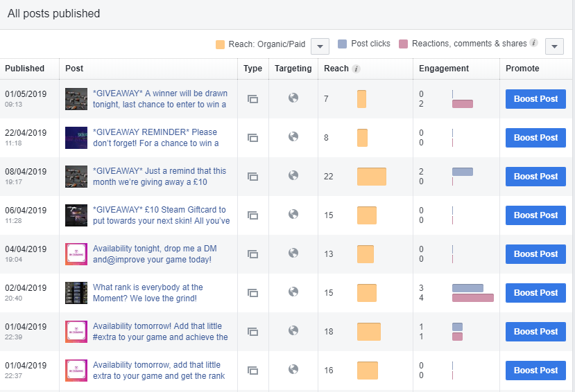
Figure 3: Facebook Post Statistics

5.3 Survey Analysis
This section will provide the analysis of the survey’s answers. This will be related to if the answer was expected or not based upon the research gathered in chapter 2. There will also be a summary of the results.

5.3.1 Question 1
What is the name of the Business you run?

Summary
Out of all the twenty five people businesses that were asked, only twenty responded to the survey. Out of these twenty respondents sixteen replied with their business name, while four chose to remain anonymous.
Appendix M shows a complete list of the answers to this question.

5.3.2 Question 2
What's your business type?

Summary
Out of the twenty businesses that were surveyed none of them, to a little amount, of them should be similar. From the sample size they should all be something different as that was the general idea when sending out the survey to the different businesses.
Appendix N shows a complete list of the answers to this question

5.3.3 Question 3
What size is your business?

Summary
Eight out of the twenty businesses are small businesses, while three would class themselves as a medium sized business. The last five businesses would class themselves as a large business. The smaller businesses should operate about the same in terms of social media, at least when comparing them to the larger businesses – these businesses should operate however they would want to.

Appendix O shows a complete list of the answers to this question

5.3.4 Question 4
Does your business have a social media presence?

Summary
The answers to this question were surprising, in the sense that there were a fair amount, four businesses, that said that they did not have a social media presence. The other sixteen do have a social media presence, as would be expected by a company in today’s market.
The only companies that were theorised to not have a social media account were the ones that were dedicated to health care or for the care of the public, in this case that means that Meddygfa Tywyn Bach and South Wales Police should not have had a social media account – the theory was half correct with Meddygfa Tywyn Bach not having a social media account and South Wales Police having a social media account.

If yes, then why?

4.1 Summary
This type of answer can be predictable when it comes to the fast food or takeaway type businesses, as they will always want customers and customer reviews to help boost themselves on social media and to get noticed by more people.
When it comes to South Wales Police the answers were shocking but made sense. The answer was that they utilise the public in helping to find criminals and to get any information regarding the criminal’s whereabouts.
The gaming, recruitment and shopping all have the same goal when it comes to social media as it turns out. They all want more customers and for customers to leave good reviews on their social media so that they can be noticed and get out on the social media more and to beat their competitors.

Appendix P shows a complete list of the answers to this question

5.3.5 Question 5

What social platform(s) are you currently operating on?

Summary
The answers for this question made sense. All of the businesses that answered said that they use Facebook, with only a handful using more than one. The ones that used more than one generally tended to be the larger companies and the South Wales Police – this would be expected as they would more than likely have a team of people or have a third party company to work on the social media for them and therefore can manage a larger set of social media when compared to a couple of the smaller companies that were interviewed.

Appendix Q shows a complete list of the answers to this question

5.3.6 Question 6

Which social media platforms does your business use the most?

Summary
For the companies that only utilised one social media, the answer makes sense – example being that AstraViva Recruitment only uses Facebook, so it would make sense for their social media platform with the most use would be Facebook.
However, only one company really said that they use two social media equally. The company would be South Wales Police, this makes sense as if they use the community to help them to catch criminals then they would need to utilise more social media than say Tesco, who only would use social media for customer reviews/customer complaints.
Appendix R shows a complete list of the answers to this question

5.3.7 Question 7
What are the positive impacts of social media on the business?

Summary
Depending on the company the answer to this question does make sense. An example of this would be that a gaming company that was interviewed, CD Projekt Red, said that a positive impact of social media was that they can send job applications out on social media to gain new employees that have are an expert in the field.
The smaller companies, however, would only be using the social media for gaining new followers and more views for their social media. This was true when comparing this to the answers of the smaller businesses, i.e. Mentor Computer Services has used social media for this reason, that and the potential good reviews.
Appendix S shows a complete list of the answers to this question

5.3.8 Question 8
What are the negative impacts of social media on the business?

Summary
The negative impacts of the social media on the business should be the same when it comes to the small businesses, i.e. one bad review can make or break the business when it comes to social media. Unfortuantely no hotels were interviewed but they would have said that if someone left a bad review than that could have destroyed their reputation – however, the larger companies were complaining more about bad reviews on social media, an example of one of the answers came from Tesco.
Appendix T shows a complete list of the answers to this question

5.3.9 Question 9
Do the business ever utilise paid features? I.e. Boosts

Summary
As it turns out by the answers most of the companies that responded to utilise boosts. The companies that do not utilise boosts are either the ones that did not answer the questionnaire or the ones that do not utilise social media. This was the case with the smaller companies anyways, as they need to get a boost to help them get out on their social media.
The larger companies did not really need to use a boost, as they would have sponsorships with the social media and the fact that there are millions of people on their social media pages anyways means that it would not be necessary for them to even think about using a boost.

Appendix U shows a complete list of the answers to this question

5.3.10 Question 10
If yes, then what are the impacts of the paid features?

Summary
Generally all the smaller companies said the same response, which was that the impacts of the social media boost, was that they gained more views on their page, while other smaller businesses said that they only gained more customers. However, the only large company to use boosts – CD Projekt Red – said that they got more applicants for their job propositions.

Appendix V shows a complete list of the answers to this question

5.3.11 Question 11
How do you monitor the businesses social media presence?

Summary
The answers to this question was theorised, in the sense that the larger companies would have a team always on their social media who would monitor and analyse their social media posts and would implement new stratagems within the social media for gaining new customer and more views etc.
The smaller companies, however, being smaller cannot afford a massive team or to buy a third party to utilise their social media, so they would use the free options on the social media – in the case with all the small companies they use Facebook Insights.
Appendix W shows a complete list of the answers to this question

5.4 Conclusion

5.4.1 Instagram
To summarise all the findings, it would seem that Instagram is the better choice for social media promotion when it comes to Mr. McCann’s business. The overall effectiveness of communication with the necessary tools for spreading the business to people seems to compliment Mr. McCann’s business style.
It would also seem that on Instagram the clientele appear to already be searching for a business alike to Mr. McCann’s. The reasoning behind stating this is that Mr. McCann has gained a large volume of followers in a short amount of time, i.e. around three months or so. Even when Mr. McCann’s Instagram page was not posting anything there still seemed to be an influx of followers, as is shown in the appendices.

6. Evaluation
In conclusion there are a couple of items that would be changed if this was to be carried out again. One of the main items would be that the author and Mr. McCann would plan out the posting times more thoroughly and post every day for a month – instead of being unable to due to both university requirements and work requirements.
In the literature review, there would be more case study examples of well-known social media marketing schemes. This would allow the author to get information second hand and have a higher quality of second hand information – on the subject of resources, there could have been more resources and more academic/well known journal resources that could have been used, this would have given the information more credibility and validity when comparing some of the resources used in this literature review.
However, the main aim and the goals were achieved with great success. In terms of the business, Mr. McCann said he was happy to help with the case study and said that he was extatic with the results over the month implementation. However, one thing he will consider for the future is adding more social media to his business, such as YouTube and/or Twitch.tv. He also said that if this were too happen again he would like bespoke graphics and would pay someone to make them, as neither himself nor the author had any expertise in the area of graphical design.

Bibliography

[1] | P. R. B, L. P, Kirk and D. S, “Marketing meets Web 2.0, social media, and creative consumers: Implications for international marketing strategy,” Business Horizons, vol. 55, no. 3, pp. 261-271, 2012.
[2] | The Statistics Portal, “Social media usage in the UNited Kingdom,” Statista, 1 January 2018. [Online]. Available: https://www.statista.com/topics/3236/social-media-usage-in-the-uk/. . [Accessed 24 October 2018].
[3] | D. Hendricks, “Complete History of Social Media: Then and Now,” Small Business Trends, 8 May 2013. [Online]. Available: https://smallbiztrends.com/2013/05/the-complete-history-of-social-media-infographic.html. [Accessed 24 October 2018].
[4] | History Cooperative, “The History of Social Media: Social Networking Evolution!,” History Cooperative, 26 July 2018. [Online]. Available: http://historycooperative.org/the-history-of-social-media/. [Accessed 24 October 2018].
[5] | D. Hendricks, “Complete History of Social Media: Then And Now,” smallbiztrends, 8 May 2013. [Online]. Available: https://smallbiztrends.com/2013/05/the-complete-history-of-social-media-infographic.html. [Accessed 27 October 2018].
[6] | biteable, “The 7 different types of social media,” biteable, [Online]. Available: https://biteable.com/blog/tips/the-7-different-types-of-social-media/. [Accessed 25 February 2019].
[7] | Rosie's Creative LLC, “Social Media Marketing 101: The "Big Three" of Social Media,” Rosiescreative, 10 July 2017. [Online]. Available: https://rosiescreative.com/2017/07/10/social-media-marketing-101-the-big-three-of-social-media/. [Accessed 25 February 2019].
[8] | C. Foreman, “10 Types of Social Media and How Each Can Benefit Your Business,” hootsuite, 10 June 2017. [Online]. Available: https://blog.hootsuite.com/types-of-social-media/. [Accessed 25 February 2019].
[9] | Entrata, “The Big Three: Facebook, Youtube and Instagram,” Entrata, 2 March 2017. [Online]. Available: https://www.entrata.com/blog/the-big-three-of-social-media-advertising-facebook-instagram-and-youtube/marketing/P/7686/ . [Accessed 7 November 2018].
[10] | M. Osman, “28 Powerful Facebook Stats Your Brand Can’t Ignore in 2018,” sproutsocial, [Online]. Available: https://sproutsocial.com/insights/facebook-stats-for-marketers/. [Accessed 28 October 2018].
[11] | H. Guinness, “How Facebook’s News Feed Sorting Algorithm Works,” howtogeek, 28 February 2017. [Online]. Available: https://www.howtogeek.com/290919/how-facebooks-news-feed-sorting-algorithm-works/. [Accessed 25 February 2019].
[12] | Facebook, “Target future customers and fans,” Facebook, [Online]. Available: https://www.facebook.com/business/ads?ref=ens_rdr. [Accessed 28 October 2018].
[13] | spredfast, “The 2018 Social Audience Guide,” spredfast, 1 January 2018. [Online]. Available: https://www.spredfast.com/social-media-tips/social-media-demographics-current. [Accessed 28 October 2018].
[14] | Facebook, “Success Story,” Facebook, [Online]. Available: https://www.facebook.com/business/success/birds-eye. [Accessed 28 October 2018].
[15] | Rosie's Creative LLC, “SOCIAL MEDIA MARKETING 101: THE “BIG THREE” OF SOCIAL MEDIA,” Rosie's Creative LLC, 10 July 2017. [Online]. Available: https://rosiescreative.com/2017/07/10/social-media-marketing-101-the-big-three-of-social-media/.. [Accessed 28 October 2018].
[16] | webwise.ie, “Explained: What is YouTube?,” webwise.ie, [Online]. Available: https://www.webwise.ie/parents/what-is-youtube/. . [Accessed 28 October 2018].
[17] | M. Holland, “How YouTube Developed into a Successful Platform for User-Generated Content,” Elon Journal of Undergraduate Research in Communications, vol. 7, no. 1, pp. 52-59, 2016.
[18] | freemake, “YouTube Upload 101: Account, Specs, Limits, Formats,” freemake, [Online]. Available: https://www.freemake.com/blog/youtube-upload-tips-specs-limits-formats/. . [Accessed 29 January 2018].
[19] | L. K. Mattock, C. Theisen and J. B. Pierce, “A Case for Digital Squirrels: Using and Preserving Youtube for Popular Culture Research,” vol. 23, no. 1, p. 1, 2018.
[20] | E. Moreau, “What Is Instagram, Anyway?,” lifewire, 19 November 2018. [Online]. Available: https://www.lifewire.com/what-is-instagram-3486316. [Accessed 24 November 2018].
[21] | A. York, “Social Media Demographics to Inform a Better Segmentation Strategy,” sproutsocial., [Online]. Available: https://sproutsocial.com/insights/new-social-media-demographics/#instagram. [Accessed 5 November 2018].
[22] | C. W. Holsapple, S.-H. Hsiao and R. Pakath, “Business social media analytics: Characterization and conceptual framework,” Decision Support Systems, vol. 110, no. 60, pp. 32-45, 2018.
[23] | M. Rouse, “LinkedIn,” techtarget, [Online]. Available: https://whatis.techtarget.com/definition/LinkedIn . [Accessed 3 November 2018].
[24] | M. Iqbal, “Twitch Revenue and Usage Statistics (2019),” businessofapps, 27 February 2019. [Online]. Available: http://www.businessofapps.com/data/twitch-statistics/. [Accessed 28 February 2019].
[25] | Kotler, Social Media Marketing, 2017.
[26] | P. D. M. Opresnik, “New Kotler book "Social Media Marketing", 2nd ed. 2017, excerpt 2,” linkedin, 31 August 2017. [Online]. Available: https://www.linkedin.com/pulse/new-kotler-book-social-media-marketing-2nd-ed-2017-excerpt-opresnik/. [Accessed 1 March 2019].
[27] | J. Rampton, “5 Reasons You Shouldn't Use AdWords,” Forbes, 7 July 2014. [Online]. Available: https://www.forbes.com/sites/johnrampton/2014/07/07/5-reasons-you-shouldnt-use-adwords/. [Accessed 20 November 2018].
[28] | T. Taylor G, J. E. Lewin and D. Strutton, “Friends, Fans, and Followers: Do Ads Work on Social Networks? How Gender and Age Shape Receptivity,” JOURNAL OF ADVERTISING RESEARCH, pp. 258-276, 2011.
[29] | N. Patel, “The Psychology Of Liking On Facebook,” Marketing Land, 12 August 2015. [Online]. Available: https://marketingland.com/psychology-liking-facebook-135599. [Accessed 20 November 2918].
[30] | G. Todorova, “MARKETING COMMUNICATION MIX,” Trakia Journal of Sciences, vol. 13, no. 1, pp. 368-374, 2015.
[31] | D. Shane, “How Often Should You Post On Social Media, According to 10 Studies,” inc.com, [Online]. Available: https://www.inc.com/dakota-shane/how-often-you-should-post-on-social-media-according-to-10-studies.html. [Accessed 20 November 2018].
[32] | K. Egan, “he Difference Between Facebook, Twitter, Linkedin, Google+, YouTube, & Pinterest [Updated for 2019],” Impact, 1 January 2019. [Online]. Available: https://www.impactbnd.com/blog/the-difference-between-facebook-twitter-linkedin-google-youtube-pinterest. [Accessed 10 January 2019].
[33] | H. Baskin and S. Morse, “Interactive graphics in data processing: A multilevel modeling structure for interactive graphic design,” IBM Systems journal, 2016.
[34] | Canva, “Graphics that connect with your audience on social media and how to create them,” Canva, [Online]. Available: https://www.canva.com/learn/how-to-create-graphics-that-connect-with-your-audience-on-social-media/. [Accessed 4 November 2018].
[35] | Smart Insights Commentator, “What is ‘digital branding’?,” Smart Insights, 6 March 2017. [Online]. Available: https://www.smartinsights.com/online-brand-strategy/brand-development/digital-branding-definition/. [Accessed 2 March 2019].
[36] | M. Armstrong, Armstrong's Essential Human Resource Management Practice, Rossendale: Kogan Page, 2010.
[37] | E. R. Babbie, “Doing Quantitative Research in Education with SPSS,” The Practice of Social Research, vol. 12, no. http://libguides.usc.edu/writingguide/quantitative, pp. 34-36, 2010.
[38] | A. Bhat, “QUALITATIVE RESEARCH: DEFINITION, TYPES, METHODS AND EXAMPLES,” questionpro, [Online]. Available: https://www.questionpro.com/blog/qualitative-research-methods/. [Accessed 1 March 2019].
[39] | D. E. Polkinghorne, “Language and Meaning: Data Collection In Qualitative Research,” Journal of Conducting Psychology , vol. 52, no. 2, pp. 137-145, 2005.
[40] | J. Dudovskiy, The Ultimate Guide to Writing a Dissertation in Business Studies: A Step by Step Assisstance, Pittsburgh, 2018.

Appendix
Appendix A


Appendix B


Appendix C
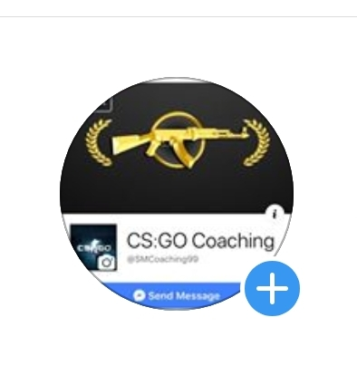

Appendix D
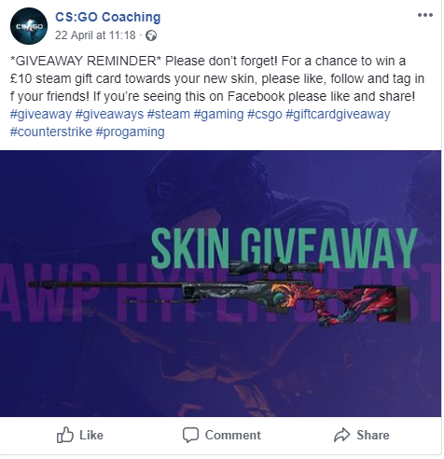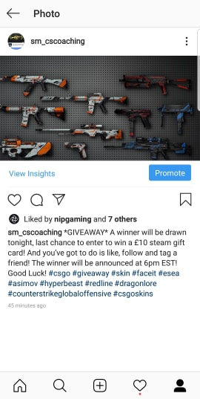
Appendix E
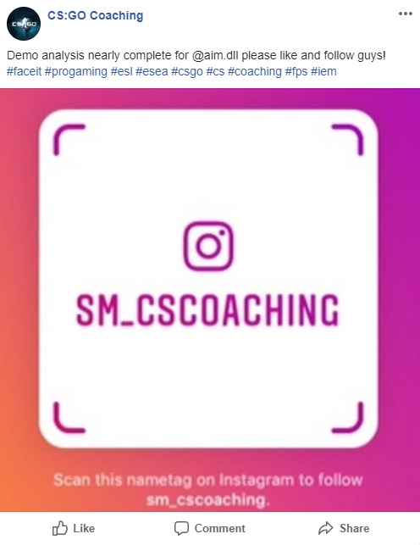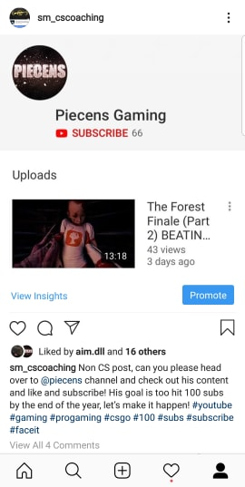

F
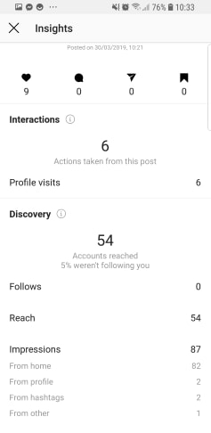

G
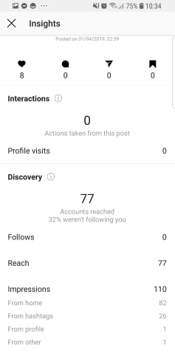

H
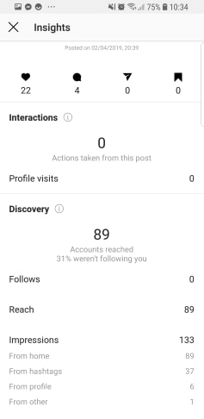

I
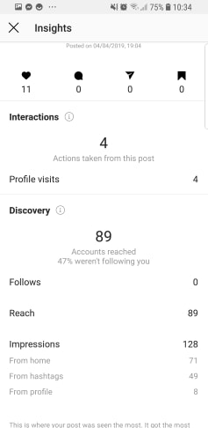

J
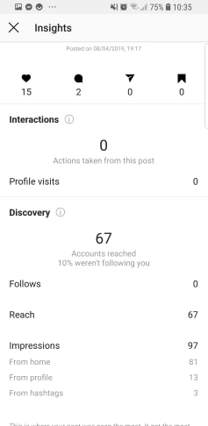
K
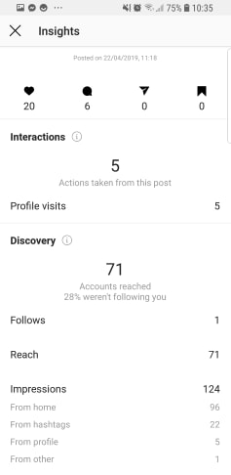

L
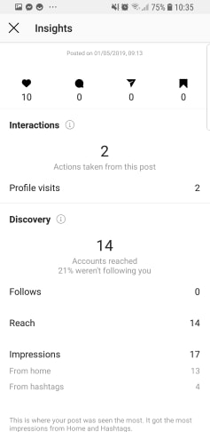

Appendix M
GEMEG Accountancy
AstraViva Recruitment
KCK Quality Meat
Swan Garden
Top Pizza
Bits & Pieces
John's Fish and Chip Bar
Green Energy Assessors
Mentor Computer Services
Domino's Pizza Gorseinon
Meddygfa Tywyn Bach
Tesco
Asda
South Wales Police
CD Projekt Red
GAME
Anonymous
Anonymous
Anonymous
Anonymous

Appendix N
Small
Small
Small
Small
Small
Small
Small
Medium
Small
Medium
Medium
Large
Large
Large
Large
Large
Prefer not to say
Prefer not to say
Prefer not to say
Prefer not to say

Appendix O
Accountancy
Recruitment
Food
Takeaway
Takeaway
Shopping
Takeaway
Energy Consultants
Technology
Takeaway
Healthcare
Shopping
Shopping
Public Servant
Gaming
Gaming
Prefer not to say
Prefer not to say
Prefer not to say
Prefer not to say

Appendix P
No
Yes
Yes
Yes
Yes
Yes
No
No
Yes
Yes
Yes
Yes
Yes
Yes
Yes
Yes
Prefer not to say
Prefer not to say
Prefer not to say
Prefer not to say

N/A
Recruitment
Looking for customers
Customer Reviews
Customer Reviews
Looking for customers
N/A
N/A
Customer Reviews
Customer Reviews
Patient Relations
Customer Reviews
Customer Reviews
Community Oriented Policing
Recruitment
Customer Reviews
Prefer not to say
Prefer not to say
Prefer not to say
Prefer not to say

Appendix Q
N/A
Facebook
Facebook
Facebook
Facebook
Facebook
Facebook
Facebook
Facebook
Facebook, Twitter and Instagram
Facebook
Facebook, Twitter and Instagram
Facebook, Twitter and Instagram
Facebook and Twitter
Facebook, Twitter, Instagram and Snapchat
Facebook and Twitter
Prefer not to say
Prefer not to say
Prefer not to say
Prefer not to say

Appendix R
N/A
Facebook
Facebook
Facebook
Facebook
Facebook
N/A
N/A
Facebook
Facebook
Facebook
Facebook
Facebook
Facebook and Twitter equally
Facebook
Facebook
Prefer not to say
Prefer not to say
Prefer not to say
Prefer not to say
N/A
N/A
N/A

Appendix S
N/A
People apply for jobs
We reach new customers daily
We can check customer reviews
Customer reviews help us to promote ourselves
People walk into the store and say how they have read good reviews about us
N/A
N/A
People have left good reviews about us
We can update our menu based on customer feedback
N/A
We can change the stock based on customer feedback
We can change the stock based on customer feedback
The community has helped to catch criminals in the area
We have gained new employees, globally, that have been crucial to our team.
We can chat to customers about any enquiries they may have about selling or purchasing.
N/A
N/A
N/A
N/A

Appendix T
N/A
There is a high influx of applicants thanks to social media
We get the same messages of customers all the time
There can be bad reviews
One bad review can distract you from ten good ones
No one messages us on Facebook. Mainly used for the address to the store.
N/A
N/A
customers don’t check the website and ask us about prices
There is a lot of information to get through, relating to customers
N/A
Customers tend to leave bad reviews over one simple thing
Customers tag the wrong store and then don't respond when we do
Trolling and jokes from the public
Not everyone is serious about the applications
People complain about the bad prices in the store
N/A
N/A
N/A
N/A
Appendix U
N/A
Yes
Yes
Yes
Yes
Yes
N/A
N/A
Yes
No
N/A
No
No
No
Yes
No
N/A
N/A
N/A

Appendix V
N/A
more views
more views
more views
more views
more views
N/A
N/A
More customers
N/A
N/A
N/A
N/A
N/A
More applicants
N/A
N/A
N/A
N/A

Appendix W
n/a
Facebook Insights
Facebook Insights
Facebook Insights
Facebook Insights
Facebook Insights
N/A
N/A
Facebook Insights
Social media company
N/A
Social media company
Social media company
Facebook Insights
Social media team
Social media company
Social media company
Social media company
Social media company

