Assignment of the Strategic Management Module:

Report on potential strategic options
for more personalised customer care

Module code: BMMB7013D

Student ID number: 1906345

Date: 17th of December 2020
Total number of pages: 34

Executive summary
Our organisation is a global manufacturer of power tools. As one of the industry leaders we were successfully growing revenue and profit in the past. The business world is currently experiencing dramatic changes. To continue the success in future, we will put our customer at the centre of strategy. Personalised customer care is the key factor for sustainable growth in an increasingly product saturated market.
There are various strategic options when improving personalised customer care. To facilitate a decision on the best solution forward, extensive strategic analysis and critical evaluation of potential strategic options have been carried out. After a brief introduction in Section 1, this report presents in Section 2 the main findings of the investigations using strategic management tools. In Section 3, conclusions are drawn on the findings to then give recommendations for the most promising strategic option in Section 4. The Appendix provides a brief background of our organisation.
The strategy to personalise the customer care on a digital basis is not only urged by the current pandemic situation. It is also advantageous for customer engagement and loyalty as it individualises the customer and allows direct interaction not only for improved service but also for product development. The investment in a new, US-based customer service department and the talents driving it will be beneficial for our complete business and ensure that we will meet our goal of further growth also in future.

Table of content

1 Introduction 5

2 Strategic analysis and critical evaluation of the strategic options 6
2.1 Macro, meso and micro environment 7
2.1.1 Macro environment 8
2.1.2 Meso environment 9
2.1.3 Micro environment 10
2.2 Capabilities and culture 10
2.2.1 Capabilities 11
2.2.2 Culture 13
2.3 Corporate and business strategy 14
2.3.1 Corporate strategy 15
2.3.2 Business strategy 17
2.3.3 Functional strategy 19
2.4 Change and capacity 19
2.4.1 Change 21
2.4.2 Capacity 22

3 Conclusions 24

4 Recommendations 28

References 30

Appendix: Background of chosen organisation 34

Introduction
Our organisation is a global manufacturer of tools, power tools and other products mainly used in the construction and Do-It-Yourself (DIY) industry. In the current pandemic environment, it is harder than ever before to meet the organisation’s goals set for growth of revenue and profit. Potential customers are missing the physical experience of our performance driven power tools they intend to purchase. Therefore, the digital experience the customer can get online is key for further success. The personal impression customers used to get when in touch with our power tools and sales specialists, they now must get when interacting with our products and team online. Moreover, we risk our abilities to develop competitive products meeting the future requirements when losing the direct feedback from the field. We therefore need a clear strategy for a personalised customer care.
As senior engineering manager I have been asked by the corporate senior management to join the emergency team investigating potential strategic options for more personalised customer care within our strategic business unit (SBU) of power tools. This report has been compiled to provide the corporate senior management the information needed to take an informed decision on the strategic option to pursue. The report outlines options developed by thorough strategic analysis and critical evaluation. Upon conclusions about these including implications on other areas of the organisation, recommendations are given for making the organisation resilient against the threats of the current pandemic and its aftermath.

Strategic analysis and critical evaluation of the strategic options
Provocatively Porter (Porter, 1996) claims that strategy is not about doing things better, e.g. by operational excellence, but doing things differently. Anyway, strategy is certainly about goals and means to achieve them (Morrison, 2011). Being competitive is critical. To improve their competitive advantage, organisations need strategies tailored to their specific situation and the given time. Grant (Grant, 2015) emphasizes the importance of making choices in this context, leading to the basic question: Where and how to compete?
As a manufacturer of power tools our organisation belongs to the classical industry where changes are dynamic but predictable enough to plan and manage strategy. Using the right planning and management strategy tools makes all the difference between success and failure (Figure 1). In the following we will use several tools to conduct a strategic analysis and to evaluate critically the strategic options we have to stay competitive and successful. Since strategy is always context related, the current environment is an important aspect of the investigation. Some of our products are technically complex, so we will have a look at the capabilities the culture as a historical context of our organisation, requiring aligned corporate and business strategies. This then funnels to the proposal of changing and personalising customer care, and the capacities required to do so. All these aspects are intertwined but for the discussion broadly arranged in four subsections.
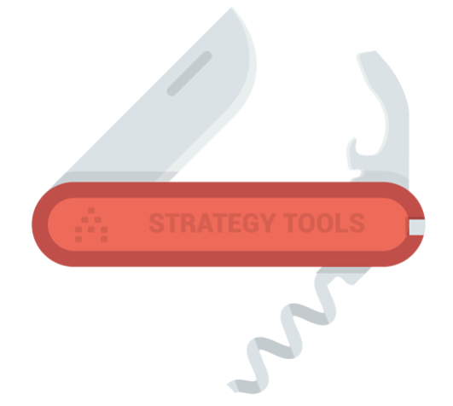
Figure 1: The right tool for strategy planning and management (Wright, 2019)

Macro, meso and micro environment
The strategical analysis starts with the environment providing the context. If there is one word which describes best the environmental conditions we are operating in already for a while, it is VUCA, the acronym for volatility, uncertainty, complexity and ambiguity. Covid-19 is just another experience in a series of financial and political crises. The short term effect of the Covid-19 pandemic is that our Do-It-Yourself (DIY) business is doing very good (people have more time to spend in-house and want to save costs by doing it themselves), while the professional construction business in 2020 has been difficult (stumbling economy, US elections). In the following, we will investigate the environment on a micro, meso, and macro level (Figure 2).

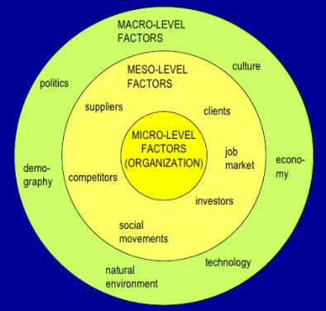
Figure 2: Macro, meso, micro level factors (Luksha, 2020)

Macro environment
When looking at the macro environment, the PESTEL analysis is a helpful tool considering aspects describing the macro-economic framework an organisation is set in, i.e. Political, Economical, Social, Technological , Environmental, and Legal:
The dominating political issue these days is the US-China tariff war and the Brexit. The tariff politics affects business on a daily and strategic basis. For companies producing in China and selling in the US, trade restrictions threaten the fundamental business model. The Brexit adds further uncertainness, not only to the economy but also to the customers weighing on consumption (Carney, 2019).
The economical situation is stressed, and a recession is feared. Historically low interest rates enable acquisitions organisations need to achieve growth in revenue. The above mentioned tariff war and the Brexit are risks for every international business and their inherent uncertainty makes strategic decision-making extremely difficult (Flaaen and Pierce, 2019).
Socially the population transforms quickly to a society characterized by home office and home shopping. The world is getting more female and the customers more emotional, and gender equality in business is getting important as part of corporate social responsibility (CSR). Organisations today are closing the gender gap and increasing the diversity in general e.g. by providing family friendly jobs and engagement in the community (Conway et al., 2019).
Technological innovations are important; however, even more important than the technological advance of the products is the digital transformation of the production and commercialisation processes. Digital processes allow integrating and optimising processes for lean production and smart selling (Anon, 2016). Additional IT-professionals and software systems are needed to manage the flow of products and services.
Environmental aspects are not only important for the production but also critical selling points for customers. Increasing environmental regulations matter as well as finally the climate change, after it has been publicly discussed for a decade (Cowan, 2010).
Legal issues play an important role particularly in a big US company like ours where the legal department is historically strong (Novak and Psenicny, 2014). Product liability but also corporate compliance subjects like corporate governance etc. are very prominent as organisations want to avoid any costly lawsuits from stakeholders including shareholders and customers.

Meso environment
To analyse our specific industry on a meso level, Porter’s 5 forces model (Porter, 1996) analyses the five major competitive forces acting on a company: These are the threat of new entrants and of substitutes, the bargaining power of customers and of suppliers, and the industry rivalry.
The threat of new competitors entering the market is real, adding to the existing threat of substitutes. In an increasingly globalised world, there are already plenty of competitors and further companies are expanding their product portfolio into the same area (Hill, 2016). These threats require a steady improvement of the products and services.
The bargaining power of the customers is high as there are many competing distributors offering a variety of competitor products, all readily available online. Customer loyalty is key. However, the bargaining power of the suppliers is decreasing as there are globally excess capacities and suppliers are keen of supply contracts with global enterprises. The US-China tariff war has aggravated the situation of Chinese suppliers further; not least because consumers are increasingly sensitive about where products and services originate from.
The industry rivalry is high due to new entrants flocking in and the replaceability of hardware products. In the current VUCA environment with globally cooling down economy and reduced market volumes, the pressure on costs and larger market shares to stabilise sales volumes is high. Individual companies have to take care that they do not get into a state of hyper competition (Johnson et al., 2017), calling for interactive engagement of the customer.

Micro environment
Yet one level closer to the core of business environment leads us to the micro environment of the organisation itself. Here, aspects like innovation strategy and game changing opportunities are born in interaction with the outer environmental levels. Blue ocean methodology (Kim and Mauborgne, 2004) might come into play but are not further discussed here. Note that the term ‘micro environment’ is sometimes also used to describe what is here presented as ‘meso environment’, in which case the organisation is not taken as part of the environment.

Capabilities and culture
Capabilities and culture are internal determinants defining largely the strategic position and the resulting options. Both, capabilities and culture, are specific to any organisation and critical to its business performance (Figure 3), and have an impact on how new services are strategically set up (Storey and Hughes, 2013). The superior performance of an organisation is explained by the distinctiveness of its capabilities (Johnson et al., 2017).

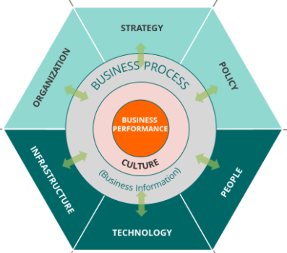
Figure 3: The Burlton Hexagon connecting culture and capabilities (Burlton, 2020)

Capabilities
Capabilities are primarily determined by resources and competences an organisation has or tries to develop. Depending on the perspective, the strategic concepts may have a resource based view (RBV) (Wernerfelt, 1984) or, if the knowledge is considered as the most significant resource of an organisation, a knowledge based view (KBV) (Foss, 1996). The more advanced the product (or if the product is a service) the more the capability is defined by knowledge as the critical resource.
Our organisation manufactures products that are to a variable degree engineered, with some innovations which however are seldomly disruptive. In the sense of Wernerfelt’s VRIN criteria (Valuable, Rare, Imitable and Non-substitutable), our products do not have a pronounced value position compared to competitors we are benchmarking against. A classical analysis of the current strategic capabilities is therefore more promising. Because of its conciseness, the SWOT analysis (Strength – Weakness – Opportunity – Threats) is favoured over other methods like TOWS (Weihrich, 1982) or SOAR (Stavros and Hinrics, 2009):
Our strength is our size allowing economies of scale, and our strong product portfolio fed from a well-established supply base. The annual report documents a robust organic grow of 7% per annum. A healthy cash flow provides the means to expand to new products for incremental growth by acquiring companies like other tool brands. Or it can be invested in services.
On the downside, the US focus makes the organisation vulnerable to the economic situation there, and the US market is generally saturated. Another weakness is the low grade of digitisation in the organisation to date. The investment in digital excellence has been increased over past few years, however, it is still lagging behind of what peer organisations do (Wurzer et al., 2019).
One opportunity might lie in emerging markets, where we currently generate only 14% of the revenue and that are potential winners of the US-China war (Harding, 2019). In the saturated US market, where many manufacturers provide nearly identical products, emotions are getting more important and critical for competitive advantage (Birkinshaw and Cohan, 2013). In this sense, driving the ‘Made in the USA’ strategy further forms a great opportunity. Moreover, E-commerce including advanced analytics and digital marketing capabilities has been one of the key drivers for organic growth already before the Covid-19 crisis.
The biggest threat for our organisation relying on a combination of Chinese supply basis and US focused sales is the ongoing tariff war. Further headwinds come from increasing commodity and raw material costs as well as the disadvantageous development of foreign exchange rates. Customers will ask for additional assets our products can offer, e.g. for ‘Made in the USA’ products to strengthen the US home basis, or by improved customer care.

Culture
The importance of culture in strategic management is often missed or not fully recognised; at least the term is seldomly explicitly referenced. However, as for any other organisation, it is important for our organisation, too, and in fact cultural aspects like values and behaviours are emphasised. The individual can only be understood in his cultural context. Within the context of this report, culture is important for several reasons:
- Strategic drift: This term describes the phenomenon where strategies fail to keep pace with a changing environment. For example, our organisation is gradually improving on customer service but not taking into account the fundamental changes we currently experience asking for a different approach as required by the Covid-19 crisis.
- Path dependency: Historical founded styles or decisions based e.g. on historically available capabilities. Organisations are often locked in their culture and things are taken for granted, hampering rational decisions for strategies requiring different set of resources and a new mind-set, e.g. for customer care.
- National cultures: For international organisations, the national cultures are critical regarding employees but even more importantly regarding the customers. Not only the employee’s attitude to work or authority matter but also how the customer expects to be treated (Hofstede and Minkov, 2010).
- Strategic purpose: The shareholders are the key stakeholder in an US company like ours. Therefore, deciding in the interest of the shareholders is of paramount importance also regarding governance. Longer-term strategy decisions can be difficult in this short-termed management. If something beyond the horizon of the next quarter report is planned, e.g. with a 2025 perspective, extra effort is required to empower the management within Mendelow’s stakeholder matrix (Mendelow, 1983).
- Corporate social responsibility (CSR): Particularly organisations with a strong focus on shareholders are well advised to not neglect CSR. In the long run, only that organisation is sustainable and profitable, that engages in CSR (Hansen et al., 2014) and, in the broader sense, engages the customer.
Next to these specific aspects, culture influences how a strategy is developed, how it is implemented and where the focus is put on. If looking at Mintzberg’s 5Ps (Mintzberg, 1987), the culture in our resource driven, huge and international organisation is strong in planning as well as in ploy and positioning, less so in perspective and pattern , resulting in an occasionally bad communication style. It is important to make use of our strengths as a global player??? and to be aware of the culturally founded weaknesses when ramping up a strategy.

Corporate and business strategy
Corporate and business strategy determine the strategic direction of an organisation. They form choices as to how the organisation positions itself in relation to competitors. For smaller organisations, corporate and business strategies might fall into one place. For larger organisations like ours, however, the business is split to several SBUs. While business level strategy deals with the question how to compete, corporate level strategy is about the question where to compete (Grant, 2015). If this differentiation is not been made, large organisation prone to bureaucracy would be less entrepreneurial with potentially fewer ventures and no acquisitions (Wickham, 2008). Together with the functional strategy, business and corporate strategy form a hierarchical pyramid (Figure 4).

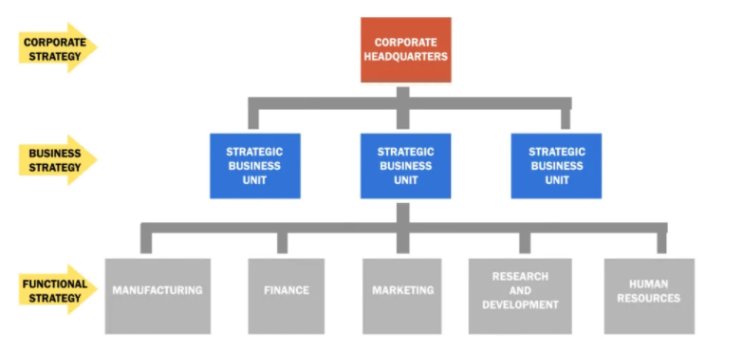
Figure 4: Three level hierarchy with corporate headquarters, strategic business units, and functional departments (Administrator, 2020)

Corporate strategy
At the corporate level our strategy is to increase revenue und profit by organic and incremental growth within the SBUs. Our organisation is a diverse conglomerate in the sense of the Ansoff scheme (Ansoff, 1988) where hardware manufacturing units entering into new markets and growing with new products and services. The primary parental benefit of the corporation is the vertical integration along the value chain (Porter, 1985). As a big organisation we gain competitive advantage by economies of scale, by leveraging our market power for favourable contract conditions (Diez-Vial, 2008), and by system processes like customer service.
Another important aspect of our corporate strategy are the international operations where each region is assigned with functional tasks or commercial purpose it is good in. Following, the location and competitive advantage aspect is considered in more detail by means of the Porter’s diamond (Porter, 1990). This model, also known as National Diamond, considers five components including the organisational framework:
First, factor conditions refer to production where our organisation has the advantage of being a global player: Development in Europe, production in China, accounting in India, marketing in the US – if new functional roles are created, e.g. for personalised customer care, the organisation can lever employed resources by appointing this task to a region where the local factor conditions are best for it.
Second, related and supporting industries we have only to a small degree. Of course there are suppliers around the Chinese factories, and maybe related research institutes nearby our European development centres. But their vicinity is not relevant enough to call it clusters of mutually supporting industries.
Third, demand conditions are primarily referring to those in the home market. There are no special demands for power tools in general, however, the expectation in regard how this demand is met differs from region to region and changes over time. The expectation in quality is for example in the US relatively low. But there is an increasing demand for products and services made in the US.
Forth, firm strategy, industry structure and rivalry can be a basis of advantage. Our organisation experiences lots of rivalry by US and European companies as the industry structure is very competitive anyway, helping us to strive for outperformance. In the attempt to distinguish us from others we are increasingly emphasising the US identity of our organisation. This approach could be easily extended from the products to the service we are offering.
Fifth, the role of government is generally low in our industry but recently increasing in the US. Here, products made in the US are favoured for governmental investments like big infrastructure or military projects. This is certainly applicable also to services.

Business strategy
Our individual SBUs create growth by driving competitive advantage of products. The SBU discussed in this report pursues this strategy by creating high performing yet price competitive power tools. We have a multi brand strategy segmenting the market broadly in consumers and professional customers (Hooley et al., 2008). The typical buyers of our tools are men with a just-do-it mentality. They are mid-age, active, white, middle class, brand sensitive, and their financial situation allows investments, but they expect a good service. The tools are positioned with a strong emphasis on the US brand.
Obviously, our organisation has a differentiation strategy, a very important asset if you do not want to compete on costs spoiling your margin (Trout and Rivkin, 2008). In terms of Porter’s generic strategy (Porter, 1996), our organisation is therefore clearly in the quadrant of differentiation focus. We have a premium brand for professionals with a focus on the North America market. And we have another brand of reasonably priced power tools targeting at the consumer market. This multi-brand strategy is typical for big manufacturers (Fahy and Jobber, 2019). By this the competitive advantage is not only utilised in different ways but it also provides the necessary flexibility to respond to environmental changes including changing expectations towards customer service.
Porter’s generic strategy is in some cases a bit square with its costs or differentiation approach. For this reason, I would like to further reference the strategy clock from Bowman (Faulkner and Bowman, 1995) where the perceived benefits are opposed to the price. Our organisation follows a hybrid strategy as it offers low prices for products that are of reasonable or good quality, differentiated and depending on the brand. The hybrid strategy is often used by big and globally operating companies (Echchakoui, 2018). Their financial background allows employing a hybrid strategy to change the strategic direction as required.

Functional strategy
For the sake of completeness, the functional strategy is mentioned as it is the level where the actual innovation takes place. Functional strategy is executed by every functional unit, like a department breaking down the strategy into action plans. It is critical that all strategy levels, i.e. corporate and business strategies as well as the functional strategy are aligned and fit to the organisational capabilities (Trevor and Varcoe, 2017). This is particularly important when there are changes. Strategies that are misaligned or do not match with the corporate culture are doomed to fail (Ewenstein et al., 2016).
If we want to innovate our customer care, we have to balance technology push and customer pull. Pushing customer service by means of the latest digital technology will not work if we fail to get the customer to the point where he is pulling for more support (Guo et al., 2020). Strategic alignment and the functional excellence of the employees is critical to success here.

Change and capacity
The ability to change is critical for staying successful. When analysing the strategic options for a given change context, a number of aspects need to be considered (Balogun et al., 2015). One key aspect is the capacity which can be defined as the organisation’s ability to deliver normal business operations plus change activities (Figure 5). If the organisation does not have enough change capacity it is unlikely the employees will be able to take on any extra workload.

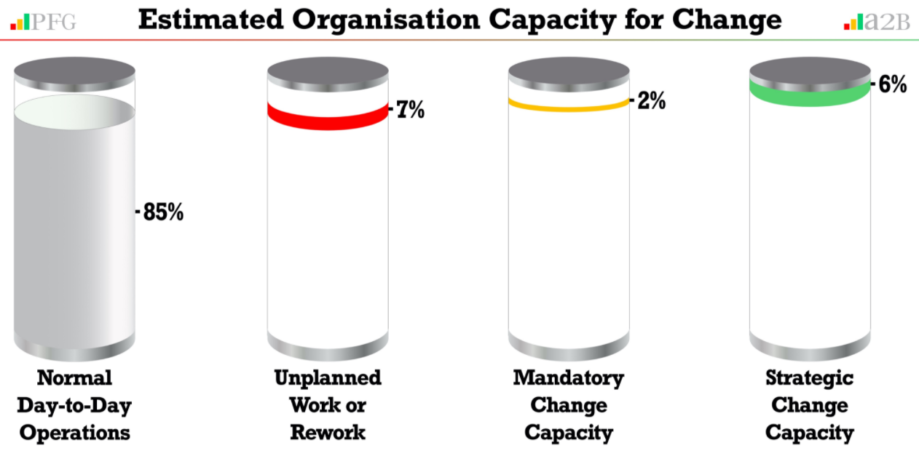
Figure 5: Estimated organisation capacity for change (Gallagher, 2020)

Change
We need a change by putting customer care in the centre to meet his expectations. It is an approach different to what we have done in the past. A good plan increases the chance for a successful change. In the past various approaches to manage change have been developed, e.g. the 9-stage process by Thompson (Thompson et al., 2006) or the 8-step proposal by Kotter (Kotter, 2007). An application of Kotter’s blueprint is briefly presented in the following:
- Create urgency: Employees as well as all managers need to get aware of the urgency for a change. This context should be clear for the current Covid-19 environment.
- Form powerful coalitions: Critical personnel, not only including management, but also key employees of the relevant departments who are ready for a change, have to bundle forces to drive the transformation by creating a network and a framework.
- Create a vision for change: These coalitions define a clear strategy. The already presented tools like PESTEL or SWOT analysis form a good base for this.
- Communicate the vision: The vision then have to be communicated persuasively to the entire organisation. It is important to engage all employees for this endeavour.
- Remove obstacles: There will be many obstacles and a lot of resistance by some of the employees. In this phase it is important to build the necessary infrastructure and skills.
- Create short-term wins: The expectation of the employees is to be managed to allow establishing the changes in the organisation’s culture. Short-term wins help to gain trust.
- Build on the change: It may take some time until the success becomes visible but once it is there, the momentum is to be kept propelling the change process further.
- Anchor the change: The changes have to be secured to ensure sustainability and to avoid a reversal pushed by those unhappy with the new situation. Persistent opponents should be removed in the extreme case.
To establish a new approach to customer care, a professional change management is required (Hechanova et al., 2018). In fact, change management is one of the most critical aspect of management and leadership (Henderson, 2017). The human factor plays a significant role in implementing transformational changes successfully and its neglection is one of the main reasons why organisational changes fail (Kotter, 2012). Radical changes can be very disturbing for many employees experiencing psychological stress and phases of grief (Kübler-Ross, 2005). Therefore, the change management strategy should always have the employee’s perspective in mind.
Resistance by the employees and portions of the management is a natural response to changes. However, particularly our staff interacting with the customer must be fully convinced, otherwise our efforts run the risk to falter. Change leadership is important to guide the employees during the transformational journey and to create the visionary culture of change, otherwise we will fail to hit strategic targets (Köseoglu et al., 2009).

Capacity
Change requires enough excess capacity in several departments including R&D, HR, and marketing. As a big organisation, we have the financial background to make the required investment. On the other hand, as a profit oriented organisation we will not be able to hire tons of extra people for implementing a change.
We all have a full plate on our desk with only little extra capacity. We will move the change only if we can win the key personnel by waking their sense for entrepreneurship and by re-adjusting our focus. It is therefore critical to emphasize this when communicating the vision of personalised customer care.

Conclusions
We analysed and evaluated the strategic background and options, key takeaways are:
- Environment: The threat by competitors together with the rise of the customer’s raising expectation ask for a different approach especially for the customer care. Customer emotions are particularly important in the current Covid-19 environment preventing the direct contact to the customer and by this the intelligence required to develop competitive products meeting future requirements.
- Capabilities and culture: The analysis reveals our industry position in a saturated market as the biggest concern, however, our ‘Made in the USA’ strategy can potentially help us to get emotionally happy and satisfied customers by means of appropriate customer care. While the capabilities are obvious, the relatively long time perspective till 2025 needed for a strategic change is a challenge for our organisation’s culture.
- Corporate and business strategy: Digitalisation will play an important role in our differentiation strategy for customer service which can be seen as another part of vertical integration along the value chain. Customer interactivity will enable us to develop our brands and to secure loyalty. We have the financial means to give our strategy the impetus to introduce a more sophisticated customer care.
- Change and capacities: To respond to the environmental changes, we have to make use of our capacities wisely by an incremental but determined change till 2025. Particularly the staff interacting with the customer has to be 100% beyond the change. Change leadership to empower the management and to overcome the employees’ resistance is therefore essential.
For these reasons, putting the customer in the centre is priority. It is a necessity, not a luxury.

Recommendations
The above conclusions clearly yield the strategic options for a more personalised customer care. To address these, the following measures are recommended:
- To implement an advanced customer care, a separate customer service department is established. It supervises all activities of pre-sale and after-sale service. The department reports directly to the SBU leadership. Historically, customer service was always seen as expenditure to be kept to the minimum. In future, we will focus on the customer and see customer care as a driver for branding, innovation and ultimately profitability (Dalenogare et al., 2018). The customer service department should get all resources needed, that are people, expertise and infrastructure.
- Digital technology will be the critical aspect of the customer care, including data analytics, artificial intelligence (AI), machine learning etc. for hyper-personalisation (Leff et al., 2020). This is to provide the best service e.g. in regard to availability (24/7), responsiveness (real-time), and expert knowledge. It will also help us to keep the human resource required to run the service to a minimum. Moreover, the big data collected will give us valuable input for marketing and product development, allowing more informed decisions (Micheaux et al., 2019). Other digital aspects just briefly mentioned are social media, one-stop online shopping, and chat and feedback functionality of websites.
- While the bulk of customer service will be computer supported, the human touch remains an important factor to stay connected to the customer. For this a classic call centre is required. In light of the importance of our ‘Made in USA’ strategy and the cultural story-telling in a digital age (Goran et al., 2017), it is just natural to have this located in the US. The computer assistance and therefore limited number of staff, next to declining wages and office costs, and the increasing multilingualism makes an US centre possible.
- Know and engage your customer is key and nobody knows and will know him better than us. Therefore I recommend not to outsource the strategic control of these measures or their change management (Bourgoin and Harvey, 2018). However, we should seek external consultancy in areas we are less familiar with, namely certain digital expertise, technology disruption, or assessment of special risks evolving when we start to provide direct technical advice (Christensen et al., 2013). Further, external consultants should coach the middle management to make it fit for the changes.
Let us be clear, the changes in front of us will be fundamental. The new customer care will be a completely different approach to what we did in the past. We will be directly connected to the customer (Figure 6), bypassing the distributors. The complete organisation as well as other stakeholders like the shareholders must comprehend this strategic change. In the end of the change process, we have the chance to transform to an exponential organisation (Ismail et al., 2014) where operations can be scaled up at relatively small extra costs.


Figure 6: The importance of personalization in customer service (Pandey, 2019)

References
Administrator, A. (2020) ‘Hierachy of strategy: Corporate strategy, business strategy, functional strategy’, Gartner Report [Online]. Available at https://www.business-to-you.com/levels-of-strategy-corporate-business-functional/ (Accessed 12 August 2020).
Anon (2016) ‘Becoming digital - and innovative - manufacturers. Area Development Site and Facility Planning Journal, Vol. 51 No. 2’, Easton.
Ansoff, H. (1988) ‘The new corporate strategy’, Penguin Books.
Balogun, J., Hope Hailey, V. and Gustafsson, S. (2015) ‘Exploring strategic change’, Prentice-Hall, London.
Birkinshaw, J. and Cohan, J. (2013) ‘Make time for the work that matters’, Harvard Business Review, September-October Issue [Online]. Available at https://hbr.org/2013/09/make-time-for-the-work-that-matters (Accessed 25 March 2020).
Bourgoin, A. and Harvey, J. (2018) ‘How consultants project expertise and learn at the same time’, Harvard Business Review July 2018 issue [Online]. (Accessed 15 October 2020).
Burlton, R. (2020) ‘The Burlton Hexagon: culture and capabilities’, Process Renewal Group [Online]. Available at https://processrenewal.com/business-architecture-essentials-aligning-capabilities-processes-business-information-connecting-dots/ (Accessed 12 August 2020).
Carney, M. (2019) ‘In focus - Uncertainty and Brexit. Section 4 of the Monetary Policy Report - November 2019’, Bank of England [Online]. Available at https://www.bankofengland.co.uk/-/media/boe/files/monetary-policy-report/2019/november/monetary-policy-report-november-2019.pdf (Accessed 30 December 2019).
Christensen, R., Wang, D. and Bever, D. (2013) ‘Consulting on the cusp of disruption’, Harvard Business Review October 2018 issue [Online]. Available at https://hbr.org/2013/10/consulting-on-the-cusp-of-disruption (Accessed 15 October 2020).
Conway, M., Ellingrud, K., Nowski, T. and Wittemyer, R. (2019) ‘Closing the tech gender gap through philanthropy and corporate social responsibility. McKinsey Report September 2018’, McKinsey & Company.
Cowan, J. (2010) ‘How will climate change issues affect your business? Canadian Business, Toronto Vol. 83, No. 1’, Rogers Media Inc.
Dalenogare, L., Benitez, G., Ayala, N. and Frank, A. (2018) ‘The expected contribution of Industry 4.0 technologies for industrial performance. International Journal of Production econmomics, Vol. 204’, Elsevier.
Diez-Vial, I. (2008) ‘Explaining vertical integration strategies: Market power, transactional attributes and capabilities’, Oxford, UK: Wiley. Journal of management studies, 2007-09, Vol.44 (6), p.1017-1040.
Echchakoui, S. (2018) ‘An analytical model that links customer-perceived value and competitive strategies’, Palgrave Macmillan Ltd. Journal of Marketing Analytics, 2018, Vol.6 (4), p.138-150.
Ewenstein, B., Hancock, B. and Komm, A. (2016) ‘Ahead of the curve: The future of performance management’, McKinsey & Company.
Fahy, J. and Jobber, D. (2019) ‘Foundations of marketing’, McGraw-Hill.
Faulkner, D. and Bowman, C. (1995) ‘The essence of competitive strategy’, Prentice Hall.
Flaaen, A. and Pierce, J. (2019) ‘Disentangling the effects of the 2018-2019 tariffs on a globally connected U.S. manufacturing sector’, Federal Reserve Board [Online]. Available at https://www.federalreserve.gov/econres/feds/files/2019086pap.pdf (Accessed 29 November 2019).
Foss, N. (1996) ‘More critical comments on knowledge-based theories of the firm’, Organization Science, (7:5), 1996, pp. 519–523.
Gallagher, P. (2020) ‘Estimated organisation capacity for change’, [Online]. Available at https://www.thinkers360.com/tl/blog/members/change-management-organisation-change-capacity-and-workload (Accessed 12 August 2020).
Goran, J., LaBerge, L. and Srinivasan, R. (2017) ‘Culture for a digital age’, McKinsey Quaterly, July 20, 2017 [Online]. Available at https://www.mckinsey.com/business-functions/mckinsey-digital/our-insights/culture-for-a-digital-age (Accessed 28 October 2020).
Grant, R. (2015) ‘Contemporary strategy analysis, 7th edition’, John Wiley & Sons Ltd.
Guo, H., Wang, C., Su, Z. and Wang, D. (2020) ‘Technology push or market pull? Strategic orientation in business model design and digital start‐up performance’, Wiley Subscription Services, Inc., The Journal of product innovation management, 2020-07, Vol.37 (4), p.352-372.
Hansen, E., Zvezdov, D., Harms, D. and Lenssen, G. (2014) ‘Advancing corporate sustainability, CSR, and business ethics’, Philosophy Documentation Center, Business & Professional Ethics Journal, 2014, Vol.33 (4), pp. 287-297.
Harding, R. (2019) ‘Asia’s emerging economies are winning US-China trade war’, Financial Times [Online]. Available at https://www.ft.com/content/b01d048c-df59-11e9-9743-db5a370481bc (Accessed 23 November 2019).
Hechanova, R., Caringal-Go, J. and Magsaysay, J. (2018) ‘Implicit change leadership, change management, and affective commitment to change’, Leadership & Organization Development Journal, 39(7), 914-925.
Henderson, I. (2017) ‘Human Resource Management for MBA students’, 3rd Ed., Chartered Institute of Personnel and Development (CIPD).
Hill, C. (2016) ‘International business: Competing in the global market place, 9th Ed.’, McMcGraw-Hill/Irwin.
Hofstede, G. and Minkov, M. (2010) ‘Cultures and organizations: Software of the mind’, McGraw-Hill Education.
Hooley, G., Nicolaud, B., Piercy, N. and Rudd, J. (2008) ‘Marketing strategy and competitive positioning’, 4th Edition Pearson.
Ismail, S., Malone, M. and Van Geest, Y. (2014) ‘Exponential organizations: Why new organizations are ten times better, faster, and cheaper than yours (and what to do about it)’, Diversion Publishing Corp.
Johnson, G., Whittington, R., Scholes, K., Angwin, D. and Regnér, P. (2017) ‘Exploring strategy’, Pearson Education.
Kim, W.-C. and Mauborgne, R. (2004) ‘Blue Ocean strategy’, Harvard Business Review Press.
Köseoglu, M., Karayormuk, K. and Barca, M. (2009) ‘A study on the causes of strategies failing to success’, Journal of Global Strategic Management 3(2), 77-91.
Kotter, J. (2007) ‘Leading change: Why transformation efforts fail’, Harvard Business Review, January 2007 Issue.
Kotter, J. (2012) ‘Leading change’, Harvard Business Review Press.
Kübler-Ross, E. (2005) ‘On Grief and Grieving: Finding the Meaning of Grief Through the Five Stages of Loss’, Simon & Schuster, New York.
Leff, S., Ploog, H. and Williams, B. (2020) ‘The care of one – Hyperpersonalization of customer care’, McKinsey & Company Customer care compendium June 2020.
Luksha, P. (2020) ‘Growth strategies - environments: Space for growth’, [Online]. Available at https://www.slideshare.net/PavelLuksha/growth-strategies-external-environment (Accessed 12 August 2020).
Mendelow, A. (1983) ‘Setting corporate goals and measuring organizational effectiveness - A practical approach’, Elsevier B.V. Long Range Planning, 1983, Vol.16 (1), p.70-77.
Micheaux, A., Bosio, B., Crittenden, V. and Peterson, R. (2019) ‘Customer journey mapping as a new way to teach data-driven marketing as a service’, Sage Publications Inc. Journal of Marketing Education, 2019, Vol.41 (2), pp. 127-141.
Mintzberg, H. (1987) ‘The strategy concept I: Five Ps for strategy’, California Management Review, 30(1), 11-25.
Morrison, J. (2011) ‘The global business environment - Meeting the challenges, 3rd edition’, Palgrave Macmillan New York.
Novak, R. and Psenicny, V. (2014) ‘The importance of legal organisation of rapidly growing companies for international business compettiveness. Innovative Issues and Approaches in Social Sciences, 01 September 2014, Vol.7 No. 3’,.
Pandey, K. (2019) ‘The importance of personalization in customer service’, [Online]. Available at https://becominghuman.ai/the-importance-of-personalization-in-customer-service-51174053ffd3 (Accessed 12 December 2020).
Porter, M. (1985) ‘Competitive advantage’, New York Free Press.
Porter, M. (1990) ‘The competitive advantage of nations’, Free Press New York.
Porter, M. (1996) ‘What is strategy?’, Harvard Business Review, November-December 1996 Issue [Online]. Available at https://hbr.org/1996/11/what-is-strategy (Accessed 2 November 2020).
Stavros, J. and Hinrics, G. (2009) ‘Thin book of SOAR: Building strengths-based strategy’, Thin Book Publishing.
Storey, C. and Hughes, M. (2013) ‘The relative impact of culture, strategic orientation and capability on new service development performance’, Emerald Publishing Limited, European Journal of Marketing, 2013, Vol.47 (5/6), p.833-857.
Thompson, A., Gamble, J. and Strickland, A. (2006) ‘Strategy: Winning in the marketplace - core concepts, analytical tools, cases’, (2nd ed.), Boston, MA: McGraw- Hill/Irwin.
Trevor, J. and Varcoe, B. (2017) ‘How Aligned Is Your Organization?’, Harvard Business Review, February.
Trout, J. and Rivkin, S. (2008) ‘Differentiate or die: Survival in our era of killer competition’, Wiley.
Weihrich (1982) ‘The TOWS matrix A tool for situational analysis’, Long Range Planning, 15(2), 54-66.
Wernerfelt, B. (1984) ‘A resourced-based view of the firm’, Strategic Management Journal, 5(2), 171-180.
Wickham, P. (2008) ‘Strategic entrepreneurship’, Pearson College Div.
Wright, T. (2019) ‘20 of the best strategy tools for your organization’, Cascade Strategy Blog [online] [Online]. Available at https://www.executestrategy.net/blog/best-strategy-tools (Accessed 26 November 2020).
Wurzer, A., Nöken, S. and Söllner, O. (2019) ‘Hilti business model trnsformation to adapt to the digitization in the ocntruction industry’, [Online]. Available at https://www.wurzer-kollegen.de/wp-content/uploads/2019/12/Hilti_MIPLM-Industry-Case-Study-Series.pdf.

Appendix: Background of chosen organisation
The organisation I am considering for this report is a multinational enterprise (MNE) founded 110 years ago in the US. It is still headquartered in the US but employs more than 50,000 people in over 50 countries. It is listed at international stock exchanges and the annual revenue is more than 8 billion USD spread across some 50 brands and multiple business units. The organisation manufactures hardware products for various industries. This report, however, focuses on the strategic business unit (SBU) of power tools. Only data is used which is freely available either in public domain or in the annual report of the company. As the discussions partly reflect personal views, the organisation’s name is given in an anonymised form and is simply referred to as the organisation.
The product portfolio of the considered SBU comprises several thousand parts. The organisation sells their products globally via channels like big do-it-yourself (DIY) markets or distributors for professional customers. The organisation operates also as an original equipment manufacturer (OEM) for some renowned brands of other companies which may be competitors in other product categories. The products are primarily sourced and manufactured in China and then sold primarily in western countries.
While the organisation’s brand and product portfolio is diversified, there is a clear business strategy focusing on growth of revenue and profit. The growth is fuelled by innovative and high-performance products in a category for which the organisation is considered as one of the global leaders. Improved personalised customer care will be key for continuing the successful path to grow the business further. The presented report analyses in detail strategic options the organisation has for more personalised customer care using various strategic management tools.

