

CERT HE BUSINESS SKILLS FOR THE WORKPLACE

MODULE CODE: EMPLOYABILITY AND CAREER DEVELOPMENT
MODULE TITLE: LCLM4005

STUDENT NAME:Yasir Ibrahem
STUDENT ID:2429666
Lecturer:Richard Olusayi
Table of contents
Task: 1 3
Select Job Adverts: 3
Identify Key Skills: 3
Task: 2 5
Self-Assessment: 5
Evidence of Readiness: 6
Task: 3 7
Set Employment Goals: 7
Develop a Personal Development Plan: 8
References 10
Appendix 11

Task: 1

Select Job Adverts
The chosen job adverts are:
- HGV driver at Newrest (Indeed, 2025).
- HGV driver at Essential Access Platforms & Site Services Ltd (Indeed, 2025).
- HGV driver at Caesarstone (Indeed, 2025).
- HGV driver at Breedon (Indeed, 2025).

Identify Key Skills
Criteria | Newrest (Airport Catering) | Essential Access Platforms & Site Services | Caesarstone (Quartz/Porcelain Delivery) | Breedon Group (Construction Materials)
Location | Manchester Freight Terminal | Kent (Marden) | Enfield (North London) | Naunton Concrete Plant
Licence Requirements | HGV Class 2, CPC, Digital Tacho | HGV Class 2 (Class 1 advantage), CPC, Digital Tacho | HGV Class 2, CPC, Digital Tacho, HIAB advantageous | Class C Licence, Driver CPC
Key Duties | Delivering in-flight catering, loading aircraft, airside driving | Delivering/collecting access platforms, operating beavertail trucks | Delivering large slabs, possible HIAB use, nights out | Delivering concrete/asphalt, liaising with customers
Skills Required | Safety awareness, HACCP/Food hygiene, teamwork, communication | Customer service, communication, load management | Customer service, careful driving, manual handling | Problem-solving, communication, safe operation
Physical Demands | Lifting 25kg, working in cold (5°C), outdoor conditions | Handling heavy/complex loads, site access assistance | Manual handling of large slabs, nights out | Working on construction sites, variable weather
Working Hours | Rotating shifts, early starts, weekends | 50 hrs/week, weekends & overtime | 45 hrs/week + 2–3 nights out | Variable hours, occasional nights/weekends
Benefits | Free meals, life assurance, virtual GP, discounts | Training, overtime, social events, discounts | Healthcare, 25+ days leave, pension, bonuses | 33 days leave, pension, discounts, EAP

Analysis
In all four employers, communication skills are emphasized. Be it airline employees, construction employees, or customers of the fabricator, drivers are supposed to act professionally. They have good inter-personal skills and make a positive input to the team work (Cameron, 2021; Grinerud, 2022). Essential Access Platforms and Caesarstone focus particularly on customer service, as the driver is a critical part in client satisfaction.
Flexibility is another popular demand (Hopkins et al., 2024). Every job involves early shift, work on weekends, shift schedules or night shift. This is an indication of the logistics and transport labor demanding nature where the operations requirements are constantly evolving.
Nevertheless, there are also specific competencies suggested in each of the job adverts: Newrest will need knowledge of food safety and HACCP, Essential Access Platforms will desire experience in working with powered access/plant, Caesarstone will require an interest in the construction materials industry, and Breedon will desire an interest in the construction materials industry.

Task: 2

Self-Assessment
In order to assess my suitability to work in the HGV Driver position, I did a personal SWOT analysis that I identified in the Huws Gray job advertisement and the demands of the work in the logistics sector.
Strengths
My good work ethic and reliability is a primary strength as it was proven during my tenure as an Amazon Delivery Driver and is still present as a Shift Engineer in DoubleTree by Hilton. These positions demanded that one be punctual, responsible and work under pressure on their own (Ji-Hyland and Allen, 2022). My customer service skills are also excellent, as I have been dealing with customers every day, making deliveries, and addressing the maintenance concerns in a timely manner in the hotel setting. My newly obtained Class 2 HGV licence, CPC and Digital Tachograph card indicate a determination to advance in professional driving. I am also flexible and can work on a shift basis and can operate in physically demanding working conditions.
Weaknesses
Since I am a newly graduated HGV driver, my greatest weakness lies in my lack of experience in driving large vehicles in a commercial setting. Other specialised skills that I need to develop further include operation of HIAB, load-straining methods and knowledge of products of builder’s merchants. The next opportunity to enhance my competitive edge is to improve my self-confidence in handling depot-based logistics systems and administration (delivery documentation).
Opportunities
The Huws Gray advert shows great potentials of new drivers including on-job training, assistance to recognised qualifications, and well-defined career advancement when it comes to long term career prospects. My experience in customer facing jobs allows me to have an upper hand when trying to create a good rapport with clients along the delivery routes. The development of the construction materials industry also opens opportunities for long-term stability and development (Sharma et al., 2022).
Threats
The competitive essence of the driving industry is a possible threat since the same positions can be sought by more seasoned Class 2 drivers. The ability to learn the new systems or to learn the new procedures too slowly might also impact on the early performance and it may be hard to adjust to the large-vehicle driving in the busy and residential neighborhoods without additional hands-on experience.

Evidence of Readiness
My education and work experience are good arguments for my willingness to begin a career in being an HGV Driver. I used to show safe driving, effective navigation, and quality customer service in my Amazon Delivery Driver position. This was also a significant experience that made me acquire some key transferable skills including attention to detail, time management and following rigorous delivery procedures- which was highly applicable in the roles that Huws Gray had to offer.
My role as a Shift Engineer has enhanced my understanding of health and safety laws, risk evaluation, and hazard awareness that are crucial in driving safely and keeping the state of the vehicles. The position has also enhanced my problem-solving skills, communication and teamwork as well as professionalism in how I handle guests, supervisors and contractors.
My credentials include Class 2 licence, DCPC, Digital Tachograph card, NVQ Railway Maintenance Level 2 and other PTS/Sentinel qualifications which demonstrate a proper enthusiasm in building technical competence and adherence to safety measures. Supervisor feedback has revealed that I am reliable, have a positive attitude, and am willing to learn, and this is very similar to what Huws Gray made in their job advert.
On the whole, my experience, training, and personal qualities prove that I am prepared to join the HGV profession and pursue the additional development of my profession.

Task: 3

Set Employment Goals
Short-term goals (0–12 months)
The first short-term objective is to have my first full-time HGV Class 2 driving role, preferably in a constructive organisation like Huws Gray, where training and development opportunities are promoted. It will enable me to gain working experience in the routine check-ups of the vehicles, loading safely, using tachograph and route operation with heavy goods vehicles. The other short-term objective is to graduate in HIAB training because such a qualification is very desirable within the merchant settings of builders, and it would seriously boost my chances of being hired. I will also develop my skills in load-securing methods and gain more confidence in dealing with different materials that are regularly carried in the construction supply market.
These are relevant objectives, in that they will enable me to move into the professional HGV driving industry well. They also go in line with my long-term goal of advancing to higher levels of driving jobs and I may have to drive Class 1 in the future.
Long-term goals (1–5 years)
In the long run, I will strive to become a highly qualified and confident HGV driver possessing good knowledge of the industry. In the next three-five years, I will seek to upgrade to Class 1 (C+E) licence, so that I could have access to a broader scope of driving jobs, such as long-haul transportation or senior driver positions. The other long-term objective is to have knowledge of specialist equipment like HIAB cranes or Moffett forklifts, which will increase the number of positions I can apply for. Finally, I hope to establish a long-term, stable career either in the construction supply or the logistics sphere where I will be able to further my professional life.
These are aligned to my career aspiration of becoming a good driver who can be trusted with more responsibility. These increase responsibility and become known to be reliable, safety conscious and customer oriented (Hu et al., 2025).

Develop a Personal Development Plan
Development Area | Actions to Take | Timeline | Resources Needed | How Progress Will Be Measured
Limited HGV commercial experience | Apply for Class 2 driving roles and gain regular on-road experience | 0–6 months | Updated CV, job sites, employer training | Number of shifts completed; feedback from supervisors
Confidence in handling Class 2 vehicles | Request mentoring from experienced drivers; practice manoeuvres regularly | 0–12 months | Support from employer; on-the-job practice | Improved driving confidence; reduction in errors or corrections
Need HIAB qualification | Enrol in HIAB training course | 3–9 months | HIAB training provider, course fees | Completion certificate; ability to operate equipment safely
Improve load-securing knowledge | Complete online/load safety courses; observe senior drivers | 3–6 months | Online learning platforms; company training modules | Demonstrated correct use of straps, chains, fastenings
Strengthen tachograph and compliance skills | Attend company induction and CPC refresher modules | 0–12 months | CPC centre, in-house training | Accurate tachograph use; fewer compliance mistakes
Build industry-specific knowledge (builders’ merchant products) | Shadow warehouse teams and ask questions about materials | 6–12 months | Internal staff support; product catalogues | Increased ability to identify products and understand safe handling

References
Cameron, B.W., 2021. Talent and Teams in Elite Motor Sport: Driving Development Through An Interpersonal Focus. Available at: https://knowledge.lancashire.ac.uk/id/eprint/38687/1/38687%20Brian%20Cameron%20Thesis%20Oct%202020.pdf [Accessed on 9th Dec 2025].
Grinerud, K., 2022. Work-related driving of heavy goods vehicles: factors that influence road safety and the development of a framework for safety training. Safety, 8(2), p.43.
Hopkins, D., Medappa, K., Davidson, A.C., Gregson, N. and James, A., 2024. Views from the cab: the working lives of heavy goods vehicle drivers in the UK. Available at: https://ora.ox.ac.uk/objects/uuid:546d5789-9592-438a-8623-ab04e885aa83/files/smg74qn864 [Accessed on 9th Dec 2025].
Hu, L., Zhou, X., Choi, T.M. and Du, S., 2025. Making delivery platform drivers safer: Platform responsibility versus consumer empowerment. Production and Operations Management, p.10591478241310218.
Indeed. 2025. HGV Driver Jobs in UK Work, jobs (with Salaries) | Indeed United Kingdom [online]. Available at: HGV Driver Jobs in UK Work, jobs (with Salaries) | Indeed United Kingdom [Accessed on 9th Dec 2025].
Ji-Hyland, C. and Allen, D., 2022. What do professional drivers think about their profession? An examination of factors contributing to the driver shortage. International Journal of Logistics Research and Applications, 25(3), pp.231-246.
Sharma, R., Jang, J.G. and Hu, J.W., 2022. Phase-change materials in concrete: Opportunities and challenges for sustainable construction and building materials. Materials, 15(1), p.335.

Appendix
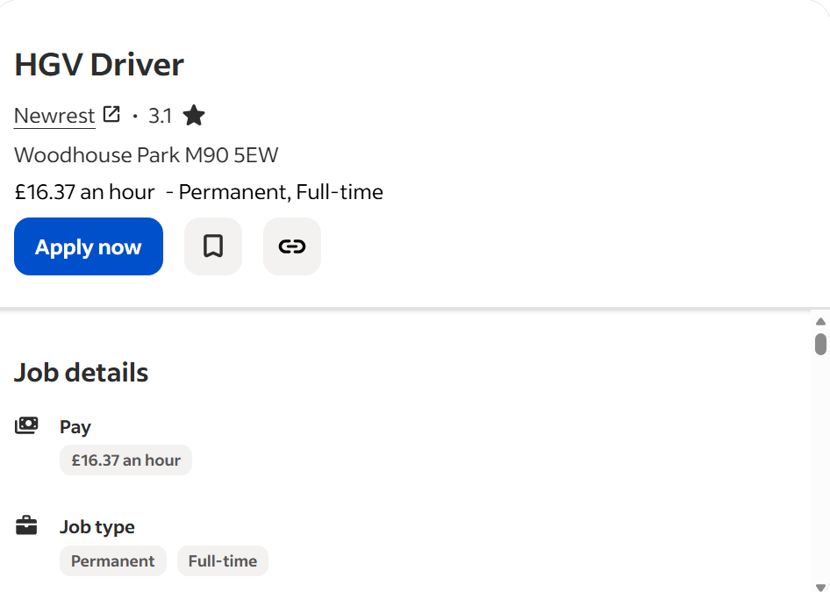
Link: HGV Driver Jobs in UK Work, jobs (with Salaries) | Indeed United Kingdom
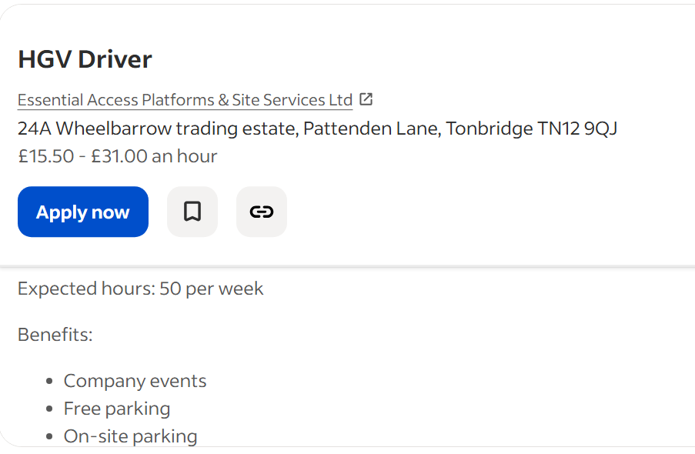
Link: HGV Driver Jobs in UK Work, jobs (with Salaries) | Indeed United Kingdom
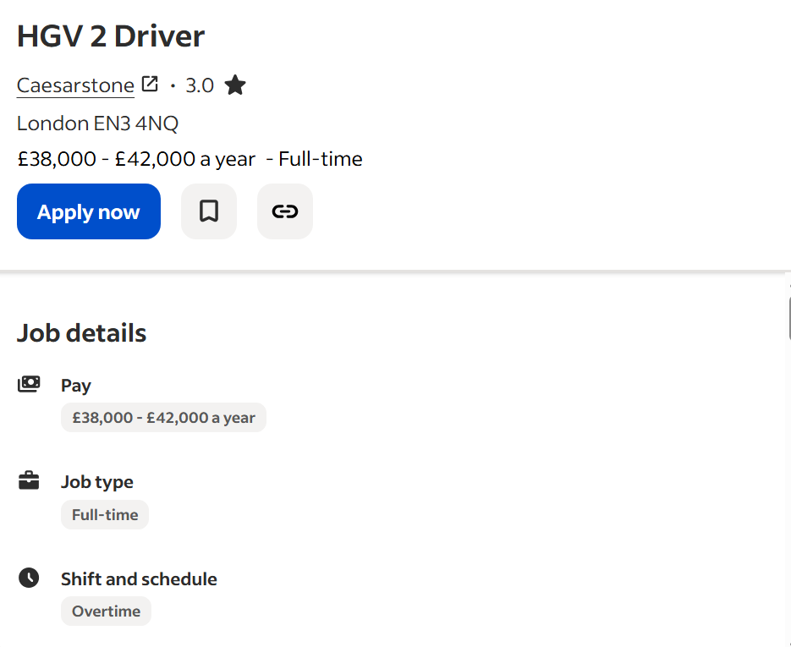
Link: HGV Driver Jobs in UK Work, jobs (with Salaries) | Indeed United Kingdom
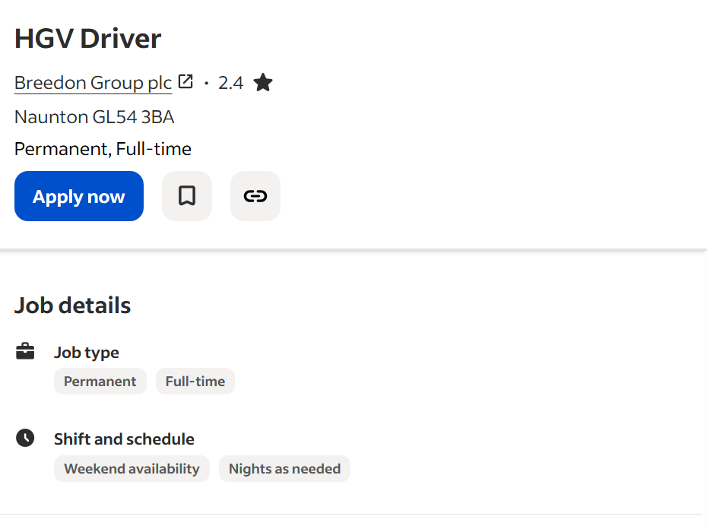
Link: HGV Driver Jobs in UK Work, jobs (with Salaries) | Indeed United Kingdom

