

Developing Workplace Critical Thinking

Individual Report on -

“How do organisational beliefs, attitudes, and value systems affect workplace behaviour?
Lecturer name: Molly Jack
Student name: Anca Sultan
Student ID: 1921337

Table of Contents

Introduction 3
Analysis 5
Conclusion 17
Reference List 18

Introduction
Aim
Beliefs, values and attitudes are all important components within an organisation as it helps in creating a culture through which critical thinking abilities is facilitated by the managerial heads (Bailin, 2003). The key aim of this report is to find out ways, strategies and approaches used by the Aviva plc to survive in UK market over three centuries.
Introduction to company
Throughout this report, Aviva Plc will be taken into consideration that will focus upon understanding the ways in which the business and its management heads such as Adam Winslow (CEO of Aviva UK & Ireland General Insurance), Nick Amin (Chief Operating Officer), Mark Versey (CEO of Aviva Investors) and others who have facilitated in creating a methodology through which better critical thinking environments is promoted. Company has been serving its customers over 320 years and which makes them absolutely unbeatable in UK territory. This British multinational insurance company has been generating billions of revenues (£46.53 Billion in 2020) by using their excellent staff management and service development technique, which is leading the company towards exponential success in upcoming days (aviva.co.uk, 2017).
Justification for selection of the company
Along with this, it can be illustrated that focus must be given towards understanding organisational examples that will be provided here in this assessment through various products being created by Aviva Plc in the past. The way in which the management has been able to create effective productivity oriented environments shall be explored here through various management approaches. Incredible managerial styles, approaches and frameworks used by the company are another vital aspects, which would be critical evaluated in this study. The methods that are being used by the business to help in achieve customer relationship optimisation and facilitate in different types of issues to be eliminated by the employees of the business when interacting with prospective clients shall be enumerated here in this research. As the company has been continuing its business operations since last three centuries, it should be interesting to identify some of the strategies, approaches, key models, theories, and styles used by managers and leaders to maintain their market competitiveness. Therefore, selection of Aviva plc for this project is justified.
Introduce key management theories that will be underpinned in the report
Throughout this research, focus will be given upon understanding multiple types of managerial frameworks as well as critical thinking approaches, which help leaders and managers to meet expectation of employer and needs of business at the same time (TRIPATHY, 2018). Some of the different types of frameworks that will be highlighted and underpinned in this assessment will include of Contingency Theory, Bureaucratic Theory, and other methodologies. These are all important management approaches that facilitate the leadership who have a higher margin of control over different types of circumstances and move forward effectively (Bowell et al.,2010).
Moreover, multiple different types of critical thinking strategies shall be underpinned here in the study as well through which focus can be given towards evaluating the ways in which Thinking Hat Method, Critical Thinking Model, RED model, and other strategies will be elaborated here in this research. Throughout these models, the way in which the business is able to create teamwork and focused towards a variety of business activities shall be explored here in this assessment.

Analysis
Q1. “How do organisational beliefs, attitudes, and value systems affect workplace behaviour? Also, how will tailoring workplace changes for the post-COVID mindset tackle the challenges we face now, and create more resilient businesses in the future?”
Logic is important as it facilitates in much more effective decisions to take place. Several different principles of logic encompasses of eliminating contradiction, focusing upon identifying recent, and excluding the relevant facts that are not important (Copi et al., 2018). These are factors that facilitate in much more critical thinking to develop in Aviva Inc. Utilisation of logic in Aviva Inc is an important factor that facilitates in elevating casual relations through which single variant factors such as quick responsiveness allows the scope of taking decisions on developing terms of contract, changing parameters, and initiating premiums. In critical thinking, being able to possess skills such as good tonality, volume, dictation, and clarity are all important aspects that help in creating a rational argument and point of view in Aviva when establishing one's own beliefs, attitudes and other viewpoints amongst executive heads and clients. It can be said that, through better communicative approach helps in more insurance to be sold.
The value of reflection in learning within Aviva is immense as it helps in embracing new financial contracts, creating better terms in agreements for the insurances and an improved operating approach in the financial industry (Chang, 2019). Multiple ways are there through which emotions, value and beliefs affect rational thinking. Being able to strategically and critically think facilitate in taking control of an emotional irrational decision and facilitate in imposing values that are much more concrete and grounded in facts for better positioning of Aviva.
Different types of techniques of comparison have been implemented that facilitates in evaluating multiple propositions which has facilitated in exploring options to deal with the post corona virus situation. It has been understood that some critical path options include implementing social distancing, increasing sanitisation measures, facilitating in engaging remote working facility, and others (Mukherjee et al., 2018).
Utilising indicators and deductive reasoning, it has been understood that at a broad margin (deductive), an organisational restructuring is required through which remote management of employees in the pandemic situation can be implemented. However, at a specific (indicative) level, it can be understood that being able to work with essential employees at a personal margin is important as well. Aviva can be benefitted through this combined organisational structure that can directly enable enhanced remote performance and much more effectiveness with essential workers that are coming to the organisation as well.
In order for the business to be able to effectively manage and helping in creating optimised beliefs, attitudes, and value systems for the workplace behaviour, several different types of management strategies can be explored for Aviva Inc.
Applying the key theory/theories to your chosen organisation
Human Relations: This is a management theory focused upon optimising work satisfaction and internal informal workplace environment. This allows the scope of prioritising individual needs and enhancing behaviour of people so that they are result oriented (Dubin, 2017). In the case of Aviva, this type of theory is implemented in prior to service line situations where optimisation of different types of aspects of services is required. This facilitates in making sure that it is easier for there to be outcome oriented guidance and work related to insurance allocation being attained.
Scientific Management: Scientific management is the strategy that focuses upon economic efficiency to be attained through labour productivity. In order to implement this strategy, focus upon creating pressure on subordinates is emphasised (Trist, 2016). This type of strategy was previously implemented in Aviva Inc by Adam Winslow. Winslow has done this in order to make alterations in the terms of insurance documents. Scientific actions have been taken in order to stay in a regulation and compliant with statutory laws, and focusing upon internal harmony being present (Borch et al., 2016). These are some of the different types of Aviva services products stay optimised against competitive hardware.
Contingency Theory: This form of strategy focuses upon being able to find different types of ways through which the best possible outcome can be attained through effective situational decision-making. In Aviva, this has been the foundational strategies through which as early as health and life insurance products which had been initiated, the business has been able to adapt with its limited insurance products and take better decisions for consumer oriented commodities.
Bureaucratic Management (Max Webber): Bureaucratic management is a corporate strategic formal strategy through which emphasis is given upon creating a hierarchy of rules and regulations to govern (Stark, 2016). In the monopolistic environment of Aviva, Adam Winslow presently has the ultimate say in most of the areas of the business through which efficiency had been raised and a larger scope of product line. Some of the products that have been created through him might include of life insurance, car insurance, home insurance, and other intangible products.
Just in time theory: just in time theory focuses upon implementing a resource based strategy on the basis of which, as soon as items or raw materials are coming into the organisation, outcome oriented plans are initiating through the operation management system (Li et al., 2017). In the context of Aviva, this form of strategy is only implemented when an insurance product is required to be launched and effective demand for the same is effectively created for the coming few years. Owing to which, all of the materials that come into the organisation are effectively pushed further at a higher margin to satiate the investors to profit by selling to the consumers.
Scanlon human relation approach: this is an organisational gain sharing strategies through which the employees within an enterprise focus upon the established cost-saving strategies which facilitates in making sure that the effort of the employees optimised. This is a strategy which facilitates in incentive-based formulas to be implemented through which it is easier for there to be making Aviva employees feel as if they have a large margin of stake in the businesses revenue enhancement as well.
Elton Mayo approach: this is a specific management approach through which the morals and values that are present within an organisation are given importance rather than the legal aspects (Bendix and Fisher, 2017). This strategy is also known as the clinical approach. In the context of Aviva, this type of strategy was not always considered by Adam Winslow as well as. In the management level had always focused upon a balance between values, morals, and legal operations in order to make sure that optimised results are always being undertaken effectively for faecal endeavours to be achieved.
From all of the approaches that have been elaborated above, it can be understood that as per the circumstances and stages that Aviva was presenting, different types of management approaches by different executive heads have been implemented. This has allowed the scope of flexibility to be maintained and providing employees with a higher margin of variety that has eliminated in monitoring to be created which could have elevated the margin of subordinates' turnover to be raised.
Difference between - beliefs, attitudes, and values within a workplace context
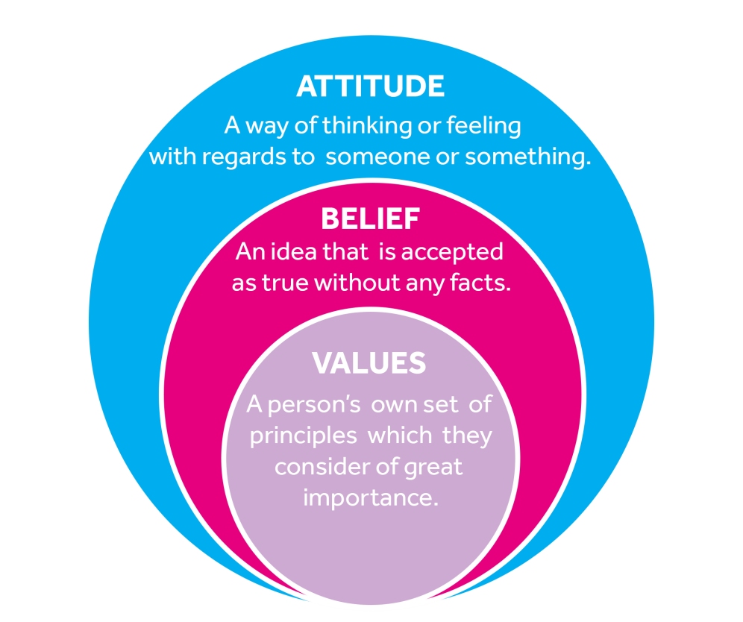
Figure 1: Difference between - beliefs, attitudes, and values
Critically assesses organisation’s own beliefs, at critical thinking plays an essential role in building values, beliefs, and attitudes of an individual. All of these three aspects are interconnected critical thinking within an individual. Values can be defined as the numerous principles that an individual believes to be of the utmost importance to him when operating with other individuals in personal or professional life. Beliefs can be illustrated similarly as an idea or thought process which an individual believes in without or with any form of facts being present. In the context of the insurance enterprise, belief systems are required to be ethical as they help in establishing trust and reliability. Finally, attitudes can be the way or pattern of thinking that an individual possesses in regards to something else or someone else. The contrasting factor which is differentiating all of these three aspects is that values are immensely personal while beliefs are aspects that have personal thought processes and influence of others. Finally, attitude is illustrated as the interactive aspect which influences an individual's responses towards other things or someone else (Bailin, 2003).
In the context of Aviva, it can be understood that the initiation of Adam Winslow within the company, several different types of values had been immensely embedded within the organisation through which innovation, critical and logical thinking, being able to stay ethical, were all empowered. Some of the values of Aviva focus upon being able to create new insurance products as technology is changing and enables much more digital features to be provided to the market. It can be said that, these form the different personal values that the organisation has through the vision of Adam Winslow.
The beliefs of Aviva as illustrated by Nick Amin has focused upon the way in which the enterprise believes that it has been created in order to facilitate in making great products. This belief is based upon utilising different types of insurance products and making sure that simplicity in the businesses product range is being facilitated that helps in making sure that people of all different ages are able to take part in a simplified approach towards learning. The belief of organisation such as Aviva is based upon the activities that it has performed before through the life, travel, health, motor, mobile, cycle, and other types of insurance products provided.
In the context of Aviva, the organisation has a competitive attitude towards its rivals through which it is easier for the business to be able to consistently focus upon development. Along with this, it can also be illustrated that the organisation does not personally treat other entrepreneurs negatively however, due to the nature of the business, consistent and organisation through innovation of its own is emphasised by Aviva in order to facilitate in uniqueness and differentiation to be attained effectively.
Critically assesses organisation’s own beliefs, attitudes and value systems and their impact on workplace behaviour.
As can be illustrated by Andrew (2018), through Aviva's internal culture, the beliefs and value system of are very different when compared to other insurance companies. The value of Aviva is consistently focused upon innovation, critical thinking and making sure that each team member is able to provide some form of value to the products which are being created. In the context of workplace behaviour, this facilitates in being able to stay relevant in a competitive environment in the atmosphere of the organisation itself. This lets subordinates focus upon providing a higher range of impact on the commodities and services of the business.
As a result of this, Aviva has been able to consistently work upon any type of errors that are placed in the terms of agreement of the business and remove them from the operating system. An effective example of this can be through the consumer friendly insurance products of Aviva. For instance, it can be said that, when a number of years pass for any users when using an insurance holder by Aviva. The business facilitates in providing the service of revising the insurance contract if required that helps in availing higher benefits and extending the tenure of the agreement if required.
In terms of attitude, it can be understood that Aviva employees are very well paid provided high benefits, and are given the prospect of working in different types of circumstances. These have facilitated in creating an effective funnel through which it is much easier for there to be employer and employee connection being built and maintained. As a result of this, it has been much easier for the enterprise to be able to create final strategies through which it is easier for efficiency to be maintained. As a result of this, it can be understood that a higher margin of confidence in the capabilities of Aviva employees is facilitated within the business through which it is easier for there to be a tight pack environment created. This also facilitates in making sure that the organisational secrets do not get leaked due to which it is simpler for there to be long term development being attained (Andrew, 2018)
Several examples can be undertaken in order to illustrate the way in which the values, beliefs and attitude of Aviva has benefited the business in the long term. For instance, in the middle of 2000 and 2010, a series of insurance and extended service products had been initiated by an Aviva. This had provided the scope of connecting with consumers, understanding their needs, reassessing the terms of the insurance agreements, optimising them so that competitive performance is being raised amongst other companies. In order to launch these different types of programs and insurances, optimal marketing, stating the terms clearly, conveying the benefits, are all important aspects that were considered by a favour. As a result of this, a higher level of reach and visibility was enabled.
As a result of this, it had facilitated in creating a industrial shift in insurance products and services. This had enabled evaluating what type of insurances were being demanded by consumers and understanding how Adam Winslow had created an attitude of secrecy within the organisation and had filed for different types of patents for this intellectual property rights of the insurance products. Moreover, the beliefs and values of the organisation was focused towards optimising the commodities of the business so that it was much more easier for there to be a new service being given to consumers that was revolutionary in nature (automationworld.com, 2019).
Critical evaluation of the theory/theories to assess how someone with different beliefs, attitudes and values might interpret the theory differently
Red model
RED is a management model which is focused upon optimising the way in which critical thinking can be reached. Three core areas are present within this approach that includes of Recognising assumptions, Evaluating arguments, and Drawing conclusion (Tom Chatfield, 2017).
This is a stage in which a wide range of assumptions are created within an organisation that facilitates in making employees believe something is true even if the proof of the same is not present. For instance, in the case of Aviva, the managerial heads, team leaders, and other individuals might illustrate that some statements of Adam Winslow were put forward through which work efficiency could be enhanced. Prioritising different types of clients is an important aspect that has enabled logical thinking and scheduling to be created for the insurance enterprise. However, if the record of the same is not present, the statement would still be believed as employees will be working within the organisational environment in which those rules will be implemented at a higher margin.
However, employees might be tested within Aviva to facilitate empowering that critical thinking ability and making sure that it is easier for there to be persuasion being categorised and achieved. This can facilitate in making sure that a particular belief is being put into action through which it is much easier for there to be an evaluation if the employees are able to think on their own or they believe the facts that are being provided to them by the managers. Evaluation also helps in making sure that effective utilisation of psychology is implemented in both ends of the manager as well as they employed as this helps in evaluating if the employee has the chance of implementing logic and reaching deductive thinking processes through which conclusions can be raised (Bowell et al., 2010). Being able to utilise psychological tactics and anticipating the needs of the market are an essential aspect that has facilitated in better interactions, higher level of loyalty, and other aspects to be generated.
In this final stage, conclusions are drawn on the basis of the several read-throughs of the insurance documents that helps Aviva to be able to understand how employees can be trained, customers can be engaged, and a final approach can be initiated. This helps in making sure that evidence-based growth is always being achieved effectively in the organisation.
De Bono 6 thinking hats method
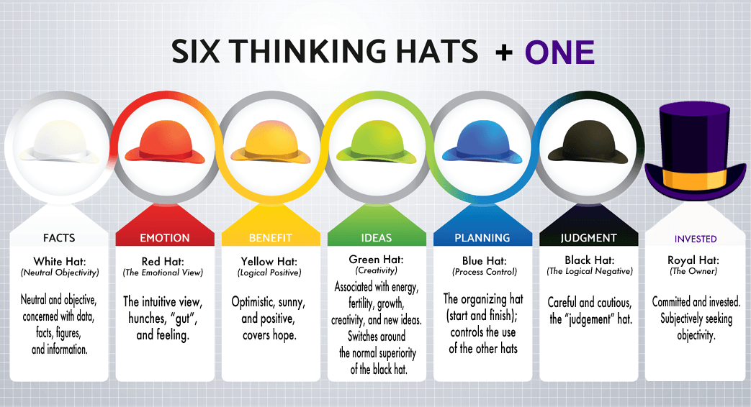
Figure 2: De Bono 6 thinking hats method
This critical thinking methodology focuses upon taking decisions to multiple different types of point of view is being considered. It is through this framework that specific aspects such as judgement, planning, idea generation, investment, benefit, fact checking, and others are explored. In the case of Aviva, it can be illustrated that the executive heads of the business such as Adam Winslow take this form of role in critical thinking that facilitates in making sure that all of the products that are being put forward is judged through multiple different types of aspects. This helps in providing effective feedback. As a result of this, improvement for the commodities over a long stretch of time is always facilitated. The level of perfection of the goods arises to this critical hats thinking strategy being implemented (TRIPATHY, 2018).
Alfaro Lefevre 4 Circle CT (Critical Thinking) model
This Critical Thinking specific model focuses upon clinical reasoning to be undertaken through which learning, safety, cost effective care, and other aspects are attempted to be considered. These facilitates in making sure that when a product or project is being created, the amount of cost being undertaken to research the item is not overspent. Technical skills, interpersonal and management skills, theoretical skills, behavioural critical thinking skills are all important aspects of this strategy. In the case of Aviva Inc, technical skills in terms of understanding effective legal writing for the insurance contracts are required. Moreover, changing the contract as per the needs of the clients is an effective an important aspect as well. Aviva employees need to consider this in order to make sure that insurance sales are being attained much more often. Moreover, interpersonal efficiency as well as self-management is also an aspect that each of the employees of Aviva possesses in order to have accountability and sure what type of developments they are being able to make it within the organisation (PEAKS et al., 2018).
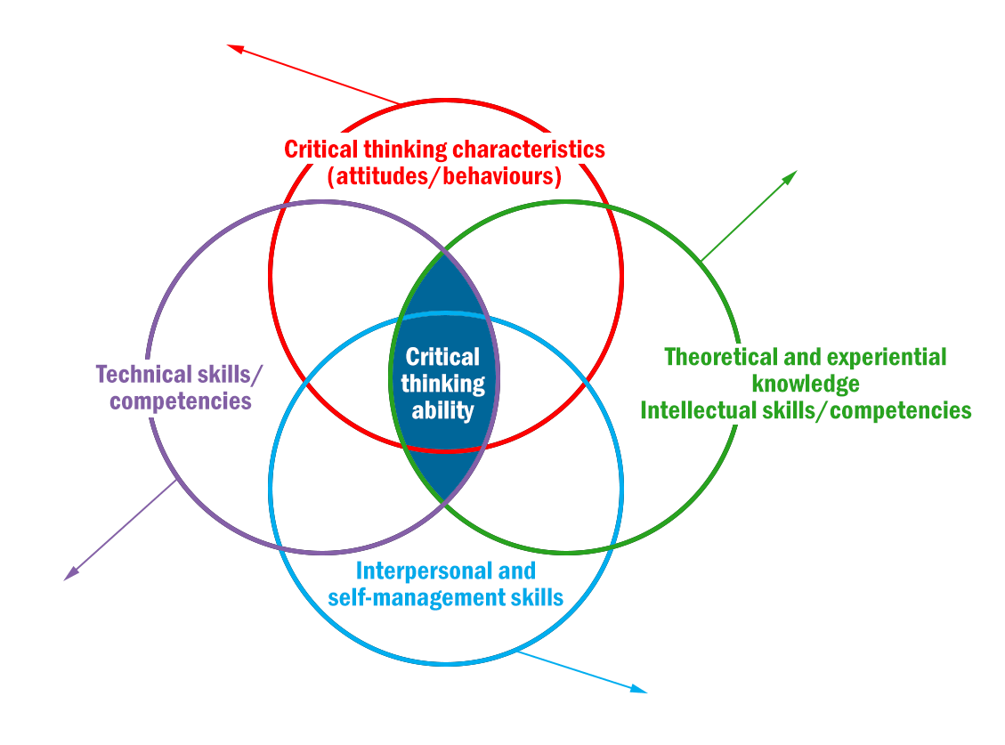
Figure 3: Critical Thinking model
In addition, theoretical knowledge over the market and realising what type of gaps are present also facilitates in intellectual skills being created that facilitate in different types of headways being made through the products and services of the business in the market. Finally, critical thinking abilities through attitude and behaviour facilitates in making sure that it is easier for there to be a competitive behaviour to be created that facilitates in easier innovation, unique product creation, and other aspects to be achieved.
Benner's Novice to Expert Theory
This critical thinking strategy focuses upon being able to learn consistently and evaluate the ways in which the abilities of an individual or a team within an organisation is able to serve its target audience at a much more effective level (NAIR et al., 2013). Through this entire process, an individual starts at the novice or beginner level with no experience and focuses upon understanding what the need of consumers is and effectively rising above and on a repeated basis being able to provide a much more better experience than before. Aviva started as a two person company with a few employees
However, through effective combination of Adam Winslow, the individual has been able to effectively and raise their competency level at a higher margin that facilitated in making sure that much more individuals with different types of skill sets was being brought into the organisation through which it was easier for there to be efficiency being raised. As a result of this, it had been much easier for there to be focus being given upon serving consumers with competitive skills that were on par with international companies. All of these aspects were important for Aviva as Adam Winslow had envisioned the business to have enough capabilities so that insurance products for younger entrepreneurs as well.
Relationship between beliefs, attitudes and value systems and culture and norms
Beliefs, attitudes and value systems have an immense relationship within an organisation to help facilitate in creating culture. The norms of Aviva help in elaborating that the business is focused upon achieving different types of activities that concentrate upon optimised quality standards, helping in providing support to employees that required up skill and other aspects as well. The belief within Aviva is to focus upon strategically making headway into different types of products and believing that a unique angle strategy to make things simplified is always present. This type of belief facilitate in exploring things that have not been achieved by other individuals before. In addition to this, it can also be highlighted that these types of beliefs is directly in tandem with the values that illustrate that consumers want something less complicated and with good user interface. This facilitates the business to be able to perform at an effective margin and have a competitive attitude consistently that helps in creating a culture of individualism, long-term orientation, creating low intelligence, and other aspects (KUHN, 2018).
In the context of Aviva, in order for effective performance in the post corona virus pandemic situation, critical thinking is being implemented through emphasis upon focusing more upon Internet-based communication, videoconferencing strategies, making sure that sanitisation measures being implemented, are all aspects being considered. Moreover, it can also be understood that in order to perform effectively in the corona virus situation, vaccination services are being initiated within the work environment through different types of doctors in the multiple branches of Aviva. This helps in making sure that antibodies are being created which facilitates in improved performance to be undertaken by all of the individuals that are associated with the business so that consumer protection is being enhanced at a greater margin.
Make recommendations with valid justifications for specific organisational changes for the post-COVID mindset
Several challenges are present against Aviva after the effect of the corona virus has taken place and the mindset of both employees and consumers have changed. Being able to wear gloves when creating service with documents and quality checking different aspects of the organisation can help in making sure that it is easier for there to be effective growth being undertaken (Thomas et al., 2016).
Another aspect that can be considered within an organisation such as Aviva in order for critical thinking ability and organisational changes to take place is to introduce new types of training and development programme as to how employees can conduct themselves in the post corona virus situation. This can facilitate directly in being able to create an effective method through which independent work, interaction only when required and other aspects can be addressed. This will facilitate in easier work efficiency to be maintained and minimal interactions to be conducted unless required. Since insurance products and services can be created remotely through interaction with clients to video calling conferences, messaging, and other facilities, it is necessary that work from home prospects are provided to sales agents in the pandemic situation (Van der Zwaard and Bannink, 2014).
In order to optimise the beliefs, attitudes, and value system of Aviva at a further margin for the future, the approach that had been created by Adam Winslow in order to create simplicity, initiate new products, focus upon developing commodities that are unique, are some of the aspects in which the business has the chance of making headway. This can help in making sure that it is easier for the organisation to stay ahead of the market consistently and deliver products that are unique. In order to tackle the changing market, it is important for adaptability as of value to be integrated within Aviva as well as this will help in taking in a variety of different types of commodities that are being initiated by competitors and focusing upon researching through which further development for the products can be attained effectively. This can also help in critical thinking abilities to rise as a result of change occurring consistently and new problems being solved by the employees and the managerial heads and the business (ORTEGON-MONROY, 2003).

Conclusion
Throughout this entire critical thinking study for Aviva and being able to develop and create an effective workplace environment, several aspects has been evaluated for the business. Throughout this assessment, multiple different types of management strategies have been explored that has enabled the scope of understanding the flexibility that has been created by Adam Winslow in the company. The way in which the business is able to follow the values, beliefs and attitude of being competitive, focusing upon product simplicity, and other aspects has been elaborated here in this research.
All of these aspects are effectively essential so that it is easier for there to be development being attained. Throughout this assessment, several different types of models that put emphasis upon critical thinking, novice to expert framework, contingency management theory, and others have been evaluated as well. All of these have been essential for Aviva Inc as they have facilitated in being able to understand how the business can operate after the corona virus has taken place.

Reference List
Andrew, 2018. Maund BA in Leadership and Management: Skills for the Workplace Student Yearbook, 1st Year SAGE Publications, Limited, 2018
automationworld.com 2019. Innovative Touchscreen Available at: https://www.automationworld.com/products/control/blog/13305030/innovative-touchscreen (Accessed: 22 July 2021).
aviva.co.uk, 2017. It takes Aviva Available at: https://www.aviva.co.uk/ (Accessed: 6 August 2021).
Bailin, Sharon, 2003. . The Virtue of Critical Thinking. Web.Philosophy of Education Yearbook, 2003 available at: https://web-b-ebscohost-com.ezproxy.uwtsd.ac.uk/ehost/pdfviewer/pdfviewer?vid=1&sid=21482f89-0a43-4cc6-bc0d-0e48862e21f4%40sessionmgr102
Bendix, R. and Fisher, L.H., 2017. The perspectives of Elton Mayo. In The Anthropology of Organisations (pp. 11-18). Routledge.
Borch, K.H., Sandmo, A. and Aase, K.K., 2016. Economics of insurance. Elsevier.
Bowell, Tracy, and Gary. Kemp, 2010. Critical Thinking : A Concise Guide. 3rd ed. London: Routledge, 2010. Print.
Chang, B., 2019. Reflection in learning. Online Learning, 23(1), pp.95-110.
Copi, I.M., Cohen, C. and Rodych, V., 2018. Introduction to logic. Routledge.
Cottrell and Stella 2011. Critical Thinking Skills: Developing Effective Analysis and Argument. 2nd ed. Basingstoke: Palgrave Macmillan, 2011. Print. Palgrave Study Skills.
Dekkers, R., 2016. Applied systems theory. Zurich, Switzerland: Springer International Publishing.
Dubin, R., 2017. The world of work: Industrial society and human relations. Taylor & Francis.
KUHN, D., 2018. A Role for Reasoning in a Dialogic Approach to Critical Thinking. Topoi, 37(1), pp. 121-128. available at: https://search-proquest-com.ezproxy.uwtsd.ac.uk/docview/2291274963?OpenUrlRefId=info:xri/sid:primo&accountid=130472
Li, H., Shang, W., Zou, Y. and Hassan, A.E., 2017. Towards just-in-time suggestions for log changes. Empirical Software Engineering, 22(4), pp.1831-1865.
Mukherjee, N., Zabala, A., Huge, J., Nyumba, T.O., Adem Esmail, B. and Sutherland, W.J., 2018. Comparison of techniques for eliciting views and judgements in decision‐making. Methods in Ecology and Evolution, 9(1), pp.54-63.
NAIR, GIRIJA G,PHD., R.N. and STAMLER, LYNNETTE LEESEBERG, PHD,R.N., F.A.A.N., 2013. A Conceptual Framework for Developing a Critical Thinking Self-Assessment Scale. Journal of Nursing Education, 52(3), pp. 131-138. available at: https://search-proquest-com.ezproxy.uwtsd.ac.uk/docview/1313217549/3A16624FD942E9PQ/2?accountid=130472
ORTEGON-MONROY, M., 2003. Chaos and complexity theory in management: an exploration from a critical systems thinking perspective. Systems Research and Behavioral Science, 20(5), pp. 387-400. available at:https://search-proquest-com.ezproxy.uwtsd.ac.uk/docview/196882780?accountid=130472&rfr_id=info%3Axri%2Fsid%3Aprimo
Stark, A., 2016. Bureaucratic values and resilience: An exploration of crisis management adaptation. Public Administration, 92(3), pp.692-706.
THOMAS E. CONINE JR. and BARRY LESKIN, 2016. Developing Emotional Intelligence and Conflict Management Skills Through the 360 Assessment ©2016 Wiley Periodicals, Inc. Published online in Wiley Online Library (wileyonlinelibrary.com) Global Business and Organizational Excellence • DOI: 10.1002/joe.21667 March/April 2016 available at:https://web-a-ebscohost-com.ezproxy.uwtsd.ac.uk/ehost/detail/detail?vid=0&sid=63750d69-96c8-4a00-8db6-fd4af98567d2%40sdc-v-sessmgr03&bdata=JnNpdGU9ZWhvc3QtbGl2ZQ%3d%3d#AN=112901225&db=bth
Tom Chatfield, 2017. Critical Thinking SAGE Publications, Limited, 2017
TRIPATHY, M., 2018. ROLE OF CREATIVE THINKING AS AN IMPERATIVE TOOL IN COMMUNICATION AT WORKPLACE. Journal of Organizational Culture, Communications and Conflict, 22(2), pp. 1-7. available at: https://search-proquest-com.ezproxy.uwtsd.ac.uk/docview/2177045878/fulltextPDF/A4DCB42126EF4C4BPQ/1?accountid=130472
Trist, E., 2016. A socio-technical critique of scientific management. In The Social Engagement of Social Science, a Tavistock Anthology, Volume 2 (pp. 580-598). University of Pennsylvania Press.
Van der Zwaard, R. and Bannink, A., 2014. Video call or chat? Negotiation of meaning and issues of face in telecollaboration. System, 44, pp.137-148.

