Project management Part A,B,C
- Lecture name: Samson Oladejo
- Module code :LCLM 5003
- Student name: Ivaylo Trandev
- Student number: 2413667

Contents
Part A 3
Part B 3
Reflection 3
Introduction 5
Project Description 5
Scope of the Project 6
Work Breakdown Structure 7
Quad Chart 8
Gantt chart 9
Stakeholder Involvement 10
Statutory and regulatory Bodies – The Enablers 10
Commercial and Logistics Partners - The Economic Drivers 10
Technical and Delivery Partners - The Builders 11
The Public and Community - The Impacted 11
Stakeholder Matrix 11
Stakeholder management plan 11
Resource Allocation 12
Human Capital 12
Physical Resources 13
Technical Resources 13
Budget Allocation 13
Risk Analysis 14
Conclusion 16
REFERENCE 17

Part A

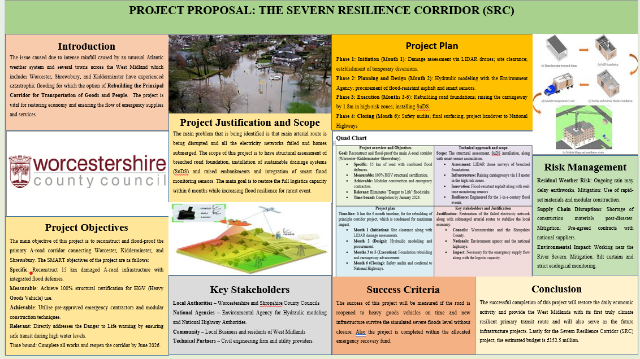

Part B

Reflection
I was very excited to get the feedback that I received from my tutors and peers regarding the project proposal for the Severn Resilience Corridor (SRC). The feedback that I have received highlighted strengths in the project strategic alignment with the regional needs while providing critical insights into areas requiring further technical and operational depth.
The positive thing that I get from the feedback is that my proposal excels in its clarity of purpose and urgency. By framing the project as a direct response to the catastrophic July 2025 flooding in Worcester, Shrewsbury, and Kidderminster, the proposal successfully justifies the £152.5 million investment. The SMART objectives were one of the significant strengths of my proposal. I also received feedback specifically on idea and the commitment to reconstructing 15 km of A-road infrastructure with integrated flood defenses provides a concrete, measurable goal that peer reviewers found easy to evaluate. Also, idea of integrating modern technology such as LIDAR drones for damage assessment and smart flood monitoring sensors was praised for moving beyond traditional like for like repair toward a forward thinking and resilient infrastructure model.
The areas of improvement that I must make in my final project plan. The feedback I received is that my conceptual framework is strong but some of my peers questioned the ambitious 6-month timeline. And as per the industry standards the issue that they raised structural assessments, hydraulic modeling and the physical raising of the carriageway in the tight deadline seem impossible task. Also, in the final plan I need to include the detailed Gantt chart for accounts for potential float time especially during the execution phase. I also received feedback that the key stakeholder list is comprehensive, but the proposal lacks clear communication strategy. The final section needs to include a dedicated section on how the community stakeholder group will be managed and specifically the local business and residents for minimizing the disruption during the five-month construction period.
There was another feedback that I received, and it was about sustainability and ecology. As per the feedback I mentioned, slit curtains and ecological monitoring the feedback highlighted a need for more comprehensive plan for environmental impact. As per my idea the work takes place near the river severn the final report needs to detail how SuDS (Sutainable Drainage Systems) will be integrated with a local ecosystem to ensure the project does not inadvertently push floodwaters towards downstream communities. The last feedback that I received was that the financial breakdown that I presented was only the total amount and for improving transparency, I need to provide high level cost breakdown in the final version and separate the cost of road foundations, modular constructions and sensor technology.
All I can say is that the feedback I received has been very valuable for me to draft the final project plan. I also realized that my proposal was not perfect and for my final project plan I need to consider all of the above-mentioned points. If I implemented all the feedback, then the SRC will serve as a definitive blueprint for climate resilient transit in the West Midlands.

Introduction
Project management is the strategic utilisation of knowledge, skills as well as tool to provide the particular objectives within the defined constraints of scope, time as well as cost (Andersen, Grude, and Haug, 2025). This report will emphasis on the West Midlands, which is now facing the logistical crisis because of the flood. It has mainly focused on rebuilding the principle corridor for the transportation of goods as well as people.
This Project Management Plan will define the Project Scope as well as the Description, it will provide the Work Breakdown Structure (WBS). It will later, visualise the progress with the help of the Quad Chart along with the Gantt chart. Further, it will provide the necessary details regarding the Stakeholder Involvement, Resource Allocation, as well as Risk Analysis, ultimately it will provide the aspects regarding the framework for long-term climate resilience.

Project Description
Following the catastrophic flooding in July 2025, which severed this arterial link, this project will move beyond simple repairs to introduce flood-resilient engineering, restoring secure, 24/7 access for both logistics and local. The Severn Resilience Corridor (SRC) is a critical recovery initiative designed to transform a vulnerable transport link into a climate resilient arterial route. The project mainly focuses on the strategic reconstruction of the A-road network connecting Worcester, Kidderminster, and Shrewsbury, which serves as the economic backbone of the West Midlands.
Technical Strategy – It will be one of the most important strategy for the project in which there will not be like for like replacement or repair but SRC will employ an Integrated Resilience approach. The structure will be elevated meaning several low lying sections of the corridor will be raised by up to 1.5 meters using the reinforced embankments to ensure that the road remains above predicted one in 100 year flood level. Also there will be implementation of permeable engineering in which Sustainable Drainage System (SuDS) will be implemented that includes oversized culverts and attention pools to manage the massive water runoff without compromising the structural integrity of road infrastructure (Reed, and Miller, 2021). The project will be a smart corridor, which will have IoT based Flood Early Warning System (FEWS) and these sensors will provide the real time data on the water levels and structural vibration to National highways and from this there will be automated traffic diversion before a crisis occurs.
Functional Impact – The primary impact will be that the logistics will be restored as there will be re-establishment of the primary route for Heavy Goods Vehicles (HGVs), which will ensure that the regional supply chain for food, fuel and medical supplies is no longer dependent on narrow and flood prone rural detours (Department for Transport, 2024). The project will also include the relocation and hardening of underground fiber optic and power lines within the corridor and this will protect regional telecommunication from future water damage. The project will also bring the economic continuity as the project will protect the Just in time delivery requirements of local manufacturing hubs in the West Midlands.
Environmental Impact – As this project will require the construction of new corridor, the strategies utilised here will be environmental friendly such as reconstruction will utilise low carbon warm mix asphalt and recycled aggregate from the flood debris, which will help in reducing the project carbon footprint while maintaining high durability standards against the water erosion (Environment Agency, 2023).

Scope of the Project
The SRC project encompasses the emergency reconstruction and long term flood proofing of approximately 45 miles of the primary A-road corridor and the scope is dived into three critical aspects. Firstly, the structural assessment and reconstruction of road foundation at four major breach sites, raising the road surface by 0.8 to 1.5 meters at documented points and use of high durability and water resistant warm mix to prevent future cleaning and subgrade erosion (Office for National Statistics, 2024). Secondly, Construction of Sustainable Drainage Systems (SuDS), including filter drains, and attenuation ponds, replacement of damaged and undersized culverts with high capacity concrete structures. Also strengthening roadside embracement’s using geotextiles and turning to stabilise soil against high velocity flood currents. Lastly, Deployment of IoT flood-monitoring sensors at 15-minute telemetry intervals to provide the Environment Agency and National Highways with real-time water level data and installation of the automated early warning signs at junctions in Worcester, Kidderminster and Shrewsbury to trigger instant traffic diversions.

Work Breakdown Structure

(Figure 1: Work Breakdown Structure)
(Source: Author)
The Severn Resilience Corridor (SRC) Project, is structured into three distinctive phases over the period of six months. The project aims to improvise flood resilience via engineering as well as technological interventions.
Phase 1: Initiation phase (Month 1)
This phase emphasises on the foundational assessments. The main activities comprise conduction of the damage assessment with the help of the LIDR drones along with the performing hydraulic modelling with the collaboration of the Environment Agency.
Phase 2: Planning and Design Phase (Month 2)
This phase is inclined towards the planning as well as procurement. This comprises the site clearance, the establishment of the temporary traffic diversions, along with the procurement of the specialised materials such as the flood-resistant asphalt along with smart sensors.
Phase 3: Execution phase (Months 3 to 5)
The longest phase is for the physical implementation of the resilience measures. This comprises the rebuilding of road foundations, raising the carriageway by 1.8 meters in the high-risk zones, along with flood-resistant asphalt as well as smart sensors.
Phase 4: Closing (Month 6)
The last phase is for the attainment of the safety audits and handover to National Highways.

Quad Chart
Project overview and Objectives  Goal: Reconstruct and flood-proof the main A-road corridor (Worcester–Kidderminster–Shrewsbury).  - Specific: 15 km of road with combined flood defences.  - Measurable: 100% HGV structural certification.  - Achievable: Modular construction and emergency contractors.  - Relevant: Eliminates "Danger to Life" flood risks.  - Time-bound: Completion by January 2026. | Technical approach and scope  Scope: The structural assessment, SuDS installation, along with smart sensor assimilation.  - Assessment: LIDAR drone surveys of breached foundations.  - Infrastructure: Raising carriageways via 1.8 meter in the high risk zones.  - Innovation: Flood-resistant asphalt along with real-time monitoring sensors  - Resilience: Engineered for the 1-in-a-century flood events.
Project plan  Time-line: It has the 6 month timeline, for the rebuilding of principle corridor project, which is condensed for maximum impact.  - Month 1 (Initiation): Site clearance along with LIDAR damage assessments.  - Month 2 (Design): Hydraulic modelling and procurement.  - Months 3 to 5 (Execution): Foundation rebuilding and carriageway advancement.  - Month 6 (Closing): Safety audits and conferral to National Highways. | Key stakeholders and Justification  Justification: Restoration of the failed electricity network along with submerged arterial routes to stabilise the local economy.  - Councils: Worcestershire and the Shropshire County.  - Nationals: Environment agency and the national highways.  - Impact: Necessary for the emergency supply flow along with the logistic capacity.
(Figure 2: Quad chart)
(Source: Author)

Gantt chart
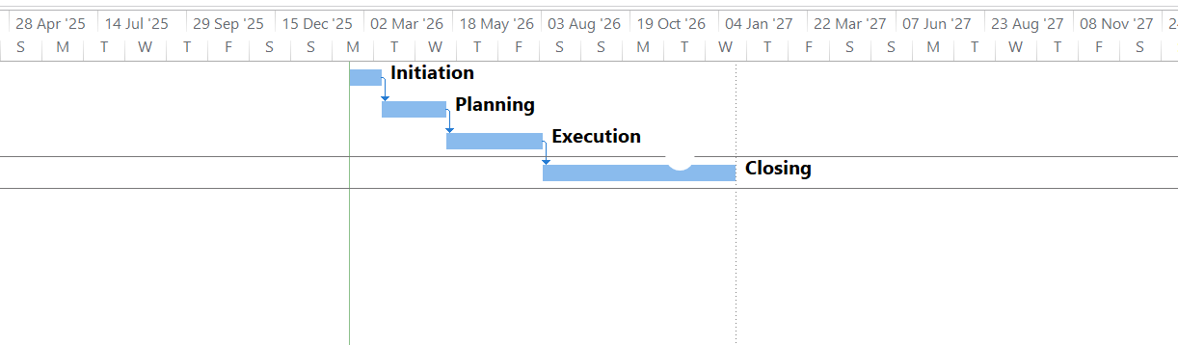
(Figure 3: Gantt chart)
(Source: Author)
Task Name | Duration | Start | Finish | Predecessors
Initiation | 1 mon | Tue 17-02-26 | Mon 16-03-26
Planning | 2 mons | Tue 17-03-26 | Mon 11-05-26 | 1
Execution | 3 mons | Tue 12-05-26 | Mon 03-08-26 | 2
Closing | 6 mons | Tue 04-08-26 | Mon 18-01-27 | 3

Stakeholder Involvement

Statutory and regulatory Bodies – The Enablers
Worcestershire and Shropshire County Councils – They are the asset owner as they provide the emergency capital and their role is to include fast tracking of planning application and issuing temporary traffic regulation orders for 24/7 construction shifts.
The Environment Agency – Their hydraulic engineers are embedded in the design team and they provide National Flood Risk Assessment data that is used to determine the exact height of raised embankments while they also monitor slit curtains to ensure construction does not harm river ecosystem.
National Highways – The main roles is to ensure that SRC seamlessly integrate with wider UK strategic road network and their involvement focuses on safety Audits and handover of the smart corridor sensor data to regional traffic control centers (National Highways, 2025).

Commercial and Logistics Partners - The Economic Drivers
West Midlands Logistics Partners – Many large-scale distributors are consulted for minimum lane widths and gradient limits for heavy goods vehicles to ensure the raised sections does not impede safety or fuel efficiency.
Chamber of Commerce – They act as liaison for small business in Worcester and Shrewsbury by providing weekly updates on access routes to ensure that while the principal corridor is being built local shops can still receive the deliveries via some arrangement.

Technical and Delivery Partners - The Builders
Civil Engineering Firms – They are involved in the early contractor involvement, which includes designing, suggestion on buildability improvements and ensuring work is on the proposed timeline.
Utility Providers – Their involvement is very critical for project, as they need to physically relocate vulnerable cabling before the road is raised and also proactively work on daily Street Works Coordination meetings to prevent accidental damage.

The Public and Community - The Impacted
Local resident Group – They have the direct involvement through the digital twin visualization, which allow residents to see how the raised embankments will look for mitigating any kind of future opposition (Shropshire Council, 2024).
Emergency Services – They are involved in such a way that during peak of construction emergency vehicles have dedicated fast track lane through the worksite and they also have the blue light access priority.

Stakeholder Matrix
POWER
HIGH | Local Authorities | Local Residents and Small Businesses, National Agency
LOW | Logistics and Retail | Utility Providers, Technical Partners,
 | LOW | HIGH
INTEREST

Stakeholder management plan
Stakeholder Group | Key Involvement | Engagement Method
Local Authorities | Responsible for permissions and funding, Local Residents and Small Businesses | Weekly committee meetings and planning protocols
National Agency | Responsible for providing flood risk data and ensuring project aligns with national safety standards. | Collaborative data-sharing and technical audits on the basis of project phases
Logistics and Retail | Responsible for providing feedback on HGV route requirements. | Industry forums and direct consultation for duration of project.
Local Residents and Small Businesses | Responsible for monitoring noise levels and managing local access during construction | Virtual town halls and 24/7 project helpline.
Technical Partners | Responsible for Implementation of SuDS, sensor installation, and road surfacing and site safety | Daily site briefings and BIM coordination
Utility Providers | Responsible for coordinating the relocation and hardening of power and fiber lines | Dedicated utility liaison officers and Street Works coordination

Resource Allocation
The project will require several resources to ensure the road is paved before the peak of winter.

Human Capital
This is most important resource as it will need core group of Hydraulic Engineers and Civil surveyors that are assigned specifically to the SRC to prevent any bottlenecks in design approvals. There will also be need for 24/7 construction crew, which will have rotating shifts of skilled operatives to maximise daylight and night time productivity (Worcestershire County Council, 2023). A dedicated utility and stakeholder Coordinators whose sole task is to ensure that National Grid and construction teams are on site at the exact moment foundations and are ready for cabling.

Physical Resources
These types of resources are also crucial as they are for plants and materials. The main resources that will be required for this project include long-reach excavators and heavy-duty pavers. There will also be requirement of dedicated on-site maintenance workshops to solve the issue of any failure on the site. As per requirement there will be need for a warm mix of asphalt and precast culverts, which will bypass the weeks that are required for on-site concrete curing (Smith, Patel and Williams, 2023). There will also be need for onsite crushers as there will be use of flood debris and for processing of that and also for reducing the need for truck movements through local villages. The materials that will be required are Recycled Concrete Aggregate (RCA), Polymer-modified Asphalt, Reinforced Concrete, and Geotextiles for Stabilisation, Gabion Baskets for Embankments, Smart Monitoring Sensors, Smart Drainage Pipes.

Technical Resources
There will be use of Building Information Modelling to stimulate the flood scenarios against the digital design before a single issue emerges (UK BIM Framework, 2022). Also there will be procurement of hydrostatic level sensors and technology for smart corridor monitoring. Other include 3D mapping for surveying, temporary traffic management system.

Budget Allocation
The total allocated budget for this project is 145 million pounds that will be distributed in the following way:
Category | Allocation | Budget | Key deliverables
Civil engineering and core construction | 55% | £79.75M | The key deliverables include road elevation, reinforced embankments and high durability warm mix
Drainage Systems | 20% | £29.00M | Installation of Sustainable Drainage system, attenuation ponds and high capacity concrete culverts.
Utility | 10% | £24.50M | The key deliverable from this department is undergrounding and waterproofing of National Grid power lines.
Technologies | 5% | £7.25M | The key deliverables include deployment of real time flood sensors and national highways early warning traffic system.
Risk Contingency Funds | 10% | £14.50M | This is for the reserve as large project often have the cost overruns and can be used if there is any weather delay and spot market material procurement.
Total | 100% | £145.00M

Risk Analysis
The risk analysis for the 6th month Worcestershire- Shropshire A- road construction project underlines the vulnerabilities, which tends to disrupt the tight timeline along with the budget. The main risk comprises adverse weather disrupting earthworks, supply chain failures for specialised materials along with the unexpected geotechnical issues at the time of foundation repair. Mitigation strategies tend to emphasis on proactive, resilient as well as technical solutions in ensuring about the completion.
Risk | Risk description | Impact Intensity | Mitigation strategy
Environmental and Weather | Ongoing, unforeseen, or heavy rainfall at the 3 to 5 month execution phase, which could cause soil saturation, prevents the earthworks along with delaying the raising of road by 1.8 meter. | High | Utilisation of rapid-set materials, modular construction components to reduce on-site curative time, and incorporate rigid silt curtains along with consistent ecological monitoring near the River Severn
Supply chain and logistical | Post-disaster shortage of high-strength, flood resistant asphalt or smart sensors, which halt progress | High | Secure pre-agreed, fixed price contracts with national suppliers at initial phase. Use emergency contractor for material sourcing.
Geotechnical and design | Sub-surface damage while foundation rebuilding might worse than identified LIDAR surveys, need structural redesign. | High | Conduction of geotechnical testing upon site clearing. Building contingency time into schedule to address soil instability.
Stakeholder and Community | Temporary closures at the time of construction can cause substantial disruption to local business and resident access, which led towards complaints and political pressure. | Medium | Proactive communication approaches, implementing clearly marked efficient, and safe alternatives route for management of constant dialogue.
Health, Safety and Technical | Failure of new 1.8 meter raised infrastructure towards withstanding future floods, failing in success criteria | High | Rigorous hydraulic modelling with environment agency during phase 2, the SuDs installations tend to meet the maximum flood standards along with performing the final safety audits.

Conclusion
This report has concluded about the project management, it has focused on the West Midland’s logistical crisis because of the flood. This has provided the project scope and description. Later, it has provided the Work Breakdown Structure, it has visualised the progress with the help of Quad Chart along with the Gantt chart. Further, it has provided the necessary details associated with the stakeholder involvement, resource allocation along with the risk analysis.

REFERENCE
Books and journals
Andersen, E.S., Grude, K.V. and Haug, T., (2025). Goal directed project management: effective techniques and strategies. Taylor & Francis.
Department for Transport (2024). Future of transport: resilient infrastructure and climate adaptation. London: Department for Transport.
Environment Agency (2023). National Flood and Coastal Erosion Risk Management Strategy for England: 2023-2030 Roadmap. Bristol: Environment Agency.
Jha, A. and Seneviratne, S. (2022). Smart infrastructure for flood-prone regions: IoT and real-time monitoring. Journal of Civil Engineering and Management, 28(4), pp. 312-328.
National Highways (2025). Design manual for roads and bridges (DMRB): climate change adaptation for road pavements. Birmingham: National Highways.
Office for National Statistics (2024). Economic impact of flood-related transport severance in the West Midlands. Newport: ONS.
Reed, K. and Miller, P. (2021). Sustainable Drainage Systems (SuDS) in highway design: a practitioner's guide to climate resilience. 2nd edn. London: ICE Publishing.
Shropshire Council (2024). Local Transport Plan 4: 2024-2030 – Securing the Shrewsbury-Worcester link. Shrewsbury: Shropshire Council.
Smith, J., Patel, R. and Williams, T. (2023). ‘The role of modular construction in rapid post-disaster infrastructure recovery’, International Journal of Project Management, 41(2), pp. 154-169.
UK BIM Framework (2022). Guidance Part 2: Processes for project delivery using Building Information Modelling. London: UK BIM Framework.
Worcestershire County Council (2023). Severn Valley Flood Management Scheme: Infrastructure Resilience Report. Worcester: Worcestershire County Council.

