Sustainable Hospitality
and Tourism management
REPORT

Student Name: Andreea Balanescu
Student ID: 2211130
Module: Sustainable Hospitality and Tourism Management (BMIH5006)
Lecturer name: Ruth Taylor Davies
Word count: 2199
Date: 28 May 2024

Executive summary

The hospitality industry increasingly prioritises sustainability due to growing environmental concerns and consumer demand for eco-friendly practices. Achieving eco-certification, such as the Green Key label, requires hotels to meet specific sustainability criteria. This report explores the steps necessary for certification, the benefits, and challenges of integrating sustainability, and the outlook for the industry. The move towards sustainability in the hotel and hospitality industry offers numerous benefits, including resource conservation, reduced pollution, and improved operational efficiency. However, it also presents challenges such as high initial costs and the need for continuous improvement. Understanding the Butler Model and its application in Sustainable Tourism is crucial for sustainable tourism planning, as it helps destinations manage growth and avoid the negative impacts of over-tourism. For managing sustainable tourism, it highlights the importance of balancing tourism growth with the well-being of local communities using Doxey's Irridex Model and understanding the changing attitudes of residents towards tourism development in their community, to prevent negative feelings, maintaining a positive and sustainable tourism environment.
The industry's commitment to eco-friendly practices is expected to intensify, driven by technological advancements, regulatory pressures, and growing consumer demand for sustainable travel options, applying the right strategies can lead to success.

Contents
Executive summary 1
1. Introduction 2
2. Sustainable Accreditation in the Hotel Industry 3
2.1. Requirements for obtaining Green Key accreditation: 3
2.2. Other ecological certification schemes 4
3. Implementing Sustainability in Hotel Operations 4
4. Benefits of Sustainability Integration 6
5. Challenges of Integrating Sustainability 9
6. Future of the Hotels and Hospitality Industry 10
7. Recommendations 11
8. Conclusion 11
Reference List 11
Appendix 1 Green Key and the Sustainable Development Goals 14
Appendix 2 Ecological Certifications 15
Appendix 3 Butler’s Model Tourism Area Life Cycle (TALC) 18

Introduction

Nowadays, an increasing number of hotels and hospitality industry suppliers recognise the importance of environmental protection and the implementation of sustainable business practices. Sustainability is no longer just a trend, it is a necessity that protects natural resources and reduces the negative impact on the environment (Popșa, 2023). This report investigates the steps hotels must take to achieve green credentials, such as the Green Key certificate, and the benefits and challenges of incorporating sustainability into daily operations, looking at future trends in the hotel sector and their impact on adopting a more ecologically responsible attitude, using different Models like Butler’s and Doxey’s to apply the right strategies for maintaining a positive and sustainable tourism environment.
Highlighting the importance of sustainability and providing practical recommendations for hotels, helping them to become greener and more efficient. This critical evaluation examines the benefits and drawbacks of sustainable tourism linked to green accreditation, comparing it with successful hospitality organisations to emphasise the need for continued development.

Sustainable Accreditation in the Hotel Industry

The premier standard for excellence in environmental responsibility and sustainable operation in the tourism sector is the Green Key certificate, guiding tourism establishments in achieving the 17 Sustainable goals (see Appendix 1).
To receive a sustainable accreditation, such as the Green Key award, hotels must meet certain standards and implement specific environmental protection measures. Green Key is known as an international green certification that recognises and encourages sustainability in the hotel industry. This certification involves a rigorous review of the hotel’s environmental procedures and the fulfillment of strict standards (Foundation for Environmental Education, 2023a).

Requirements for obtaining Green Key accreditation:

- Environmental management: Hotels must develop and implement a clear environmental policy that includes sustainability goals and targets,
- Efficient use of resources: This includes taking steps to reduce energy and water use, such as installing energy-efficient equipment and water-saving devices,
- Waste management: Hotels must have well-established recycling programs and reduce the amount of waste generated. It must also promote reuse and waste reduction,
- Food and drink: Using local and organic food, minimising food waste,
- Educating employees and guests: The staff must be well-trained in sustainable practices and engage guests in environmental efforts through education and green activities,
(Foundation for Environmental Education, 2023b).
Numerous studies have shown that organisational attributes, prior sustainability experience, and alignment between external standards and business practices influence firms' ability to integrate sustainability standards into their structures (Ngawenja Mzembe, Idemudia and Angel, 2021).

Other ecological certification schemes

In addition to the Green Key certification programme, there are other green certification schemes (see Appendix 2). One that could be mentioned is LEED (Leadership in Energy and Environmental Design), which focuses on the design and construction of green buildings, evaluating their energy efficiency, resource consumption, and indoor environmental quality (Haski-Leventhal, 2018).
Achieving an eco-credential not only demonstrates the hotel’s commitment to the environment but also provides competitive advantages by attracting sustainability-minded guests and reducing long-term operational costs (Edgell, 2020).

Implementing Sustainability in Hotel Operations

Hotels must adopt sustainable measures and policies to minimise environmental impact, save money, and enhance their reputation, promoting environmental sustainability.
Energy efficiency is one of the most important components of sustainability. Hotels can save energy by installing LED lights, automatic lighting systems, and energy-efficient equipment. Installing programmable thermostats, as well as efficient heating and cooling systems, can dramatically cut energy use (Sloan, Legrand and Chen, 2017).
Waste management is also an important aspect. Hotels should implement well-designed recycling programs and encourage guests to participate in these efforts. Separating recyclable from non-recyclable waste and composting organic waste are essential steps. Hotels can also reduce plastic consumption by providing reusable water bottles and by removing straws and single-use items (Corkill, 2023).
Water conservation is important in locations where water is a limited resource. Installing water-saving technologies like low-flow faucets and showers, as well as dual-flush toilets, can considerably cut water consumption. Furthermore, hotels can implement towel and bed linen reuse programmes, which not only conserve water but also the energy required to wash them (Sloan, Legrand and Chen, 2017).
Food and beverage are another area in which hotels may improve their sustainability. Using local and organic food not only benefits local communities but is also lowers the carbon footprint associated with food transportation. Hotels can also reduce food waste by donating surplus to charity or composting food leftovers (Wickham, Donnelly and French, 2021).
As an example, Six Senses Resorts focuses on sourcing locally produced, organic food for their restaurants, and promoting farm-to-table dining experiences (Six Senses, 2024).
Equally important, employee and guest education and engagement are also an essential component of sustainability. This is critical to the success of sustainability initiatives. Staff must be well-trained in sustainable practices and motivated to implement them. Guests can be encouraged to participate in the hotel’s green programs through information campaigns and by offering rewards for sustainable behaviours (Haski-Leventhal, 2018).
By presenting all the essential components of sustainability, it is important to know that implementing sustainability in hotel operations requires continuous commitment and a systematic approach. Hotels that adopt these measures not only help protect the environment but also improve their operational efficiency and customer satisfaction, strengthening at the same time their market position (Edgell, 2020).
Implementing models like Butler’s Tourism Area Life Cycle, (see Appendix 3), destinations can influence their course both upward and downward in the life cycle, or even halt their development at a specific time, planning and management, help destinations manage growth and avoid the negative impacts of over-tourism (Fennell and Cooper, 2020, p. 168).

Benefits of Sustainability Integration

The process of adopting sustainable practices in hotel operations has various advantages that assist both the environment and the long-term success of hotels. These advantages are numerous, including economic, social and environmental considerations.
Conservation of natural resources is one of the primary benefits of incorporating sustainability. Hotels that adopt green practices, such as efficient water and energy use, contribute to the conservation of these valuable resources. Using energy-efficient equipment and water-saving devices significantly decreases consumption and, as a result, environmental effects (Sloan, Legrand and Chen, 2017).
For example, Hilton's "LightStay" program has saved millions in energy costs while reducing its carbon footprint, measuring and managing energy, water, and trash using variables such as occupancy and weather to estimate future usage (Stories from Hilton, 2019).
Reduced operational costs are another significant advantage. Even if the initial investment in sustainable technologies and practices may be substantial, the long-term savings are considerable. Lower operational expenses are achieved by reducing energy and water use, managing trash more efficiently, and optimising supply operations. As a result, hotels improve their efficiency and profitability (Cooper, 2021).
InterContinental Hotels Group (IHG) has reduced its carbon footprint through energy management systems and renewable energy use (IHG Hotels and Resorts, 2024).
Marriott's Serve 360 Initiative: Marriott’s commitment to reducing its environmental footprint through sustainable operations and sourcing highlights how large chains can leverage their scale to drive significant environmental impact (Marriott International, 2023).
Improving the hotel's image and reputation is essential in a competitive industry. Guests are growing more conscious of the importance of environmental protection and are willing to choose hotels with a strong commitment to sustainability. Obtaining green certifications, such as Green Key, and promoting sustainable practices attract clients who value the hotel’s environmental efforts and are prepared to pay more for ecologically responsible services (Haski-Leventhal, 2018).
According to Statista (2024), (graph 1), on a global survey taken in 2022, travellers are more concerned about the environment, and the main reason visitors stay in sustainable accommodation is to help reduce their impact on the environment.
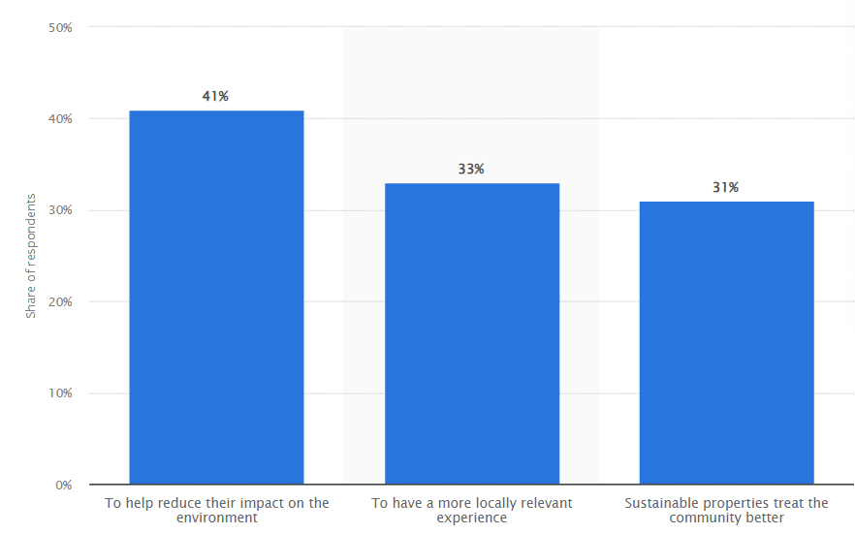
Graph 1. Global travellers are motivated to stay in sustainable accommodation.

Attracting and retaining employees is also an important benefit. Employees prefer to work for companies that value sustainability and social responsibility. Hotels that promote green practices can attract talent more easily and reduce staff turnover. An organisational culture focused on sustainability can improve employee morale and satisfaction, contributing to a more productive and harmonious work environment (Wickham, Donnelly and French, 2021).
Increasing customer loyalty is another key advantage. Guests who enjoy the hotel’s sustainability initiatives are more likely to return and recommend it to others. This improved loyalty can result in increased revenue and a stable consumer base (Edgell, 2020).
Helps to build the local community. Hotels that engage with local suppliers and participate in community projects contribute to the economic and social development of the communities in which they operate. These actions could include using local products, supporting local procedures, and taking part in environmental projects (Jauhari, 2021).

Understanding the changing attitudes of residents towards tourism development in their community, organisations can implement Doxey’s Irridex Model, essential for managing sustainable tourism involving the community for a positive feeling in increasing the number of tourists and mitigating the negative impact (Cheung and Li, 2019).
Integrating sustainability into hotel operations offers multiple benefits that go beyond simply protecting the environment. These benefits include financial savings, improved image and reputation, employee attraction and retention, increased customer loyalty and positive contribution to the local community. Hotels that adopt sustainable practices not only secure a competitive advantage but also contribute to a greener and more sustainable future (Costa and Costa, 2022).

Challenges of Integrating Sustainability

Implementing sustainability in hotel operations has a variety of obstacles that management must carefully navigate. Most significant impediments:
- High upfront cost. Implementing green technology, such as energy-efficient equipment or water management systems, necessitates substantial investment. Although these expenditures can pay off in the long run through savings, the upfront cost can be prohibitively expensive for many hotels, particularly small or independent ones (Cooper, 2021).
- Demand for staff training and education. Employees must be thoroughly trained in the new procedures and equipment for long-term measures to be effective. This requires time and resources, and managers must ensure that all employees understand and support green efforts. It is also important to foster an organisational culture that prioritises sustainability (Haski-Leventhal, 2018).
- Resistance to change. Some employees may be hesitant to accept new methods or use new technologies, and visitors may be inconvenienced by changes in service offerings, such as towel and linen reuse regulations. Effective communication and participation of all stakeholders are required to overcome this resistance (Sloan, Legrand and Chen, 2017).
Managing change in operational processes can be complex and requires careful planning. Implementing sustainability can involve significant changes, from sourcing and waste management to room maintenance and cleanliness. Managers must be prepared to adapt processes and closely monitor the impact of these changes (Wickham, Donnelly and French, 2021).
While incorporating sustainability into hotel operations has several advantages, the inherent obstacles should not be overlooked. Hotels may overcome these challenges with careful planning, continued education, and proper assistance, contributing to a more sustainable future for the hospitality industry (Costa and Costa, 2022).

Future of the Hotels and Hospitality Industry

The hotel industry's future is influenced by global environmental trends and technological advancements. As sustainability awareness rises, hotels must adapt by adopting green technologies, investing in renewable energy sources, and utilizing intelligent energy management systems. (Edgell, 2020).
Technology has a big impact on sustainability. Advanced technologies, such as the Internet of Things (IoT), allow for more effective resource monitoring and management. For example, smart sensors can detect water leaks and automatically modify lighting and temperature in response to the presence of guests. These improvements not only cut resource usage but also enhance the user experience (Sloan, Legrand and Chen, 2017).
Government policies and regulations will play a vital role in promoting hospitality sustainability. Governments can stimulate the adoption of environmentally friendly activities through subsidies, tax breaks, and strict regulations. Also, collaborations between the public and private sectors can help speed up the implementation of sustainability projects while also benefiting the environment and the local economy (Haski-Leventhal, 2018).
The increased demand for sustainable tourism has an ongoing impact on the industry. Guests are becoming increasingly concerned about their impact on the environment and prefer to choose hotels that demonstrate a real commitment to green practices, hotels that highlight their green credentials and sustainability initiatives will have a competitive advantage in an increasingly environmentally concerned market (Cooper, 2021).
Innovations in hotel design and construction will also be critical to the industry's future success. Green buildings, intended to maximise energy efficiency while minimising environmental damage, will become the standard. Sustainable construction materials and green building approaches will be essential for reaching these objectives (Wickham, Donnelly and French, 2021).
After all, the future of the hospitality industry is promising, but challenges remain. Technological innovation and sustainable practices are crucial for long-term success (Costa and Costa, 2022).

Recommendations

- Comprehensive sustainable audits: identifying areas for improvement,
- Educate and engage employees and guests: Organise staff training sessions and guest awareness campaigns on green practices, (Fredericks, 2023).

Conclusion

Integrating sustainability into the hotel industry has numerous advantages, including saving natural resources, lowering operational costs, improving image, and recruiting green clients. However, difficulties such as significant upfront expenses and reluctance to change necessitate a planned strategy, using models like Butler’s and Doxey’s, involving the community and continual staff education can lead to success. Hotels that implement these procedures can help to clean up the environment and ensure the hospitality industry’s long-term viability.

Reference List

Cheung, K. S. and Li, L.-H. (2019) ‘Understanding visitor–resident relations in overtourism: developing resilience for sustainable tourism’, Journal of Sustainable Tourism, 27(8), pp. 1197–1216. doi: 10.1080/09669582.2019.1606815.
Cooper, C. (2021) Essentials of tourism. Third edition. London: SAGE.

Corkill, E. (2024) ‘Efficient Hotels Waste Management: Sustainable Solutions for a Greener Future’ HomeBiogas, 1 March. Available at: https://www.homebiogas.com/blog/hotels-waste-management/ (Accessed: 20 May 2024).

Costa, V. and Costa, C. (2022) Sustainability and Competitiveness in the Hospitality Industry. 1st ed. Hershey: IGI Global.

Edgell, D.L. (2020) Managing sustainable tourism: a legacy for the future. Third edition. New York: Routledge.

Fennell, D.A. and Cooper, C. (2020) Sustainable tourism: principles, contexts, and practices. Bristol; Channel View Publications.

Foundation for Environmental Education (2023a) Green Key. Available at: https://www.greenkey.global/ (Accessed: 19 May 2024).

Foundation for Environmental Education (2023b) About Green Key Our Programme. Available at: https://www.greenkey.global/our-programme (Accessed: 19 May 2024).

Fredericks, L. (2023) ‘Sustainable Hotel Ideas: 25 Ways to Go Green’, Cvent, 24 August. Available at: https://www.cvent.com/en/blog/hospitality/eco-friendly-hotel-ideas (Accessed: 26 May 2024).

Green FINS (2018) Six Senses Laamu Resort is raising the sustainability bar in the industry in partnership with The Reef-World Foundation. Available at: https://greenfins.net/news/six-senses-laamu-partnership/ (Accessed 20 May 2024).

Haski-Leventhal, D. (2018) Strategic corporate social responsibility: tools & theories for responsible management. London: SAGE

Hoshino Resorts REIT (2023) Policy. Sustainability Policy. Available at: https://www.hoshinoresorts-reit.com/en/sustainability/index.html (Accessed: 21 May 2024).

IHG Hotels and Resorts (2024) Carbon and Energy. Available at: https://www.ihgplc.com/en/responsible-business/carbon-and-energy (Accessed: 25 May 2024).

Jauhari, V. (2021) Managing Sustainability in the Hospitality and Tourism Industry: Paradigms and Directions for the Future. 9th ed. Oakville: Apple Academic Press. Inc

Marriott International (2023) 2023 SERVE 360 REPORTS. Environmental, Social, and Governance Progress. Available at: https://serve360.marriott.com/wp-content/uploads/2023/06/Marriott-2023-Serve-360-ESG-Report-accessible.pdf (Accessed: 24 May 2024).

Ngawenja Mzembe, D.A., Idemudia, D.U. and Angel, M.E. (2021) ‘Sustainability led innovations in the hospitality industry: A case study of the adoption of the Green Key Scheme standards in the Netherlands’, Journal of cleaner production, 291, pp. 125210-. Available at: https://doi.org/10.1016/j.jclepro.2020.125210.

Popșa, R.E. (2023) ‘Importance of Sustainability in the Hotel Industry’, Expert Journal of Business and Management. Available at: https://business.expertjournals.com/23446781-1116/ (Accessed: 21 May 2024).

Proximity Hotel (2024) Sustainable Practices at the Proximity Hotel in Greensboro, NC. Available at: https://www.proximityhotel.com/features/sustainable-practices/ (Accessed: 24 May 2024).

Sault, E. (2024) Bournemouth hotel aims for greener stays, 23 Apr. Available at: https://www.bbc.co.uk/news/uk-england-dorset-68875766 (Accessed: 24 May 2024).

Six Senses (2024) Fast track from farm to fork. Available at: https://www.sixsenses.com/en/corporate/news/farm-to-fork/ (Accessed: 25 May 2024).

Sloan, P., Legrand, W., and Chen, J.S. (2017) Sustainability in the hospitality industry: principles of sustainable operations. 3rd ed. London: Butterworth-Heinemann.

Statista (2024a) Reasons global travellers stayed in sustainable lodging at least once last year 2022. Available at: https://www.statista.com/statistics/1339443/reasons-global-travelers-used-sustainable-accommodation/ (Accessed: 25 May 2024).

Statista (2024b) Sustainable tourism worldwide - statistics & facts. Available at: https://www.statista.com/topics/1916/green-tourism/#topicOverview (Accessed: 25 May 2024).

Stories from Hilton (2019) LightStay – A Decade of Managing our Environmental and Social Impact. Available at: https://stories.hilton.com/hilton-history/lightstay-a-decade-of-managing-our-environmental-and-social-impact (Accessed: 25 May 2024).

Svart (2024) Hotel Svart. Available at: https://svart.no/hei-verden/ (Accessed: 25 May 2024).

Wickham, Donnelly, T., and French, L. (2021) Strategic Sustainability Management in the Event Sector. Event Management, 25(3), 279-296.

Appendix 1 Green Key and the Sustainable Development Goals

Green Key is a leading standard of excellence in sustainable tourism, assisting tourism establishments to achieve the United Nations' 17 Sustainable Development Goals.

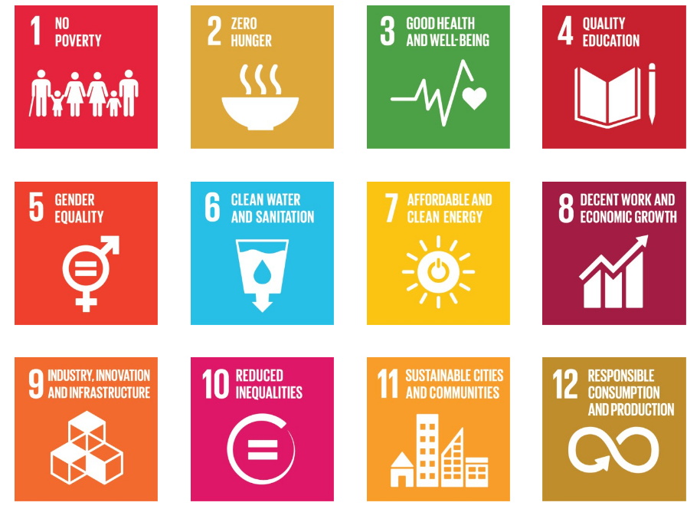
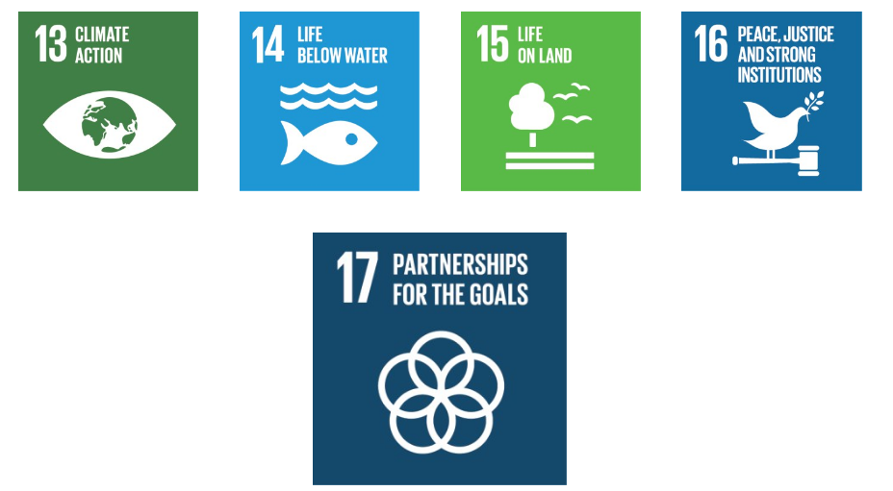
(Foundation for Environmental Education, 2023a).

Appendix 2 Ecological certifications

Hotel | Ecological Certification | Specific Measures Adopted | Obtained Results
Six Senses Laamu, Maldive  (Foundation, 2018) | Green Globe | - Solar panels  - Recycling programs  - Using local and organic food | - Reduction of energy consumption by 20%  - Reduction of food waste by 50%  - Improving the perception of the brand as eco-friendly
The Green House, Bournemouth, UK  (Sault, 2024) | Green Key | - Use of renewable energy  - Water management systems  - Ecological cleaning products | - Reduction of energy consumption by 31%  - Saving 732,000 liters of water per year  - National recognition for sustainability initiatives
Proximity Hotel, Greensboro, USA  (Proximity Hotel, 2024) | LEED Platinum | - Energy efficient windows  - Solar panels for hot water  - Residual heat recycling system | - Reduction of energy consumption by 39%  - 30% savings on the water bill  - The first LEED Platinum certified hotel in the USA
Hoshinoya Karuizawa, Japan  (Hoshino Resorts, 2023) | ISO 14001 | - Small hydropower plants  - Waste management systems  - Employee education programs | - Energy autonomy of 70%  - Reduction of CO2 emissions by 90%  - Increasing employee and customer satisfaction
Svart, Norway  (Svart, 2024) | The Futurebuild Nordic Swan Ecolabel | - Construction based on sustainable wood  - 85% higher energy efficiency  - Water and waste recycling | - Zero carbon emissions  - Energy consumption reduced by 85% compared to conventional hotels  - Model for future sustainable constructions

Appendix 3 Butler’s Model Tourism Area Life Cycle (TALC)
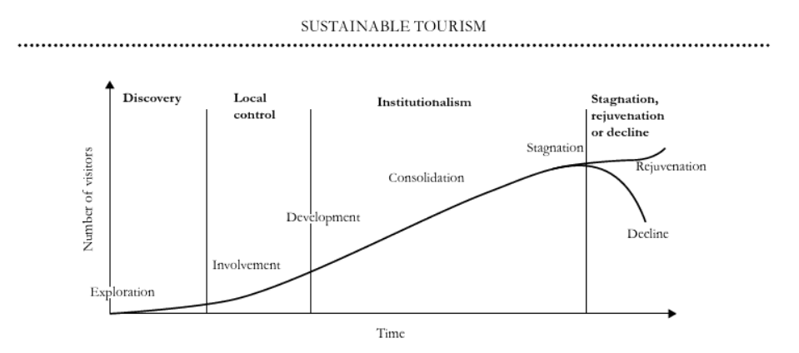
The Butler Model provides a useful framework for understanding and managing the lifecycle of tourist destinations. By integrating sustainable practices at each stage of development, destinations can achieve long-term viability, avoid over-tourism, and ensure that tourism benefits both the environment and local communities. Using this model, stakeholders can strategically plan and implement sustainable tourism practices to foster a balanced and thriving tourism sector. Factors like government policy, market trends, access, competition, and the rate of tourism, each of these factors has the potential to slow or speed up the progression through the stages. Indeed, construction can be paused at any point in the cycle, and only tourist developments that promise significant financial returns will mature and go through the entire cycle. As a result, the length of each stage, as well as the entire cycle, varies (Fennell and Cooper, 2020, p. 168).

