Assignment 2

Task A

A production area in a factory measures 60 metres x 24 metres x 8 metres in height.
The factory’s work benches are set at a height of 1m above the floor level.
The area’s reflectance’s are 0.3 for the ceiling and 0.5 for the walls.
The Lighting design specifies Fluorescent lamps in recessed louvre with DLOR of 50%.
(The actual size for the luminaires is 1200mm (1.2m) in length and 200mm (0.2m) wide.)

A Lighting Design Lumen (LDL) output of 18,000 lumens is required.

The illumination required for the factory area is 200 lux at the working plane.
Light Loss Factor = 0.75

1: Calculate:

1) The Room Index
2) The Utilisation Factor (from tables)
3) The Number of lamps required
4) A suitable layout (value of S) for the lamp fittings

- RI = L x W / Hm x (L+W)

RI = Room Index
L = Length of room
W = Width of room
Hm = Height of the luminaire measured from the working plane

Length = 60 metres
Width = 24 metres
Hm = 8 – 1.2 – 1 = 5.8 metres

Subsituting values

60 x 24 / (8 – 1.2 – 1) x (60 + 24)

1440 / 5.8 x 84

1440 / 487.20

2.9556

RI = 3

2) Utilization factor from using tables is 0.47

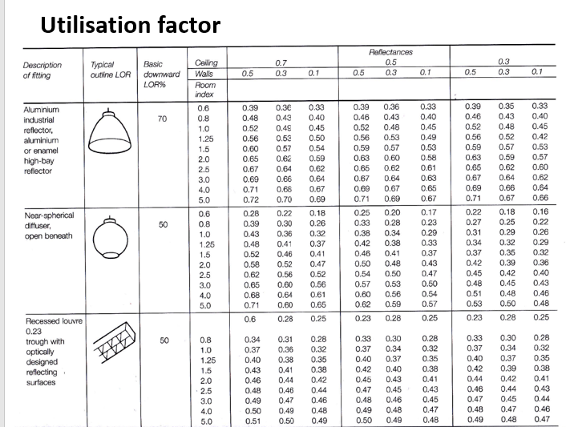

- N = E x A / F x UF x LLF

N = Number of lamps required
E = 200 LUX
A = 60m x 24m = 1440m
F = 18000
UF = 0.47
LLF = 0.75

200 x (60 x 24) / 18000 x 0.47 x 0.75

200 x 1440 / 6345

288000 / 6345

45.39007

Number of lamps required = 46

4) S max = 1.5 x Hm

1.5m x 5.8m

= 8.7 meters apart

My suggested layout is 2 rows of 15 lamps and 1 row of 16

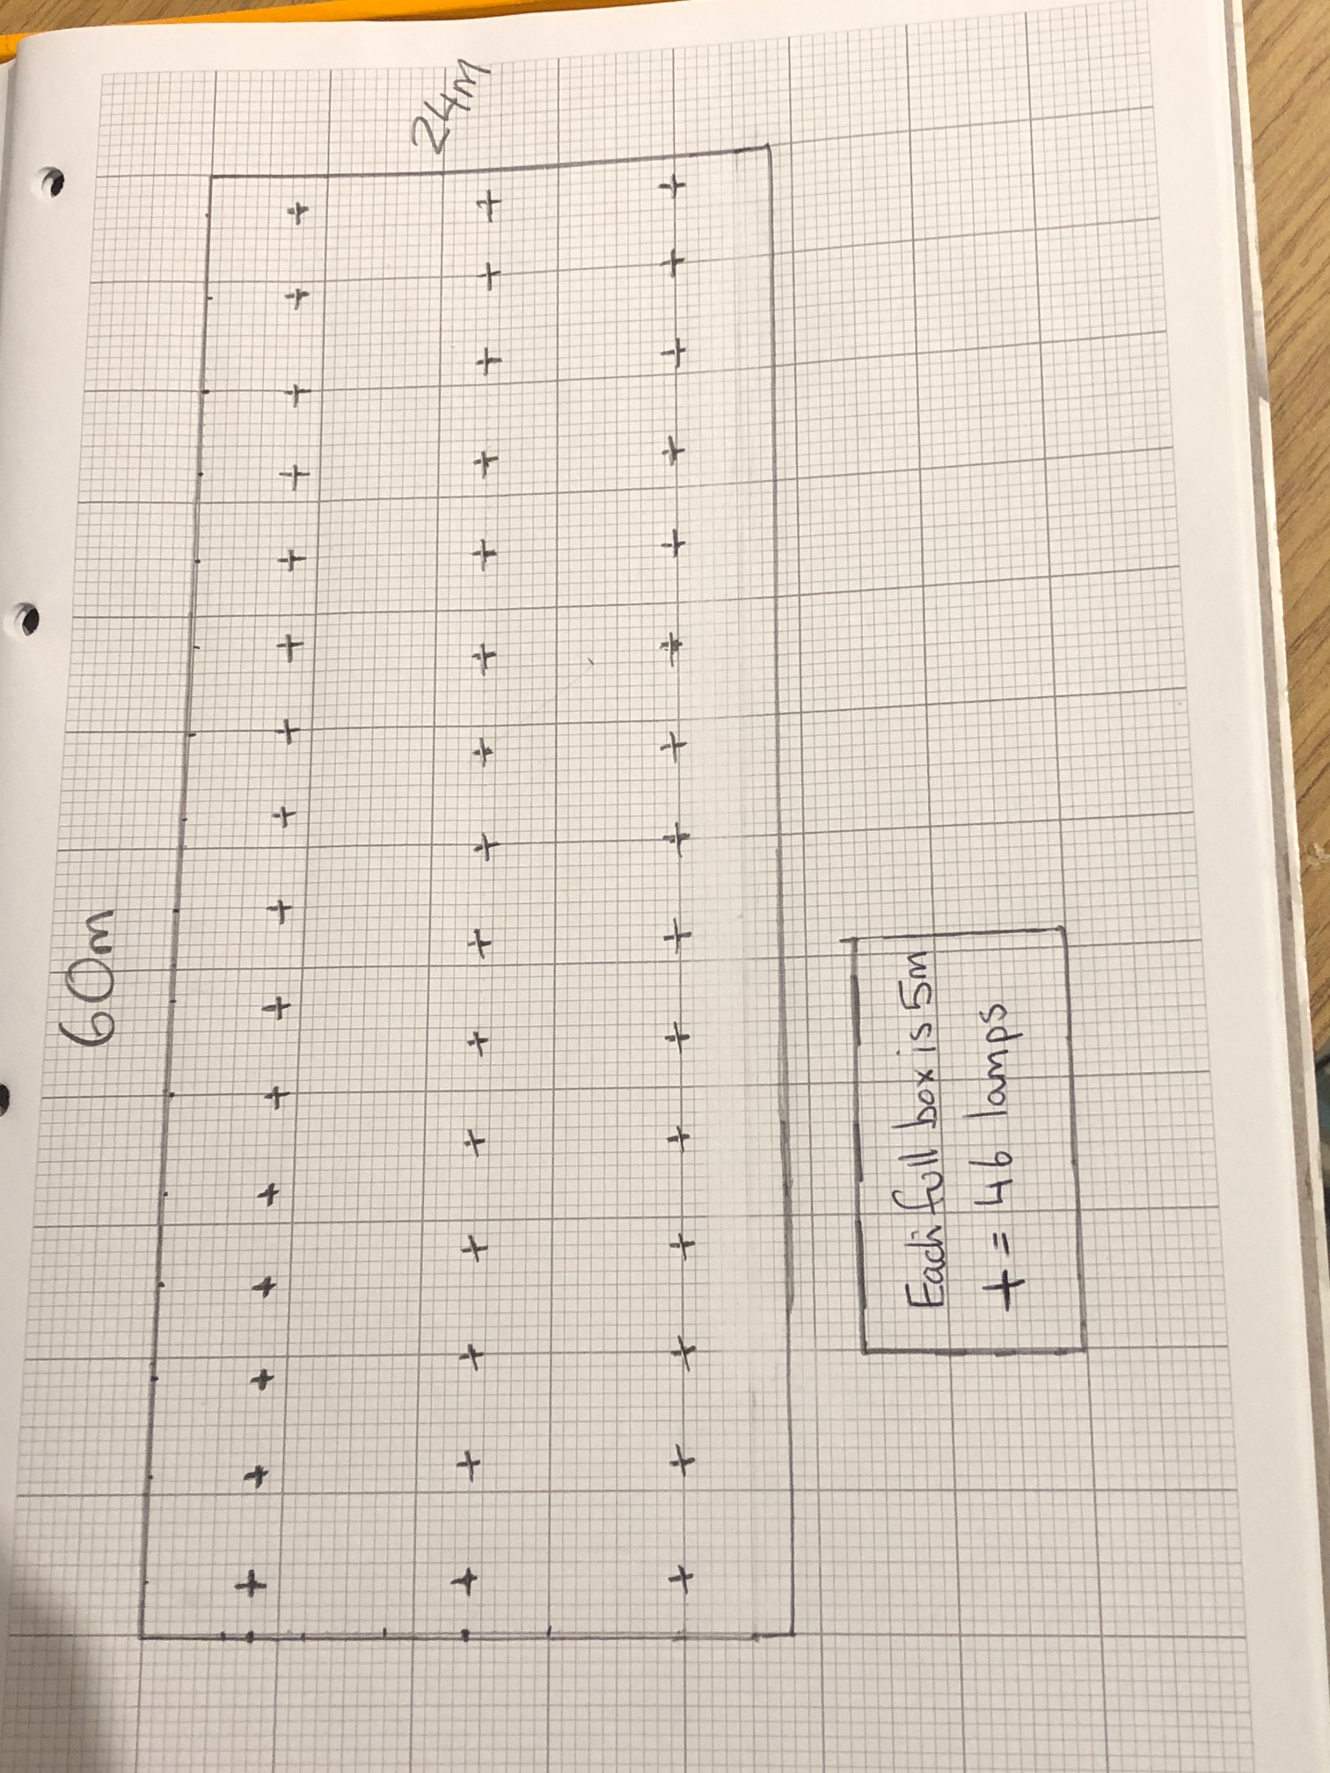

An example of efficient lighting is where reasonable provision should be made to enable effective control and/or use of efficient lamps such that:
- Either, lamp capacity does not exceed 150 Watts per light fitting and the lighting automatically switches off when there is enough daylight and when it is not required at night;
- or the lighting fittings have sockets that can only be used with lamps having an efficacy greater than 40 lumens per circuit-Watt.
Please see Approved Document L1B in the main Building Regulations section of this site for further guidance.
https://www.planningportal.co.uk/info/200130/common_projects/35/lighting/2

Part B

1. A brick wall of area 20m2 contains a window of area 4m2.

The values of sound reduction indexes are:
50dB for the brickwork and 10dB for the window.
Calculate the overall sound reduction index for the entire wall.

The Brickwork – a1 = 20 – 4 = 16m2 SRI = 50db
The Window – a2 = 4m2 SRI = 10db

SRI formula = 10 x (log 10 (1/T))

Brick

50= 10 x (log₁₀ (/t₁))
5 = log₁₀ x (1/t₁)
1/t₁ = 10⁵
T₁ ₌ ₁₀ ⁻⁵
T₁ ₌ 0.000010

Window

10= 10 x (log10 (/t₂))
1 = log10 x (1/t₂)
1/t₂ = 10¹
T₂ = 10¹
T₂ = 0.10

T = (T₁ x A₁) + (T₂ x A₂) / A₁ + A₂
= (10⁻⁵ x 16) + (10 ⁻¹ x 4) / 16 + 4
= 0.00016 + 0.4 / 20
= 0.020008

SRI = 10 x (log₁₀ ( 1/T))
SRI = 10 x (log₁₀ ( 1/0.020008))
SRI= 10 x (log₁₀ ( 49.980007))
SRI = 10 X 1.69
SRI = 17 Db

B) 2. Discuss the implications of frequency and wavelength in internal sound management,
partition wall construction technique and insulation choice. (500 words)

Sound is any pressure vibration that a human ear can pick up. The frequency is the number of vibrations per second. This is related to the period in units or hertz. The human ear can detect different types of sounds from physical moving objects such as a speaker and also moving air like jet engines. The issue we have with sound is making it a comfortable frequency for the human as too much can harm the human body. It is measured in decibels. A average human conversation is around 20, 000 decibels which is a healthy level of decibels. The frequency of sound can either be high pitched or low. The low frequency sound is more annoying to the human comfort level. The human ear has 3 different parts which have different jobs for your brain to process. The outer ear collects the sound waves. The middle ear which passes the vibrations. The inner ear carries electrical impulses to the brain. Each object that creates noise gives off different wavelength. A wave length is the horizontal length of one cycle of the wave.
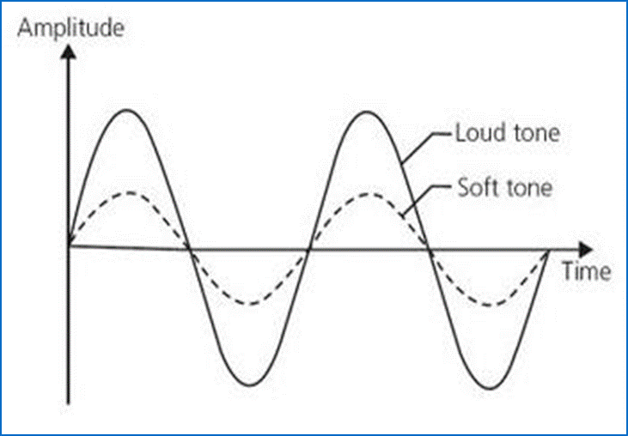
Loud wavelength compared to a soft one.
When sound becomes too loud and unwanted it becomes noise. This can really effect the human body with increase in blood pressure, stress, breathing rate, upset stomach etc. It is important that the human body is protected especially when living in a household. For example noise can be heavy machinery and natural components such as wind. There will always be background sound in day to day life in households and work place. It is about finding how much is ok to live with and how to combat it.

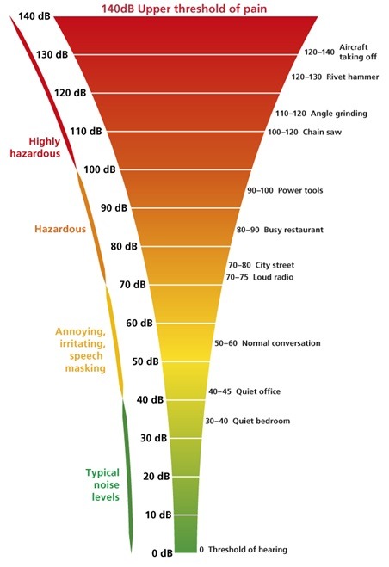
This graph shows different sounds and the rate at which their sound effects the human.

Large rooms can have issues with reflective sound which is also knows as a echo. Where the wave length travels for up to 17m longer than a normal wave. This can be counteracted by curved reflectors and plane reflectors. A major part of a construction is to ensure the wall absorbs sound to muffle the effect. Sound absorption is a reduction in sound energy after reflection from surface. There are many different materials that have different coefficients and these materials varies the frequency of sound.

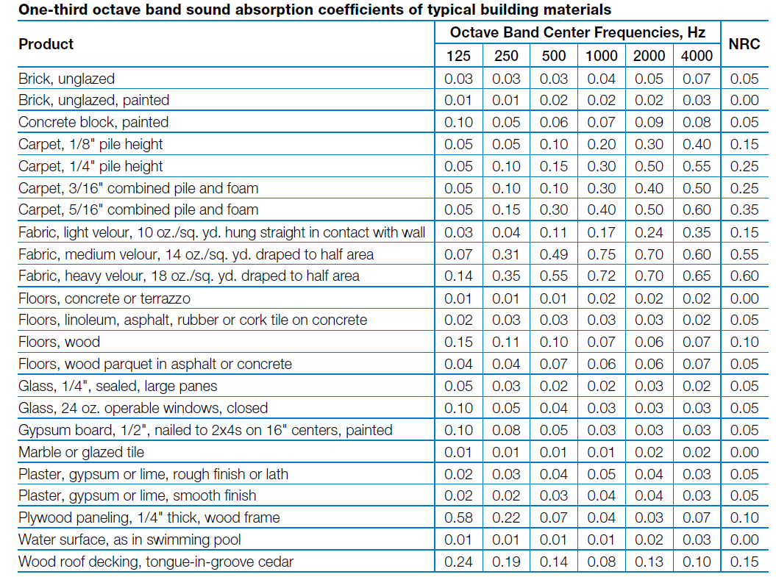
Material absorption chart to sound ratio.
If building a house my recommendation for a wall construction would be to have some sort of absorber within the wall this could be porous absorber for high frequency, panel absorber for low and finally cavity absorber for specific frequency. My personal preference would be to use a panel absorber which is constructed from fixed sheets with continuous space behind. The panels absorb the sound energy and convert to mechanical vibrations.
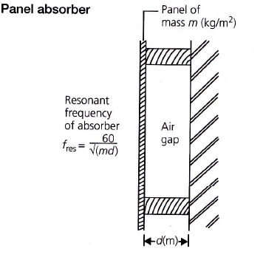

Panel absorber.
Another method used are damping materials. These transmit huge amounts of the sound energy through it. Sound insulation is a major factor when constructing a wall to sound proof the building to the best of its ability. Preventing the airborne sound with insulation will be the best way, you can do this by using acoustic foam within the walls. These boards are good at absorbing annoying sounds and mid to high frequent ones. They are the same type of boards you will find in classrooms and offices.

Pre-Completion Testing
Part E states that 10% of all units constructed on a project must be pre-completion sound tested (PCT) on site. The separating walls and floors within each unit must be tested to show compliance. This applies to rooms used for residential purposes, houses and flats generated by the conversion of other buildings and new build houses and flats. The separating walls between flats and the communal areas do not require a sound test
The required insulation values are set out in the tables and apply to rooms that are completed but not furnished or occupied and that also separate spaces used for domestic purposes.
An accredited acoustician (ANC, UKAS) must carry out the tests to show compliance with the relevant performance standards in accordance with:
BS EN ISO 140-4: 1998 (airborne)
BS EN ISO 140-7: 1998 (impact)
https://soundproofyourhome.com/building-regulations/

