
Applied Industrial Placement (SPORT)
M5X02295
Theo Wortelhock

Student Name
Name – Theo Wortelhock
P Number – 148430
Report
Title – PGL Placement
Word Count –3551
References (Total) – 7
Job Title – Activity Instructor/Group leader
Organisation
Name – PGL
Address – PGL Barton Hall
Kingskerwell Road
Torquay
Devon
TQ2 8JY
Email – Daniel.harrop@pgl.co.uk\

Telephone Number – 01803321426
Line Manager
Name – Daniel Harrop
Position – Team Leader
Email – Daniel.harrop@pgl.co.uk

Telephone Number – 01803321426

TASK A – (Reflective Learning Log 1 - 500 words – First Experience of Placement)
Recommend to link the reflective experience to two different key themes.
Training

Training is a great opportunity to increase the knowledge of employees. An employee who receives the necessary training is able to perform their job better. They become more aware of the safety procedures for all tasks needed for the job. The training may also build the employee's confidence because they will have a stronger understanding of the industry and the responsibilities of their job. This confidence may push them to perform even better and think of new ideas that help them do well. Constant training also keeps the employees up to date with industry developments. The more informed employees who are and on top of changing industry standards help a company stay on top as a leader and strong competitor within the industry.

I will be using the Gibbs reflective cycle (Gibbs, 1988) to reflect on my experiences at PGL. Firstly, I went to do five days of training in Swindon at one of the bigger centres that PGL have, called Liddington. I was trained how to teach archery, problem solving, and first aid. These are only qualifications recognised by PGL, therefore are not applicable outside of this organisation. I was originally very nervous when I started but during the training there were lots of other people going to different centres across the UK, France and Spain. All of whom were really nice and created a nice vibe whilst training was going on. Therefore, I felt relaxed and managed to create and maintain some good friendships with other colleagues including some that came to work at Barton Hall with me.

The positives from the training week at Liddington were that the training was very thorough in how much detail we were given regarding how to approach our role. Also, the training course was very fun and enjoyable as myself and the other employees were treated as if we were guests and therefore we took part in lots of different activities such as evening entertainments, archery and problem solving. I felt that there were few negatives from the training course however there was a lot of information to take in in a very short period of time. Also, we didn’t get put in groups of employees that were going to be together in each centre, so it was hard to find people that were going to work at the same centre, so when I got to the centre I didn’t know everyone that came down from the training course.

First Impressions Of PGL

The first impressions of Barton hall, my placement, is that it is a relatively small centre compared to others, but it is good because it is easier to get to know all the staff and therefore being able to form friendships whilst at PGL. Also, because you tend to teach each group more than once throughout their stay as there are not as many here compared to many other centres, which in turn allows you to get to know the groups better and create a good rapport with them.

TASK A – (Reflective Learning Log 2 - 500 words – Mid Point Experience)
Recommend linking the reflective experience to two different key themes.
History of PGL

PGL is the UK’s leading outdoor education provider, delivering inspirational learning through adventure. The story behind how PGL started is that the name PGL stands for Peter Gordan Lawrence, who was the founder of the company. After leaving Engineering college, Peter Lawrence embarked on his first canoeing holiday down the River Danube in 1955. As he journeyed down the river, taking in the breath-taking landscape along the way, he was inspired by his passion for the outdoors and wanted to share his experience to enrich the lives of others. In 1957, he started leading similar canoe trips back on home turf along the River Wye, for small groups of young adults. A different stretch of the river was tackled each day, making camp under the stars on the riverbank every night and striking tent in the morning to paddle onwards. Peter called this new venture ‘PGL Voyages’ and over a 60-year period, it has grown into the company known today as PGL Travel Ltd (PGL 2018). Nowadays it is also known as being called parents get lost by the children who attend.

Activities

Once I was at Barton hall, I was asked to start my training for other activities straight away. The first activity I was trained in was called “Ground up one” this qualifies me in trapeze and climbing. However, when teaching ground up one climbing, I am only able to teach one rope at a time. Trapeze only uses one rope at a time anyway as well. I was given 12 hours of training over two days then there is an external assessment that needs to be passed on the following day. This included learning how to belay and also how to get the guest up and down safely. I also had to learn how to teach the guests how to belay in order to include as many people in the group as possible at any one time. There is also another job which is called the back-up belay where another guest is involved by just holding the excess rope in case the belayer was to let go. This process is the same for trapeze and climbing. I am also now trained in “Ground up two” which means that I can teach the same activities and a few extra ones such as Jacobs Ladder and Vertical Challenge that require two or more ropes to be watched at any one time. Furthermore, there are plenty of other activities that are being taught at PGL. Depending on the centre, depends on which activities are available to the guests. There are however a few activities that are the same across all centres. Other activities include archery, problem solving, sensory trail, team games, buggy build, mountain biking, swimming, zip wire, abseiling, Jacobs ladder, vertical challenge, all aboard, High ropes, low ropes, challenge course, quad biking, fencing, orienteering, raft building, kayaking, excursions, airoball, and rifle shooting. I’m sure there are a few more but these are the majority of the other activities. PGL trains all instructors in a number of these activities when they get to centre. The ropes activities that include, climbing, vertical challenge, all aboard, trapeze, Jacobs ladder and abseiling require an external assessor to come to the centre and assess the instructors on a pass/ fail basis. If they pass they then start teaching groups in that activity and are observed by team leaders for the first session that they teach. For all the other activities that don’t require a rope or a harness, there is an on-site induction on how to teach a session in that activity and then the first session that is taught is observed and the instructor is given feedback.

TASK A – (Reflective Learning Log 3 - 500 words – Mid Point Experience)
Recommend linking the reflective experience to two different key themes.
Safety
Safety is one of the most important things that PGL believe in. As before anything else comes the safety of the guests. My job throughout my time at PGL is to make sure the guests have fun and enjoy their time but also, that they remain safe when taking part in activities. That requires, multiple safety procedures in the activities to ensure that they are carried out safely to make sure no one is going to get hurt or injured. My job is to check that all safety equipment is secured to the guest properly and appropriately. Also, that they understand not to touch any of the safety mechanisms that they might have on. I also do a safety talk before each session so that all the kids understand the risks and where they shouldn’t go so that they stay safe. From PGL’s point of view they have always placed a huge emphasis on safety – as a founder member of BAPA (British Activity Providers Association) and a licence holder for activities in scope of AALA (Adventure Activities Licencing Authority) regulations. Canoeing at all their centres is approved by the BCU (British Canoe Union) and all their sailing centres are recognised RYA (Royal Yachting Association) teaching establishments. They have always been pioneers of a safe approach to outdoor education. At the same time, they acknowledge that risk is part of life and so we try to help ensure that children understand the concept of risk benefit, so that they can learn to remain safe whilst still being able to live life to the full (PGL 2018). This is what PGL say regarding the different licences that they hold to ensure that they are able to train instructors in different activities under PGL only.
Management Structure
PGL use the traditional hierarchical structure as their management structure. The traditional hierarchical model arranges individuals within the organization according to power. At the very top level, the organization has a board of directors followed by the chief executive officer. In some organizations, the CEO also serves as the chairman of the board of directors and the president of the organization. Under the CEO, the organization has other executives including the chief financial officer, the chief information officer and the chief operating officer. This level of executives typically has upper management under them including vice presidents, managers and directors. Depending on the size of the organization, department heads usually follow upper management followed by regular employees whose levels are categorized according to experience and authority (Brian Bass 2018). This works well for PGL because it is a big company it means that the lines of communication between centres is easier and also it brings managers and employees closer together which gives a more relaxed but professional feel. From my point of view this was only relevant to me when I had to speak to senior members of staff about different matters on the job and also when I found out that I would be assigned a line manager to help support me with my time at PGL.

TASK A – (Reflective Learning Log 4 - 500 words – Near end of Experience)
Recommend linking the reflective experience to two different key themes.
Hospitality
At Barton hall there are several different jobs that come under the bracket of hospitality. Firstly, the whole team of staff members are there to welcome guests and make them feel comfortable when staying. Secondly, there is the catering team, they cook breakfast, lunch and supper for all staff and guests that come through the centre. Sometimes a lunch or supper time serving can be up to 700 people. This is a big part of life at Barton hall, and I admire the hard work that goes into making sure that every food need is catered for and that everyone is able to enjoy the food. Hospitality can be described as the act of being friendly and welcoming to guests and visitors (Cambridge University 2018). Furthermore, there is another department that is crucial to the day to day servicing of Barton hall. That is the maintenance team. They have such an important role because they make sure everything is kept to a high standard and is looking nice for when guests arrive.

Retail and Marketing

Marketing is an organizational function and a set of processes for creating, communicating, and delivering value to customers and for managing customer relationships in ways that benefit the organization and its stakeholders (PHILIP KOTLER & KEVIN LANE KELLER 2006). This is also a key area of Barton hall and PGL in general. Although lots of business for PGL comes from word of mouth and a good reputation, the amount of marketing and advertising that is done is immense. I personally found out about PGL through a talk that was done at university by one of the recruitment team. It is clear that they take recruitment and advertising very seriously to make sure they get the best staff but also, so they can attract more guests.

Retail is another part of Barton hall as they make a secondary income from the site shop and bar, which I imagine to be quite profitable due to the popularity of the bar every evening and also when the school kids visit the shop everyday too. The bar is a place where mainly the staff hang out in the evenings when all work is done. But sometimes the guest teachers or parents come in to have a drink or two too. Most importantly the retail department provides guest some time to chill out and get some energy back from all the activities they have been doing.

TASK A – (Add 250 words on link to future Continued Professional Development and Reference list based on total referenced material in Task A)
Continued Professional Development post placement (250 words - Link to pre-placement module)
CPD stands for Continuing Professional Development. It refers to the process of tracking and documenting the skills, knowledge and experience that you gain both formally and informally as you work, beyond any initial training. It's a record of what you experience, learn and then apply. The term is generally used to mean a physical folder or portfolio documenting your development as a professional (Melanie Allen 2009). Therefore, I have enjoyed documenting my time at PGL and look forward to seeing where it could take me in the future.

My experience with PGL has been a very positive one as I have had so many new experiences at a great centre with great people. I believe that PGL is definitely an option for work in the future for me because I really enjoyed the atmosphere of the place and also it is a lot of fun and brings great satisfaction when the group you are teaching enjoy the session too. However, I would like to explore other areas of the industry such as sports marketing industry and see where things go from there. But I did definitely enjoy my time at PGL and would consider a job in it later in life.

References from TASK A (10+ references)
- Peter Lia (2016) Using Gibbs’ Reflective Cycle, Available at: https://www.kcl.ac.uk/campuslife/services/disability/onlineresources/StudyGuides/USING-GIBBS-REFLECTIVE-CYCLE-IN-COURSEWORK-DEC-2016-P-LIA.pdf (Accessed: 25th July 2018).
- PGL (2018) About PGL, Available at: https://www.pgl.co.uk/en-gb/about-us (Accessed: 25th July 2018).
- PGL (2018) Safety Operating standards, Available at: https://www.pgl.co.uk/en-gb/about-us/how-we-operate/safe-operating-standards (Accessed: 25th July 2018).
- Brian Bass (2018) The Traditional Hierarchy Business Model, Available at: https://smallbusiness.chron.com/traditional-hierarchy-business-model-20784.html(Accessed: 25th July 2018).
- Cambridge University (2018) Hospitality, Available at: https://dictionary.cambridge.org/dictionary/english/hospitality (Accessed: 25th July 2018).

- PHILIP KOTLER & KEVIN LANE KELLER (2006) Marketing Management, Available at: https://www.researchgate.net/profile/Philip_Kotler/publication/225084026_ Marketing_Management/links/5509bd450cf26198a63994d8/Marketing-Management.pdf (Accessed: 26th July 2018).

- Melanie Allen (2009) What is Continuing Professional Development, Available at: https://www.jobs.ac.uk/careers-advice/managing-your-career/1318/what-is-continuing-professional-development-cpd (Accessed: 26th July 2018).

TASK B – (Picture Board – 5 pics (40MB upload limit to Turnitin) (Experience, Roles, Improvements)
Picture | Text (Paragraph)
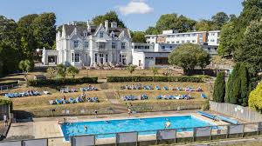 | In this picture, this is showing the main areas on site at Barton Hall which is the main house where the dining hall is and also guest accommodation, the bar and the main office too. In the back ground of the picture is more guest accommodation as well. Below the main house is the pool where swimming sessions take place and also where the staff can swim in at certain times.
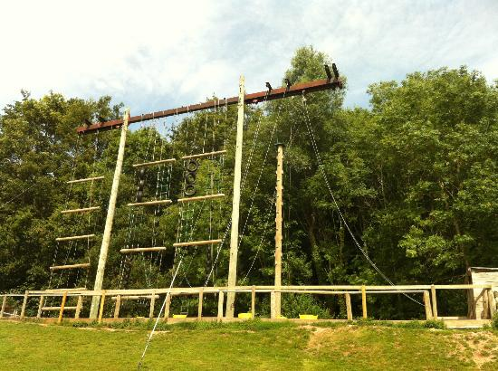 | In this picture this is showing the only T bar on centre, where three different activities take place. This picture is an old photo as due to safeguarding reasons I wasn’t allowed to take photos on site. However, the only difference in this photo to now is that there are now two Jacobs ladders on the left and the right sides and in the middle is two vertical challenge ladders. Both of these activities I am qualified at PGL to teach.
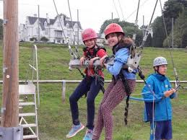 | This activity is called the giant swing. This is where the instructor gets the rest of the group to pull two people up as high as they can on a swing in harnesses, then they get the two on the swing to pull a rope which lets them go down and swing really quickly. Again, this is a picture I got off the internet as I wasn’t allowed to take photos of children due to safe guarding.
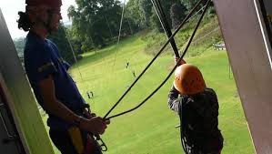 | This is the zip wire at Barton. It is the only zip wire at PGL that goes out of a brick building out of doors. There are two different types zip wire one is for anyone under 14 stone and the other one is for any up to 16 stone. The main difference is that the wire is a lot thicker. Made up of multiple wires.
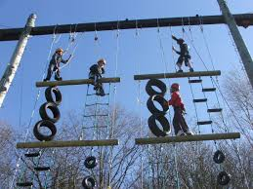 | This picture shows kids taking part in the vertical challenge activity where they have to climb up as far as they can up different obstacles on the way, such as tyres, ladders and sometimes can be a section of climbing wall too.

TASK B – (Picture Board Cont.–5 pics (40MB upload limit to Turnitin) (Experience, Roles, Improvements)
Picture | Text (Paragraph)
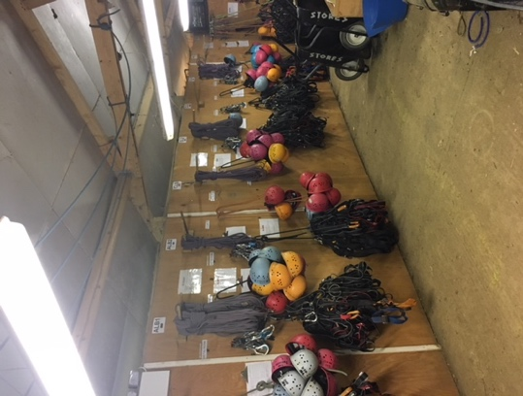 | This is the store shed where all the equipment is kept for every activity at PGL everything from helmets for any climbing activity to bow and arrows for archery. This store shed was at the centre in Lincoln called caythorpe where I was a loan member of staff for two weeks. Which I really enjoyed.
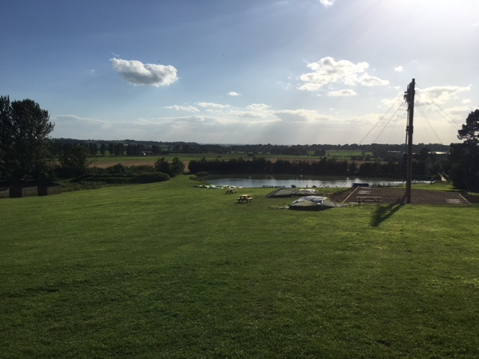 | Due to not being able to take photos whilst I was on session, I managed to take a picture of an activity base that I taught at for several sessions at caythorpe where I taught, vertical challenge and trapeze. Also, in the picture is a lake where kayaking takes place. However, I wasn’t qualified to teach it as you had to do a separate course.
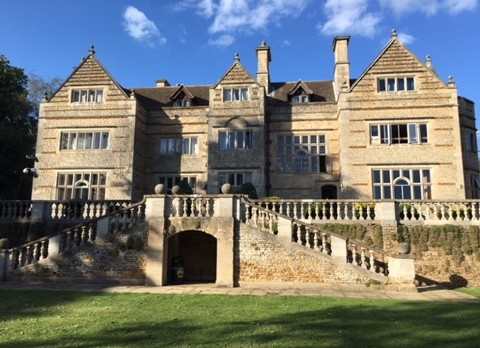 | This picture is of the main staff accommodation at caythorpe which I think is absolutely beautiful to look at from the outside. This holds most of the staff at PGL and also some of the guest and teachers too. On separate floors obviously.
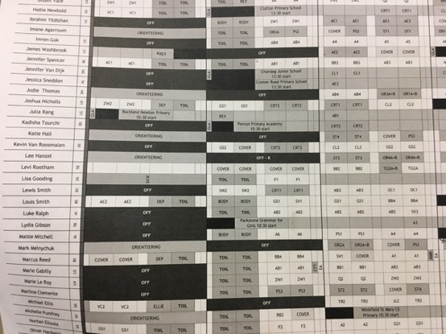 | This image shows the rota that we had to check every day in order to know what activities we were meant to teach for the next day. I would have to check the activity, then on a different sheet there would be a list of all the schools and I had to try and find the school that I was teaching then match them to the zone I was meant to collect them from. As each school has a number of different groups so I would have to work out which group was allocated to me as well.
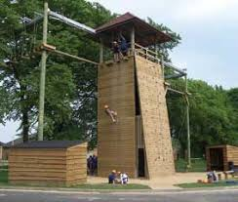 | This Image is of one of the 3 towers at caythorpe, where there are several different activities taking place. It has two different climbing walls, two abseiling walls and an activity called high ropes going around in a square at the top. I was qualified to only teach climbing on this base, but it was interesting to see what other activities were doing at the same time.

TASK C Evidence – Employer Report (Signed),
NOTE – This will be compared against the report sent to the University.
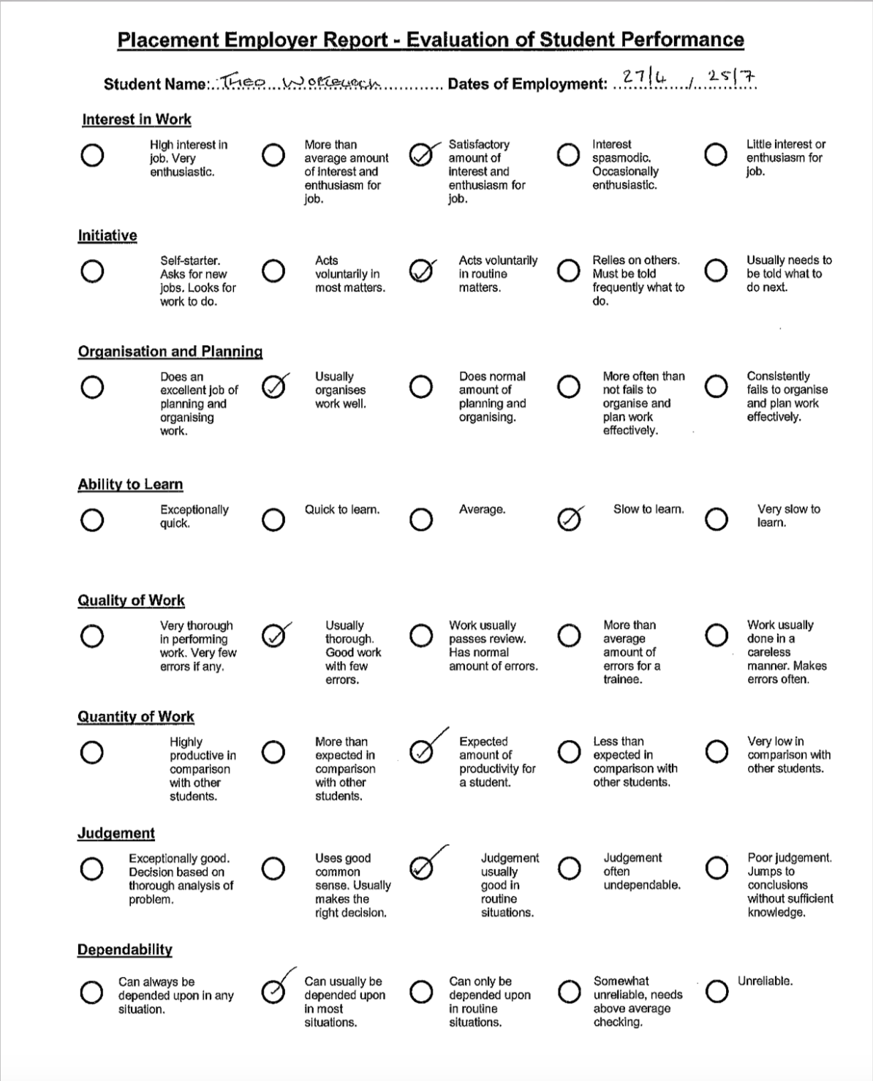

TASK C Continued Evidence – Employer Report (Signed),
NOTE – This will be compared against the report sent to the University.
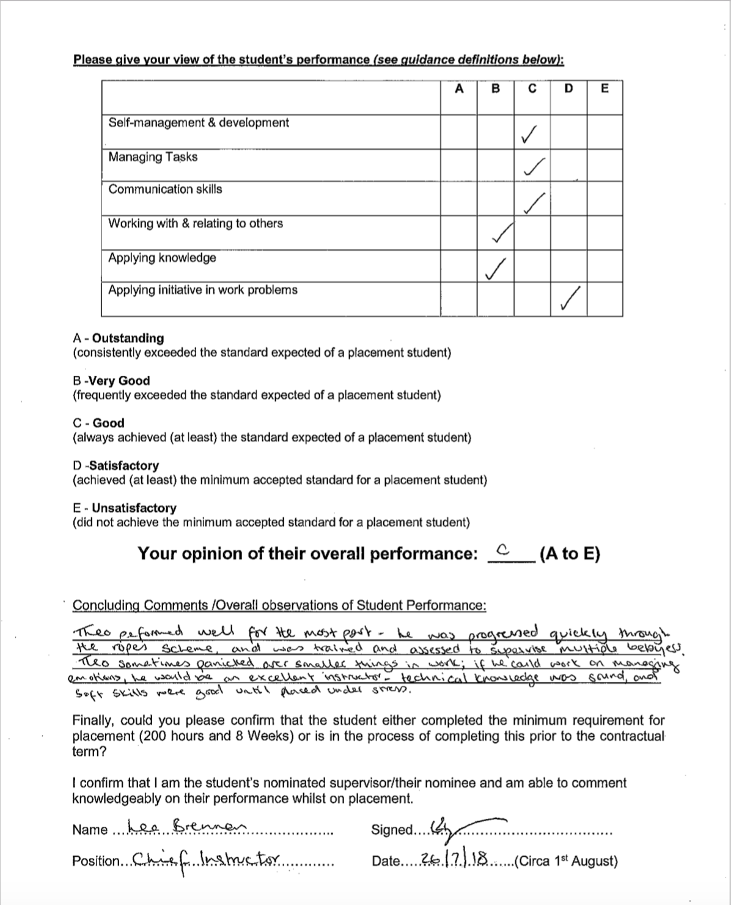

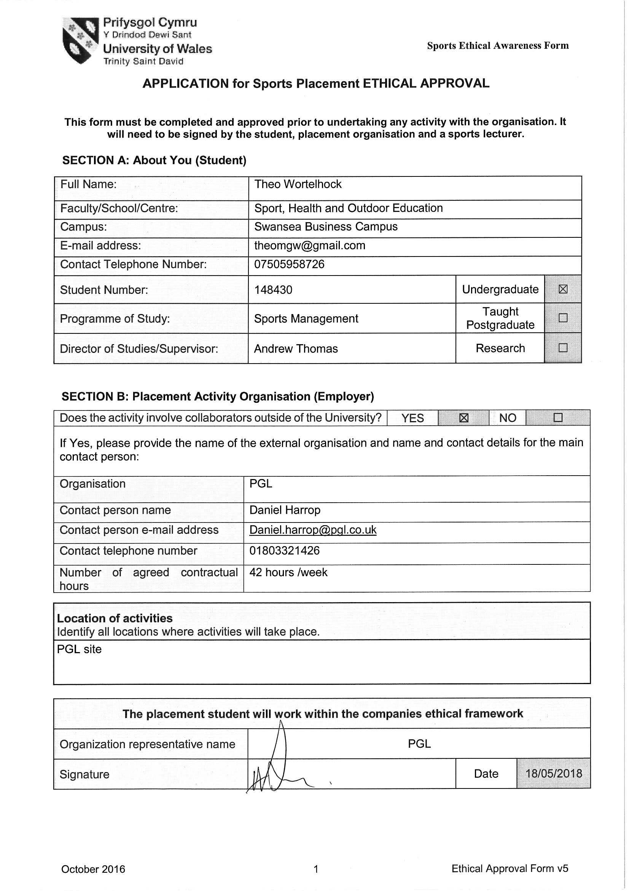TASK C Evidence – Ethics Form – Signed by Organisation and Lecturer

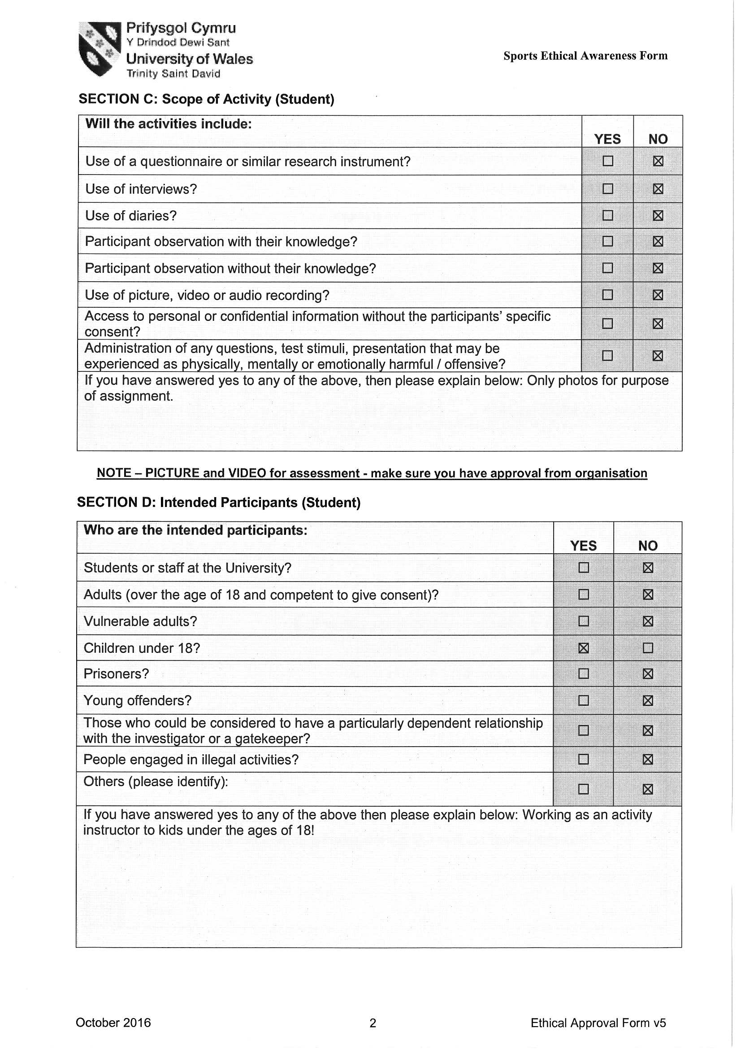
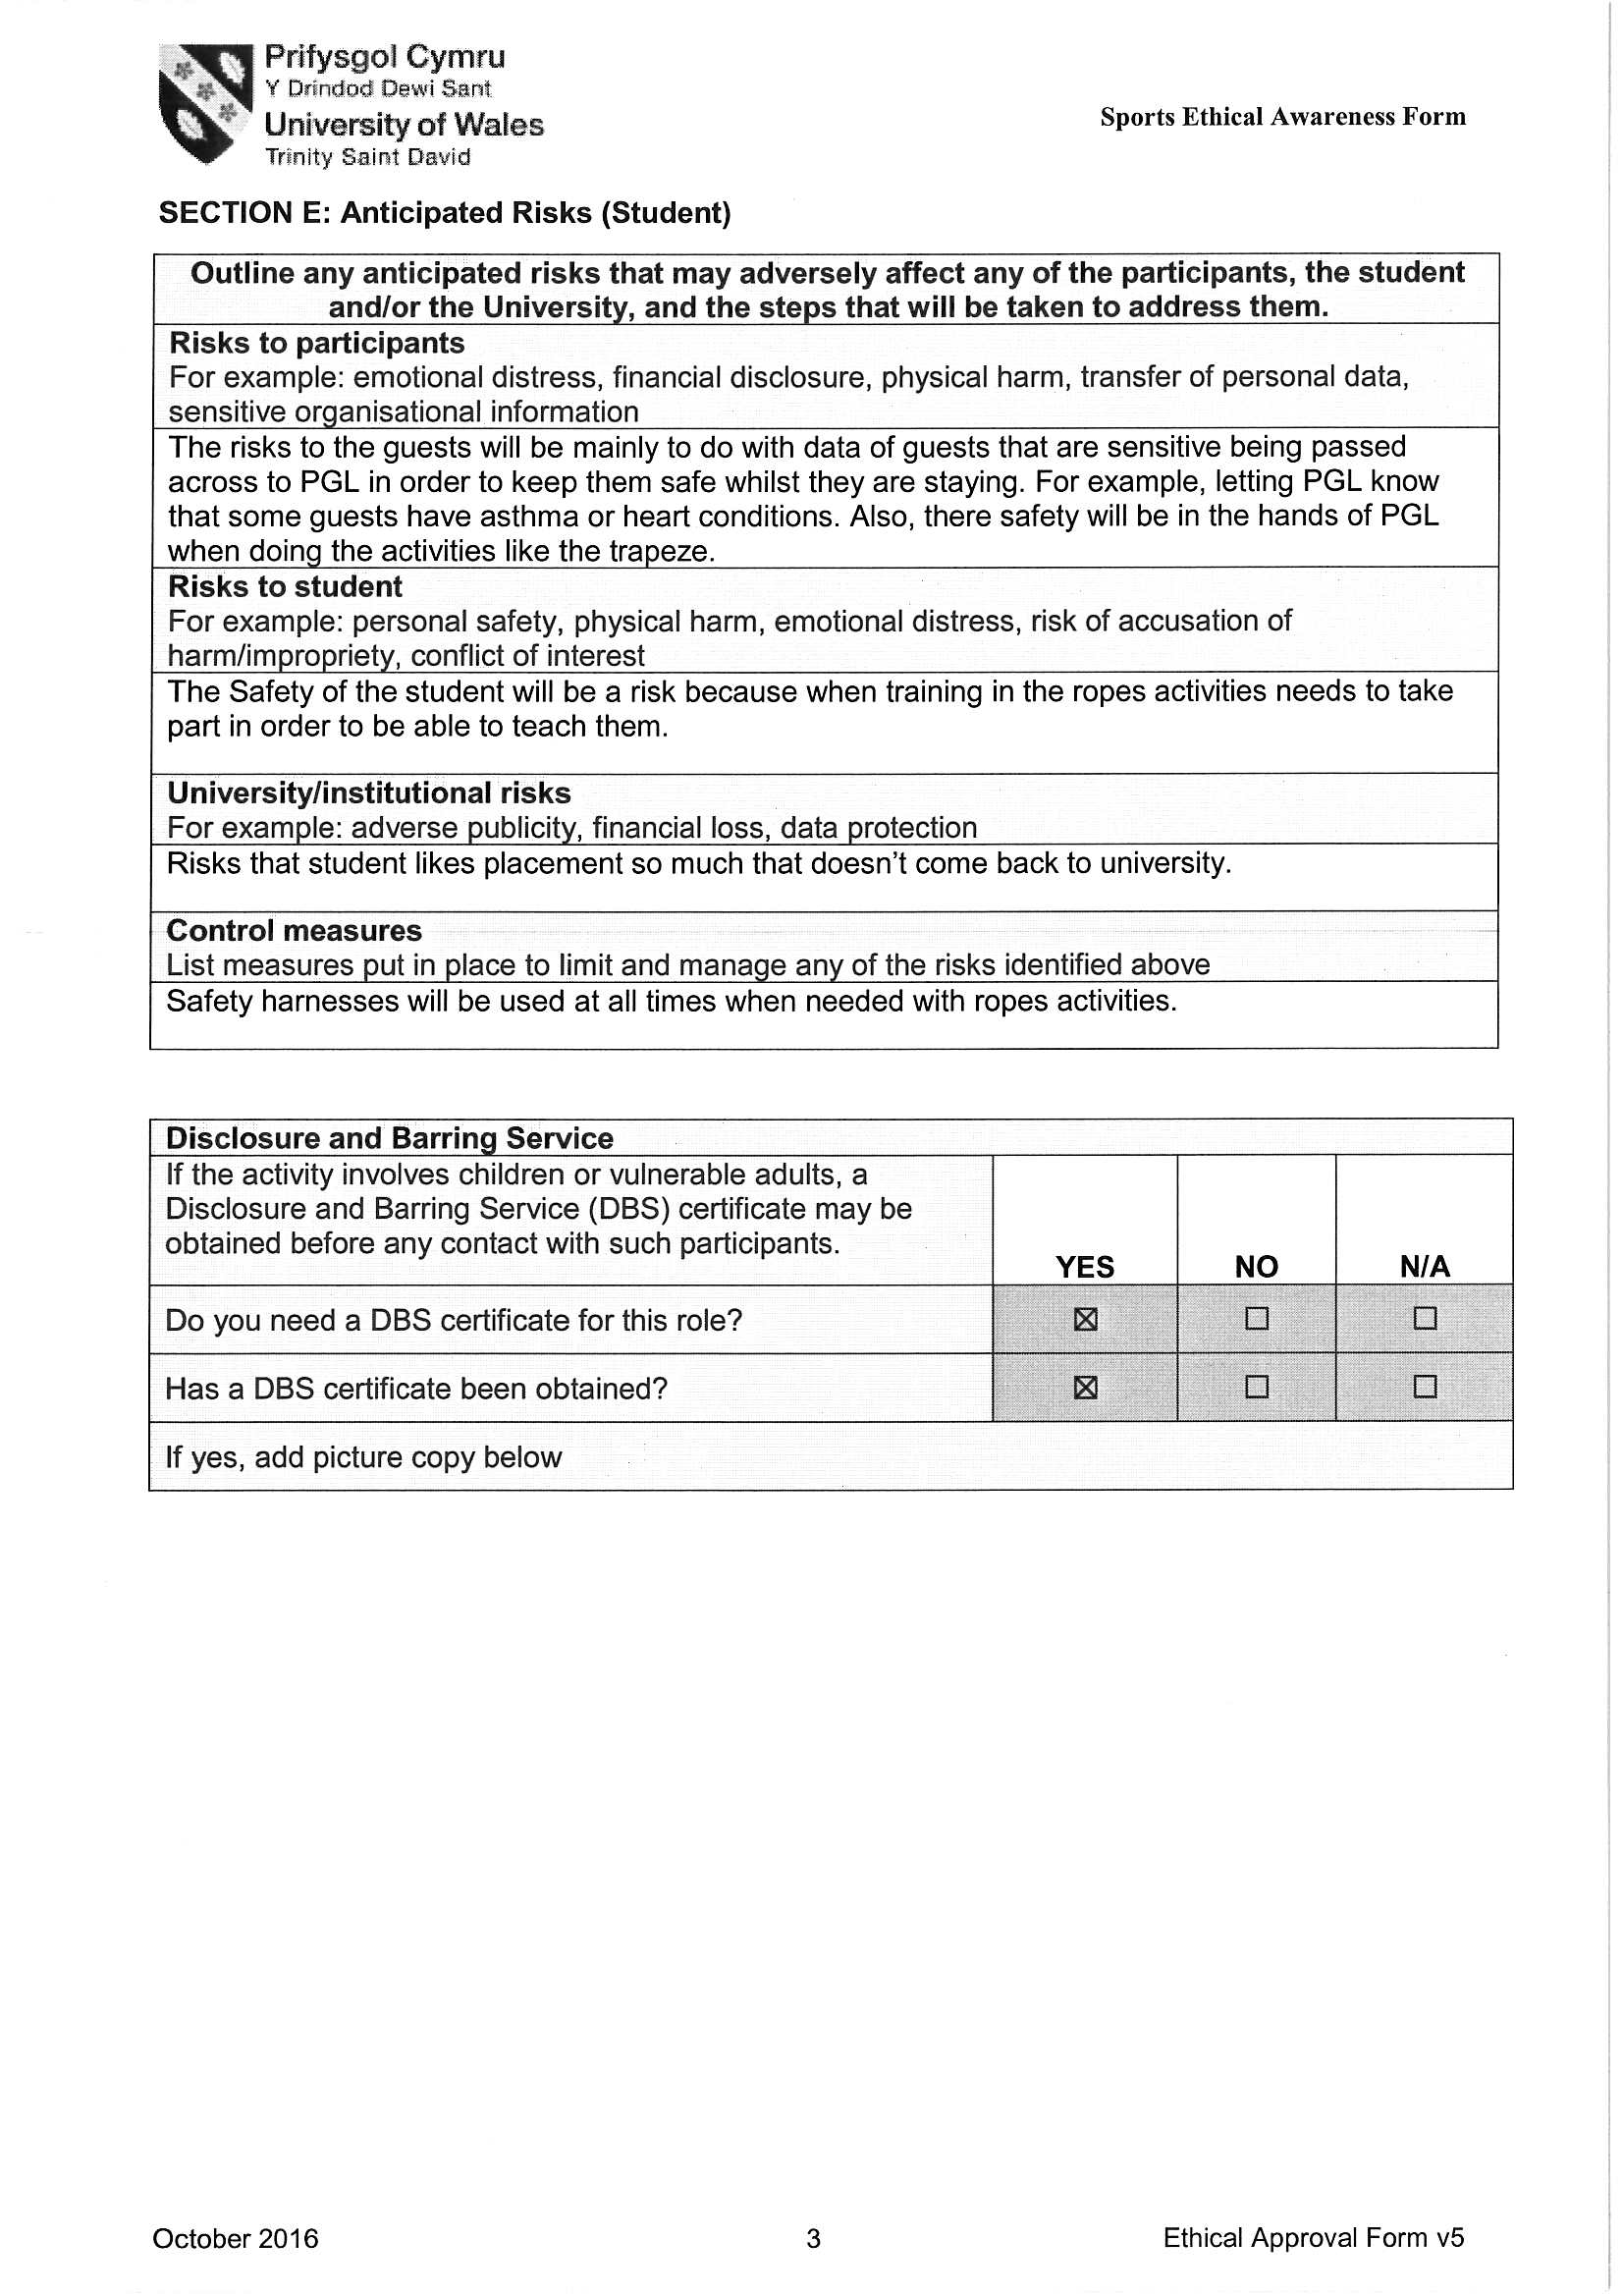

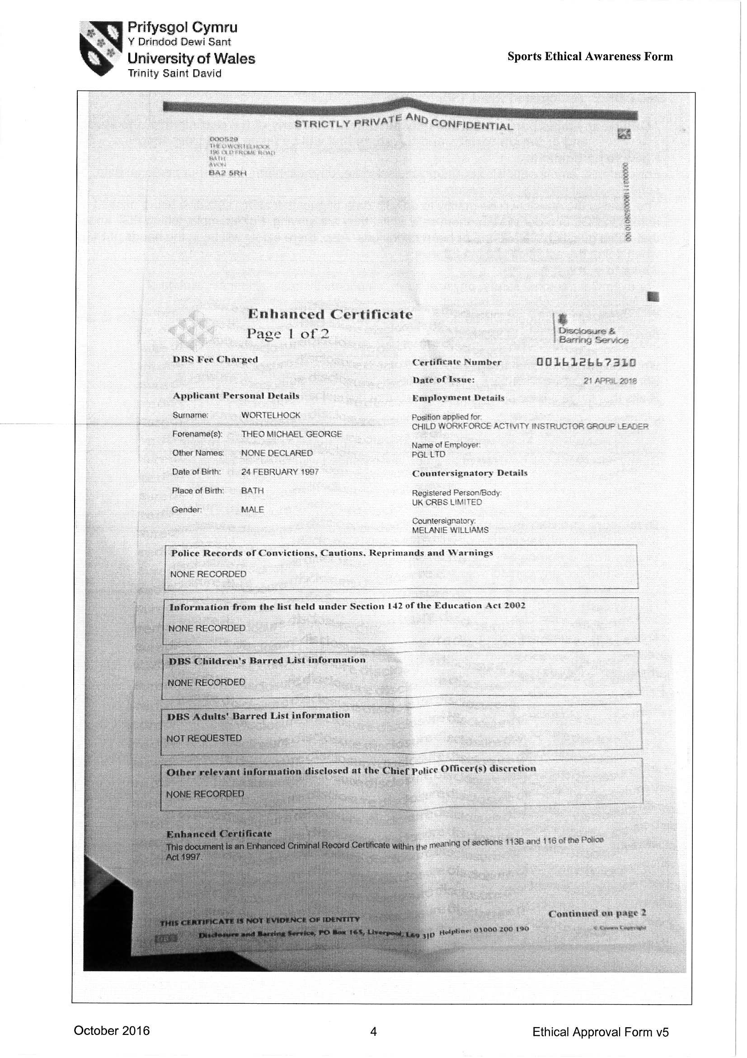TASK C Evidence – Ethics Form Continued


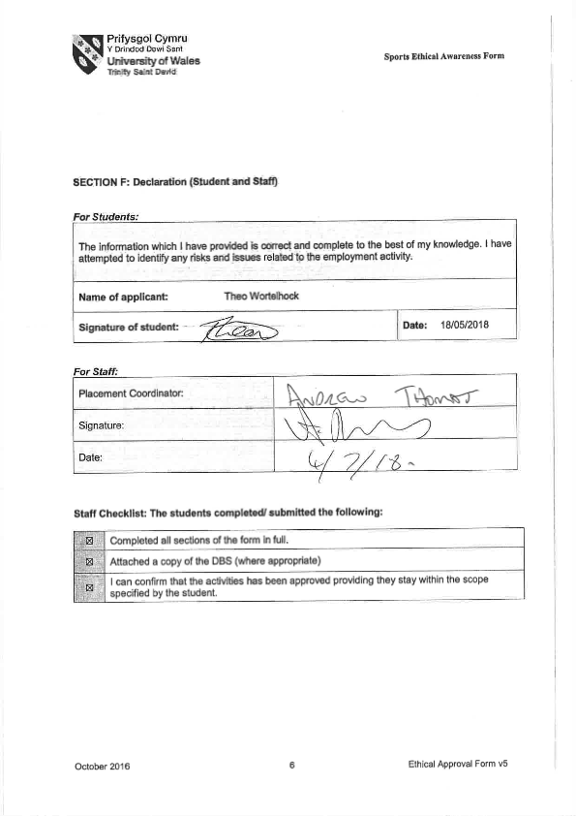

TASK C Evidence – Post Placement Review and Feedback
Dear Participant

Many thanks for your involvement in the work placement. I hope that you had a positive experience. The University of Wales Trinity Saint David reviews the provision annually for enhancement purposes and so we would be pleased to hear your feedback on any aspect of the placement.

Yours sincerely

Andrew Thomas, Placement Coordinator Sports Management Portfolio

Name of provider’s organisation: |  | PGL
Name of student: |  | Theo Wortelhock
What were the positive aspects?
The positive aspects are that I would definitely recommend a placement at PGL to anyone else who needs it in the future. You make great friends and it is a good atmosphere to work in.

Were there any problems?
No problems at all whilst I was working, I really enjoyed every part of it. However, I struggled to get the relevant paper work done as quickly as I wanted to as my line manager could have been more proactive when it came to be filling in paper work for my placement portfolio.

Do you have any recommendations for enhancement for the future?
Maybe, encourage more people to apply to work for PGL as a placement as it is such a good experience. Maybe also I would make sure that there is relevant support from line managers to help out with the portfolio when needed as I didn’t feel that was the best it could have been.

Signed: | T MG Wortelhock
Name in block capitals: | THEO WORTELHOCK
Position (please tick one): | ☐ Placement Provider  ☒ Student  ☐ Placement Tutor |  | Date: | 16th July 2018

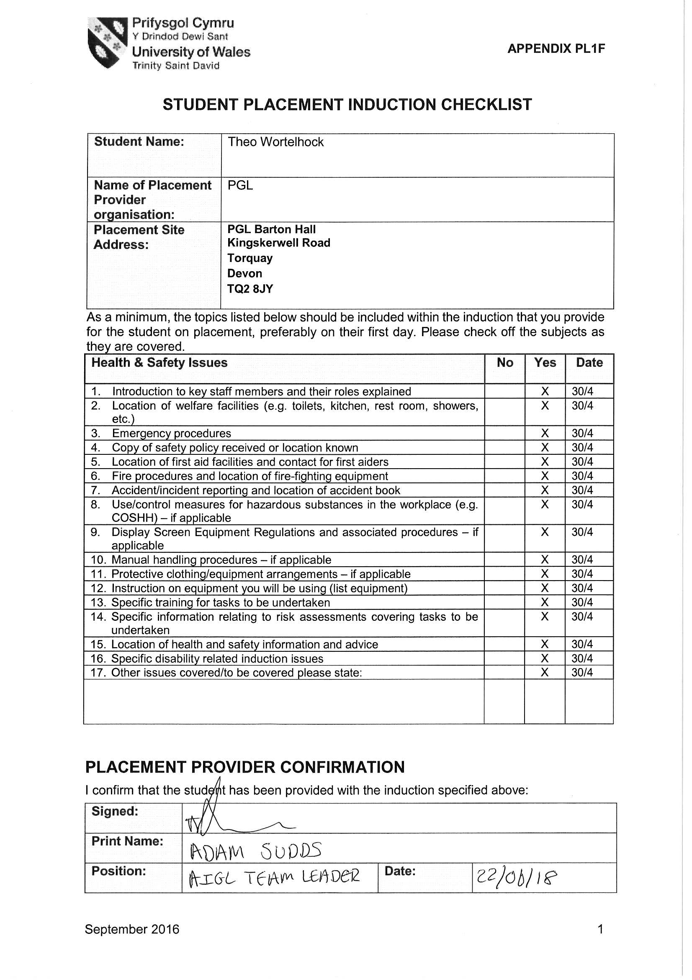TASK C Evidence – Student Placement Induction Checklist

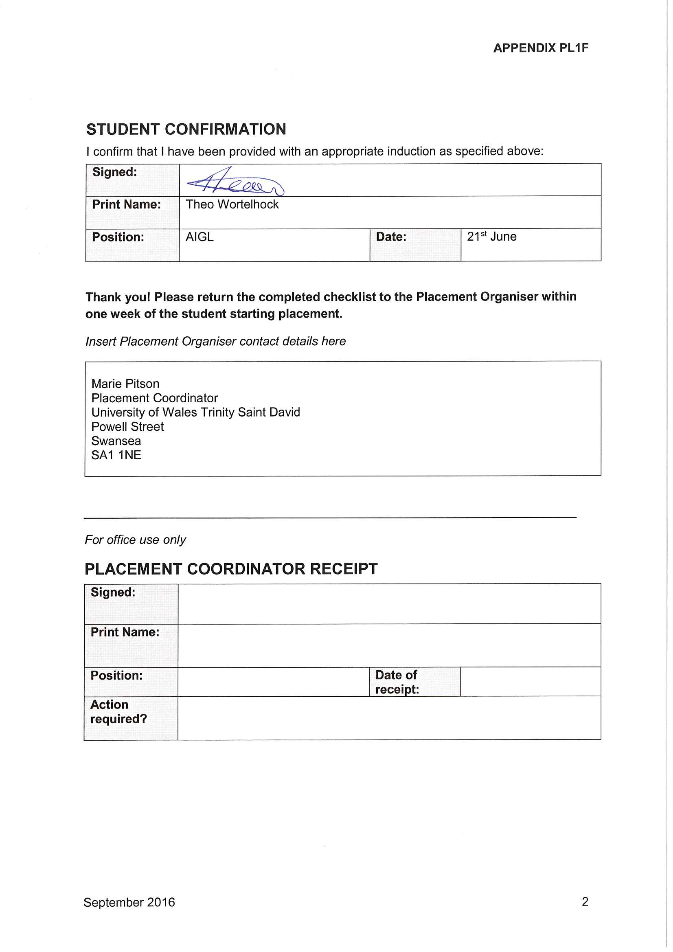


UWTSD SPORT
Placement

