Module name: The First 1000 Days
Module code: ECEY4005
Student ID: 2403964

Contents
Introduction 3
Exceptional care 5
Professional partnerships 6
Activities 8
Challenges 9
Conclusion 13
Slides 14
References 20

Introduction

The first thousand days of human life are a period that shapes our entire future. During this critical window, every experience and interaction contributes to building the foundation of human development. Recent biological research has revealed that this period has exceptional rates of growth and development, making it a key time for establishing lifelong health and well-being patterns (Kraemer et al., 2018). This key time begins at conception and continues through pregnancy and the first two years after birth. During this period, the human body and brain undergo rapid development that sets the stage for physical health, emotional well-being, and learning abilities throughout life (Indrio et al., 2023).

Scientific research has revealed just how significant these early days are for human development. Studies have shown that during this time, the foundations are being built for everything from basic body functions to complex thinking abilities. The changes happening during this period are so fundamental that they influence health outcomes and learning capabilities (Kraemer et al., 2018).

Healthcare workers in communities worldwide have observed the critical nature of this period. Their experiences show that proper support and care during the first 1000 days can considerably affect a child’s future development and opportunities. This understanding has led to increased focus on providing support for families during this key time (Bust and Pedro, 2022).

The environment plays a vital role in shaping development during these early days. According to Bronfenbrenner’s ecological systems theory, a child’s development is influenced by various layers of interaction, from immediate family relationships to social systems. This means that support during the first 1000 days needs to come from multiple sources within the community (Guy-Evans, 2020).

The relationship between caregivers and children during this period is important. Research has shown that early emotional bonds significantly impact future social and emotional development. These early relationships create patterns that influence how people connect with others throughout their lives (Holmes, 2014).

Physical movement and activity during this period also play key roles in development. The way children move and explore their environment helps build neural connections and supports development. This physical development goes hand in hand with cognitive and emotional growth (Goodger, 2023).

Healthcare systems see the first 1000 days as a critical window for preventing future health issues and promoting positive life results. Research shows that providing proper support during this period can help prevent various health problems and support better development outcomes. This makes the first 1000 days a key focus for healthcare providers and community support services (Mahmood, 2022).

Understanding the importance of this period has led to significant changes in how we support early development. This knowledge shows why we need coordinated support systems that help both children and families during these key early days. The support provided during the first 1000 days is an investment in the future health and well-being of both individuals and communities.

Research is also revealing how environmental factors during this period can influence gene expression and biological development. Scientists have discovered that experiences during the first 1000 days can modify how genes are expressed and potentially affecting health outcomes throughout life. This understanding of the biological impact of early experiences has strengthened the need for support during this period (Kraemer et al., 2018).

Global health organisations have understood the significance of this developmental window. Studies from different contexts show that investing in support during the first 1000 days can help reduce health inequalities and improve societal outcomes. This global movement has led to more approaches to supporting early development across different communities and cultures (Indrio et al., 2023).

Exceptional care

High-quality care during the first 1000 days goes beyond meeting basic needs. Research shows that the type of care children receive during this period significantly impacts their development and future well-being. This care needs to support physical growth, brain development, and emotional well-being (Kraemer et al., 2018).

Community health workers have observed that successful early care requires attention to both the child’s immediate needs and their environment. Their experiences show that when care is provided in a supportive way, children develop stronger foundations for future growth and learning. This understanding has changed how we think about early childhood care (Bust and Pedro, 2022).

The way caregivers interact with children during this period matters greatly. Studies on early relationships show that consistent, responsive care helps children develop secure emotional attachments that support healthy development. These early experiences create patterns that influence how children relate to others and handle emotions throughout their lives (Holmes, 2014).

Creating supportive environments is key for effective care. According to ecological systems theory, a child’s development is influenced by their immediate surroundings and social contexts (Guy-Evans, 2020). This means care settings need to provide both physical safety and opportunities for exploration and learning (Guy-Evans, 2020).

Movement and physical activity play important roles in early care. Research shows that allowing children to move freely and explore their environment supports both physical and cognitive development. Care settings should provide safe spaces for this type of exploration and movement (Goodger, 2023).

Healthcare providers point out that quality care during this period can prevent future health issues and support better development outcomes. Proper support and care practices during the first 1000 days create foundations for lifelong health and well-being (Mahmood, 2022). This makes high-quality care a key investment in children’s futures.

Research has expanded our understanding of how care practices influence brain architecture during this period. Studies show that consistent, responsive caregiving helps form and strengthen neural connections in developing brains (Indrio et al., 2023). This biological evidence reinforces the importance of providing care during these early days.

Community health workers are aware how different care approaches can be adapted to various cultural contexts while maintaining the principles of responsive caregiving. Their observations show that successful care practices can take many forms while still supporting optimal development. This understanding helps create inclusive and culturally sensitive approaches to early care (Bust and Pedro, 2022).

The role of movement in early care has gained increased attention from researchers. Studies indicate that freedom of movement during early development not only supports physical growth but also contributes to cognitive and emotional development in significant ways. This has led to new approaches in how we think about creating supportive care environments (Goodger, 2023).

Health researchers have also identified specific aspects of care that appear particularly key during this period. These include responsive feeding practices, appropriate sleep support, and opportunities for sensory experiences. Each of these elements contributes to different aspects of development, from physical growth to cognitive advancement. Understanding these specific needs helps create more effective care practices (Kraemer et al., 2018).

Professional partnerships

The success of early development relies heavily on professional partnerships and support systems. Research shows that coordinated professional support during the first 1000 days greatly impacts both child development and family well-being. These partnerships create networks that help families access resources and support when they need them most (Indrio et al., 2023).

Early years practitioners play a vital role in supporting development during this key period. Their expertise helps families understand and support their child’s development needs (. These professionals work directly with families to create supportive environments and identify potential concerns early Guy-Evans, 2020).

Community health workers have a particularly important role in these partnerships. Their work shows how professional support can help families manage challenges and access resources during the first 1000 days. They often serve as a bridge between families and other healthcare services (Bust and Pedro, 2022).

Successful partnerships between professionals and families require clear communication and mutual respect. Research indicates that when professionals and families work together effectively, children show better developmental outcomes. These partnerships work best when they understand parents as the primary caregivers while providing professional guidance and support (Kraemer et al., 2018).

Early relationships between professionals and families create foundations for ongoing support. Studies on attachment and early relationships demonstrate how important these professional connections are for supporting healthy development (Holmes, 2014). When families feel supported by professionals, they are better able to support their child’s development.

Many factors can affect early development, particularly those related to maternal health and well-being. Physical health, emotional well-being, and social support all play key roles in supporting healthy development during the first 1000 days. Professional partnerships need to address these various factors to provide effective support (Mahmood, 2022).

Physical factors include nutrition, rest, and recovery after birth. Mental health factors such as stress and emotional well-being also significantly impact early development. Social factors, including support networks and access to resources, affect how well families can support their child’s development (Indrio et al., 2023).

Activities

Professional support also includes guidance on physical development and movement. Research shows that understanding how to support physical development helps create better outcomes for children. Professionals can help families learn how to support their child’s natural movement and exploration safely (Goodger, 2023).

Effective professional partnerships create systems that support both immediate and long-term needs. These partnerships help ensure that families have access to necessary resources and support throughout the first 1000 days. By working together, professionals and families can create environments that support optimal development during this key period (Mahmood, 2022).

Research has revealed that successful professional partnerships often extend beyond traditional healthcare settings. Studies show that including diverse professional perspectives, from mental health specialists to nutritionists, creates more support systems (Indrio et al., 2023). This approach helps address the complex needs of families during this period.

Community health workers have identified specific strategies that make partnerships more effective. These include regular communication between different service providers, shared goal setting with families, and flexible support options that adapt to changing needs. These strategies help create more responsive and effective support systems (Bust and Pedro, 2022).

The importance of cultural competency in professional partnerships has become increasingly clear. Research shows that when professionals understand and respect cultural differences, they can provide more effective support to diverse families. This cultural awareness helps create inclusive and accessible support systems (Guy-Evans, 2020).

Research continues to reveal how professional partnerships can better support attachment and emotional development. Studies on early relationships suggest that when professionals work together effectively, they can help create more secure and supportive environments for both children and families. This understanding helps shape how different professionals coordinate their support efforts (Holmes, 2014).

Challenges

Despite understanding the importance of the first 1000 days, providing high-quality care during this period faces several significant challenges. Research shows that various obstacles can affect how well support services reach families and impact early development outcomes (Indrio et al., 2023).

One major challenge involves ensuring equal access to resources and support services. Community health workers have observed that many families struggle to access the care they need during this key period. This can be due to various factors, including location, transportation, or economic constraints (Bust and Pedro, 2022).

Social and economic differences significantly impact access to quality care. Research shows that these factors can create substantial variations in the support families receive during the first 1000 days. These differences can affect everything from nutrition to healthcare access (Kraemer et al., 2018).

The environment where children spend their early days can present challenges. According to ecological systems theory, various environmental factors affect development, and not all environments provide optimal support. This includes both physical environments and social contexts that influence early development (Guy-Evans, 2020).

Coordinating different support services often proves challenging. Healthcare systems sometimes struggle to provide consistent, connected support throughout the first 1000 days. This can lead to gaps in care or difficulty accessing all needed services (Mahmood, 2022).

Supporting physical development and movement can also present challenges. Research shows that providing appropriate spaces and opportunities for movement and exploration is not always straightforward. This affects how well children can develop their physical abilities during this key period (Goodger, 2023).

Creating environments that support healthy emotional development and attachment can be complex. Studies show that various factors can affect the formation of secure attachments during early development. These challenges can impact long-term emotional and social development (Holmes, 2014).

Research has identified additional challenges that affect service delivery during this key period. Studies show that factors such as workforce training, resource allocation, and service coordination can impact the quality of support available to families. Understanding these challenges helps in developing more effective solutions (Indrio et al., 2023).

Community health workers have observed that language and cultural barriers often create additional complexities in providing support. Their experiences show that these barriers can affect everything from communication effectiveness to families’ willingness to engage with support services. Addressing these cultural and linguistic challenges requires specific strategies and resources (Bust and Pedro, 2022).

The increasing complexity of modern family structures presents new challenges for support systems. Research indicates that changing family patterns and work arrangements can affect how families access and engage with support services during the first 1000 days. Support systems need to adapt to these changing family dynamics (Kraemer et al., 2018).

Technology integration in support services presents both opportunities and challenges. While digital tools can help reach more families, they also raise questions about access equality and effectiveness. Finding the right balance between technological and traditional support methods remains an ongoing challenge (Mahmood, 2022).

Supporting development during the first 1000 days involves various learning activities that help children grow and develop. Research shows that appropriate activities during this period can significantly influence future development outcomes (Kraemer et al., 2018).

Physical movement plays a key role in early development. Studies show that when children have opportunities to move and explore freely, they develop better physical and cognitive abilities. These movement-based activities support brain development and help children understand their environment (Goodger, 2023).

The environment itself serves as a learning tool during early development. According to ecological systems theory, interactions with different environments significantly impact how children learn and develop. This understanding has led to various approaches that use natural environments to support early learning (Guy-Evans, 2020).

Community health workers have observed that activities involving both parents and children create stronger developmental outcomes. Their experiences show that when learning activities include family participation, children show better progress in various developmental areas (Bust and Pedro, 2022).

Different cultures and countries have developed various approaches to supporting early development. Research shows that these different methods can provide valuable insights into supporting children during the first 1000 days. Each approach offers unique perspectives on supporting early development (Indrio et al., 2023).

Activities that support emotional development and attachment are particularly important. Research on early relationships shows that interactive activities between caregivers and children help build strong emotional bonds. These activities create foundations for future social and emotional skills (Holmes, 2014).

Healthcare systems understand the importance of developmental activities. Studies show that combining appropriate activities into healthcare support can improve development outcomes. This has led to better approaches to supporting early development (Mahmood, 2022).

Recent research has expanded our understanding of how different activities support various aspects of development. Studies show that carefully designed activities can simultaneously support multiple developmental areas, from physical skills to cognitive abilities. This understanding helps create more effective activity programs (Goodger, 2023).

The role of technology in supporting developmental activities has gained attention. While maintaining a focus on physical interaction and real-world experiences, research shows that appropriate use of technology can complement traditional developmental activities. This creates new opportunities for supporting development in modern contexts (Indrio et al., 2023).

Community health workers have observed how cultural practices influence activity preferences and effectiveness. Their experiences show that successful activity programs often include elements from local cultural traditions while maintaining core developmental principles. This cultural sensitivity helps create more engaging and effective activities (Bust and Pedro, 2022).

The impact of environmental factors on activity effectiveness has become clearer through research. Studies based on ecological systems theory show that the same activities can have different effects depending on the environmental context. This understanding helps create more adaptable and context-appropriate activity programs (Guy-Evans, 2020).

Conclusion

The first 1000 days represent a key period that shapes human development in fundamental ways. From brain development to emotional bonds, the experiences during this time create foundations that influence entire lifetimes. Understanding this period helps us provide better support for healthy development.

Professional partnerships, quality care, and appropriate activities all play vital roles in supporting development during this critical time. While challenges exist in providing support, continued research and improved understanding help create better outcomes for children and families.

The combination of theoretical knowledge and practical experience continues to improve how we support early development. By addressing various aspects of development and providing appropriate support, we can help create strong foundations during these key first 1000 days.

Recent scientific advances have deepened our understanding of this critical period. Biological research continues to reveal new insights about brain development and genetic expression during the first 1000 days. This growing knowledge base helps create more effective support strategies.

Global perspectives on early development have helped our understanding of how to support children and families during this period. Studies from different cultural contexts show that while developmental principles may be universal, successful support strategies often need to be adapted to local contexts. This understanding helps create more inclusive and effective support systems (Indrio et al., 2023).

The role of community support in early development has gained increased recognition. Research shows that when communities provide support during the first 1000 days, outcomes improve for both children and families. This highlights the importance of building strong community support systems (Bust and Pedro, 2022).

As we look to the future, continued research and practical experience will likely reveal new ways to support development during this key period. By maintaining focus on this critical window of development while remaining open to new insights and approaches, we can continue improving how we support children and families during the first 1000 days.

Slides

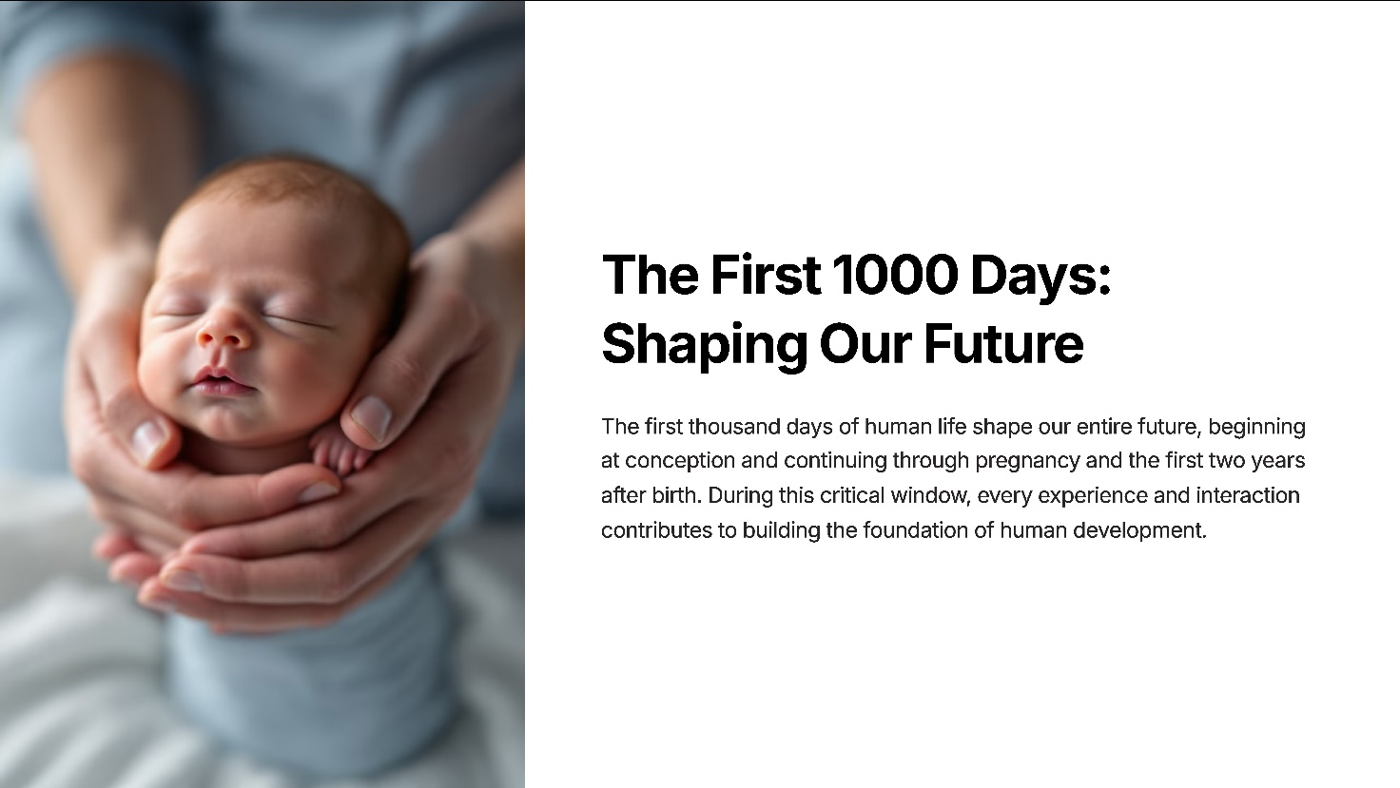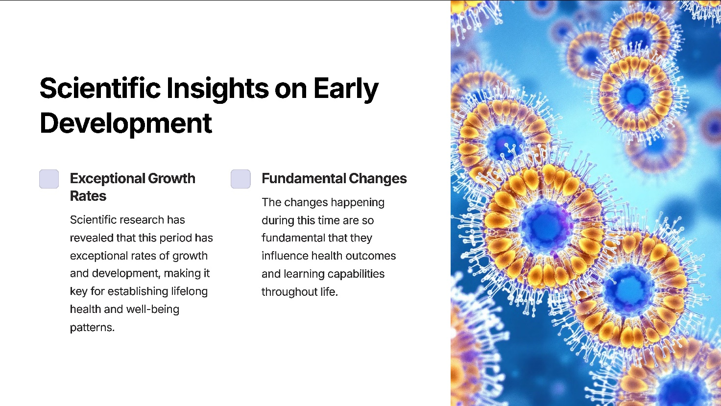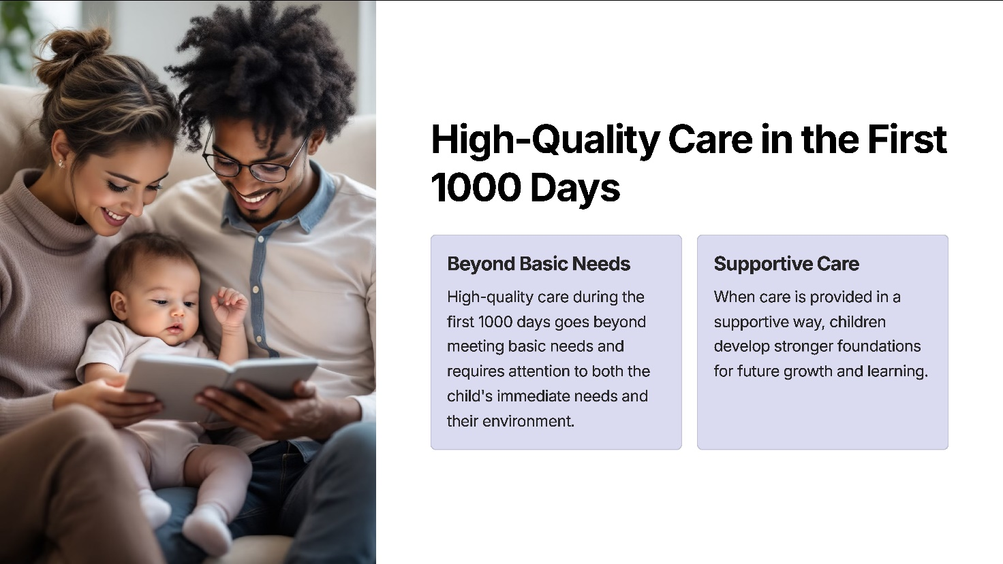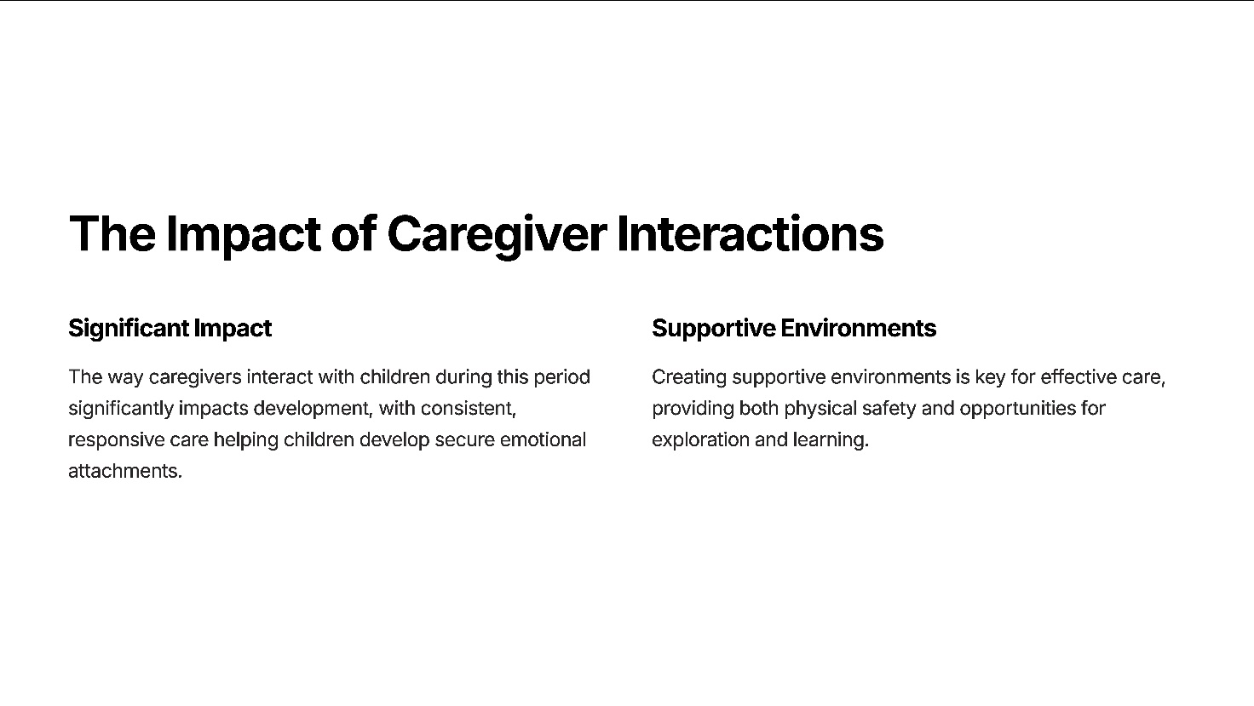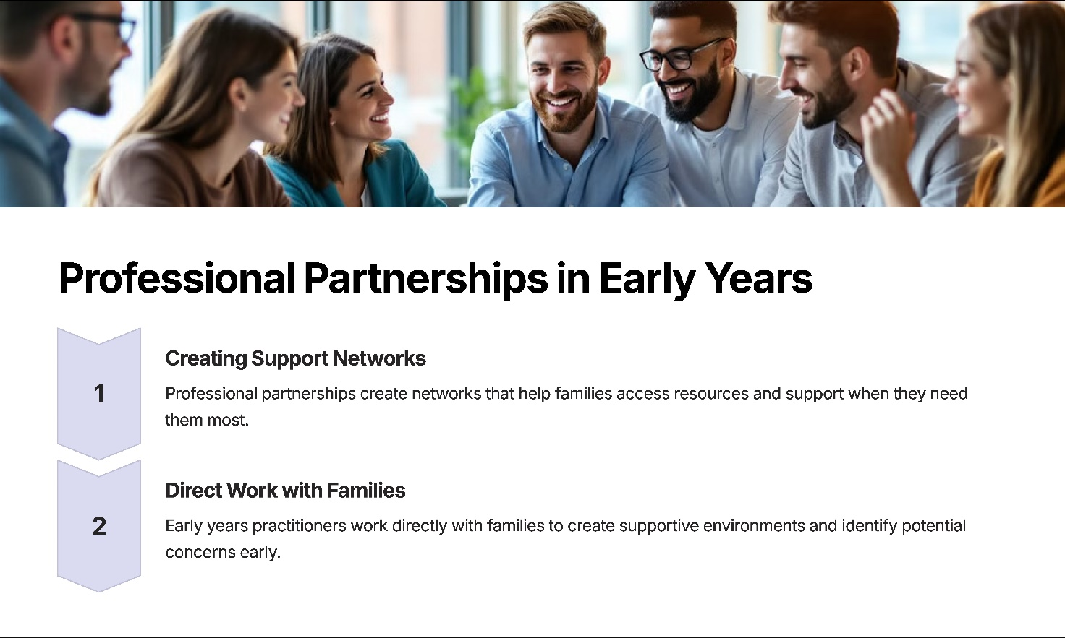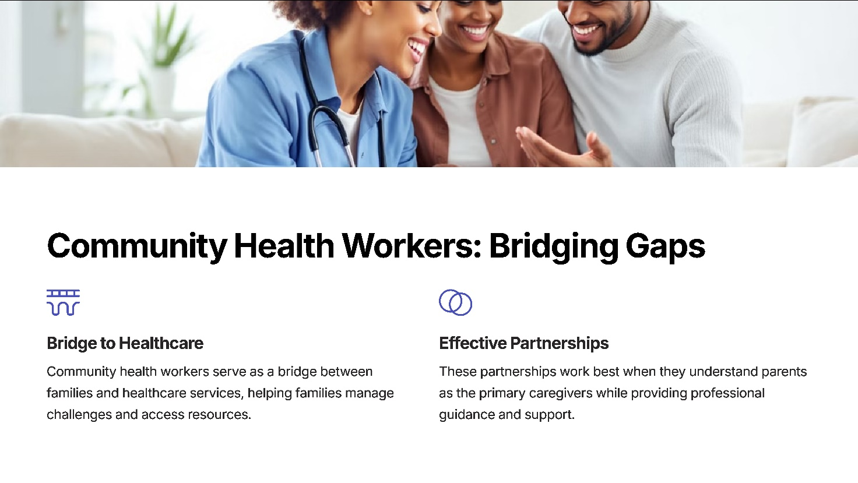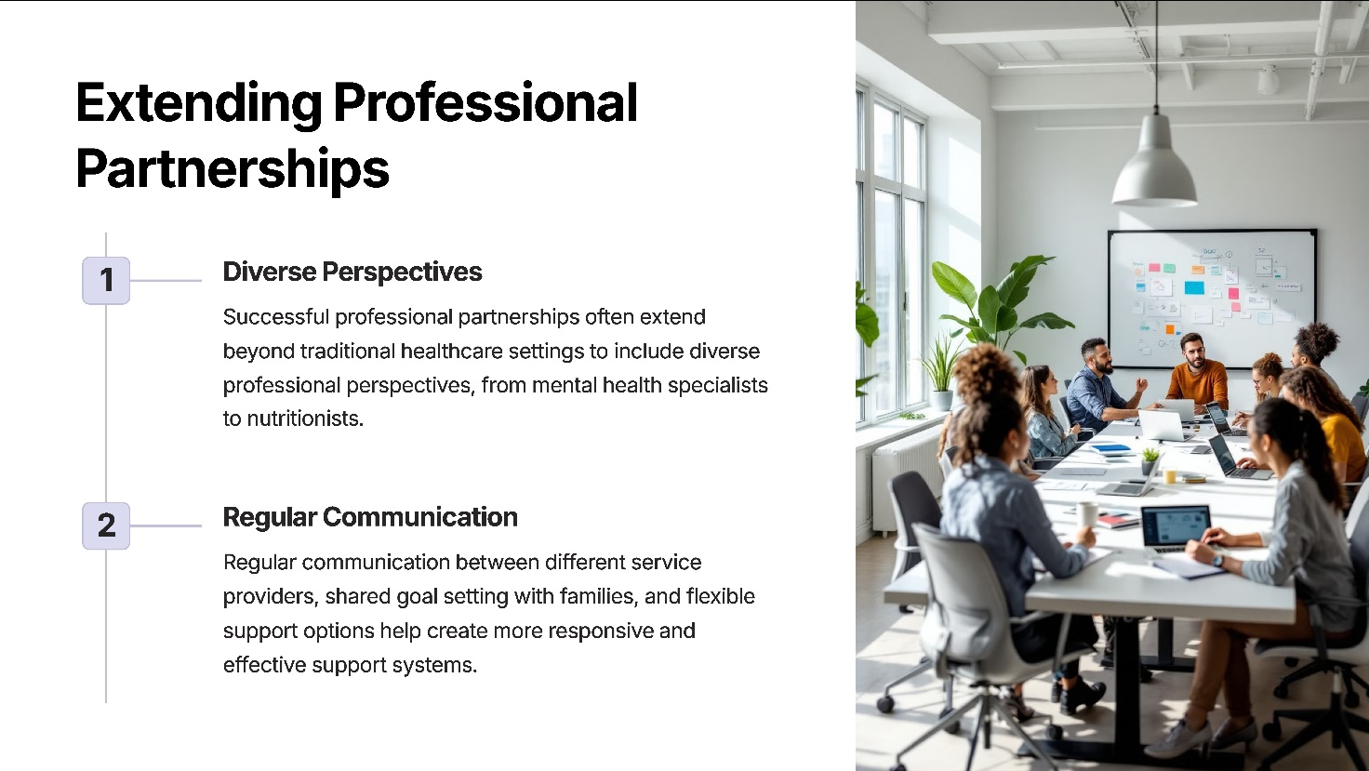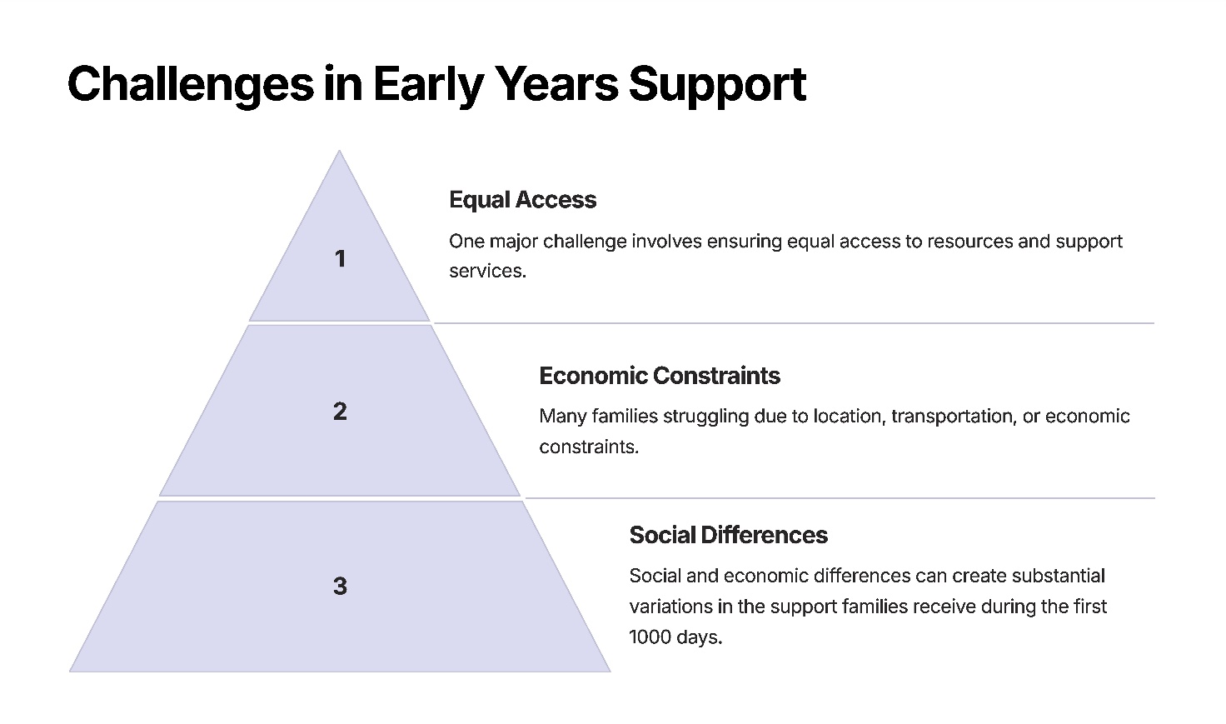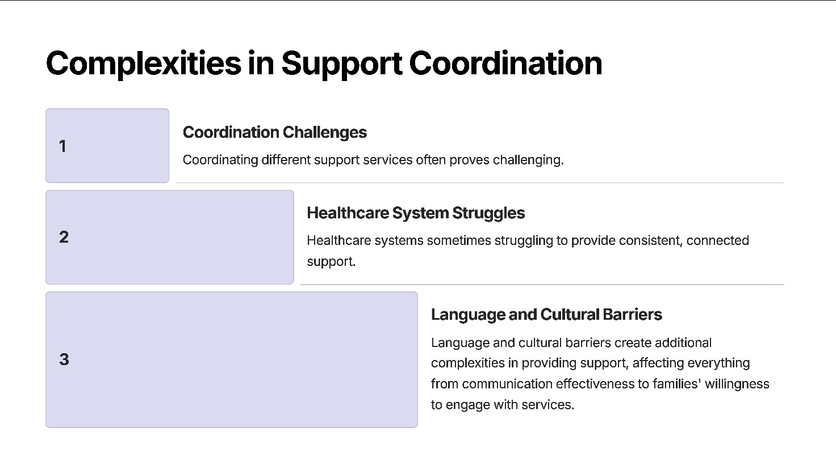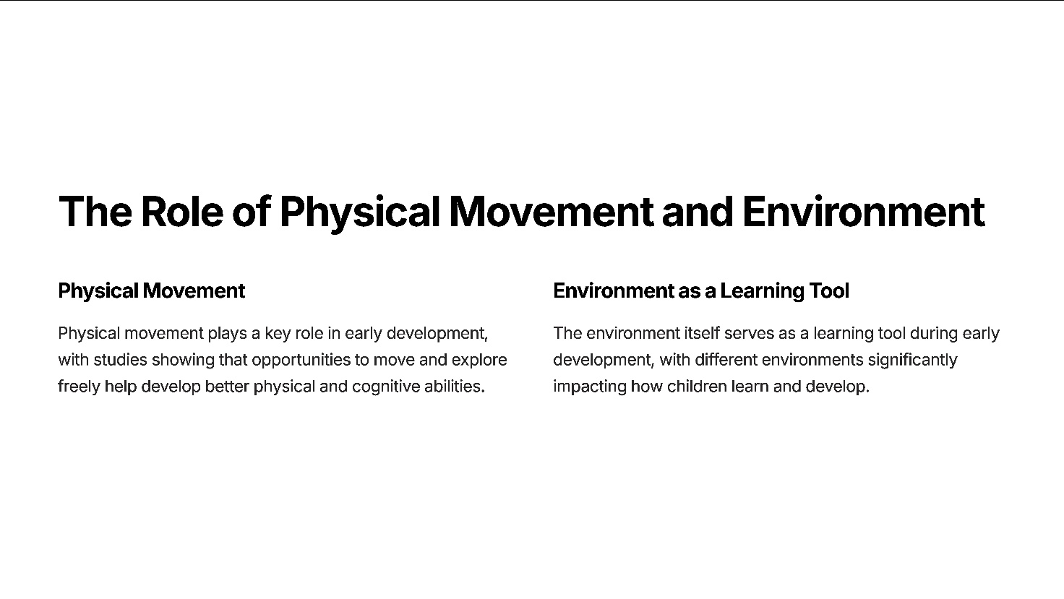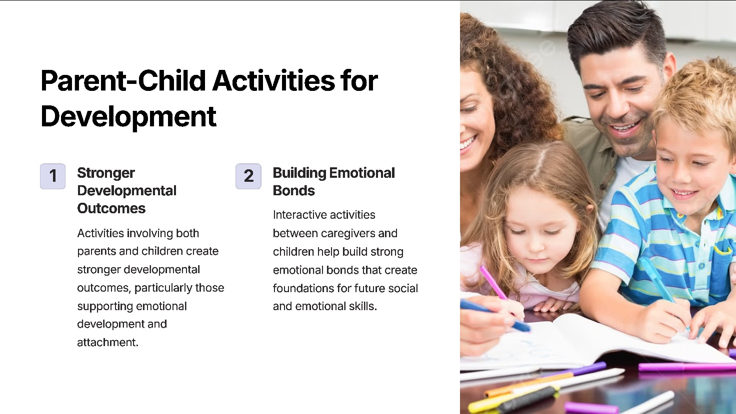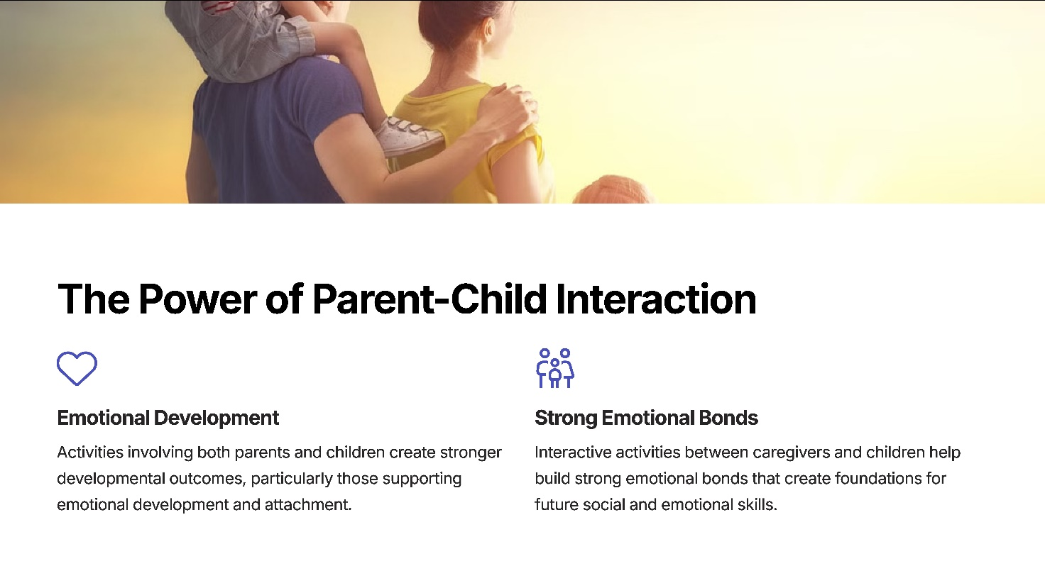

References

Bust, E. and Pedro, A. (2022) Your baby’s life depends on those first 1000 days: community health workers’ perspectives of the first 1000 days of life, Early Child Development and Care, 192(6),.
Goodger, D. (2023) Creative Movement in the Early Years. Place of publication missing: Publisher missing.
Guy-Evans, O. (2020) Bronfenbrenner’s Ecological Systems Theory. Available at: Simply Psychology (URL missing) (Accessed: 10 January 2025).
Holmes, J. (2014) John Bowlby and Attachment Theory. London: Routledge.
Indrio, F., Pietrobelli, A., Dargenio, V.N., Marchese, F., Grillo, A., Vural, M., Giardino, I. and Pettoello-Mantovani, M. (2023) ‘The key 1000 life-changing days’, Global Pediatrics, 4. Available at: https://www.sciencedirect.com/science/article/pii/S2667009723000155 (Accessed: 12 January 2025).
Kraemer, K., Green, T.J., Karakochuk, C.D. and Whitfield, K.C. (2018) The Biology of the First 1000 Days. Boca Raton: Taylor & Francis.
Mahmood, H. (2022) Building a Supportive and Empowering First 1,000 Days of Life. Available at: https://www.nhsconfed.org/case-studies/building-supportive-and-empowering-first-1000-days-life (Accessed: 08 January).

