In Osm


SOCIAL ENGINEERING ATTACKS AND MITIGATION STRATEGIES
By
Jamie Gau
Supervisor: Dr Kapilan Radhakrishnan

Project submitted as part of the requirements for the award of BSc (Hons) Applied Computing

April 2022

DECALARATION OF ORIGINALITY
I, James Phillip Richard Gau, declare that I am the sole author of this Project; that all references cited have been consulted; that I have conducted all work of which this is a record, and that the finished work lies within the prescribed word limits.

This work has not previously been accepted as part of any other degree submission.

Signed: …………………………………………………………….

Date: 26/04/2022

FORM OF CONSENT
I, James Phillip Richard Gau, hereby consent that my Project, submitted in candidature for the BSc (Hons) Applied Computing degree, if successful, may be made available for inter-library loan or photocopying (subject to the law of copyright), and that the title and abstract may be made available to outside organisations.

Signed: …………………………………………………………….

Date: 26/04/2022
COPYRIGHT ACKNOWLEDGMENT
I acknowledge that the copyright of this project report, and any product developed as part of the project, belong to University of Wales Trinity Saint David, Swansea.

ACKNOWLEDGEMENTS
I would like to thank my parents, Becky and Chris, as they have greatly supported me throughout my study and without them, I would not be where I am at today.
I would massively like to thank my older brother, Ryan, for his constant support and help throughout this project. As a previous computing student of UWTSD himself, his advice has been invaluable, and I cannot thank him enough.
I would also like to thank Dr Kapilan Radhakrishnan for his supervision and help throughout this project, and also Dr Nik Whitehead for her help with the ethics form that supported the experiment, as well as any other staff from UWTSD that gave me advice or helped me out this year.

ABSTRACT
This project is about social engineering attacks that affect organisation and individuals, and the mitigation strategies that can be employed to prevent them or reduce the damage they can cause. This includes research into the many different types of social engineering attacks that can be encountered and why they are so effective, such as phishing attacks, diversion theft, baiting, scareware, tailgating attacks etc. As well as that, various mitigation methods that can be used to prevent these attacks were examined and analysed based on their effectiveness, such as ID checking, breaking the loop, spam filters, digital footprint reduction etc. This will all be found within the research and review of literature section.
The research methodology section contains information about various types of research that can be conducted and focusses specifically on the research methodologies that were used during this project and justified appropriately.
The design and implementation sections contains the design of the primary research experiment, which was carried out, justifying the design choices, and explaining how the survey was carried out.
The testing and evaluation section contains the results of the research experiment carried out, analysing how a variety of participants are familiar with social engineering attacks, and whether or not they think they are able to protect themselves against them, giving insight as to how the average user can deal with these attacks.
The conclusion section contains a brief summary of the report, detailing how the project was managed, as well as giving any recommendations for future researchers. The section after that will be a self-evaluation of the author’s actions over the course of the project.
At the end of the report will be a table of references used, as well as the appendix containing useful documents about the project, such as the ethics form and a project Gantt chart.

CONTENTS
TABLE OF FIGURES 7
CHAPTER 1 – INTRODUCTION 9
1.1 - Introduction 9
1.2 - Aims 10
1.3 - Objectives 10
1.4 - Structure of the Project 11
CHAPTER 2 – RESEARCH AND REVIEW OF LITERATURE 13
2.1 – The Basics of Social Engineering Attacks 13
2.2 – Types of Social Engineering Attacks 14
2.2.1 – Angler Phishing 14
2.2.2 – Spear Phishing 14
2.2.3 – Whaling 15
2.2.4 – Diversion Theft 15
2.2.5 – Baiting 15
2.2.6 – Honey Trap 16
2.2.7 – Pretexting 16
2.2.8 – SMS / Text Message Phishing 17
2.2.9 – Scareware 17
2.2.10 – Tailgating / Piggybacking 18
2.2.11 – Watering Hole 18
2.3 – Common Mitigation Strategies to Prevent Social Engineering Attacks 19
2.3.1 – Foreword 19
2.3.2 – Source Checking 19
2.3.3 – Breaking the Loop 19
2.3.4 – Asking for ID 20
2.3.5 – Spam Filters 20
2.3.6 – Device Security 20
2.3.7 – Reducing Digital Footprint 21
2.4 – Related Work 22
2.4.1 – Advanced Social Engineering Attacks [64] 22
2.4.2 – Social Engineering Attacks: A Survey [65] 22
2.4.3 – Identification of Social Engineering Attacks [66] 22
2.4.4 – Social Engineering Attacks: Recent Advances and Challenges [67] 23
2.4.5 – Identification and Prevention of Social Engineering Attacks on an Enterprise [68] 23
2.4.6 – Social Engineering Attacks During the COVID-19 Pandemic [69] 23
2.4.7 – A Taxonomy of Social Engineering Defence Mechanisms [70] 24
2.4.8 – Strategies Used to Mitigate Social Engineering Attacks [71] 24
2.5 - Conclusion 25
CHAPTER 3 – RESEARCH METHODOLOGY 26
3.1 – Introduction 26
3.2 – Research Overview 27
3.2.1 – Research Process 27
3.2.2 – Research Philosophy 27
3.2.3 – Research Methodologies 27
3.2.4 – Data Collection 28
3.3 – Research Design 29
3.3.1 – Research Deliverables 29
3.4 – Triangulation 30
3.5 – Conclusion 30
CHAPTER 4 – DESIGN AND IMPLEMENTATION 31
4.1 – Introduction 31
4.2 – Problem Formulation 31
4.3 – Design 32
4.4 – Implementation 35
4.5 – Conclusion 35
CHAPTER 5 – TESTING AND EVALUATION 36
5.1 – Experiment Testing 36
5.2 – Evaluation of the Results 37
5.3 – Conclusion 45
CHAPTER 6 – CONCLUSION 46
6.1 – Analysis of the Aims and Objectives 46
6.2 – Recommendations for Future Work 47
CHAPTER 7 – SELF EVALUATION 48
7.1 – Improvements to Future Study 48
7.2 – Personal Benefit 48
7.3 – Project Management 49
CHAPTER 8 – REFERENCE LIST 50
APPENDIX 58
Appendix 1 – Ethics Form 58
Appendix 2 – Gantt Chart 69

TABLE OF FIGURES
Chapter 2 Figures
Figure 2.1 – A diagram of the Social Engineering ‘Life Cycle’ [4]………………………………………13
Figure 2.2 – A Diagram Showing the Pretexting Process [27]…………………………………………..16
Figure 2.3 – An Example of a Scareware Popup[36]…………………………………………………………17
Chapter 3 Figures
Figure 3.1 – A Flowchart of the Research Process [72]………………………………………………….…29
Chapter 4 Figures
Figure 4.1 – Question 1 – What is your age? [73]………………………………………………………….…32
Figure 4.2 – Question 2 – Do you work in an IT-related job? [74].……………………………………32
Figure 4.3 – Question 3 – Have you personally ever been a victim of a social engineering attack? [75]……………………………………………………….……………………………………………………………33
Figure 4.4 – Question 4 – Has anyone you've ever known been a victim of one of these attacks? [76]……………………………………………………..……………………………………………………………33
Figure 4.5 – Question 5 – If you were to be targeted by one of these attacks, would you know what precautions to take in order to protect yourself? [77].….………………………………34
Figure 4.6 – Question 6 – Scenario [78]……………..……………………………………………………………34
Chapter 5 Figures
Figure 5.1 – Survey Responses [79]…………………………………………………………………………………36
Figure 5.2 – Question 1 Responses [80]…………………………………………………………………………..37
Figure 5.3 – Question 2 Responses [81]…………………………………………………………………………..38
Figure 5.4 – Question 3 Responses [82]…………………………………………………………………………..39
Figure 5.5 – Question 4 Responses [83]…………………………………………………………………………..40
Figure 5.6 – Question 5 Responses [84]…………………………………………………………………………..41
Figure 5.7 – Question 6 Responses Part 1 [85]…………………………………………………………………42
Figure 5.8 – Question 6 Responses Part 2 [86]…………………………………………………………………42
Figure 5.9 – Question 6 Anomalous Result 1 [87]…………………………………………………………….43
Figure 5.10 – Question 6 Anomalous Result 2 [88]………………………………………………………….44
Figure 5.11 – Question 6 Anomalous Result 2 Analysis [89]…………………………………………….44

CHAPTER 1 – INTRODUCTION

1.1 - Introduction
Security is extremely vital these days; cyber-attacks are becoming more common along with the advancements that are made in the technology field. With more advanced systems, comes more advanced methods used to break into said systems in order to carry out malicious acts. However, whilst attacks such as SQL Injections, Dedicated Denial of Service (DDoS) attacks and Man-in-the-Middle (MITM) attacks require clear vulnerabilities and flaws within the computer systems, there are attacks that focus on another type of vulnerability entirely: human error.
Social Engineering attacks are attacks that are carried out primarily by using and exploiting human interactions. Psychological manipulation can be used to trick victims into giving away sensitive information such as bank account details, usernames, passwords, company information etc. Many people deal with these attacks every day, even if they may not realise it. The problem with these attacks is that most people will likely not fall for them, so to make up for this, they tend to target more vulnerable groups of people, such as the elderly, as they will be less likely to have the technological knowledge to tell when these attacks are happening, or how to mitigate them. As such, these attacks are highly exploitative and very immoral.
There are a few different types of social engineering attacks, but this report will cover the more common types. The most common attack is called ‘phishing’. Phishing is primarily used to gain hold of sensitive information such as card numbers or login details by posing as a trusted party and tricking a user into opening an email or text message that contains a link. When the user clicks on this link, malicious software could be installed on their system, or they could be taken to a very convincing login screen, where they may accidentally reveal password information.
Another technique is called ‘Baiting’. This is an attack that relies on piquing the users interest in order to trick them into infecting a system with malicious software. This could be performed both physically and digitally, through the use of online ads or removable disk drives, respectively. ‘Scareware’ is another common tactic. This involves exploiting a user’s fear, most commonly by using online popups to claim that the user’s computer is infected with a virus, then prompting them to click a link to install an antivirus program, which in itself is most likely infected with malware. Both of these techniques are equally reviled but have unfortunately proven to be very effective attack methods.
The main problem that comes with the act of preventing these types of attacks is that they are very difficult to monitor and control, as honest mistakes made by users are unpredictable, and can’t be easily prevented using any anti-malware software, like many other cyber-attacks. However, there are steps and precautions that can be taken to ensure that a user is less likely to fall for these attacks, and these will be covered in the following report.

1.2 - Aims
The main aim of this project is to outline the many social engineering attacks that are utilised against unsuspecting users and companies on a daily basis, and what mitigation strategies can be taken in order to prevent them from happening, or just mitigate the damage they can do. A primary research experiment will be carried out in order to demonstrate how effective these types of attacks are, and how prepared the average user is when it comes to preventing them from doing any harm.

1.3 - Objectives
The main objectives of this project are as follows:
- Research into the types of social engineering attacks that are utilised against unsuspecting users and companies on a daily basis, and outline what makes them so effective.
- Research into the common mitigation strategies that most companies and users recommend, and outline how the average user can employ some of these methods in order to protect themselves.
- Analyse and compare previous literature and experiments that relate to this topic and evaluate their usefulness to the project in question. Results from the primary research experiment can also be compared with previous results from similar experiments.
- Perform a primary research experiment to gather data on the effectiveness of phishing attacks, and if users are prepared to protect themselves against them. This will be done through the use of an academic survey, sent out to many of the author’s acquaintances, who will then in turn be asked to share the survey out to their own family/friends too, in order to amplify the reach of the survey as much as possible.

1.4 - Structure of the Project
This report will be laid out in 4 parts. The first part will contain the background research into what social engineering attacks are and how effective they are. The main types of attacks will be outlined, and reasons why they are so heavily utilised will be given. Next, literature from similar papers and experiments on the topic will be analysed and reviewed for their usefulness. The section after that will be focussed on the primary research experiment that will be performed, including the process of setting up the experiment, then analysing the results. The final section will be about proposing guidelines and strategies that will both help to prevent and mitigate these attacks, all in the format of a security recommendations report.
Chapter 1 will be a brief introduction to the project, including an introduction that gives a brief outline of what the project will be about. The aims that the project hopes to achieve will be listed, as well as the necessary objectives needed to be completed in order to achieve that aim. The structure of the report will also be laid out in the final section.
Chapter 2 will contain the secondary research done for the project, as well as the literature review. Different types of social engineering attacks will be outlined in this section. Secondary research about mitigation strategies will also be analysed, and then will later be compared to the guidelines given in the project. The psychology that goes behind these attacks will also be analysed on top of that. Various literature relating to the topic of the project will be collected and analysed. Papers that outline the various social engineering attacks that affect users, including ones that take place during recent events such as the COVID-19 pandemic, will be analysed.
Chapter 3 will contain the research methodology. This includes topics such as the research design, philosophy, research methodology and research methods for data collection. The research process will be outlined in this section and related back to the research what was done for the project.
Chapter 4 will be the section where the designing and implementation of the practical element of the project will be outlined. This section will go over the process of developing the practical element and will contain designs needed to ensure this project is a success. This chapter will also include written information about any software or hardware needed for the experiment.
Chapter 5 will show an analysis of the results of the experiment and draw conclusions from those results on how effective social engineering attacks can be. These results will also be compared to findings in the literature review, to see how effective the experiment was, then evaluated accordingly to see what could be done better next time.
Chapter 6 will contain a summary of the entire report, including a detailed conclusion, and an evaluation of how the aims and objectives of the project were reached, or if they were even reached at all. This section will also list some recommendations for future researchers who may also want to look into the same topic that the author has.
Chapter 7 will contain a self-evaluation of the author’s actions throughout this process, including any improvements that could be made for future study, how the author personally benefited from this project, and overall how the project was managed over the course of the timeframe.
Chapter 8 will contain a list of references used throughout this project, primarily the literature review. Any other important documents, like the research ethics form, will be put into the appendices after this chapter.

CHAPTER 2 – RESEARCH AND REVIEW OF LITERATURE

2.1 – The Basics of Social Engineering Attacks
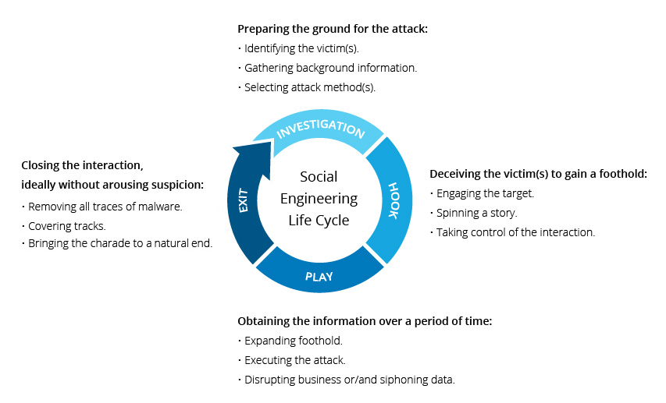
A social engineering attack is an umbrella term for a range of attacks that employ the use of human interactions in order to perform malicious acts. They use psychological manipulation in order to trick a person into possibly giving away their sensitive information, like passwords or financial information [1]. Common types of social engineering attacks include angler phishing (attacks carried out via spoof customer service accounts, usually through social media), business email compromise (emails claiming to be from senior members of staff within a company), pharming (redirecting traffic from legitimate sites to a malicious clone site), tabnabbing (rewriting unattended browser tabs for malicious purposes), as well as spear phishing and whaling (targeted phishing attacks aimed at specific companies or perhaps a high profile target, like a CEO)[2]. Social engineering can be divided into two types based on the performance of the attack. These are human-based social engineering and software-based social engineering. Human-based social engineering is conducted directly by another person. The attacker will interact directly with the target in order to gain information from them. Software-based social engineering attacks are attacks carried out with the help of a computer system in order to get the desired information. In contrast to human-based social engineering, there can be many more targets at once with software-based social engineering, and they are usually the method used for attacks such as spear phishing [3].

“The Social Engineering ‘Life Cycle’ [4]”

2.2 – Types of Social Engineering Attacks

2.2.1 – Angler Phishing
Due to increased use of social media by legitimate businesses in recent years, an emergence of attacks known as anger phishing attacks have emerged. Angler phishing attacks take advantage of the trust that users place in the social media accounts associated with these businesses and pose as the legitimated brands themselves, in order to lull them into a false sense of security [5]. A typical angler phishing attack may play out like this: a customer goes on to a social media site like Facebook, for example, to complain about their bank and the fact that they’re not happy with the service they’ve provided. A fake account using the same handle as their bank will directly message the user with a link, possible saying that the link will direct the user to an agent in order to sort the problem out [6]. Many of these scammers will have alert systems in place to tell them when a specific word gets mentioned in a post. This link they provide will install malicious software onto the user’s computer, gaining access to a lot of personal information. These attacks are simplistic in nature, but very effective and heavily utilised as a result [7][8].

2.2.2 – Spear Phishing
Spear phishing attacks are another form of phishing attacks. Unlike angler phishing, these attacks are tailored to target specific recipients. The target will normally be investigated beforehand in order to maximise the effectiveness of this attack. The motivation behind this act is the idea that personalisation creates trust between the attacker and the target, and the targets are usually high-profile individuals, so there is a quote-on-quote “higher return in investment” [9]. A lot of the time, government-sponsored hackers and hacktivists are behind these attacks. Cybercriminals take advantage of this and use that opportunity to resell data to governments and private companies. Due to the level of personalisation that goes into these stacks, even going as far as to make personalised websites, even top executives may find themselves accidentally falling for these attacks. They are less reliable than angler phishing attacks but have a much higher reward if they are successful [10].

2.2.3 – Whaling
Another form of phishing is whaling, which also leads on from the previous section about personalising a phishing attack to make it more effective. Whaling work similar to spear phishing, in which a high-profile target (referred to as a ‘whale’ because of their prominence in society), such as a CEO, celebrity or political figure is targeted by an attack [11]. One of the most effective things about these attacks is the belief that phishing attacks only affect frontline staff, whereas these attacks prove the opposite [12]. The reason for going after such targets is obvious, the higher up in an organisation you are, the more access to personal data you have. This is the case for CEOs. In the case of people like celebrities, they may take valuable data from them to sell to the press or threaten to leak them unless a certain amount is paid [13].

2.2.4 – Diversion Theft
Diversion theft is more of an obscure social engineering attack. This attack occurs when a scammer tricks a courier into dropping a package off at a wrong location, allowing the attackers to then intercept the package themselves [14]. They can alter the delivery schedule in a couple of ways, using spear phishing is a very common method. Diversion theft can also be used online to make a user send information to a wrong location, though it is more used as an umbrella term rather than a method, as most of these attacks involve that in some form [15].

2.2.5 – Baiting
The act of baiting is a social engineering attacks that relies on exploiting the target’s greed in order to get them to perform a malicious act without their knowledge. This could mean revealing sensitive information about themselves or perhaps company data. They could also trick the user into installing malware on to their system, meaning that the data could be used as ransomware [16][17]. The act of baiting is not restricted to online activites, physical devices such as USB memory sticks can be used as bait too. For example, a memory stick with a label on it stating “company records” could be left in an obvious. When an employee takes this stick and puts it into a computer, malware is installed instead [18].

2.2.6 – Honey Trap
A honey trap is another less known, but commonly utilised type of social engineering attack. It involves the attacker posing as an individual that could be deemed as attractive to the victim, and act as interested potential romantic partner, in order to trick the target into performing malicious acts, such as giving away vita information [19]. These attacks are most commonly used on online dating sites, where people will usually have their guard down, as the users on them sites will be interested in looking for a partner, so it will not be seen as suspicious [20]. These attacks aren’t just used for malicious acts, many companies will offer to set up a honey trap in exchange for money in order to test if an individual is cheating on their significant other, though there are many ethical issues surrounding this [21][22].

2.2.7 – Pretexting
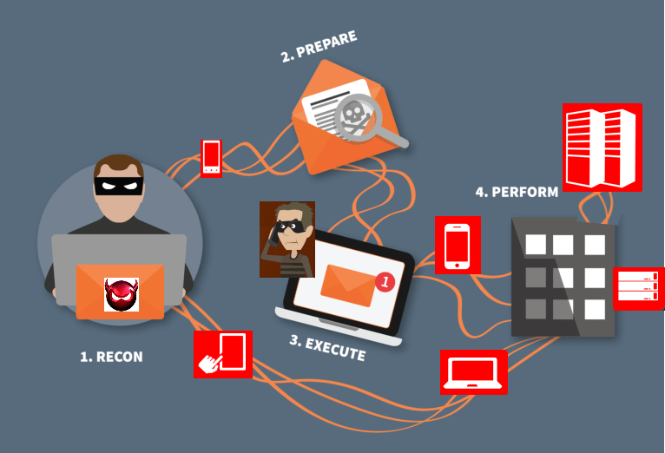
A pretexting attack is another form of social engineering attack. It involves an attacker building up a fictitious scenario in order to increase the likeliness of the target giving away sensitive information. To sum it up, the attacker is giving the attacks ‘pretext’, hence the name [23][24]. This approach means that the attack can reach a large audience, if it is general enough to apply to many different target’s circumstances, though pretexting is slowly being phased out with the growing suspicion of unsolicited messages from internet users [25]. As a result, more personalisation is needed for these messages, as discussed earlier, as this will reap bigger rewards. One of the other main reasons this attacks in not used as often anymore is that there is not much point in using publicly available data to pretext messages, as the targets with publicly available data are not worth going after, as they will not be deemed as important as someone such as a CEO, for example [26].

“The Pretexting Process [27]”

2.2.8 – SMS / Text Message Phishing
Yet another form of social engineering attack is SMS / text message phishing. This is also known as ‘SMIshing’. This is a phishing attack sent through the use of text messaging or using an SMS (short message service) in order to trick a user into committing malicious activities. It is not as commonly use in today’s world, as SMS and other text messaging systems have been phased out in place of online messaging systems, but they still happen regardless [28][29]. The most common method of utilising this attack is by sending a link to an unsuspecting user, posing as a legitimate company. For example, it could be a fake message from a courier, telling the user that their package has failed to be delivered, and to click the link to resend the parcel. This link, of course, will not redirect to a legitimate courier site, but may install malware on to the user’s device, or trick them into giving away sensitive information, such as their address [30]. Another attack that has come out in recent years is known as a VCFA (verification code forwarding attack). This is when an attacker requests a password reset from a user’s servicer provider, before immediately texting the user, posing as the service provider, to ask for that same verification code. With this, they can get access to all sorts of information [31].

2.2.9 – Scareware
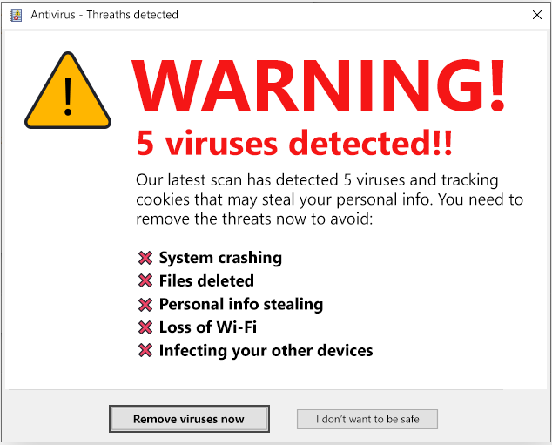
Scareware is a type of social engineering attacks that exploits a user’s fears in order to trick them into performing malicious acts. The most common method is tricking a user into thinking that they need to download some sort of program, possibly an antivirus, in order to keep their PC running [32]. An example of scareware could be a popup appearing on a website, claiming that the user’s PC has a virus, and that they need to download a program in order to get rid of it [33]. Scareware can also be used as a form of ransomware, with attackers bombarding the user’s PC with popups, possibly to the point of inoperability, then requesting a certain amount of money in order to make it operable again [34][35].

“An Example of a Scareware Popup [36]”

2.2.10 – Tailgating / Piggybacking
A tailgating attack occurs when an individual with unauthorised access to a certain area, or piece of information, closely shadows an unsuspecting individual that does have said authorisation in order to gain access to these restricted areas [37]. This can be something as simple as waiting for someone to leave a door unlocked to sneak in behind when they leave, or to wait for them to scan an access card to get into a building. It could also mean looking over their shoulder when they enter a password, or perhaps even impersonating someone else, like an employee or delivery man [38]. These attacks usually affect large businesses with huge staff turnovers, that would be less likely to spot a stray person within the building. Piggybacking works the same as tailgating, only that the “victim” is fully aware of the person shadowing them, and instead helping them gain access to the area, in what is known as an ‘insider attack’ [39][40].

2.2.11 – Watering Hole
A watering hole attack is another form of social engineering attack. It takes its name from the concept of a predator waiting for its prey by a watering hole in the wild, and the attack works in a similar, albeit less literal way. These attacks work by attackers researching individuals and the specific websites that they may visit on a daily basis. They then try to infect the website with malware, causing damage to the victim’s system [41][42]. These attacks follow the same philosophy as that of a spear phishing attack or a whaling attack, where personalisation of the attack can lead to greater results for the attacker, as watering hole attacks usually are saved for high profile targets such as a CEO [43]. If a target such as the one mentioned were to be hit by an attack, this could lead to the attacker gaining access to company assets or information, potentially allowing the attacker to create a cycle of repeating these same attacks utilising the data stolen [44].

2.3 – Common Mitigation Strategies to Prevent Social Engineering Attacks

2.3.1 – Foreword
The most vital thing to learn about social engineering attacks is that they are not easily preventable, due to them exploiting human nature, which is not a controllable variable by any means (more will be covered about this in section 2.4). However, there are some precautions a user can take in order to either prevent an attack from occurring in the first place, or at least minimise their chances to be targeted by these attacks. Listed below are a few of these methods.

2.3.2 – Source Checking
One way to protect a user from social engineering attacks is by always checking for potential sources of attacks whenever you are doing anything involved with data protection, or even just when simply browsing the web. Checking a website’s security is a great way to prevent any sort of malware from getting on your system [45]. A simple way you can do this is by checking the SSL certificate of the page, which sits in the URL bar of most browsers. Having an SSL certificate verifies that the website is the original and not a fake one deployed by a potential attacker and checking for this discrepancy takes less than a second [46].

2.3.3 – Breaking the Loop
Social engineering attacks often rely on a sense of urgency, with the attackers hoping that the victims will not pay too much attention to the situation and will instead just blindly do an action out of panic [47]. Therefore, it is important to “break the loop”. The user should think hard about these attacks and their authenticity, in order to expose these attacks for the fakes they are. Good methods to break the loop involve ringing the official number of the “company” that is contacting you or visiting the official website from a search engine results page, rather than clicking a link [48].

2.3.4 – Asking for ID
Asking for proof of identification from an individual can greatly reduce the risk of suffering from a physical social engineering attack. Attackers can easily walk through the front door of any unguarded office building with ease, so it is best to train your staff to always ask for identification [49]. Establishing a good security culture with your staff about these issues is always a good prevention method, regardless of what the attack type is, as this will hopefully always prepare them for any situation [50].

2.3.5 – Spam Filters
In the case of email or SMS phishing, spam filters could potentially be useful. Spam is defined as unwanted or unsolicited emails or text messages transmitted over a network [51]. These filters use heuristics, meaning they are subjected to thousands of predetermined rules and algorithms in order to determine what whether email is spam or not [52]. While these may help the average user, there are many arguments as to whether these filters are truly effective or not. There have been many reviews on some of these filters, and a lot of them are ineffective, with only a few being truly effective, therefore it is very important that the user is selective about what filter they use, as an ineffective spam filter could lead to a potential attack [53] [54] [55].

2.3.6 – Device Security
Whilst it may not necessarily stop a social engineering attack altogether, it is very important to ensure that a device’s security is up to date, as this alone could possibly lead to preventing an attack, especially in a business environment [56]. One method of securing a device is making sure any antivirus software programs are up to date [57]. Another method may include ensuring that your device has a good password, by following a sound password policy. This can go a long way in ensuring your device is safe, as attackers may try to get into your device physically, and a password may hinder their efforts [58]. Finally, two factor authentication on a device ensures, again, that any attacker who tries to physically access a device will be stopped in their tracks [59].

2.3.7 – Reducing Digital Footprint
A user’s digital footprint refers to the trace that is left over from them whenever they use an online service or when someone posts about them online, such as on a forum or blog, for example [60]. Many companies use learning algorithms in order to learn about a user’s digital footprint, in order to deliver services that are more personalised to the user’s tastes. Example of companies that do this include Google, Facebook and Amazon, to name a few [61] [62]. Attackers may also use a user’s digital footprint against them, such as scouring through their social media in order to find out potential password names, or by gathering information about a target in order to make a convoluted, yet convincing phishing attack that will make it more likely to trick the user into giving away sensitive information [63]. While it may not be necessary to get rid of all your social media accounts, it may be good advice to double check that what you are posting online can’t be used in any way, as well as delete any accounts connected to services that you no longer use, as these can all provide personal details about a user.

2.4 – Related Work

2.4.1 – Advanced Social Engineering Attacks [64]
This research paper provides a taxonomy of well-known social engineering attacks, as well as an in-depth look of more advanced social engineering attacks on the knowledge worker. This paper differs from the author’s in that it is more focussed on the specific social engineering attacks that affect workers daily, whereas the types of attacks are only briefly covered in this project. It is very effective as a research source, as it goes into great detail about the many different attack types. It does lack content in regard to the mitigation methods, as it doesn’t tend to list any, solely focussing on the attacks themselves, meaning that it isn’t as useful on the mitigation method front. Nonetheless, it was interesting to analyse.

2.4.2 – Social Engineering Attacks: A Survey [65]
This paper was very useful when it came to researching the topic of social engineering attacks. It provides an in-depth survey about social engineering attacks, the classifications of them, detection strategies and prevention procedures. This paper covers everything that is being covered in this topic, with the exception of detection strategies, therefore it was very interesting to analyse. It also helped to provide the author with a general guideline on how to conduct a research survey, which will be done later in the project. Unlike the previous paper, it went fairly in-depth about some potential mitigation methods, including anti-phishing filters, which prompted the author to use it as starting point for researching their own section about prevention techniques.

2.4.3 – Identification of Social Engineering Attacks [66]
This next paper was interesting. It is a research study, a deep learning, custom-built CNN-based framework for the identification of social engineering attacks delivered through malicious advertisements is proposed. In the framework, the authors of the study implement federated learning on top of transfer learning in order to train an AI based on data collected through research on attack campaigns, in order to identify attacks as malicious ads or not. In the end, results show that the framework can indeed identify the ads with fairly impressive detection scores. This paper differs greatly from the author’s paper in that it dives into a software engineering aspect of these attacks and seeks to develop a way to stop certain attacks, whereas this paper’s purpose is to merely serve a research purpose. It shows that this topic can be research in a variety of ways, rather than just being purely researchable.

2.4.4 – Social Engineering Attacks: Recent Advances and Challenges [67]
This paper/article is very similar to the project author’s paper. It is a research article that presents recent, state-of-the-art social engineering attacks and the way attackers manipulate users into falling for them using various methods of deception. It then goes into the classification of these attacks, as well as listing a few mitigation methods. Therefore, as mentioned before, it is strikingly similar to the author’s paper. This paper as a research method was very useful, as it is one of the more recent pieces of research, meaning that the information was mostly up to date, having only been released last year in 2021. The paper is more focussed on the business side of social engineering attacks, as compared to the author’s paper, which aims to see how these attacks affect both businesses and personal user’s lives daily.

2.4.5 – Identification and Prevention of Social Engineering Attacks on an Enterprise [68]
As a result of the previous paper being more business focussed, the author decided to look for more papers that followed along the same topic. This research paper discusses the broad spectrum of social engineering attacks that can be used against an enterprise, and how a business can potentially use various effective methods to stop said attacks, as it agrees that businesses should always be prepared for any kind of attack that may be employed to exploit a weakness of an employee. It does go a tiny bit into more software-focussed attacks too, as well as social engineering attacks, though these were not seen as relevant or useful pieces of information for the author. It shares the same belief with a lot of the other research papers, in that it states that the employees are the weakest links of a business, as they are prone to manipulation, and this is much more effective than any code injection attack.

2.4.6 – Social Engineering Attacks During the COVID-19 Pandemic [69]
This paper was also very interesting for the author to read. It delves into how social engineering attack rates have gone up in recent times. It says that the COVID-19 pandemic has helped to set the stage for these attacks to happen, due to the massive increase of online users, due to lockdown restriction forcing vulnerable people to stay inside. These same vulnerable people are more likely to let their guard down and fall for social engineering attacks, due to many reasons, the main reason being them not being as technologically knowledgeable as someone, for example, in an enterprise environment. It does show that people will take advantage of any situation in order to initiate one of these attacks, no matter the circumstances, which is both interesting and sad to see.

2.4.7 – A Taxonomy of Social Engineering Defence Mechanisms [70]
These final two papers delved more into the mitigation methods that can be used to prevent social engineering attack. This research paper develops a taxonomy of social engineering defence mechanisms that can be used to develop materials for educational purposes, specifically for use in enterprises, which is where these attacks occur the most. In order to develop this taxonomy, a systematic literature review is conducted by the authors, in order to discern the main target points of these attacks, and the defence strategies regarding each point. This paper is interesting to the author, as they are also hoping to write a security report in their project, and this could be a key piece of literature that will help with the development of it.

2.4.8 – Strategies Used to Mitigate Social Engineering Attacks [71]
The final paper is a case study that explores strategies that CISOs use to prevent social engineering attacks within the organisations that they control. They used a group of 6 CISOs across 6 various-size organisations that use electronic transfer payment data across the west coast of the US, conducted through telephone interviews. The data was then analysed through the use of the interview transcript and various other methods, in order to identify any major themes. 3 major themes were identified, them being IT risks, security awareness and IT strategies. The study proposed that it was important to look at these 3 themes in order to come to a proper understanding of how to prevent these attacks from occurring. This was interesting for the author to look at, because they never considered using case studies in order to figure out how best to mitigate social engineering attacks.

2.5 - Conclusion
This concludes the literature review chapter for the project, which contains the research that was done prior to the primary research experiment. The main findings of this section include the many different types of social engineering attacks that affect people on a daily basis, as well as the various mitigation methods used to stop them, all found from various academic papers and websites on the internet. This section is split into 5 sections that all serve a different purpose.
The first section is a brief introduction to the research, containing a brief description of what defines a social engineering attack, and who the main targets of one might be. The second section lists various common social engineering attacks that may affect people’s lives daily, even if they may not realise it. The third section list various mitigation methods than any user can take in order to prevent a social engineering attack from happening, even if it is just advisory tips rather than actual prevention methods. The fourth and final section lists similar research projects and shows what other authors have done in a similar field to this project.
The next section will delve into the research methodology that was used throughout this project, specifically the literature review.

CHAPTER 3 – RESEARCH METHODOLOGY

3.1 – Introduction
This chapter will cover the research methodologies that were used within this project. Before anything else, the title of the project was researched, in order to see it’s relevant to the current situation going on in today’s society. The author believes the title’s project is relevant, as social engineering attacks are very prevalent in our society and have increased a fair amount in numbers due to recent events such as the COVID-19 pandemic. This report is aimed at IT professionals, mainly in an enterprise environment, but it can also be perceived as general advice for any user with personal information that they want to protect.
Chapter 1 of this section will be a brief introduction to the research methodology section. Chapter 2 will contain an overview of the research process, including going through the stages of research in order, and how they were undertaken. Chapter 3 will delve into the design of the research, explaining how the methods utilised will be used to achieve the aims and objectives set out for the project, and what outcomes are expected from the research. Chapter 4 will go into the verification that the data collected draws the right conclusion. Finally, chapter 5 will include a summary of the chapter’s contents, in the form of a conclusion.

3.2 – Research Overview

3.2.1 – Research Process
The aim of this research is to develop a model of research, upon which an adaptive system can be built. There are two different processes used for approaching research. One is inductive research, where data will be gathered, then conclusions will be gathered from said data. This is as compared to a deductive approach, where a hypothesis is drawn from a pre-existing theory. The research for this project will be deductive, as the project will try some mitigation methods that are used to prevent social engineering attacks, and a security report will be made from the findings.

3.2.2 – Research Philosophy
There are 4 main types of research philosophies, them being pragmatism, positivism, realism and interpretivism. The philosophy of pragmatism accepts concepts to be relevant only if they support action. The philosophy of positivism is based on the use of data collection and hypothesis development. The philosophy of realism is pertained to disclose the truth of reality and the existence of objects that are prevalently independently in the human brain. Finally, the philosophy of interpretivism is focussed on assessing the differences between humans as social actors. The philosophy that will be used for this project is positivism, where the researcher will only acknowledge factual information and then draw a conclusion from it.

3.2.3 – Research Methodologies
There are 2 different strategies that can be employed when researching a topic. One is by employing the use of qualitative research, and the other is by doing quantitative research. Qualitative research is research that is expressed through the medium of words and is used in order to test or confirm assumptions and theories. Data collection methods of qualitative data includes methods such as interviews, focus groups and literature reviews. Quantitative research is research that is expressed through numbers and graphs. This project will use both mostly qualitative research methods, as a literature review has been carried out in order to find pre-existing theories. However, a quantitative research method will be used, in the form of a survey, as the primary research experiment.

3.2.4 – Data Collection
A research paper requires both primary and secondary research to be considered successful and effective. In the case of this project, most of the research will be from secondary sources, as this is a widely studied area of expertise, and the project heavily relies on the pre-existing work of others in order to develop a theory, or a security report in this case. The research comes from various research sources, such as research papers, journal entries and academic websites. The primary research on this project will be done in the form of a questionnaire, surveying people on their experience with social engineering attacks.

3.3 – Research Design
The research process will go as follows:
Quantitative
Survey
Qualitative
Quantitative
Literature Review
Qualitative

Security Report

“The Project Research Process [72]”

3.3.1 – Research Deliverables
The main deliverables of this project will be the literature review, the survey results, and the security report. The research from the literature review can be found in chapter 2 of this report. The results of the survey will be recorded and displayed in a graph format, which can be found in chapter 5 of the report. From these results, a security report will be recommended. This will be found in chapter 6 of the report, along with a general conclusion to the report.

3.4 – Triangulation
In order to draw the correct conclusion from the research, all data will have to be verified before a conclusion is reached. A few different methods will be used in order to verify the data’s integrity.
In regard to the literature review, all sources have been reviewed beforehand in order to check their accuracy and relevance to the project. Only academic sources have been analysed, consisting of research papers and websites, meaning that there is no bias in the per-existing information.
For the survey, all the responses will be filtered in order to pick out only appropriate answers, as any data anomalies may skew the results and make them inaccurate, leading to an unfair experiment.

3.5 – Conclusion
This concludes the research methodology section of the report. This chapter detailed the research strategies that were utilised during this project, as well as the overall research process. Data verification was also examined, in chapter 4 of this section.
The next section looks at the design and implementation of the primary research experiment.

CHAPTER 4 – DESIGN AND IMPLEMENTATION

4.1 – Introduction
This chapter will look at the design and implementation of the primary research experiment. The chosen experiment for this project was a survey, asking people about the various experiences they may have had with social engineering attacks and the steps they took to mitigate them.
The chapter will be split into 5 sections. Section 1 will be a brief introduction to the chapter, and detail what each section of the chapter will contain. Section 2 will look at how the experiment will relate to this project, and what the results hope to show. Section 3 will outline the design process of the experiment, and justify the decisions made during the process. Section 4 will look at how the experiment was implemented, and any problems that may come with it. Finally, section 5 will contain the conclusion to the chapter, with a brief summary of the chapter’s contents.

4.2 – Problem Formulation
The aim of the primary research experiment is to analyse what types of people are affected by social engineering attacks, and how prepared they are to deal with them in the event that they are targeted by one. It will hopefully give insight into how the average user will deal with one of these attacks.
The survey will be made with an online survey program called survey monkey. The only necessary equipment the participants will need to complete the survey is a compatible device, such as a computer, laptop, or tablet. The users will be giving consent by clicking on the link to answer the survey, more on this will be discussed in the implementation section (see chapter 4.4).

4.3 – Design
The survey consists of 6 questions. 5 of the questions are multiple choice, with the 6th being an open question, in order to not put anyone off from answering the survey, as longer surveys tend to not get answered, due to the participant not wanting to put the effort in.
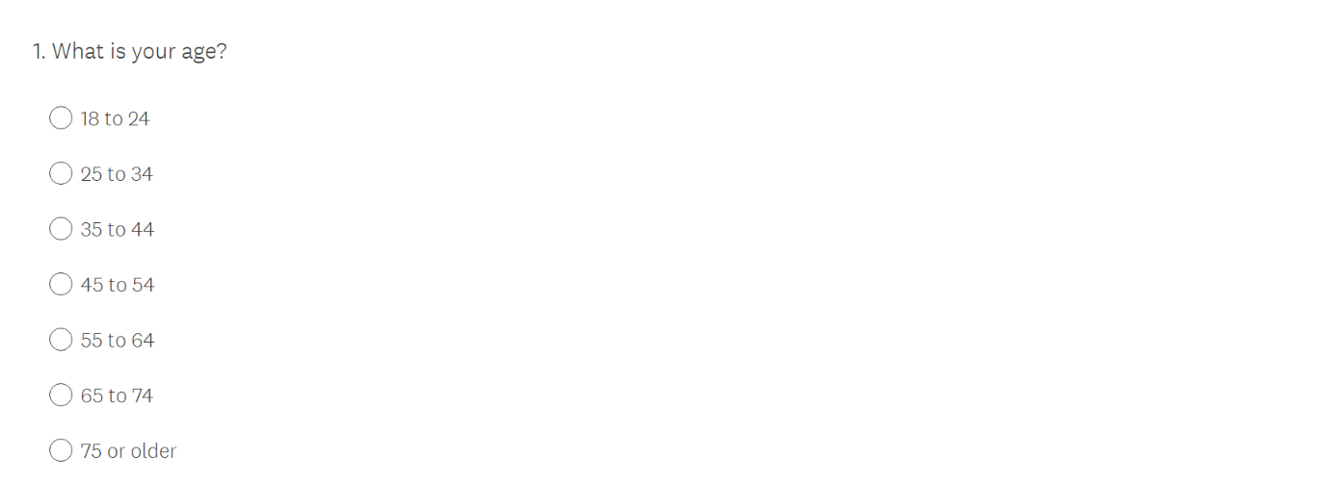
Therefore, it was ensured that the survey was made quick and easy to answer. The questions asked are as follows:
“Question 1 – What is your age? [73]”
The first question asks for the participant’s age, in the form of a multiple-choice answer. This gives insight on the age range of the participant’s and may possibly highlight a trend amongst certain age groups and their familiarity with social engineering attacks.
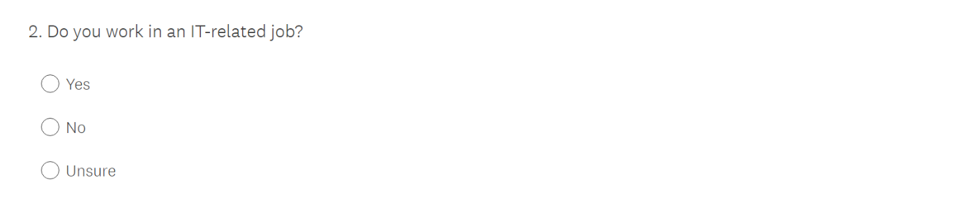
“Question 2 – Do you work in an IT-related job? [74]”
The next question served a similar purpose as the first, in that it looks to gather data about the participants, in order to find any trends. This trend in particular looks at the employment status of the participants, as it would be interesting to see if any participants who worked in the IT field has fallen victim to one of these attacks.

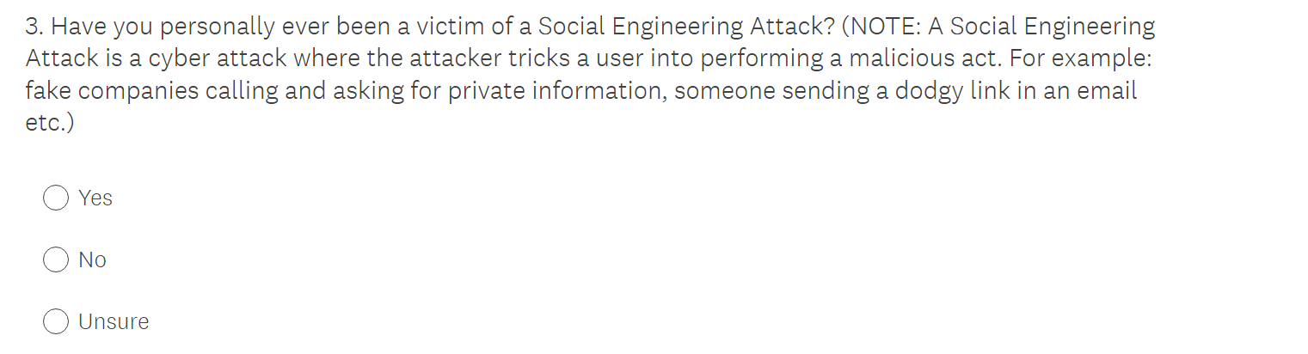
“Question 3 – Have you personally ever been a victim of a social engineering attack? [75]”
The next question is another multiple-choice question that asks the participant whether or not they have personally been a victim of a social engineering attack. This should hopefully get a lot of responses of either yes or no, but in case people are unsure of themselves, there is a box for that too. To remedy the uncertainty of the participant, an extremely brief explanation of social engineering attacks has been provided, and hopefully this will be enough.

“Question 4 – Has anyone you’ve ever known been a victim of one of these attacks? [76]”
The next question follows a similar vein and aims to do two things. The first aim is to check whether or not the participant has an understanding of what these attacks are, as hopefully all of the people who answered the first question with yes or no, should answer this one with the same. However, if someone answers both questions with ‘unsure’ then it is clear that the explanation was not good enough. The second aim is to act as an alternative for anyone who has not personally experienced a social engineering attack, to maybe gather data on whether or not they are aware of these attacks existing.

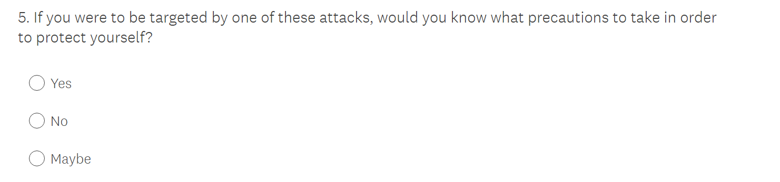
“Question 5 – If you were targeted by one of these attacks, would you know what precautions to take in order to protect yourself? [77]”
This is the first question that looks into the mitigation strategies that people may take. It is a multiple-choice question, asking the participants on whether or not they know what precautions to take in the event that they become a target of one of these attacks. This question is less fact-based than the previous ones, as it is down to the individual person whether or not they think they know how to protect themselves against something. Thus, the next question is also present…
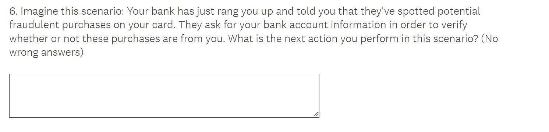
“Question 6 – Scenario [78]”
This is the last question, and the only open question in the survey. It asks the participant to picture a scenario, then write down the next action they would take in this event. It leads on from the previous question by determining whether or not they actually are prepared to deal with a social engineering attack scenario. If the survey has been understood, these answers should all be quite similar, so the question also doubles as an understanding test for the participant, and the results of it can be then reflected in the evaluation.

4.4 – Implementation
The survey will be sent out through the use of social media. The author will share it on their Facebook page, then encourage others to share it out as much as possible, in order to get a wide variety of answers from various people of all demographics. It will also be sent to various people within the author’s social circle, as they come from an IT background. In order to confirm consent, participants will be notified on what the survey is about and what it is in relation to.
The survey will be sent out over the course of a week, from Monday to Friday, in order to maximise the amount of time possible gathering answers. The work week was chosen as people may be less inclined to take a survey on their weekends off, and more people may be on a device whilst working, so the chance to see the survey is higher. The number of responses the author is hoping to gather is dependent on the quality and variety of the answers, but somewhere between 20 – 40 would be satisfactory.

4.5 – Conclusion
This concludes chapter 4 of this report. The research experiment will be a survey sent out to various individuals, consisting of 6 questions, mostly closed, and will gather responses over the course of a week. It hopes to outline the different types of users that are targeted by these attacks and how ready they are to protect themselves against them. The next chapter will look at the survey testing and evaluation of the results.

CHAPTER 5 – TESTING AND EVALUATION

5.1 – Experiment Testing
The survey, as planned, was sent out over the course of a week. It was shared through mainly through the use of social media, with the help of the author’s friends and family, who shared the link on their respective profile too. As a result of this, a wide array of responses was gathered. The original plan was to gather approximately 20-40 responses. When the author checked the survey at the end of the week, it had garnered over 70. The participants were thanked for their time in the survey response post, and the post was subsequently deleted in order to minimise the chance of any more responses.
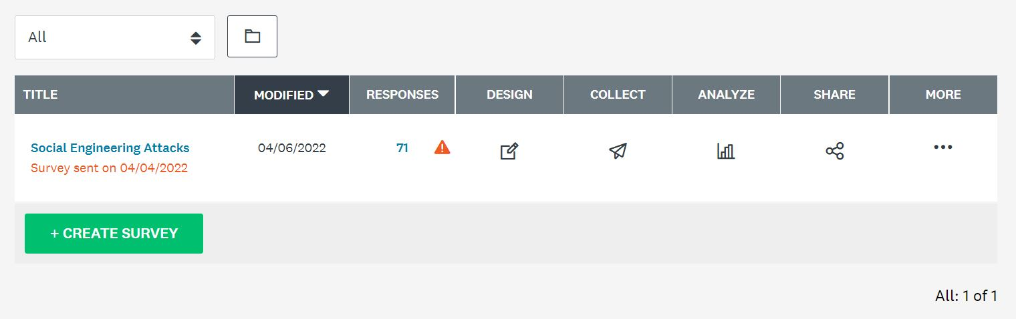
“Survey Responses [79]”
Having this many responses does come with its difficulties. Whilst it provides a better data spread of the closed questions, the final open textbox question seemed much more difficult to analyse, as each response now had to be gone through individually. This task did prove much simpler than the author though, however, as will be discussed in the next section (5.2 – Evaluation of the results).

5.2 – Evaluation of the Results
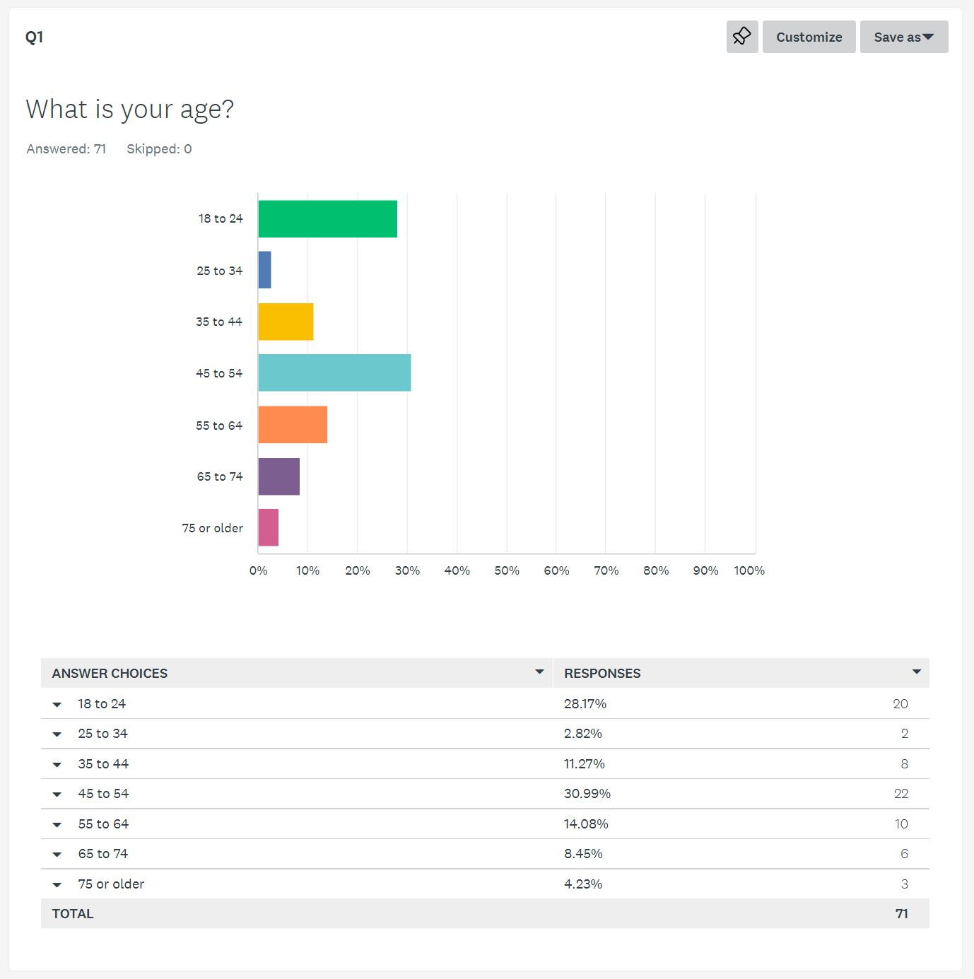
The first question asked in the survey was “What is your age?” (See figure 4.1). The author was surprised to see how varied the results were, as they expected the most responses to fall into the 18 – 24 range. However, here is what the final results looked like:
“Question 1 Responses [80]”
As is shown here, most of the participants actually fell into the 45 – 54 age range, with 18 – 24 coming in closely second, and participants aged 25 – 34 having the least responses. The author has a theory as to why this is the case. The family members that they asked to share the survey had significantly more social media connections, as compared to their own, so this is probably the reason why a lot of people in the 45 – 54 age range answered it.
The next question asked was “Do you work in an IT-related job?” (See figure 4.2). The author put this in expecting to get almost no responses in the ‘yes’ field, so they sent it out to an older relative in the IT business and asked them to spread it around to their colleagues. As a result of this, some responses from IT-related workers did end up in the results, and they ended up looking like this:
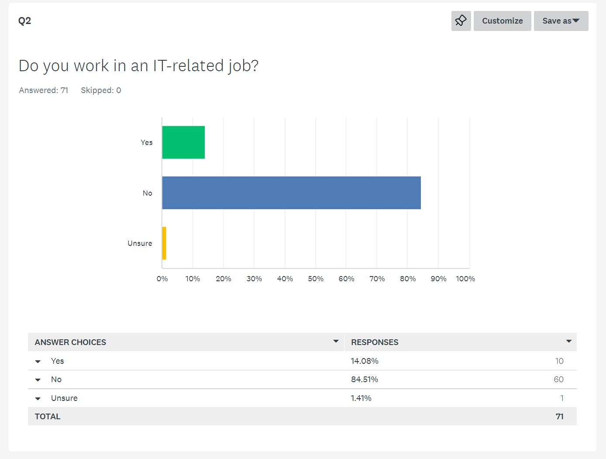
“Question 2 Responses [81]”
The result was, as expected, tipped in the favour of ‘no’ but, out of the 71 responses, a surprising 10 people said that they did work in the IT field. The author suspects that these are the results of the aforementioned relative’s colleagues and thought that they would be very helpful when it came to later questions. The outlying piece of data here is the one participant who marked ‘unsure’ as a response. This may be someone who has a job that consists of half IT-related tasks, and then half non-IT-related tasks, and didn’t know what to put as a result of that. This is the main reason why the author put this option on the first place, so it is being used correctly, which the author was happy to see.
The next question on the survey was “Have you personally even been a victim of a social engineering attack?” (See figure 4.3). This was the most important question on the survey, as the author was curious to see how many of the participants had actually experienced one of these attacks before:
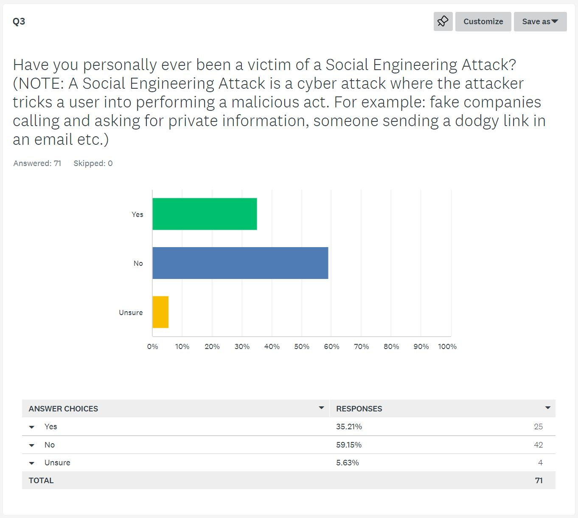
“Question 3 Responses [82]”
From the results, you can see that the majority of people haven’t experienced one of these attacks before, with 42 of the 71 respondents saying ‘no, 25 saying ‘yes’ and 4 being unsure of whether or not they’ve dealt with one of these attacks before. The author did expect there to be more ‘no’ answers, so this lined up with their expectations. The 4 participants who put ‘unsure’ could either have not understood what one of these attacks are, or just in fact don’t know whether or not they’ve been targeted by one of these attacks. Nevertheless, the explanation could be made clearer for next time.
The next question on the survey was “Has someone you’ve ever known been a victim of one of these attacks?” (See figure 4.4). The author expected the results of this one to be the inverse of the previous question, with most responses favouring ‘yes’, as a way of proving how often these attacks happen, as if someone wasn’t directly involved with one of these attacks, they may at least know someone who was. Here are the results of this question:
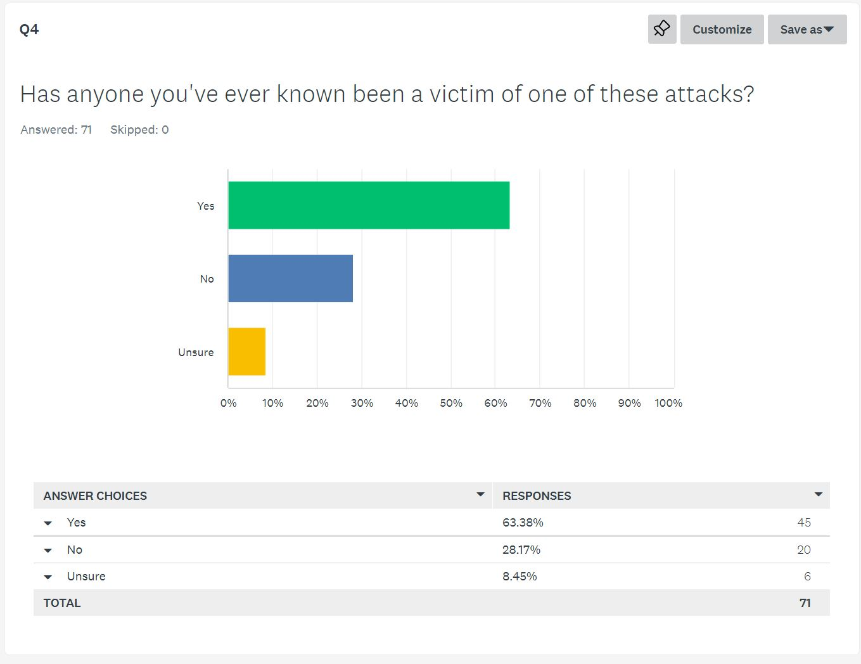
“Question 4 Responses [83]”
As expected, the results do indeed favour the ‘yes’ field, with 45 of the 71 responses being there, 20 putting that they don’t know anyone who has been affected by one of these attacks and 6 people being unsure. The uncertain responses were expected too, due to the fact that people such as friends may not be willing to share this fact with the participant in question, and tend to keep it on the quiet, either due to reasons such as embarrassment or just not thinking they need to talk about it. This question does in fact, as the author hoped, prove how common these attacks are in our society nowadays, so the question achieved what it set out to prove.
The final closed question on the survey asked, “If you were to be targeted by one of these attacks, would you know what precautions to take in order to protect yourself?” (See figure 4.5). The author didn’t know what to expect from this question because (as mentioned in chapter 4) this question is left down to personal opinion. Nevertheless, the author was still curious to see the results:
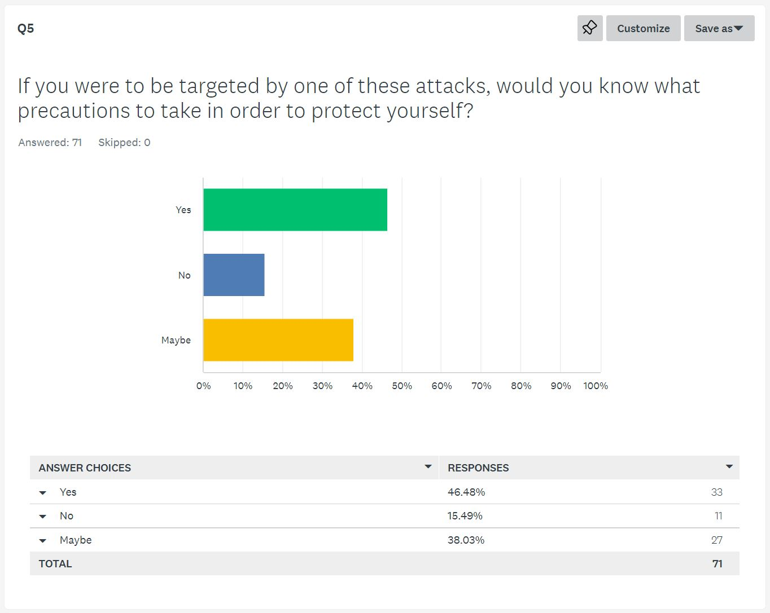
“Question 5 Responses [84]”
The responses were fairly surprising to the author. The majority of participants said that they could indeed protect themselves from these attacks, with 33 of the 71 responses going in that box. This could be due to a few reasons, such as people either not fully understanding what these attacks are and saying they can protect themselves in some form of overconfidence, or people just genuinely knowing that they can keep themselves safe from these attacks. The ‘unsure’ field had a very similar number of responses, albeit slightly less, so this is possibly where the author expected most of the responses to go. Factors such as the aforementioned IT colleagues could have affected this outcome.
The actual final question on the survey was an open question. It presented a scenario in which an attacker rings up the participants, posing as their bank, and asks them to hand over details in connection with potential fraudulent purchases spotted on their debit card. The question asks then what they would do in this situation (See figure 4.6). The results of this question were expected to greatly vary, so the results surprised the author:
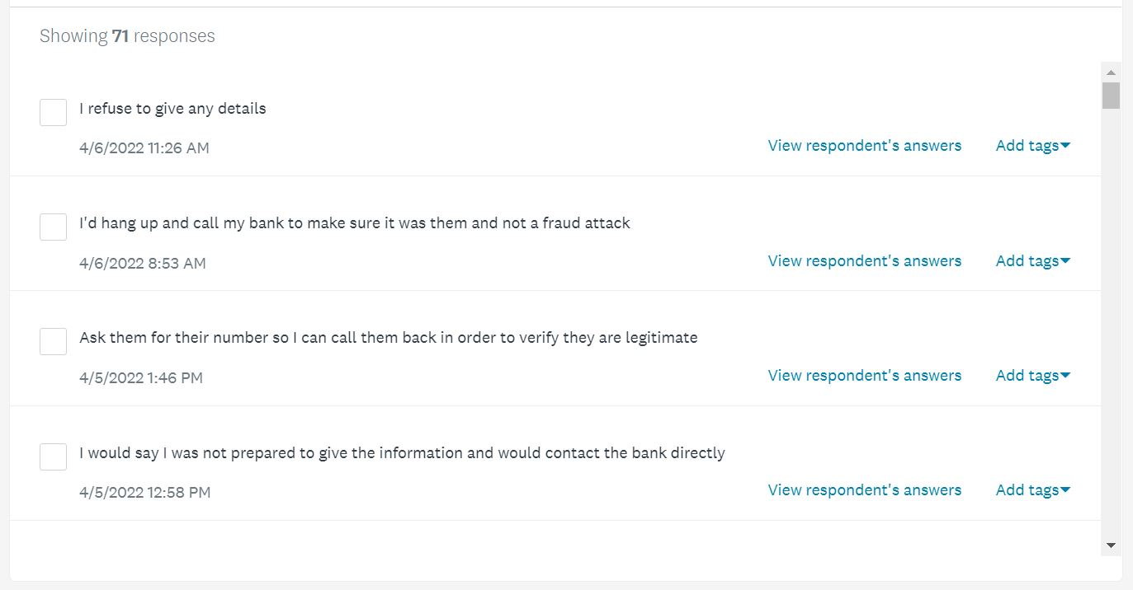
“Question 6 Responses Part 1 [85]”
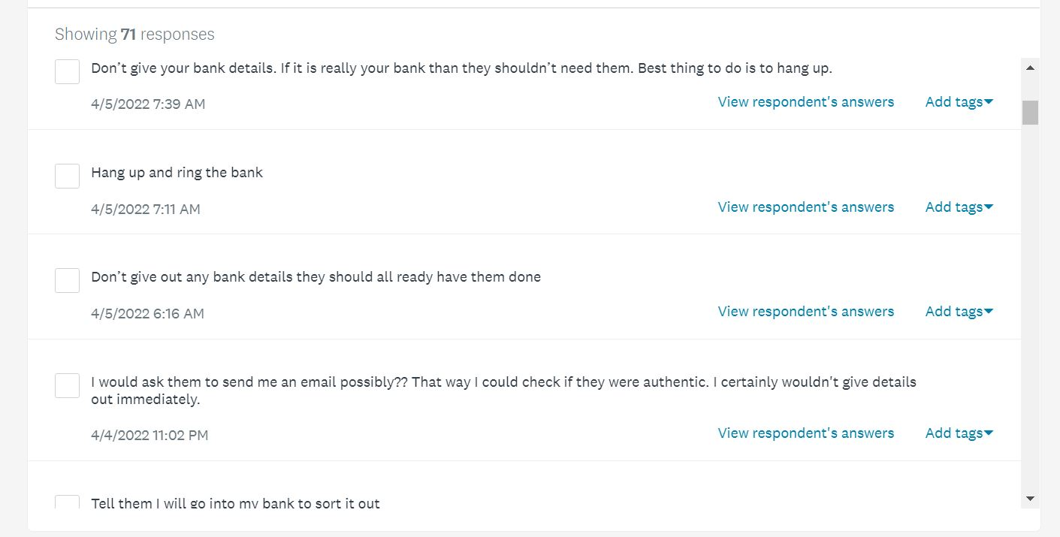
“Question 6 Responses Part 2 [86]”
This is just a small sample of the 71 responses but, much to the author’s surprise, all but 2 of the answers included people saying that they would not give the details, some saying they would hang up and others saying that they would contact their own bank to confirm whether or not the claims of fraud were true. The author didn’t know what they expected people to answer, but the fact that most of the responses did the sensible thing showed them a few possibilities as to why this happened.
The first theory as to why so many of the participants responded as such is because they were already on guard for any open questions as soon as they understood what the survey was about. As a result, they knew what a social engineering attack was, then knew that giving out information to “trusted” companies was a trap, and then responded as such. The second theory is that the author made the scenario too simple, and it was fairly obvious that you shouldn’t give out information to people with no firm credentials ringing you over the phone. As a few people in the responses pointed out, banks will not ring you. The third theory is that maybe the participants are just aware of how bad these attacks can be and would just genuinely perform this course of action in real life. Nevertheless, the author was happy to see that, even if they had only just learned what a social engineering attack was, people generally knew how to protect themselves from one.
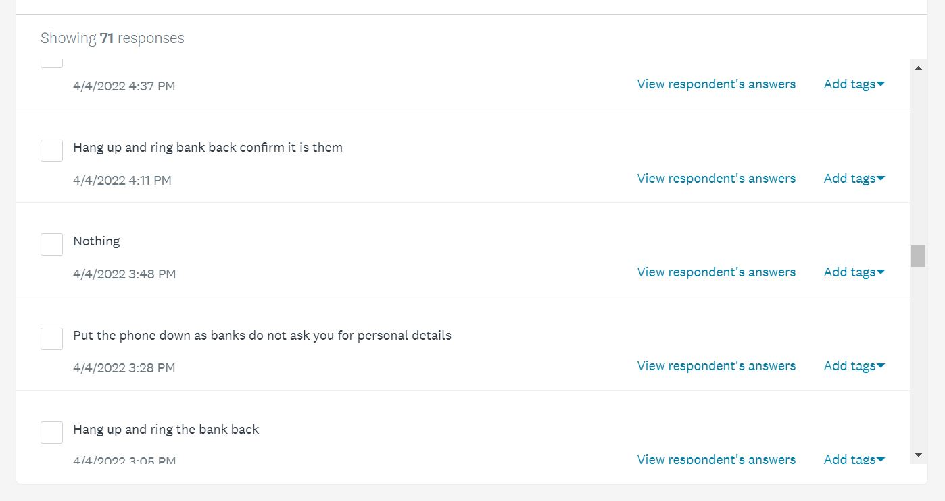
However, there were 2 results that did confuse the author. Here is the first:
“Question 6 Anomalous Result 1 [87]”
This response claimed that they would do “nothing” if this situation happened to them. The author was going to examine this result further but then decided that it was just a joke answer, which is a danger that comes with sending the survey out to family and friends. The other strange answer was this one:
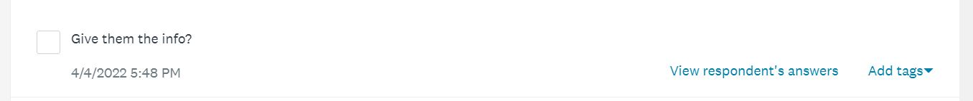
“Question 6 Anomalous Result 2 [88]”
This participant responded that they would “give them the info?” The question mark at the end here implied that they were also confused by the question, so their response was analysed further:
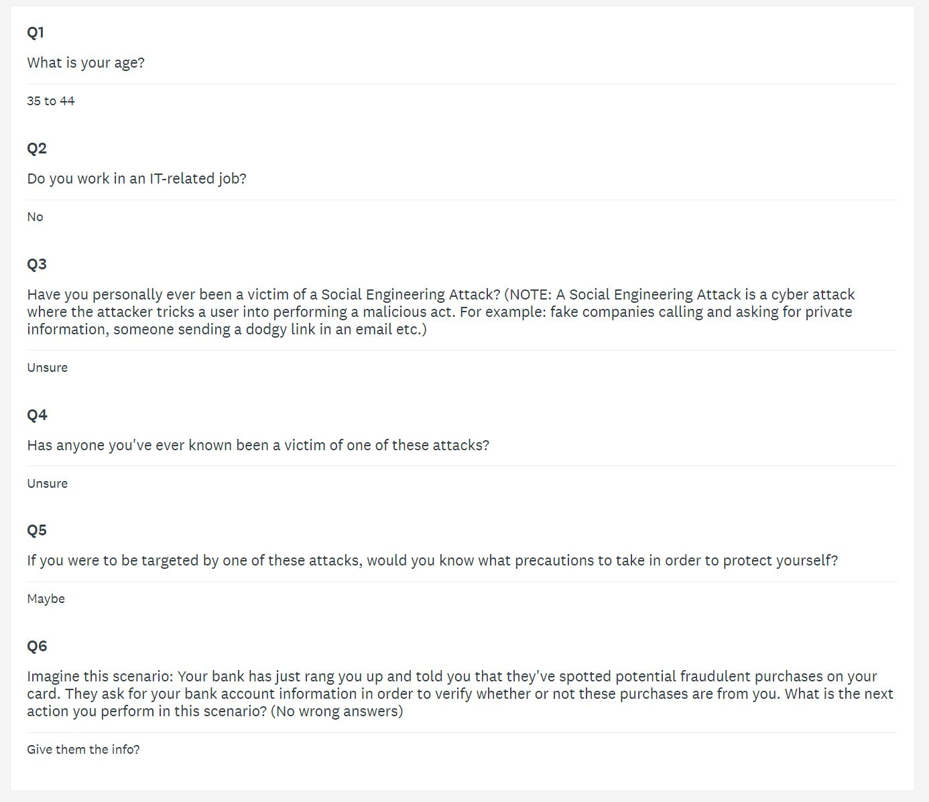
“Question 6 Anomalous Result 2 Analysis [89]”
The author was not as quick to write this response off as a joke one, as the participant seemed genuinely confused about the survey as a whole, answering most of the questions with the ‘unsure’ option. This could mean that the author should have put a clearer and more concise explanation of what one of these attacks are, in order to avoid any more potential confusion.

5.3 – Conclusion
This concludes the testing and evaluation section of this report. The author was surprised by both the number and quality of the responses received, and overall is pretty satisfied with how this research survey panned out. In the next section, a brief summary to the entire report will be laid out in the form of a conclusion.

CHAPTER 6 – CONCLUSION

6.1 – Analysis of the Aims and Objectives
At the start of this project, objectives were laid out, in order to provide a methodical way in which this project could achieve its aim. The project’s aim was to outline the many social engineering attacks that are utilised against unsuspecting users and companies on a daily basis, and what mitigation strategies can be taken in order to prevent them from happening, or just mitigate the damage they can do. To conclude the project, the author would overall say that the project was a success. In the next few sections, the objectives will be analysed on how effectively they were achieved during the course of this project.
The first objective was to research into the types of social engineering attacks that are utilised against unsuspecting users and companies on a daily basis, and outline what makes them so effective. This objective was achieved in chapter 2 of this report. The section talked about a many varieties of social engineering attacks, including some more uncommon ones, but mainly highlighted the common attacks that could affect anyone, such as phishing attacks. Details were also given on why they were so effective, so overall this objective was completed fully, and to great detail.
The second objective was to Research into the common mitigation strategies that most companies and users recommend, and outline how the average user can employ some of these methods in order to protect themselves. This was also, like the previous objective, achieved in the second chapter of this report. This was a very hard section to research, as there are not a lot of commonly agreed upon ways to prevent these attacks because they come in so many different shapes and sizes. However, many different mitigation methods were proposed, with advisory words on how the average user can employ them to protect themselves.
The third objective was to analyse and compare previous literature and experiments that relate to this topic and evaluate their usefulness to the project in question. Again, this was also done in chapter 2 of the report, which is where most of the content of this report is. Many different academic papers were analysed, and their usefulness to the current project was analysed briefly. Admittedly, the only way in which this objective may have been lacking in content was because not many experiments were analysed, but the author didn’t think that this would affect the project in the long run, and they were right. None of the papers showed that much evidence of any primary research evidence done, as they were mostly secondary research papers, just like the author’s. Therefore, they were quite helpful to the project.
The fourth and final objective was to perform a primary research experiment to gather data on the effectiveness of phishing attacks, and if users are prepared to protect themselves against them. This was achieved in chapters 4 and 5 of the report, where the experiment was carried out in the form of a research survey. This objective was achieved very well, as the survey got a lot more responses than the author was expecting, thus making the experiment a success. All of the results were varied, and gave a lot to analyse, and proved that people were much more prepared to deal with a common phishing attack than the author initially thought.

6.2 – Recommendations for Future Work
There are many more areas of research in this topic that future researchers could possibly look at if they decide to pursue this same academic field in the future. The field of cybersecurity, specifically social engineering attacks, is so widely vast that there are a lot of different methods that haven’t been talked about in this report, which could possibly greatly affect an individual or organisation. The author just did not find it necessary to go into these attacks, as the chances of being hit by one of them are quite low. However, this doesn’t mean they are impossible, so future papers could absolutely go into them and how to mitigate them.
Another area of recommendation for future work is the mitigation methods that can be used to mitigate these attacks. As mentioned a few times before in this project, there are not a lot of concrete ways to prevent these attacks, as a lot of them rely on human psychology, which is an unstable entry point. However, this doesn’t mean that there are absolutely no concrete ways at all. Password policies were very briefly covered in this report, but there are a lot more ways that these attacks can be mitigated by using tools such as that, and future papers could possibly go into that a bit more.

CHAPTER 7 – SELF EVALUATION

7.1 – Improvements to Future Study
Although this project was overall seen as a success, there are still some areas in which the author could have improved. The biggest problem the author encountered was the scope of the primary research experiment. The experiment was originally planned to be much more intricate than just a research survey. Originally, the author planned to send hoax emails out to various students of a specific computing class, in the form of third-party company, then gather the emails of the students who clicked on the link within the emails. There were many technical limitations that the author encountered with this experiment setup that would have made it too unethical to carry out, so the author eventually had to abandon this experiment and make the project more research focussed as a result. The author could have found a way to change this experiment to make it more ethical, but they chose to do a survey instead out of fear of time constraints. If the author managed their time more efficiently, the primary research could have been of a much higher quality than what it currently is.

7.2 – Personal Benefit
Despite the problems, the author managed to greatly benefit from this project in many ways too. One way the author benefited is by doing a heavy amount of research, which was a massive boost to their researching skills. Because of this project, the author can now greatly increase their research quality in future projects. Another way the author benefited from this project is learning a lot more about the world of cybersecurity. Before this project, the author just thought that most attacks done on a network were all done digitally, but after doing the research they found out just how many network attacks were started by something as simple as an employee accidentally clicking on a link in an email. This really broadened the author’s perspectives on IT as a whole. Finally, the completion of the project brought great satisfaction and pride to the author, who will be proud of this achievement for years to come.

7.3 – Project Management
At the start of this project, a Gantt chart was created in order to manage the user’s time a bit better, this will be included in the appendices. This chart was very loosely stuck to, leading to lots of time crunches with this project, meaning that the author has to massively improve their time managements skills. The longest section of this report that took to complete was the literature review, as lots of research had to be done for this topic. The research experiment didn’t take that long to complete but could have possibly garnered more results if more time was given to it. All in all, this project was managed mostly fine, but there is definitely room for improvement.

CHAPTER 8 – REFERENCE LIST
[1] Imperva.com, “Social Engineering”, 2016. [Online] [Available at: https://www.imperva.com/learn/application-security/social-engineering-attack/]
[2] ITGovernance.co.uk, “What is Social Engineering | Techniques and Prevention”, 2019. [Online] [Available at: https://www.itgovernance.co.uk/social-engineering-attacks]
[3] A.Koyun, E.A.Janabi, “Social Engineering Attacks”, JMEST, Vol.4. Issue 6, June 2017. [Online] [Available at: https://www.jmest.org/wp-content/uploads/JMESTN42352270.pdf]
[4] “Social Engineering Life Cycle”.
[5] L.O’Hagan, “Angler Phishing: Criminality in Social Media”, ECSM 2018 5th European Conference on Social Media, 2018. [Online] [Available: https://books.google.co.uk/books?hl=en&lr=&id=b09mDwAAQBAJ&oi=fnd&pg=PA190&dq=angler+phishing&ots=Al4uIoszs7&sig=kfpW4-AuwQ0KyGosiPm7W0eDUCc&redir_esc=y#v=onepage&q=angler%20phishing&f=false]
[6] Experian.com, “What is Angler Phishing and How Can You Avoid it?”, 2018. [Online] [Available at: https://www.experian.com/blogs/ask-experian/what-is-angler-phishing-and-how-can-you-avoid-it/]
[7] Velocitmsp.com, “What is Angler Phishing”, 2020. [Online] [Available at: https://www.velocitmsp.com/angler-phishing/]
[8] G.Sonowal, “Types of Phishing”, Phishing and Communication Channels, pp. 25-50. Apress, Berkeley, CA. 2022. [DOI: https://doi.org/10.1007/978-1-4842-7744-7_2]
[9] J.Bullee, L.Montoya, M.Junger, P.Hartel. "Spear phishing in organisations explained", Information and Computer Security, Vol. 25 No. 5, pp. 593-613. 2017. [DOI: https://doi.org/10.1108/ICS-03-2017-0009]
[10] Kapersky.co.uk, “What is Spear Phishing”, 2014. [Online] [Available at: https://www.kaspersky.co.uk/resource-center/definitions/spear-phishing]
[11] D.Pienta, JB.Thatcher, A.Johnston, “Protecting a whale in a sea of phish”, Journal of Information Technology, vol. 35, issue 3, pp. 214-231, 2020. [DOI:10.1177/0268396220918594]
[12] R.Rutherford, “The Changing Face of Phishing”, Computer Fraud and Security, vol. 2018, issue 11, pp. 6-8, 2018. [DOI: https://doi.org/10.1016/S1361-3723(18)30107-6]
[13] Rapid7.com, “What is a Whaling Phishing Attack?”, 2018. [Online] [Available: https://www.rapid7.com/fundamentals/whaling-phishing-attacks/]
[14] ITPerfection.com, “Social Engineering Attacks”, 2020. [Online] [Available at: https://www.itperfection.com/network-security/social-engineering-attacks-cybersecurity-cyber-attacks-network-security-baiting-diversion-theft-scareware-spear-phishing-quidpro-water-holing/]
[15] NetworkMidlands.co.uk, “What is Diversion Theft?”, 2020. [Online] [Available at: https://www.network-midlands.co.uk/what-is-diversion-theft/]
[16] KeepNetLabs.net, “Baiting”, 2020. [Online] [Available at: https://www.keepnetlabs.com/baiting/]
[17] Datto.com, “5 Types of Social Engineering”, 2020. [Online] [Available at: https://www.datto.com/uk/blog/5-types-of-social-engineering-attacks]
[18] Medium.com, “Social Engineering: What is Baiting?”, 2016. [Online] [Available at: https://medium.com/@Mailfence/social-engineering-what-is-baiting-747255c55a52]
[19] HailBytes.com, “What is Social Engineering?”, 2021. [Online] [Available at: https://hailbytes.com/what-is-social-engineering/]
[20] SecureList.com, “Honey Traps on the Internet”, 2013. [Online] [Available at: https://securelist.com/honey-traps-on-the-internet/36854/]
[21] AreTheySafe.com, “Honey Trapping”, 2022. [Online] [Available at: https://aretheysafe.co.uk/honey-trapping/]
[22] N.Shaw, “You can Hire a Honey Trapper to Check on your Partner, or Even Become One”, WalesOnline, Dec 2019. [Online] [Available at: https://www.walesonline.co.uk/news/uk-news/you-can-hire-honey-trapper-17355732]
[23] S.Lohani, “Social Engineering: Hacking into Humans”, International Journal of Advanced Studies of Scientific Research, Vol. 4, Issue No. 1, 2019. [Online] [Available at SSRN: https://ssrn.com/abstract=3329391]
[24] D.Irani, M.Balduzzi, D.Balzarotti, E.Kirda, C.Pu, “Reverse Social Engineering Attacks in Online Social Networks”, Detections of Intrusions and Malware, and Vulnerability Assessment in DIMVA 2011 Lecture Notes in Computer Science, Vol. 6739, pp. 55-74, 2011. [DOI: https://doi.org/10.1007/978-3-642-22424-9_4]
[25] A. S. Alazri, "The awareness of social engineering in information revolution: Techniques and challenges," 2015 10th International Conference for Internet Technology and Secured Transactions (ICITST), pp. 198-201, 2015. [DOI: 10.1109/ICITST.2015.7412088]
[26] CSOOnline.com, “What is Pretexting? Definition, Examples and Prevention”, 2020. [Online] [Available at: https://www.csoonline.com/article/3546299/what-is-pretexting-definition-examples-and-prevention.html]
[27] “The Pretexting Process”.
[28] S. Mishra, D. Soni, “SMS Phishing and Mitigation Approaches”, 2019 Twelfth International Conference on Contemporary Computing (IC3), pp. 1-5, 2019. [DOI: 10.1109/IC3.2019.8844920.]
[29] E. O. Yeboah-Boateng, P. Amanor, “Phishing, SMiShing & Vishing: An Assessment of Threats Against Mobile Devices”, Journal of Emerging Trends in Computing and Information Sciences, Vol. 5, Issue No.4, pp. 297 – 298, 2014. [ISSN: 2079-8407]
[30] Barracuda.com, “Smishing (SMS Phishing)”, 2018. [Online] [Available at: https://www.barracuda.com/glossary/smishing]
[31] M. Jakobsson, “Two-Factor Inauthentication – The Rise in SMS Phishing Attacks”, Computer Fraud and Security, Vol. 2018, Issue 6, pp. 6-8, 2018. [DOI: https://doi.org/10.1016/S1361-3723(18)30052-6]
[32] ForcePoint.com, “What is Scareware?”, 2019. [Online] [Available at: https://www.forcepoint.com/cyber-edu/scareware]
[33] J.Giles, “Scareware: The Inside Story”, NewScientist, Vol. 205, Issue 2753, pp. 38-41, 2010. [DOI: https://doi.org/10.1016/S0262-4079(10)60731-2]
[34] C. Beaman, A. Barkworth, T. D. Akande, S. Hakak, M. Khan, “Ransomware: Recent Advances, Analysis, Challenges and Future Research Directions”, Computers and Security, Vol. 111, 2021. [DOI: https://doi.org/10.1016/j.cose.2021.102490]
[35] A. Kumari, M. Bhuiyan, J. Namdeo, S. Kanaujia, R. Amin, S. Vollala, “Ransomware Attack Protection: A Cryptographic Approach”, Security, Privacy, and Anonymity in Computation, Communication and Storage in Lecture Notes in Computer Science, vol. 11611, pp. 15-25, 2019. [DOI: 10.1007/978-3-030-24907-6_2]
[36] “An example of a Typical Scareware Popup.”
[37] I. Ghafir, V. Prenosil, A. Alhejailan, M. Hammoudeh, “Social Engineering Attack Strategies and Defence Approaches”, 2016 IEEE 4th International Conference on Future Internet of Things and Cloud (FiCloud), pp. 145-149, 2016. [DOI: 10.1109/FiCloud.2016.28.]
[38] T. Li, Y. Ni, “Paving Ontological Foundation for Social Engineering Analysis”, Advanced Information Systems Engineering. CAiSE 2019 in Lecture Notes in Computer Science, vol. 11483, pp. 246-260, 2019. [DOI: https://doi.org/10.1007/978-3-030-21290-2_16]
[39] CyberTalk.org, “What is Tailgating and Why it Matters”, 2021. [Online] [Available at: https://www.cybertalk.org/2021/11/12/tailgating-social-engineering-attacks-what-is-tailgating-and-why-it-matters/]
[40] TechSlang.com, “What is a Tailgating Attack?”, 2021. [Online] [Available at: https://www.techslang.com/definition/what-is-a-tailgating-attack/#:~:text=A%20tailgating%20attack%2C%20also%20referred,person%20into%20a%20restricted%20location.]
[41] P.Chen, L.Desmet, C.Huygens, “A study on Advanced Persistent Threats”, IFIP International Conference on Communications and Multimedia Security in Lecture Notes in Computer Science, Vol 8753, pp 63-72, 2014. [DOI: https://doi.org/10.1007/978-3-662-44885-4_5]
[42] K. Ismail, M. Singh, N. Mustaffa, P. Keikhosrokiani, Z. Zulkefli, “Security Strategies for Hindering Watering Hole Cyber Crime Attacks”, Procedia Computer Science, Vol 124, pp 656-663, 2017. [DOI: https://doi.org/10.1016/j.procs.2017.12.202]
[43] T. Subburaj, K. Suthendran, “Digital Watering Hole Attack Detection using Sequential Pattern”, Journal of Cyber Security and Mobility, Vol 8, Issue 1-2, 2018. [DOI: https://doi.org/10.13052/2245-1439.711]
[44] RGCS.co.uk, “Tech Insight: What is a ‘Watering Hole’ Attack?”, 2022. [Online] [Available at: Tech Insight: What Is A ‘Watering Hole’ Attack? | Really Good Computer Support (rg-cs.co.uk)]
[45] CISA.gov, “Avoiding Social Engineering and Phishing Attacks”, 2020. [Online] [Available at: Avoiding Social Engineering and Phishing Attacks | CISA]
[46] CloudFlare.com, “What is an SSL Certificate?”, 2022. [Online] [Available at: https://www.cloudflare.com/learning/ssl/what-is-an-ssl-certificate/]
[47] ContegoSecurity.com, “How to Avoid Social Engineering and Phishing Attacks”, 2021. [Online] [Available at: How to Avoid Social Engineering & Phishing Attacks | Contego Inc. (contegosecurity.com)]
[48] Forbes.com, “Using Neuroscience to Disrupt Social Engineering”, 2017. [Online] [Available at: Using Neuroscience To Disrupt Social Engineering (forbes.com)]
[49] Abass.I, “Social Engineering Threat and Defence: A Literature Survey”, Journal of Information Security, Vol. 9, Issue 4, pp 257-264, 2018. [DOI: 10.4236/jis.2018.94018]
[50] GRCELearning, “5 Ways to Mitigate Social Engineering Attacks,” 2021. [Online] [Available at: 5 ways to mitigate social engineering attacks - GRC eLearning Blog]
[51] MailChannels.com, “What is Spam Filtering?”, 2019. [Online] [Available at: https://www.mailchannels.com/what-is-spam-filtering/]
[52] S. Delaney, M.Buckley, D.Greene, “SMS Spam Filtering: Methods and Data”, Expert Systems with Applications, Vol. 39, Issue 10, pp 9899-9908, 2012. [DOI: https://doi.org/10.1016/j.eswa.2012.02.053]
[53] S. M. Abdulhamid et al, "A Review on Mobile SMS Spam Filtering Techniques," IEEE Access, Vol. 5, pp 15650-15666, 2017, [DOI: 10.1109/ACCESS.2017.2666785.]

[54] A.Bhowmick, S.Hazarika, “E-Mail Spam Filtering: A Review of Techniques and Trends”, Advances in Electronics, Communication and Computing in Lecture Notes in Electrical Engineering, Vol. 4, pp 583-590, 2017. [DOI: https://doi.org/10.1007/978-981-10-4765-7_61]
[55] E.Dada, J.Bassi, H.Chiroma, S.Abdulhamid, A.Adetunmbi, O.Ajibuwa, “Machine Learning for Email Spam Filtering: Review, Approaches and Open Research Problems”, Heliyon, Vol. 5, Issue 6, 2019. [DOI: https://doi.org/10.1016/j.heliyon.2019.e01802]
[56] R. Palanisamy, A. Norman, L. Kiah, “Compliance with Bring your own Device Security Policies in Organisations: A Systematic Literature Review”, Computers and Security, Vol 98, 2020. [DOI: https://doi.org/10.1016/j.cose.2020.101998]
[57] O. Sukwong, H. Kim, J. Hoe, “Commercial Antivirus Software Effectiveness: An Empirical Study”, Computer, Vol 44, pp 63-70, 2011. [DOI: 10.1109/MC.2010.187]
[58] PandaSecurity.com, “8 Mobile Security Tips to Keep your Device Safe”, 2019. [Online] [Available: 8 Mobile Security Tips to Keep Your Device Safe - Panda Security]
[59] P.Gope, B.Sikdar, "Lightweight and Privacy-Preserving Two-Factor Authentication Scheme for IoT Devices," IEEE Internet of Things Journal, Vol. 6, Issue. 1, pp. 580-589, 2019. [DOI: 10.1109/JIOT.2018.2846299.]
[60] CPNI.gov.uk, “My Digital Footprint”, 2021. [Online] [Available: My digital footprint | CPNI]
[61] U. Peters, “Reclaiming Control: Extended Mindreading and the Tracking of Digital Footprints”, Social Epistemology, 2022. [DOI: 10.1080/02691728.2021.2020366]
[62] E. Orlova, “Methodology and Models for Individuals’ Creditworthiness Management using Digital Footprint Data and Machine Learning Methods”, Mathematics, 2021. [DOI: https://doi.org/10.3390/math9151820]
[63] MitnickSecurity.com, “How Social Engineers use your Digital Footprint Against you”, 2021. [Online] [Available: How Social Engineers Use Your Digital Footprint Against You (mitnicksecurity.com)]
[64] K. Krombholz, H. Hobel, M. Huber, E. Weippl, “Advanced Social Engineering Attacks”, Journal of Information Security and Applications, Vol. 22, pp 113 – 122, 2015. [DOI: https://doi.org/10.1016/j.jisa.2014.09.005]
[65] F. Salahdine, N. Kaabouch, “Social Engineering Attacks: A Survey”, Future Internet, 2019. [DOI: https://doi.org/10.3390/fi11040089]
[66] R. Jyani, "Identification of Social Engineering Attacks." Order No. 28646174, University of Georgia, Ann Arbor, 2021.
[67] N. Mashtalyar, U. Ntaganzwa, T. Santos, S. Hakak, S. Ray, “Social Engineering Attacks: Recent Advances and Challenges”, HCI for Cybersecurity, Privacy and Trust in HCII 2021. Lecture Notes in Computer Science, Vol. 12788, pp 417 – 431, 2021. [DOI: 10.1007/978-3-030-77392-2_27]
[68] P. Parthy, G. Rajendran, “Identification and Prevention of Social Engineering Attacks on an Enterprise”, 2019 International Carnahan Conference on Security Technology (ICCST), pp. 1-5, 2019. [DOI: 10.1109/CCST.2019.8888441.]
[69] V. Sushruth, K. Reddy, B. Chandavarkar, “Social Engineering Attacks during the COVID-19 Pandemic”, SN Computer Science, 2021. [DOI: https://doi.org/10.1007/s42979-020-00443-1]
[70] D. Alharthi, M. Hammad, A. Regan, “A Taxonomy of Social Engineering Defence Mechanisms”, Advances in Information and Communication FICC 2020 in Advances in Intelligent Systems and Computing, Vol. 1130, pp 27-41. [DOI: https://doi.org/10.1007/978-3-030-39442-4_3]
[71] L. Hove, "Strategies used to Mitigate Social Engineering Attacks." Order No. 28149753, Walden University, Ann Arbor, 2020.
[72] “The Project Research Process”
[73] “Question 1 – What is your age?”
[74] “Question 2 – Do you work in an IT-related job?”
[75] “Question 3 - Have you personally ever been a victim of a Social Engineering Attack?”
[76] “Question 4 - Has anyone you've ever known been a victim of one of these attacks?”
[77] “Question 5 - If you were to be targeted by one of these attacks, would you know what precautions to take in order to protect yourself?”
[78] “Question 6 - Imagine this scenario: Your bank has just rang you up and told you that they've spotted potential fraudulent purchases on your card. They ask for your bank account information in order to verify whether or not these purchases are from you. What is the next action you perform in this scenario?”
[79] “Survey Responses”
[80] “Question 1 Responses”
[81] “Question 2 Responses”
[82] “Question 3 Responses”
[83] “Question 4 Responses”
[84] “Question 5 Responses”
[85] “Question 6 Responses Part 1”
[86] “Question 6 Responses Part 2”
[87] “Question 6 Anomalous Result 1”
[88] “Question 6 Anomalous Result 2”
[89] “Question 6 Anomalous Result 2 Analysis”

APPENDIX

Appendix 1 – Ethics Form

APPLICATION FOR ETHICAL APPROVAL

In order for research to result in benefit and minimise risk of harm, it must be conducted ethically.

The University follows the OECD Frascati manual definition of research activity: “creative work undertaken on a systematic basis in order to increase the stock of knowledge, including knowledge of man, culture and society, and the use of this stock of knowledge to devise new applications”. As such this covers activities undertaken by members of staff, postgraduate research students, and both taught postgraduate and undergraduate students working on dissertations/projects.

The individual undertaking the research activity is known as the “principal researcher”.

This form must be completed and approved prior to undertaking any research activity.

SECTION A: About You (Principal Researcher)
1 | Full Name: | James Phillip Richard Gau
2 | Student Number: | 1910799
3 | Email address: | 1910799@student.uwtsd.ac.uk
4 | Programme of Study: | BSc Applied Computing
5 | Director of Studies/Supervisor: | Dr Kapilan Radhakrishnan

SECTION B: Internal and External Ethical Guidance Materials
 | Please list the core ethical guidance documents that have been referred to during the completion of this form (including any discipline-specific codes of research ethics, location-specific dodes of research ethics, and also any specific ethical guidance relating to the proposed methodology). Please tick to confirm that your research proposal adheres to these codes and guidelines. You may add rows to this table if needed.
1 | UWTSD Research Ethics & Integrity Code of Practice | ☒
2 | UWTSD Research Data Management Policy | ☒
3 | Data Protection Act 2018 | ☒

SECTION C: Details of Research Activity
1 | Indicative title: | Social Engineering Attacks and Mitigation Techniques
2 | Proposed start date: | 10/10/2021 | Proposed end date: | 15/05/2021
Introduction to the Research (maximum 300 words in each section)
Ensure that you write for a Non-Specialist Audience when outlining your response to the three points below:
- Purpose of Research Activity
- Proposed Research Question
- Aims of Research Activity
- Objectives of Research Activity
Demonstrate, briefly, how Existing Research has informed the proposed activity and explain
- What the research activity will add to the body of knowledge
- How it addresses an area of importance.
3 | Purpose of Research Activity  To analyse and outline the different social engineering attacks that affect individuals, then outline and demonstrate mitigation techniques against them.  (this box should expand as you type)
4 | Research Question  What are the different types of social engineering attacks?  What are the different methods used to mitigate these attacks?  What guidelines can be proposed to help others with preventing these attacks?  (this box should expand as you type)
5 | Aims of Research Activity  To find the many different types of social engineering that affect individuals, and how aware they are of their existence.  (this box should expand as you type)
6 | Objectives of Research Activity  1. Create a survey asking individuals about their experiences with these attacks.  2. Collect the results and compare them with existing results from online research sources.  3. Display these results in my project.  (this box should expand as you type)
Proposed data collection methods (maximum 600 words)
Provide a brief summary of all the methods that may be used in the research activity to collect data, making it clear what specific techniques may be used. If methods other than those listed in this section are deemed appropriate later, additional ethical approval for those methods will be needed. You do not need to justify the methods here, but should instead describe how you intend to collect the data necessary for you to complete your project.
7 | The only data collection method used will be a survey, that will be sent out to various individuals through the use of social media, to ask about any experiences that people or their acquaintances have with social engineering attacks.  (this box should expand as you type)

SECTION D: Scope of Research Activity
 | Will the research activity include: | YES | NO
1 | Use of a questionnaire or similar research instrument? | ☒ | ☐
2 | Use of interviews? | ☐ | ☒
3 | Use of focus groups? | ☐ | ☒
4 | Use of participant diaries? | ☐ | ☒
5 | Use of video or audio recording? | ☐ | ☒
6 | Use of computer-generated log files? | ☐ | ☒
7 | Participant observation with their knowledge? | ☐ | ☒
8 | Participant observation without their knowledge? | ☐ | ☒
9 | Access to personal or confidential information without the participants’ specific consent? | ☐ | ☒
10 | Administration of any questions, test stimuli, presentation that may be experienced as physically, mentally or emotionally harmful / offensive? | ☐ | ☒
11 | Performance of any acts which may cause embarrassment or affect self-esteem? | ☐ | ☒
12 | Investigation of participants involved in illegal activities? | ☐ | ☒
13 | Use of procedures that involve deception? | ☐ | ☒
14 | Administration of any substance, agent or placebo? | ☐ | ☒
15 | Working with live vertebrate animals? | ☐ | ☒
16 | Procedures that may have a negative impact on the environment? | ☐ | ☒
17 | Other primary data collection methods. Please indicate the type of data collection method(s) below. | ☐ | ☒
Details of any other primary data collection method:

(this box should expand as you type)

If you have ticked NO to every question then the research activity is (ethically) low risk and you may skip section E and continue to section F.

If YES to any question, then no research activity should be undertaken until full ethical approval has been obtained.

SECTION E: Intended Participants
 | Who are the intended participants: | YES | NO
1 | Students or staff at the University? | ☒ | ☐
2 | Adults (over the age of 18 and competent to give consent)? | ☒ | ☐
3 | Vulnerable adults? | ☐ | ☒
4 | Children and Young People under the age of 18? (Consent from Parent, Carer or Guardian will be required) | ☐ | ☒
5 | Prisoners? | ☐ | ☒
6 | Young offenders? | ☐ | ☒
7 | Those who could be considered to have a particularly dependent relationship with the investigator or a gatekeeper? | ☐ | ☒
8 | People engaged in illegal activities? | ☐ | ☒
9 | Others. Please indicate the participants below, and specifically any group who may be unable to give consent. | ☐ | ☒
Details of any other participant groups:

(this box should expand as you type)

Participant numbers and source
Provide an estimate of the expected number of participants. How will you identify participants and how will they be recruited?
10 | How many participants are expected? | 50 – 100 responses would be an appropriate amount of responses. The survey link would be sent out to social media platforms and to groups within the university.  (this box should expand as you type)
11 | Who will the participants be? | Students of the university, adults  (this box should expand as you type)
12 | How will you identify the participants? | The only method that can be taken, as this will be an open survey, is a disclaimer to not participate if under the age of 18. Otherwise, there is no way to identify the participants other than an age range question on the survey.  (this box should expand as you type)

 | Information for participants: | YES | NO | N/A
13 | Will you describe the main research procedures to participants in advance, so that they are informed about what to expect? | ☒ | ☐ | ☐
14 | Will you tell participants that their participation is voluntary? | ☒ | ☐ | ☐
15 | Will you obtain written consent for participation? | ☒ | ☐ | ☐
16 | Will you explain to participants that refusal to participate in the research will not affect their treatment or education (if relevant)? | ☒ | ☐ | ☐
17 | If the research is observational, will you ask participants for their consent to being observed? | ☒ | ☐ | ☐
18 | Will you tell participants that they may withdraw from the research at any time and for any reason? | ☒ | ☐ | ☐
19 | With questionnaires, will you give participants the option of omitting questions they do not want to answer? | ☒ | ☐ | ☐
20 | Will you tell participants that their data will be treated with full confidentiality and that, if published, it will not be identifiable as theirs? | ☒ | ☐ | ☐
21 | Will you debrief participants at the end of their participation, in a way appropriate to the type of research undertaken? | ☒ | ☐ | ☐
22 | If NO to any of above questions, please give an explanation
 | (this box should expand as you type)

 | Information for participants: | YES | NO | N/A
24 | Will participants be paid? | ☐ | ☒ | ☐
25 | Is specialist electrical or other equipment to be used with participants? | ☐ | ☒ | ☐
26 | Are there any financial or other interests to the investigator or University arising from this study? | ☐ | ☒ | ☐
27 | Will the research activity involve deliberately misleading participants in any way, or the partial or full concealment of the specific study aims? | ☐ | ☒ | ☐
28 | If YES to any question, please provide full details
 | (this box should expand as you type)

SECTION F: Anticipated Risks

 | Outline any anticipated risks that may adversely affect any of the participants, the researchers and/or the University, and the steps that will be taken to address them.
1 | Risks to participants  For example: sector-specific health & safety, emotional distress, financial disclosure, physical harm, transfer of personal data, sensitive organisational information. If you have identified in section D that there are no participants then enter N/A and go skip to question 3.
 | Risk to participants:  Accidental oversharing of information  (this box should expand as you type) | How you will mitigate the risk to participants:  Make the questions more general, to prevent participants from going into too much detail  (this box should expand as you type)
2 | If research activity may include sensitive, embarrassing or upsetting topics (e.g. sexual activity, drug use) or issues likely to disclose information requiring further action (e.g. criminal activity), give details of the procedures to deal with these issues, including any support/advice (e.g. helpline numbers) to be offered to participants. Note that where applicable, consent procedures should make it clear that if something potentially or actually illegal is discovered in the course of a project, it may need to be disclosed to the proper authorities
The participants will give their consent to answer the survey by giving their response, and they will be heavily reminded that they survey is completely voluntary, and participants will be given the option to opt out of any questions

(this box should expand as you type)
3 | Risks to the investigator  For example: personal health & safety, physical harm, emotional distress, risk of accusation of harm/impropriety, conflict of interest
 | Risk to the investigator:  Risk of accusation of data misuse/data theft  (this box should expand as you type) | How you will mitigate the risk to the investigator:  Remind participants that the responses they give will be used only for academic purposes, and that the responses will be completely anonymous  (this box should expand as you type)
4 | University/institutional risks  For example: adverse publicity, financial loss, data protection
 | Risk to the University:  Possible conflicts with the university data management guidelines  (this box should expand as you type) | How you will mitigate the risk to the University:  Ensure with every step that the research doesn’t conflict with the guidelines.  (this box should expand as you type)
5 | Environmental risks  For example: accidental spillage of pollutants, damage to local ecosystems
 | Risk to the environment:  N/A  (this box should expand as you type) | How you will mitigate the risk to environment:  N/A  (this box should expand as you type)

SECTION G: Feedback, Consent and Confidentiality

If you have identified in section D that there are no participants then enter skip this section and continue to section H.

1 | Feedback  What de-briefing and feedback will be provided to participants, how will this be done and when?
Provide an email in which they can contact me for further information.
(this box should expand as you type)
2 | Informed consent  Describe the arrangements to inform potential participants, before providing consent, of what is involved in participating. Describe the arrangements for participants to provide full consent before data collection begins. If gaining consent in this way is inappropriate, explain how consent will be obtained and recorded in accordance with prevailing data protection legislation.
Have a screen acting as a consent form before displaying the questions.
(this box should expand as you type)
3 | Confidentiality / Anonymity  Set out how anonymity of participants and confidentiality will be ensured in any outputs. If anonymity is not being offered, explain why this is the case.
By not collecting names unless I really need them. Also, by not naming participants or organisations in any research publications (including the thesis) without their explicit permission.

(this box should expand as you type)

SECTION H: Data Protection and Storage

 | Does the research activity involve personal data (as defined by the General Data Protection Regulation 2016 “GDPR” and the Data Protection Act 2018 “DPA”)? | YES | NO
1 | “Personal data” means any information relating to an identified or identifiable natural person (‘data subject’). An identifiable natural person is one who can be identified, directly or indirectly, in particular by reference to an identifier such as a name, an identification number, location data, an online identifier or to one or more factors specific to the physical, physiological, genetic, mental, economic, cultural or social identity of that natural person. Any video or audio recordings of participants is considered to be personal data. | X | ☐
 | If YES, provide a description of the data and explain why this data needs to be collected:
2 | Consent forms, names(only if needed), ages(only if participant states), emails(only if participant states)  (this box should expand as you type)
 | Does it involve special category data (as defined by the GDPR)? | YES | NO
3 | “Special category data” means sensitive personal data consisting of information as to the data subjects’ –  (a) racial or ethnic origin,  (b) political opinions,  (c ) religious beliefs or other beliefs of a similar nature,  (d) membership of a trade union (within the meaning of the Trade Union and Labour Relations (Consolidation) Act 1992),  (e) physical or mental health or condition,  (f) sexual life,  (g) genetics,  (h) biometric data (as used for ID purposes), | ☐ | X
 | If YES, provide a description of the special category data and explain why this data needs to be collected:
4 | (this box should expand as you type)

 | Will data from the research activity (collected data, drafts of the thesis, or materials for publication) be stored in any of the following ways? | YES | NO
5 | Manual files (i.e. in paper form)? | ☐ | ☒
6 | University computers? | ☒ | ☐
7 | Private company computers? | ☐ | ☒
8 | Home or other personal computers? | ☒ | ☐
9 | Laptop computers/ CDs/ Portable disk-drives/ memory sticks? | ☒ | ☐
10 | “Cloud” storage or websites? | ☒ | ☐
11 | Other – specify: | ☐ | ☒
12 | For all stored data, explain the measures in place to ensure the security of the data collected, data confidentiality, including details of backup procedures, password protection, encryption, anonymisation and pseudonymisation:
All data will be kept in password protected cloud storage on the University Office 365 system which
will not be shared. Audio/visual data will be transcribed and would be shown to participants to
check accuracy of reporting. Any USB sticks used to store or transfer data will be password protected. All participants will be given a unique identifier to ensure confidentiality and this list will be kept securely in the password protected folder.

(this box should expand as you type)

 | Data Protection
 | Will the research activity involve any of the following activities: | YES | NO
13 | Electronic transfer of data in any form? | ☐ | ☒
14 | Sharing of data with others at the University outside of the immediate research team? | ☐ | ☒
15 | Sharing of data with other organisations? | ☐ | ☒
16 | Export of data outside the UK or importing of data from outside the UK? | ☐ | ☒
17 | Use of personal addresses, postcodes, faxes, emails or telephone numbers? | ☐ | ☒
18 | Publication of data that might allow identification of individuals? | ☐ | ☒
19 | If YES to any question, please provide full details, explaining how this will be conducted in accordance with the GDPR and Data Protection Act (2018) (and/or any international equivalent):
All data will be encrypted and kept in password protected cloud storage on the University Office 365 system which will not be shared. Any USB sticks used to store or transfer data will be password protected. All data transfers will be encrypted and password protected. All participants will be given a unique identifier to ensure confidentiality and this list will be kept securely in the password protected folder. The data will be stored until the completion of the project and then deleted. In accordance with the DPA2018, participants will have the right to ask to see what data is held relating to them, and this data will be deleted immediately if the participant requests this, in which case the data will not be used in the project.

(this box should expand as you type)
20 | List all who will have access to the data generated by the research activity:
The principal researcher, the supervisor, the external examiner who marks the project

(this box should expand as you type)
21 | List who will have control of, and act as custodian(s) for, data generated by the research activity:
The principal researcher

(this box should expand as you type)
22 | Give details of data storage arrangements, including security measures in place to protect the data, where data will be stored, how long for, and in what form.
All data will be encrypted and kept in password protected cloud storage on the University Office 365 system which will not be shared. Any USB sticks used to store or transfer data will be password protected and will be reformatted at the end of the project in order to destroy the data. The data will be stored until the completion of the project and then deleted.

(this box should expand as you type)
22 | Confirm that you have read the UWTSD guidance on data management (see https://www.uwtsd.ac.uk/library/research-data-management/) | ☒
23 | Confirm that you are aware that you need to keep all data until after your research has completed or the end of your funding | ☒

SECTION I: Declaration
The information which I have provided is correct and complete to the best of my knowledge. I have attempted to identify any risks and issues related to the research activity and acknowledge my obligations and the rights of the participants.

In submitting this application I hereby confirm that I undertake to ensure that the above named research activity will meet the University’s Research Ethics and Integrity Code of Practice which is published on the website: https://www.uwtsd.ac.uk/research/research-ethics/
 | 1 | Signature of applicant: |  | Date: 10/10/2021
2 |  | Director of Studies/Supervisor: | Dr Kapilan Radhakrishnan |  | Date:
3 |  | Signature: |  |  | Date:

FOR INTERNAL USE ONLY:
 | Ethical approval given
1 | Signature of assessor: |  | Date:
2 | Name:
3 | Role:

Appendix 2 – Gantt Chart


