
Level 5

MODULE CODE: BMSS5001

WORD COUNT: 2000
MODULE TUTOR: Geraint Forster
PROGRAMME: BSc Sport and Exercise Science
MODULE: Exercise Physiology
MODULE TITLE: Case Study Report
HAND IN DATE: 03/05/2024

Jordan Discombe – 2214228

Word Count - 2176

Introduction

Triathlon is a demanding multisport event that combines swimming, cycling and running in a single competition. This unique challenge requires athletes to excel across three different disciplines and maintain high levels of performance throughout. Understanding the physiological demands of triathlon is crucial for aspiring triathletes, as it informs targeted training strategies and performance optimisation (Olaya-Cuartero and Cejuela, 2021).
Triathlons vary in duration, ranging from sprint distances to Ironman races. The swim can last from 10 minutes to over an hour, depending on the race length. This requires triathletes to have a strong aerobic base, efficient stroke mechanics and the ability to navigate open water conditions (Ben-Zaken et al., 2022).

The cycling leg, spanning distances from 20 to 180 km, demands efficient power output and optimal pacing strategies. Triathletes must maintain consistent performance while managing their effort levels within the aerobic zone to sustain performance over long periods (Cejuela, Arévalo-Chico and Sellés-Pérez, 2024).

The running segment occurs after the swim and cycle legs when athletes may already be fatigued. Maintaining a steady pace and efficient running economy is essential for success. Triathletes must rely on their training and experience to sustain a high level of performance and avoid hitting the "wall" (Smyth, 2021).

Triathletes possess several critical physiological characteristics to excel in the sport. A high VO2 max, the maximum volume of oxygen the body can utilise during intense exercise, allows athletes to maintain high levels of aerobic performance throughout prolonged periods (Wiecha et al., 2023)
Lactate threshold is another key component for triathletes. It marks the point at which lactate begins to accumulate in the blood, signalling a transition from aerobic to anaerobic metabolism. Athletes with a high lactate threshold can maintain higher intensities without accumulating excessive fatigue, providing an advantage during races (Casado et al., 2023)
Efficiency in energy use, including optimal substrate utilisation, is crucial for triathletes. The ability to effectively use carbohydrates and fats as fuel sources helps sustain peak performance throughout the competition (Xabibullaevna, 2023).
Economy in all disciplines is essential for conserving energy and optimising performance. An improved economy allows triathletes to maintain a faster pace while minimising energy expenditure, ultimately enabling them to sustain effort across the three disciplines (Etxebarria et al., 2021)
Muscle fibre type distribution is another important factor for triathletes. The balance between slow-twitch (type I) and fast-twitch (type II) muscle fibres impacts an athlete's performance in each discipline. Slow-twitch fibres support endurance and fatigue resistance, while fast-twitch fibres provide the explosive power needed for speed and intense efforts (Plotkin et al., 2021).
Method
Par Q: Before conducting the physiological assessments, it was imperative to ensure the safety and suitability of the subject for the testing procedures. The completion of a Physical Activity Readiness Questionnaire (PAR-Q) was essential in identifying any potential risks or contraindications to exercise (Shingala and Shukla, 2021). This screening tool helped to safeguard the well-being of the participant and provided valuable information to guide the assessment process. Notably, in our case study, the completion of the PAR-Q revealed no notable concerns, ensuring the subject's readiness for the physiological assessments and minimizing any potential risks associated with the testing procedures (See Appendix 1).
Body Fat Assessment: Measurements were calculated using the three-site formula which involved marking three specific anatomical sites: chest, tricep and subscapular areas (Liguori, 2021). Measurements were taken exclusively on the right side of the body. After marking, the skinfold was firmly grasped and pulled away from the body. The calliper was then applied perpendicular to the skinfold, ensuring it remained approximately 1 cm away from the thumb and forefinger to maintain consistent pressure. Once the calliper grip was released, the skinfold size was read within 1 to 2 seconds. Three measurements were taken per site, with at least a 15-second interval between each to allow the skinfold to return to its normal state (Liguori, 2021). Finally, body composition characteristics were determined using the designated worksheet 34.1 (See Appendix 2).
This assessment provides valuable insight into the subject's body composition, helping to identify areas of improvement for optimal performance in triathlon. While bodybuilders often prioritise muscle mass, excessive body fat can hinder endurance performance. By understanding their current body composition, our clients can make informed decisions regarding nutrition and training to achieve an ideal balance of lean muscle mass and body fat percentage conducive to endurance sports (Puccinelli et al., 2020).
Sit and Reach Test: Begin by having the subject warm up with walking or stationary cycling and static stretching exercises. Instruct them to sit with their shoes off, knees fully extended, and feet no more than 8 inches apart, aligning their heels with the 23cm mark on the measuring scale. With arms extended straight forward, palms down and fingertips even, have the subject reach along the measuring scale for 1 to 2 seconds, recording the furthest point reached on worksheet 40.1 (See Appendix 3) for three trials. Repeat the test if there are uneven fingertips or knee flexion during the reach (Riebe et al., 2018).
Flexibility plays a crucial role in swimming, cycling, and running mechanics, impacting performance and reducing the risk of injury. For a bodybuilder transitioning to triathlon, improving hamstrings and lower back flexibility can enhance movement efficiency and range of motion, leading to more fluid and economical movement patterns in all three disciplines (Holliday and Swart, 2021).
VO2 Max Test: Aerobic capacity (VO2 max) was assessed using open-circuit spirometry, which was considered a gold standard for measuring oxygen consumption during exercise. During a VO2 max test, the participant was supervised by a practitioner. The test began with a minimum 4-minute low-intensity warm-up on a cycle ergometer, allowing adjustments to the setup. The intensity gradually increased until the participant reached exhaustion, with the practitioner adjusting the power output accordingly based on individual factors. The test ended when the participant reached volitional fatigue, signalled by stopping cycling or a significant drop in cadence. A sample of expired air was collected at the final workload. After the test, the participant continued cycling at a reduced intensity for at least 5 minutes to cool down before dismounting (Gordon and Chambliss, 2022).
By assessing the subject's VO2 max, we gain insight into their cardiovascular fitness level and maximal oxygen uptake. This information guides the development of targeted training programs aimed at improving aerobic capacity, enhancing endurance, and optimising performance across all three disciplines of triathlon (Wiecha et al., 2023)
Maximal Push-Up Test: Upper body strength and endurance were assessed using the Maximal Push-Up Test. The push-up procedure for male subjects began with assuming the up position, where the arms were fully extended, and the body was kept straight. Hands were positioned forward, approximately shoulder-width apart. Toes served as the pivot point for males. From this position, the subject lowered their body until the chin contacted the floor. Subsequently, they pushed back up to the starting position by straightening their elbows. Throughout the exercise, a partner diligently counted the number of push-ups executed correctly, without any pauses (Gordon and Chambliss, 2022).
While bodybuilding emphasises muscular hypertrophy and strength, upper body endurance is equally important in triathlon, particularly during the swimming portion and for maintaining proper form in cycling and running. The maximal push-up test assesses the subject's upper body muscular endurance, highlighting areas for improvement and guiding the implementation of specific strength and conditioning exercises to enhance performance and reduce the risk of fatigue-related performance decrements during prolonged efforts (Marterer et al., 2023).

Results:
The comparison of the subject’s physiological metrics with the male group means standard deviation and relevant normative data for triathletes is depicted in Table 1.
Physical fitness assessment results compared to male participants and normative data.
Parameter | Subjects Results | Group Mean | Group SD |  | Normative Data
VO2max (ml/kg/min) | 38.4 | 58.2 | 20.3 |  | Male Triathletes >68 ml/kg/min (Wiecha et al., 2023)
Body Fat % | 22.6 | 14.0 | 8.0 |  | Male Triathletes typically <15.68% (Wiecha et al., 2023)
Press Ups | 21 | 24.8 | 13.0 |  | Cyclists / Runners typically >40 push-ups (Pavlović, Vrcić and Radulović, 2023)
Sit and Reach (cm) | 15 | 21.6 | 9.9 |  | Competitive Cyclists >38.99 cm (Holliday and Swart, 2021)
Table 1 presents a comparison between the subject’s physiological metrics and the male group's mean and standard deviation, along with normative data for triathletes.

Figure 1 -shows Z scores against the male group assessment mean scores for physiological metrics relevant to triathlon.
The z-score profile for the subject delineates their departure from the group mean across various parameters. In this context, negative z-scores denote measurements falling below the group mean, whereas positive z-scores denote measurements surpassing the group mean. Consequently, it is imperative to underscore that although the case study presents a positive deviation concerning body fat, this observation corresponds to a negative score within the context of the analysis.
The subject's results have been compared to relevant normative data, where available, for elite triathletes (see Table 1). It is observed that the subject's VO2 max falls below the norm for elite triathletes, while their body fat percentage surpasses the recommended threshold. Moreover, the subject's performance in press-ups and sit-and-reach measurements also falls below the thresholds commonly observed in elite athletes.
By comparing the subject's results against both the group mean and normative data, valuable insights are gleaned into their current physiological status and areas warranting potential improvement.
Discussion:
The subject exhibits below-average performance in VO2 max, Press Up’s and sit-and-reach measurements, as indicated by negative z-scores, suggesting a potential deficit in cardiovascular fitness and flexibility compared to the group mean. Conversely, the subject demonstrates an above-average body fat percentage, denoted by a positive z-score, indicating a deviation from the desirable threshold for endurance sports.
Comparisons to published normative data further elucidate the subject's standing within the context of elite triathletes. The subject's VO2 max falls below the established norm, highlighting a crucial area for improvement to align with the cardiovascular fitness standards prevalent in elite endurance athletes (González-Parra, Mora and Hoeger, 2013). It is noteworthy that more up-to-date data specific to triathletes, rather than individual disciplines like swimming, biking, and running, may provide a more accurate benchmark for comparison and further inform training strategies. Moreover, the subject's elevated body fat percentage deviates significantly from the optimal range observed in elite triathletes, emphasising the necessity for targeted interventions to enhance body composition through nutrition and training regimes (Barros et al., 2022). Furthermore, the subject's subpar performance in press-ups underscores the importance of upper-body muscular endurance, a vital component in triathlon disciplines such as swimming and maintaining proper form in cycling and running (Luckin et al., 2021). Additionally, the subject's sit-and-reach scores fall below the average norms for competitive cyclists. This suggests limited flexibility, particularly in the hamstrings and lower back, which could impact the subject's overall performance and range of motion in all three disciplines (Holliday and Swart, 2021).
Recommendations:
Based on the identified strengths and weaknesses, targeted training interventions are recommended to optimise the subject's capabilities for triathlon performance. Priority should be given to enhancing cardiovascular fitness through structured aerobic training programs aimed at improving VO2 max and lactate threshold (Borrego-Sánchez et al., 2021). Concurrently, strategies to reduce body fat percentage through a balanced nutrition plan and tailored resistance training regimens should be implemented to achieve an optimal body composition conducive to endurance sports (Borrego-Sánchez et al., 2021). Furthermore, emphasising upper-body muscular endurance exercises, such as specific strength and conditioning routines, can address the observed deficit in press-up performance and enhance overall muscular endurance, which holds significant benefits for triathletes (Barros et al., 2024).
Moreover, the adaptation of muscle fibre types is crucial for success in elite triathlon. Elite triathletes require a balance of both slow-twitch (Type I) and fast-twitch (Type II) muscle fibres to excel in endurance activities while maintaining the explosive power needed for sprints and climbs. Therefore, alongside the recommended interventions for cardiovascular fitness, body composition, and muscular endurance, it's imperative to incorporate specific training modalities to promote the transformation of muscle fibre types tailored to the demands of elite triathlon (Plotkin et al., 2021).
Endurance training, characterised by long-duration, light-to-moderate and high-intensity activities such as easy jogging, interval swimming and cycling at race pace stimulates the development of slow-twitch fibres, enhancing endurance and fatigue resistance essential for elite triathletes during gruelling competitions (Hall et al., 2021). Additionally, incorporating high-intensity interval training (HIIT) sessions targeting all three disciplines can further diversify muscle fibre types, optimising both endurance and speed capacities crucial for success at the elite level (Hall et al., 2021).
Addressing this deficit with targeted flexibility training, including stretching exercises and yoga, can enhance the subject's range of motion and contribute to improved efficiency and performance in swimming, cycling, and running (Holliday and Swart, 2021).
Conclusion:
In conclusion, the discussion illuminates the subject's physiological strengths and weaknesses concerning the demands of triathlon, supported by pertinent research findings. By pinpointing specific areas for enhancement discerned through z-score analysis and comparison to normative data, the subject can optimise their chances of success in transitioning from bodybuilding to elite triathlon competition. These recommendations provide a targeted roadmap for training interventions aimed at addressing identified deficits and enhancing the subject's capabilities for elite triathlon performance.

References

Ben-Zaken, S., Eliakim, A., Nemet, D., Kaufman, L. and Meckel, Y. (2022) 'Genetic Characteristics of Competitive Swimmers: A Review', Biology of Sport, 39(1), pp. 157-170 Available at: https://doi.org/10.5114/biolsport.2022.102868.

Borrego-Sánchez, A., Vinolo-Gil, M.J., de-la-Casa-Almeida, M., Rodríguez-Huguet, M., Casuso-Holgado, M.J. and Martín-Valero, R. (2021) 'Effects of Training on Cardiorespiratory Fitness in Triathletes: A Systematic Review and Meta-Analysis', International Journal of Environmental Research and Public Health, 18(24), pp. 13332 Available at: https://doi.org/10.3390/ijerph182413332.

Casado, A., Foster, C., Bakken, M. and Tjelta, L.I. (2023) 'Does Lactate-Guided Threshold Interval Training within a High-Volume Low-Intensity Approach Represent the “Next Step” in the Evolution of Distance Running Training?', International Journal of Environmental Research and Public Health, 20(5), pp. 3782 Available at: https://doi.org/10.3390/ijerph20053782.

Cejuela, R., Arévalo-Chico, H. and Sellés-Pérez, S. (2024) 'Power Profile during Cycling in World Triathlon Series and Olympic Games', Journal of Sports Science & Medicine, 23(1), pp. 25-33 Available at: https://doi.org/10.52082/jssm.2024.25.

Etxebarria, N., Wright, J., Jeacocke, H., Mesquida, C. and Pyne, D.B. (2021) 'Running Your Best Triathlon Race', International Journal of Sports Physiology and Performance, 16(5), pp. 744-747 Available at: https://doi.org/10.1123/ijspp.2020-0838.

González-Parra, G., Mora, R. and Hoeger, B. (2013) 'Maximal Oxygen Consumption in National Elite Triathletes that Train in High Altitude', Journal of Human Sport and Exercise, 8(2), pp. 342-349 Available at: https://doi.org/10.4100/jhse.2012.82.03.

Gordon, B.T. and Chambliss, H. (2022) ACSM's Resources for the Exercise Physiologist a Practical Guide for the Health Fitness Professional. 3rd ed. Philadelphia: Wolters Kluwer.

Hall, E.C.R., Semenova, E.A., Bondareva, E.A., Borisov, O.V., Andryushchenko, O.N., Andryushchenko, L.B., Zmijewski, P., Generozov, E.V. and Ahmetov, I.I. (2021) 'Association of Muscle Fiber Composition with Health and Exercise-Related Traits in Athletes and Untrained Subjects', Biology of Sport, 38(4), pp. 659-666 Available at: https://doi.org/10.5114/biolsport.2021.102923.

Holliday, W. and Swart, J. (2021) 'Performance Variables Associated with Bicycle Configuration and Flexibility', Journal of Science and Medicine in Sport, 24(3), pp. 312-317 Available at: https://doi.org/10.1016/j.jsams.2020.09.015.

Liguori, G. (2021) ACSM'S Guidelines for Exercise Testing and Prescription Philadelphia: Lippincott Williams & Wilkins.

Luckin, K., Badenhorst, C., Cripps, A., Landers, G., Merrells, R., Bulsara, M. and Hoyne, G. (2021) 'Strength Training in Long-Distance Triathletes: Barriers and Characteristics', Journal of Strength and Conditioning Research, 35(2), pp. 495-502 Available at: https://doi.org/10.1519/JSC.0000000000002716.

Marterer, N., Mugele, H., Schäfer, S.K. and Faulhaber, M. (2023) 'Effects of Upper Body Exercise Training on Aerobic Fitness and Performance in Healthy People: A Systematic Review', Biology (Basel, Switzerland), 12(3), pp. 355 Available at: https://doi.org/10.3390/biology12030355.

Olaya-Cuartero, J. and Cejuela, R. (2021) 'Influence of Biomechanical Parameters on Performance in Elite Triathletes along 29 Weeks of Training', Applied Sciences, 11(3), pp. 1050 Available at: https://doi.org/10.3390/APP11031050.

Pavlović, R., Vrcić, M. and Radulović, N. (2023) 'Differences in Physical Fitness Profiles of Athletes in Cyclic Activities (Running, Cycling, Biathlon)', European Journal of Physical Education and Sport Science, 9(4) Available at: https://doi.org/10.46827/ejpe.v9i4.4666.

Plotkin, D.L., Roberts, M.D., Haun, C.T., Schoenfeld, B.J., Olmo, J., Terrados, N., Njaradi, N., Sassi, R., Requena, B., Milanovic, L., Krakan, I., Chatzichristos, K. and Alcaraz, P.E. (2021) 'Muscle Fiber Type Transitions with Exercise Training: Shifting Perspectives', Sports (Basel), 9(9), pp. 127 Available at: https://doi.org/10.3390/sports9090127.

Puccinelli, P.J., Lima, G.H.O., Pesquero, J.B., de Lira, C.A.B., Vancini, R.L., Nikolaids, P.T., Knechtle, B. and Andrade, M.S. (2020) 'Previous Experience, Aerobic Capacity and Body Composition are the Best Predictors for Olympic Distance Triathlon Performance: Predictors in Amateur Triathlon', Physiology & Behaviour, 225, pp. 113110 Available at: https://doi.org/10.1016/j.physbeh.2020.113110.

Riebe, D., Ehrman, J.K., Liguori, G. and Magal, M. (2018) ACSM's Guidelines for Exercise Testing and Prescription Philadelphia: Wolters Kluwer.

Shingala, M. and Shukla, Y. (2021) 'Validation and Reliability of the Gujarati Version of the Physical Activity Readiness Questionnaire for Everyone (PAR-Q+)', International Journal of Health Sciences and Research, 11(6), pp. 290-293 Available at: https://doi.org/10.52403/ijhsr.20210642.

Smyth, B. (2021) 'How Recreational Marathon Runners Hit the Wall: A Large-Scale Data Analysis of Late-Race Pacing Collapse in the Marathon', PloS one, 16(5), pp. e0251513 Available at: https://doi.org/10.1371/journal.pone.0251513.

Wiecha, S., Kasiak, P.S., Cieśliński, I., Takken, T., Palka, T., Knechtle, B., Nikolaidis, P.Τ, Małek, ŁA., Postuła, M., Mamcarz, A. and Śliż, D. (2023) 'External Validation of VO2max Prediction Models Based on Recreational and Elite endurance Athletes', PloS one, 18(1), pp. e0280897 Available at: https://doi.org/10.1371/journal.pone.0280897.

Xabibullaevna, B.G. (2023) 'Metabolic Reactions of the Body of Highly Qualified Athletes', American Journal Of Biomedical Science & Pharmaceutical Innovation, 3(12), pp. 36-41 Available at: https://doi.org/10.37547/ajbspi/Volume03Issue12-07.

Appendices
Appendix 1 – UWTSD PAR-Q
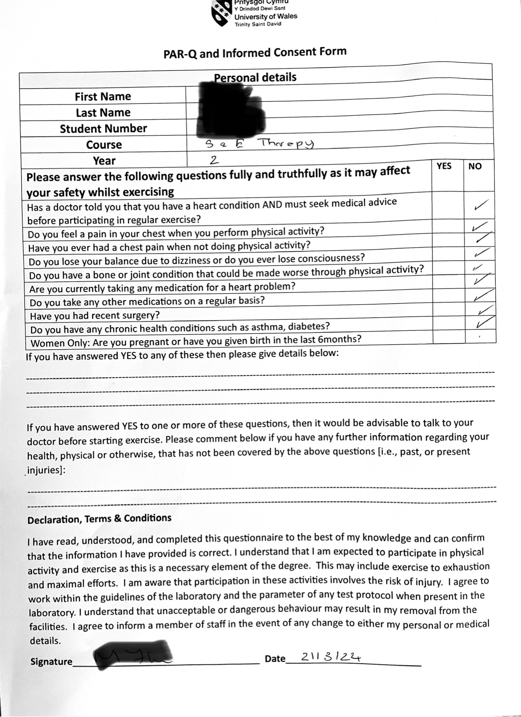

Appendix 2 – Worksheet 34.1
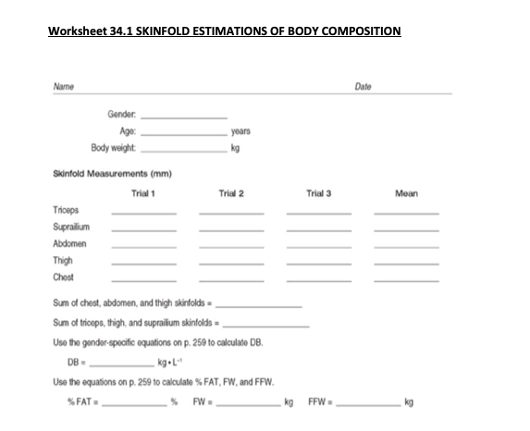

Appendix 3 – Worksheet 40.1

