

An analysis into the problem at ASDA
Written report

Lee Roath 1817040
BMSK4004
Melanie Squire
19th June 2020

What is the purpose of this report?

On completion of this report I will be able to identify key problems that Asda are facing, the nature, scope and impact of the problem. I will gather and interpret the information to solve problems that Asda have. I will evaluate all options to make my decision on how to solve their issues.
The changes we will implement need to be planned, monitor and reviewed to make sure the change made are working well for Asda.
I will demonstrate the use of a SWOT analysis and PESTLE analysis in this report to identify and investigate the problems that Asda face.

Identify A problem that Asda faces currently and what the nature, scope and impact of the problem is?
Nature
The threat of covid-19 to customer and staff
Most people infected with the COVID-19 virus will experience mild to moderate respiratory illness and recover without requiring special treatment. Older people, and those with underlying medical problems like cardiovascular disease, diabetes, chronic respiratory disease, and cancer are more likely to develop serious illness, and can die.
(world health organisation, 2020)

Scope and impact of problem

This is data from the world health organisation showing the number of covid-19 cases in the world.
appendix 1
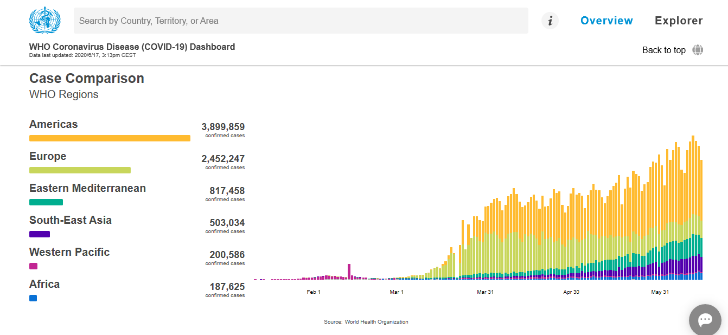
(world health organisation, 2020)

This data below shows the number of deaths worldwide

Appendix 2

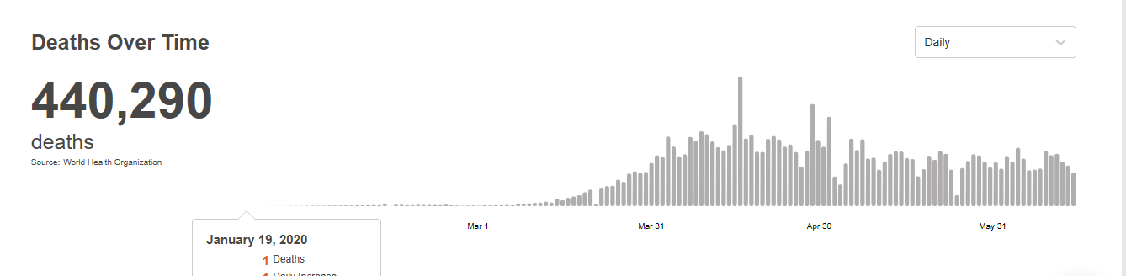

(world health organisation, 2020)

This data shown in appendix 1 it is clear to say the scope of covid-19 is very large, and cannot be ignored.

The impact of COVID-19 is very high as there have been 440,290 death reported this is shown on appendix 2.

Asda need to ensure safety to their customers and their staff member; they need to follow government guideline which have been set out and make sure they are implement correctly throughout their organisation.
timeline of key events

The COVID-19 pandemic spread to the UK in late January 2020. Up in till the 18 June 2020 there have been 300,469 confirmed cases, and 42,288 deaths of confirmed cases. The UK had the world’s second-highest death-rate, there were 52,525 deaths where COVID-19 was mentioned on the death certificate by 5 Jun 2020.
In March, the UK government imposed a lockdown banning all "non-essential" travel and contact with people outside their home including family and partners. They closed almost all schools, business and places of worship. people were made to keep the two-metre rule in public. Police were given powers to enforce the lockdown, and the coronavirus act 2020 gave the government emergency powers which have not been used since the second world war. panic buying was reported and shelves where soon very bare.
It has been forecasted that the length of this lockdown will have a severe impact on the UK economy, and it may take many years to recover from the damaged caused.
it was reported that social distancing had helped lower the cases of infection. Then In late April, the Prime Minister said that the UK had passed the peak of its outbreak.
Early may the lockdown have been relaxed in England, and on the 7 May, the lockdown in Wales was extended by the Welsh Government, with some slight relaxations.
This pandemic is still current and still on going, the government are making changes to their rules and legislations regularly and can often be seen on the news and on the gov.uk website.
(wikipedia, 2020)
What is a SWOT analysis?
S.W.O.T. stands for Strengths, Weaknesses, Opportunities, and Threats. A SWOT analysis is a reviewed list of your business’s greatest strengths, weaknesses, opportunities, and threats.
(berry, 2017)
SWOT analysis on ASDA
Strengths  - Strong brand portfolio  - Online presence  - Asda logistical services  ASDA SWOT | Weakness  - Bad press  - Quality of own branding products  - Critics
Opportunity  - Expanding into other country  - Asda long tern goals  - Buying other companies | Threats  - Price of other retailers  - Government changing policy’s  - Global pandemic
Strengths
Strong brand portfolio
Asda have many own brands such as Asda, Asda extra special, Asda smart price, Asda farm stores, little hero, Asda butcher’s selection and grower’s selections they even have their own pet food brand and toilet paper. These brand cover food product, household items, fruits & vegetables, butchers’ product and much more.These brands are constantly bringing out more products to the shelves and building the Asda own brand portfolio.
Introduced in 1989, George is currently sold in over 560 stores and through George.com, which is one of the largest growing online fashion companies they serve over 800,000 customers per week and is growing that number continually.

Online presence
Asda started their online grocery home shopping in 1997, their intention was purely to sell food, but that soon changed in 2008 where non-food items where introduced to their platform, in 2016 98% of all homes in the UK where served by asda.com and goerge.com.

(asda, 2020)

Asda logistical services
Asda distribution includes 39 operations nationwide, which includes 21 food depots, three clothing centres, two ambient GM hubs, two import centres, and two dot.com fulfilment centres.
Asda delivers to a five-store format, they deliver parcels to customers homes also to their click and collect hubs.
Asda process a high volume of product, they delivered 1.8 million cases, with these high volumes they employee more then 12,000 staff across their distribution.
Asda now operate more than 4,000 heavy good vehicles and 2,000 home delivery vehicles and our drivers travel 130 million miles each year, making 800,000 deliveries to store and 20,000,000 deliveries to customers’.
(asda, 2020)

Weakness

Bad press
Asda have been criticised for leaving factory workers in Bangladesh go hungry during the pandemic, by cancelling and stopping orders without payment. The allegations are made by an anti-fast fashion group called remake which has named and shamed Asda for their wrongdoing and reported about it in The Grocer magazine.
(nazir, 2020)

Quality of own branding products

Mr Clarke, Asda new boss admitted that their food was not at a good enough standard, as he stated the sales for the fruit, vegetables, fish and meat sales where not good enough throughout their 377 stores.

‘Food quality is something Asda hadn’t been as focused on in the past as it should have been,’ admitted Mr Clarke.
(cunningham, 2010)

Critics
Asda have many people which will critics the quality of Asda products, this may have great impact on the Asda reputation.

(bhasin, 2019)

Opportunity
Expanding into other country

Asda has partnered with Azadea Group by introducing the George fashion label to the Middle East, also another which will see brands introduced to stores in Jersey and Guernsey this partnership is with SandpiperCI.
(chapman, 2012)
Asda long tern goals

Asda are committed to using 30% recycled content in its plastic packaging by the end of 2020. This in turn will help reduce 19, 500t of virgin plastic which is used in their packaging.
(pakaging gateway, 2019)
Buying other companies

Asda can take the opportunity to purchase other companies like its competitor Tesco’s £3.7bn takeover of cash-and-carry group Booker in November 2017

(monaghan & wood, 2017)

threats
Price of other retailers
Asda loses sales to the fast-growing discounters Aldi and Lidl, even though they did major price cut and Christmas promotions, their sales where down for the festive period and at a record low.

(wood, 2020)

Government policy’s
Government refused Asda to merge with Sainsbury’s, as the Competition and Markets Authority (CMA) found that shopper and motorist will be worst of if the companies merged, so it was blocked by the (CMA).

(gov.uk, 2019)

Global pandemic COVID-19
The UK along with the whole world are facing a great threat from the current (COVID -19) pandemic, Asda are a essential business and are expected to stay open during these dangerous times to supply the public with food and medicines. Asda need to ensure the safety of their staff and customers during this pandemic.

(asda, 2020)

What is pestle analysis?

2. PESTLE Analysis
There are many factors in macro-environment that will affect decision making and strategies for an organization. Changes in law, tax, Trade Barriers, Cultural changes, Demographic Changes, Changes in Political Environment & Government Policy. These are examples of macro environment. These changes could bring certain positives as well as negatives for every business. PESTEL (Political, Economic, Social, Technological, Environmental and Legal) Analysis this is a tool which is used by businesses to analyse these critical factors. It is great for development of strategic decision making. Asda PESTLE Analysis below critically evaluates and identifies different strategies that can be adopted by Asda
(rodrigo, 2012)
2 elements of pestle analysis applied to further investigate the problem Asda is facing?
Legal factor
Legal factors related to the laws, regulation and legislation that will affect the way the business operates during COVID-19.
As an employer, Asda are required by law to protect their employees, and others, from harm.
Under the Management of Health and Safety at Work Regulations 1999, the minimum you must do is:
- identify what could cause injury or illness in your business (hazards)
- decide how likely it is that someone could be harmed and how seriously (the risk)
- take action to eliminate the hazard, or if this isn’t possible, control the risk
Assessing risk is just one part of the overall process used to control risks in your workplace.

(hse, 2020)

social factors
Social environment
Due to the (COVID-19) pandemic it has changed our social environment, and the way consumer now shop, people are making less frequent trip to the supermarket and buying more at once, so it last longer, also purchasing more goods with longer shelf life, e.g. tined fruit and vegetable rather than fresh also online shopping has increased.
During the pandemic the supermarket shelves have often been seen empty with store reducing their opening hour just to keep up with stocking up their shelves.
Certain item having to be restricted to how many you can purchase, as some customers where panic buying and buying big bulks of these good, by restricting these items, it gives everybody a chance to get their essential good.

potential solutions to my legal concerns

the governments advise to business during COVID-19 pandemic is to take step to working safely. These are broken down into 5 steps:
Practical actions for businesses to take based on the 5 main steps.
1. COVID-19 risk assessment
2. Develop cleaning, handwashing and hygiene procedures
3. Help people to work from home
4. Maintain 2m social distancing, where possible
5. Where people cannot be 2m apart, manage transmission risk

(gov.uk, 2020)

Potential solution to my social concerns
Store opening hours- 24- hour stores need to reduced hours of trading, giving them time to replenish their shelves and deep clean the stores.
To support the NHS, care workers and most vulnerable need to be given a priority hour a few times a week, so they do not get left without.

Purchasing limits will need to be put in place to ensure everyone get their essentials, so we will need to limit certain product that are in high demand.

Customer limits instore when necessary, to observe social distancing, this will ensure safety of our staff and customers, and to follow government guidelines.
This include setting up a queuing system outside the store to ensure the safety of everybody, having marker 2 meter away from each other.

Contactless payments have been increased to £45 to help with surface contact.
Delivery driver and collection college will all adhere to the 2-metre social distancing guideline which has been put in place by the government.
Our staff will be provided with alcohol hand gel and cleaning product to keep all equipment clean for every order.
We will pre-pack our delivery orders straight into their carrier bag to insure less contact with products.
Help for care homes we will give them priority slots for home delivery.

(asda, 2020)

How we will monitor our changes
The action will be monitored every day with daily managers meeting, this will be to make sure all changes are being implement correctly and all updated from head office are being adhered to. They will be constantly reviewing and improving all changes which we will made, also team meeting will assure employees have a chance to voice any concern any issue they have, also give a chance for the managers to update employees on updated from head office. The risk assessment will be regularly reviewed, and government guideline continually reviewed and implemented.
Asda legal team and human resources will have daily communication to insure they are legally and safely dealing with the pandemic correctly.
COVID-19 risk assessment will be able to be seen online for staff and the public to view. As this is a requirement of the health and safety at work regulation 1999.

Conclusion
After evaluating this report I have identify the problems Asda are currently facing , and not just Asda but many other business too, as this pandemic is global and has a affect on the whole world, we need to follow the government guideline which have been set out. This will assist us in keeping our workers and customers safe during these times. We need to constantly monitor and evaluate our procedures to make sure we are complying with the Health and Safety at Work Regulations 1999, and government guidelines. We will need to keep up to date with changes in government legislation and guideline which are set out, they are constantly changing as the pandemic curve being to come down.
The economic impact of this pandemic is catastrophic and may take many years to recover, along with the rest of the world economies.
Asda need to manage the risk and work toward looking into more contactless forms of shopping and pushing their websites more. They will need to increase their home delivery drivers and their logistical network to keep up with demand.

Appendix

appendix 1
(world health organisation, 2020)

This data below shows the number of deaths worldwide

Appendix 2

(world health organisation, 2020)

References
asda, 2020. Asda Stores Limited (Asda) - COVID-19 Risk Assessment. [Online]
Available at: https://corporate.asda.com/asda-stores-limited-asda-covid-19-risk-assessment
[Accessed 16 june 2020].
asda, 2020. Company Facts. [Online]
Available at: https://corporate.asda.com/our-story/company-facts
[Accessed 16 june 2020].
asda, 2020. Company Facts. [Online]
Available at: https://corporate.asda.com/our-story/company-facts
[Accessed 16 june 2020].
asda, 2020. Feeding the Nation. [Online]
Available at: https://www.asda.com/feeding-the-nation
[Accessed 16 june 2020].
berry, t., 2017. How to Do a SWOT Analysis for Better Strategic Planning. [Online]
Available at: https://articles.bplans.com/how-to-perform-swot-analysis/
[Accessed 15 june 2020].
bhasin, h., 2019. SWOT Analysis of Asda (Complete SWOT Matrix and Analysis). [Online]
Available at: https://www.marketing91.com/swot-analysis-of-asda/
[Accessed 17 june 2020].
chapman, m., 2012. Asda targets overseas expansion for George brand. [Online]
Available at: https://www.campaignlive.co.uk/article/asda-targets-overseas-expansion-george-brand/1113844
[Accessed 16 june 2020].
cunningham, t., 2010. It's famously cheap but Asda's boss says his food isn't good enough - is he right?. [Online]
Available at: https://www.dailymail.co.uk/femail/article-1306236/Its-famously-cheap-Asdas-boss-says-food-isnt-good--right.html
[Accessed 16 june 2020].
gov.uk, 2019. CMA blocks merger between Sainsbury’s and Asda. [Online]
Available at: https://www.gov.uk/government/news/cma-blocks-merger-between-sainsburys-and-asda
[Accessed 16 june 2020].
gov.uk, 2020. Working safely during coronavirus (COVID-19). [Online]
Available at: https://www.gov.uk/guidance/working-safely-during-coronavirus-covid-19/5-steps-to-working-safely
[Accessed 16 june 2020].
hse, 2020. Managing risks and risk assessment at work. [Online]
Available at: https://www.hse.gov.uk/simple-health-safety/risk/index.htm
[Accessed 17 june 2020].
monaghan, a. & wood, z., 2017. Tesco's £3.7bn takeover of Booker given green light. [Online]
Available at: https://www.theguardian.com/business/2017/nov/14/tescos-37bn-takeover-of-booker-given-green-light
[Accessed 16 june 2020].
nazir, s., 2020. Asda accused of leaving Bangladesh garment workers to go hungry. [Online]
Available at: https://www.retailgazette.co.uk/blog/2020/05/asda-accused-of-leaving-bangladesh-garment-workers-to-go-hungry/
[Accessed 16 june 2020].
pakaging gateway, 2019. Asda plans to reach 30% recycled content goal ahead of schedule. [Online]
Available at: https://www.packaging-gateway.com/news/asda-recycled-content/
[Accessed 16 june 2020].
rodrigo, 2012. Strategic Analysis (SWOT, PESTEL, Porter) of Premier Inn (Whitbread Plc). [Online]
Available at: https://writepass.com/journal/2012/12/strategic-analysis-swot-pestel-porter-of-premier-inn-whitbread-plc/
[Accessed 16 june 2020].
wikipedia, 2020. COVID-19 pandemic in the United Kingdom. [Online]
Available at: https://en.wikipedia.org/wiki/COVID-19_pandemic_in_the_United_Kingdom
[Accessed 16 june 2020].
wood, z., 2020. Cost-cutting at Asda supermarket chain puts 2,832 jobs at risk. [Online]
Available at: https://www.theguardian.com/business/2020/jan/10/cost-cutting-at-asda-supermarket-chain-puts-2832-jobs-at-risk
[Accessed 16 june 2020].
world health organisation, 2020. Coronavirus. [Online]
Available at: https://www.who.int/health-topics/coronavirus#tab=tab_1
[Accessed 12 july 2020].
world health organisation, 2020. WHO Coronavirus Disease (COVID-19) Dashboard. [Online]
Available at: https://covid19.who.int/
[Accessed 15 june 2020].

Bibliography
asda, 2020. Asda Stores Limited (Asda) - COVID-19 Risk Assessment. [Online]
Available at: https://corporate.asda.com/asda-stores-limited-asda-covid-19-risk-assessment
[Accessed 16 june 2020].
asda, 2020. Company Facts. [Online]
Available at: https://corporate.asda.com/our-story/company-facts
[Accessed 16 june 2020].
asda, 2020. Company Facts. [Online]
Available at: https://corporate.asda.com/our-story/company-facts
[Accessed 16 june 2020].
asda, 2020. Feeding the Nation. [Online]
Available at: https://www.asda.com/feeding-the-nation
[Accessed 16 june 2020].
berry, t., 2017. How to Do a SWOT Analysis for Better Strategic Planning. [Online]
Available at: https://articles.bplans.com/how-to-perform-swot-analysis/
[Accessed 15 june 2020].
bhasin, h., 2019. SWOT Analysis of Asda (Complete SWOT Matrix and Analysis). [Online]
Available at: https://www.marketing91.com/swot-analysis-of-asda/
[Accessed 17 june 2020].
chapman, m., 2012. Asda targets overseas expansion for George brand. [Online]
Available at: https://www.campaignlive.co.uk/article/asda-targets-overseas-expansion-george-brand/1113844
[Accessed 16 june 2020].
cunningham, t., 2010. It's famously cheap but Asda's boss says his food isn't good enough - is he right?. [Online]
Available at: https://www.dailymail.co.uk/femail/article-1306236/Its-famously-cheap-Asdas-boss-says-food-isnt-good--right.html
[Accessed 16 june 2020].
gov.uk, 2019. CMA blocks merger between Sainsbury’s and Asda. [Online]
Available at: https://www.gov.uk/government/news/cma-blocks-merger-between-sainsburys-and-asda
[Accessed 16 june 2020].
gov.uk, 2020. Working safely during coronavirus (COVID-19). [Online]
Available at: https://www.gov.uk/guidance/working-safely-during-coronavirus-covid-19/5-steps-to-working-safely
[Accessed 16 june 2020].
hse, 2020. Managing risks and risk assessment at work. [Online]
Available at: https://www.hse.gov.uk/simple-health-safety/risk/index.htm
[Accessed 17 june 2020].
monaghan, a. & wood, z., 2017. Tesco's £3.7bn takeover of Booker given green light. [Online]
Available at: https://www.theguardian.com/business/2017/nov/14/tescos-37bn-takeover-of-booker-given-green-light
[Accessed 16 june 2020].
nazir, s., 2020. Asda accused of leaving Bangladesh garment workers to go hungry. [Online]
Available at: https://www.retailgazette.co.uk/blog/2020/05/asda-accused-of-leaving-bangladesh-garment-workers-to-go-hungry/
[Accessed 16 june 2020].
pakaging gateway, 2019. Asda plans to reach 30% recycled content goal ahead of schedule. [Online]
Available at: https://www.packaging-gateway.com/news/asda-recycled-content/
[Accessed 16 june 2020].
rodrigo, 2012. Strategic Analysis (SWOT, PESTEL, Porter) of Premier Inn (Whitbread Plc). [Online]
Available at: https://writepass.com/journal/2012/12/strategic-analysis-swot-pestel-porter-of-premier-inn-whitbread-plc/
[Accessed 16 june 2020].
wikipedia, 2020. COVID-19 pandemic in the United Kingdom. [Online]
Available at: https://en.wikipedia.org/wiki/COVID-19_pandemic_in_the_United_Kingdom
[Accessed 16 june 2020].
wood, z., 2020. Cost-cutting at Asda supermarket chain puts 2,832 jobs at risk. [Online]
Available at: https://www.theguardian.com/business/2020/jan/10/cost-cutting-at-asda-supermarket-chain-puts-2832-jobs-at-risk
[Accessed 16 june 2020].
world health organisation, 2020. Coronavirus. [Online]
Available at: https://www.who.int/health-topics/coronavirus#tab=tab_1
[Accessed 12 july 2020].
world health organisation, 2020. WHO Coronavirus Disease (COVID-19) Dashboard. [Online]
Available at: https://covid19.who.int/
[Accessed 15 june 2020].

