[Date]
CAO
Assignment 2: Computer Architecture & Operating Systems
ACCA4022

Lecturer: REDHWAN AL MARI
Student: MIKIALE TSEGAY
Student ID: 2426722

Table of Contents
Definition and Overview of Operating Systems 2
Evolution of Operating Systems 2
Categories of Operating Systems 3
1. Key Functions of General Operating Systems 4
Introduction to Key Functions of Modern General Operating Systems 4
Analysis of Key Functions 4
Key Functions in Popular General-Purpose OS 5
2. Use of Windows OS CLI Commands 7
3. Use of Linux OS CLI Commands 11
4. Use of Windows OS Scripts 12
PowerShell Scripting: Key Features 12
1. Cmdlets (Command-Let) 13
2. Object-Oriented Nature 13
3. Pipelining 14
4. Variables and Control Flow 15
5. Use of Linux OS Scripts 16
Bash Scripting: Key Features 16
1. Shebang Line 16
2. Variables 17
3. Conditional Statements (if, elif, else) 17
4. Loops (for, while) 18
Conclusion 18
Reference list 19

Introduction
Operating systems (OS) are the backbone of modern computing, serving as critical software that manages hardware resources, facilitates user interaction, and enables application execution. This report explores the definition, functions, evolution, and categories of OS, alongside their scripting capabilities in Windows and Linux environments. By examining key OS functions like process, memory, and file management, as well as command-line tools such as PowerShell and Bash, the report highlights how OS and their scripting languages ensure efficient, secure, and flexible computing. The analysis draws on practical examples and historical context to illustrate the pivotal role OS play in diverse computing ecosystems.

Definition and Overview of Operating Systems
An operating system is system software that manages computer hardware, software resources, and provides common services for applications. It acts as an intermediary between users and hardware, ensuring efficient resource allocation and a user-friendly interface. Key functions include process management (scheduling and executing tasks), memory management (allocating RAM and virtual memory), file management (organizing data storage), device management (handling hardware via drivers), security (enforcing access controls), networking (facilitating communication), and user interface (providing GUIs or CLIs). Examples like Windows, macOS, and Linux demonstrate these functions, with tools like Task Manager or GNOME System Monitor for monitoring. OS ensure system stability, resource optimization, and adaptability to modern demands like cloud computing and IoT.

Evolution of Operating Systems
Operating systems have evolved significantly since the 1940s. Early computers lacked OS, requiring manual hardware operation. The 1950s introduced batch processing systems (e.g., GM-NAA I/O), automating repetitive tasks. The 1960s brought multitasking OS like IBM’s OS/360, supporting concurrent processes. The 1970s saw Unix, emphasizing modularity and portability, influencing modern Linux. The 1980s introduced GUIs with Apple’s Macintosh and Microsoft Windows, enhancing accessibility. The 1990s and 2000s focused on networking and internet integration, with Linux gaining traction for servers. Today, OS like Windows 11, macOS, and Ubuntu prioritize cloud integration, AI, and security, adapting to mobile and distributed environments.

Categories of Operating Systems
OS are categorized based on functionality and use cases:
- General-Purpose OS: Windows, macOS, Linux (e.g., Ubuntu) support diverse applications, offering multitasking, GUIs, and networking for desktops/servers.
- Mobile OS: Android and iOS focus on touch interfaces, energy efficiency, and app ecosystems for smartphones/tablets.
- Real-Time OS (RTOS): VxWorks, QNX ensure predictable, time-critical responses for embedded systems (e.g., automotive, medical devices).
- Embedded OS: Lightweight systems like FreeRTOS run on resource-constrained devices (e.g., IoT gadgets).
- Server OS: Windows Server, Red Hat Enterprise Linux optimize for high-performance, networked environments. Each category addresses specific needs, from user-friendly desktops to mission-critical systems.

1. Key Functions of General Operating Systems

Introduction to Key Functions of Modern General Operating Systems
Modern general-purpose operating systems (OS) act as intermediaries between hardware and software, managing resources to enable efficient, secure, and user-friendly computing. Key common functions include process management, memory management, file management, device management, security, networking, and user interface. These functions ensure system stability, resource optimization, and seamless user interaction.
Process management involves creating, scheduling, and terminating processes or threads, supporting multitasking and concurrency. It allocates CPU time, handles context switches, and isolates processes to prevent errors or vulnerabilities from affecting the system. Memory management allocates RAM, implements virtual memory via paging or swapping to disk, and enforces protection to avoid interference between programs. File management organizes data in hierarchies, supporting operations like creation, reading, and deletion, with caching for performance and checksums for integrity. Device management interfaces with hardware through drivers, handling I/O via interrupts and DMA for efficiency.
Security enforces access controls, privilege separation, and hardening techniques like randomization to safeguard data and maintain CIA (confidentiality, integrity, availability). Networking provides protocols for communication, enabling distributed systems and remote access. User interface offers GUIs (e.g., desktops with icons) or CLIs for interaction, supporting input devices and accessibility.

Analysis of Key Functions
These functions are vital for modern computing. Process and memory management optimize resource sharing, preventing bottlenecks and enabling multitasking, which is essential for performance in resource-constrained environments. File and device management ensure reliable data handling and hardware abstraction, reducing user complexity and improving reliability during failures. Security mitigates risks in connected systems, protecting against exploits. Networking supports cloud and distributed workloads, while user interfaces enhance accessibility, making OS usable for diverse users. Overall, they abstract hardware, boost efficiency, and adapt to evolving demands like AI and IoT.

Key Functions in Popular General-Purpose OS
Windows (Microsoft): Focuses on broad hardware compatibility, multitasking, and user-friendly GUI. Process management via Task Manager monitors running apps, CPU/memory usage, and allows termination. Memory uses virtual allocation; file management via Explorer; device plug-and-play; security with Defender; networking for connectivity; intuitive interface. Screenshot of Task Manager (Processes tab, showing usage):
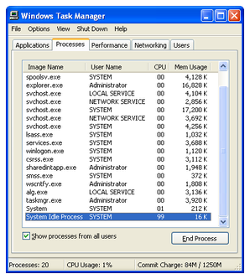
macOS (Apple): Emphasizes hardware-software integration, stability, and energy efficiency. Activity Monitor manages CPU, memory, energy, disk, and network usage, allowing process control. Memory optimizes RAM; file via Finder; device seamless; security with Gatekeeper; networking robust; elegant GUI. Screenshot of Activity Monitor (CPU tab, showing loads):
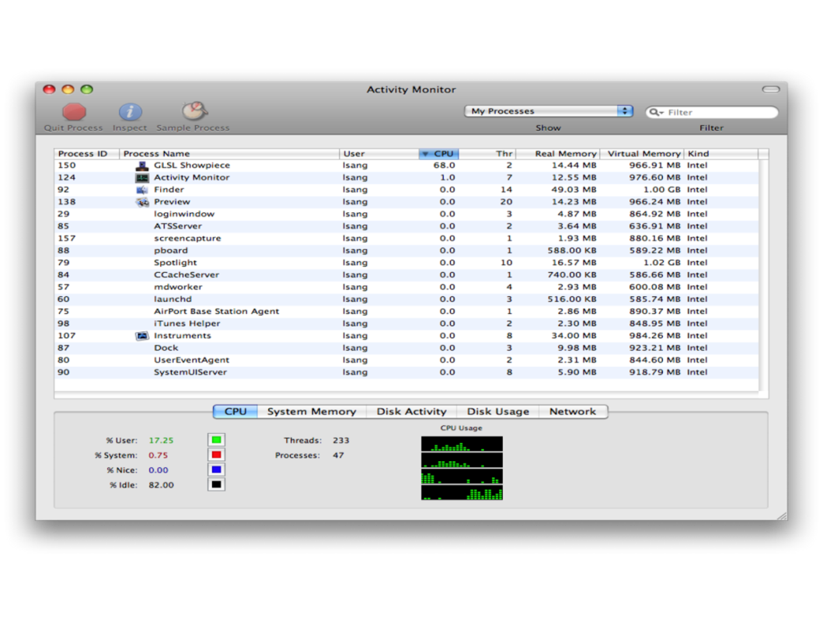
Linux (e.g., Ubuntu with GNOME): Open-source, customizable, secure for servers/desktops. GNOME System Monitor handles processes, resources (CPU/memory/network), and file systems, with kill/renice options. Kernel manages memory/files; permissions for security; networking tools; flexible CLI/GUI. Screenshot of GNOME System Monitor (Resources tab, showing graphs):
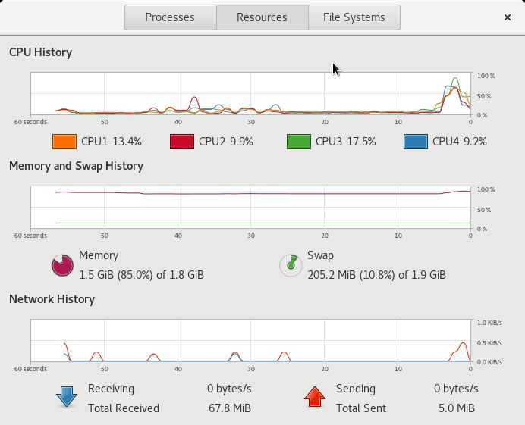

2. Use of Windows OS CLI Commands
Windows provides two primary CLI environments: Command Prompt (Batch) for simple scripting and PowerShell for advanced automation. Batch commands use .bat files, while PowerShell offers object-oriented cmdlets. Both support options (switches) for customization. Below are 10 examples, with usage, switches, screenshots (code & output), and descriptions.
- dir (Batch): Lists directory contents. Example: dir /b /s (bare format, recursive). Displays files/subdirectories without headers, useful for scripting file lists.
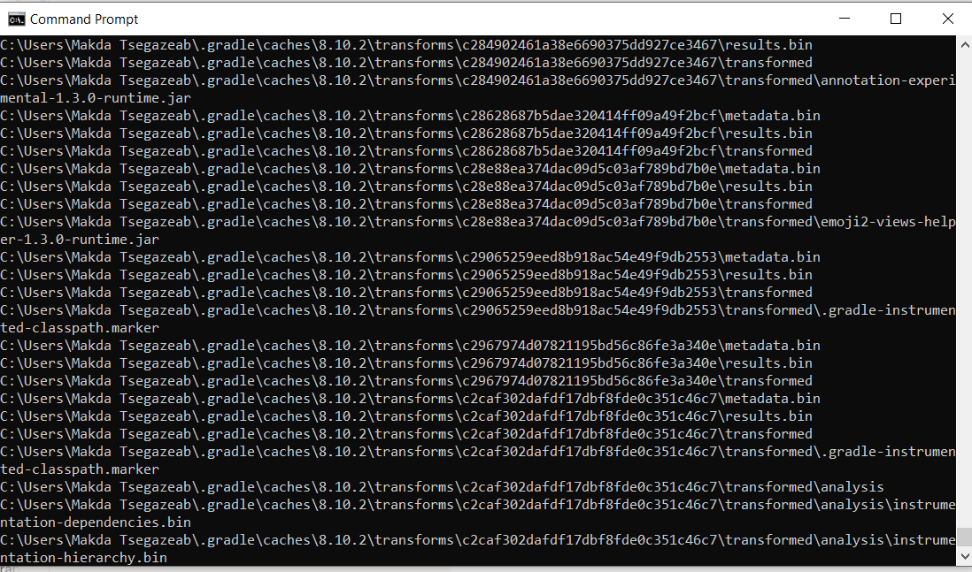
- ipconfig (Batch): Displays IP configuration. Example: ipconfig /all (detailed info). Shows adapters, IP, DNS; troubleshooting connectivity.

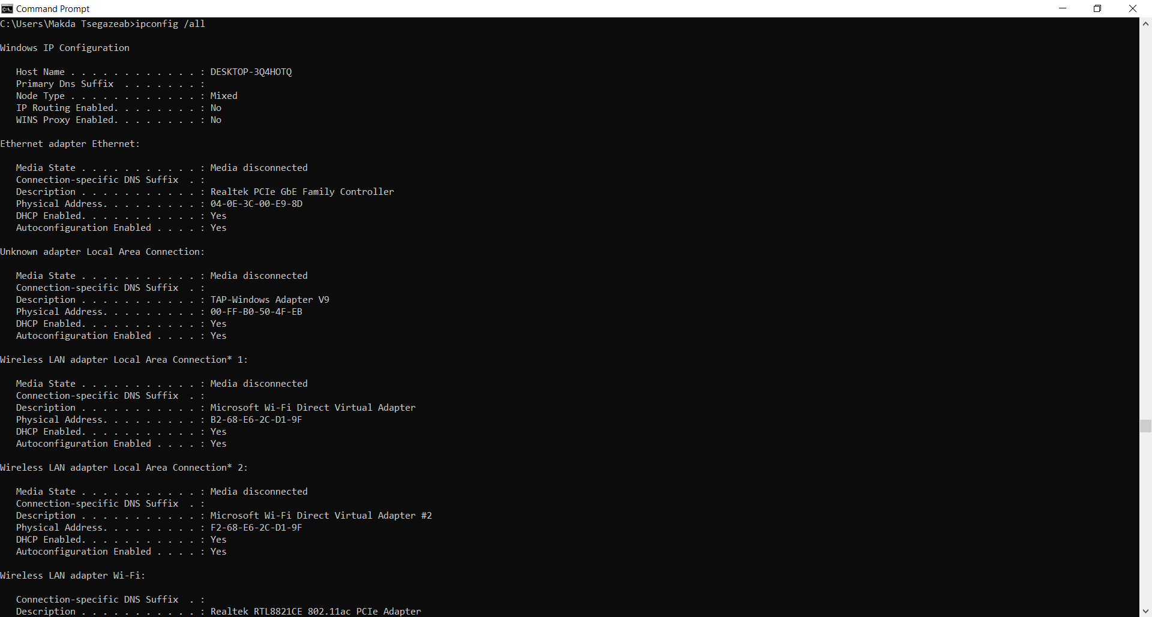
- ping (Batch): Tests reachability. Example: ping /t google.com (continuous). Checks latency, packet loss; verifies network paths.

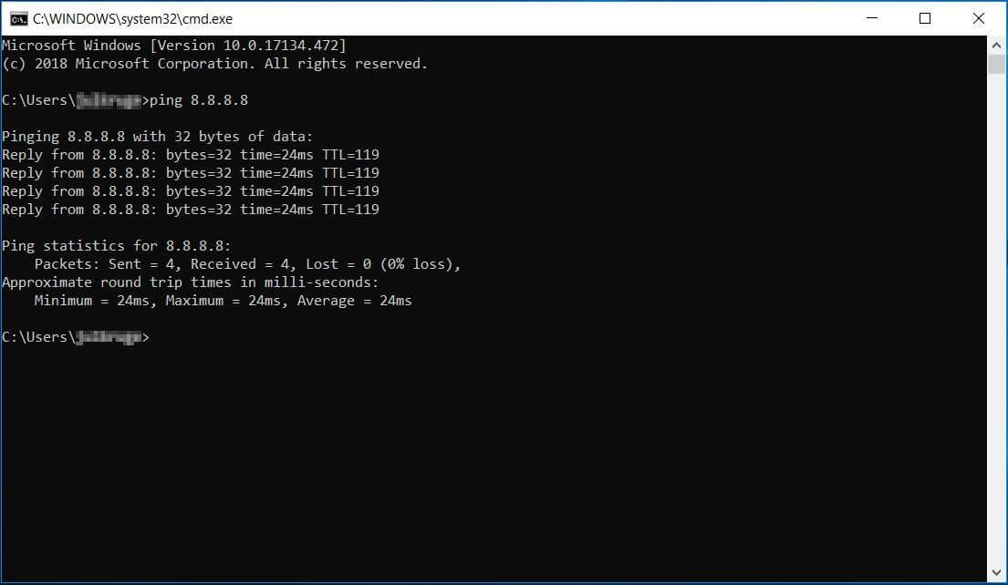
- tasklist (Batch): Lists running processes. Example: tasklist /svc /fi "imagename eq svchost.exe" (services hosted). Monitors tasks, PIDs; aids debugging. Screenshot: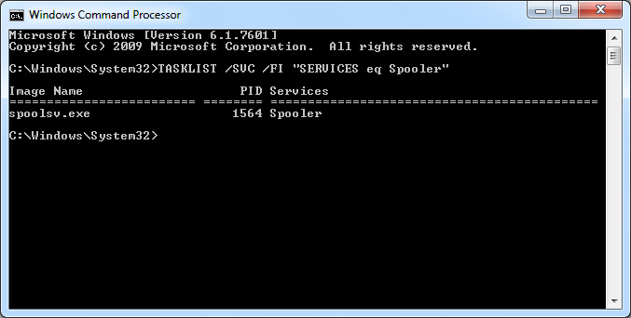

- echo (Batch): Displays messages. Example: echo off & echo Hello > file.txt (hides commands, writes file). Controls output in scripts.
- netstat (Batch): Shows network stats. Example: netstat -an (all connections, numeric). Views ports, connections; detects anomalies.

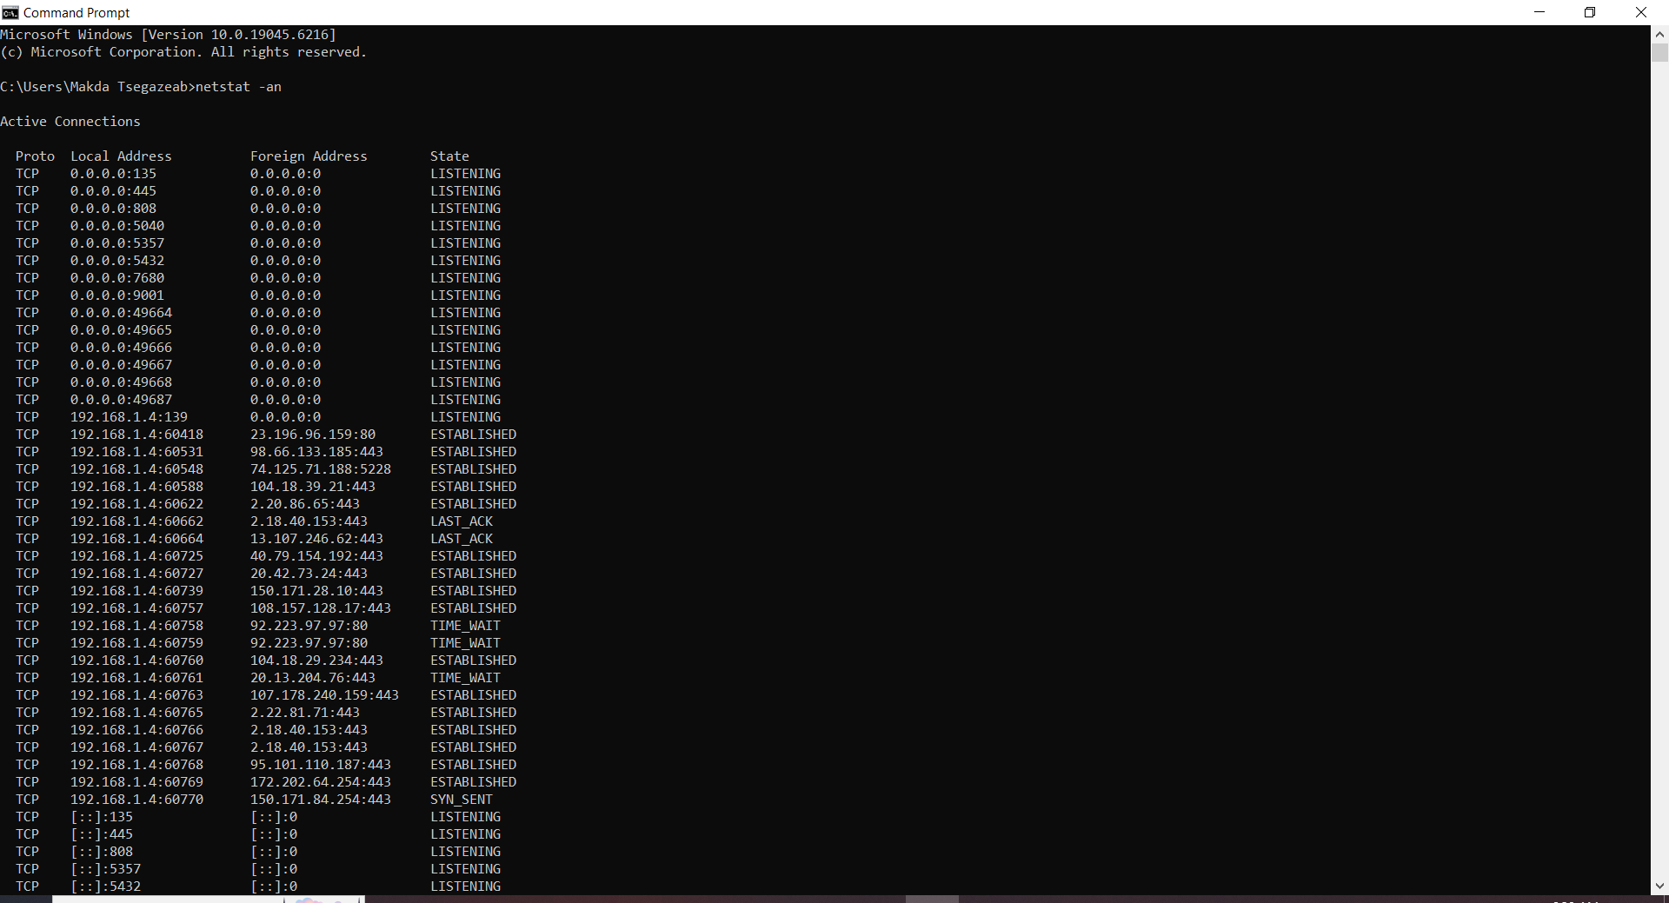
- Get-Process (PowerShell): Lists processes. Example: Get-Process -Name chrome | Select Name,Id,CPU (filters Chrome). Monitors resource usage. 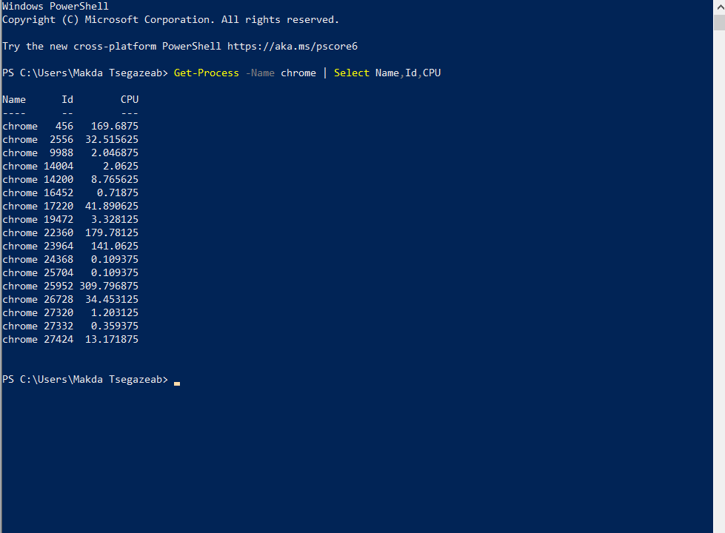
- Get-ChildItem (PowerShell): Lists items. Example: Get-ChildItem -Path C:\ -Recurse -Filter *.txt (recursive TXT files). File management.
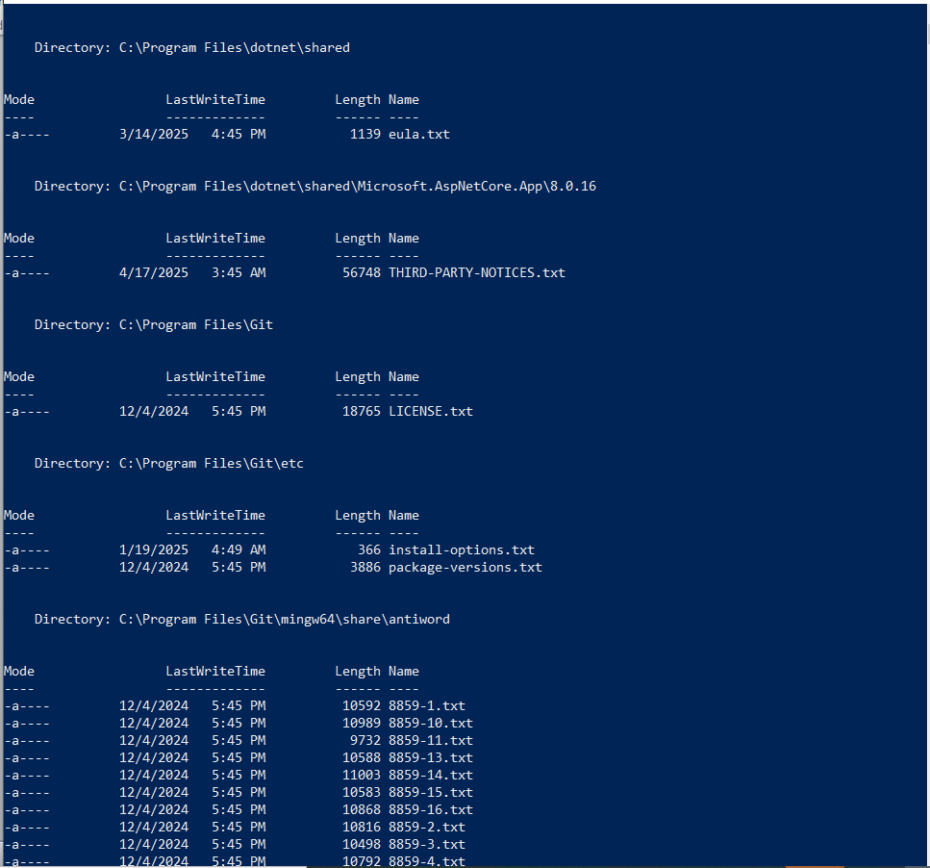
- Invoke-WebRequest (PowerShell): Sends web requests. Example: Invoke-WebRequest -Uri google.com -Method Get (fetches page). Automates downloads.
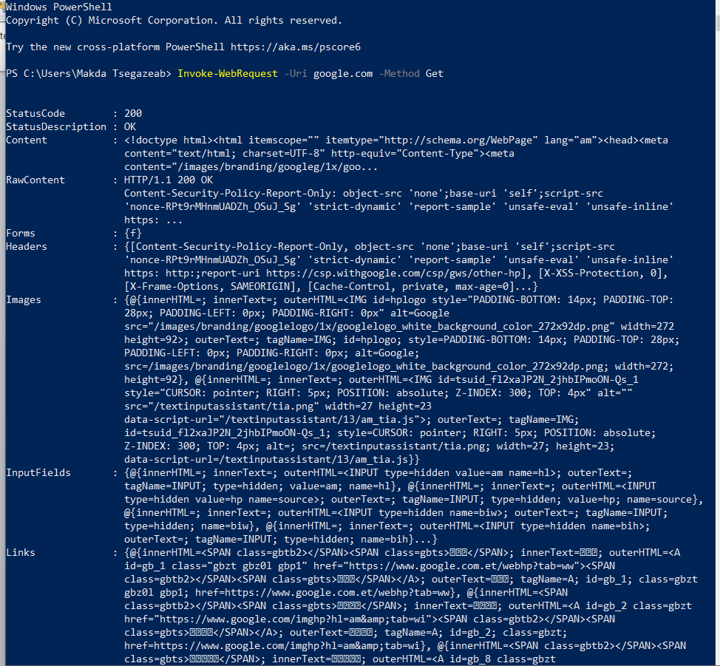
- Test-Connection (PowerShell): Pings hosts. Example: Test-Connection -ComputerName google.com -Count 4 (4 pings). Tests connectivity.

3. Use of Linux OS CLI Commands
Linux Bash serves as the primary shell for command-line interaction, offering powerful tools for file management, system monitoring, and automation. Below are 10 common Bash commands, with options/switches, examples, descriptions, and screenshots (code & output).
- ls: Lists directory contents. Example: ls -l -a (long format, including hidden files). Displays files with details like permissions and sizes; useful for navigation.
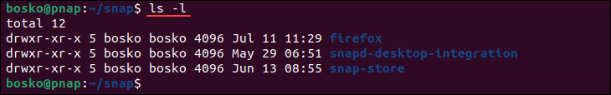
- cd: Changes directory. Example: cd ~ (to home). Navigates file system; supports relative/absolute paths.
- pwd: Prints working directory. Example: pwd -P (physical path). Shows current location, aiding scripts.
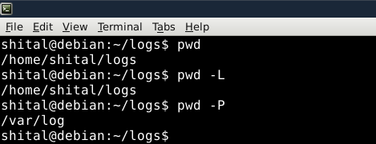

- mkdir: Creates directories. Example: mkdir -p newdir/subdir (parent directories). Organizes files; no error if exists with -p.
- rm: Removes files/directories. Example: rm -r dir (recursive). Deletes items; -f forces without prompt.
- cat: Displays file contents. Example: cat -n file.txt (line numbers). Views/concatenates files; -b for non-blank lines.
- touch: Creates/updates files. Example: touch -m file.txt (modify time). Makes empty files or timestamps.
- grep: Searches patterns. Example: grep -i "text" file (case-insensitive). Finds strings in files; -c counts matches.
- echo: Outputs text. Example: echo -e "Hello\nWorld" (interpret escapes). Prints messages/variables; -n omits newline.
- man: Shows manuals. Example: man ls (ls manual). Provides command help; -f for brief

4. Use of Windows OS Scripts

PowerShell Scripting: Key Features
PowerShell is a powerful object-oriented scripting language from Microsoft, built on the .NET framework. It allows for automation, system management, and configuration. Here are some key features:

1. Cmdlets (Command-Let)
PowerShell uses specialized commands called cmdlets (pronounced "command-lets"). These are lightweight commands designed to perform specific functions. They follow a Verb-Noun naming convention, making them easy to discover and understand.
For example, to list files and folders, you use Get-ChildItem. To stop a process, you use Stop-Process.
Example: Listing files in a directory.
Get-ChildItem -Path "C:\Windows" | Select-Object Name, Length
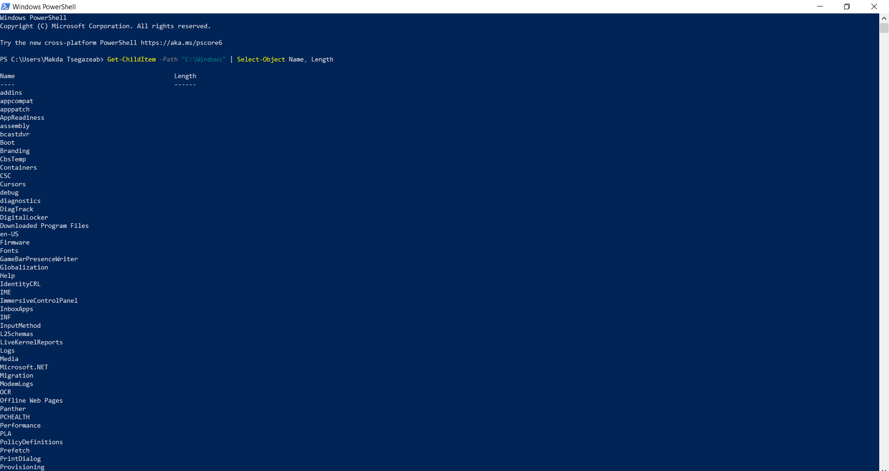

2. Object-Oriented Nature
Unlike traditional text-based scripting, PowerShell works with objects. When a cmdlet outputs data, it's not just plain text; it's a structured object with properties and methods. This allows for powerful filtering, sorting, and manipulation of data.
Example: Filtering processes with high CPU usage.
Get-Process | Where-Object {$_.CPU -gt 100} | Select-Object ProcessName, CPU, ID
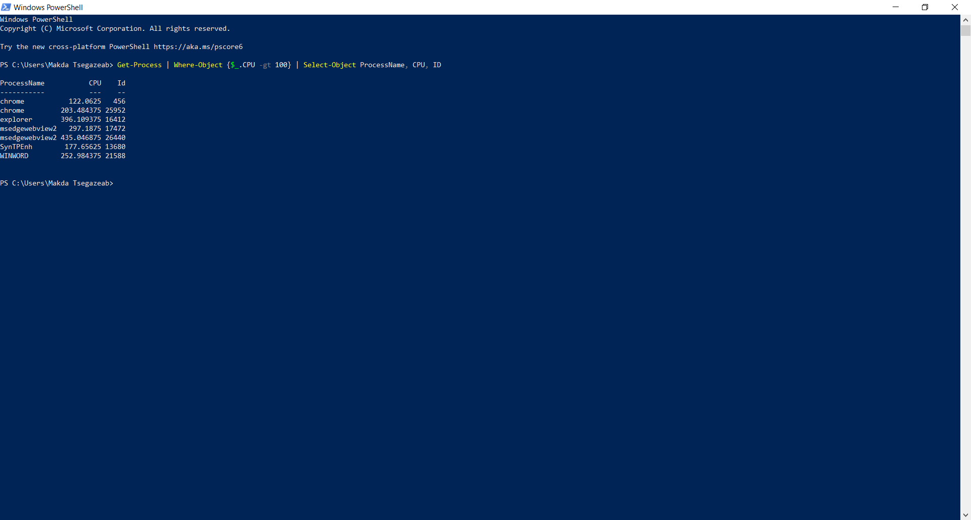

3. Pipelining
PowerShell's pipeline is a fundamental feature that allows you to connect multiple cmdlets together, sending the output of one cmdlet as input to the next. This creates powerful and concise scripts. The | symbol is used for piping.
Example: Getting running services, filtering by name, and then stopping them.
Get-Service | Where-Object {$_.DisplayName -like "*Update*"} | Stop-Service –WhatIf
(Note: -WhatIf is used here to preview the action without actually stopping the service, a good practice for potentially destructive commands.)
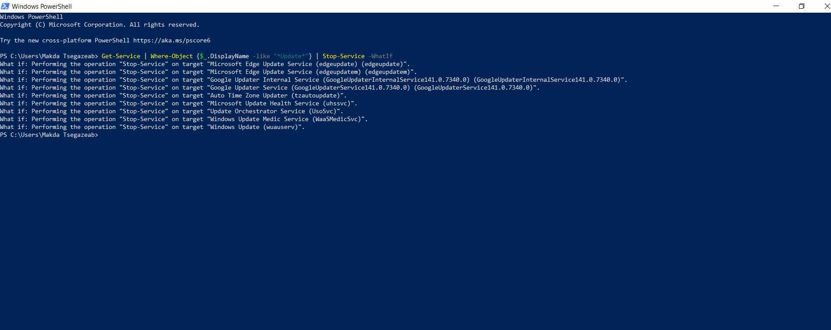

4. Variables and Control Flow
PowerShell supports variables (prefixed with $), conditional statements (if, else), loops (for, foreach), and functions, enabling complex script logic.
Example: A simple if-else statement.
$serviceName = "Spooler"
$service = Get-Service -Name $serviceName -ErrorAction SilentlyContinue

if ($service -and $service.Status -eq "Running") {
Write-Host "$serviceName is running."
} elseif ($service -and $service.Status -eq "Stopped") {
Write-Host "$serviceName is stopped."
} else {
Write-Host "$serviceName service not found."
}
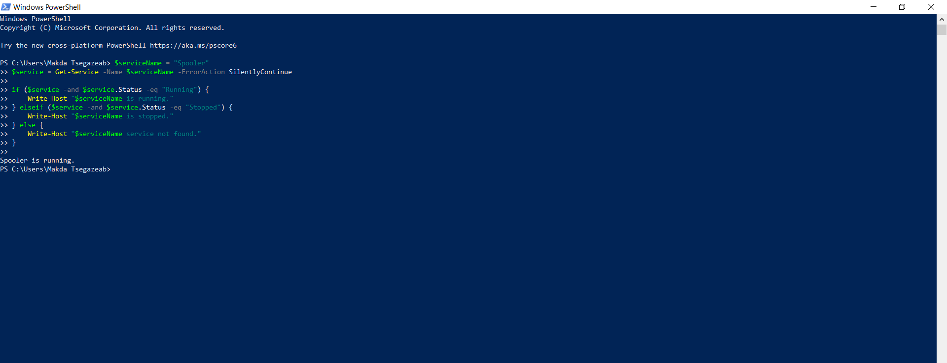

5. Use of Linux OS Scripts

Bash Scripting: Key Features
Bash (Bourne Again SHell) is the default shell for most Linux distributions. Bash scripts are plain text files containing a sequence of commands that the shell executes.

1. Shebang Line
Every Bash script typically starts with a shebang line #!/bin/bash. This line tells the operating system which interpreter to use for executing the script.
Example: A simple "Hello, World!" script.
#!/bin/bash
# This is a comment
echo "Hello from Adwa, Tigray, Ethiopia!"

2. Variables
Bash allows you to store data in variables. Variables are case-sensitive and can hold numbers, text, or the output of commands. You assign values using the = operator (no spaces around it) and access them using a $ prefix.
Example: Using variables to store and display information.
#!/bin/bash
name="Adwa"
location="Tigray, Ethiopia"
message="Welcome to $name, $location!"
echo $message

3. Conditional Statements (if, elif, else)
Conditional statements allow your script to make decisions based on whether a certain condition is true or false.
Example: Checking if a directory exists.
#!/bin/bash
read -p "Enter a directory name: " dir_name

if [ -d "$dir_name" ]; then
echo "Directory '$dir_name' exists."
elif [ -f "$dir_name" ]; then
echo "'$dir_name' is a file, not a directory."
else
echo "Directory '$dir_name' does not exist."
fi

4. Loops (for, while)
Loops enable repetitive execution of commands. for loops iterate over a list of items, while while loops continue as long as a condition is true.
Example: Using a for loop to list files with specific extensions.
#!/bin/bash
echo "Listing .txt and .log files in the current directory:"
for file in *.txt *.log; do
if [ -f "$file" ]; then
echo "$file"
fi
done

Conclusion
The exploration of modern general-purpose operating systems (OS) and their scripting capabilities reveals their critical role in managing computing resources and enabling automation. Key OS functions—process management, memory management, file management, device management, security, networking, and user interface—are foundational across Windows, macOS, and Linux. Process and memory management optimize multitasking and resource allocation, ensuring efficient performance in constrained environments. File and device management abstract hardware complexities, enhancing reliability and user experience. Security mechanisms, like Windows Defender or Linux permissions, mitigate risks, while networking supports distributed systems, and intuitive interfaces (e.g., Windows Explorer, macOS Finder, GNOME) improve accessibility. These functions, monitored via tools like Task Manager, Activity Monitor, and GNOME System Monitor, adapt to modern demands like AI and IoT, ensuring system stability and flexibility.
Windows CLI environments—Batch and PowerShell—offer distinct scripting strengths. Batch commands (e.g., dir /b /s, ipconfig /all, ping /t) provide simple, task-specific automation for file and network management. PowerShell’s object-oriented cmdlets (e.g., Get-Process, Invoke-WebRequest) enable advanced automation with pipelines and error handling, ideal for complex tasks. Linux Bash commands (e.g., ls -la, grep -i, mkdir -p) excel in file manipulation, system monitoring, and automation, with switches adding flexibility. Bash scripting leverages shebangs, variables, conditionals, and loops for robust automation, as seen in scripts checking directories or listing files.
PowerShell’s key features—cmdlets, pipelining, object-oriented output, variables, conditionals, loops, and error handling—offer structured, powerful scripting for system administration. Bash’s simplicity, with shebangs, variables, and control structures, suits Linux’s open-source ecosystem, enabling efficient task automation. Together, these OS and scripting capabilities provide comprehensive tools for managing modern computing environments, balancing user accessibility with technical depth.

Reference list
[0] A. Silberschatz, P. B. Galvin, and G. Gagne, Operating System Concepts, 10th ed. Hoboken, NJ, USA: Wiley, 2018.
[2] Microsoft, "Dir," Microsoft Learn, [Online]. Available: https://learn.microsoft.com/en-us/windows-server/administration/windows-commands/dir. [Accessed: Aug. 29, 2025].
[3] W. Stallings, Operating Systems: Internals and Design Principles, 9th ed. Boston, MA, USA: Pearson, 2018.
[4] M. E. Russinovich and D. A. Solomon, Windows Internals, 7th ed. Redmond, WA, USA: Microsoft Press, 2017.
[5] R. Love, Linux Kernel Development, 3rd ed. Boston, MA, USA: Addison-Wesley, 2010.
[10] B. Ward, How Linux Works: What Every Superuser Should Know, 3rd ed. San Francisco, CA, USA: No Starch Press, 2021.
[11] The Linux Foundation, "Linux man pages," [Online]. Available: https://man7.org/linux/man-pages/. [Accessed: Aug. 29, 2025].
[12] M. Tim Jones, "Anatomy of the Linux kernel," IBM Developer, May 2007. [Online]. Available: https://www.ibm.com/developerworks/library/l-linux-kernel/. [Accessed: Aug. 29, 2025].
[13] E. Siever, S. Figgins, R. Love, and A. Robbins, Linux in a Nutshell, 6th ed. Sebastopol, CA, USA: O’Reilly Media, 2009.
[15] P. J. Denning, "The evolution of operating systems," in Encyclopedia of Computer Science, 4th ed., A. Ralston, E. D. Reilly, and D. Hemmendinger, Eds. Hoboken, NJ, USA: Wiley, 2003, pp. 1282–1290.
[19] Microsoft, "Windows Overview," Microsoft Learn, [Online]. Available: https://learn.microsoft.com/en-us/windows/. [Accessed: Aug. 29, 2025].
[20] A. S. Tanenbaum and H. Bos, Modern Operating Systems, 4th ed. Upper Saddle River, NJ, USA: Pearson, 2015.
[25] Canonical Ltd., "Ubuntu Documentation," [Online]. Available: https://help.ubuntu.com/. [Accessed: Aug. 29, 2025].
[31] Microsoft, "Ipconfig," Microsoft Learn, [Online]. Available: https://learn.microsoft.com/en-us/windows-server/administration/windows-commands/ipconfig. [Accessed: Aug. 29, 2025].
[32] B. P. Lientz and E. B. Rea, Operating Systems: Concepts and Design, 2nd ed. New York, NY, USA: McGraw-Hill, 2010.
[35] D. Jones, PowerShell 7 for IT Pros, Hoboken, NJ, USA: Wiley, 2021.
[39] Microsoft, "About PowerShell," Microsoft Learn, [Online]. Available: https://learn.microsoft.com/en-us/powershell/scripting/overview. [Accessed: Aug. 29, 2025].
[53] PowerShell Tutorial, "PowerShell Scripting," [Online]. Available: https://www.powershelltutorial.net/. [Accessed: Aug. 29, 2025].
[60] TutorialsPoint, "PowerShell Tutorial," [Online]. Available: https://www.tutorialspoint.com/powershell/. [Accessed: Aug. 29, 2025].

