University of Wales Trinity Saint David
School of Engineering
Engine Performance Characteristics
Olivia Jenkins
1910165
Motorsport Engineering BEnG
Vehicle Technology (M4X00394)


Contents
Contents 2
1. Introduction 3
2. Experimental Method 4
2.1 Dynamometer Sweep test 4
2.2 Raw and researched data 4
2.3 Calculations from collected raw data 4
2.3.1 Torque (T): (Nm) 4
2.3.2 Power (P): (W) 4
2.3.3 Specific Fuel Consumption (S.F.C): (kg/kWh) 4
2.3.4 Brake Mean Effective Pressure (B.M.E.P): (Pa) 5
2.3.5 Brake Thermal Efficiency (BTE): (%) 5
2.3.6 Graphs 5
3. Results 7
4. Analysis 9
5. Conclusions 10
6. Evaluation 10
7. References 11

Introduction
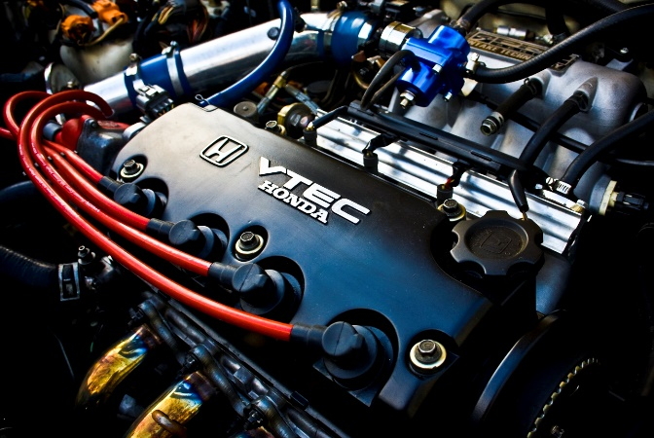
A Dynamometer is an instrument that can be used to measure the power outputs of an engine. An experiment using the Universities Dynamometer, to step test a Honda 1.6 Vtec. D16 series 1.6lt engine will measure its power outputs. The aim of this experiment is to use the raw data obtained to calculate the emitted torque, break power, corrected power, break mean effective pressure and break thermal efficiency and use these values to analyse the Honda engine’s performance efficiency.
Figure 1 Vtec Honda engine. Youwheel.com, 2017.
This Technical report will explain the method of the Dyno-test used to record and collect raw data from the Honda engine and the equations used to calculate the forces emitted. These values will be compared with the Honda engines expected values so that the efficiency of the engine and the dynamometer itself can be analysed. This report will also show graphs showing the correlation between Engine speed with SFC, Torque and Brake Power with suggested reasoning behind the correlations. The Report will end with a conclusion about the engine’s performance characteristics, considering any limitations to the experiment.

Experimental Method

2.1 Dynamometer Sweep test
The experiment takes place in the Universities Dynamometer testing room. The Dynamometer is attached to a Honda 1.6 Vtec D16 series engine in the ventilated room and the computers that can manually manipulate the Dyno and present the data from the engine is in a separate room. Once the Dynamometer is set up in the room with ventilation a sweep test can be performed using the computer systems connected to the Dyno. The engine speed is manually determined in the sweep test starting from 1000rpm and ending at 5500rpm. Each measurement for Load, engine speed, fuel flow rate and lambda is logged at each 50rpm increments during.

2.2 Raw and researched data
The raw data obtained from a sweep test includes the Load(N), Engine speed(W), Fuel flow rate and Lambda acquired from the excel spreadsheet in Group D Vehicle Technology folder on Moodle.com.
Researched data necessary to carry out the calculations of the engine’s output included:
- Radius of the torque arm =0.815776m (displayed on the dyno)
- Ambient temperature and pressure of the day =25 degrees, 1027.85 mBar (GrD excel spreadsheet, Moodle.uwtsd.ac.uk)
- Bore and stroke of the engine = 0.075mx0.09m (Honda manual, 1990)
- Calorific value of fuel = 45800kJ/kg (Fuels, engineeringtoolbox.com)

2.3 Calculations from collected raw data
This raw and researched data can be used to find values for the following forces that test the engines output efficiency. Then these values can be entered into a spreadsheet and analysed.

2.3.1 Torque (T): (Nm)
Torque is the engines rotational force.
$T=WR$
Where W=Load (N)
R=Radius of torque arm (m)

2.3.2 Power (P): (W)
The Brake Power (BP) of the engine is found using the equation:
$$BP=\frac{2πNT}{60}$$
Where N=Engine speed (rpm)
The corrected power ($P_{S }$) according with the ambient temperature ($T_{a}$) and ambient pressure ($P_{a}$) of the day the data was collected. Found by rearranging the equation:
$$\frac{P_{S}}{BP}=\frac{1.01325}{P_{a}}\sqrt{\frac{T_{a}}{293}}→P_{S}=BP\left(\frac{1.01325}{P_{a}}\sqrt{\frac{T_{a}}{293}}\right)$$
Where $T_{a}$ is in Kelvin and $P_{a}$ is in Bar.

2.3.3 Specific Fuel Consumption (S.F.C): (kg/kWh)
The S.F.C shows the fuel efficiency of the engine:
$$S.F.C=\frac{V×0.75×3600}{t×1000×BP}$$
This equation can be worked out in the following steps:
First converting the fuel flow rate from l/min to kg/min by multiplying by the researched value for specific gravity of fuel.
Next converting this into kg/hour by multiplying by 60.
And finally dividing this value by BP in kW. This will give the S.F.C value in kg/kWh.

2.3.4 Brake Mean Effective Pressure (B.M.E.P): (Pa)
The B.M.E.P shows the measured brake horse power. This value is an indication of the engine’s performance efficiency.
$$B.M.E.P=\frac{BP×60×2}{L×A×N×n}$$
Where L is the stroke of the engine
A is the piston Area
N is the engine speed
n is the number of cylinders
L and n values are to be researched.
The number of cylinders for the Honda vtec engine is 4 (Honda manual, 1990). However, in working out this equation, to change the units from rpm to no. power strokes, 4 is divided by 2. Therefore making the value of n=2.
The value for A can be found using the equation:
$$A=\frac{πd^{2}}{4}$$
Where d=the diameter of the piston

2.3.5 Brake Thermal Efficiency (BTE): (%)
This determines the efficiency of the engines brake power.
$$BTE=\frac{\frac{BP}{1000}}{S.F.C\left(\frac{kg}{s}\right)×C.V}×100$$
Where S.F.C is converted into kg/s
C.V is the researched calorific value of fuel

2.3.6 Graphs
In order to present the data and competently come to conclusions on the engine’s efficiency, the output values of Torque, Power and SFC were plotted against the Engine speed. The format shows how these outputs changed during the sweep test and therefore how efficiently the engine ran at low to high speeds.
In order to get accurate readings, the graphs were smoothed at a rate of 0.25 using the website mazurka.org to input and smoothen the raw data values. These new smoothened values were then copied into the spreadsheet and used in the graph, to cut out any anomalous readings. (Mazurka.org)

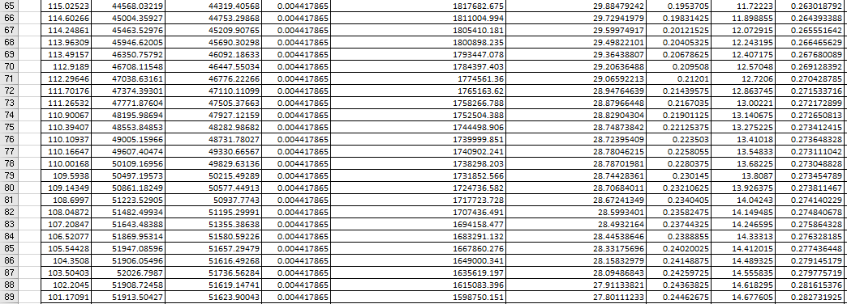
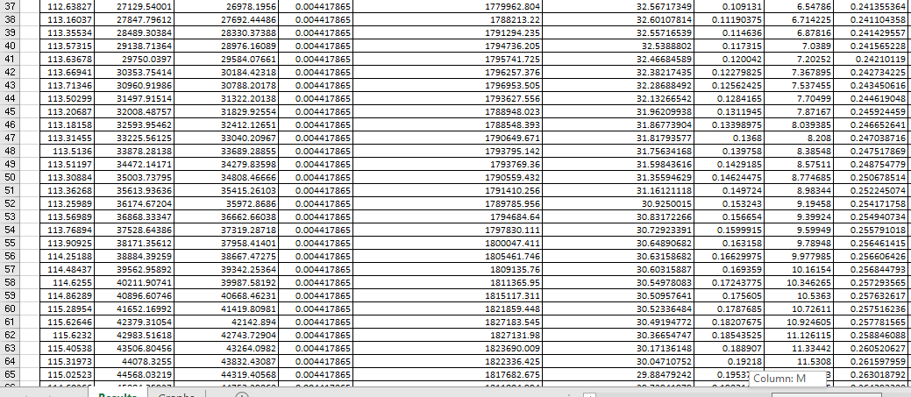
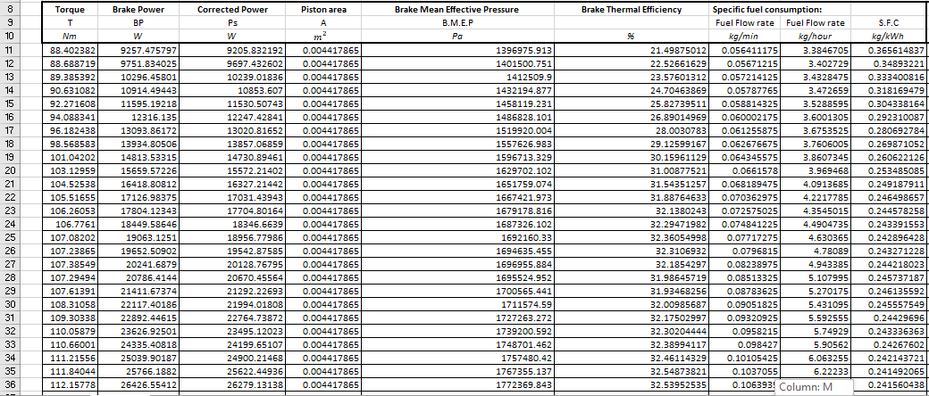
Results
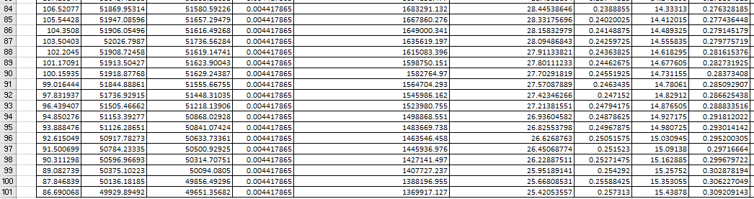
Figure 5 Graph showing Power(kW) against Engine Speed (rpm)
Figure 4 Graph showing Torque(Nm) against Engine Speed(rpm)
Figure 2 Engine Output Calculations
Figure 6 Graph showing SFC(kg/kWh) against Engine Speed (rpm)

Analysis
Referring to Figure 4, the peak torque value was 115.6 Nm at around 3500rpm. The expected peak torque for a gasoline, Honda Vtec engine is 152Nm at 4600rpm (findparts.org, 2013). Torque is the force produced from rotational energy in the crankshaft, high amounts of torque can make the engine run faster and more efficiently. The torque in this experiment peaked 1100rpm earlier than expected and at a value of 36.4Nm lower. This comparison reveals how inefficiently the engine is producing torque. The dip in torque towards the end of the sweep test, as the speed gets higher, implies that the engine was not capable of creating enough torque for the power required at that speed.
This could be due to a drop in the air to fuel ratio. As the engine speeds up the amount of fuel and air needed to keep it performing efficiently also increases. If the air is not being properly expelled in the engine then the mix of air and fuel to burn hotter and heat the engine meaning it can no longer keep up the amounts of torque and power needed to keep it running at, in this case 5500rpm.
The expected peak power for this engine is 81kW at 5600(findparts.org, 2013) compared to the peak power value of over 50kW at 4750rpm shown in figure 5, achieved from the dynamometer test. This supports the previous idea that the engine is not running efficiently, nor providing sufficient outputs needed to convert fuel into power. The decline in power after its peak at 4750rpm could be caused by the lack of torque start shown in figure 5 which started declining before at 3500rpm. The significant reduction in torque meant more fuel was being used but also being burned off at a faster rate and not efficiently converting into power. Again, reiterating that the engine is not running efficiently and possibly the poor expenditure of air in the engine is making the fuel work harder to convert into power for the higher speeds.
This point is further pressed referring to figure 6, the Specific fuel consumption levels. The SFC levels show how efficiently the engine converts fuel into power. At around 3600rpm the fuel consumption levels start to slowly rise from 0.25kg/kWh to 0.3kg/kWh at 5400 rm. The torque in figure 4 also starts to drop at the same Engine speed, after the peak torque level at 3500rpm. Therefore, more fuel was being expelled from the acceleration between 3500rpm to 5400rpm than during the acceleration from 1000rpm to 3500rpm. According to these results there was high amounts of fuel being expelled at greater speeds, which indicates too much air is in the engine, so in compensation the engine is forced to deplete more fuel. Figure 6 also shows an anomalous large spike of SFC at the start of the sweep test, at 1000rpm, before quickly declining to a more sustainable SFC value at 1400rpm. From figure 4 we can see that the torque levels are also low during this period, however the graph from figure 5 shows that the power is not affected. This shows us that at lower speeds, not as much torque is needed to keep the engine running but with less torque there is a higher SFC, meaning at lower torque levels, more fuel is being expelled than needed to create a certain amount of power.

Figure 7 shows the raw lambda value against engine speed(rpm) from the dyno test. Lambda shows us how efficiently the engine is running according to its air to fuel ratio. In a dyno test, it is aimed to achieve a Lambda value of 0.8-1. This is where the air to fuel ratio is working at its most efficient to provide power. At the start of the dyno test the Lambda is at what is considered a very high value of air against fuel meaning there is too much air in the engine causing the mixture to burn hotter and heat the engine too high. This is a consistent theme as the line slopes down to a minimum level of only 1. This means not enough fuel is being used and consequently the engine is losing power.
Figure 7 Graph showing Lambda against Engine speed

Conclusions
The aim of this technical report was to come to a reliable and accurate conclusion about a specific Honda D16V1 engines performance characteristics, using data from a dynamometer sweep test.
From this analysis of collected and calculated data of the engines output forces and fuel consumption, the conclusion can be made that the engine does not efficiently convert fuel into power at the standard researched rate for a Honda D16 engine.
The outcomes of this dynamometer test show that the Honda engine is running with an inadequate air filtering system, causing the mixture of fuel and air to burn and heat the engine too far. This air restriction causes a Lean outcome in the air-fuel mix ratio leaving the engine burning too hot and therefore not producing satisfactory amounts of power. This is an inefficiency that will lead to a waste of fuel and higher emissions from the engine.
However, we can conclude that the dyno sweep test was an accurate way to analyse the engine’s performance.

Evaluation
There are limitations within this dyno test, if the experiment could be done again, a Dyno step test would produce more accurate values of raw data as a step test pauses at each individual reading to create better resolution of the engines output load, speed and fuel flow rate. This would have produced more accurate readings and therefore more accurate calculations of power, torque and SFC.
Also, the results for Break mean effective pressure (BMEP) can only be considering a theoretical value as there were no pressure censors to accurately measure the pressure. This, therefore reduces the reliability of this value and it cannot be used to truthfully reflect the actual break mean effective pressure of the engine. If this experiment could be replicated the use of pressure censors would increase the accuracy of presented values.

References
- Carr, (2017). Development of the Honda VTEC: A Brief History. [Online]. Available at: http://youwheel.com/home/2017/05/02/development-of-the-honda-vtec-a-brief-history/
- 2019, Engine Dynamometer GrD. Excel Spreadsheet. Website: Moodle.uwtsd.ac.uk.
- Honda Motor Co Ltd, (1990). SHOP MANUAL HONDA CIVIC COUPE CRX SUPPLEMENT. Service publication office. Moodle.uwtsd.ac.uk Pdf Available at: file:///C:/Users/livvj/Downloads/VTEC_Honda%201.6%20(1).pdf [Accessed 6/1/20]
- Engineering ToolBox, (2003). Fuels - Higher and Lower Calorific Values. [online] Available at: https://www.engineeringtoolbox.com/fuels-higher-calorific-values-d_169.html [Accessed 6/1/20].
- Findparts.org (2013). Engine HONDA D16V1. [online] Available at: http://www.findpart.org/engine/honda-d16v1

