

Module Name: Academic Skills in the Digital Era
Module Code: BMSW4013
Assessment 1: E-Portfolio

Student Name: Sonia Jaman
Student Number: 2506072
Lecturer: Scott James

AI Acknowledgement
I acknowledge the use of Grammarly (https://www.grammarly.com/) on Date 14-11-2025 to check my work using the prompt(s): N/A

Table of Contents
Component 1: Research and Planning 1
1.1 Source Exploration 1
1.2 Key Challenge for Students 1
1.3 Key Opportunity for Students 2
1.4 Planning My Report 2
Component 2: Answering the Question 3
2.1 Introduction 3
2.2 Challenges Students Face 3
2.3 Opportunities Digital Tools Provide 4
2.4 How Students Can Adapt 4
2.5 Conclusion 5
Component 3: Reflective Presentation 6
References 9
Appendices 11
A 01: CRAAP Test 11

Component 1: Research and Planning

1.1 Source Exploration
Article Title: Education in the Digital Age: Opportunities, Challenges, and Innovations.
The chosen source is written by Mukhamad Saekan Muchith and published in 2023.
Muchith (2023) argues that digital tools such as online learning platforms, artificial intelligence (AI)-based learning assistants, and virtual classrooms make education more accessible, flexible, and personalised. Students have the opportunity to study at their own pace and from anywhere. Nevertheless, the article also states the challenges, such as the digital divide, the problem of cybersecurity, and teacher (digital literacy) improvement. Muchith concludes that equal access to technology, good infrastructure and continuous training of educators are the key to successful learning during the digital age.
The source was chosen as it is current and very relevant (Appendix 01) to the experiences of students in the digital age. It is published in a peer-reviewed journal, which shows its authority and accuracy. Its content is directly related to the point of intersection between digital means and education, which is in line with the research question of confrontations and opportunities students go through.
The article offers valid and precise information on the challenges (such as the skill gaps and digital inequality) and opportunities (such as flexibility and innovation) of digital learning. I can use the information in this report.

1.2 Key Challenge for Students
The digital divide is one of the major challenges that students face while using digital tools. It refers to unequal access to technology and reliable internet. As an illustration, certain students will face issues with internet speeds or old technology, and it will be hard to attend online classes, complete assignments or access learning resources (Afzal et al., 2023). In my experience, group projects were a difficult situation as members did not have equal access to digital platforms, which caused delays and frustration. This issue is significant as the failure to provide equal access may adversely affect learning, worsen the educational disparity, and restrict the ability to develop a skill set. This problem needs to be addressed to make sure that every student can enjoy the benefits of digital education and reach their academic potential.

1.3 Key Opportunity for Students
One of the biggest advantages of digital tools is that they are flexible and accessible in the process of learning. Technologies like Google Classroom, Khan Academy, and AI-based learning applications enable students to learn at their own pace, review challenging material, and find a range of multimedia resources (Rafique, 2023). As an example, in the context of remote learning, I could watch the lectures several times, which enhanced my comprehension of complicated issues. This is a good opportunity because it facilitates personalised learning, learning styles, and students find it easier to manage their time. Also, online tools provide access to more resources in the world, collaboration, and skill-building platforms that otherwise are not available, boosting not only academic performance but also the prospects of lifelong learning (Tariq, 2025).

1.4 Planning My Report
In my report, I will balance the challenges and opportunities equally because it is important to understand both to offer a balanced picture of how students can adjust to the digital era. I will also introduce particular examples, including online learning systems, AI-assisted studying technologies, and problems connected with the digital divide. The report will be organised into three key points, namely: introduction to digital learning and a detailed discussion of major challenges and opportunities with examples and finally practical approach and reflections on how students can use digital tools effectively to achieve academic success.
Timeline of Component 02:
Task | Date / Deadline
Finish research | 20-Oct-25
Draft first section (Introduction & Challenges) | 28-Oct-25
Complete first draft (Full report) | 07-Nov-25
Final editing and proofreading | 14-Nov-25

Component 2: Answering the Question

2.1 Introduction
The digital era has transformed education, providing students with unprecedented access to learning resources, collaboration tools, and innovative technologies. Digital tools, ranging from online learning platforms to AI-assisted study applications, have made education more flexible, personalised, and accessible (Akour and Alenezi, 2022). However, alongside these advantages come challenges such as unequal access to technology, distractions, and the need to develop digital literacy skills. For students today, understanding both the benefits and difficulties of using digital tools is essential to maximise learning outcomes and succeed academically (Alenezi et al., 2023). This report will explore two key challenges students face when using digital tools, examine two major opportunities digital learning provides, and offer three practical strategies for adapting effectively to thrive in the digital learning environment.

2.2 Challenges Students Face
The digital divide is one of the major challenges that students experience during the digital era, where the digital divide is defined as unequal access to technology and the reliable internet. It is possible that students who do not have high-speed connections or modern devices will have difficulties attending online classes, using e-learning resources, and submitting assignments on time (Afzal et al., 2023). In my own experience, group projects were often delayed when some teammates had connectivity issues, highlighting how technological inequality can impede collaboration. This problem is significant as it may increase educational disparities and reduce the chances of academic achievements. Muchith (2023) stresses that without fair access to digital materials, students might not be able to use online platforms of learning, AI-based information, and virtual learning rooms.
Another challenge is overreliance on technology, which can lead to distractions and reduced critical thinking. Notifications from social media or multitasking between applications often interrupt learning (Singh et al., 2024). Students who are constantly distracted by digital tools mention less focus and reduced information retention (Saufi, 2025). This shows that although digital tools may be convenient, they must also be self-regulated by an individual in order to learn effectively.

2.3 Opportunities Digital Tools Provide
Digital tools offer students significant opportunities for flexible and personalised learning. Google Classroom, Khan Academy, and AI-assisted apps, to name a few, enable learners to learn at their own pace, repeated knowledge, and access other learning materials (Rafique, 2023). Indicatively, in remote learning, I would repeat recorded lectures, which reinforced my comprehension of difficult subjects. Muchith (2023) argues that such tools are more engaging, more accessible, and more inclusive, especially with learners possessing varying abilities or schedules.
Another opportunity is enhanced collaboration and global connectivity. Digital tools allow students to interact, exchange assets, and undertake projects with other students across the globe (Mexhuani, 2025). Applications such as Zoom, Microsoft Teams, and collaborative document programs provide an easy interaction experience even when those involved are not at the same location. It has been proven that cooperative online learning fosters problem-solving, communication, and knowledge exchange (Johnston and López, 2022). This is a worthy opportunity since it enables students to learn to work as a group and use digital communication skills, which are vital in contemporary workplaces. Digital tools can power the learner with education whereby the learner can control their learning, enhance results, and stage them to lifelong learning in a technology-driven world (Tariq, 2025).

2.4 How Students Can Adapt
To thrive in the digital era, students need practical strategies for managing challenges and leveraging opportunities.
1. Time Management Tools: Using digital planners, calendar apps, or the Pomodoro technique can help students structure study sessions and minimise distractions. For instance, apps like Trello or Notion allow tracking assignments and deadlines. Research by Jin et al. (2023) highlights that structured time management improves productivity and reduces stress in online learning.
2. Critical Use of AI Tools: AI tools like ChatGPT may be helpful in research, but students should review the references and should not directly copy the results. Responsible use of AI involves learning to check the information and incorporate it, which enhances analytical capabilities. Muchith (2023) also stresses that students who critically use digital tools have a deeper perception and do not overuse them.
3. Improving Digital Literacy: It is essential to master the skill of evaluating information on the Internet, efficient navigation of sites and resources, as well as the security of personal data. Cybersecurity knowledge and skills can be increased by attending the online skills training workshops, using online library training, and adhering to the guidelines on digital skills. It has been proven that digitally literate students are better students and better able to adjust to the dynamic online learning environments (Tariq, 2025).
These measures can assist students to overcome distractions and achieve fair learning as well as to maximise the advantages of digital tools so that they can excel both in school and the workplace.

2.5 Conclusion
In conclusion, digital age students are challenged, and opportunities affect their learning. There are important barriers, such as the digital divide and excessive dependence on technology, that can be disabling in providing equal access and attention. Nevertheless, online technologies can be used to provide a flexible learning process and improve collaboration, which allows engaging in it more and developing skills. To succeed, students are supposed to manage time, be critical of AI tools, and enhance their digital literacy. The balances between these aspects help learners to adjust, improve their academic performance, and acquire the necessary skills to be successful in their lives in an ever-growing digital society.

Component 3: Reflective Presentation
Slide 01: Overview
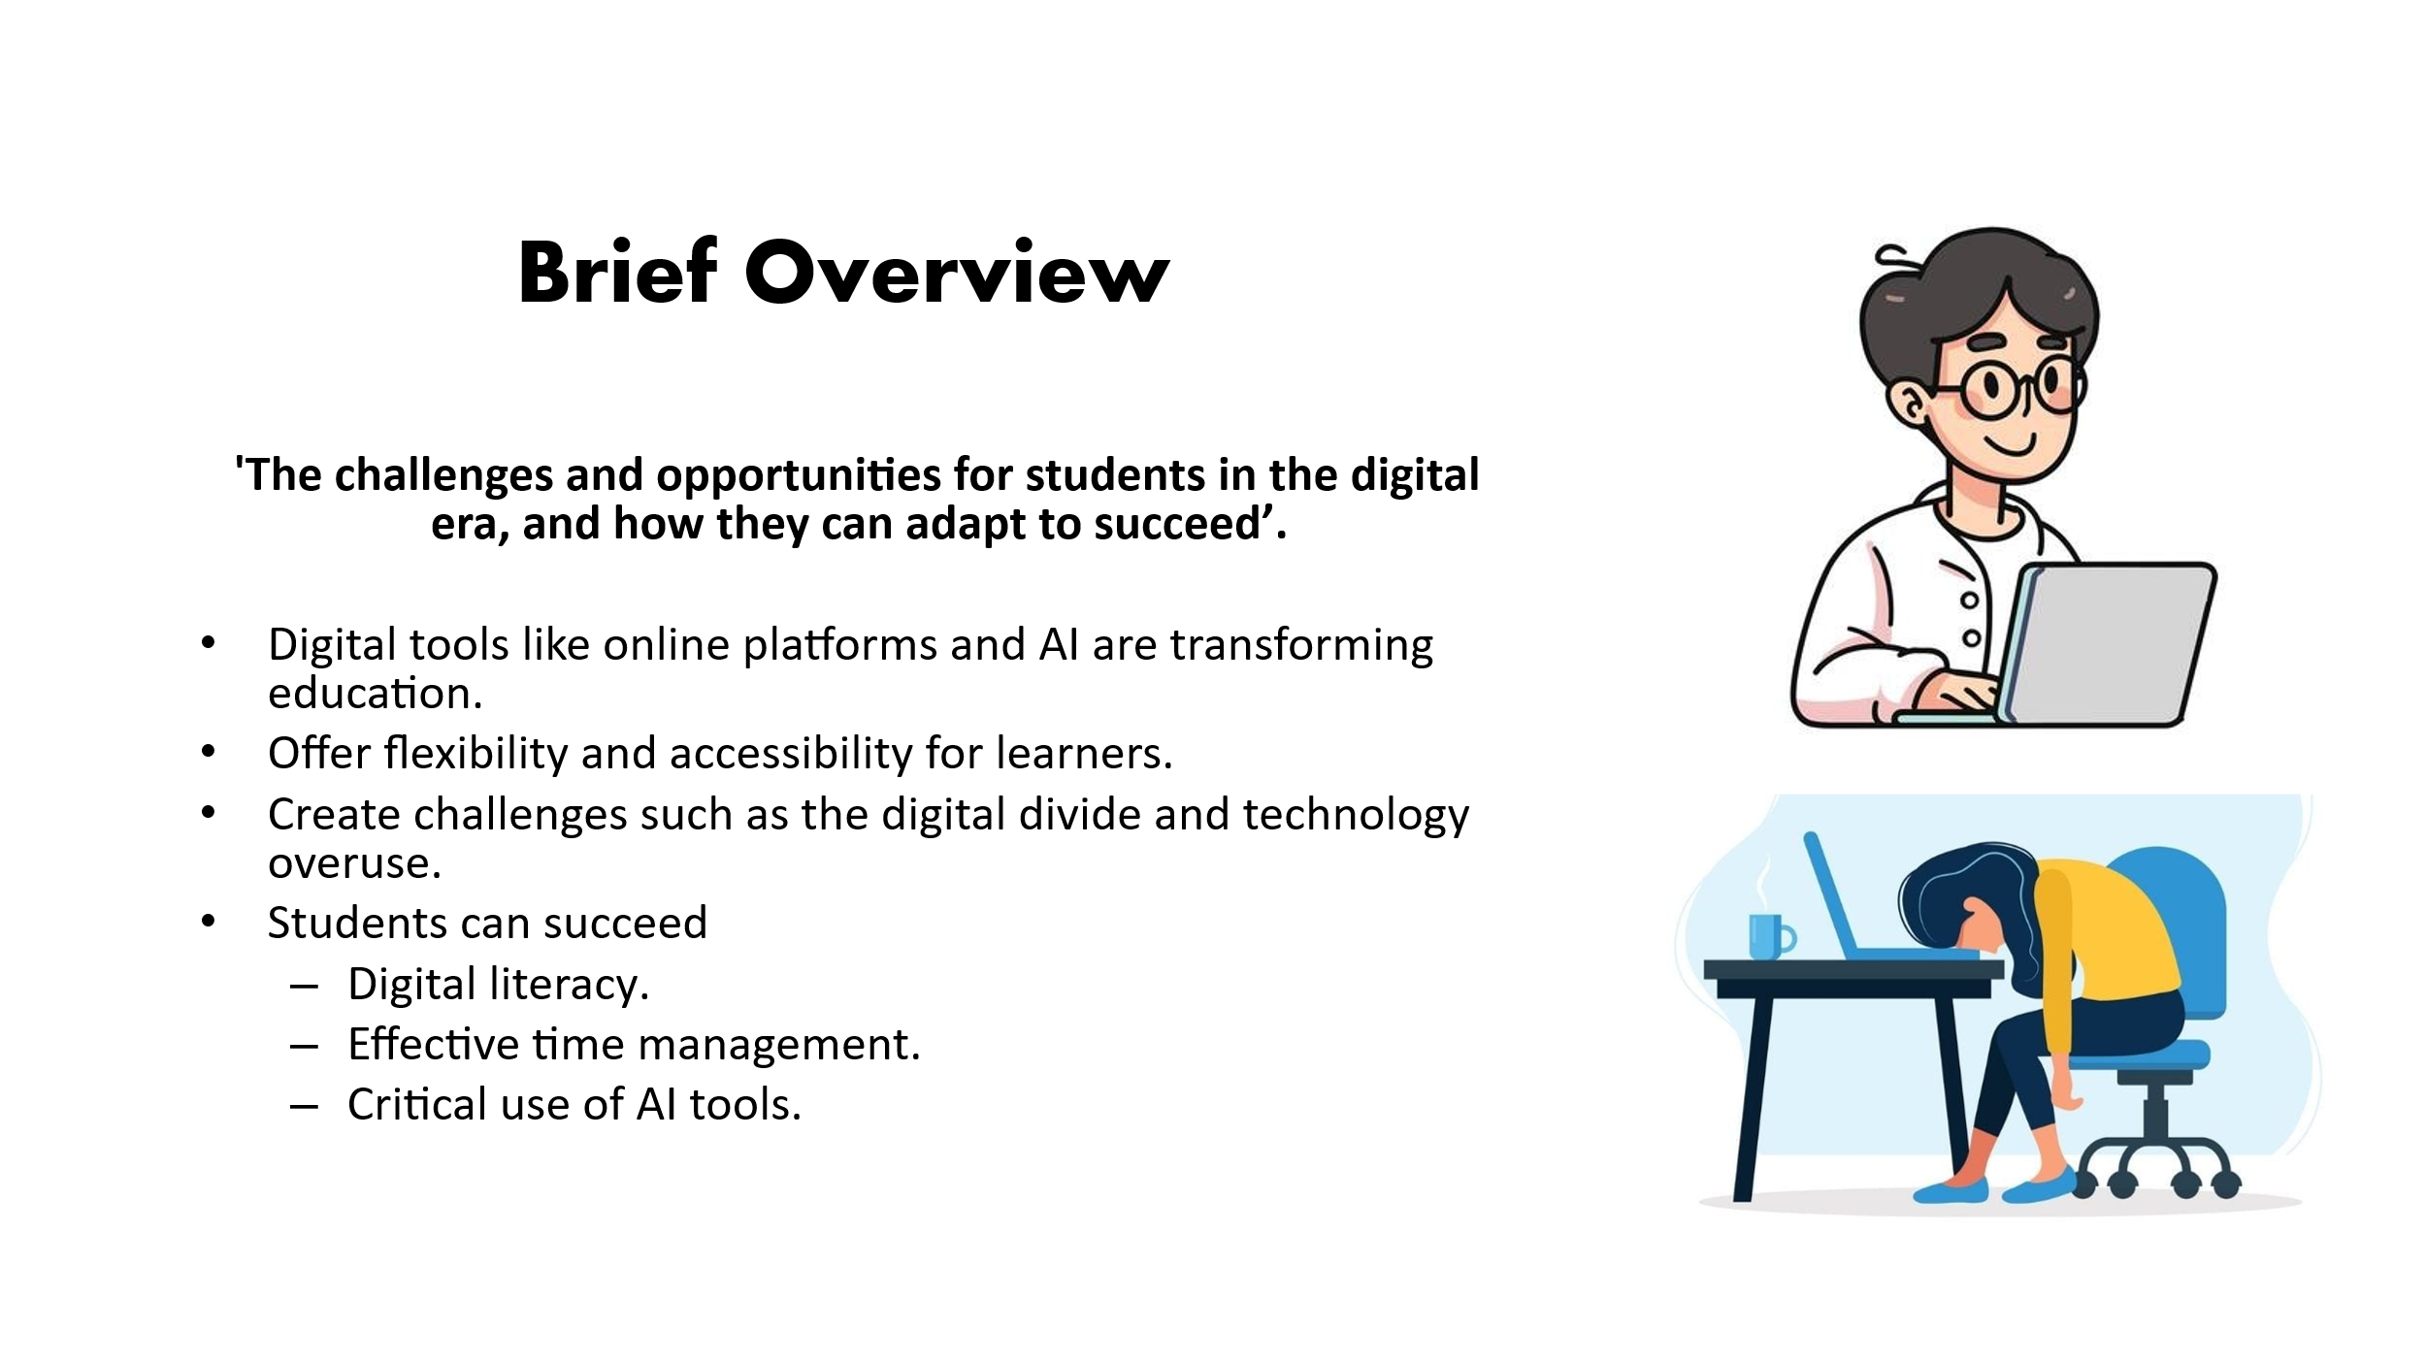
Slide 02: Research Process
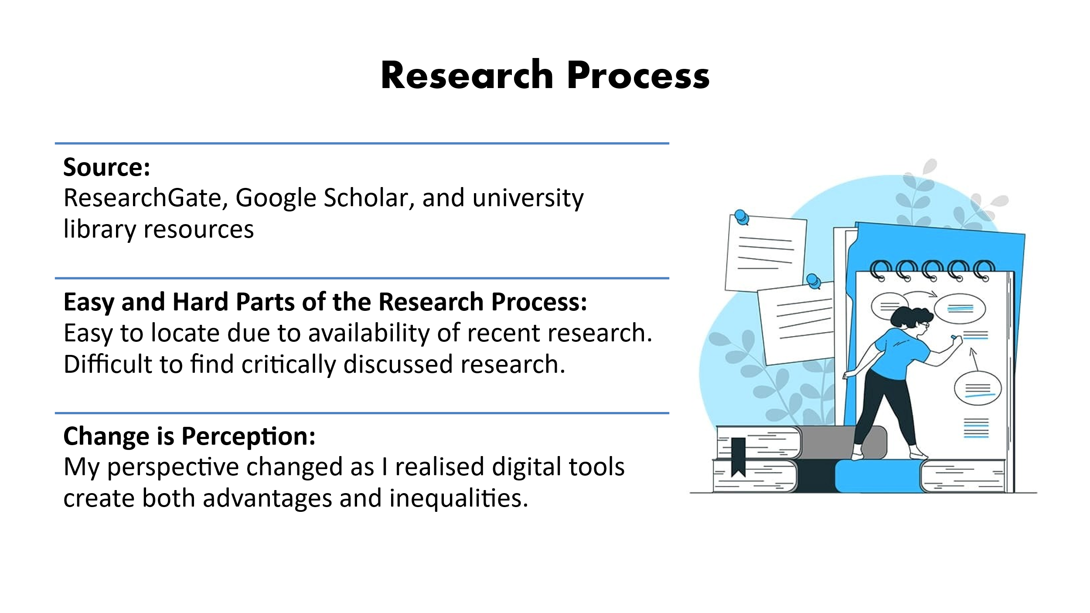

Slide 03: Planning & Writing Process
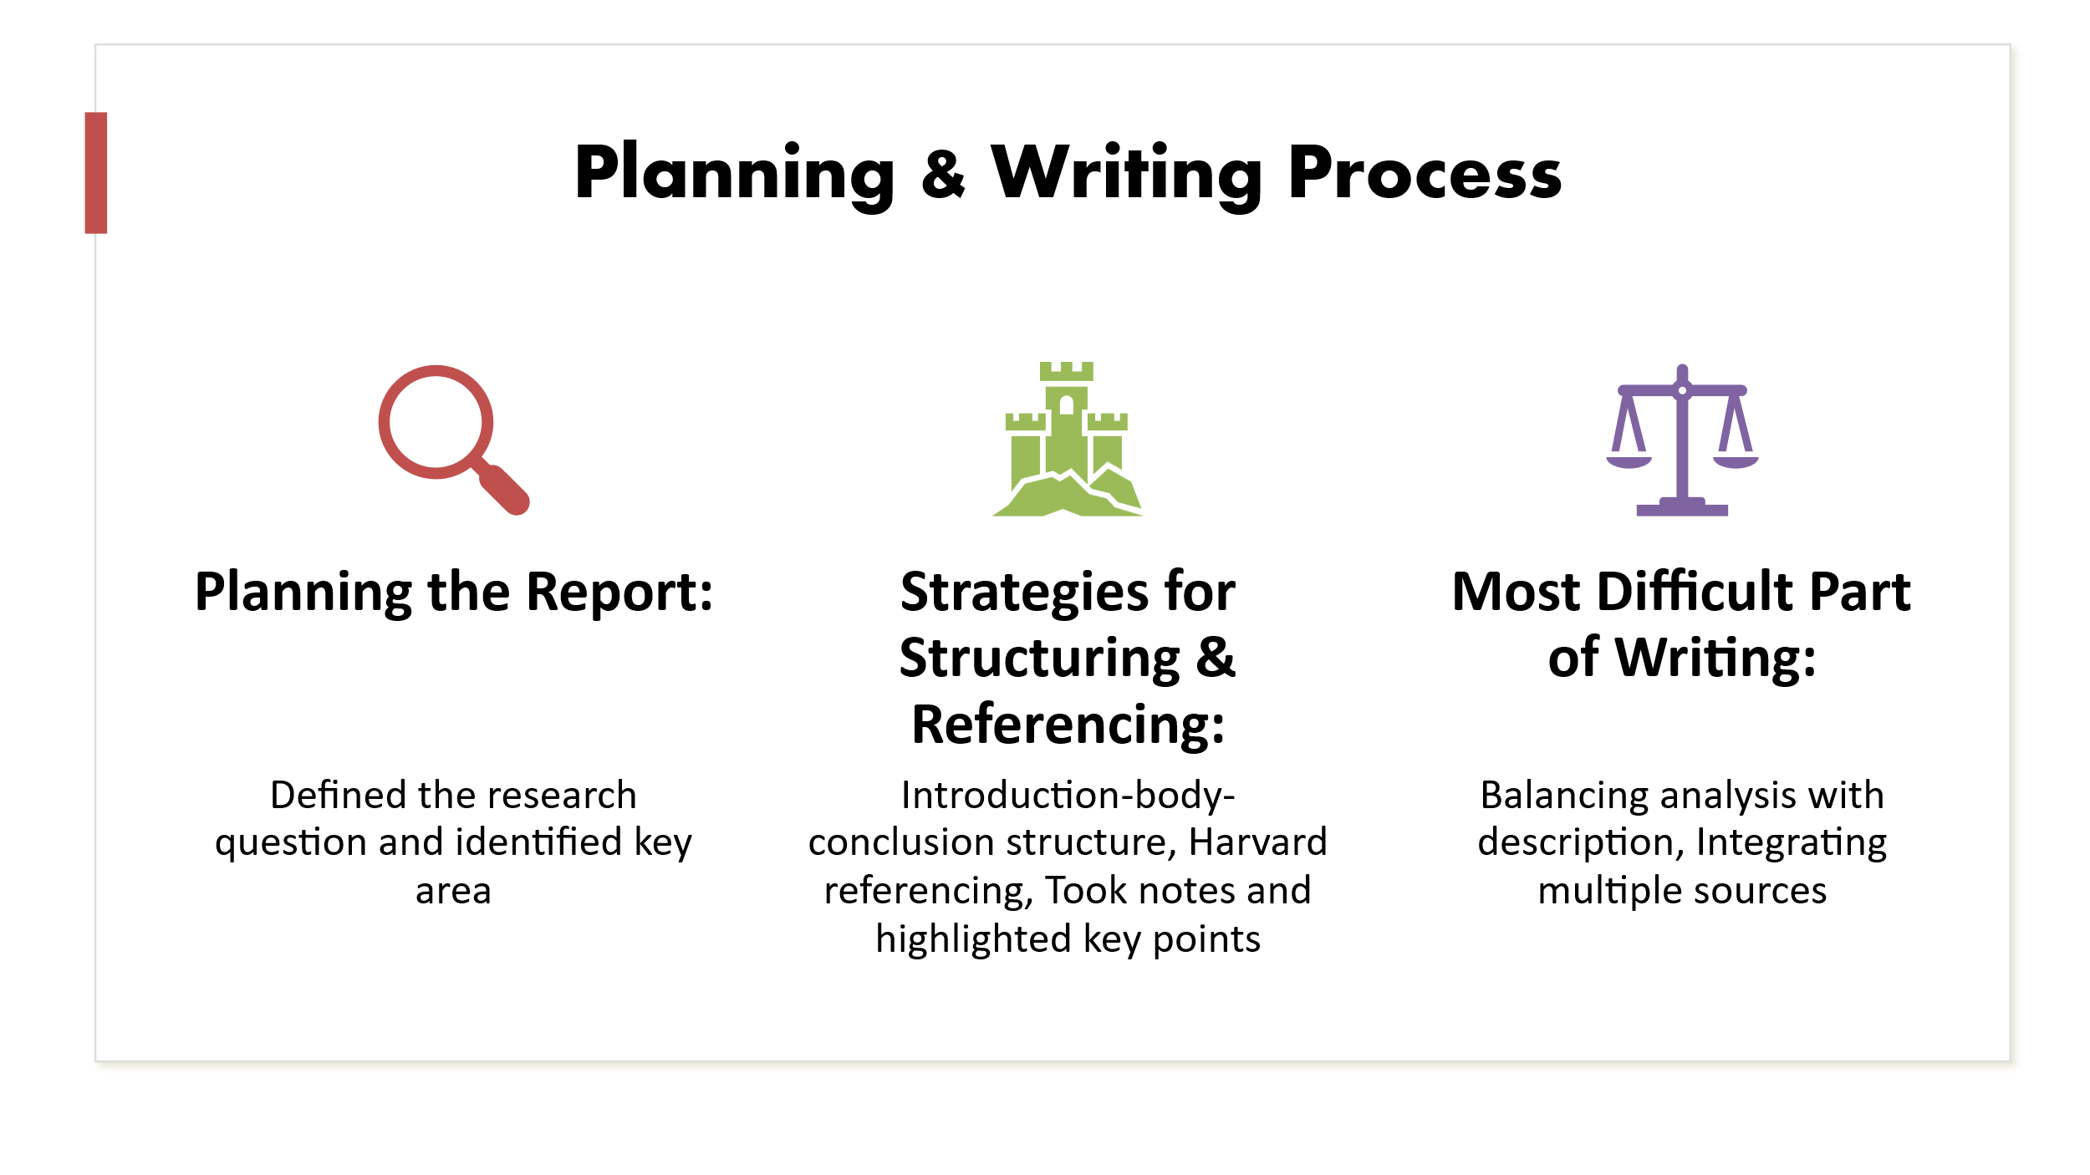
Slide 04: Challenges
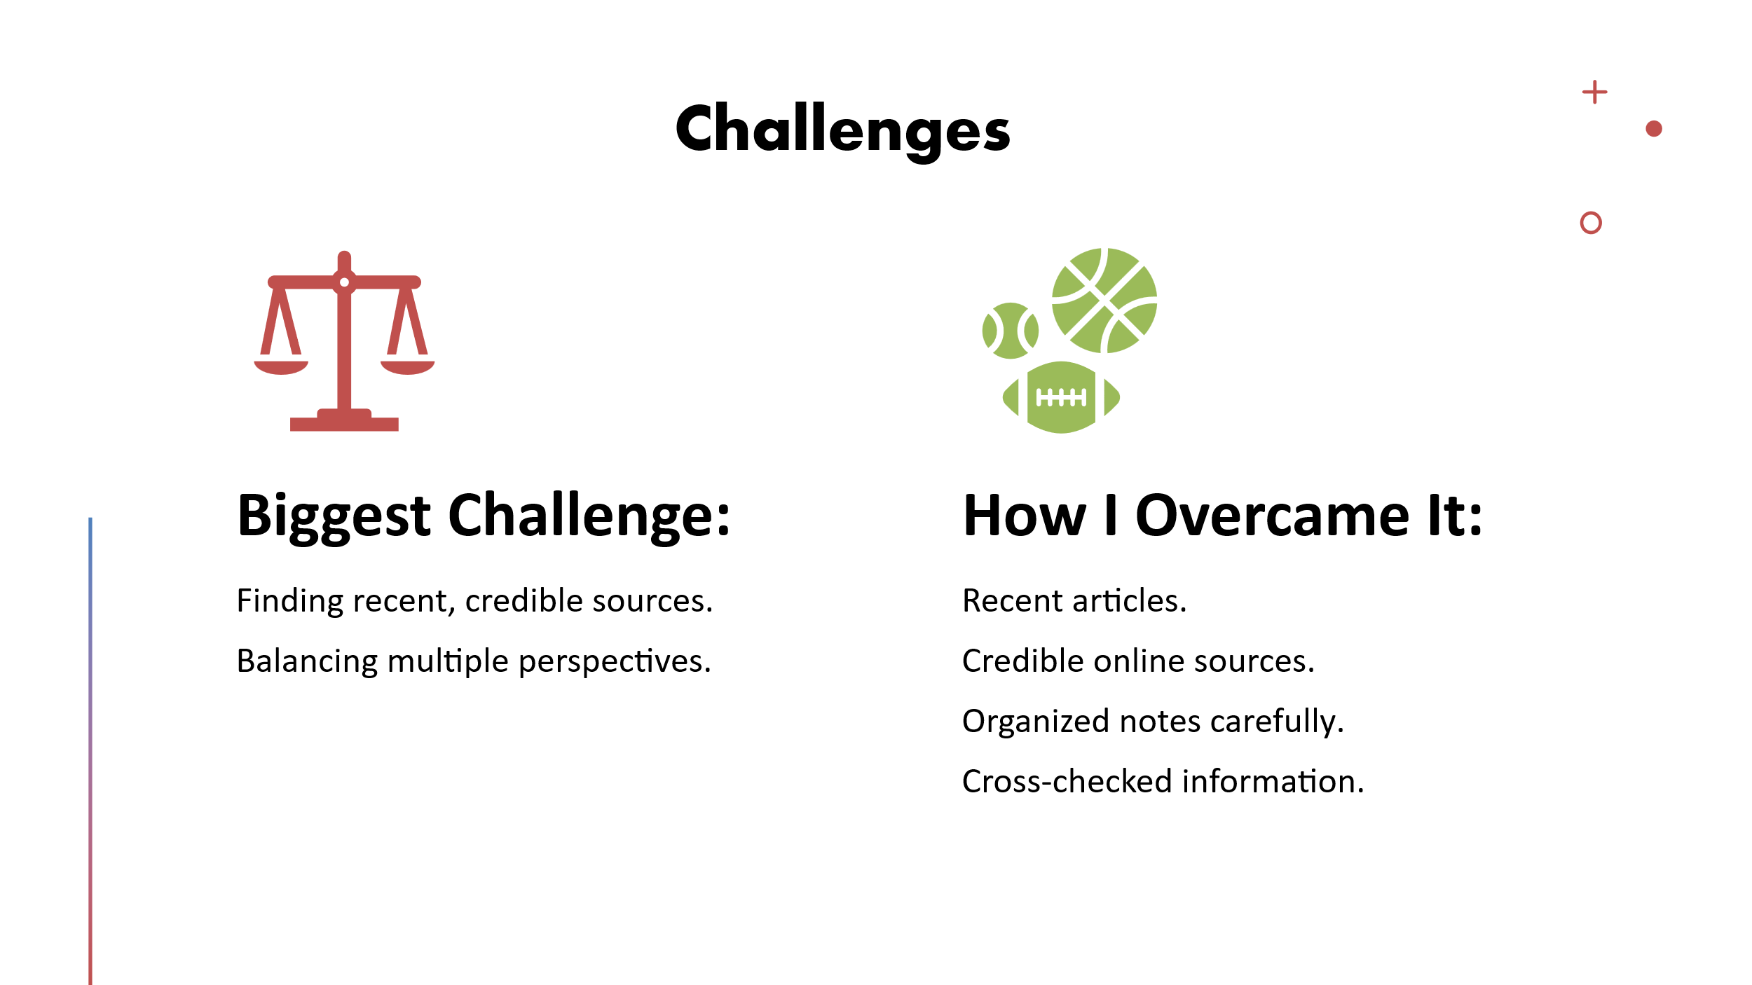

Slide 05: Successes
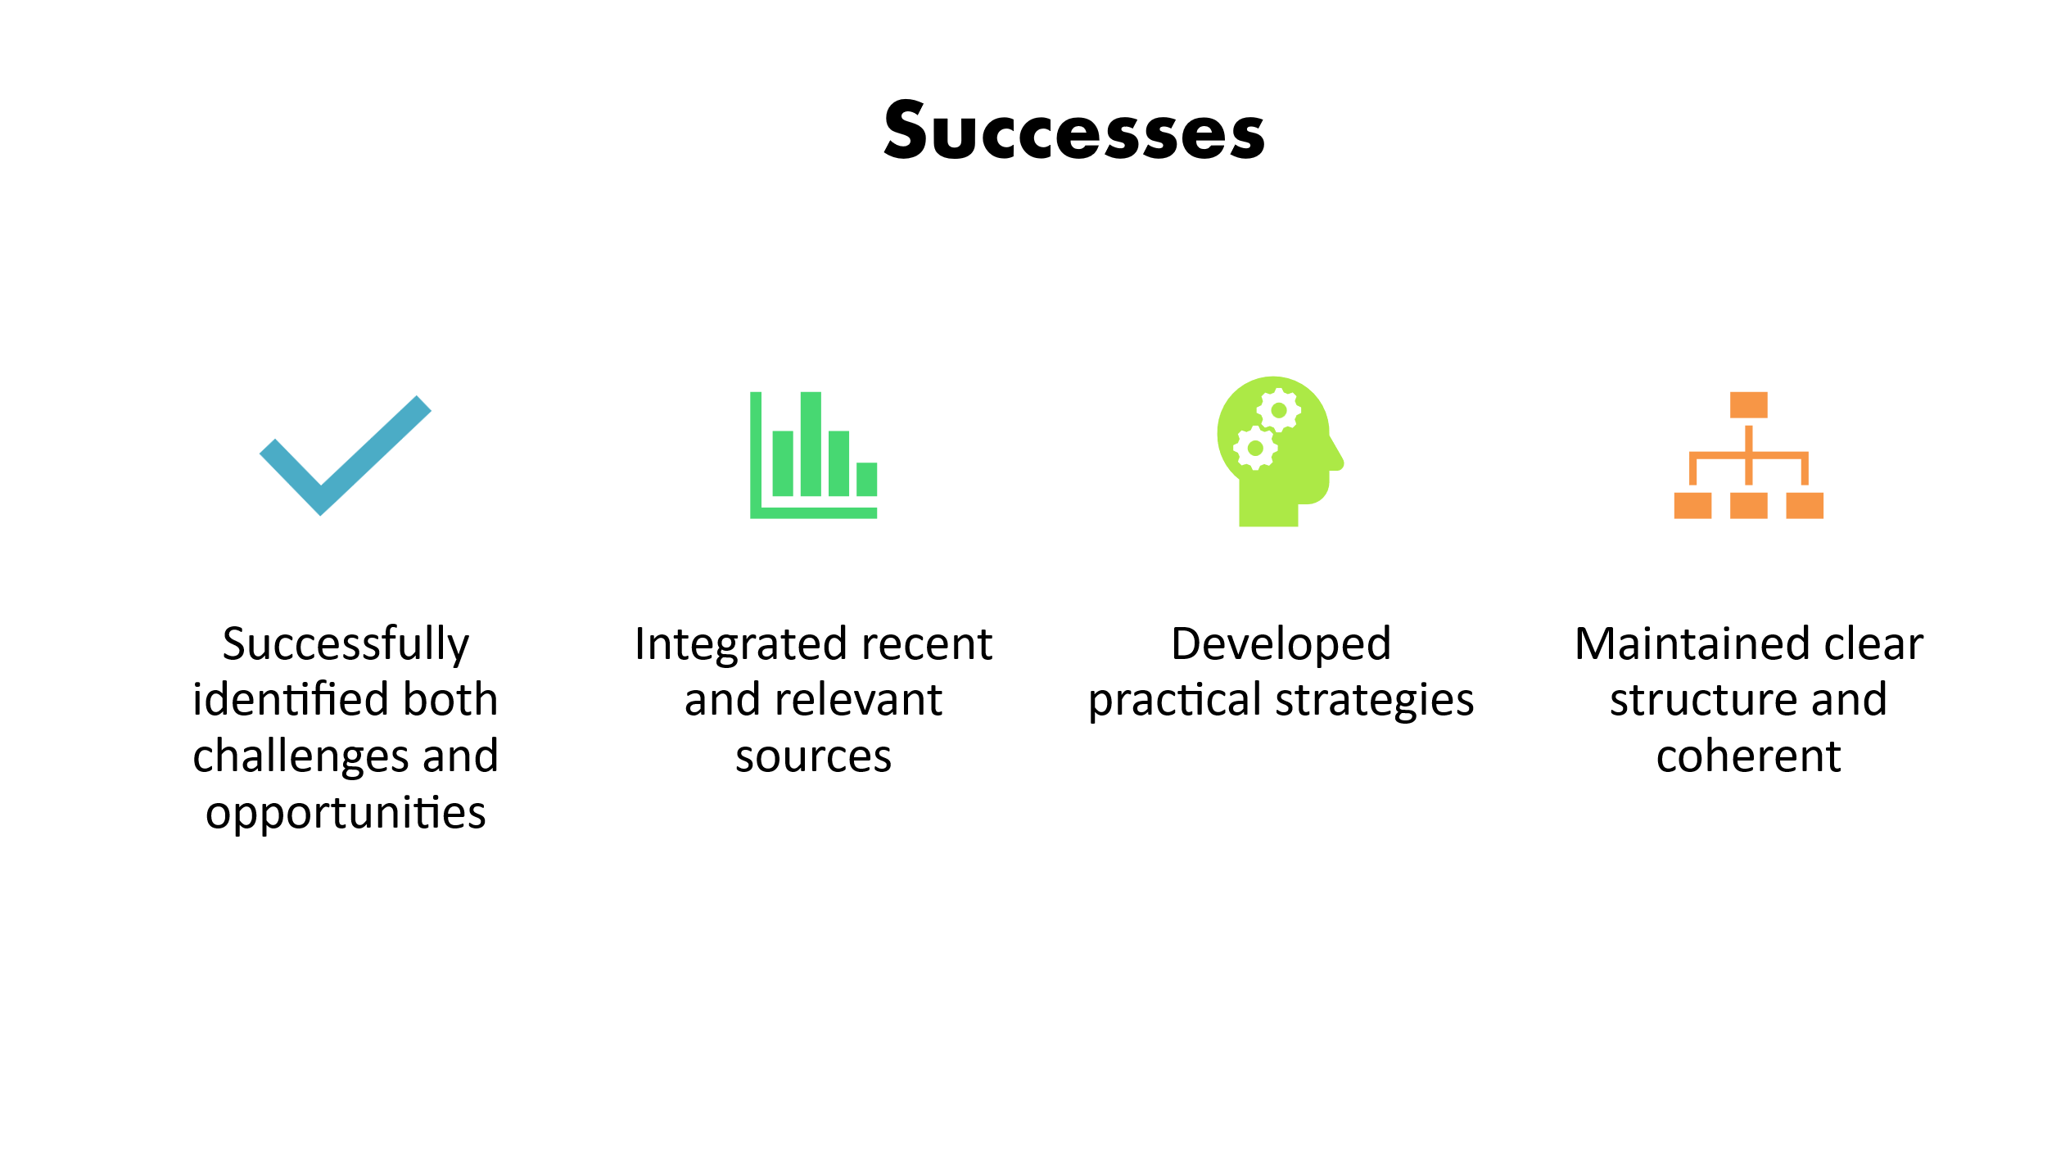

References
Afzal, A., Khan, S., Daud, S., Ahmad, Z. and Butt, A. (2023). Addressing the digital divide: Access and use of technology in education. Journal of Social Sciences Review, 3(2). Available at: https://doi.org/10.54183/jssr.v3i2.326
Akour, M. and Alenezi, M. (2022). Higher education future in the era of digital transformation. Education Sciences, 12(11), p.784. Available at: https://doi.org/10.3390/educsci12110784
Alenezi, M., Wardat, S. and Akour, M. (2023). The need for integrating digital education in higher education: Challenges and opportunities. Sustainability, 15(6), p.4782. Available at: https://doi.org/10.3390/su15064782
Jin, S.H., Im, K., Yoo, M., Roll, I. and Seo, K., 2023. Supporting students’ self-regulated learning in online learning using artificial intelligence applications. International Journal of Educational Technology in Higher Education, 20(1), p.37. Available at: https://doi.org/10.1186/s41239-023-00406-5
Johnston, D. and López, I. (2022). The Wiley handbook of collaborative online learning and global engagement. John Wiley & Sons. Available at: https://books.google.com.bd/books?hl=en&lr=&id=VT97EAAAQBAJ&oi=fnd&pg=PA1987&dq=Johnston,+D.+and+L%C3%B3pez,+I.+(2022).+The+Wiley+handbook+of+collaborative+online+learning+and+global+engagement.+John+Wiley+%26+Sons.&ots=F3bIx0DT29&sig=kGoqbp81gbNSXQ7KJf1Jk9laiSs&redir_esc=y#v=onepage&q=Johnston%2C%20D.%20and%20L%C3%B3pez%2C%20I.%20(2022).%20The%20Wiley%20handbook%20of%20collaborative%20online%20learning%20and%20global%20engagement.%20John%20Wiley%20%26%20Sons.&f=false
Mexhuani, B. (2025). Adopting digital tools in higher education: Opportunities, challenges and theoretical insights. European Journal of Education, 60(1), p.e12819. Available at: https://doi.org/10.1111/ejed.12819
Muchith, M.S. (2023). Education in the Digital Age: Opportunities, Challenges, and Innovations. International Journal of Education and Digital Learning (IJEDL), 2(1), pp.10-20. Available at: https://www.researchgate.net/publication/391297318_Education_in_the_Digital_Age_Opportunities_Challenges_and_Innovations
Rafique, R. (2023). Using digital tools to enhance student engagement in online learning: An action research study. In Local Research and Glocal Perspectives in English Language Teaching: Teaching in Changing Times (pp. 229-248). Singapore: Springer Nature Singapore. Available at: https://doi.org/10.1007/978-981-19-6458-9_15
Saufi, S. (2025). From Traditional Classrooms to Digital Learning: Exploring Research Trends in Contemporary E-Learning Challenges in Education. SunText Review of Arts & Social Sciences, 6(1), p.186. Available at: https://suntextreviews.org/uploads/journals/pdfs/1738743438.pdf
Singh, A., Singh, D. and Chhikara, S. (2024). Online learning: Challenges and suggestions to enhance student engagement in higher education institutions. In Reshaping entrepreneurial education within an Industry 4.0 context (pp. 59-80). IGI Global Scientific Publishing. Available at: https://www.igi-global.com/chapter/online-learning/337227
Tariq, M.U. (2025). Empowering learning through networked and connected education: case studies in digital engagement. In Cases on Enhancing P-16 Student Engagement with Digital Technologies (pp. 169-198). IGI Global Scientific Publishing. Available at: https://www.igi-global.com/chapter/empowering-learning-through-networked-and-connected-education/367147

Appendices

A 01: CRAAP Test
CRAAP Criteria | Evaluation
Currency | Published in 2023, the source is up-to-date and reflects current trends and technologies in digital education.
Relevance | Highly relevant to the research question, as it directly discusses how digital tools impact students’ learning, highlighting both challenges and opportunities.
Authority | Written by Mukhamad Saekan Muchith and published in the International Journal of Education and Digital Learning, a peer-reviewed academic journal, ensuring credibility.
Accuracy | Supported by research and examples, with logical arguments and evidence, information can be cross-verified with other recent studies.
Purpose | Aims to inform and analyse digital education developments; the objective is educational rather than promotional, showing a balanced discussion of benefits and challenges.

