Bruno Antunes Jeronimo (2442240)
LONDON CAMPUS
Assignment
Computer Architecture and Operating Systems
Module Name: Computer Architecture and Operating Systems.
Module Code: ACCA 4022

Student Name: Bruno Jeronimo
Student ID:2442240
Group:1

Lecturer’s Name: Dr. Redhwan Al-amri

Table of Contents
Introduction 2
Main Body 3
Key functions of general Operating Systems 3
Process Management 3
Memory Management 4
Device Management 6
Security and User Management 7
User Interface 9
Windows OS CLI commands 10
Use of Linux OS CLI commands 14
Use of Windows OS scripts 20
Use of Linux OS scripts 22
Conclusion 25
References 26

Introduction

This report explains the main jobs of a general Operating System (OS). The first part covers the five Keys functions an OS must do, Like running programs (Process Management), handling memory and managing devices and users.

The second part of the report shows how to use command-line tools (CLI) and scripts in both Windows and Linux. This includes simple commands like (dir and ls) and more advanced scripting with PowerShell and Bash to automate tasks.

Main Body

Key functions of general Operating Systems

An Operating System (OS) is the main software that controls a computer hardware and software. It acts as bridge between the user and the computer hardware, allowing programs to run and users to interact with the system. Popular general purpose operating systems include Microsoft Windows, Linux and MacOS. These Oss are widely used at home, in schools and in the businesses because they manage hardware resources efficiently and provide a user-friendly interface [1].

Process Management
One of the main functions of an OS is process management. A process is any program that is running on the computer. The OS ensures that each process gets enough CPU time to run efficiently. It also allows multiple programs to run at the same time without interfering with each other, which is called multitasking.
Windows example: Press Ctrl + Shift + Esc to open Task Manager, where you can see running processes, CPU usage and memory usage and end programs if they are unresponsive. (see below picture)
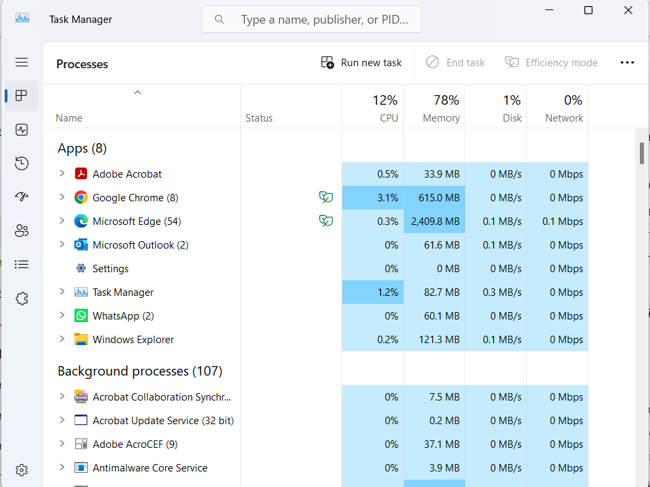

Linux example: Use the command top or htop in the terminal to see all running processes, CPU usage and memory allocation. (see picture below)
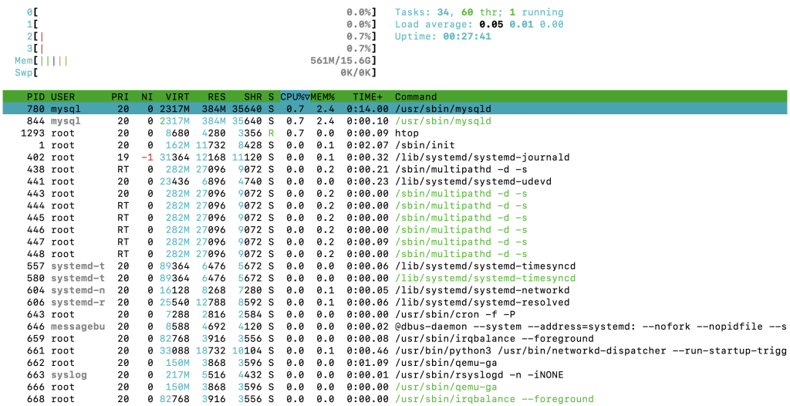

Memory Management
Memory management is another key function. The OS controls how to much RAM each program can use. It keeps track of free and used memory and prevents programs from using memory allocated to others. Efficient memory management prevents the system from slowing down or crashing.

Windows example: open File Explorer to view drives, folders and files
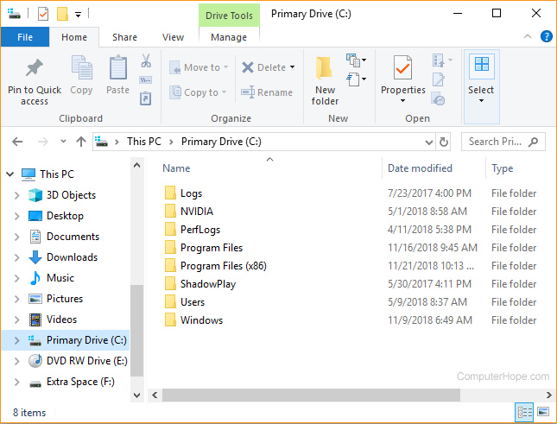

Linux example: Commands like ls, cp, mv and rm allow users to list, copy, move and delete files in the terminal.

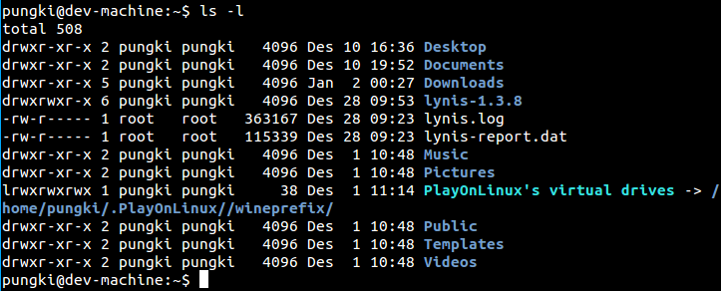

Device Management
The OS also manages hardware devices such as printers, keyboards, USB drives and network adapters. It uses drivers which are small programs that allow hardware to communicate with the OS. Device management ensures that hardware works correctly and efficiently.
Windows example: Open Device Manager to see all connected devices
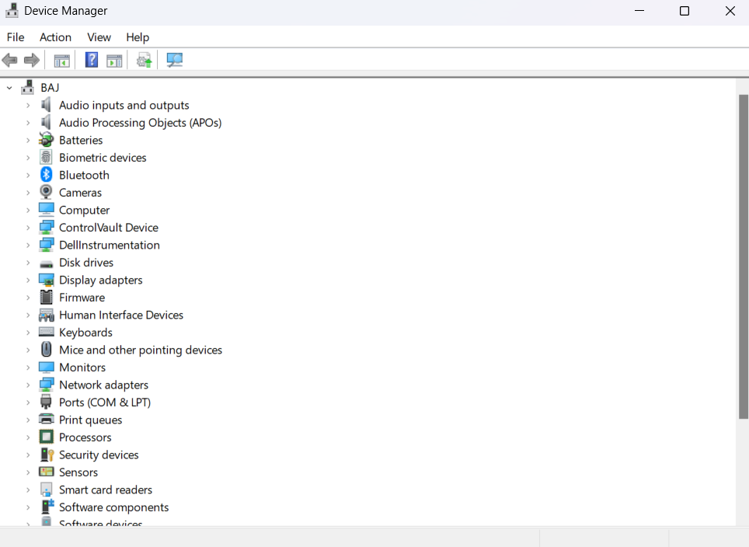
Linux example: Commands like lsusb or lspci list connected USB and PCI devices.
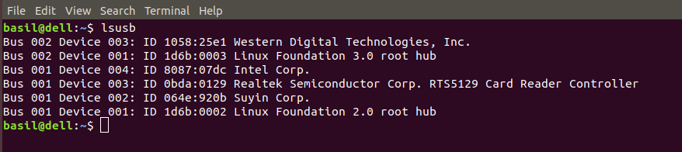

Security and User Management

Security is another critical function. The OS controls user accounts, permissions and access rights to protect the system from unauthorized access. It also ensures that only authorized users can install software or make system changes.
Windows example: Settings Accounts Family & other users manages users
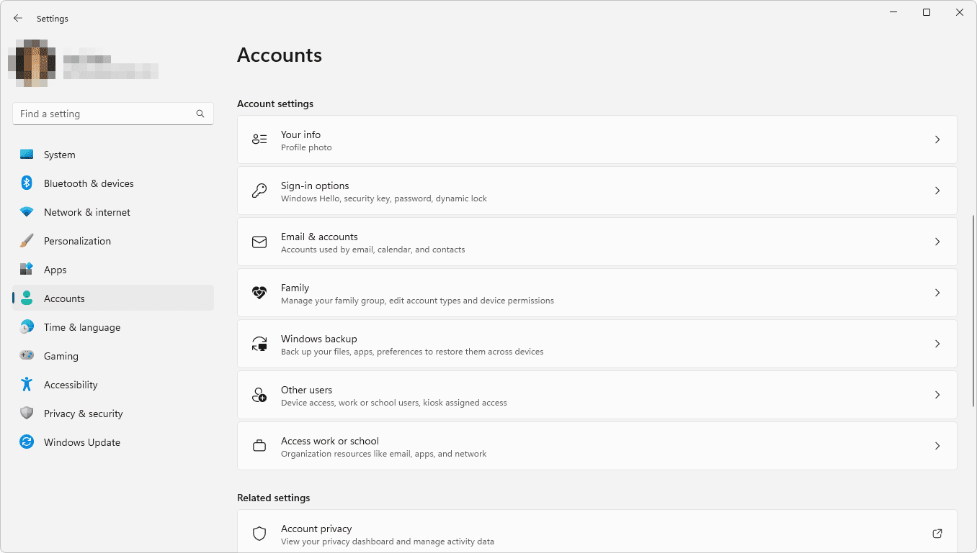

Linux example: Commands like adduser or sudo control user creation and administrative permissions.
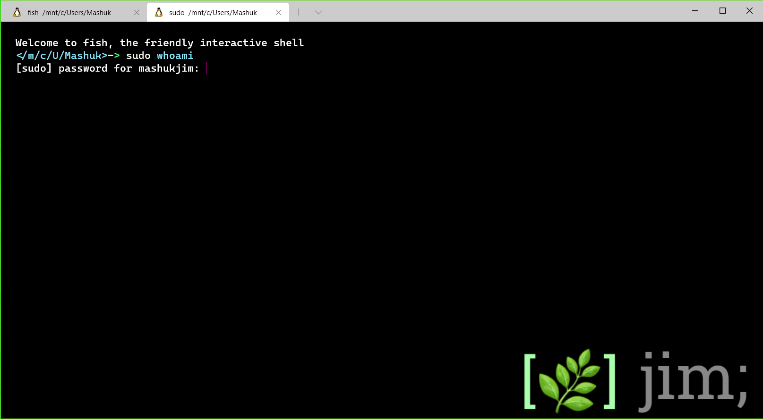

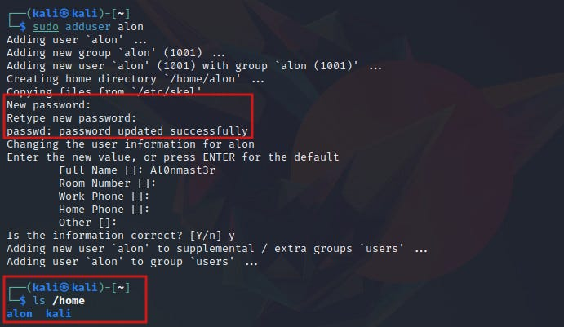

User Interface

Finally the OS provides a user interface. Windows and macOS offer graphical interfaces with icons and menus. Linux can have both graphical interfaces like GNOME or KDE, and text based command line interfaces.
Windows Desktop
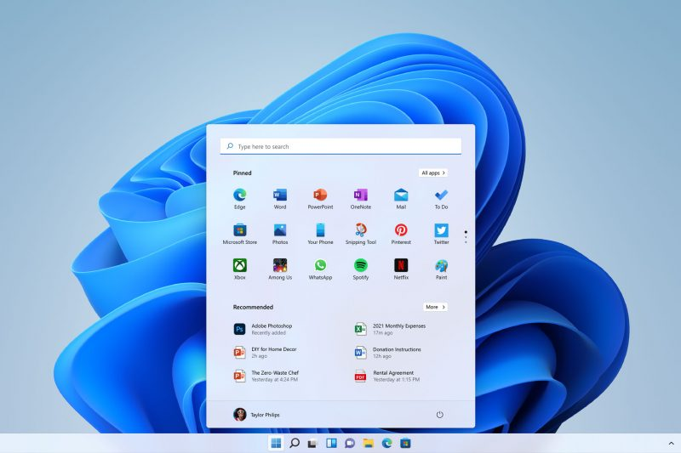
Linux GUI


In Summary general purpose Operating Systems manage processes, memory, files, devices, users and interfaces. They make computers efficient, secure and user friendly for both every day and advanced tasks [2] [3] .

Windows OS CLI commands

Windows provides powerful command-line interfaces through Command Prompt and PowerShell, allowing administrators to automate tasks efficiently. These Environments are essential for system management, troubleshooting, and executing repetitive administrative operations without relying on the graphical user interface. Command Prompt offers legacy support and simplicity, making it suitable for quick file operations, network diagnostics and process handling. On the other hand, PowerShell is a more advanced automation framework built on the .NET platform offering object oriented scripting capabilities, pipelining and access to system APIs. IT professionals use these tools to configure services, manage user accounts, handle file systems and monitor system performance remotely. Mastering both interfaces significantly enhances productivity, control and flexibility in Windows based environments.

- dir – Lists directories and files
- Example dir /w /p
- /w displays in wide format while /p pauses after each screen
- 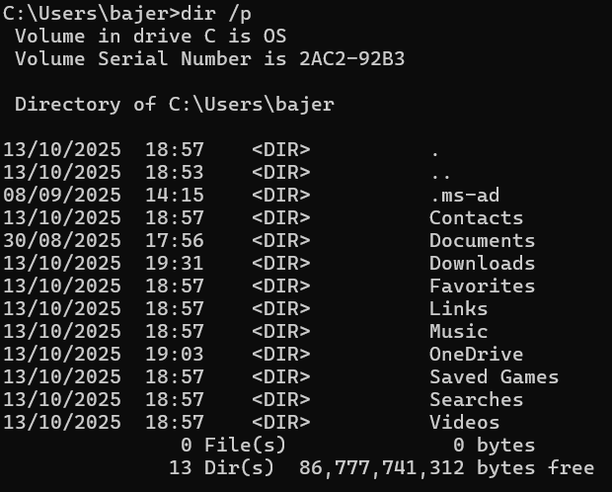

- Ping – Tests network connectivity
- Example: ping.google.com /t
- /t keeps sending requests until manually stopped
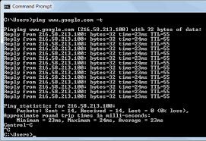

- Tasklist – Displays running processes
- Example: tasklist /fi “status eq running”
- /fi filters processes by status or name
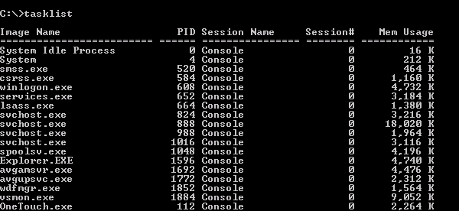

- Get-Process (PowerShell) – Lists active processes
- Example: Get-Process | sort-Object CPU -Descending
- Pipes output and sorts by CPU usage
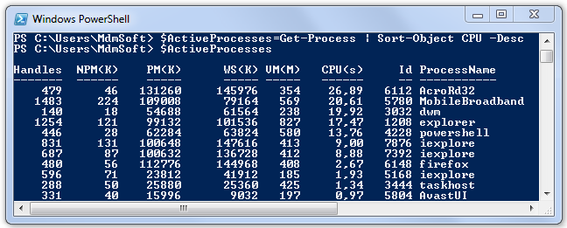
- Get-Service (PowerShell) – Checks service states
- Example: Get-Service | Where-Object {$_.Status -eq “running”}
- Filters only active services
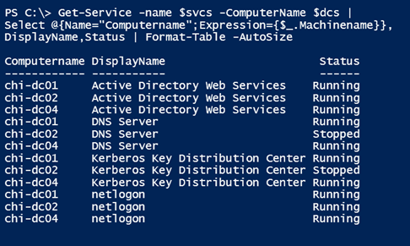
- Set-ExecutionPolicy (PowerShell) – Changes script execution permissions
- Example: Set-ExecutionPolicy RemoteSigned
- Allows running local unsigned scripts
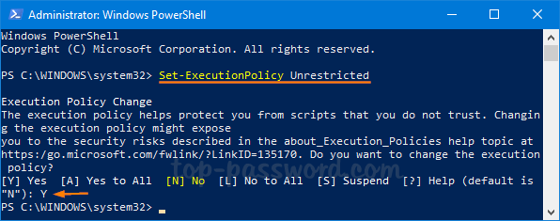
- Get-EventLog (PowerShell) – Retrives system logs
- Example: Get-EventLog -LogName System -Newest 20
- Displays the latest 20 system events
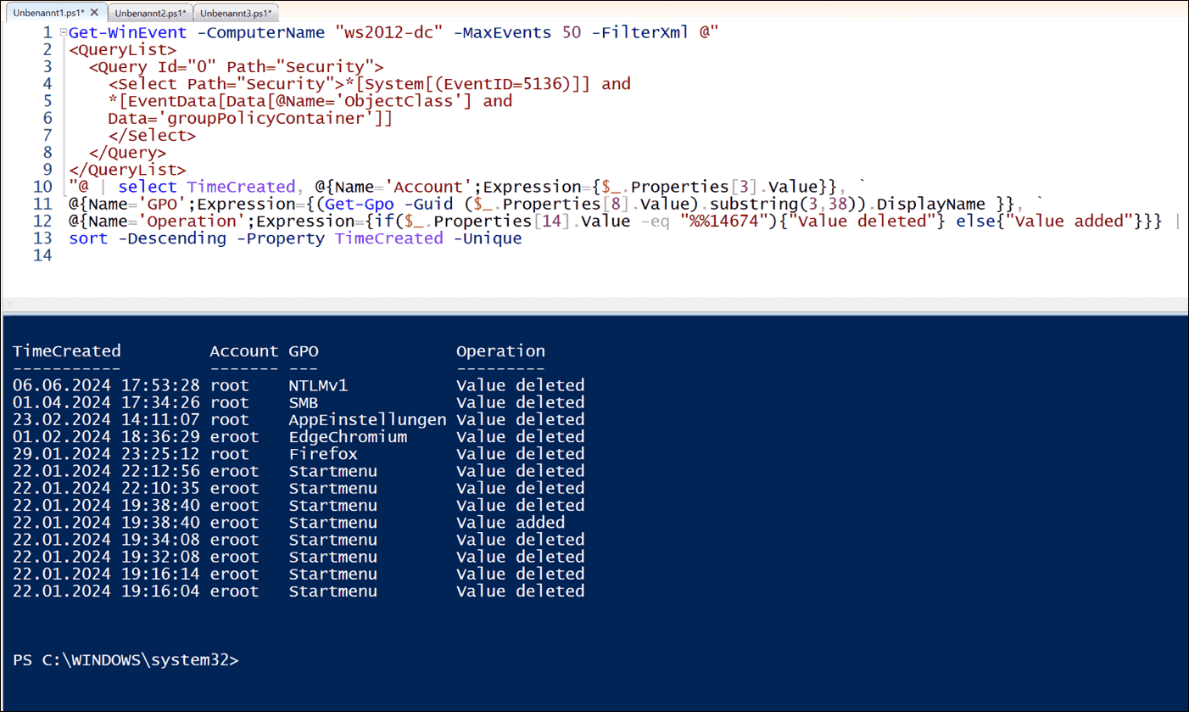

- New-Item (PowerShell) – Creates files or folders
- Example: New-Item -Patch c:\Scripts -Name “test.ps1” -ItemType File
- Automatically generates an empty script file

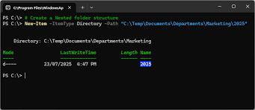

Conclusion
Batch commands such as dir, xcopy and ping are ideal for quick administrative tasks, while PowerShell commands like Get-Service and Get-EventLog provide deeper system insights. Combining These tools enhances automation and system control in Windows environments [4] [5].

Use of Linux OS CLI commands

Linux provides a robust Command-Line Interface (CLI) through Bash (Bourne Again Shell), enabling users and systems administrators to perform powerful operations efficiently. Compared to GUI-based interaction, Bash allows precise control, automation via shell scripting and faster execution of repetitive tasks. Understanding CLI commands is considered essential for system maintenance, networking, process management and file handling in Linux environments. The flexibility of command chaining, piping and scripting allows professionals to combine simple commands to perform complex system operations [6].
Additionally the availability of manual pages and help flags makes Bash a self-documented environment, reducing the dependency on external tools. Mastery of Bash commands greatly enhances administrative efficiency and system reliability [7].

Document Bash Commands with Options

ls command
Example: ls -l -a
Description: Lists directory contents, including hidden files, in detailed format.
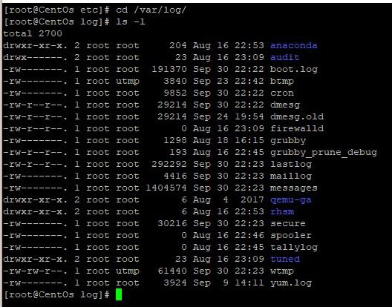
cd Command
Example: cd /var /log
Description: Changes the current working directory to /var /log
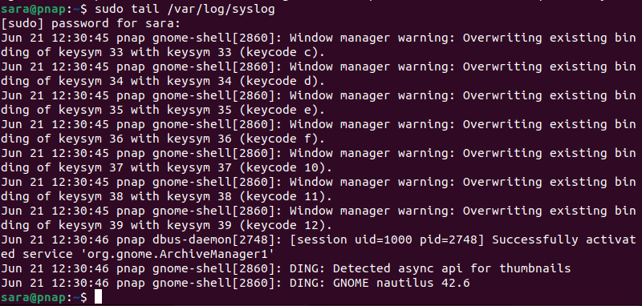

cp Command
Example: cp -r /home /docs /backup
Description: Recursively copies the docs directory to backup
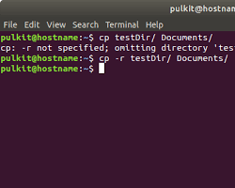

mv Command
Example: mv file.txt /home /user /documents
Description: Moves and Renames files
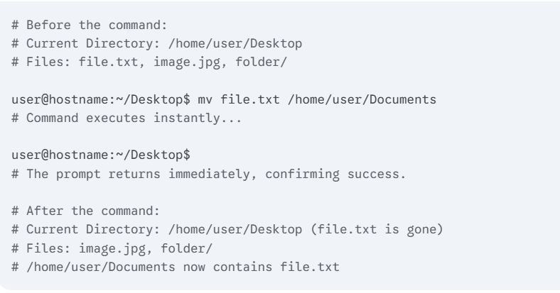

rm Command
Example: rm -rf temp/
Description : Forcefully removes the temp directory and all its contents
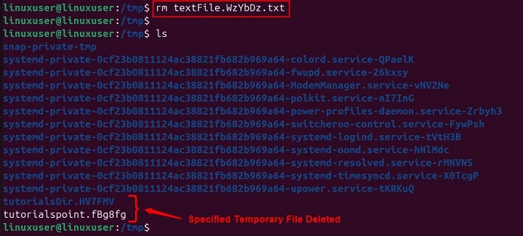

mkdir Command
Example: mkdir -p /data /logs
Description: Creates directories, including parent directories
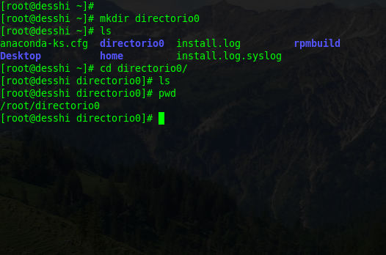

top Command
Example: top -u username
Description: Displays real time system process usage filtered by user
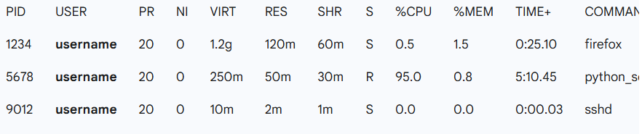

grep Command
Example: grep -I “error” logfile.txt
Description: Searches for the term “error” in logfile.txt, ignoring case sensitivity
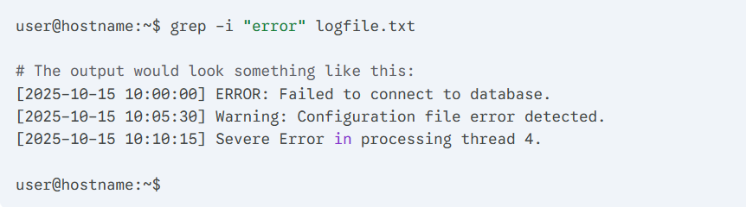

chmod Command
Example: chmod 755 script.sh
Description: Modifies file permissions to allow execution
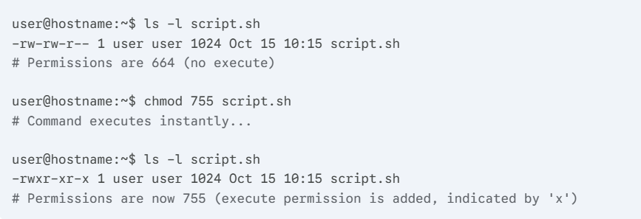

ping Command
Example: ping -c 4 google.com
Description: Sends four ICMP packets to test connectivity to google.com
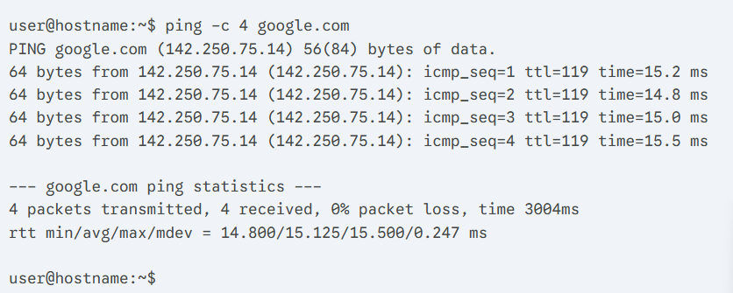

Use of Windows OS scripts

Scripting in the Windows operating system allows users and administrators to automate repetitive tasks, streamline workflows, and manage system configurations efficiently. Windows provides two primary scripting options the traditional Baych (.BAT) scripts and the more advanced PowerShell (.PS1) scripts. While Batch scripting has been part of Windows since the MS-DOS era, PowerShell introduces a more powerful object oriented environment built on the .NET framework. It enables Users to manipulate data, control System resources and automate complex administrative tasks through a rich set of commands known as cmdlets. This report demonstrates the use of PowerShell scripting, outlines its key features and compares it briefly with Batch scripting through practical examples and explanations.

PowerShell Script Example
# DemoScript.ps1
Param (
[string]$TargetFolder = "C:\Temp",
[int]$DaysOld = 30
)
Write-Output "Cleaning folder: $TargetFolder older than $DaysOld days"
Get-ChildItem -Path $TargetFolder -Recurse |
Where-Object { $_.LastWriteTime -lt (Get-Date).AddDays(-$DaysOld) } |
ForEach-Object {
$_.FullName
Remove-Item -Path $_.FullName -Force
}
Write-Output "Done."

This PowerShell script automates the cleanup of files older than a specified number of days. It demonstrates several key scripting features.
- Parameterisation: The Param() block allows dynamic user input, improving script flexibility.
- Object-oriented pipeline: Instead of plain text, PowerShell passes objects (e.g., file objects) through the pipeline, allowing access to attributes like .LastWriteTime.
- Cmdlet integration: Get-ChildItem, Where-Object, and Remove-Item are examples of built-in cmdlets that interact with the Windows file system.
- Automation and reusability: The script can run manually or as a scheduled task for continuous system maintenance.

Comparison with Batch Script
A similar script task in a Batch file looks like this:
@echo off
set "Target=C:\Temp"
forfiles /p "%Target%" /s /m *.* /d -30 /c "cmd /c del @path"
echo Clean up complete.

While Batch scripts are simpler, they operate using text based commands and lack PowerShell’s advanced features such as variables, Objects and modules. PowerShell integration with .NET makes it far more capable for modern system administration. [8] [9]

PowerShell represents a significant evolution in Windows automation. It offers structured programming features, object based pipelines, security controls and comprehensive administrative capabilities, making it the preferred scripting tool for modern Windows environments.

Use of Linux OS scripts

A bash script is just a plain text file. Inside we can put a list of commands for the Linux computer to run, one after the other. It’s really good for doing the same job over and over again, like keeping the system tidy. [10] [11]

The Main Parts of a Script
Bash scripts use a few clever tricks to get things done

Variables (holding Information)
A variable is just a name you give to a piece of information. You can store a word or a number in it, and the script can use that information later.

Simple code:

#!/bin/bash
#We name a variable ‘GREETING’ and put “Hello” in it
GREETING=”Hello”
NAME=”mate”
Echo “$GREETING, $NAME!”

What it does: It tells the screen: Hello mate!

If Statements (Making Decisions)
This lets the script check something and decide what to do next. If a condition is true, it does one thing, if it’s false it does another.

Simple Layout
If [ a check is true ]; then
#Do this job
Else
#Do this job instead
Fi

Simple Code:

#!/bin/bash
NUMBER=10
# Is the number bigger than 5?
If [ $NUMBER -gt 5 ]; then
Echo “It’s a big number.”
Else
Echo “It’s a small number.”
Fi

What is does: It tells the screen: It’s a big number

Loops (Doing Jobs again and again)
A loop is perfect for repeating a task. The for loop is often used to go through a list of things.
Simple Layout (for loop)

For ITEM in a list of things; do
# Do this job for each ITEM
done

Simple Code (for loop)

#!/bin/bash
For FRUIT in Apple Banana Cherry; do
Echo “I like $FRUIT.”
Done

What it does: it prints the following one line after the other
- I like Apple
- I like Banana
- I like Cherry

Conclusion

In conclusion, the Operating system is essential because it manages all parts of the computer to keep it efficient, secure, and easy to use.

The report showed that both Windows and Linux offer powerful ways to control the system without using the mouse. Using commands and especially scripting (like PowerShell in Windows and Bash in Linux) is critical for systems administrators because it allows them to automate complex and repeated jobs quickly and reliably.

References

[1] | Microsoft, “Windows OS Overview,” Microsoft, 2025. [Online]. Available: https://www.microsoft.com/en-us/windows?r=1.
[2] | A. Hasenack and S. , “Ubuntu Server documentation,” 2025. [Online]. Available: https://documentation.ubuntu.com/server/.
[3] | “Reports and Guides from the Linux Foundation,” The Linux Foundation, 2025. [Online]. Available: https://www.linuxfoundation.org/resources/publications.
[4] | D. Holme, “Windows Command Line Administration,” O’Reilly Media, 2015. [Online]. Available: https://www.oreilly.com/library/view/windows-command-line/9781491937296/.
[5] | B. Lee and J. Walker, “PowerShell scripting for system automation,” TechNet Magazine, March 2020. [Online]. Available: https://techcommunity.microsoft.com/t5/itops-talk-blog/bg-p/ITOpsTalkBlog.
[6] | The Linux Foundation, “Linux Command Reference Guide,” [Online]. Available: https://www.linuxfoundation.org.
[7] | W. Shotts, “The Linux Command Line,” 2019. [Online]. Available: https://www.linuxcommand.org.
[8] | Techneads, “The Benefits of Scripting in PowerShell: A Comprehensive Guide,” 10 October 2024. [Online]. Available: https://techneaks.co.uk/the-benefits-of-scripting-in-powershell-a-comprehensive-guide/.
[9] | A. Howell, “See PowerShell parameter default values in action,” 09 October 2025. [Online]. Available: https://www.techtarget.com/searchwindowsserver/tutorial/Try-default-values-in-PowerShell-parameters-for-flexibility.
[10] | M. Garrels, “Bash Guide for Beginners,” 27 December 2008. [Online]. Available: https://tldp.org/LDP/Bash-Beginners-Guide/html/index.html.
[11] | Z. Hira, “Bash Scripting Tutorial – Linux Shell Script and Command Line for Beginners,” 20 March 2023. [Online]. Available: https://www.freecodecamp.org/news/bash-scripting-tutorial-linux-shell-script-and-command-line-for-beginners/.

