Digital Skills and Research Methods
BMSK4003
Name: Ioan-Alexandru Sumanaru

Id: 1713838
Contents
Title of research 2
Introduction: Background of the Research 2
Aims 2
Literature review 2
Methodology 4
Research design and strategy: 4
Data sources 4
Sampling 5
Ethical issues 5
Findings 6
Survey questionnaire outcomes: 6
Interview outcomes: 9
Secondary research outcomes: 10
Effects of the research on use of cloud technologies on increasing efficiency of the organization 10
Conclusion and recommendation 11
Reference 12
Appendix 14

Title of research
“Impact of cloud technologies in increasing business efficiency: A Study on Deliveroo”.

Introduction: Background of the Research
With the revolutionary development of the technologies in the recent business world, the use of cloud technologies has increased significantly. The efficiency of the organization largely depends on the uses of the resources properly in the case of running daily operational activities. In this case, the cloud technologies reduce cost of operations, increases quality of performance and reduces time wastages in processes of the organisation (Keys, 2015). The research is aimed at finding the impacts of the cloud technologies in the case of increasing the efficiency of the business by analysing different data related to the cloud technologies.

Aims
The key aims of the underlying research are stated below:
- To find out the different impacts of the cloud technologies
- To determine the extent of impact of cloud technologies on the profit and revenue of the organization
- To find out the ways of increasing efficiency by using cloud technologies. l

Literature review
Compaine and Read (1999) mentioned that Cloud technology refers to the use of tools, software, applications, services and resources via the internet through a shared network among the personnel of the organization. With the revolutionary development of the technologies in the recent business world, the use of cloud technologies has increased significantly. Bloomfield (2000) stated that the use of cloud technologies requires proper IT infrastructure, IT skills, data management and efficient knowledge on cloud technology management. However, Galama and Hosek (2008) stated that using the Cloud technologies in the workplace, the organization can significantly increase efficiency of workplace by reducing operating cost and time wastes. Cloud technologies increases flexibility among the resources of the organization and increases interoperability. Hallows (1999) suggested that it increases security of data by providing high protection to the stored data and is reduces disasters of losing data due to any accidents in the workplace as all data are stored in the internet which can be assessed and used at anytime from anywhere. However, Dornberger (2010) argued that the cloud technologies can increase cost due to high cost of installing IT infrastructure, maintenance cost and lack of skills of the employees to run cloud technology properly.
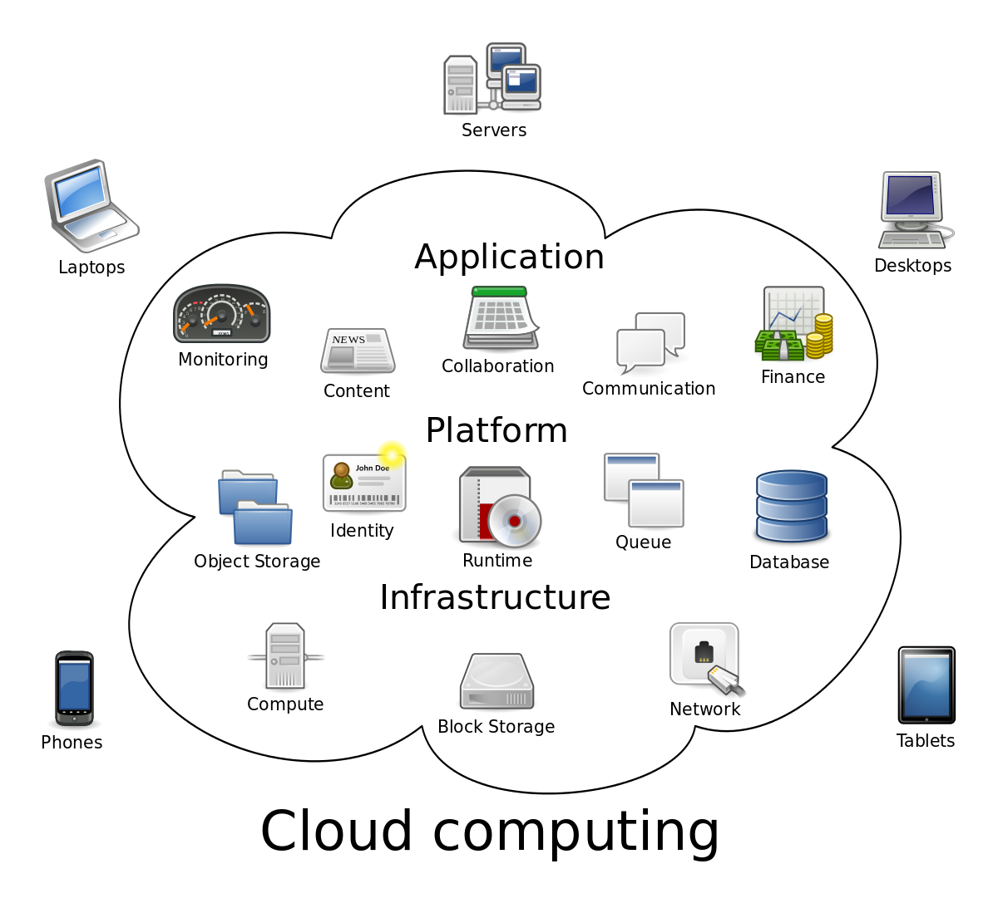
Figure: Cloud technologies
Source: (O'Brien, 2004)
The gap analysis shows that the use of cloud technologies have not increased the efficiency of the organization up to the expectation. The gap is in cost reduction process which has arised because of increased maintenance cost.
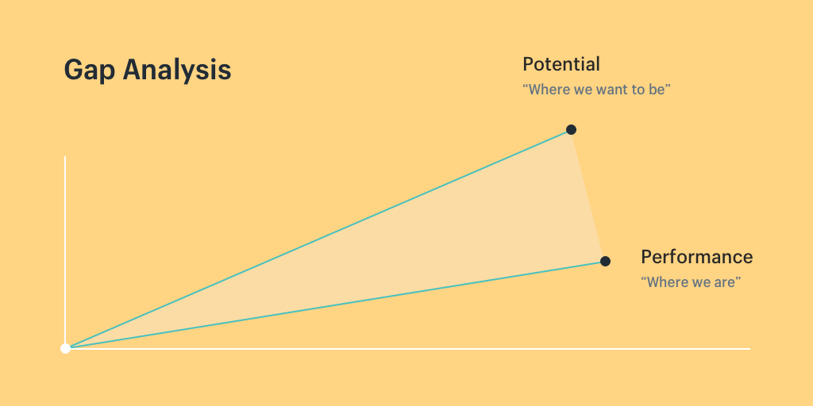
Figure: gap analysis
Source: (Jiang, et al., 2014)

Methodology

Research design and strategy:
The research on the impact of cloud technologies in the efficacity of the organization has used both qualitative and quantitative research methods in analysis of the data. The researcher has collected both primary and secondary data to perform the qualitative and quantitative researches.
Qualitative research: the abstract and descriptive data of the research including the suggestions, perceptions and opinions of the research participants regarding the use of cloud technologies to increase efficiency have been analyzed under the qualitative research method (White, 2013). Thus, this method has helped the researcher to find out the behavior of the employees of the organization in case of using cloud technologies to increase efficiency in workplace.
Quantitative research: the numeric and mathematical data of the underlying research including the responses of the survey participants has been analyzed by using the quantitative research method (Williamson, 2009). By using this method, the researcher has performed different mathematical and statistical analysis of the survey data in order to get numerical outcomes which is used in decision making process of the company regarding the use of cloud technologies.

Data sources
In the underlying research of finding the impacts of cloud technologies in increasing the efficiency of the organization, the researcher has collected both primary and secondary data. In this way, the researcher has been able to increase accuracy of research analysis and also to reduce the cost of data collection (Kemp, et al., 2010). For primary data collection, the researcher has used survey questionnaire including 6 questions and also take interview of the participants. (Dabrowski, et al., 2014). For secondary data collection, the researcher has used company’s financial reports, newspapers, journal, published research papers etc.

Sampling
As population data is very costly and time consuming to use in the research, the underlying research has used sample data from the population data. Different sampling methods are random sampling, cluster sampling, simple random sampling, group sampling etc. (Dabrowski, et al., 2014). The underlying project has used random sampling method to select sample data for the research analysis. Among the entire employees of the Deliveroo company, the researcher has randomly selected 30 employees as participants of the research. The random sampling method is easy and cost saving method which has ensured that the sample is unbiased towards the population data (Burns & Bush, 2017). The survey questionnaire including 6 questions were sent to the 30 participants via email and responses have been collected within 20 working days.

Ethical issues
The ethical issues regarding the research are authenticity of collected data, are accuracy of the research outcomes and privacy of the information owners (Huang, 2013). In order to fulfil the ethical issues, the researcher of the underlying research on impacts of the cloud technologies has used password protected data storage system so that collected data can be used by only authorized persons with permission (Yao, 2009). Moreover, the research has not included any personal questions and information of the participants and used the appropriate tools and methods to generate the most accurate results for the research users.

Findings

Survey questionnaire outcomes:
Results of question 1: Do you think that cloud technologies have increased productivity of the company along with flexibility and disaster resistance in Deliveroo?

Figure 1: Results of survey question “Do you think that cloud technologies have increased productivity of the company along with flexibility and disaster resistance in Deliveroo?”
The above pie chart shows that among the 30 survey participants, 36% strongly agree and 30% agree that the cloud technologies have increased productivity of the company along with flexibility and disaster resistance in Deliveroo. Only 7% of the participants believe that the cloud technologies have decreased proper uses of the resources and flexibility.
Results of question 2: Do you think that cloud technologies have reduced IT problems in Deliveroo company?

Figure 2: Results of survey question “Do you think that cloud technologies has reduces IT problems in Deliveroo company?”
The results of the question two shows that among the 30 participants of the survey, 37% strongly agree and another 33% agree that the cloud technologies have reduced the IT problems significantly in recent years in Deliveroo company. Only 7% of the participants believe that the cloud technologies have increased cost of installing technical tools and replacing it regularly along with high maintenance costs.
Results of question 3: Do you feel comfortable and believe that cloud technologies are safe and secure to be used in Deliveroo company?

Figure 3: Results of survey question “Do you feel comfortable and believe that cloud technologies are safe and secure to be used in Deliveroo company?”
The pie chart shows that among the 30 survey participants, 14 participants strongly agree and 9 participants agree that they are comfortable and believe that cloud technologies are safe and secure. Only 1 participant strongly disagree and 2 participants disagree with the statement while 4 participants are neutral.

Results of question 4: Do you think that the performance of the Deliveroo company has increased by using the cloud technologies?

Figure 4: Results of survey question “Do you think that the performance of the Deliveroo company has increased by using the cloud technologies?”
The survey questionnaire results show that 39% of the participants of the survey strongly agree and another 32% participants agree with the statement that cloud technologies have improved the overall performance of the Deliveroo company. Only 3% of the participants disagree with the increase of performance by using cloud technologies.
Results of question 5: Do you agree that the cost of the company has reduced and it is economical to use cloud technologies in small businesses?

Figure 5: Results of survey question “Do you agree that the cost of the company has reduced and it is economical to use cloud technologies in small businesses?”
From the results of the question 5 in the survey questionnaire, it is found that 30% of the participants strongly agree and 50% of the participants agree that it is economical for the Deliveroo company to use cloud technologies as it reduces cost of operation and increases efficiency.
Results of question 6: Do you think that the cloud technologies can reduce the privacy of data of the Deliveroo company?

Figure 6: Results of survey question “Do you think that the cloud technologies can reduce the privacy of data of the Deliveroo company?”
The above pie chart shows that around 33% of the survey participants strongly believe that the cloud technologies can reduce the privacy of data of the Deliveroo company and another 30% participants agree with the statement. Thus, it indicates the urgency of the company to use sufficient privacy protection strategies in the case of using the cloud technologies.

Interview outcomes:
From the interview, it has been found that the employees of the Deliveroo company believes that the cloud technologies have improved the operational costs and increased revenue of the company. However, the employees think that the Deliveroo company should be more careful of using cloud technologies due to the threat of privacy loss and increased maintenance cost.

Secondary research outcomes:
The secondary data analysis shows that by using the cloud technologies, the revenue and profits of the company has increased significantly from 2013. But due to the increasing maintenance cost, the cloud technologies, the net income has reduced in 2015 from the 2014 but still higher than the previous years (Chen & Lin, 2016)
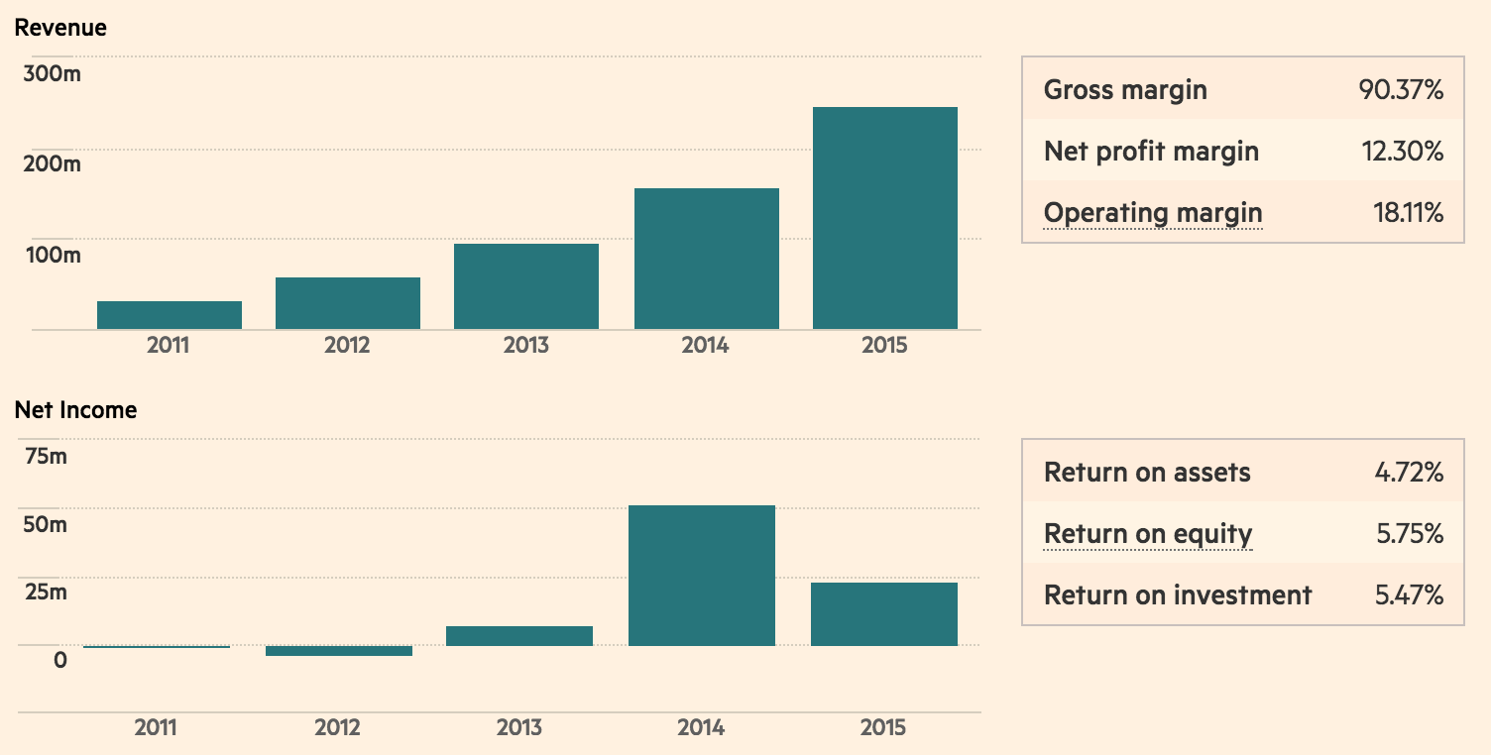
Figure: performance of Deliveroo company

Effects of the research on use of cloud technologies on increasing efficiency of the organization
By using the research analysis, the Deliveroo company has been able to collect details information on different aspects of using the cloud technologies in the company. This research has provided the company with the suggestions and opinions of the employees on cloud technologies and thus helped to find out whether these are actually helpful and necessary for the Deliveroo company. Therefore, the research has helped the organization to take proper decisions on their investment in cloud technologies which has reduced risk and thus efficiency of the organization significantly.

Conclusion and recommendation
The research on the impact of cloud technologies in the efficacity of the organization has used both qualitative and quantitative research methods and also collected both primary and secondary data. As population data is very costly and time consuming to use in the research, the underlying research will use sample data from the population data. The outcomes of the analysis show that majority of the survey participants, agree that the cloud technologies have increased productivity of the company, reduced the IT problems and thus have improved the overall performance of the Deliveroo company significantly. Some recommendation to reduce the cost of cloud technologies are:
- To provide training to the employees
- Installing the cost effective and modern technologies
- Regularly monitoring the process of cloud technologies

Reference
Burns, A. and Bush, R. (2010).Marketing research. 1st ed. Upper Saddle River, N.J.: Prentice Hall.
Bloomfield, B. (2000). Information technology and organizations. Oxford, England: Oxford University Press.
Compaine, B. and Read, W. (1999). The Information resources policy handbook. Cambridge (Mass.): MIT Press.
Chen, Y., Hsu, I. and Lin, C. (2016). Website attributes that increase consumer purchase intention: A conjoint analysis. Journal of Business Research, 63(9-10), pp.1007-1014.
Dabrowski, D., Basinska, B. and Sikorski, M. (2014). The impact of Usability Website Attributes on Users' Trust, Satisfaction, and Loyalty. Social Sciences, 85(3).
Dornberger, R. (2010). Business Information Systems and Technology 4.0.
Galama, T. and Hosek, J. (2008). U.S. competitiveness in science and technology. Santa Monica, CA: RAND Corp.
Hallows, J. (1999). Information systems project management. Boulder, Colo.: NetLibrary, Inc.
Huang, M. (2013). Designing website attributes to induce experiential encounters. Computers in Human Behavior, 19(4), pp.425-442.
Jiang, B., and Chen, P. (2014). An Economic Analysis of Online Product Reviews and Ratings. SSRN Journal.
Kemp, G., Eagle, L., and Verne, J. (2010). Mass media barriers to social marketing interventions: the example of sun protection in the UK. Health Promotion International, 26(1), pp.37-45.
Keys, P. (2015). A methodology for methodology choice. Syst. Res., 5(1), 65-76. doi:10.1002/sres.3850050108
O'Brien, J. (2004). Management information systems: managing information technology in the business enterprise. Boston: Irwin.
White, K. (2013). Practical Project Management for Agile Nonprofits. [Place of publication not identified]: Maven House Press.
Williamson, L. (2009). On-demand writing. New York: International Debate Education Association.
Yao, P. (2009). Estimating future recreational demand. New York: Nova Science Pub Inc

Appendix
Questionnaire form:
Questions | Strongly Disagree | Disagree | Neutral | Agree | Strongly Agree
Do you think that cloud technologies have increased productivity of the company along with flexibility and disaster resistance in Deliveroo? | 2 | 3 | 5 | 11 | 9
Do you think that cloud technologies have reduced IT problems in Deliveroo company? | 3 | 2 | 4 | 10 | 11
Do you feel comfortable and believe that cloud technologies are safe and secure to be used in Deliveroo company? | 1 | 2 | 4 | 9 | 14
Do you think that the performance of the Deliveroo company has increased by using the cloud technologies? | 1 | 5 | 3 | 10 | 12
Do you agree that the cost of the company has reduced and it is economical to use cloud technologies in small businesses? | 3 | 2 | 1 | 15 | 9
Do you think that the cloud technologies can reduce the privacy of data of the Deliveroo company? | 5 | 4 | 2 | 10 | 9

Interview form
 | Questions of the interview form:
1 | Do you think the Deliveroo should be more careful in using cloud technologies?
2 | how do you think that the Deliveroo can increase efficiency at work by using cloud technologies?

