

LOCATION: SWANSEA LLEOLIAD: ABERTAWE
LEVEL 3 LEFEL 3
EXAMINATION PERIOD CYFNOD ARHOLIADAU
JANUARY 2019 IONAWR 2019

MODULE CODE: M3X01513
SCIENCE
COURSEWORK PART 2

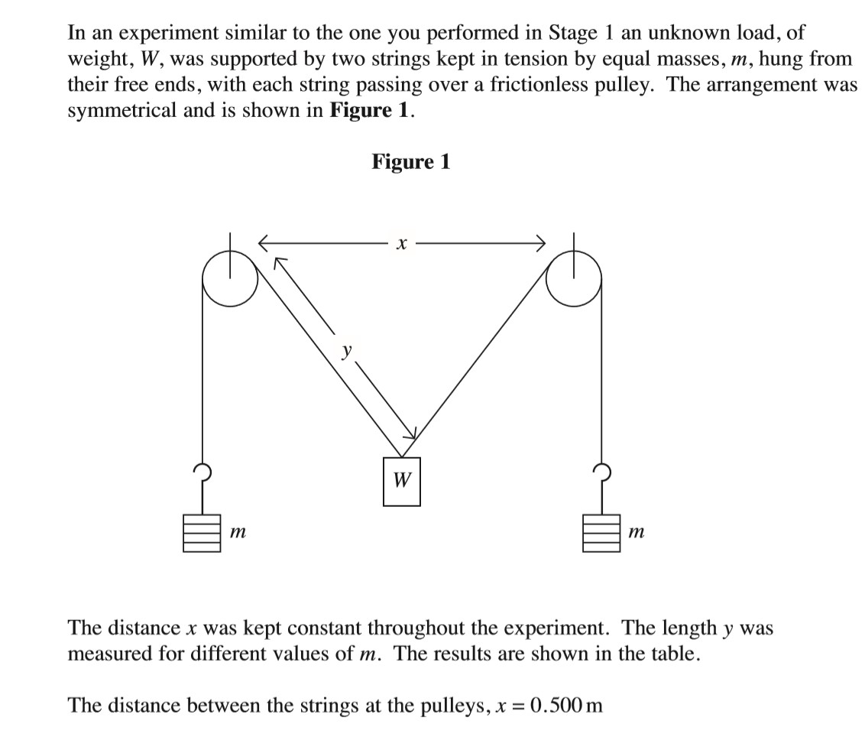
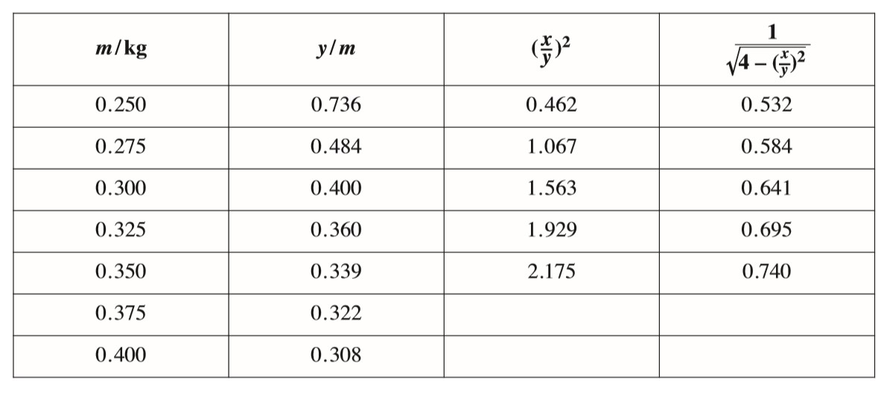
0.856
0.793
2.635
2.411
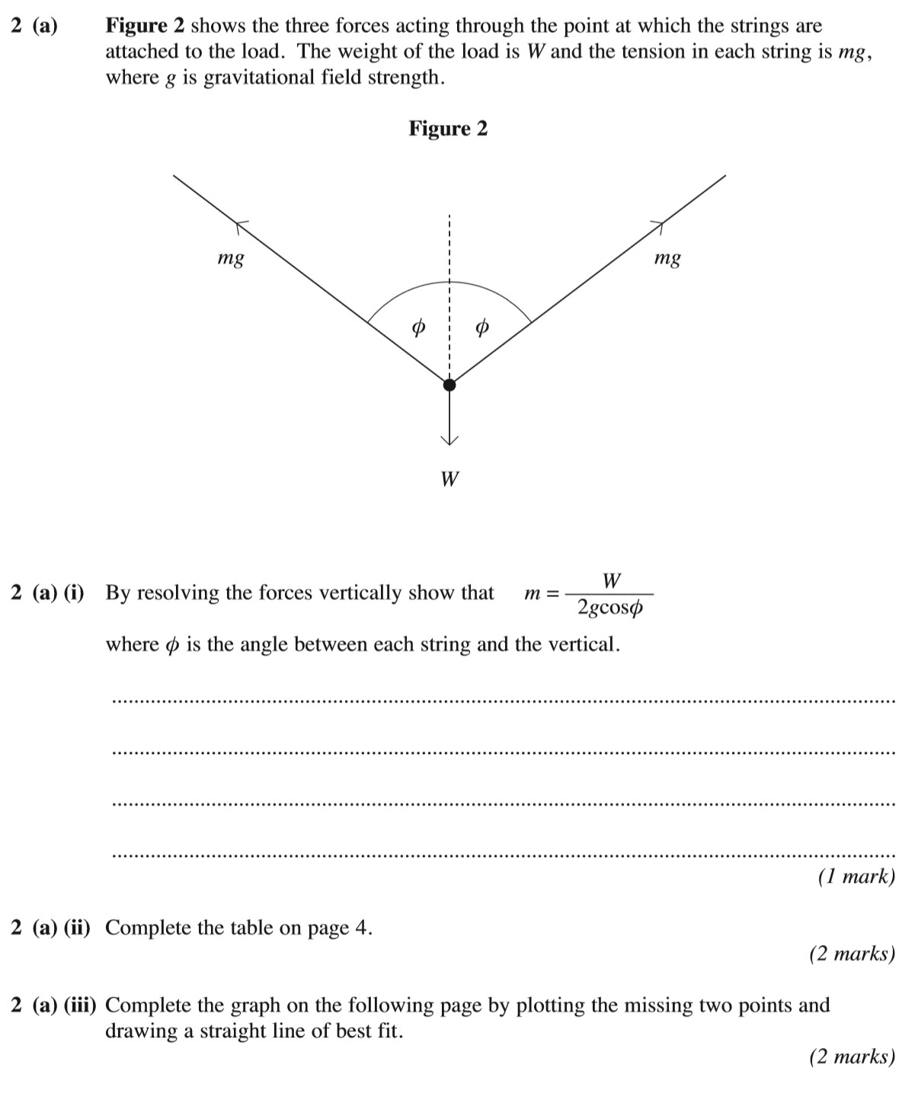
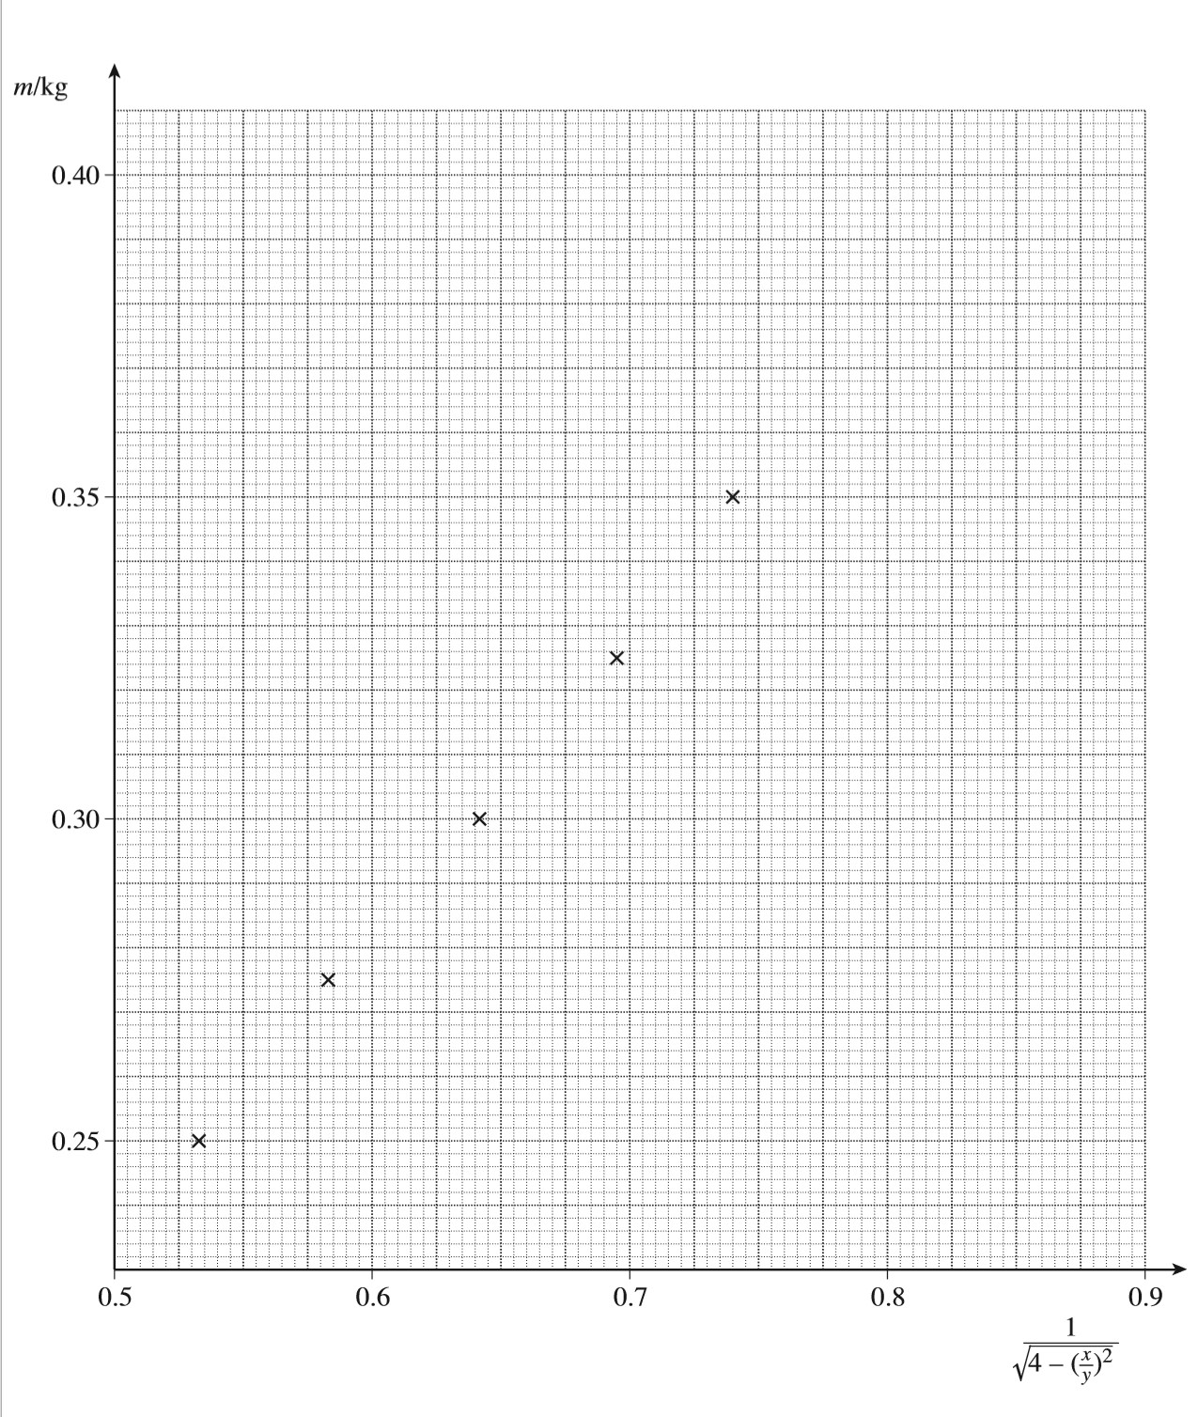

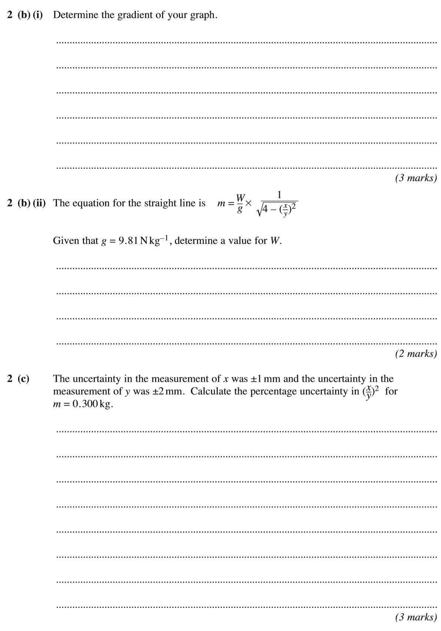
X = 0.5m +/- 1mm
Y= 0.4m +/- 2mm
X= 1/0.500 = 0.002 = 0.2%
Y= 1/0.400 = 0.0025 = 0.25%

(9.81^-1 x 0.4) / (9.81^-1 x 0.856) = W
W= 0.467 3dp
Gradient; (y2-y1)/(x2-x1)
(0.400-0.375)/(0.856-0.793)= 0.396825
= 0.397 3dp
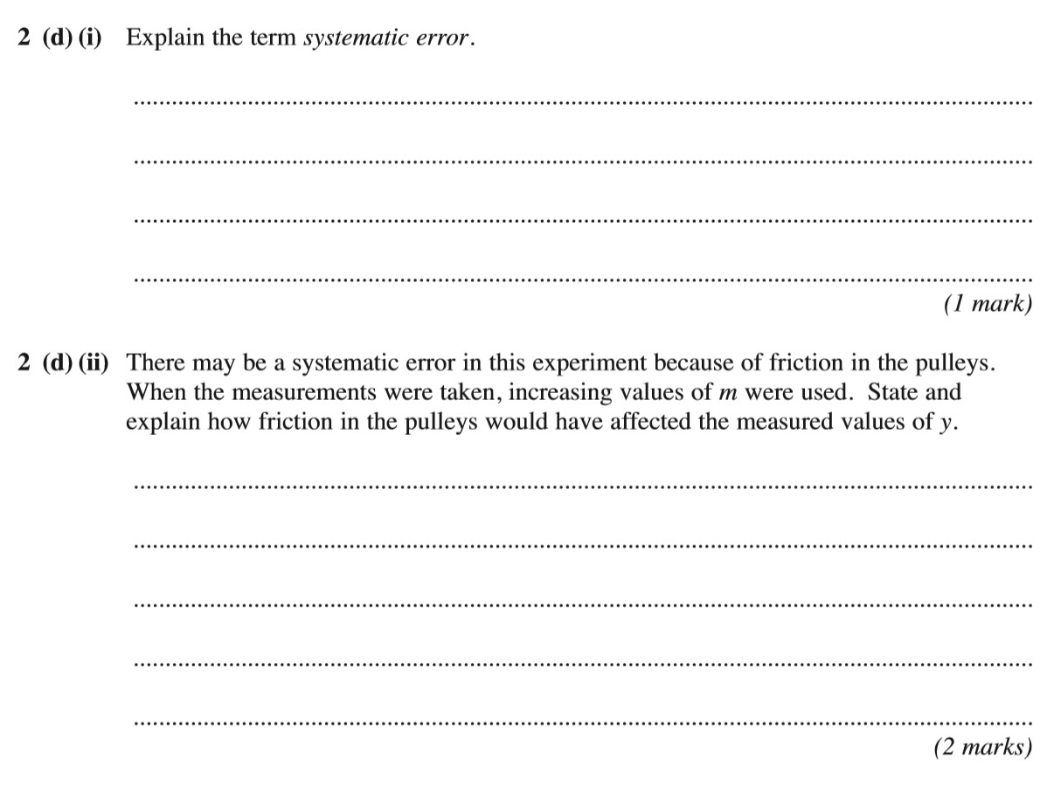
The friction on the pulleys could have an effect because it would allow a small amount of energy to go to waste through the friction, in extreme circumstances of friction you could lose even more energy through heat as the friction continues.
This is an error that is not affected by averaging due to having a mean that does not equal zero.

