MA Visual communication
The Role of Kenya Hara in Minimalist Design Thinking through the Packaging Design of Iwafune Rice

Professions:Visual communication
Name:Liyue Zhan
Submission Date: Thursday 9th December 2021
Word Count: 4392
Contents
Abstract 3
1.Theoretical background 5
2.Kenya Hara's Design Work and Design Thinking 9
2.1.1 Product "Iwafune rice" 9
2.1.2 Aesthetic Ideas in the Packaging Design of "Iwafune Rice" 10
2.1.3 The Indies 11
2.1.4 Design Thinking in "Muji" 13
2.1.4.1 Modelling aspects 13
2.1.4.2 Colour aspects 15
2.1.4.3 Material aspects 20
3. Artistic Criticism and Analysis of Kenya Hara's Design Thinking 21
4. Summary 24

Figure Content
Figure1 13
Figure2 15
Figure3 17
Figure4 19
Figure5 21

Abstract
Kenya Hara's book, "Design in Design," begins with an intriguing question: "What exactly is design?" As a designer, Hara examines design's response to the evolving aesthetic consciousness brought about by contemporary technological and economic advancements. In 2000, he curated the exhibition "Redesign: Everyday Objects for the 21st Century," showcasing the interplay between daily life, design, and people. This exhibition highlights the growing significance of design in our rapidly advancing economy and the onset of the creative era, prompting a deeper consideration of design's essence.
Matus, in his book "Above Design Trends," observes that we live in a world saturated with chaotic designs. This observation resonates today, as design becomes increasingly ubiquitous, emphasizing the importance of discerning good design. Design is commonly associated with creativity and originality, and Hara notes that creativity can be found not only by leading the times but also by looking back into history.
Deeply influenced by traditional Japanese culture, Hara’s minimalist and uncluttered design style has gained immense popularity in Japan and globally. He advocates for articulating design in the most natural and appropriate manner, guided by the principle of "creating something out of nothing." This philosophy aligns with the Chinese Taoist concept of valuing "nothingness," a principle evident in Hara's work, including the packaging design for "Iwafune Rice."
Hara’s design ethos is characterized by a profound sense of emptiness and purity, reminiscent of the aesthetic of Chinese ink paintings. However, rather than fully adopting or rejecting this foreign influence, Japanese culture has deconstructed, assimilated, and adapted it, creating a unique blend. Hara’s work exemplifies this integration, enriching Japan's cultural connotation and forming a distinctive design culture with Southeast Asian traits.
The "Iwafune Rice" packaging, a testament to Hara's design philosophy, champions simplicity, naturalness, and the use of unadorned materials. Rejecting excessive embellishment, Hara opts for the beauty of natural, plain colors, embodying simplicity, cleanliness, and purity. His designs, rooted in everyday life, bridge traditional culture and contemporary living, stripping away complexity to reveal design's true essence. This article critically examines Hara's minimalist design approach, using the "Iwafune Rice" packaging as a focal point to explore his influential role in minimalist design thinking.
Key Words: Kenya Hara, minimalist design, Muji
- Theoretical background
Minimalism was developed from the modernist movement that emerged in the 1920s, and it was first widely used in architectural design, and later influenced all aspects of the design field. The architect Mies van der Rohe's design concept of "less is more" articulated the core idea of minimalist aesthetics [2], which contributed to the expansion and refinement of the minimalist ideology. The modernist movement advocated the idea of "form follows function" to break the position that design is only for the service of the rich and powerful, and change the complex and complicated decorative design style, which gave birth to a variety of design schools, minimalism is also among them. Minimalism is not only a kind of design idea, but also an attitude and philosophical concept towards life. Minimalism focuses on the word "simplicity", that is, to eliminate all complex design language and decorative techniques, the pursuit of the ultimate refreshing simplicity, free from the constraints of the rules, to the most natural and simple form presented in front of the general public [3]. It can not only give the audience enough imagination to analyse and interpret, so that people return to the most genuine state, but also intuitively show their own aesthetic concepts, in the return to the basics at the same time but also let a person evocative. Minimalism advocates is not a simplified generalisation without logic, but focuses on the effect of "simple but not simple" performance, the most core design ideas and content with the most understandable way to show. Clean lines, simple graphic combinations and pure colours can soothe the viewer's inner turmoil and anxiety, thus temporarily detaching themselves from the burden of noisy and fast-paced life, and feeling the tranquility, harmony and natural purity in the pure land of the soul, thus satisfying the individual's spiritual needs [4]. Artists express the most sincere and pure thoughts and emotions through simple combinations of geometric forms, reflecting their concerns about the development of modern civilisation. Minimalism excludes all factors affecting the expression of the theme in the visual language, and transforms the obscure ideological concepts and symbolic intentions in art into plain and simple representations, and upgrades them into a highly condensed and highly generalised form of abstraction [5]. With the bursting of the financial bubble, people began to reflect on their past behaviour and gradually turned to a greener lifestyle, with the public more inclined to buy affordable, cost-effective goods, and the Muji brand was born in this context. Muji Goods at that time to promote excellent quality, affordable and useful products, which was widely loved by the public, the simple and plain design appearance of its products is more with Japan at that time, once extravagant and excessive packaging formed a stark contrast Muji Goods initially promote environmental protection, minimalist, quality first attitude to life, do not promote the worship of the brand Muji Goods is the original intention of the Muji Goods, refused to be over-packaged is the creed of the Muji Goods. Its distinctive brand concept impacted the market at that time, appearing in front of the public in a posture close to daily life, and transmitting the simple and unadorned design concept and brand culture to consumers. The design of MUJI products reflects Ikko Tanaka's unique design style, and conveys to consumers a sense of beauty that is unique to MUJI. MUJI articulates its unique design aesthetics in a quiet and calm manner. In the course of cultural exchange between China and Japan throughout history, Zen culture was gradually introduced to Japan. Zen culture has had a huge impact on the development of Japanese culture, permeating every aspect of people's lives. Zen aesthetics regards "nothing" as the essence of aesthetics, and under the influence of Zen aesthetics, the Japanese people's aesthetic consciousness gradually reflects uniqueness. Influenced by Zen aesthetics, Kenya Hara has integrated the unique culture of the Japanese nation to form a unique aesthetic style, which is reflected in the product design of MUJI. "Nothingness" is an important aesthetic characteristic of Zen Buddhism, and Kenya Hara focuses on the Zen concept of "nothingness" in downplaying the brand's iconicity and advocating environmentally friendly and frugal design brand concepts. The brand covers a wide range of areas, focusing on clothing, food, housing, and transport, and the design aims to satisfy people's basic needs in order to show the connotation of the product. Kenya Hara embodies Zen culture in the lifestyle of the public, and the embodiment of the lifestyle is the product itself [6]. Zen culture advocates the concept of "one is many, many is one", and believes that natural simplicity is beauty, and is about returning to the basics. In the product design of MUJI, Kenya Hara embodies this concept to the fullest, through the concept of "nothing" to develop a unique minimalist design style. The Japanese people, influenced by Zen aesthetics, are favourably disposed towards MUJI, which promotes minimalism. Kenya Hara is deeply influenced by Japanese Zen aesthetics, which promotes natural and simple aesthetics. His designs make extensive use of white, in keeping with the simplicity and silence of Japanese aesthetics. White does not mean colour in Kenya Hara's concept, but rather silence, bleakness, minimalism, emptiness, nothingness and other connotations. Each of these concepts reflects the Zen philosophy of "one is many, many is one".

2.Kenya Hara's design works and design thinking
2.1.1 Product "Iwafune Rice"
In 1999, Kenya Hara designed the packaging for Niigata Prefecture's "Iwafune Rice", which fully embodies his application of the concepts of "emptiness" and "nothingness". The packaging eschews complex patterns and bright colours, and is devoid of any ostentatious decorations; instead, it adopts simple, light and elegant colours, and returns to the grains themselves to give a sense of sophistication.Although the packaging uses the most simple and elegant colors, it does not give people a monotonous feeling, but the heart can feel. Even if there is no visible image, the soul can feel its existence, which can inspire people's various associations about "high sense", "taste", "ethereal" and so on.The handwritten fonts in the package, with the traditional Japanese cultural flavour, and the creative handles, are both practical and special. The overall design gives people a feeling of returning to the most natural and essential, which is in fact the expression of "simplicity" and "nature" in the philosophy and aesthetics of Lao Tzu. This is actually the expression of "simplicity" and "nature" in Lao Tzu's philosophy and aesthetics. The design is not overly embellished and emphasises the design guidelines of good value and natural simplicity, which not only achieves the right balance between form and function, but also breaks down the barrier between the product and the customer. It stands above the consumer's position and emphasises the principle of practicality and moderation of the product.

2.1.2 Aesthetic Ideas in the Packaging Design of "Iwafune Rice"
From the perspective of traditional Japanese culture, Kenya Hara adheres to a simple and unadorned design style and a muted view of colour, which is the basic spirit of Taoist aesthetics. In the design of Iwafune rice packaging, Kenya Hara used the purest style and the application of paper materials, eliminating the floating and keeping simplicity, and the overall colours are simple and light, which not only contain deep Japanese traditional cultural connotations, but also do not lose the modern style, and if you taste it carefully, you will find that Chinese Taoist aesthetics are infiltrated in it. Lao Tzu once said: "All things are numerous, each returning to its roots. Returning to the root is called quietness, and quietness is called restoration of life. Restoration of life is said to be constant, know constant is said to be clear", are said to keep the simple to express the unity of the natural state of the Taoist body. Zhuangzi also said: "simple and the world can not compete with the beauty", is to say that the origin of the spiritual power of simplicity is supreme, unparalleled, pure and simple beauty is a kind of can not be made and the most noble and noble sublime realm. The word "simplicity" is closely related to nature, and is a natural state, with the characteristic of being natural and free, and it is the admiration and praise for the great beauty of nature and the pure beauty of personality. In addition to the meaning of "nature", the aesthetic sense of "Park" also implies simplicity and rusticity, so simplicity and rusticity are often complementary to each other. This is very similar to the simple and elegant design and colour concepts of Iwafune Rice packaging. On the other hand, the aesthetics of Iwafune's packaging also reflects Kenya Hara's application of the concepts of emptiness and nothingness, which also coincide with the essence of Taoism. As Lao Tzu said, "Everything under the sun is born from existence, and existence is born from nothing", which means that everything is born from nothing in the end, and Lao Tzu believes that beauty lies in the "emptiness" and "nothingness" of "nothing". Lao Tzu believes that beauty lies in the "emptiness" and "emptiness" of "nothing", just like the Taoist reverence for "no painting becomes a wonderful world", which is reflected in the "Rock Boat Rice" packaging. This is reflected in the packaging of "Iwafune Rice".

2.1.3 The Indies
Muji was officially established in 1990, and its original purpose was to build a brand image with the goal of natural simplicity. It provides a simple and natural lifestyle and concept of living [7], which is in line with the concept of nature advocated in today's world. It abandons the flashy external appearance, shaves off too much artificial processing, pays more attention to quality, shows the original texture and natural beauty, so as to build a bridge to communicate with the soul, so that more people recognise the design ideas and pursuits conveyed by MUJI. The aesthetics and design advocated by MUJI are always leading today's era. Minimalism began to emerge in the 1960s, and it pursues a simple but uncomplicated form of expression in design aesthetics, creating a sense of serenity, harmony and unadorned beauty in the visual sense. MUJI has perfectly applied the aesthetics of minimalism to all aspects of conceptual design and poster design. The design aesthetics of MUJI is consistent with minimalism, but it is more of a reflection of traditional Japanese aesthetics and consumerism, so it cannot be equated with the so-called minimalism in the West. MUJI advocates returning to the origin of design [8], starting from nature, and also attaches importance to dispatching design to the origin of life, that is, the design is not just for aesthetics and good looks, but should be simple and practical, and this approach makes the design made by MUJI full of the breath of life. The 21st Century Everyday Goods exhibition featured 32 designers from Japan. But it is not easy to give redesign novelty. In his preface, Kenya Hara says, "To define something or to write it down in words does not necessarily mean that you know it. A deeper understanding of a known thing is only possible if one can make it unfamiliar and then try to challenge its authenticity." [9] Many of the design works in the exhibition "Redesign: Everyday Goods for the 21st Century" break out of the confines of the conventional, defining the product from a different perspective and telling a new story. A good example of this is the MUJI "Mushroom Crush", designed by Kenya Hara as an art director. In the past, shiitake mushrooms were usually sold in their entirety. MUJI thought that people would cut the mushrooms when cooking and that they would have the same quality as whole mushrooms, so why not just sell them in pieces? With this in mind, chopped shiitake mushrooms became a hot item at MUJI. When designing a product, designers tend to put a lot of thought into the packaging. MUJI's chopped mushrooms are not simply chopped and sold, but are a breakthrough in people's daily perception, reflecting the limitlessness of design. When designing products, designers should not just stay on the surface level of function and appearance, but also go deeper into the usage scenarios to reveal the infinite possibilities of daily life.

2.1.4 Design Thinking in "Muji"
2.1.4.1 Modelling aspects
Kenya Hara succeeded Ikko Tanaka as the Art Director of MUJI. After Ikko Tanaka's design concept of "vegetarianism", Kenya Hara proposed the concept of "emptiness". He advocated that design should be simple in form and colour, with an emphasis on expressing the origin of the product. This
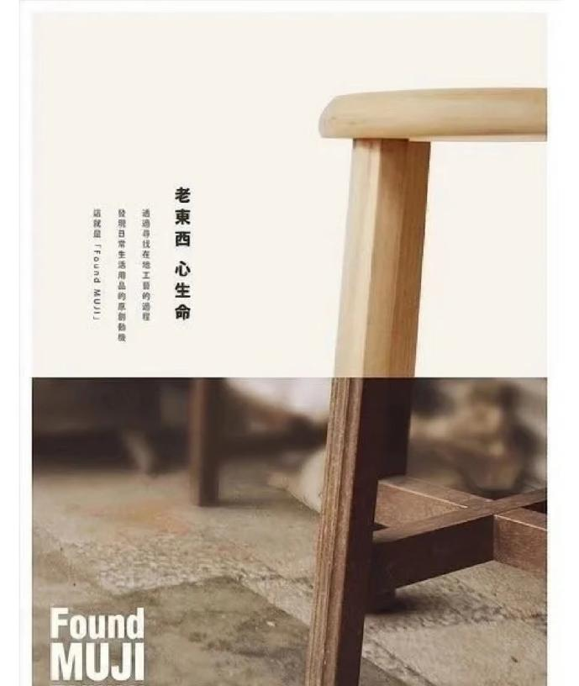
concept has influenced all areas of MUJI's product design since its emergence, including products, advertisements, packaging, posters, etc., so that MUJI's design has been given a richer cultural connotation by "emptiness"[10]. MUJI's product styling advocates natural simplicity and authenticity, with natural and harmonious styling derived from "nothing", reflecting more of the product itself. This design not only shows the value of the product, but also allows consumers to experience the unique and natural aesthetics of life through the design. For example, the design of the MUJI poster (Figure 1) fully reflects
Figure 1:MUJI poster
MUJI poster (Figure 2)
MUJI's design philosophy. By removing the logo and other superfluous designs, the product shows a sense of simplicity, honesty and originality, and its brand characteristics are obvious.

2.1.4.2 Colour aspects
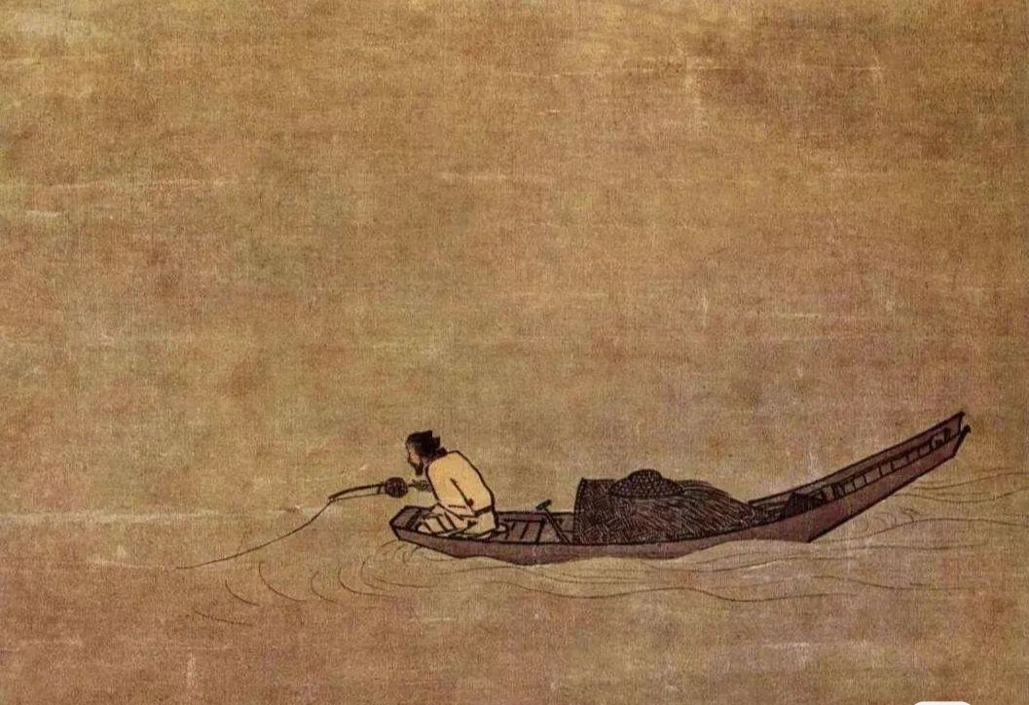
For designers, the effect of colour design is directly related to the public's acceptance of the finished product, and the colour effect of different colour combinations has a direct impact on the design effect. Influenced by Zen aesthetic philosophy, Kenya Hara prefers to keep the colour of the material itself. In the colour design of MUJI's products, we can often find examples of Zen aesthetics being fully expressed. For example, MUJI's logo design uses red as the representative colour, with low brightness and saturation, combined with simple geometric lines, conveying the concept of simplicity and nature. MUJI's product design mostly uses soft natural colours with similar hue and brightness, which is different from the high-purity colours with high impact chosen by some products in the market. Such a colour design is less stimulating to the human eye and gives a sense of calm while having a minimalist aesthetic. At the same time, Kenya Hara paired it with white to create a vibrant, energetic visual effect. Kenya Hara has a saying, "Escape colour and let the sense of touch awaken." He believes that white is the colour from which all colours "escape", but its diversity is endless. All of this expresses Kenya Hara's love of white. This philosophy also incorporates Japan's cultural connotations of "Zen, tranquility and emptiness". Kenya Hara discusses his understanding of white from a philosophical point of view, mentioning that "white, originating from chaos, is the primordial form of life and information"[11] and that "white exists in the surroundings of life"[12]. For example, breast milk is white, representing the continuation of life and rich in nutrients. Kenya Hara's concept of white is similar to the concept of white space in Chinese painting, both emphasise leaving enough space for the viewer's imagination to think. First of all, white space is an important category in Chinese painting, and it is a commonly used expressive technique in the creation of Chinese paintings. Take Ma Yuan's Cold River Fishing Alone from the Southern Song Dynasty as an example (Figure 2), in which an old man sits
Figure 2：Old man fishing alone in a cold river
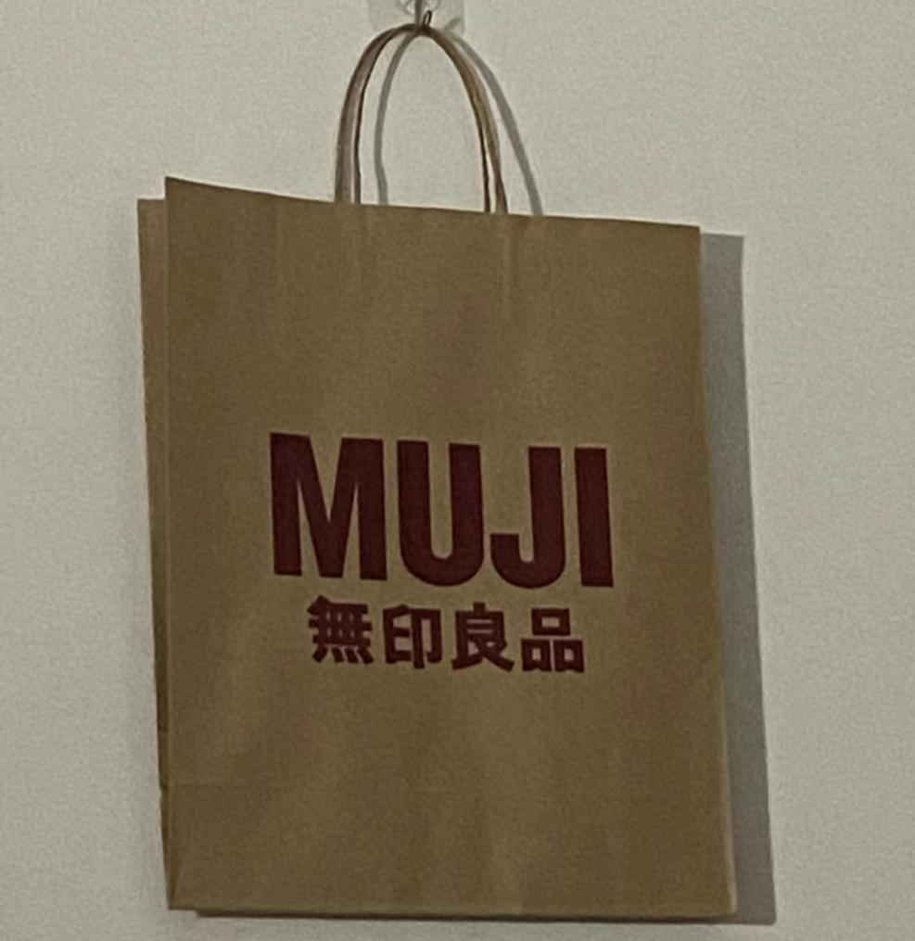
alone in a lonely boat and fishes, and the smoky and shimmering water surface is sketched out with just a few lines, giving the sense of a cold and desolate feeling, and the large area of white space gives the person a space for imagination. It can be said that even in a small area, the width of heaven and earth is also apparent. China and Japan as early as thousands of years ago, there are cultural influences and penetration, especially China's Tang Dynasty period of culture, the most profound impact on Japan. Edwin Reischauer of the United States wrote in his book "The Japanese" that "the Japanese know very well that their writing, vocabulary, art, and many of their traditional values come from China, which is their Greece and Rome." Despite the influence of traditional Chinese culture, but in essence, it is the same, seems to be the same but actually different, Japan is the process of mingling with foreign cultures through the "conflict, coexistence, integration" of cultural patterns and become the reconciliation of McDonald's to move into Kyoto, for example, in order to ensure that Kyoto's national characteristics of the city's unity and wholeness of the logo's original colour changed to the ancient capital of the tone of the colour. In order to ensure the unity and integrity of the national characteristics of Kyoto, the original colour of the logo was changed to dark brown, which is roughly the same as the tone of the ancient capital, for which the Japanese people have extraordinary ability and wisdom. Secondly, the Japanese revere white, which is related to the traditional national culture of Japan, which believes that objects with bright colours are dirty and unclean, and regards white as the only pure and holy God. Kenya Hara mentions in his book "White" that there is no such thing as white, but rather there are other colours associated with it for white to be called white. White is considered clean and pure in Japanese culture and is considered to be the colour of purity. It symbolises harmony in Japanese culture and has largely influenced the aesthetic sense of the Japanese people. In many ways, Japanese design demonstrates the Japanese aesthetic of less is better than more, and simplicity is better than complexity, which can also be said to be a way of life aimed at the spirit of simplicity. Kenya Hara's design of MUJI's logo and shopping bags (Figure 3), as well as the YUKU series of packaging designs,
Figure3：Muji's bag
are simple and generous, using a lot of white space, which can be described as "everything is everything" in terms of visual effect and brand culture. Taking the MUJI kraft paper bag as an example, it is made of untreated original colour paper, with the MUJI logo printed on the natural original colour, without any unnecessary auxiliary graphics, and without any decorative text patterns. Green kraft paper packaging design, the colour of the plain packaging, advocating minimalism, retaining the original texture and characteristics of the material. Emphasis on the tone of nature, to the simple vegetarian as the clan, because the simple vegetarian can produce natural flavour, advocating a return to the original origin of the original object. The Japanese aesthetics school advocates purity, asceticism, unspoken words, and minimalism. Kenya Hara to simple design elements to express the return to the basics, the overall design of a single tone, a large area of white, but with the overall picture, can bring readers a comfortable, harmonious feeling, creating a simple and clear minimalist Zen atmosphere. Kenya Hara, as a Japanese design master, works more to convey a kind of thinking, although the language of the design of MUJI form of minimalist, but often can feel from the works of rigorous order, so that the design works in the "something out of nothing" under the state of the power of "nothing"! Kenya Hara Kenya Hara captures the essence of design with a keen eye, and accurately grasps the hearts of the public to find the form of creation in minimalism and white space, which is also the meaning of "emptiness" in minimalism. Simplicity does not mean simplicity, but the pursuit of the beauty of the elements. Kenya Hara's works fully reflect his respect for the original, retaining the original natural texture, and "empty" is the colour he uses most frequently in his works. The colour "empty" is the most frequently used colour in his works. It seems to be empty, but it has enough power to express the meaning of design, and clearly expresses the precise meaning and interprets the design concept by leaving white space in the way of "one is more than one".

2.1.4.3 Material aspects
As Japanese society continues to develop, the scarcity of natural resources has become more apparent, and as a result, the concept of sustainable development has been embraced in various areas of Japanese society. Designers are also paying more attention to the choice of materials in order to meet the trends of society. MUJI's product design pursues the concept of simplicity, opposes excessive carving, and elevates the concept of naturalness to the level of natural philosophy, creating a unique aesthetic mood. The MUJI
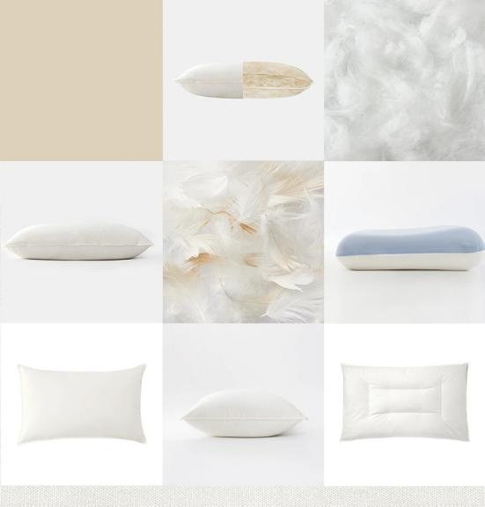
Figure 4：Product Showcase
product display diagram (Figure 4) shows the state of the product to the user in
a more intuitive way. As can be seen from the diagram, the products evoke the user's desire for nature with their simple and primitive texture. He is good at showing the initial state of materials, which can deepen consumers' impression of the brand in an invisible way.

3. Artistic Criticism and Analysis of Kenya Hara's Design Thinking
Kenya Hara's design philosophy is known for his minimalist style and modern interpretation of traditional Japanese aesthetics. His work, whether in furniture, products or graphic design, reveals a simple, pure aesthetic that emphasises the idea that less is more. However, despite the global acclaim for his designs, they have faced a number of criticisms and challenges.
Firstly, Kenya Hara's minimalist designs may be seen as too cold and impersonal to some extent. His work is often criticised for focusing too much on visual simplicity at the expense of user experience and emotional connection. Against the backdrop of today's trend towards diversity and individuality, this minimalism may not fully satisfy the needs and preferences of all users. Emotions cannot be contained when images are too minimalist. This, in a way, is undoubtedly depriving the user of an emotional experience. The development of this kind of design outside of Japan is also undoubtedly a hindrance to design diversity if nature and simplicity are repeatedly emphasised because of different religious beliefs.
Secondly, whilst Kenya Hara's design philosophy at emphasises purity of materials and form, this approach may at times overlook considerations of environmental and social sustainability. At a time when sustainable and eco-friendly design is increasingly emphasised globally, this may become a limitation of his design philosophy . In Australia, for example, an emphasis on purity of materials, with a basic exclusion of synthetic chemicals, would also be a threat to the local ecology.
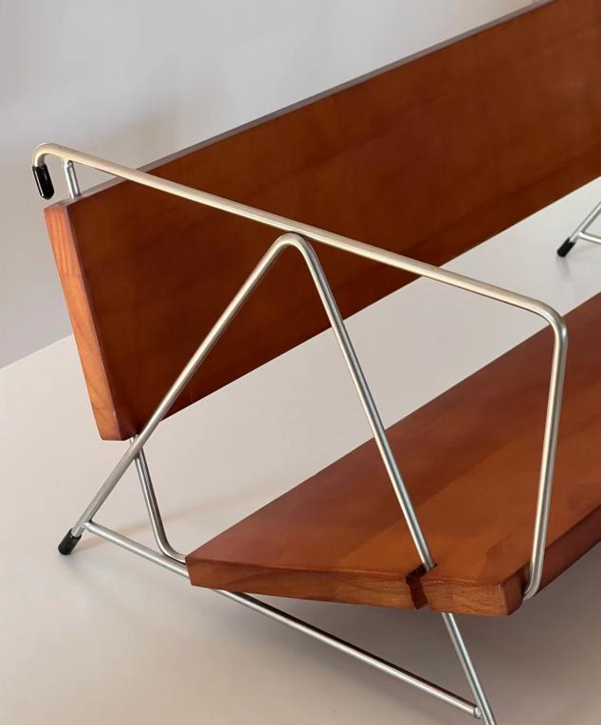
In addition, although Kenya Hara's design style is popular internationally, its adaptability in different cultural and economic contexts is an issue worth considering. Kenya Hara's design philosophy focuses heavily on simplicity and minimalism, and he believes that designs should be simple and straightforward, without any unnecessary decoration. However, this philosophy may lead to some designs appearing too monotonous and boring. For example, as shown in the picture (Figure 5), the furniture he designed is simple and beautiful, but
Figure 5:chair

lacks some practicality and comfort, which may make the user's experience not perfect. His designs may also be less acceptable or adaptable in certain cultural and social environments, especially in those societies that emphasise decorative and traditional styles. An example is India. India is known for its rich and diverse cultural heritage and decorative arts. Indian architecture and art often emphasise detail and ornamentation. The most distinctive representation of this is the Taj Mahal.

- summaries
In our in-depth study of Kenya Hara's design methodology, we have found it to be of significant importance in design thinking. In addition, Kenya Hara's design philosophy is deeply rooted in a profound insight into the details of everyday life, which enables his work to meet practical needs while resonating emotionally with users.
However, there is also some room for improvement in Kenya Hara's approach. In the current rapidly changing design environment, the exploration of new materials and technologies may further enrich his design language. For example, incorporating more sustainable elements or using emerging technologies such as augmented reality and virtual reality may bring new dimensions to his design philosophy. With these improvements, Kenya Hara's approach will not only maintain its core philosophy, but will also be better adapted to the challenges and opportunities of modern design.
References
[1] (Japanese) Kenya Hara.（2006）. Design in Design [M]. Zhu E, Translation. Jinan: Shandong People's Publishing House, 39-44.
[2] Jun Li. （2021）The application of minimalist style in web interface design[J]. Computer Knowledge and Technology, 1217(10).
[3] Fu Zhongfang. (2015(10). Less is more - on the application of minimalism in graphic design[J]. Beauty and era (above).
[4] Zhang Ning. (2011(08)).The use of minimalist art concepts in contemporary Chinese design[J]. China Art Museum.
[5] Zhou Liting. (2010).The Way to Simplicity and the Return to Truth[D]. Shandong Academy of Arts and Crafts.
[6] He Lu. ( 2013). Research on Design Concept and Style of Kenya Hara [D]. Kaifeng: Henan University. P-58.
[7] Li Yi. (2010).Minimalist characteristics of Indy's packaging design[D]. Hebei University,
[8] Guo Meng. (1997). Interpreting the Oriental Mind: The Design Language of Ikko Tanaka[J]. Northwest Fine Arts.
[9] Kenya Hara. (2006) Design in Design [M]. Zhu E, Translation. Jinan: Shandong People's Publishing House, P: 39-44.
[10] Zhang Miao. Exploring the design philosophy of Kenya Hara [D]. Beijing: Beijing Jiaotong University, p: 24
[11] (Japanese) Kenya Hara. (2006) Design in Design [M]. Zhu E, Translation. Jinan: Shandong People's Publishing House, p: 39-44.
[12] (Japanese) Kenya Hara. (2012) White [M]. Ji Jianghong, Translation. Nanning: Guangxi Normal University Press, p: 16-20.

Bibliography
- Xie Tao. The beauty of simplicity - web interface minimalist design based on visual experience[J].Art World,2013(12):1.DOI:CNKI:SUN:MSJZ.0.2013-12-050.
- (Japanese) Kenya Hara. Design in Design [M]. Zhu E, Translation. Jinan: Shandong People's Publishing House, 2006: 39-44.
- Feng Ziming,Fan Kun. Minimalist design in graphic design[J]. Art Ocean, 2010(7):1. DOI:10.3969/j.issn.1673-1611.2010.07.037.
- SONG Jinghua,LIU Junya. Minimalist design from the perspective of complex systems[J]. New Architecture, 2021(6):6.
- Cao Yayu. Minimalist design based on the perspective of green packaging--an example of berry tea packaging[J]. Green Packaging, 2022(008):000.
- Zhong Jing. Feeling, Art and Life - Interpretation of the Thought of Japanese Graphic Design Master Kenya Hara[J]. Art Observation, 2009(8)：3.
- Sun Mingjie. Where is the Beauty of Craft - Reading The Way of Craft [J]. Art Hundred, 2016(A01):3. DOI:10.3969/j.issn.1003-9104.2016.z1.156.
- Bai Yongfang. The Way of Craft read epub The Way of Craft and the Way of Non-Genetic Inheritance[J]. Literature for Young People, 2020, 000(007):P.1-1.
- Bao Yu Tang Ying, 2016(35).Step in the right direction - the way of craftsmanship[J]. Seeking knowledge guide, 152-152.
- Fang Chun，2013，The Beauty of Simplicity, Refinement and Practicality - Reading The Way of Craft[J]. Hangzhou: quality of life, (6):1.
- Xiao Ya. Research on the beauty of craftsmanship in design [D]. Shaanxi Normal University,2014.
- Xu Yan. (2014). Liu Zongyue and The Way of Craft. Popular Literature.
- [1] J. Yanagi, S. E.. (2011). The Way of Craft. Guangxi Normal University Press.p-32
- Guo, Minghui. (2018). Reading The Way of Craft, Savouring the Value of Folk Art. Folk Art (3), 2.
[15] Wang Yuan.(2021). A study on the commercial application of packaging design in the promotion of Shangluo agricultural specialties for docking [J]. P:68-68.
[16] Zhong Lei, Miao Yanrong. (2006). An introduction to the concept of sustainable development and green packaging design [J]. Packaging World,
[17] Guo Hao. (2011) Research on modern packaging design based on the concept of sustainable development [J]. Business Manager.
[18] Ma Xuezi. (2017). Fundamental research on modern packaging design based on sustainable development [J]. Design.
[19] Zhang Yu. (2014).A brief discussion on the positioning principles of sustainable design for packaging [J]. China Packaging Industry.
[20] Zhou Dapeng. (2016). Principles and strategies of packaging design in the context of sustainable development [J]. Art and Design: Theory Edition.
[21]Wang Shuguang. The Way of Craft and Cultural Self-Consciousness:An Inquiry into Aesthetics, Sociology and Economics - On the Thought of Craft Aesthetics of Liu Zongyue. Art Review.

