Individual Presentation & Supporting Marketing Plan
Student Name: Ioana-Catalina Dobre
Student ID: 2224087
Module Title Marketing Essentials
Lecturer name: Ruth Taylor-Davies
Word count:1797

Table of Contents
Introduction 3
Situation Analysis 3
Objectives 5
Strategy 6
Tactics 7
Action 8
Control 9
Conclusion 10
References 11
Individual Presentation 13

Introduction
Researchers have found that marketing mix is playing an important role in business and it also helps to understand the specified item or service that is offered by an organisation to their clients (Smith and Zook, 2020). It can be said that in the 5C framework of marketing, organisations address the sustainable competitive advantage of a particular brand. In this topic, it is discussed the marketing plan of the Premier Inn.
Purpose of the marketing plan
It has been found that a low-cost strategy, as well as a low-profit margin, is one of the main issues that is faced by Premier Inn hotel in recent times. Here the purpose of the marketing plan is to mitigate the issues that are faced by the organisation at the present time. It has also shown a lack of elaboration on the worldwide presence.
Sostac marketing plan:

Situation Analysis
5C analysis of the company
Company
In the 5C framework of marketing, the company addresses the sustainable competitive advantage of a specific brand (Clow and Baack, 2013).
Strengths  - Brand Reputation  - Wide range of offers and deals  - Largest hotel brand in the UK | Weaknesses  - Low-cost strategy and low-profit margin (Terence, 2022)  - A lack of elaboration on its global presence
Opportunities  - Strategic joint-ventures  - Customer experience-based brand value (Bas and Sivaprasad, 2021)  - Investment in organisational digitalisation | Threats  - Affordable accommodations like backpackers hotels and private rooms

Customers
This proposition entails the group of customers that the brand intends to reach and serve with the product or service.
Segmentation:
- Low to middle-income customers
- Budget accommodations
- Business and Families
Targeting:
Age | 25 to 34 years
Income | Low to middle-income
Location | Europe including the UK and the Middle East

Competitors
This element aims to identify the competitors or key players operating in a similar segment of the industry.
- Travelodge Hotels
- Hyatt Corporation
- Holiday Inn
- Ibis
Collaborations
Collaborators aid in the enhancement of a firm’s ability to deliver offerings more efficiently.
- Costa Coffee
- Dubai Parks and Resorts
- Whitbread plc
Climate
This element of the framework explores the area that can affect the business but the business has no control over it.
Political: Recently the hospitality market of the United Kingdom has been affected by Brexit (Neupane and Khanal, 2022). Premier Inn's business in terms of international visitors has been significantly affected.
Economic: The low-cost strategy of Premier Inn has been witnessing challenges because of a rising inflation rate that exceeded 9 per cent.
Social: After Brexit, the UK hospitality industry has been undergoing a labour crisis and experiencing a skill shortage (Ndiuini and Baum, 2021, p. 37).
Technological: Premier Inn has incorporated technologies such as AI, Business Process Automation, AR, and machine learning to augment the guest experience.
Legal: In the digitalised environment, Premier Inn needs to emphasise GDPR rules and client data protection.
Environmental: Premier Inn should adopt green technologies as well as renewable energy sources to reduce CO2 emissions.

Objectives
SMART target
Objectives | Specific | Measurable | Attainable | Realistic | Timebound
To improve profit margin by 25% | Premier Inn needs to increase its profit margin. | Gross Profit Margin - KPI | -Introducing a premium accommodation segment  -Cost control strategy | -Automated process to reduce overhead cost | 2 years
To increase brand awareness outside the UK | Premier Inn must expand its awareness to regions outside the UK. | -Google trend data  -Brand awareness surveys | -Social media campaigns  -SEO marketing | -Joint collaborations with global brands | 2 years
To adopt robust digitalisation to reduce cost | Premier Inn requires to reduce operations costs by automating processes. | - Operating cash flow  -Operating profit margin | -Cost control tactics  -Business Process Automation | -Adoption of AI and machine learning | 2 years
Strategy
Organisational value proposition
According to Belleflamme and Neysen, (2020), the value proposition can be defined by the value created and offered by a business to customers and their alignment with the expectations and needs of the potential audience.
Benefits
- Availability of both luxury and budget accommodations in one hotel
- Digital service experience
- Agile service
- Increased amenities
- Price retention
Features
- Service Automation
- Automated digital customer support
- AI-based analytics and recommendations
Experience
- Quicker service
- Self-service facilities without the needs of employees
- Affordable as well as luxury accommodations
Liking between the value proposition and customer segmentation
Wants
- Luxury and comfort
- Affordable stay with good amenities
- Safe and secure accommodation
- Efficient service and faster response
Needs
- Affordability
- Security
- Comfort and amenities
- Agility
Fears
- High cost
- Low quality of service
- Exposure of personal data

Tactics
Marketing mix
The 4Ps of marketing mix strategy explain the product, place, promotional, and price propositions of a brand (Kotler et al., 2020).
Product: Premier Inn aims to introduce a competitive accommodation and service facility for mid-market customers with added frills and amenities to create an extra source of revenue and increase profit margin. The company will adopt digital tools such as AI-based analytics to serve customers' needs better and furthermore, business process automation will be adopted to allow self-service facilities which can help the organisation reduce costs of overheads significantly. In this manner, the hotel brand can achieve a higher profit margin through additional services and catering to different income segments of the market.
Price: The current price strategy of Premier Inn is based on the low-cost model. A low-cost strategy enables an organisation to offer items at lower prices through a cost leadership approach (Lahtinen et al., 2020, p. 367). However, in a competitive market, low-cost marketers tend to achieve a low-profit margin (Housden, 2008). However, in this new marketing plan, the Premier Inn will use a competitive pricing strategy addressing the mid-market and the higher market. Customers will need to pay for what they need. In this manner, Premier Inn can serve both low-end and high-end customers on a need basis. However, the hotel brand must improve the quality of service to justify the higher price range.
Place: This marketing plan is particularly designed for Premier Inn's UK operations. The place is the strategy of distributing the offerings and hence a brand must choose the right location (Hanaysha et al., 2021, p. 57). The standard of living in the United Kingdom is quite high and hence people can afford the mid-range services of the hotel.
Promotion: As opined by Kotler and Kartajaya (2017), digital marketing is one of the most viable tactics of promotion in the modern day. Hence, in this plan, Premier Inn will run social media marketing, website promotion, and SEO marketing.

Action
Gantt chart
Activities | Week 1 to 2 | Week 3 to 4 | Week 5 to 8 | Week 9 to 11 | Week 12 to 14 | Week 15 to 16
Planning the idea and objectives
Sourcing funds
The digitalisation of service processes
SEO marketing
Social media campaign
Offers and discounts through direct
Justifications of the marketing channels
According to Chaffey and Ellis- Chadwick, (2019), SEO marketing enhances the web traffic of visitors to the website of a business. Hence, persuasion of SEO marketing techniques can allow the hotel brand to get maximum exposure to the target audience. Moreover, customers can easily find the location of the hotel branches at the top of the search page which also improves brand image. Besides that, social media marketing helps brands stay constantly in touch with their customers (Ryan, 2012). Hence, Premier Inn can run social media advertisements and post engaging content to keep clients informed about the latest deals and offers.

Control
The success of marketing can be measured through relevant Key Performance Indicators (Ghauri, 2014).
Monthly website traffic: It will show the number of visitors visiting the brand’s website per month.
Lead conversion rate: It indicates the number of visitors that have been turned into customers by a brand. It will also encompass new walk-in visitors to the hotel
Customer satisfaction score: It can showcase the satisfaction of customers with the quality of service provided by Premier Inn.
Gross profit margin: It will indicate whether Premier Inn’s new marketing plan has been effective in delivering new customers.

Conclusion
The marketing mix is helpful to identify the particular item as well as the service that is provided by an organisation to its customers. It is also discussed some issues that are faced by Premier Inn hotels at the present time. It has been found that a low-cost strategy, as well as a low-profit margin, is faced by Premier Inn hotels in recent times. Here it can be recommended that Premier Inn hotel must build a customer loyalty program to increase its profit margin at the present time. In the above section, it is discussed the main competitors of the company are Holiday Inn and Travel lodge hostel etc.

References
Bas, T. and Sivaprasad, S., 2021. COVID-19 and Implications for Future Trends in the UK Travel and Tourism Sector. Available at SSRN 3623404. https://papers.ssrn.com/sol3/papers.cfm?abstract_id=3623404
Belleflamme, P. and Neysen, N., 2020. A multisided value proposition canvas for digital platforms. CORE. https://dial.uclouvain.be/pr/boreal/object/boreal%3A232913/datastream/PDF_01/view
Chaffey, D and Ellis- Chadwick, F. (2019) Digital Marketing. 7th ed, Pearsons, London.
Clow, K & Baack, D (2013), Integrated Advertising, Promotion and Marketing Communications. 6th ed, Pearson, London
Ghauri, P N (2014) International Marketing, 4th Ed, McGraw Hill, London
Hanaysha, J.R., Al Shaikh, M.E. and Alzoubi, H.M., 2021. Importance of marketing mix elements in determining consumer purchase decision in the retail market. International Journal of Service Science, Management, Engineering, and Technology (IJSSMET), 12(6), pp.56-72. https://www.igi-global.com/article/importance-of-marketing-mix-elements-in-determining-consumer-purchase-decision-in-the-retail-market/289416
Housden M (2008), Marketing Research & Information, Butterworth Heinemann, Oxford.
Kotler, P., Armstrong, G., Harris, L. and He, H., 2020. Principles of marketing. 8th European ed, London: Pearson Education Limited.
Kotler,P and Kartajaya, H. Marketing 4.0 Moving from Traditional to Digital (2017) Wiley. New York.
Lahtinen, V., Dietrich, T. and Rundle-Thiele, S., 2020. Long live the marketing mix. Testing the effectiveness of the commercial marketing mix in a social marketing context. Journal of Social Marketing, 10(3), pp.357-375. https://www.emerald.com/insight/content/doi/10.1108/JSOCM-10-2018-0122/full/html
Ndiuini, A. and Baum, T., 2021. Underemployment and lived experiences of migrant workers in the hotel industry: policy and industry implications. Journal of Policy Research in Tourism, Leisure and Events, 13(1), pp.36-58. https://www.tandfonline.com/doi/abs/10.1080/19407963.2020.1743487
Neupane, R. and Khanal, T.R., 2022. EVALUATION OF THE IMPACTS OF TRAINING ON EMPLOYEE PERFORMANCE IN THE UK HOTEL INDUSTRY: AN ANALYSIS OF EMPLOYEES’PERSPECTIVES AT MARRIOTT INTERNATIONAL.https://pdfs.semanticscholar.org/9998/18868ef301d019696060860db1525b03a38f.pdf
Ryan, D. (2012) Understanding Digital marketing: Marketing Strategies for Engaging The Digital Generation. Kogan Page, London.
Smith PR & Zook ZE (2020) Marketing Communications. 7th ed, Kogan Page, London
Terence, B., 2022. UK Economic Strategy Presents Opportunity for Businesses, Including Hotels, To'Level Up'. https://vtechworks.lib.vt.edu/handle/10919/109340
Individual Presentation
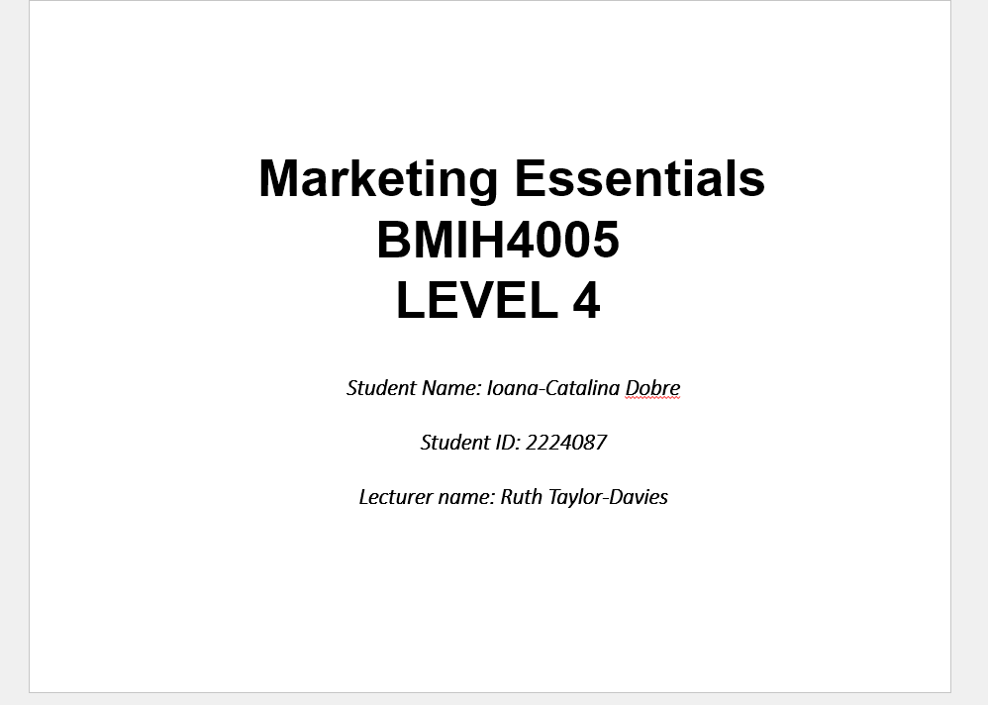
Slide 1 - Introduction 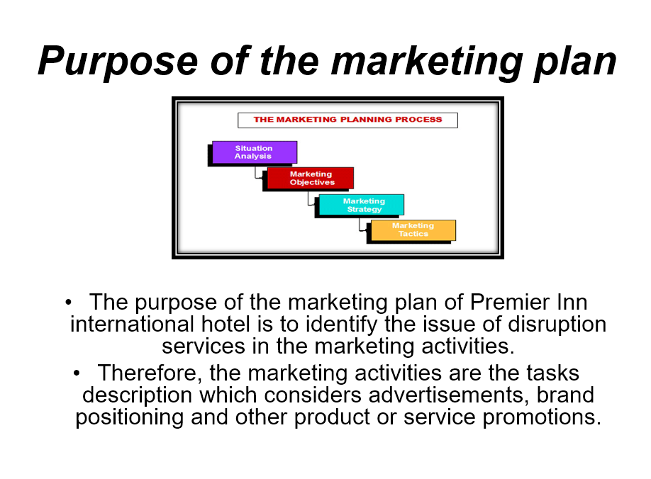

Slide 2 - Situation Analysis
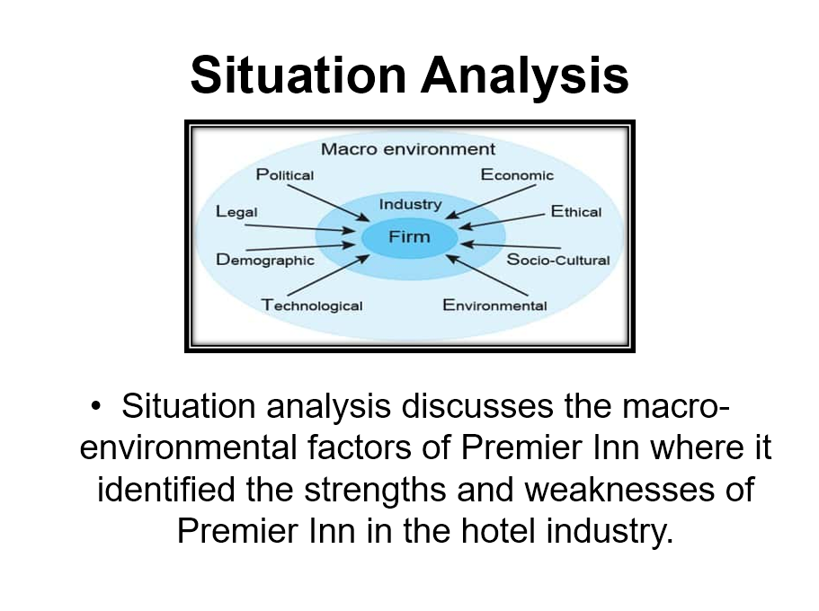Slide 3 - Objectives and strategy
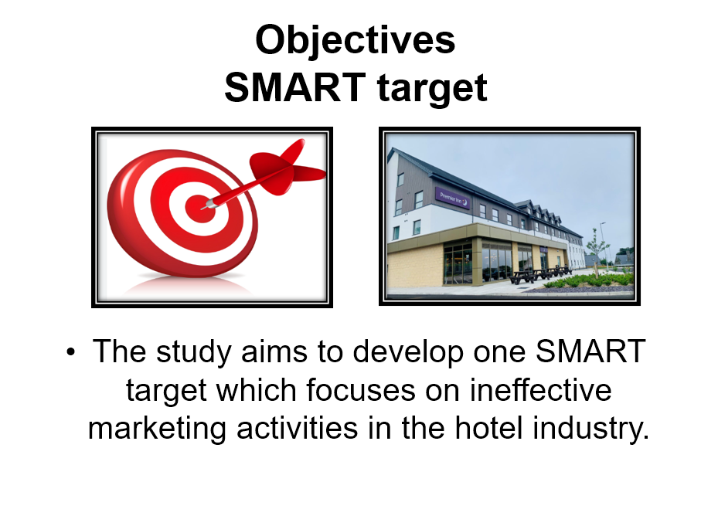

Slide 4 - Tactics
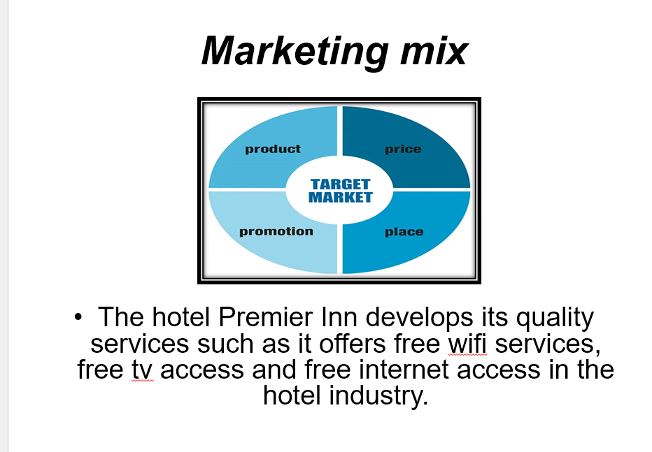

Slide 5 - Action and Control

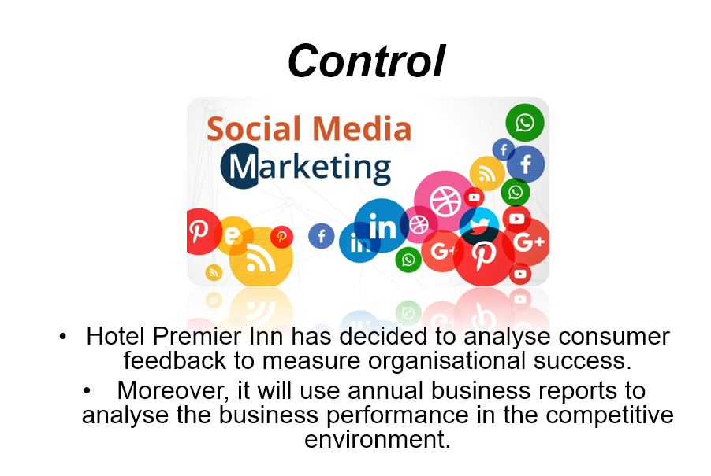

Slide 6 - Conclusion
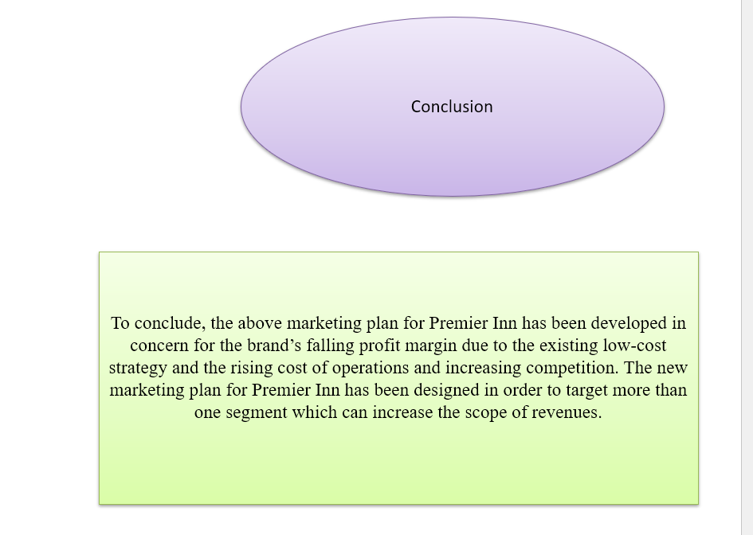

References



