Design for manufacture Exercise – Drill Press.
MSc: Design for manufacture.

Alan Norris
1/31/2020

Table of contents

Title page………………………………………………………………………..…..…………………...1
Contents page ……………………………………………….………………………….……………..2
Introduction ……………………………………..…………………..…………….…………………..3
Product review …..……………………………………………………….……………………………4
Design for Manufacturing and Assembly (DFMA)…………………....……..………..6
Sustainability of the product…………………………………..……………………………….13
Conclusion……………………………………………………………………………………………….15
References……………………………………………………………………………………………...16

Introduction.
Considering Design for Manufacture and Assembly (DFMA), involving a review the current design of the Drill Press. The sales forecast is for 500 units per week with a predicted product life time between 10 to 15 years, therefore the total volume is 390,000 units. The construction of the Drill Press is relatively simple. The only moving components are the lever arm, the link arm and the sliding unit which slides vertically on the main shaft. Cost and relaibility are key to the longevity of this product, which is a critical factor that all companies need to consider. Market returns need to be a minimum and the customers need to be satisfied with the product. The drill press target price is £59.00 each, with a total revenue of £23 million over the product life minus any returns. All parts will be reviewed to conclude what the potential changes are required to minimise or remove costs, with no impact to the reliability of the product, and confirmation of the sustainability of the product during its life cycle.

Drill press.
Support clamp
Main shaft
Guide shaft
Base
Sliding unit
Link arm
Lever arm

Figure 1: The Drill press.

Product review.
Main Shaft and Guide Shaft:
Both the Main shaft and Guide Shaft are manufactured by converting flat steel into a tube, joining the sides by either welding or a seamless pipe technology. The technology of both methods dates back to the early 1800’s, naturally this process has developed over the years and today millions of tons of steel pipe are processed every year (How Products are Made, 2020). The steel pipe is then chrome plated which was developed by C. G. Fink and C. H. Eldridge, in 1923. The plating is required for an aesthetic point of view, improving the surface finish, increasing hardness on the surface and has a low coefficient of friction and prevent oxidisation (Svenson, 2006). The manufacturing process converting the steel pipe with chrome plating, into the Main shaft and Guide Shaft will be classed as a significantly low-cost part. The investment required to manufacture these parts will be minimal as tooling would not be required as they are standard diameters.
Lever Arm and Link Arm:
Both the Lever arm and Link arm are manufactured by metal press machines, products from all sectors of travel utilise pressed parts from Space travel to riding a Bicycle. The manufacturing process from press machine’s manufacturing the Lever Arm and Link Arm will be classed as a significantly low cost part. Metal press tools require some capital investment as tooling is made from hardened steel, which is more difficult to machine due to hardness up to 55HRC (Misumi, 2020). However, the Lever Arm and Link Arm are moving parts are considered to be a risk therefore sustainability is a concern.

Sliding unit & Base:
Both the Sliding unit and Base are manufactured by Aluminium Die-casting, forming aluminium products by injecting molten material into the die. This was developed for the automotove industry in 1884 (Encylopaedia Britanica, 2020). Although the manufacturing process is well proven and mature, the Sliding unit aand Base unit in comparison to the other parts are significantly higher costs. Also, the sliding unit is a moving part but not considered a risk and the base has a potential weakness with the design which is a concern regarding sustainability within the product life.

Support clamp:
The support clamp is manufactured by extruded aluminium, typically the process is suitable for high volume production, the costs are insignificant in comparison to the sliding unit and base. Although the support clamp requires additional machining to create a slot enabling the part to to close on fitting the bolt, it also requires a drilled hole and thread to be machined. The manufacturing process is well proven and mature, however the additional machining requirements signicantly increases the cost of the Support Clamp.

Design for Manufacture and Assembly (DFMA).
Initial activities of DFMA dates back to the late 1960’s and early 1970’s (Brogue, 2012). DFMA, refers to the manufacturing of a product or or assembly to another product. Boothroyd (1994) states that the DFMA encourages both the design team and the manufacturing team to communicate and cooperate, thus improving the product and removing and reducing costs throughout the process (Boothroyd, 1994). In addition to removing costs from the product, it also reduces the time to market which is key to the product success and a companies competitiveness. Careful consideration of manufacturing and assembly is required at the start of the design cycle as its widely accepted that 70% of the product cost will be determined at this stage (Boothroyd, 1994).

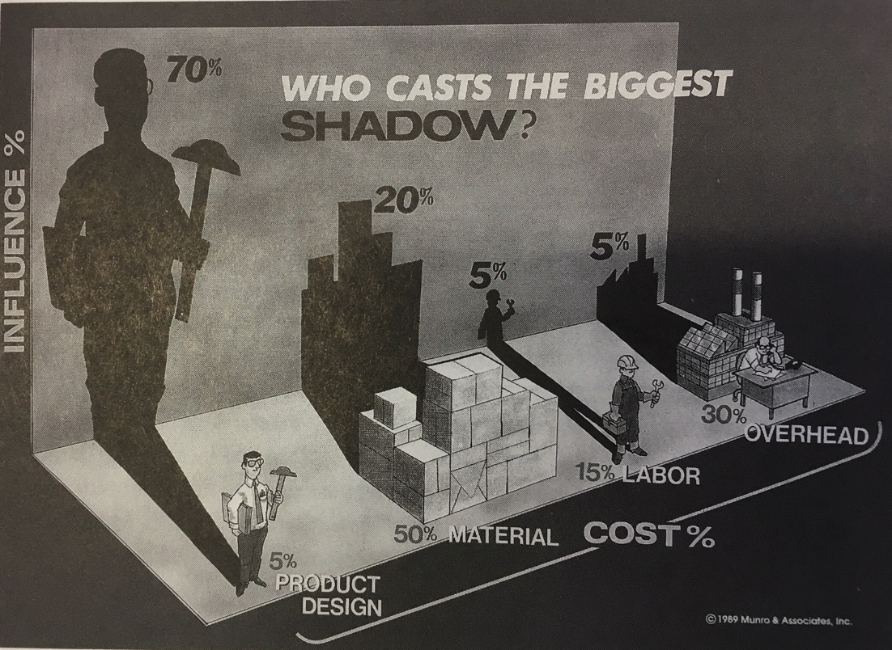

Figure 2: DFMA, “Who cast the Biggest Shadow” (Boothroyd, 1994).

Whereas Brogue (2012) has an holistic viewpoint of DFMA, stating that it provides a systematic approach for analysing a potential design, considering the manufacturing, assembly process removing and reducing costs throughout the process and reducing time to market (Brogue, 2012.) As can be seen below in figure 3, the benefits are many which is crucial for the company enabling them to be more sucessful.

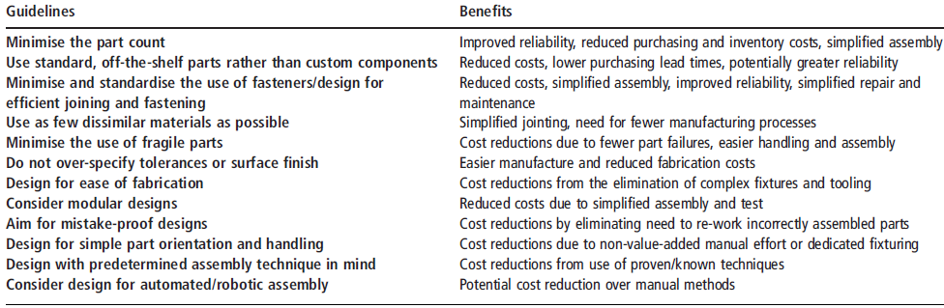
Figure 3: DFMA guidelines and benefits (Brogue, 2012).

The Product Review section raised concerns regarding cost drivers of the Sliding unit and the Base, which are both aluminium die-casting and the Support clamp is extruded aluminium with additonal machining operations.
To achieve the best quality product and lowest delivered cost for both Sliding unit and Base there are two key aspects:-

- Tooling: Firstly, the dies need to run and maintain a precise temperature and a constant cycle time. This will improve a prodcuts cycle time, thus increasing the output per hour, improving quality resulting in higher yields up to 1.5%, pushing costs down more and increasing tooling life by 10%. Potentially reducing the capital investment as less tools may be required within the products life cycle (Kumar & Hariharan, 2009).
- Product design: Secondaly, uniformed wall thickness is required to achieve the best quality product and cycle time, if there are thick sections these need additional cooling and will not cool at the same rate as thinner sections.Thus, the lower the cycle time, the lower the production cost, this is not just a piece part saving but can potentially reduce the capital investment as less tools may be required (Customerpart.net, 2020).

The Base has a potential weakness and a sharp edge that may cause an injury to the customer! The risk to the customer of the sharp edge is a fundamental error within the design, this may result in claims for cutting the customer and complaints within the market place damaging the reputation of the company.

Un-uniform thickness, weakness
and sharp edges which are a risk
to the customer

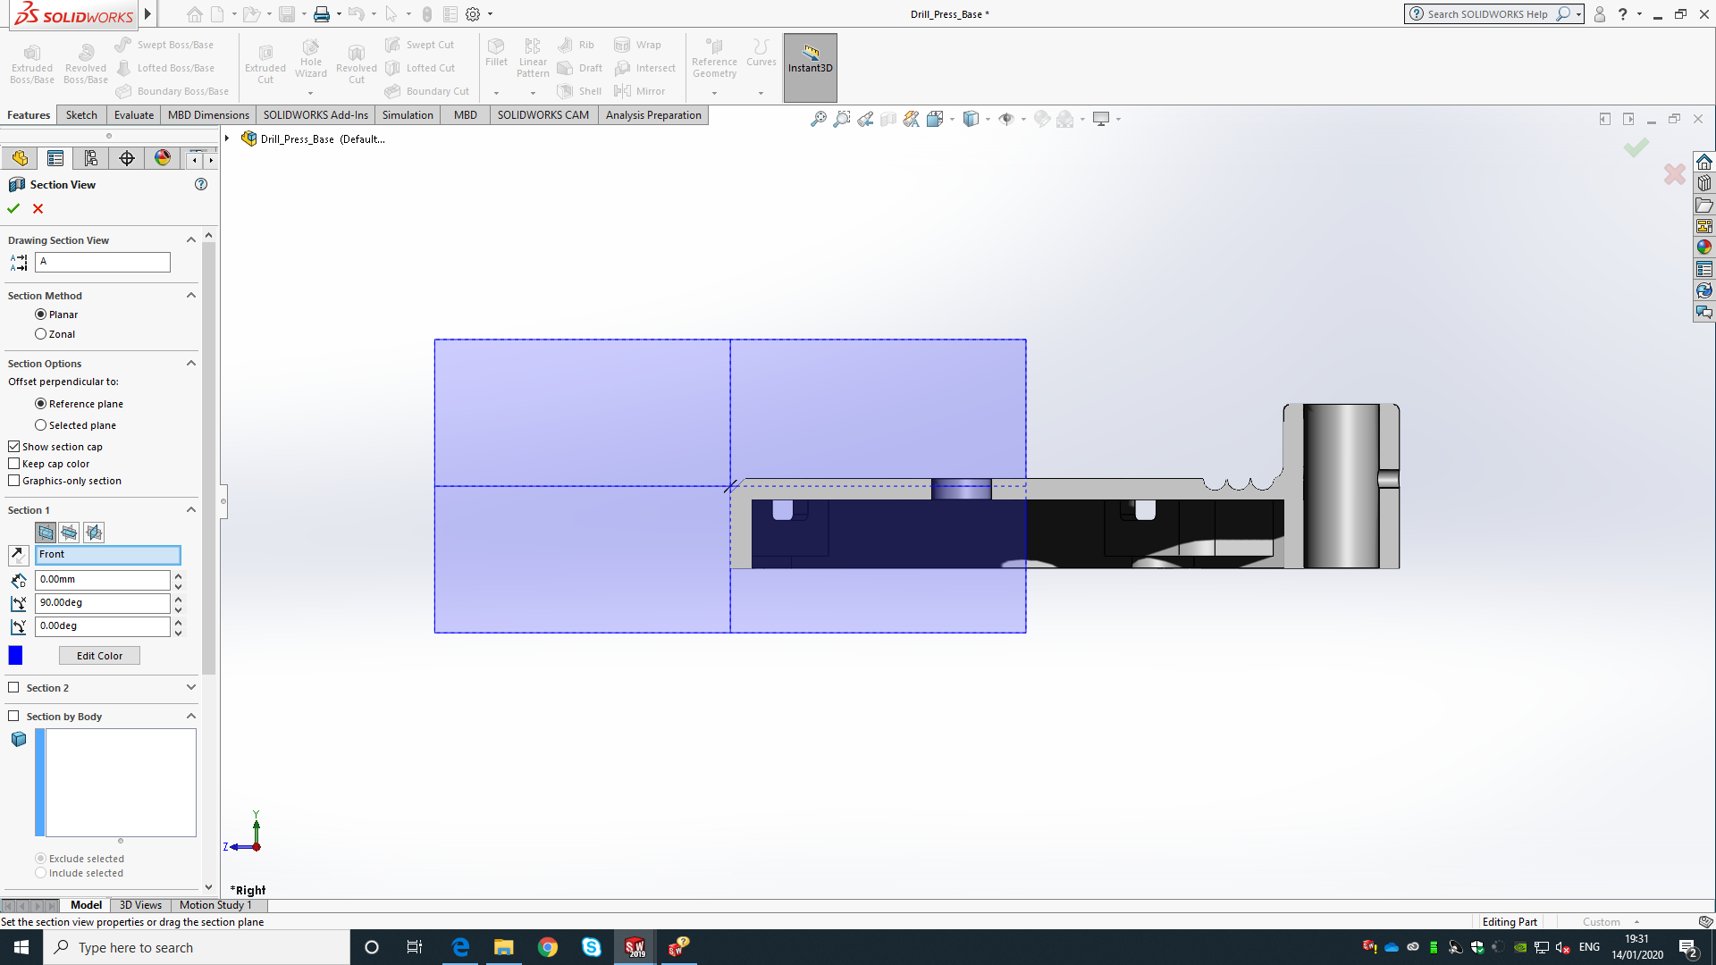
3.5mmm
7mmm
Figure 4: Section running through the Base, of original design.

There are problems of ununiform thickness of up to 7mm, no radius and draft angles which need to be corrected to ensure the production is efficient. The thinnest area is 3.5mm, therefore there is an opportunity to remove material if the base is strong enough. The mass of the original base is 2.3Kg.

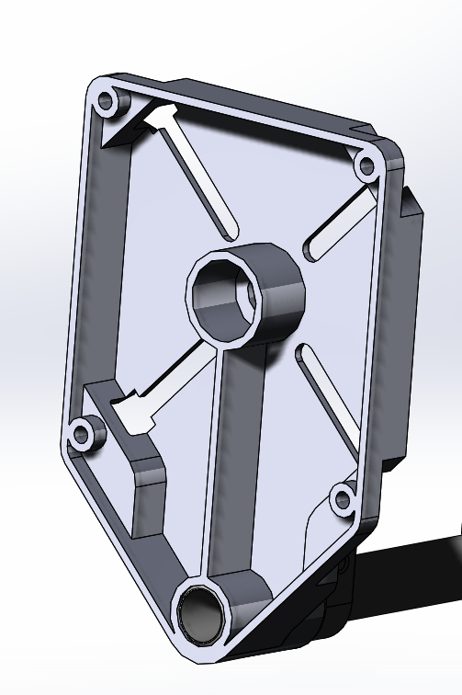
Figure 5: 3D data of the base, 3.5mm thickness and modifications of adding a rib and additional support centrally to increase the strength of the base.

The modified base (in figure 5) has a general wall thickness of 3.5mm, the mass of the modified base is 1.5Kg. Therefore a total saving of 0.8Kg, which is a saving of 35% on the base.
The Sliding unit is a solid piece of aluminium, this will require complex tooling, a very long cycle time, extensive cooling and waste material significantly (Kumar & Hariharan, 2009).
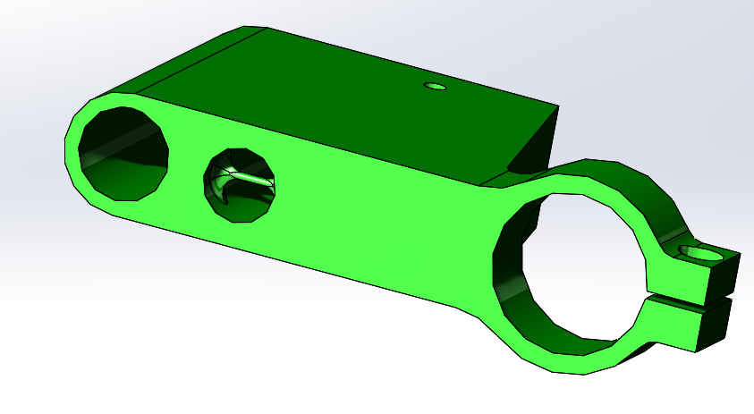
Figure 6: 3D Sliding unit, original design.

The mass of the original sliding unit 0.283Kg.
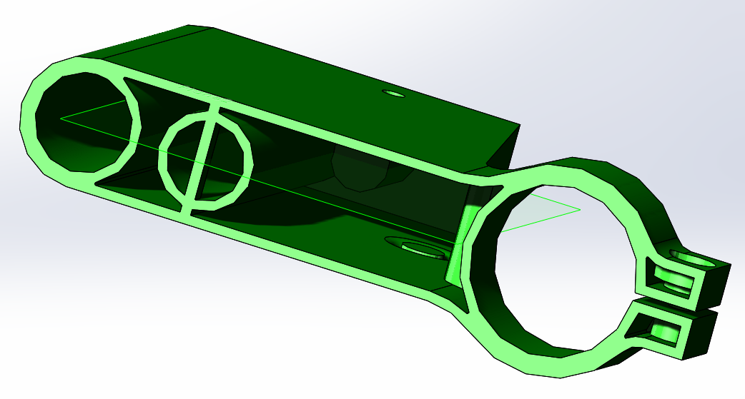
Figure 7: 3D Sliding unit, is proposed material reduction.

The mass of the modified base is 0.128Kg, therefore a total saving of 0.155Kg, which is a saving of 55% on the sliding unit.
Moreoever considering the design, the line of draw of the tool would be running vertically in the direction of the main shaft. Also requiring two additional slides would be required to produce the holes for a screw and a bolt to clamp the drill. Regardless to the parting line the hole where the main shaft slides, would require a draft angle not enabling a constant dimension running through the diameter of the hole, this would create the sliding unit to rock back and forth which is unacceptable considering the operation of the drill press. Therefore, there is a concern with the design itself! One possibility would be to design the part that has two separate parts that rely on a hinge mechanism that on closing the two parts fit together secured by the screws. This would minimise material, minimise cycle time, remove the need for two slides, thus improving the tooling cost and life of the tool itself. To achieve an optinum cycle time, reduce defects, material thickness needs to be reduced and needs to be uniform. This saves material, processing time, reduces the overall product weight and reduces internal scrap (Customerpart.net, 2020).
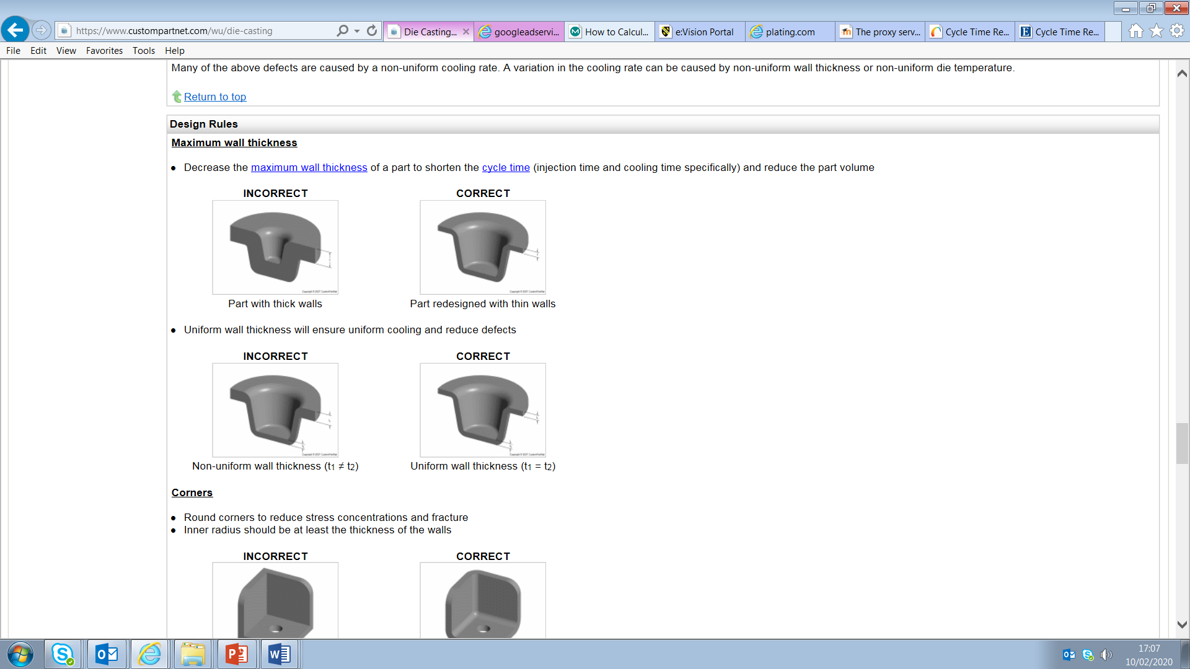
Figure 8: DFMA recommendations for die-casting (Customerpart.net, 2020).

In addition to this, to improve strength, reduce stress, fractures and overall reduction of defects radius (at least the same the thickenss) and draft angles are required (1 degree for walls and 2 degrees inside cores) (Customerpart.net, 2020).

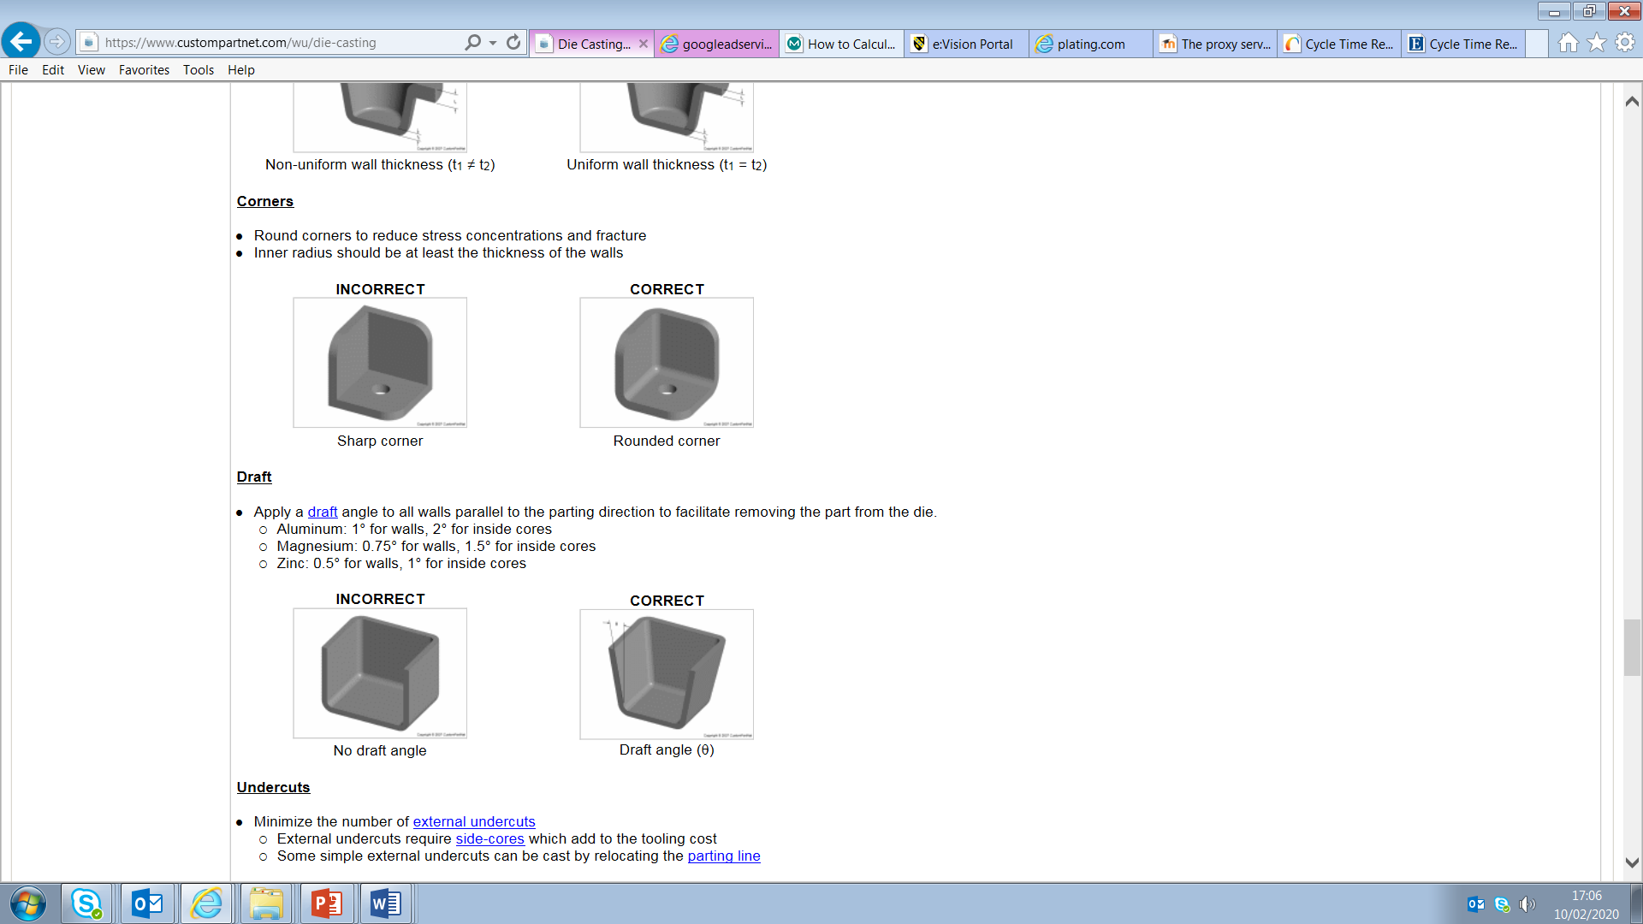
Figure 9: DFMA recommendations for die-casting (Customerpart.net, 2020).

DFMA has already been considered for the Drill Press, as the majority of parts are key to the operation of the product. However the Support clamp is not requirement, this part may be considered as to not be required as if it is removed the drill press can still operate as required. This part may be able to be removed, however before the part is removed its recommended a market review on the need for this part or not ensuring customers satisfaction is maintained.

Therefore, there is a need for minimising manufacturing and assembly costs by improving the product design, reducing the number of parts, the size, weight of the parts, the cost of the parts by utilising high cycle tools and reducing the time to assemble the parts. Thus, improving manufacturing efficiency has enabled automation, agility to thrive and create a flexible approach taking up the lean philosophy. The majority of the product costs are fixed by the design who need to challenge the design providing the functionality is maintained. Lee-Mortimer (2006) highlights that this provides significant savings, claiming to be 70% of the product cost (Boothroyd, 1994). These savings can counterbalance the threat of outsourcing to achieve the lowest cost through DFMA. While utilising DFMA enabling the company to achieve best cost internally, companies can avoid chasing low labour cost in Asia. More importantly removing the risks incurred by outsourcing, poor communication, frustration, delays in the development, long lead times, difficulties making changes, transportation delays and avoiding ongoing difficulty of managing these companies (Lee-Mortimer, 2006).
Furthermore, Research, Development and Design is more important now than ever before as competition is so severe on a global basis. Companies that do not invest in Research and Development (R&D) imitate others, naturally take less risk because they have a head start on knowing the current innovators product, enabling them to take a more effective approach learning by the mistakes of others. For example, the company Compaq with their lower priced computers against IBM, while IBM repeating the same against Apple computers (Business Dictionary, 2018). Nevertheless, by not investing in R&D, companies lose the opportunity to design the best product considering their operation and process leaving it to a third party.

Sustainability of the Drill Press.
Although this is a low cost product, customer expectations for all products regardless to price is critical, therefore its key the product withstands its expected life failing that there could be a flood of returns which will damage the reputation of the company. Returns is one of the most complex and difficult challenges facing manufacturers, distributors and retailers in today’s increasingly complex global supply chain if there is the need to recall a product from the market. No product is immune from safety incidents that may result in a recall, during the past decade the automotive sector has suffered the vast majority of “serious” safety defects (Doherty, 2018)!

The Product Review section raised concerns regarding, that may cause problems within the market impacting the product sustainability:-

- Moving parts of the, Lever Arm and Link Arm. 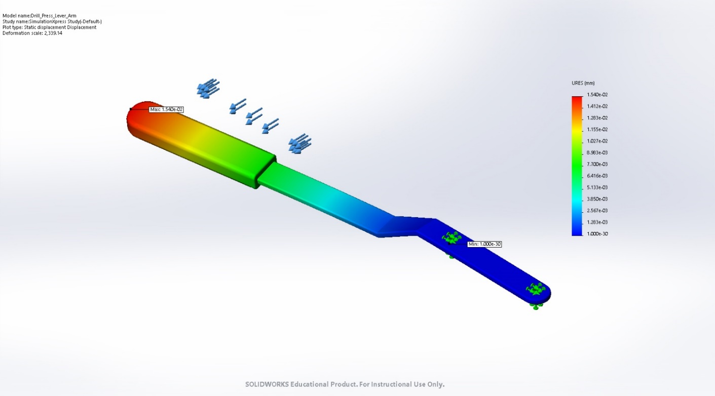
Figure 10: Simulation of a 5N force on the Lever Arm.

On simulating with a 5N force on the lever arm, the maximum displacement is 1.54mm. Therefore, a minor risk of the failure of the Link Arm within the product life cycle of the Drill Press.

- Considering the original base, with a restriction of 3.5mm thickness.

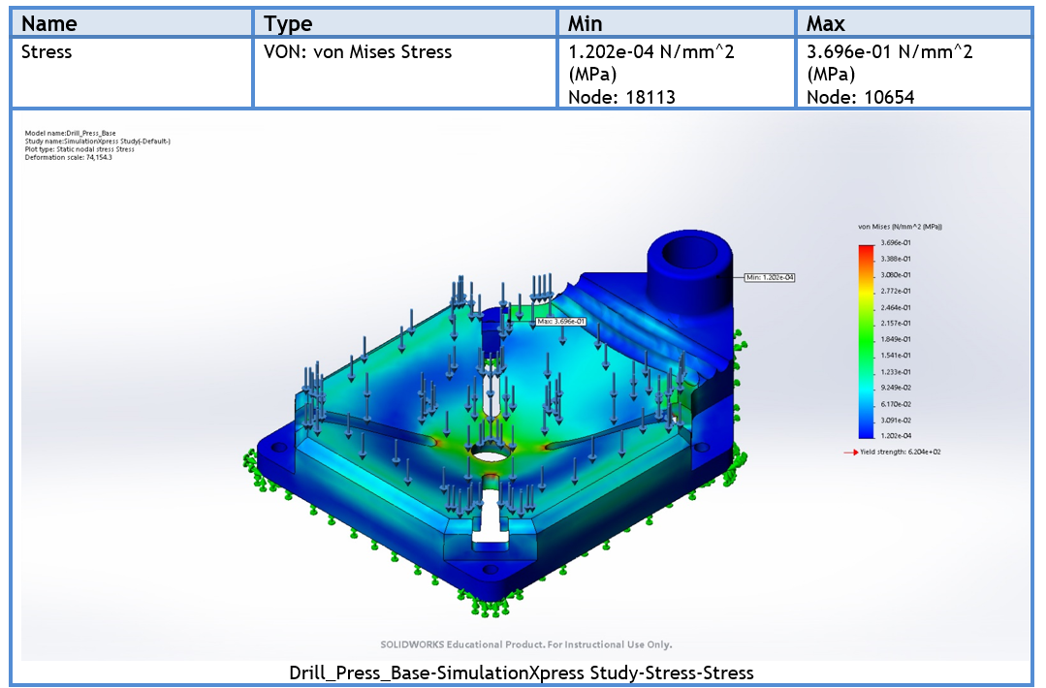
Figure 11: Simulation of the original base with a vertical 30N force on the base.
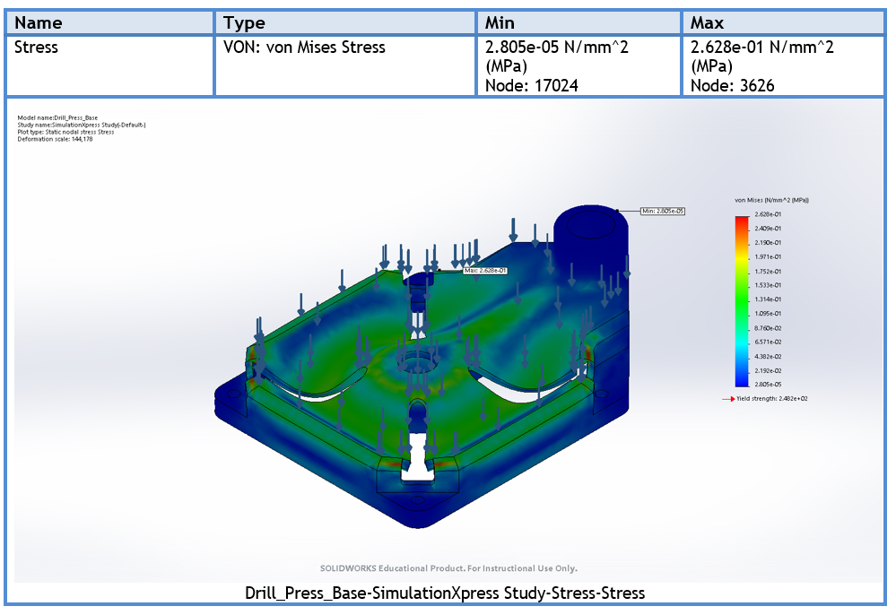
Figure 12: Simulation of the revised design base with a vertical 30N force on the base.
The modified base (as figure 5) with a general wall thickness of 3.5mm, there is significantly less stress.

Conclusion.
To conclude, the drill press DFMA exercise deletion of one part the support clamp reduces the mass of the sliding unit by 0.155Kg, which is a saving of 55% of material and the base by 0.8Kg, which is a saving of 35% of material. Naturally this will drastically reduce the cycle time, removing more costs and potentially reducing the number of tools required within the product life. In addition, concerns raised with the lack of consideration of draft angles, radius, uniform thickness and most importantly safety of the customer.
Finally, Brogue emphasises that the importance of DFMA is fundamental to the success of the product launch, sales and the company itself (Brogue, 2012). DFMA software is utilised by Ford claiming overall savings of $1 Billion, also Sony Walkman used DFMA software for “vertical assembly” where a robotic system inserted components by a straight down motion (Brogue, 2012).

Referencing

Geoffrey Boothroyd, P. D. (1994). Product Design for Manufacture and Assembley. New York: Marcel Dekker inc.

Bogue, R (2012 ‘Design for manufacture and assembly:
background, capabilities and applications’ [online] Available at:
https://search-proquest-com.ezproxy.uwtsd.ac.uk/docview/963336255/fulltextPDF/54895729C1874D04PQ/1?accountid=130472
[Accessed 11th February 2020].

Business Dictionary (2018) ‘The meaning of Innovation or innovative’ [online] Available at: http://www.businessdictionary.com/definition/innovation.html
[Accessed 31st of January 2020].

Custompart.net, (2020) ‘Diecasting’ [online] Available at:
https://www.custompartnet.com/wu/die-casting
[Accessed 9th February 2020].

Deshpande, V et al (2011) ‘Outsourcing manufacturing: Secure Price-Masking Mechanisms for Purchasing Component Parts’ [online] Available at:
https://web-b-ebscohost-com.ezproxy.uwtsd.ac.uk/ehost/pdfviewer/pdfviewer?vid=1&sid=2e7ed77a-9c1e-4d82-9768-598751d626b2%40pdc-v-sessmgr01
[Accessed 4th February 2020].

Doherty, J. (2018) ’Product recall: how to handle reports of a defective produce’ [online] Available at:
https://www.penningtons.co.uk/news-publications/latest-news/2018/product-recall-how-to-handle-reports-of-a-defective-product/
[Accessed 4th of February 2020].

Encyclopedia Britanica, (2020) ‘Die-casting’ [online] Available at:
https://www.britannica.com/technology/die-casting
[Accessed 11th February 2020].

Lee-Mortimer, A (2006) ‘Improved product design as an alternative to outsourcing manufacture and assembly’ [online] Available at:
https://search-proquest-com.ezproxy.uwtsd.ac.uk/docview/212649372/fulltextPDF/A771E9307C9B4E30PQ/1?accountid=130472
[Accessed 4th February 2020].

How Products are Made (2020) ‘Steel Pipe’ [online] Available at:
http://www.madehow.com/Volume-5/Steel-Pipe.html’
[Accessed 9th February 2020].

Kumar, S & Hariharan, S (2009) ‘Cycle Time Reduction in High Pressure Aluminium Die Casting through Optimum Design of Heat Transfer Systems’ [online] Available at: https://web-b-ebscohost-com.ezproxy.uwtsd.ac.uk/ehost/pdfviewer/pdfviewer?vid=1&sid=0e3cb465-68d2-48c4-9142-b8b9dca90fe1%40pdc-v-sessmgr03
[Accessed 9th February 2020].

Misumi Technical Tutorial (2020) ‘#090 Fundamentals of Steel Materials for Dies (9) Materials for the Main Parts of Dies – 1’ [online] Available at:
https://www.misumi-techcentral.com/tt/en/press/2011/08/090-fundamentals-of-steel-materials-for-dies-9-materials-for-the-main-parts-of-dies-1.html
[Accessed 25th February 2020].

Svenson, E (2006) ‘Plating Resources INC.’ [online] Available at:
http://www.plating.com/Book.pdf
[Accessed 9th February 2020].

