Problem Solving and Innovation (BMSW4014)
Presentation Speaker Notes
Student ID:2326183
Student Name: Paula Baruta

Strategic Recommendations for The Body Shop's Future Success
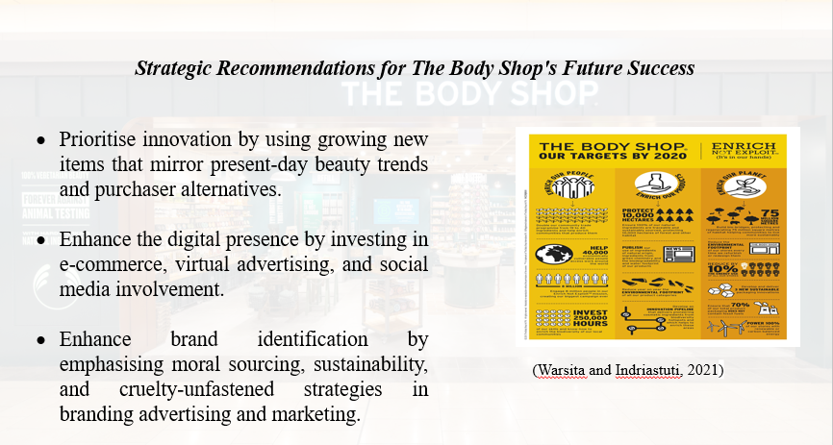
Focus on Innovation: If the Body Shop wants to get beforehand of the opposition, they ought to put a number of efforts into making new products (Warsita and Indriastuti, 2021). Adding smooth formulas, packaging, and product strains that in shape modern beauty trends and client tastes also can help to get human beings interested by the brand once more.
Expand Online Presence: To reach greater individuals and make more cash online, have to spend money on learning e-commerce abilities and running digital marketing and advertising efforts. To improve its online visibility, The Body Shop need to make its internet site simpler to use for purchasing, connect with social media networks, and search for digital partnerships (Warsita and Indriastuti, 2021).
Reinforce Brand Identity: To set itself aside from the competition, The Body Shop requirements to stress again how committed it is to ethical assets, ecology, and methods that do not harm animals. Effectively speaking its beliefs and visions by its branding, advertising, and in-store evaluations might also assist to maintain clients coming again and bring in new ones.
Keep things easy: The Body Shop desires to keep its approaches and supply chain easy to enhance overall performance and cut charges. Store plans may need to be optimised, issuer contracts may additionally need to be renegotiated, and stock management structures might also need to be installed location to ensure merchandise are to be had and cut down on waste.

Conclusion
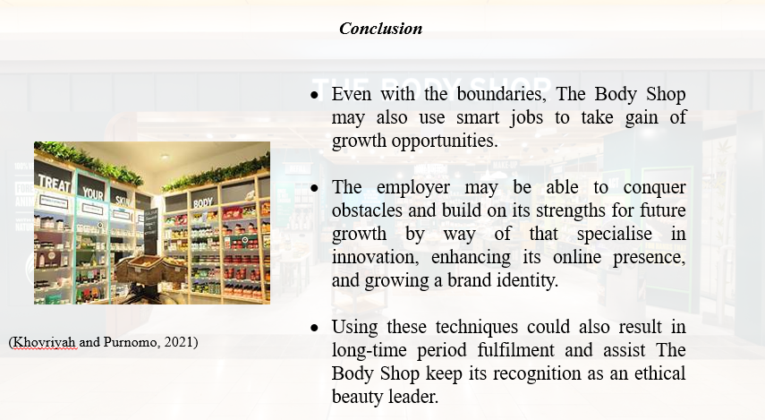
The Body Shop confronts great problems in the retail market, yet there is potential for enlargement by strategic projects. The company may manipulate its limitations whilst using its strengths for future achievement by using concentrating on innovation, enhancing its virtual presence, strengthening its brand identity, and simplifying tactics. With cautious execution of these ideas, The Body Shop may additionally attain long-time period development and hold its position as an ethical beauty leader.

References
Warsita, M. and Indriastuti, H., (2021). The Influence of Corporate Social Responsibility Towards Brand Image and Corporate Reputation on the Study of the Body Shop" Forever Againts Animal Testing" Campaign. International Journal of Economics, Business and Accounting Research (IJEBAR), 5(2).

