MA Youth and Community Work

ETS Endorsed

Fieldwork 1

1601122

Eve Audrey Robinson

STUDENT INFORMATION
Student Name | Eve Robinson
Student Address | 21 Erw Terrace  Burry Port  SA16 0DA
Student University e mail | 1601122@studnet.uwtsd.ac.uk
Student DBS Status and date | Child and adult workforce  Feb 2020
Additional requirements
Name of fieldwork supervisor | Paul mann
Fieldwork supervisor Tel. | 01554 834346
Fieldwork supervisor e mail | p.mann@pembreyburryport-tc.gov.uk

HOST ORGANISATION INFORMATION

Name of Organisation |  |  | Pembrey and Burry Port Town Council Youth Theatre group
Tel. |  |  | 01554834346
Email |  |  | p.mann@pembreyburryport-tc.gov.uk
Aims/ Purpose of the Organisation |  |  | To teach theatre, drama, singing, dance and confidence through musical theatre
Duration of placement |  |  | Level 7 Placement: 200 hours (100 or more face to face Youth Work).
Please detail the activities expected of the student  (Use more space if necessary) |  |  | To assist with supervision  To work with small groups  To support the theatre group leaders
Facilities/equipment available to student |  |  | All facilities required
Please confirm that your organisation has in place the following and where the student can have access to them:
a. Equal Opportunities Policy and procedures |  |  | Yes – CDO Office
b. Safeguarding policy and procedures including a designated child protection officer |  |  | Yes – CDO Office
c. Disability Policy (please state how you will meet any special requirements noted by the student) |  |  | Yes – CDO Office
d. Health and Safety Policy and procedures |  |  | Yes – CDO Office
e. Risk assessments including significant risks identified? A copy to be forwarded to the University. |  |  | Yes - Office
During induction the student will be made fully aware of the organisation's rules of conduct (including boundary management), practices and policies, including Safeguarding and Health and Safety (e.g. accident reporting).

The student will be covered by your employer's liability insurance whilst on your premises and undertaking any assigned tasks.

Yes No

During the placement, the student will be responsible to:
Name of Line Manager | Paul maan
Position | Cemetery super intender
Telephone No. | 01554834346
Email | p.mann@pembreyburryport-tc.gov.uk
UNIVERSITY INFORMATION

Name of visiting tutor |  | Darrel Williams
Telephone Number |  | 01267 676767
Email address |  | d.g.williams@uwtsd.ac.uk

Student, line manager, and visiting tutor to sign below:

I hereby agree to the terms and conditions outlined above

Signed (student)……earobinson……………………… Date: …

Signed (line manager)……………………………………… Date …………………

Signed (visiting tutor)………………………………………… Date: ………………….

Risk Assessment:
Details:
Description | Youth Theatre
Department: | Public Building
Location: | Burry Port Memorial Hall
Author: | Paul Mann
Line Manager: | Huw Thomas
Date: | 25/03/21
Applicable Equipment:
Associated Risk Assessment(s):
Version: | 1
Review Date: | 25/3/2022
Approved by:
Reason for latest update | Annual update

Print name: ___________________________________
Signed: ___________________________________
Authorised by: ___________________________________
Print name: _______P.Mann_____________________

MA Youth and Community Work

ETS Endorsed

Component 1

1601122

Eve Audrey Robinson

Observation Work Placement

My placement was in an all-inclusive young person’s theatre where there were no auditions, no requirement for a specific physical shape, and no requirement to be able to sing. There is nothing like it in the region because the bulk of the organisation has specific qualifications to join. Many young people worry In this instance, one could worry if children and young people will have trust in future adults because so many of them have let them down. There are also numerous conditions for joining groups, the majority of which young people have discovered they are unable to meet.

In a theatre, I saw a group of young individuals aged 11 to 16. They learned things like voice warm-ups, performance posture, and character development. The number of young people that engaged and wanted to participate was eye-opening, since there was nothing else in the community that was inclusive of all young people, regardless of ability. Seeing the differences was a great consequence. (Norman and Hyland, 2003).

I chose to watch this specific group of young people in this particular environment because engaging in something like a theatre club helps them build confidence and establish new acquaintances from a young age (Dickinson and Hutchinson 2019). It was also therapeutic to be able to leave the worst behind and enter as a different persona and individual. Pavlicevic., O’Neil., Powell., Jones and Sampathianaki (2014) are in agreement with this because there are therapeutic purposes to be able to cope with problems, development of building a character and someone who can confront challenges, change; and working in a ‘goal-oriented' approach knowing that in order to achieve the final goal, all of these steps must be completed first.

A lot was learnt through this experience and many things were taken from this. It was a benefit to go and see how young people take to a new project and how the participation grew with in week, with young people convincing friends to come and encouraging them to join in. A key research topic in the social sciences is the mechanisms by which groups come together, recruit new members and evolve over time: political movements, professional associations and religious denominations all offer basic examples of such communities (Youniss, and Smollar,1987).
Company Name: Youth Theatre Date: 3/7/2021 Location: Memorial Hall Assessed by who: Eve Robinson

Risk | Who’s at risk | Description of the risk | L, M, H  Before | Steps taken | L, M, H  After | Assessed by | By when
Slips and trips | Young people and staff | If they fall or trip while dancing and rehearsing, they may get an injury. | M | Everyone has a 2-meter area around them to guarantee that no one trips or falls over. | L | A Member of staff | The first session
Paper cut | Young People | When young people or employees turn the pages of the script, a papercut might occur. | H | Adding little tabs at the end of each page to make turning the page simpler, or encouraging all young people to write their thoughts in a Polly pocket | L | A Member of staff | When scripts are given out
Jamming fingers in door | Young people and Staff | Because the doors are heavy for fire and security reasons, not knowing the power of the door or the door closing without intention. | M | safety caps are being put on the doors to mind little fingers as well as making sure all doors are open enough to walk through when only the theatre performers are in | L | The Facilities / Health and safety Officer | Before the first session

Community Profile

Profile of the community

The purpose of this community profile is to paint a picture of a tiny town in South Wales using statistical data as well as young perspectives, ambitions, and dreams.
To get a sense of the community, I asked a group of young people between the ages of 15 and 16 to draw the community they lived in now and when they were ten years old. Due to confidentiality concerns, the young people did not allow me to include their drawings in the portfolio; however, they did allow me to make notes on what changes had occurred over time through a table made up of what was there. This was done to see what has changed in the past six years.

Equality of opportunity and valuing diversity
I obtained informed consent from the parents and the kids themselves before collecting any data for this profile. I tried to treat everyone involved with dignity and respect, and I encouraged others to do the same (Waiton, 2008, pp. 5-6).
They were more than glad to respond since it gave them a voice in their neighbourhood and asked them to tell me their favourite aspects about the region and if there was anything they'd like to change.

Methods, Subject and Context
One of the group work assignments was to create a map of the region and highlight their favourite places in the town, as well as what they gained from being there. Because the group was diverse in terms of age, gender, and ability, the results were more accurate. I also learned that one of the young people didn't reside in the village and another had recently moved in, which gave me a distinct perspective on the community because the young people perceived it differently.

Geography
Burry Port is located in Carmarthenshire , along the Loughor Estuary, and has an 8-mile beach that follows the Welsh Coastal Path. Burry Port is a little village about five minutes from Pembrey, five miles from Llanelli, and 1.5 hours from Cardiff, yet it has its own train station and can be reached from London in under four hours. With far-reaching vistas out to Carmarthen Bay, Tenby, and the Gower Peninsula, there are rewards with breathtaking views.

The Wider Community

In 2018, the population of Burry Port was estimated to be at 4,226 people, with the number growing every year. It has been identified as having one of the lowest proportions of Welsh speakers in Wales. The town has an average of 517 young people, 290 of them are male and 227 of whom are female. The town has four schools, two of which are English and the other two are Welsh. Burry Port's population is steadily increasing, with many retirees flocking to the area to immerse themselves in quiet and leisure.

Welsh Index Multi Deprivation (WIMD)
WIMD 2014 focuses on fine-grained geography for lower Super Production Areas (LSOAs). Income, Jobs, Health, Education, Housing, Access to Services, Physical Environment, and Community Safety are among the eight categories covered by the 2014 WIMD. There are 112 lower super output zones in Carmarthenshire. Burry Port is divided into three sections: Central Burry Port, South Burry Port, and Burry Port Suburbs.

Previous Youth Work

There was a global pandemic at the time the research was conducted, and there were no youth initiatives open for young people to attend. However, because it is located in an area with a large population of young people and a major railway station, the region has been targeted for youth meetings. After many reports of young people gathering, evidence suggests that additional youth initiatives and youth clubs are needed in the region (Harries, 2020). After interviewing the young people, several indicated there isn't much to do in the neighbourhood, and that when they meet up with pals down the harbour, they expect problems.

Joined up Working

Joined up working is a type of cooperation that occurs across organisational boundaries to solve common problems. It is becoming more common in the public sector, as organisations work together to solve common challenges and successfully offer customer-focused public services (Taylor and Wright, 2004). The local Pembrey and Burry Port Town Council, which works in cooperation with numerous community-based organisations, offers a variety of community grants as well as a variety of support and guidance in order to develop a more cohesive and resilient community. They've teamed up with CBSA to offer food packages for the community, as well as engaging with local churches and events to encourage participation.

Facilities and Infrastructure

The area of Burry Port offers a variety of facilities, from venues for concerts to halls, bowling greens and the copper works. One of the latest projects that’s being undertaken Is the infrastructure of the local parks, funded by the national lottery grants, a substantial amount of money is being put into the upgrade of the infrastructure of the area with development taking over a year to complete.

A main focal point of burry Port is the infrastructure of the harbour. The harbour being one of the key features and at the heart of the town is self has been developed over the last 185 years, opening in 1836, it was a busy harbour with ships delivering coal to the parishes of Pembrey. The Coal was transported along the canal by horse drawn boats, this then was stopped at 1866. The canal system was then replaced the the railway, continuing to do this until 1984 after the war had damaged much of the harbour was unable for use of commercial ships.

Bilingualism and Heritage

The fact that the area has the lowest number of Welsh speakers in Wales might be overshadowed by the area's past. From the growth and history of the waterfront through the 1895 Burry Port fire, which destroyed the town's core. The Adelphi Cinema, which had a capacity of 900 seats and was one of the most sophisticated theatres of its day in 1937, was another landmark in Burry Port. Twm's cinema was established after Adelphi, but it was not as well-known as Adelphi because the building was made of tin, which caused a lot of disruption and noise, as well as frequent breakdowns; however, despite the disruptions, it entertained the area for many years before closing in the early 1930s. The Ashburnham tin plate factory, which is located on the right side of the port, was in business until the early 1890s, manufacturing tin with the most modern equipment. It was subsequently evolved into Parson's pickles, whose goods are distributed all over the globe.

Emilia Earhart's landing is one of the most renowned and well-known events in the world with a connection to South America. Emilia was the first female to fly across the Atlantic. Emilia is commemorated in the town with two memorials, one on the seafront where she first walked and the other opposite the memorial gardens, where flowers are produced every year to beautify and honour her landing. Her crew and she remained in an Ashburnham motel before continuing their journey. This was a historic day not just for Burry Port, but also for Emilia, as she became the first woman to fly across the Atlantic in a seaplane.

Conclusion

Many facts have been discovered regarding the predicament of Burry Port's young people. How their personalities have changed as a result of living near the seaside, their likes and dislikes, learning methods, and social customs Almost all of the young people have benefitted from living in a seaside town. Many researchers have recognised the benefits of sea air for both mental and physical health, and it has had a good influence on young people, particularly during the climate of Covid-19, which has an impact on how the community works and develops.

Case Study
For this case study I will be focusing on an individual who joined our youth theatre as a 17 year old who has down syndrome. For the purpose this case study I will be referencing him as john. John is a 17 year old who was brought up in affrica with his mum and dad. With his dad changing jobs he then moved to America when he was 5, from then he would come on holiday to Burry Port to visit friends and family where they came realise that soon they would have to settle somewhere for John to attend school. So the summer before John turned 7 John and his dad moved to Burry Port with his grandmother unfortunate for them his mum was unable to get a visa as had to stay in Africa. John turned 18 this year and has always known Burry Port as his home.
John joined us back in April 2021 when we first started back in person. When we first met John, he was quite timid and had a hard time speaking in front of a group. He would generally keep his head down and maintain a closed body language, refusing to publicly offer his views or act in front of others. We saw a significant improvement in John's behaviour, attitude, and approach after working with him for a long period. He began conversing with people, became more open, and expressed a willingness to participate in activities. John’s willingness to open out demonstrated how our youth theatre facilitators had pushed him to reach his full potential.
John is a regular visitor who frequently gives his thoughts and likes learning about performance. John's behaviour might alter at times, and his excitement can cause him to be disruptive to the job at hand. We continue to develop techniques to retain attention in order to ensure that all participants of youth theatre have a good time. Our facilitators make certain that we offer sessions that incorporate exercises to enhance attention, and they understand that giving John responsibility helps him harness his abilities. The consistency of these activities has allowed John to focus and immerse himself in the world of acting and theatre-making. He's made a lot of friends at youth theatre, and he's even invited college buddies to join, which is fantastic.

He has come to use is disability in a positive way. He encourages the younger people to put them self forward and to embrace everything in their stride. John has had a lead part in the production of joseph as a brother he has his own solo as well as dance routine. Having a young person such as John the youth theatre has been a benefit to us as well as all the young people as having some like john gives the young people. Our youth theatre has been able to create a platform for John to express himself, establish friends, and realise his full potential thanks to a greater knowledge of his requirements. John's performance shows his growth as a confident, open-minded, and devoted individual. We think that with our continuing assistance, John will continue to grow and have a place where he can be artistically engaged and prosper. Our volunteers helped John realise that she had a lot of potential and that he contributed a lot of great traits to the group by giving her constructive feedback and support. His attitude shifted soon after this conversation; it was surprising how quickly he acted on the input. John was a completely different the next week.

Reflective Account’s

These reflective accounts will use Gibbs' reflective cycle to create a reflective account of my journey in a youth theatre, and the transition from being in one location before the events of Covid-19 to the imbalance and aftereffects in a new location, as well as how the change was made and the impact it had not only on my personal experiences but also on the experiences of the young people.

Critical reflection

In this critical reflection on the following work plan, the important measures implemented with the Youth Theater will be highlighted. I shall follow the reflection cycle of Kolb, since I think it would fit the kind of actions done. This assesses whether what I have prepared is successful for young people or whether I should change.

Key Action steps | Timeline | Expected outcome | Data, source and evaluation, methodology | Person’s responsible | Comments
Goal 1
Learn from the younger people to the chorus repertoire songs and the younger people to the Disney Player List. | Choose a number of songs from a musical over a 6 month period and construct a repertoire for those who have to perform. | They will have to choose the song they want to sign and the music they want to perform from. An expectation of greatness would therefore be a result. | Assess the maturity of nature and the choice of each song. Adjust everything necessary if the songs are inappropriate and need a fresh repertoire. | The youth pick the tunes then I find lyrics and music for myself. | Musical Options  - Sound of music  - Wicked  - Les Misérables  - Hamilton  - The Prom
Goal 2
Cast and rehearse the musical, Joseph and the amazing technicolour Dreamcoat. | Over the next 12-18 months depending on the current situation and restrictions | With breaking the script down into sections, and being able to focus on a certain part for a decent length of time, the script would be next to perfect. | After asking all the young people who is confident to sing on their own and if they would like a part in the production, cast the show as according and work on small bits, and if need to change the cast around to suit the young people. | The leader of youth theatre.
Goal 3
Cast the next production of Annie | As time is dragging with joseph and the young people know the whole script preparing the next show of annie will brake joseph up and help it flow better. March 2022 | With the number of young people we have in the youth theatre a very high expectation is expected form the young people | Audditions will be held for those who want a main part to assess their vocal range and who wants to preform as a main cast rather than a chorus line. | The leader of youth theatre.

Concrete experience
It is a struggle to have the skills needed to work with young people, yet to have the trust and competence necessary to be able to work with young people in a theatre. Since in a theatre performance there are numerous components, it comes as a perfected talent and expertise to have the confidence to make a person behave as another person. The experience of numerous years made a difference in how I can now prepare the young people and give them back. Creating a work plan helps myself and others plan ahead, not only does it help us but it also provides young people with a clear overview of what we'll achieve in the following weeks. This is not always a good thing, however, because events might lead to obstructions that delay and put us in the workplan.

Reflective observation
Reflecting on my experiences in the coordination of past youth theatres, the workshop has now worked with individuals in need of direction and organisation. Our young autism workers have been assisted with a work plan. As individuals in the range of autism, prefer a routine and knowing what will happen when, don't be as comfortable and worry about change, they can comprehend the inevitable occurrence and not know when the change will happen open and be honest.

Abstract conceptualization
Learn from your experience I concluded that working with a work plan which follows a simple framework worked successfully and simply not just for I and the other leaders, but also for many other individuals, including the group's young members. It was a simple method to know what we're going to do and what will happen next few weeks since something has to be followed. However, the young people have asked a lot that they don't have a plan to be spontaneous and alter anything, so that it doesn't get as organised as a school. They want it to have a framework, but not a plan so that they may enjoy themselves.

Active experimentation
I attempted to see whether we could follow the plan for one month. I took a month to evaluate if the strategy was necessary and the difference. When the strategy was in operation, it was followed not to return, but to the specific work needed for the young people. It was followed. So much that worked and it was an advantage to everyone knowing what we would do and the framework of the routine was there and no matter what happened or how difficult it was, we were able to continue and follow the scheme. However, it had a big effect that the time scale, as short and as short was, made it more tougher for us to add a week more to some objectives, since we felt that we did not have space for any adjustment and that we were in an organisation and structure.
A month without the plan, we had a lot of suggestions to attempt to improve things. Although we retained a framework that could focus on one issue at a time, it seemed that it couldn't be rushed to finish it for some time. It worked far better and young men discovered that they could be more spontaneous, if they had a song or practises to perform it, we would stop and simply sing whatever song they wanted to sing to mean that we could take a break and relaxed feeling than if we followed a framework. It also allowed us more time to explore new things and try various pieces Finally, it has enabled us, as leaders, to use the working plan in many ways, to comprehend and follow a semi-structure not just. In fact, it has helped young people. The semi structure allowed us to change things without hesitation at a minute notice, but also allowed me to take care to advocate for young people and to negotiate something other than a different kind of musical because the majority of youngsters preferred to make the choice I had submitted rather than someone else because of the nature and enjoyment of the songs.

Summary of own learning
To summarise my own learning experience with the Pembrey and Burry Port Town Council Theatre Group, I learnt more while in lockdown and had to go digitally than in person. This might be due to a variety of factors. One of those reasons was that I was more confident online than I was in person. My technical skills are my strongest suit, and I discovered that by going online, I could further hone them and use them to my advantage. However, one of my weaknesses was that I was unable to advocate on behalf of the young people if they had a problem since it was difficult to develop connections and trust with the young people over the computer.
I became more conscious that certain activities may be difficult for different individuals, and that everyone approaches things differently and can tackle challenges in different ways. I discovered that the younger ones found it more difficult to read the song lyrics, and there was a wide range of reading levels, whereas the older ones were stronger with reading but weaker with acting and being a character because they were more self-conscious and aware of their surroundings than the younger ones.
Working with young people has taught me that there is a lot to learn and experience, and that the role of youth service, along with community support, plays an important role in their transition to adulthood, and that there is a need for more opportunities in this area that will undoubtedly improve their learning and development, not to mention that it will help me understand as a future youth worker.

Reference List

Dickinson, D. and Hutchinson, N., 2019. Changes in understandings and perceptions of individuals, significant others and community supporters involved in a theatre company for adults with intellectual disabilities. Journal of Applied Research in Intellectual Disabilities, 32(3), pp.691-705.

Gov.wales. 2021. [online] Available at: <https://gov.wales/sites/default/files/publications/2019-06/youth-work-strategy-for-wales.pdf> [Accessed 12 March 2021].

History Society (no date) Heritage trail Exhibited at Pembrey and Burry Port
Mutz, M. and Müller, J., 2016. Mental health benefits of outdoor adventures: Results from two pilot studies. Journal of adolescence, 49, pp.105-114.

Norman, M. and Hyland, T., 2003. The role of confidence in lifelong learning. Educational studies, 29(2-3), pp.261-272.

Pavlicevic, M., O’Neil, N., Powell, H., Jones, O. and Sampathianaki, E., 2014. Making music, making friends: Long-term music therapy with young adults with severe learning disabilities. Journal of intellectual disabilities, 18(1), pp.5-19.

Triguero-Mas, M., Dadvand, P., Cirach, M., Martínez, D., Medina, A., Mompart, A., Basagaña, X., Gražulevičienė, R. and Nieuwenhuijsen, M.J., 2015. Natural outdoor environments and mental and physical health: relationships and mechanisms. Environment international, 77, pp.35-41.

Westerhoff, J.H., 2012. Will our children have faith?. Church Publishing, Inc..
Youniss, J. and Smollar, J., 1987. Adolescent relations with mothers, fathers and friends. University of Chicago Press.

MA Youth and Community Work

ETS Endorsed

Component 2

1601122

Eve Audrey Robinson

PROFESSIONAL DEVELOPMENT PLAN
For completion by the student after consultation with the Line Manager and Fieldwork Supervisor at the outset of the Placement
Student | Eve Robinson
Line Manager | Paul Mann
Placement | Pembrey and Burry Port Town Council Youth Theatre
Date | 12/9/21

Students will be expected to consider their placement experience to demonstrate competence in the key aspects of youth work outlined in the table below based on the National Occupational Standards for Youth Work (LSIS, 2012) and the Principles and Purposes Document (WAG, 2013).

Line manager’s opening comments about the placement – exactly what type of work will the placement involve?
To assist with supervision
To work with groups of young people
Assist the young people with learning lines
Face parents and pass any message on

Student initial comments about the Placement.
To join in with assisting the leader as well as being the main cleaner.

PROFESSIONAL DEVELOPMENT PLAN

Please complete the form electronically to enable the boxes to expand, ensuring you provide adequate detail.

 | 1. Work in accordance with the 5 pillars of Principles and Purposes of Youth Work in Wales (2013) (Educative, Expressive, Participative, Inclusive, Empowering). | 2. Facilitate the personal, social and educational development of young people | 3. Promote inclusion, equality and young people’s interests and wellbeing | 4. Work with young people and others | 5.Develop youth work strategy and practice | 6. Develop, lead and manage self and others
What do you need to learn? | I will need to learn how the 5 pillars of youth work will come into practice of the youth theatre and how important each one of them are in relation to the activity of the youth theatre. | The personal and social development are an important skill in youth work and having young people learn a skill that is not educational in the sense of school but educational in the sense of a non-structured approach of learning new skills and social development. | To understand why having an all-inclusive youth theatre in a town is important to the area as well as ensuring equality and the interests of young people are being met at the same time | The importance of including young people in making decisions and working with them to create something that they have contributed and enjoyed taking part in. | How, putting Principles and Purposes of Youth Work in Wales (2013) into practise to be able to develop youth work within the youth theatre. | How to develop my leaderships skills and manage my time with young people giving each individual my time and appreciation.
Activities you will learn from (how will you learn, what will you learn from) | I will read the Principles and Purposes of Youth Work in Wales (2013) and form my own activities where I correspond to each of the pillars to ensure that I cover each of the 5 pillars. | We will create a dance activity teaching the young people a routine to a song of their choice for us to learn each individual’s needs and strengths through dance. | Advertising an all-inclusive youth theatre will promote all young people, of all abilities which then will be used to their strengths finding something that each young person can use to their advantage. | Hold a focus group where the young people can work with us and discuss what they like and don’t like and how they would like to go about doing certain activities. | Following the Principles and Purposes of Youth Work in Wales (2013) I will produce an activity that includes the pillars for me to be able to develop my youth work and put strategies together to help develop my future practice. | I will create an activity of a young person’s choice where I will develop the young people through my management. I will take lead on the project to ensure that there is power however, I will need assistance to ensure the running of activity chosen is effective.

Student | Eve Robinson
Supervisor | Paul Mann
Date | 12/09/2021

LINE MANAGER’S FINAL REPORT (continued)
Work in accordance with the pillars of Youth Work in Wales: Principles and Purposes
A Exceptional  70%+ | B Effective  60-69% | C Satisfactory  50-59% | D Rather weak  40-49% | E Weak  0-39%
60%

Facilitate the personal, social and educational development of young people
A Exceptional  70%+ | B Effective  60-69% | C Satisfactory  50-59% | D Rather weak  40-49% | E Weak  0-39%
80%

Promote inclusion, equality and young people’s interests and wellbeing
A Exceptional  70%+ | B Effective  60-69% | C Satisfactory  50-59% | D Rather weak  40-49% | E Weak  0-39%
90%

Work with young people and others
A Exceptional  70%+ | B Effective  60-69% | C Satisfactory  50-59% | D Rather weak  40-49% | E Weak  0-39%
90%

Develop youth work strategy and practice
A Exceptional  70%+ | B Effective  60-69% | C Satisfactory  50-59% | D Rather weak  40-49% | E Weak  0-39%
75%

Develop, lead and manage others
A Exceptional  70%+ | B Effective  60-69% | C Satisfactory  50-59% | D Rather weak  40-49% | E Weak  0-39%
65%

LINE MANAGER’S FINAL REPORT (continued)
How has the student developed during the placement?
Eve has developed her social skills by involving herself more with in the griup she has interacted with the children and young people developing them into charcters.

What are your suggestions for further professional development?
For further development, It would benefit Eve to get involved with more projects that cover a wider range of young people so that she would have a greater opportunity

Has the student passed the placement? Please take into account your view of the student’s performance in each of the Key Aspects of Youth Work (Please circle clearly).
Yes, Pass | No, Fail
Line Manager’s Provision Grade for the Student (%)
70%
Further Comments

Signed Line Manager
Signed Student | earobinson
Date

PLACEMENT PROVIDER EVALUATION REPORT
To be completed by the fieldwork placement provider
The University of Wales Trinity Saint David would be grateful to receive your comments:

Name of Placement Organisation

Name of Student

How appropriate was the information you received from the institution in advance of the Placement?

Do you have any comments you would like to make about the Placement?

Do you have any recommendations for future placements?

Name:
Signed:
Date:

Contact Telephone No:

Email address:

MA Youth and Community Work

ETS Endorsed

Component 3

1601122

Eve Audrey Robinson

MA Youth and Community Work

ETS Endorsed

Component 4

1601122

Eve Audrey Robinson

FIELDWORK PRACTICE SUPERVISION CONTRACT

Practicalities
For example - timing, frequency, place, what are reasonable interruptions.
Boundaries
What can be discussed, what cannot, confidentiality, how will gossip be dealt with.
Working together
Sharing expectations, what the focus of the relationship will be hopes and fears, the ethos of the supervision.
Session Format
What will each session be like? Will all the time be spent on one incident; are supervisees expected to bring written recordings or verbatim accounts?
Organisational & Professional context
Expectations, fitness to practise, responsibilities on supervisor and supervisee, professional and ethical boundary discussions.

Signed (supervisee) Date:

Signed (supervisor) Date:

Supervision Recording Format

SUPERVISION RECORDING
DATE:
TIME: 12:15-1:15
PEOPLE PRESENT: Eve Robinson + Paul Mann
DURATION OF THE MEETING: 1 hour
AGENDA/ DISCUSSION POINTS
- what goes on during youth theatre
- why we choose a youth theatre
NOTES/ ACTION OF EACH ITEM
- I explained to Paul what goes on during youth theatre and how we make things work during the covid restrictions. Paul was intrested to see how we kept the young people sperate from each other when they mix in school and college.
- Choosing a youth theatre was an easy option for me as I knew the running’s of it from previous locations that I had done before. By me explain to paul what my role was as a part of this youth theatre was he understood that I had different views on how things where done.
PROBLEMS ENCOUNTERED
N/A

REFLECTION ANALYSIS AND LEARNING Links between theory and practice can be made here and referenced in the usual way. Also reflection on effectiveness of supervision.
Followed Gibbs reflective cycle to analyse each supervision on a weekly basis. Also, a connection was made to the 5 pillars of youth work which I focused mainly or participation and active involvement.

Supervision is incredibly beneficial, and I've learned a lot from Paul, who has helped me see things from a different perspective when reflecting and how I can integrate theory and practise into my daily work.

LINKS TO LEARNING OUTCOMES, FURTHER QUESTIONS ARISING
DATE OF NEXT MEETING:
SIGNED: earobinson
STUDENT Eve Robinson
SUPERVISOR P.Mann

Supervision Recording Format

SUPERVISION RECORDING
DATE:
TIME: 12:15-1:15
PEOPLE PRESENT: Eve Robinson + Paul Mann
DURATION OF THE MEETING: 1 hour
AGENDA/ DISCUSSION POINTS
- The change between being online to being in person
- How the theatre has advanced
NOTES/ ACTION OF EACH ITEM
I explained to paul the difference to being online to being in person and how much it is to be able to do things that involves the young people and how being able to put dance routines into the show which couldn’t be done online and how now we have now opened a younger group to 4-6 year olds. This has given us as a youth theatre a constant flow of young people. With an advanced group for over 16 years that are musical based to create a group of singers for events and fill ins when its needed during preformances.

PROBLEMS ENCOUNTERED
N/A
REFLECTION ANALYSIS AND LEARNING Links between theory and practice can be made here and referenced in the usual way. Also reflection on effectiveness of supervision.
Followed Gibbs reflective cycle to analyse each supervision on a weekly basis. Also, a connection was made to the 5 pillars of youth work which I focused mainly or participation and active involvement.

Supervision is incredibly beneficial, and I've learned a lot from Paul, who has helped me see things from a different perspective when reflecting and how I can integrate theory and practise into my daily work.

LINKS TO LEARNING OUTCOMES, FURTHER QUESTIONS ARISING
DATE OF NEXT MEETING:
SIGNED: earobinson
STUDENT Eve Robinson
SUPERVISOR P.Mann

Supervision Recording Format

SUPERVISION RECORDING
DATE:
TIME: 12:15-1:15
PEOPLE PRESENT: Eve Robinson + Paul Mann
DURATION OF THE MEETING: 1 hour
AGENDA/ DISCUSSION POINTS
- How the change happened
NOTES/ ACTION OF EACH ITEM
Paul being the Cemetery super intender as well as health and safety officer went through with me the points that needed to ensure we followed to be able make the change from online to in person. Paul went through the guidelines that where sent from welsh government for council buildings and what needed to be done he also showed me what I needed to check on, before, during and after and sanitizing everything down where the cleaning equipment was kept and how much needed to be cleaned.

PROBLEMS ENCOUNTERED
N/A
REFLECTION ANALYSIS AND LEARNING Links between theory and practice can be made here and referenced in the usual way. Also reflection on effectiveness of supervision.
Followed Gibbs reflective cycle to analyse each supervision on a weekly basis. Also, a connection was made to the 5 pillars of youth work which I focused mainly or participation and active involvement.

Supervision is incredibly beneficial, and I've learned a lot from Paul, who has helped me see things from a different perspective when reflecting and how I can integrate theory and practise into my daily work.

LINKS TO LEARNING OUTCOMES, FURTHER QUESTIONS ARISING
DATE OF NEXT MEETING:
SIGNED: earobinson
STUDENT Eve Robinson
SUPERVISOR P.Mann

Supervision Recording Format

SUPERVISION RECORDING
DATE:
TIME: 12:15-1:15
PEOPLE PRESENT: Eve Robinson + Paul Mann
DURATION OF THE MEETING: 1 hour
AGENDA/ DISCUSSION POINTS
- Benefits of being in person
NOTES/ ACTION OF EACH ITEM
I explained to Paul the difference between being online and being in person, as well as how important it is to be able to do things that involve young people, such as incorporating dance routines into the show, which could not be done online, and how we have now expanded to include a younger group of 4-6 year olds. I alos explained to paul how the young people preferred to be in person than on line as if meant creating bonds with us as youth workers.
PROBLEMS ENCOUNTERED
N/A
REFLECTION ANALYSIS AND LEARNING Links between theory and practice can be made here and referenced in the usual way. Also reflection on effectiveness of supervision.
Followed Gibbs reflective cycle to analyse each supervision on a weekly basis. Also, a connection was made to the 5 pillars of youth work which I focused mainly or participation and active involvement.

Supervision is incredibly beneficial, and I've learned a lot from Paul, who has helped me see things from a different perspective when reflecting and how I can integrate theory and practise into my daily work.

LINKS TO LEARNING OUTCOMES, FURTHER QUESTIONS ARISING
DATE OF NEXT MEETING:
SIGNED: earobinson
STUDENT Eve Robinson
SUPERVISOR P.Mann

Supervision Recording Format

SUPERVISION RECORDING
DATE:
TIME: 12:15-1:15
PEOPLE PRESENT: Eve Robinson + Paul Mann
DURATION OF THE MEETING: 1 hour
AGENDA/ DISCUSSION POINTS
- 6 week review
NOTES/ ACTION OF EACH ITEM
We had now been in person for 6 weeks and I explained to Paul how things have changed in relation to the government guidelines and what has been the best part of being In person and what’s been the worst part of being in person.
The best part of being online was – being able to see the young persons and connecting to them and forming relationships
The worst part of being in person is the rules that we have to keep to which were the masks/ visors and how they have effected the singing and involvement of the young people.

PROBLEMS ENCOUNTERED
N/A
REFLECTION ANALYSIS AND LEARNING Links between theory and practice can be made here and referenced in the usual way. Also reflection on effectiveness of supervision.
Followed Gibbs reflective cycle to analyse each supervision on a weekly basis. Also, a connection was made to the 5 pillars of youth work which I focused mainly or participation and active involvement.

Supervision is incredibly beneficial, and I've learned a lot from Paul, who has helped me see things from a different perspective when reflecting and how I can integrate theory and practise into my daily work.

LINKS TO LEARNING OUTCOMES, FURTHER QUESTIONS ARISING
DATE OF NEXT MEETING:
SIGNED: earobinson
STUDENT Eve Robinson
SUPERVISOR P.Mann

Supervision Recording Format

SUPERVISION RECORDING
DATE:
TIME: 12:15-1:15
PEOPLE PRESENT: Eve Robinson + Paul Mann
DURATION OF THE MEETING: 1 hour
AGENDA/ DISCUSSION POINTS
- Moving on – the future
NOTES/ ACTION OF EACH ITEM
Due to myself starting a full time job we where unable to do more than 6 supervisions as when ii was finishing work so was paul and due to his role he had meetings to attend and we found it hard to be able to fit supervision around everything. We discussed the future of youth theatre and where we thought the guideline would go next and if we thought they would improve or get worse. We also discussed what would happen if we had to go back to being online how that would effect everything and how the production that we had ready for October would have to be delayed which wouldn’t be fair on the young people.

PROBLEMS ENCOUNTERED
N/A
REFLECTION ANALYSIS AND LEARNING Links between theory and practice can be made here and referenced in the usual way. Also reflection on effectiveness of supervision.
Followed Gibbs reflective cycle to analyse each supervision on a weekly basis. Also, a connection was made to the 5 pillars of youth work which I focused mainly or participation and active involvement.

Supervision is incredibly beneficial, and I've learned a lot from Paul, who has helped me see things from a different perspective when reflecting and how I can integrate theory and practise into my daily work.

LINKS TO LEARNING OUTCOMES, FURTHER QUESTIONS ARISING
DATE OF NEXT MEETING:
SIGNED: earobinson
STUDENT Eve Robinson
SUPERVISOR P.Mann

FIELDWORK SUPERVISOR’S FINAL REPORT
This section of the report should be completed by the fieldwork supervisor. To complete the report we would like you to use the headings below giving specific examples to support your observations and make reference to the Table above.

How did the student use supervision and respond to feedback?
To what extent did the student seek challenging situations, and how were these worked with?
To what extent did the student show enthusiasm, commitment, creativity and innovation?
How well was the student able to relate theory to practice and reflect on her/his own practice and that of others?
How did the student articulate her/his own beliefs and values and relate them to the work?
How pro-active was the student in demonstrating anti oppressive beliefs, language, and behaviour?
In your professional opinion has the student achieved the necessary standards to function as a professionally qualified Youth and Community Worker?
Provisional grade for supervision (%).

Signed Supervisor
Signed Student
Date

MA Youth and Community Work

ETS Endorsed

Component 5

1601122

Eve Audrey Robinson



Youth and Community Work Programme

National Occupational Standards for Youth Work (LSIS, 2012) Checklist

Name: Eve Robinson

Date: 12/09/2021

Placement: Pembrey and Burry Port Town Council Youth Theatre

Description of the group: a youth theatre

Line manager: Paul Mann

Supervisor: Paul Mann

Visiting tutor: Darrel Williams

This document is a checklist to be used by students when compiling evidence for assessment. The line manager is required to sign the final page to confirm that each standard has been met. It is the responsibility of the student to ensure that each standard has been met and that the evidence for that is included within the portfolio. This evidence will be checked during observations and at the final assessment.

This checklist must be printed out, completed and included at the front of the portfolio of evidence.

Key Area A: Work with young people and others |  | Tick, if the evidence is available, whether the standard was achieved | Page No. or location in portfolio
YW01 | Initiate, build and maintain purposeful relationships with young people | X | 14
YW02 | Assist young people to express and to realise their goals | X | 13
YW03 | Engage with communities to promote the interests and contributions of young people | X | 46
YW04 | Develop productive working relationships with colleagues and stakeholders to support youth  work | X | 14
No. 32 | Lead and motivate volunteers (SFT MV D2)

Key Area B: Facilitate the personal, social and educational development of young people |  | Tick, if the evidence is available, whether the standard was achieved | Page No. or location in portfolio
YW05 | Enable young people to use their learning to enhance their future development | X | 14
YW06 | Enable young people to work in groups | X | 55
YW07 | Encourage young people to broaden their horizons to be effective citizens | X | 36
YW08 | Support young people to identify and achieve aims | X | 26
YW09 | Support young people in their understanding of risk and challenge | X | 25
YW10 | Facilitate young people’s empowerment through their active involvement in youth work | X | 25
YW11 | Plan, prepare and facilitate activities with young people | X | 55
YW12 | Work with young people to manage resources for youth work activities
YW13 | Support young people in evaluating the impact of youth work activities | X | 26
YW14 | Facilitate young people’s exploration of their values and beliefs | X | 25
YW15 | Advocate on behalf of young people and enable them to represent themselves to others | X | 30
YW16 | Enable young people to access information to make decisions | X | 26

Key Area C: Promote inclusion, equity and young people’s interests and wellbeing |  | Tick, if the evidence is available, whether the standard was achieved | Page No. or location in portfolio
YW17 | Work with young people in promoting their rights | X | 28
YW18 | Explore with young people their wellbeing | X | 26
YW19 | Work with young people to safeguard their own welfare | X | 25
YW20 | Embed organisational policy for the protection and safeguarding of young people | X | 31
No. 33 | Promote equality of opportunity and diversity and inclusion in your area of  responsibility (Management and leadership NOS B11) | X | 34
YW21 | Develop a culture and systems that promote inclusion and value diversity | X | 34
YW22 | Ensure that youth work activities comply with legal, regulatory and ethical requirements | X | 34

FUNCTIONAL AREA D: Develop Youth Work Strategy and Practice |  | Tick, if the evidence is available, whether the standard was achieved | Page No. or location in portfolio
YW23 | Investigate the needs of young people and the community in relation to youth work | X | 17
YW24 | Evaluate and prioritise organisational requirements for youth work activities | X | 58
YW25 | Influence and develop youth work strategies | X | 28
YW26 | Identify and secure funding and resources for youth work
YW27 | Facilitate and engage young people in the strategic development and delivery of youth work | X | 59
YW28 | Work in partnership with agencies to improve opportunities for young people | X | 20
No. 34 | Develop structures, systems and procedures to support volunteering  (Managing Volunteers NOS A3) | X | 20
YW29 | Monitor and evaluate the quality of youth work activities | X | 20

FUNCTIONAL AREA E: Develop, lead and manage self and others |  | Tick, if the evidence is available, whether the standard was achieved | Page No. or location in portfolio
YW30 | Work as an effective and reflective youth work practitioner | X | 45
YW31 | Provide youth work support to other workers | X | 47
No. 32 | Involve, motivate and support volunteers (Managing Volunteers UKWH B2) | X | 35
No. 33 | Promote equality of opportunity and diversity in your area of responsibility (Management and leadership NOS B11) | X | 34
No. 34 | Develop structures, systems and procedures to support volunteering (Managing Volunteers A3) | X | 20
No. 35 | Manage your own resources and professional development (Management and leadership A2) | X | 54
No. 36 | Provide leadership for your team (Management and leadership B5) | X | 57
No. 37 | Allocate and check work in your team (Management and leadership D5)
No. 38 | Recruit, select and keep colleagues (Management and leadership D3)
No. 39 | Provide learning opportunities for colleagues (Management and leadership D7)
No. 40 | Make sure your own actions reduce risks to health and safety (Health and Safety HSS1) | X | 19
No. 41 | Ensure health and safety requirements are met in your area of responsibility (Management and  leadership E6) | X | 4

SIGNED STUDENT EARobinson DATE 22/3/2021

SIGNED LINE MANAGER DATE

Appendix

The Train station

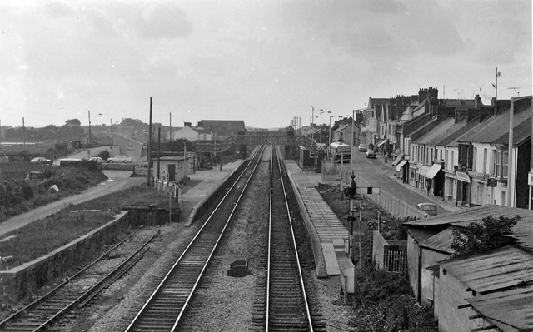

Wiki (2020)



Wiki (2020)
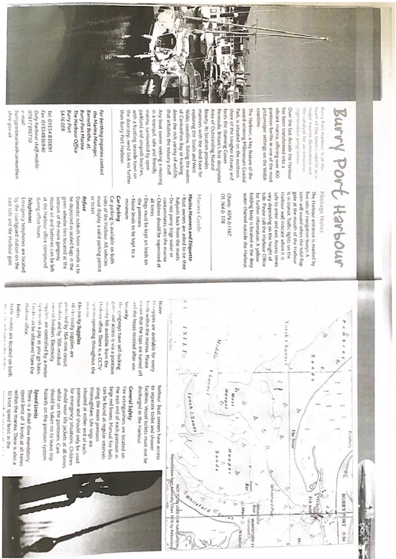
The Harbour development
.

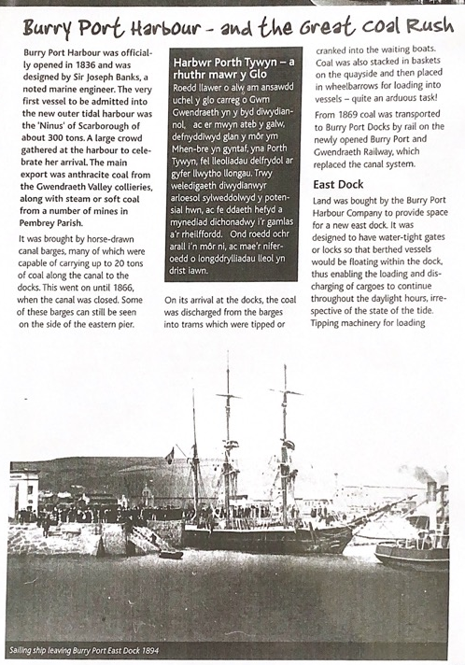
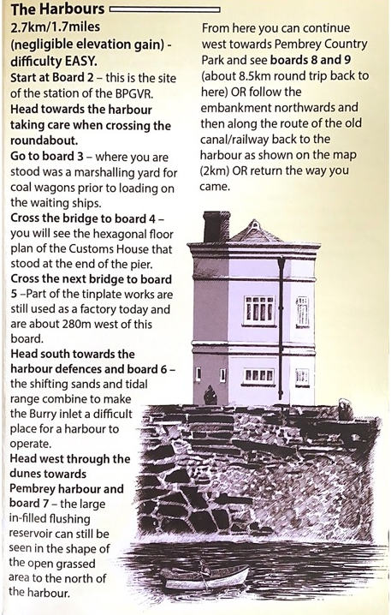

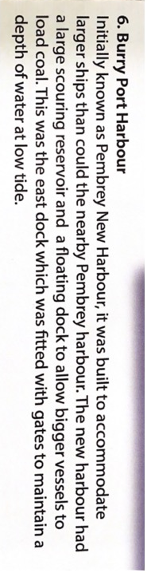
Pembrey and Burry Port town council (no date)
The deprivation table of Burry Port.

LSOA | OVERALL  INDEX |  | INCOME |  | EMPLOYMENT |  | HEALTH |  | EDUCATION |  | ACCESS TO SERVICES |  | COMMUNITY  SAFETY |  | PYHYSCAL  ENVIROMENT |  | HOUSIING
Burry Port Central | 769 | 45 | 508 | 17 | 439 | 20 | 1009 | 71 | 907 | 48 | 1771 | 110 | 1069 | 38 | 1558 | 96 | 1270 | 73
Burry Port South | 479 | 19 | 549 | 22 | 335 | 13 | 880 | 55 | 431 | 16 | 597 | 60 | 412 | 12 | 663 | 37 | 850 | 47
Burry Port Suburbs | 1379 | 99 | 1178 | 76 | 877 | 50 | 1403 | 98 | 1403 | 94 | 929 | 78 | 1641 | 85 | 1311 | 83 | 1581 | 101
LSOAs ranked 1-112 (Carmarthenshire), 1-1909 (Wale

Pembrey and Burry Port rotary club (2018)


working partnerships with CBSA – food forward and meals on wheel



Pembrey and Burry Port town council (2020)

CBSA (2021)
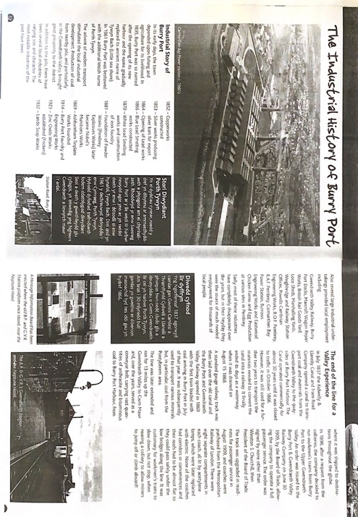
The industrial history
Pembrey and Burry Port town council (no date)

The big fire

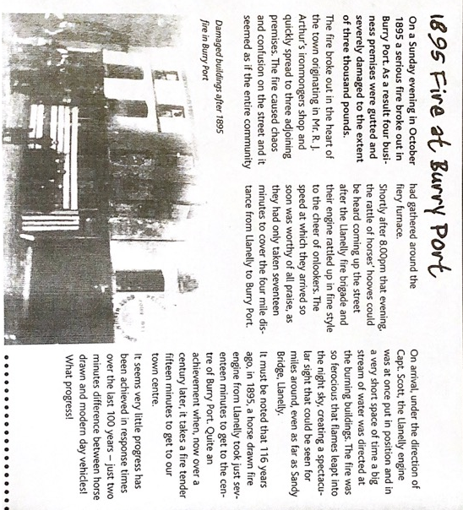

Pembrey and Burry Port town council (no date)

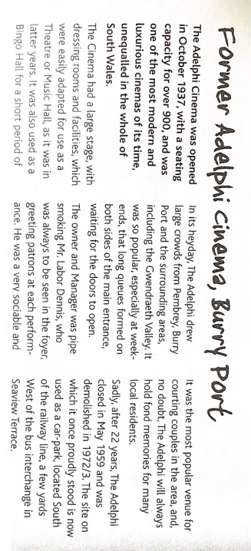
Adelphi’s Cinema

Pembrey and Burry Port town council (no date)

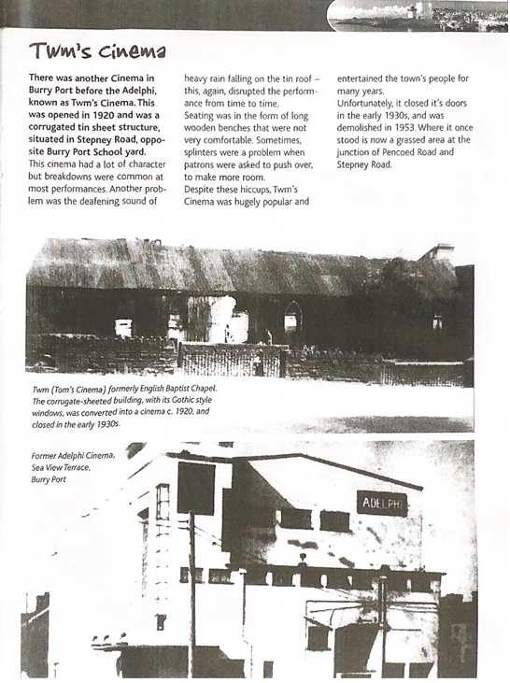
Twm’s cinema
Pembrey and Burry Port town council (no date)

Emilia Earhart
Pembrey and Burry Port town council (no date)
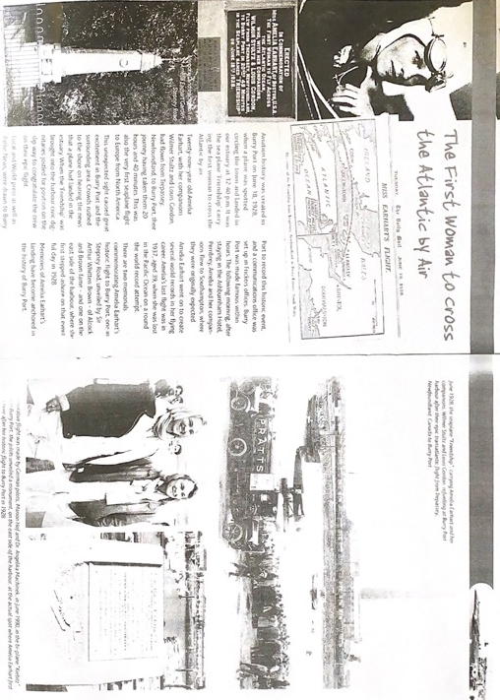

Harbour Holiday Homes


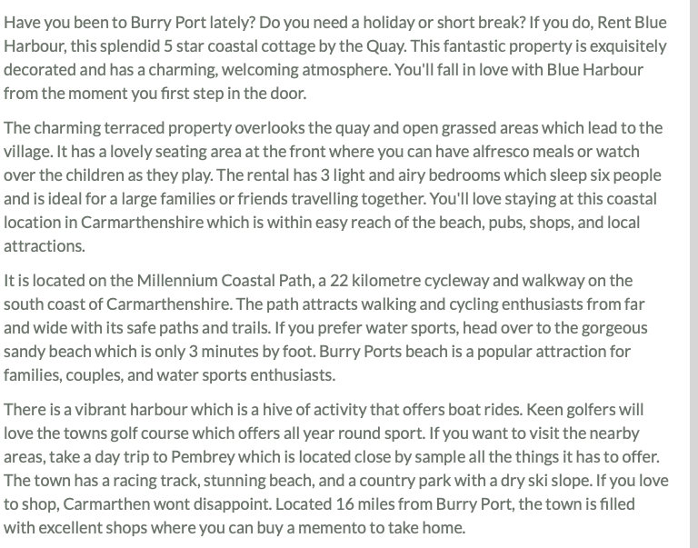

Welsh Costal Path

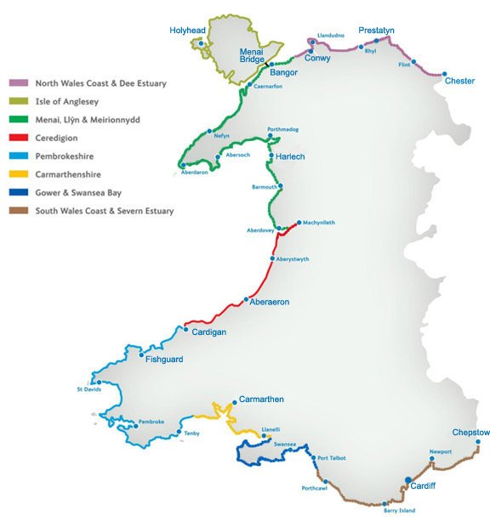
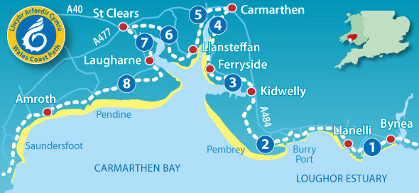

Youth theatre poster



Pembrey and Burry Port town council (no date)

APPLICATION FOR ETHICAL APPROVAL

In order for research to result in benefit and minimise risk of harm, it must be conducted ethically. A researcher may not be covered by the University’s insurance if ethical approval has not been obtained prior to commencement.

The University follows the OECD Frascati manual definition of research activity: “creative work undertaken on a systematic basis in order to increase the stock of knowledge, including knowledge of man, culture and society, and the use of this stock of knowledge to devise new applications”. As such this covers activities undertaken by members of staff, postgraduate research students, and both taught postgraduate and undergraduate students working on dissertations/projects.

The individual undertaking the research activity is known as the “principal researcher”.

Ethical approval is not required for routine audits, performance reviews, quality assurance studies, testing within normal educational requirements, and literary or artistic criticism.

Please read the notes for guidance before completing ALL sections of the form.

This form must be completed and approved prior to undertaking any research activity. Please see Checklist for details of process for different categories of application.

SECTION A: About You (Principal Researcher)

Full Name: |  |  | Eve Audrey Robinson
Tick all boxes which apply:
Member of staff: | ☐ | Student: |  | ☒ | Honorary research fellow: | ☐

Faculty/School/Centre: | MA Youth and Community Work
Campus: | Carmarthen
E-mail address: | 1601122@student.uwtsd.ac.uk
Contact Telephone Number: | 07495483383
For students:
Student Number: | 1601122 | Undergraduate | ☐
Programme of Study: | MA Youth and Community Work ETS endorsed | Taught Postgraduate | ☒
Director of Studies/Supervisor: | Darrel Williams | Research | ☐

SECTION B: Approval for Research Activity

Has the research activity received approval in principle?  (please check the Guidance Notes as to the appropriate approval process for different levels of research by different categories of individual) |  | YES | ☒ | NO | ☐
 |  |  |  | Date
If Yes, please indicate source of approval (and date where known): | Research Degrees Committee |  | ☐
 | Faculty Research Committee |  | ☐
 | Other - Part of the fieldwork Module |  | ☒ | Feb 2021
Approval in principle must be obtained from the relevant source prior to seeking ethical approval.

SECTION C: External Ethical Guidance Materials

Please list the core ethical guidance documents that have been referred to during the completion of this form (including any discipline-specific codes of research ethics, and also any specific ethical guidance relating to the proposed methodology). Please tick to confirm that your research proposal adheres to these codes and guidelines.
UWTSD Research Ethics & Integrity Code of Practice | ☒
UWTSD research Data Management Policy | ☒
Code of Occupational Ethics for Youth Service in Wales  National Occupational Standards (NOS)  British Educational Research Association | ☒

SECTION D: External Collaborative Research Activity

Does the research activity involve collaborators outside of the University? |  | YES | ☐ | NO | ☒
If Yes, please provide the name of the external organisation and name and contact details for the main contact person:
Institution
Contact person name
Contact person e-mail address

Where research activity is carried out in collaboration with an external organisation
Does this organisation have its own ethics approval system? | YES | ☐ | NO | ☐
If Yes, please attach a copy of any final approval (or interim approval) from the organisation

SECTION E: Details of Research Activity

Indicative title: | Professional Practice – Fieldwork 1 SJYW7014
Proposed start date: | October 2018 | Proposed end date: | March 2021
Purpose of research activity (including aims and objectives)
Outline the purpose, aims and objectives of the research activity, including key research questions. Show briefly how existing research has informed the proposed activity and explain what the research activity will add and how it addresses an area of importance. (Maximum 300 words)
To engage in a process of research to understand the developmental needs of young people through a community profile and a case study

(this box should expand as you type)
Proposed methods
Provide a brief summary of all the methods that may be used in the research activity, making it clear what specific techniques may be used. If methods other than those listed in this section are deemed appropriate later, additional ethical approval for those methods will be needed. (Maximum 600 words)
In order to collect data I will be using a community profile which will be desk based research, I will be researching into the area. A case study will be needed and for this I will be using a form of observation of the young people which will help me write a case study based on the young people. If needed a focus group will be set up which will help me ask the young people about the area for my community profile. An interview might be used to interview the young people and the residents of the area to be able to find out some information of the area.
(this box should expand as you type)

Location of research activity
Identify all locations where research activity will take place.
Burry Port memorial hall
Burry Port town

(this box should expand as you type)
Research activity outside of the UK
If research activity will take place overseas, you are responsible for ensuring that local ethical considerations are complied with and that the relevant permissions are sought. Specify any local guidelines (e.g. from local professional associations/learned societies/universities) that exist and whether these involve any ethical stipulations beyond those usual in the UK (provide details of any licenses or permissions required). Also specify whether there are any specific ethical issues raised by the local context in which the research activity is taking place, for example, particular cultural sensitivities or vulnerabilities of participants.
(this box should expand as you type)

SECTION F: Scope of Research Activity

Will the research activity include: | YES | NO
Use of a questionnaire or similar research instrument? | ☒ | ☐
Use of interviews? | ☒ | ☐
Use of diaries? | ☒ | ☐
Participant observation with their knowledge? | ☒ | ☐
Participant observation without their knowledge? | ☐ | ☒
Use of video or audio recording? | ☒ | ☐
Access to personal or confidential information without the participants’ specific consent? | ☐ | ☒
Administration of any questions, test stimuli, presentation that may be experienced as physically, mentally or emotionally harmful / offensive? | ☐ | ☒
Performance of any acts which may cause embarrassment or affect self-esteem? | ☐ | ☒
Investigation of participants involved in illegal activities? | ☐ | ☒
Use of procedures that involve deception? | ☐ | ☒
Administration of any substance, agent or placebo? | ☐ | ☒
Working with live vertebrate animals? | ☐ | ☒
Other primary data collection methods, please explain in this box | ☐ | ☐

If NO to every question, then the research activity is (ethically) low risk and may be exempt from some of the following sections (please refer to Guidance Notes).

If YES to any question, then no research activity should be undertaken until full ethical approval has been obtained.

SECTION G: Intended Participants

Who are the intended participants: | YES | NO
Students or staff at the University? | ☐ | ☒
Adults (over the age of 18 and competent to give consent)? | ☐ | ☒
Vulnerable adults? | ☐ | ☒
Children under 18? | ☒ | ☐
Prisoners? | ☐ | ☒
Young offenders? | ☐ | ☒
Those who could be considered to have a particularly dependent relationship with the investigator or a gatekeeper? | ☐ | ☒
People engaged in illegal activities? | ☐ | ☒
Others (please identify): | ☐ | ☐

Participant numbers and source
Provide an estimate of the expected number of participants. How will you identify participants and how will they be recruited?
There will be a maximum of 10 young people from the age of 11-16. Each young person will be identified as a letter e.g. participant a etc, Each young person will have a discussion with myself outlining what I am doing and the purpose of the research. A consent and assent form will be given to each individual for themselves and a parent/guardian giving them permission to take part in the voluntary work.

this box should expand as you type)

Information for participants: | YES | NO | N/A
Will you describe the main research procedures to participants in advance, so that they are informed about what to expect? | ☒ | ☐ | ☐
Will you tell participants that their participation is voluntary? | ☒ | ☐ | ☐
Will you obtain written consent for participation? | ☒ | ☐ | ☐
Will you explain to participants that refusal to participate in the research will not affect their treatment or education (if relevant)? | ☒ | ☐ | ☐
If the research is observational, will you ask participants for their consent to being observed? | ☒ | ☐ | ☐
Will you tell participants that they may withdraw from the research at any time and for any reason? | ☒ | ☐ | ☐
With questionnaires, will you give participants the option of omitting questions they do not want to answer? | ☒ | ☐ | ☐
Will you tell participants that their data will be treated with full confidentiality and that, if published, it will not be identifiable as theirs? | ☒ | ☐ | ☐
Will you debrief participants at the end of their participation, in a way appropriate to the type of research undertaken? | ☒ | ☐ | ☐
If NO to any of above questions, please give an explanation
(this box should expand as you type)

Information for participants: | YES | NO | N/A
Will participants be paid? | ☐ | ☒ | ☐
Is specialist electrical or other equipment to be used with participants? | ☐ | ☒ | ☐
Are there any financial or other interests to the investigator or University arising from this study? | ☐ | ☒ | ☐
Will the research activity involve deliberately misleading participants in any way, or the partial or full concealment of the specific study aims? | ☐ | ☒ | ☐
If YES to any question, please provide full details
(this box should expand as you type)

SECTION H: Anticipated Risks

Outline any anticipated risks that may adversely affect any of the participants, the researchers and/or the University, and the steps that will be taken to address them.

If you have completed a full risk assessment (for example as required by a laboratory, or external research collaborator) you may append that to this form.

Full risk assessment completed and appended?

Yes ☒
No ☐

Risks to participants
For example: emotional distress, financial disclosure, physical harm, transfer of personal data, sensitive organisational information
Emotional distress could be a risk to participants as I will be observing the young people and creating a focus group that could upset the young people.

(this box should expand as you type)
If research activity may include sensitive, embarrassing or upsetting topics (e.g. sexual activity, drug use) or issues likely to disclose information requiring further action (e.g. criminal activity), give details of the procedures to deal with these issues, including any support/advice (e.g. helpline numbers) to be offered to participants. Note that where applicable, consent procedures should make it clear that if something potentially or actually illegal is discovered in the course of a project, it may need to be disclosed to the proper authorities
Helplines will be available for NSPCC, Samaritans, Mind
a councillor’s details will be available if a young person would like any information, and for the safety of my self and others a first aider will be available.

(this box should expand as you type)
Risks to investigator
For example: personal safety, physical harm, emotional distress, risk of accusation of harm/impropriety, conflict of interest
Personal safety as I will be in a room on my own with the young people.

(this box should expand as you type)
University/institutional risks
For example: adverse publicity, financial loss, data protection
If a young person doesn’t like or agree with the research they could sew the university.

(this box should expand as you type)
Adverse outcomes
List measures put in place to limit any adverse effects or outcomes of research activity where appropriate. Include any emergency protocols.
Helplines will be available for NSPCC, Samaritans, Mind
a councillor’s details will be available if a young person would like any information, and for the safety of my self and others a first aider will be available.
A mobile phone will be available in case of an emergency and a glass window will ensure if a problem occurs the outside can see in.

(this box should expand as you type)

Disclosure and Barring Service
If the research activity involves children or vulnerable adults, a Disclosure and Barring Service (DBS) certificate must be obtained before any contact with such participants. | YES | NO | N/A
Has a DBS certificate been obtained? | ☒ | ☐ | ☐

SECTION I: Feedback, Consent and Confidentiality

Feedback
What feedback will be provided to participants, how will this be done and when?
When I finish my findings I will share my results with you and you have the option to change or opt out before I publish.

(this box should expand as you type)
Informed consent
Describe the arrangements to inform potential participants, before providing consent, of what is involved in participating. Describe the arrangements for participants to provide full consent before data collection begins. If gaining consent in this way is inappropriate, explain how consent will be obtained and recorded.
I will be gaining consent for everything. There will be an information sheet at the beginning of the questionnaire explain in detail everything.

(this box should expand as you type)
Confidentiality / Anonymity
Set out how anonymity of participants and confidentiality will be ensured in any outputs. If anonymity is not being offered, explain why this is the case.
Confidentiality is going to be taken into consideration, for this all names will be changed and all area locations will be changed.

(this box should expand as you type)

SECTION J: Data Protection and Storage

In completing this section refer to the University’s Research Data Management Policy and the extensive resources on the University’s Research Data Management web pages (http://uwtsd.ac.uk/library/research-data-management/).
 | YES | NO
Does the research activity involve personal data (as defined by the Data Protection Act)?  “personal data” means data which relate to a living individual who can be identified—  (a) from those data, or  (b) from those data and other information which is in the possession of, or is likely to come into the possession of, the data controller, and includes any expression of opinion about the individual and any indication of the intentions of the data controller or any other person in respect of the individual. | ☒ | ☐
If YES, provide a description of the data and explain why this data needs to be collected:
(this box should expand as you type)
Does it involve sensitive personal data (as defined by the Data Protection Act)?  “Sensitive personal data” means personal data consisting of information as to –  (a) the racial or ethnic origin of the data subject,  (b) his political opinions,  (c ) his religious beliefs or other beliefs of a similar nature,  (d) whether he is a member of a trade union (within the meaning of the Trade Union and Labour Relations (Consolidation) Act 1992),  (e) his physical or mental health or condition,  (f) his sexual life,  (g) the commission or alleged commission by him of any offence, or  (h) any proceedings for any offence committed or alleged to have been committed by him, the disposal of such proceedings or the sentence of any court in such proceedings. | ☐ | ☒
If YES, provide a description of the data and explain why this data needs to be collected:
(this box should expand as you type)

Will the research activity involve storing personal data on one of the following: | YES | NO
Manual files (i.e. in paper form)? | ☒ | ☐
University computers? | ☐ | ☒
Private company computers? | ☐ | ☒
Home or other personal computers? | ☒ | ☐
Laptop computers/ CDs/ Portable disk-drives/ memory sticks? | ☐ | ☒
“Cloud” storage or websites? | ☐ | ☒
Other – specify: | ☐ | ☒
For all stored data, explain the measures in place to ensure data confidentiality, including details of password protection, encryption and anonymisation:
All data that will be kept will be on a locked computer with only access to myself, after all data has been used and published everything will be destroyed for confidentiality purposes.

(this box should expand as you type)

Will the research activity involve any of the following activities: | YES | NO
Electronic transfer of data in any form? | ☐ | ☒
Sharing of data with others at the University? | ☐ | ☒
Sharing of data with other organisations? | ☐ | ☒
Export of data outside the European Union or importing of data from outside the UK? | ☐ | ☒
Use of personal addresses, postcodes, faxes, emails or telephone numbers? | ☐ | ☒
Publication of data that might allow identification of individuals? | ☐ | ☒
Use of data management system? | ☐ | ☒
Data archiving? | ☐ | ☒
If YES to any question, please provide full details, explaining how this will be conducted in accordance with the Data Protection Act (and/or any international equivalent):
(this box should expand as you type)

List all who will have access to the data generated by the research activity:
Myself being the principle of research
Examiners on request

(this box should expand as you type)
List who will have control of, and act as custodian(s) for, data generated by the research activity:
Myself being the principle of research

(this box should expand as you type)
Give details of data storage arrangements, including where data will be stored, how long for, and in what form. Will data be archived – if so how and if not why not.
You'll want to secure your documents from wear and tear, sunshine, and spills while storing them in a safe. Plastic page slips are one way to do this. File papers in a binder or box after placing them in a plastic sleeve. After that, you can put the binder inside your safe. Each piece of paper should be contained inside its own plastic page. No data will be achieved as once it has been used there will be no need to keep. Once the document has been published all data will be kept for a month and then shredded and burnt to reduce anyone being able to locate anything.

(this box should expand as you type)

SECTION K: Declaration

The information which I have provided is correct and complete to the best of my knowledge. I have attempted to identify any risks and issues related to the research activity and acknowledge my obligations and the rights of the participants.

In submitting this application I hereby confirm that I undertake to ensure that the above named research activity will meet the University’s Research Ethics and Integrity Code of Practice
Signature of applicant: EARobinson |  | Date: | 19/3/2021

For students:
Director of Studies/Supervisor: | Darrel Williams
Signature:
Date:

For staff:
Head of School/Assistant Dean:
Signature:
Date:

Checklist: Please complete the checklist below to ensure that you have completed the form according to the guidelines and attached any required documentation:
☒ | I have read the guidance notes supplied before completing the form.
☒ | I have completed ALL RELEVANT sections of the form in full.
☒ | I confirm that the research activity has received approval in principle
☒ | I have attached a copy of final/interim approval from external organisation (where appropriate)
☒ | I have attached a full risk assessment (and have NOT completed Section H of this form) (where appropriate)
☒ | I understand that it is my responsibility to ensure that the above named research activity will meet the University’s Research Ethics and Integrity Code of Practice.
☒ | I understand that before commencing data collection all documents aimed at respondents (including information sheets, consent forms, questionnaires, interview schedules etc.) must be confirmed by the DoS/Supervisor, module tutor or Head of School.

RESEARCH STUDENTS AND STAFF ONLY
All communications relating to this application during its processing must be in writing and emailed to pgresearch@uwtsd.ac.uk , with the title ‘Ethical Approval’ followed by your name.
You will be informed of the outcome of your claim by email; therefore it is important that you check your University and personal email accounts regularly.

STUDENTS ON UNDERGRADUATE OR TAUGHT MASTERS PROGRAMMES should submit this form (and receive the outcome) via systems explained to you by the supervisor/module leader.

This form is available electronically from the Academic Office web pages: http://www.uwtsd.ac.uk/academic-office/

