LCBB4004 Marketing Fundamentals

Assessment 2

Student name: GINA VELICU
Student ID:2028707

Table of Contents
Introduction 3
Body parts 4
Definition of Marketing 4
Main stages in the Marketing Process 5
Macro and Micro Environment of Business 7
Segmentation, Targeting and Positioning of Sports Direct 12
Marketing Mix of Sports Direct 14
Conclusion and recommendation 17
References 18

List of Figures
Figure 1: Definition of Marketing. 2
Figure 2: SMART Objectives. 4
Figure 3: Corruption perception index of the UK 6
Figure 4: Demo of Segmentation 9
Figure 5: Different prices at Sports Direct 11
Figure 6: Sports Direct campaign 12
Figure 7: Store of Sports Direct 13

Introduction
This report is written on the marketing fundamentals where several strategies and tools are explained. There are three parts to this report- the introductory part, the main body of the report and the conclusion and some recommendations at the last. In the body part marketing is defined elaborately, the stages of the marketing process are shown. The two business environments are explained with PESTEL and SWOT analysis for the selected company- Sports Direct. In the later part STP analysis and marketing mix is explained with 7Ps analysis.
Sports Direct Company is a British retail company in the UK that places the biggest retailer in the country. They have numerous brands under them and merge with so many brands also. So, their products are all over the market and this forms a strong loyal customer base.

Body parts

Definition of Marketing
One of the main purposes of businesses is to reach out to the maximum possible customers with the company products. For business conduct and transaction between the customers are the brand needs communication and convincing them in buying the products. Those are done by marketing. According to Malhotra (2017), marketing starts with the customer’s needs. In a marketing process, the company do market research to deliver the products. So, undertaking the activities of promoting and selling are considered as marketing.
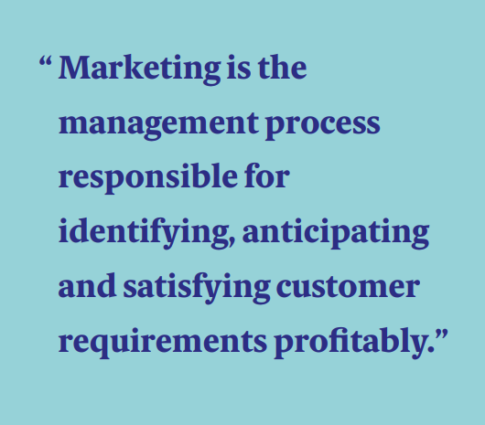
Figure 1: Definition of Marketing.
Source: (Cim.co.uk, 2021).
Many companies produce and then sell products but not all of them are called businesses. A business must have a profitability goal. What they do and treat the customers, the main focus is on gaining profit and making a strong position in the market. The basic conducts of marketing are; market research, setting objectives, carrying out the strategies, producing products and reaching them to the customers through promoting activities and distribution channels.

Main stages in the Marketing Process
To fulfil the marketing strategies and goals, the company needs to go for the marketing conducts and for that a suitable process is followed. There are some stages in a process and it may vary for various companies. Kotler and Keller (2016) mentioned marketing stages to follow including situational analysis, setting objectives, strategies (STP), implementation and control etc. Here these stages are explained broadly.
- Situational Analysis
Observing the whole company and the related parties are considered as situational analysis at a significant time. To examine the company and the competitors, the basis is;
- Nature of business
- Industry
- Cost and Profit margin.
- Market share
- Type of customers etc.
The environments of the company are analysed by;
- Law and regulation of the industry
- Economic stability
- Buying behaviour and frequency of the customers
- Atmosphere
- Threats and opportunities etc.
Before formulating the marketing strategy, these are taken into consideration and examined to get an accurate result based on that the strategies and forecasts are done.

- Setting Objectives
To attain goals companies, formulate several objectives and the growth happens with it. The business objectives have to be specific to attain. There is a helping tool to formulate efficient objectives named- SMART objectives.
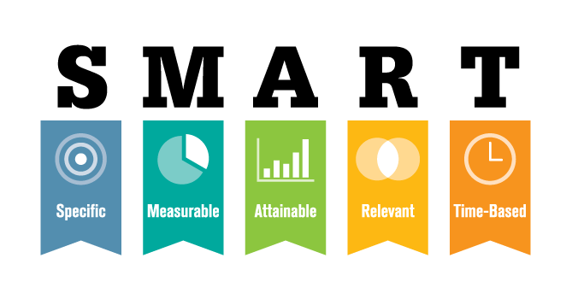
Figure 2: SMART Objectives.
Source: (Bjerke and Renger, 2017).
Specificity excludes the vagueness of the objectives and measurable indicates the quantitative criteria of the objectives. It must be attainable, unrealistic demands and ideas have to be removed. Relevancy is a must with attainable goals. Lastly, the objectives have to have a time limit. Such as 6 months, 1 year or 5 years.
- Formulating Strategies on customers
As the industries vary, products also differ for companies, so as their customers. The STP analysis finds the core customers and positions the brands in the market.
Segmentation- The customer market is segmented into different classes based on four criteria- geographic, demographic, psychographic and behavioural. (Dolnicar et al, 2018). How many customers are there in different areas, what their age, salaries, buying behaviour, lifestyles etc. are determined.
Targeting- After segmenting, a few types are selected for the final target of the customers. The types are then blended and a customer profile is made to aim for them.
Positioning- According to Saqib (2020), wrong positioning strategies may lead the whole marketing mix to fail. Identifying the company’s place in the market and then creating a distinct image on the customer's minds are explained as positioning.
- Implementation and Control
In this process, business conduct happens and strategies are implemented. Team management, communication, record-keeping etc. are included in the implementation. On the other hand, controlling are the process of auditing and working on the feedback. Flow charts, check sheets, control charts, KPI etc. tools are used to control the results.

Macro and Micro Environment of Business
There are mainly two types of business environments- a general one that affects the business operations and a close one where a business operates. Cepel (2019) mentioned that the environments have the highest impact on business conduct. The macro-environment is uncontrollable and uncertain and it can be explained with PESTEL analysis and microenvironment is the direct environment that a business operates, SWOT analysis is used to explain it.
Some advantages of these two tools are;
- These tools can give a broad idea about the company itself
- Helps to identify the broader market and competitors.
- Knowing about the political, technological and social opportunities and threats.
- Economic crisis and forecaster situations can be identified.
- By managing opportunities to minimise the threats in the environment.
- Identifying the core values and competitive advantages of the company.
- All the information helps to formulate feasible strategies
Disadvantages;
- A lengthy process
- Costly
- Things may go wrong if the collected data are not correct etc.

PESTEL Analysis of Sports Direct
In the UK the multinational company Sports Direct is affected by its political, economic, societal, technological, environmental, legal environments. Here a PESTEL analysis is explained for the company.
- Political
The tax policy in the UK has a great impact on companies like Sports Direct. The corporation tax rate is 19%. The political state is stable and there has a parliamentary democratic system. Sports Direct may not face any trade barrier as the UK has none other than after Brexit issues. There are some trading barriers in the UK with some EU countries. The corrupt state in a country indicates a lot about politics. Corruption exists in bribery, kickbacks in public procurement, embezzlement of funds etc. In 2020 the corruption index score was 77 in the UK. (Statista, 2021).

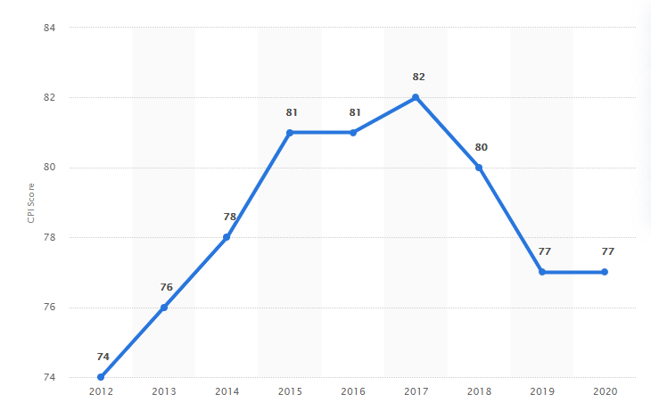
Figure 3: Corruption perception index of the UK
Source: (Statista, 2021).
In the COVID-19 situation, many people suffered and died. Political parties and the government struggled to earn common people’s trust over management and safety issues.

- Economic
Some economic factors affect the company in the UK. The inflation rate, economic growth, exchange rate, interest rate, unemployment rate etc. Inflation causes the reduction of purchasing power of the customers. In the UK the inflation rate was lower in 2020 than in 2021. It is 3.1%. This high rate may decrease the demand for Sports Direct. On the other hand, the economic growth of the UK is increasing. Forecasts say it will be 6.5% assumed. This indicates a positive sign for the economic growth of Sports Direct. The worldwide economic fall in 2020 was a disaster for all because of COVID-19. GDP was the lowest in the UK in a record time.
- Societal
Social factors help Sports direct to understand the cultures, values, preferences of the targeted customers. Demographics, gender norms, health and safety facilities, education, income level, social class tradition etc. are some factors of this element. There are people of all ages in the UK, diversity of different races and cultures blends so well here. People are mostly educated and established here. The gender norms define equality here and the adults are the money makers in the society. The pandemic has a big influence on society as well as Sports Direct. People became more conscious of their health and safety. They prefer indoor or outdoor exercise more than before. So, there is an increasing demand for sportswear and equipment among them.
- Technological
The UK is one of the most techn0logically advanced countries in the world. They are among the top5 countries that are enriched in the R&D sectors of the tech industry. Patel et al (2021) mentioned AI, machine learning is emerging rapidly in the UK. Using robots in production, cloud computing is highly used in companies like Sports Direct. In this modern era, people are so involved in the internet and social media. They prefer online shopping as the most effective way to reach them.
- Environmental
Environmental policies, activities of NGO’s, environmental laws, climate change etc. are the elements of this factor. There is a favourable environment in the UK. The government and the people are aware of their atmosphere, so environmental pollutions are prohibited. This affects sports direct as they need to consider the laws and their priorities change on product innovation as it must be aligned with the laws and regulations. The company has to keep up with the recycling process as it encourages the environmental saving process. The pandemic has had a great impact on the environment as it became greener. Because of less CO2 emission, less pollution, the ecological system has more balance than before.
- Legal
Employment law, consumer rights, patent rights law etc. legal aspects of the UK are strong and reliable. The local government is helpful to the businesses. Law enforcement is ensured here. The cases regarding companies and industries are resolved fast in the UK.

SWOT Analysis of Sports Direct
Puyt et al (2020) stated SWOT analysis as a theoretical framework and a part of designing strategical theories. As a giant company, Sport direct has so many strengths and opportunities, the number of weaknesses and threats are also there. Here all of them are shown below:
Strengths – Sports Direct is considered the largest retailer in the UK. They have around 470 stores in the UK. Their strengths are;
- The renowned brand for decades.
- Loyal customer base
- Associated with so many famous brands like Nike, Adidas, and Reebok etc.
- The subsidiaries are also renowned; Slazenger, Lilywhites, USC etc.
- Products with affordable prices
- Skilled workforce who are loyal and highly paid, so the turnover rate is low.
- Easily available to the customers
- Famous for their 24/7 availability and one-day delivery system.
- A market leader and has a huge market share.
Weaknesses- With so many strengths, the company has drawbacks in business too;
- Their low margin strategy may create danger for future profitability.
- Poor customer service has created a stir among the customers and there are lots of negative reviews on the internet.
- Mismanagements are hampering goodwill in the market.

Opportunities- In the UK the company has many opportunities to grab;
- Their merging and acquiring strategies create a large and newer customer every time with different brands.
- As the economic growth is happening in the UK, the company is getting more options to grow
- Their low-cost strategy is captivating other competitors’ customers in the market.
Threats- Threats are the external forces in the company that directly affect the state. In the UK, Sports Direct may face the following threats;
- Increasing the inflation rate may cause increased production and overall cost. It may decrease the buying ability of the customers too.
- The increased rate of raw materials is a big threat to the company’s profit and because of the low-profit margin, it may suffer more than the competitors.
- After Brexit, the smooth trading system is hampered by the company.

The mentioned strengths, weaknesses, opportunities and threats are faced by the company. They are continuously revising and formulating their strategies to defend these shortcomings with those advantages. They are making their strengths as core advantages to tackle the threats in the market.

Segmentation, Targeting and Positioning of Sports Direct
To develop an effective marketing strategy, STP analysis is a three-step process to examine the products to launch, divide and select the customers to aim for and communicate with them. (Burns et al, 2017). The process has three steps- segmenting, targeting and positioning. Here STP analysis for Sports Direct is shown.
Segmentation
Segmentation is referred to as splitting up the customers into several groups that have similar characteristics.

Figure 4: Demo of Segmentation
Source: (Müller et al, 2018).
Segmenting is done on four categories- geographically, demographically, behaviourally and psychographic. Sports Direct select cities full of business, small towns and rural areas. The UK is segmented into these categories. For Demography; young people, middle-aged and old people are divided. The sportswear is available for all genders and all sizes and colours. The equipment is gender-neutral. People who like to exercise, keep a fit body, gym-goers, trainers are segmented into a behavioural category. Many customers are fashionable and like to be fashion updated. Sports Direct segments them psychographic category.

Targeting
From the different segments, a group of people are selected from them. As the company launches products for their customers and operate in a specific industry, they have selective customers in the market. As for Sports Direct. They target the people with lower medium to high-income levels, of all social classes and who are interested in exercise. Young people are their main target as they are more eager to be fit than the elders. Sports personnel, fitness fanatics, fashion-conscious people are also targeted.
Positioning
There are numerous similar products in the market as Sports Direct. But the company has to stand out more than its competitors to attract more customers. Presenting the products and the brands genuinely is the core of positioning. It also means where the brand or product stands in the market among several competitors. As a market leader, Sports Direct offers quality products at a cheaper and affordable rate. So, they stand at the top level in the UK industry. As for the customer’s mind, the brand has a huge reputation but their occasional poor customer service incidents occur many distrusts among the customers.

Marketing Mix of Sports Direct
There are multiple areas a business needs to cover when doing business. A marketing mix is a combination of many businesses conducts such as product strategies, pricing models, distribution channels, advertisements etc. Kotler and Armstrong (2018) stated marketing mix as a set of activities to peruse the formulated objectives in a business. 7Ps analysis is a tool to carry out marketing mix and here it is explained for Sports Direct.
Products
The company has several products lines. They have their brands and also sells products of other famous brands too. Their products are; trainers, tracksuits, footwear, flip-flops, boots and shoes, jumpers, accessories, exercising equipment etc. The products with so many varieties and colours. Every year they launch batches of products of new collections. These vary in different seasons too. The products are for all genders.
Price
Prices are called the value a customer pay to the seller in return for the products. For any company, they follow different pricing strategies including premium prices, low margin price, competitor’s price, etc. Sports Direct use low margin pricing strategy for their products. This means having a cheaper price for the launched products. This helps customers to gain more value. The prices of products of the company have the same range as in the websites. The following is a part of their products and indicates a various range for different products.

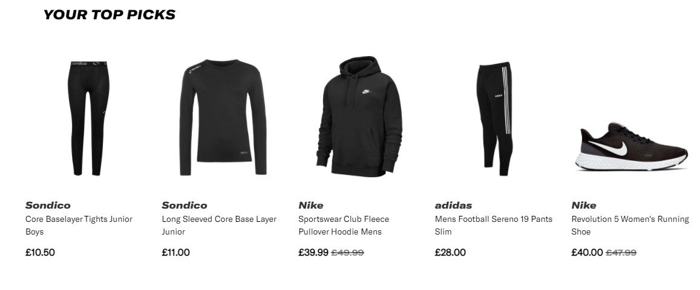
Figure 5: Different prices at Sports Direct
Source: (Sportsdirect.com. 2021).
There are several discounts and offers given to the customers occasionally. COVID-19 had an impact on pricing strategy and the prices of the products. The company had to give more offers and discounts off the prices.
Place
There are 470 shops in the UK and more around the world. All products are available on both physical shops as well as online shops. The distribution channel became easier to reach the customers because of the efficient delivery service of the company. Nowadays customers are comfortable with online shopping and having products delivered to their doorsteps. Sports Direct delivers their products within a day, from 3 to 7. There are many criteria in the delivery service that customers can choose and pay for the service they get. So, this biggest retailer is working and serving directly to their customers in the UK. The pandemic affected the delivery process a lot as there were several lockdowns in the UK, products could not be reached in the meantime.
Promotion
As a big company, their promotional activities are huge. They launch new advertisements for their new campaigns. Recently they have launched a campaign for this winter named ‘Go all out. The casted celebrities promote the brand more with this.
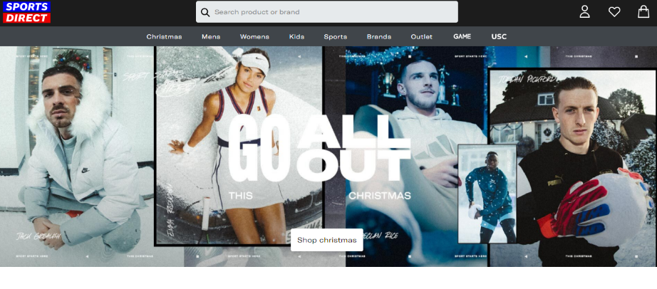
Figure 6: Sports Direct campaign
Source: (Sportsdirect.com. 2021).
The company also becomes a sponsor for many sports events and do CSR activities all over the UK. They emphasise the social network sites for massive advertisement. As young people are always on the internet, they are easy to connect there. So mass media promotion on Facebook, Twitter, and Instagram are taking place for the company.

People
The connected people with the company are all the shareholders, executives, employees, suppliers, and most importantly the customers. In a business, the workers are treated as assets and the customers are the main focus to innovate and launch products. The company has around thirty thousand employees approximately. As a retail company, the direct staffs who communicate directly with the customers in the shops are important to manage. They are trained after recruitment. In 2020, many employees lost their job because of the pandemic and it was hard for the company to bear all the employees.

Process
The company follows processes in every stage of business. Managerial process, marketing processes, work designing, authority etc. are maintained by Sports Direct. The delivery process is one of the most important ones in the company and they are trying to improve it day by day.
Physical evidence
The company has undoubtedly an outstanding physical presence in the industry. Among their stores, all of them have highly attractive interiors and decorations. The products are categorised into different segments and criteria. The below picture revealed a Sports Direct shop.
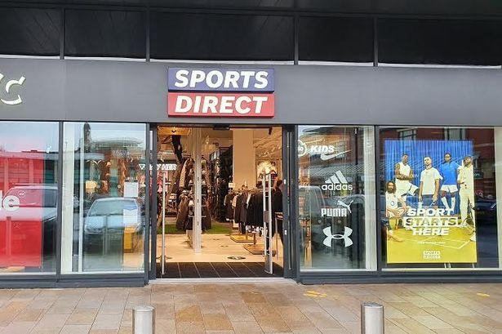
Figure 7: Store of Sports Direct
Source: (Sparks and Letham, 2018)

Conclusion and recommendation
Marketing is a process that starts from analysing the industry to reaching the products to the customers. the UK has stable politics and democratic parliament, the regulations and laws are must be obeyed by the company. Economic growth has increased and the increased 3.1% inflation is limiting the buying ability of the customers. the company targets young people who are health conscious. There are 470 stores in the UK and they operate online on a large scale too.
Recommendations: It is hard to recommend a big company like Sports Direct, but from a customer’s viewpoint the following points are recommended to them.
- The company needs to improve the customer service and deliver the products in time. Their employees need to act kindlier towards the customers.
- They need to do more CSR programs to recover their public image. Charity events are suggested.
- There should be some products that they should make luxury products to appeal to another criterion of customers.

References

Bjerke, M.B. and Renger, R., 2017. Being smart about writing SMART objectives. Evaluation and program planning, 61, pp.125-127.
Burns, A.C., Veeck, A. and Bush, R.F., 2017. Marketing research (p. 496). Harlow, Essex: Pearson.
Cepel, M., Belas, J., Rozsa, Z. and Strnad, Z., 2019. Selected economic factors of the quality of business environment. Journal of International Studies.
Cim.co.uk. 2021. A brief summary of marketing and how it works. [online] Available at: <https://www.cim.co.uk/media/4772/7ps.pdf> [Accessed 15 November 2021].
Dolnicar, S., Grün, B. and Leisch, F., 2018. Market Segmentation. In Market Segmentation Analysis (pp. 3-9). Springer, Singapore.
Kotler, P. and Keller, K.L., 2016. A framework for marketing management (p. 352). Boston, MA: Pearson.
Kotler, P. and Armstrong, G.M., 2018. Marketing Mix: Selected Chapters From: Principles of Marketing, Philip Kotler and Gary Armstrong. Pearson.
Malhotra, N., Nunan, D. and Birks, D., 2017. Marketing research: An applied approach. Pearson.
Müller, J.M., Pommeranz, B., Weisser, J. and Voigt, K.I., 2018. Digital, social media, and Mobile Marketing in industrial buying: Still in need of customer segmentation? Empirical evidence from Poland and Germany. Industrial Marketing Management, 73, pp.70-83.
Patel, U.K., Anwar, A., Saleem, S., Malik, P., Rasul, B., Patel, K., Yao, R., Seshadri, A., Yousufuddin, M. and Arumaithurai, K., 2021. Artificial intelligence as an emerging technology in the current care of neurological disorders. Journal of neurology, 268(5), pp.1623-1642.
Puyt, R., Lie, F.B., De Graaf, F.J. and Wilderom, C.P., 2020. Origins of SWOT Analysis. In Academy of Management Proceedings (Vol. 2020, No. 1, p. 17416). Briarcliff Manor, NY 10510: Academy of Management.
Saqib, N., 2020. Positioning–a literature review. PSU Research Review.
Sparks, L. and Letham, S., 2018. Sport and retailing. In Managing Sport Business (pp. 346-363). Routledge.
Sportsdirect.com. 2021. SportsDirect.com – The UK’s No 1 Sports Retailer. [online] Available at: <https://www.sportsdirect.com/> [Accessed 16 November 2021].
Statista. 2021. Corruption in the UK 2020 | Statista. [online] Available at: <https://www.statista.com/statistics/868971/corruption-perception-index-in-the-uk/> [Accessed 16 November 2021].

