

Student Name : Anjaliben Harishbhai chavda

Student ID: 2532966

Module Name: Marketing Management

Module Code: LCMB7024

Lecturer’s Name: Laila maazouz

Work Count: 2500

Term 1

Table Of Contents
1. Introduction 3
2. Task 1: Critical Analysis of the Macro Marketing Environment 6
2.1 Macro Marketing Environment 6
2.2 Analysis of Macro Factor 1: Technological Environment 11
2.2.1 Impact on Netflix (Pioneer) 11
2.2.2 Impact on Disney+ 13
2.3 Analysis of Macro Factor 2: Legal and Regulatory Environment 14
2.3.1 Impact on Netflix 15
2.3.2 Impact on Disney+ 15
3. Task 2: Strategic Responses of Pioneering and Follower Organisations 15
3.1 Netflix Strategic Responses 15
3.2 Disney+ Strategic Responses 17
4. Conclusion 20
5. Reference 21

List Of Tables

Table 1: Netflix Strategy Using Ansoff Matrix 16
Table 2: Disney+ Strategy Using Porter’s Generic Strategy 18
Table 3: Disney+ Differentiation Strategy within Porter’s Generic Framework 19

List Of Figures
Figure 1: Video Streaming Market 5
Figure 2: Netflix subscribers crossed 300 million 6
Figure 3: Netflix Revenue Growth 8
Figure 4: Netflix Subscribers 9
Figure 5: Disney+ Subscribers 10
Figure 6: Video Streaming Market Prediction 11
Figure 7: Netflix Operating Margin 12
Figure 8: Netflix Revenue 12
Figure 9: Global Disney+ subscribers forecast 13
Figure 10: Disney+ subscribers forecast till 2025 14
Figure 11: OTT gains 17

Introduction

1.1 Purpose and focus of the report
To manage marketing strategically, the external environment has to be analysed continuously to help to identify emerging opportunities and threats. The macro environment of marketing is of special relevance as changes in technology, regulation and consumer behaviour may transform complete industries and may have a significant impact on the competitive positioning.

1.2 Overview of the selected industry
The streaming industry has been on a significant, extended expansion that has been triggered by the increase in the internet penetration rate, growth in the number of smart devices in the market, paired with the rising consumer need to access on-demand entertainment services. The PwC Global Entertainment and Media Outlook indicates that the streaming and digital media industry is growing at an accelerated rate since customers are increasingly abandoning their traditional television and adopting online digital media that require subscription fees (PwC, 2025).

1.3 Importance of analysing the macro marketing environment
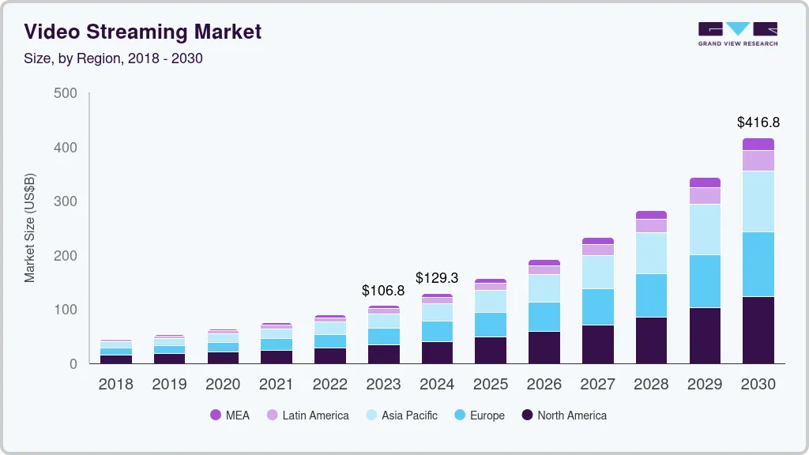
Figure 1: Video Streaming Market
(Source: GVR, 2023)
The number of subscribers that Netflix has around the world is huge, which emphasises the dominance of this company in the market. By early 2026, the corporation had more than 325 million users globally, confirming its position in the streaming industry as a dominant player (Spangler, 2026). This expansion is supported by strong investments in unique content as well as its advanced recommendation engines, which personalise viewing experiences. In comparison, Disney+ started as a streaming service and entered the industry as a follower, taking advantage of the large internet of The Walt Disney Company's intellectual property holdings.

1.4 Structure and scope of the report
This analysis applies strategic models to the analysis of how the streaming industry is affected by the macro marketing environment. It examines the prominent external aspects, which affect the competitiveness of Netflix, identifies opportunities and threats, and evaluates a strategic solution.

2. Task 1: Critical Analysis of the Macro Marketing Environment

2.1 Macro Marketing Environment
The PESTLE framework is used regularly as an attempt to cut these forces by examining the political, economic, social, technological, legal and environmental factors and how these influence the organisational performance.
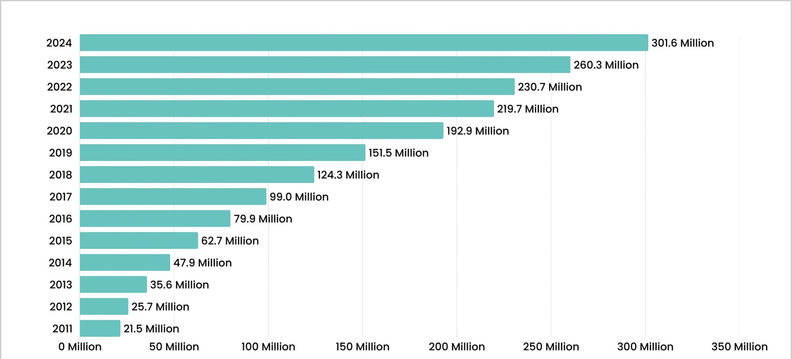
Figure 2: Netflix subscribers crossed 300 million
(Source: Singh, 2025)
One of the greatest sources of streaming industry development lies in technological innovation. Research claims that with the assistance of artificial intelligence and big-data analytics, streaming services are able to analyse user viewing trends and provide a person with a tailored content recommendation (Arshad et al., 2025). The technologies are used to enable the delivery of customised viewing experiences, which strengthen client retention and increase user engagement. Consumer behaviour has also had sharp changes with the introduction of digital media channels. Data shows that Netflix subscribers crossed 300 million in 2024 itself (Singh, 2025). Empirical data suggest that live streaming and digital entertainment services increase prompt attention and interest in digital media, thus due to the effect on the decision-making of consumers (Wang et al., 2025). Moreover, experiments on media use over the internet show that psychological aspects and involvement of emotions heavily influence the way consumers interact with the internet (Li et al., 2024).
Another relevant macro factor is the regulatory environment of a digital platform. According to the European Commission, the Digital Services Act provides new regulations that are aimed to provide the transparency and accountability of online platforms in the sphere of operation in the EU (Europa, 2025). These regulatory trends have been supported by scholarly research, which has shown how the digital media regulation is continuing to grow in the major economies worldwide (Senftleben and Izyumenko, 2025). Therefore, technological progress and legislation have significant effects on strategy decisions in the streaming sector.
PESTEL Analysis
- Political factor: The digital platforms are highly regulated by the government. Netflix has to meet the international broadcasting laws. Disney+ content strategies should lend themselves to particular market situations.
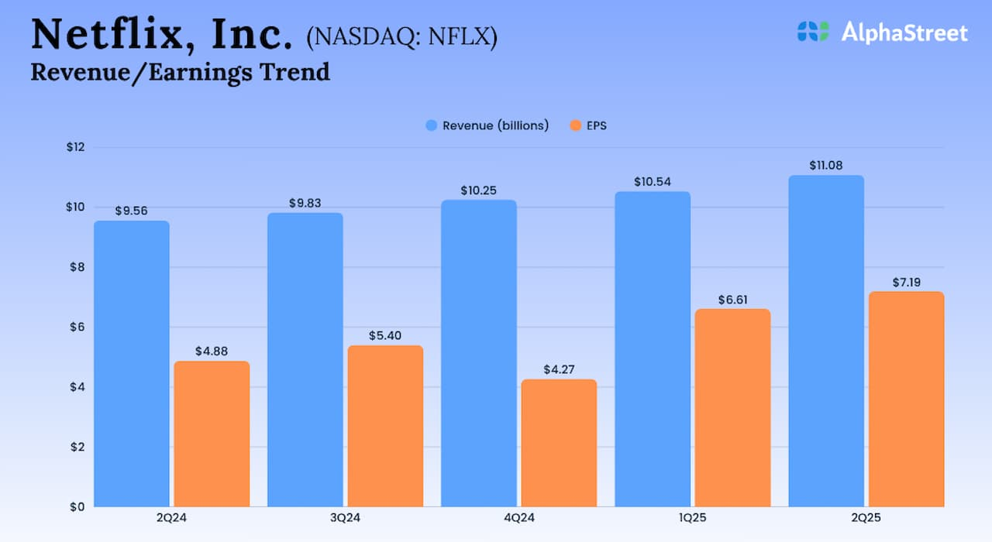
Figure 3: Netflix Revenue Growth
(Source: Alphastreet, 2025)
- Economic factor: For the second quarter of fiscal 2025, Netflix, Inc. (NASDAQ: NFLX) announced a significant growth in both revenue and profit (Alphastreet, 2025). In 2027, the video streaming market across the globe will already be larger than 184 billion dollars and grow with a compound annual growth rate of over 7 percent (PwC, 2025). Netflix uses substantial subscription revenues as the basis of investment in content. Disney+ has resources provided by its parent company, which helps in its growth.

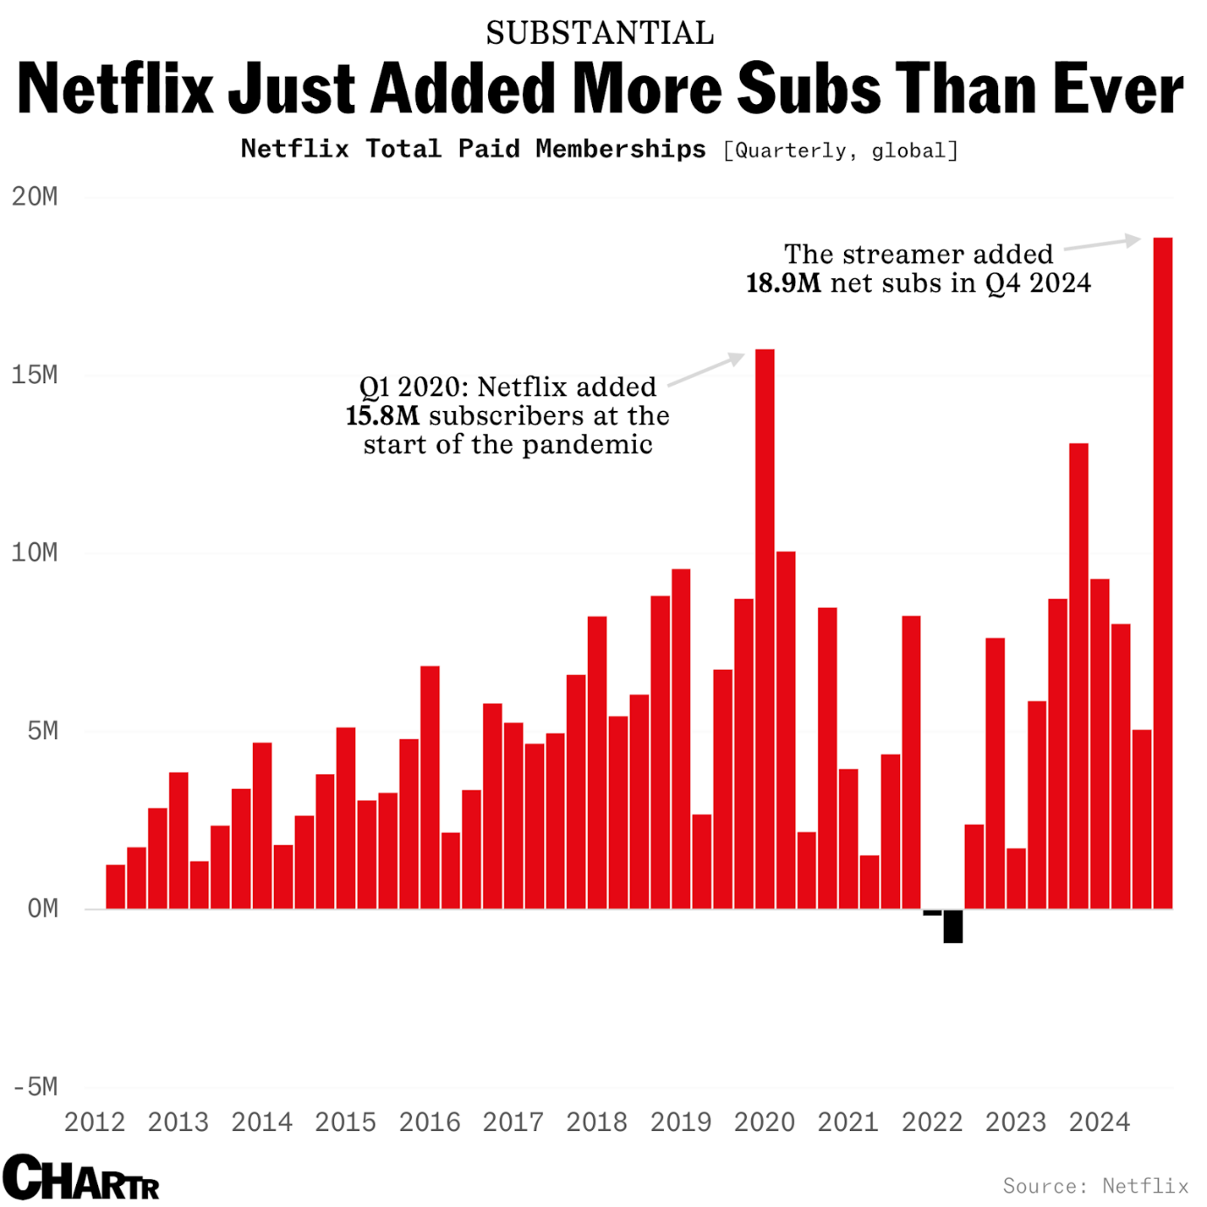
Figure 4: Netflix Subscribers
(Source: Jones, 2025)
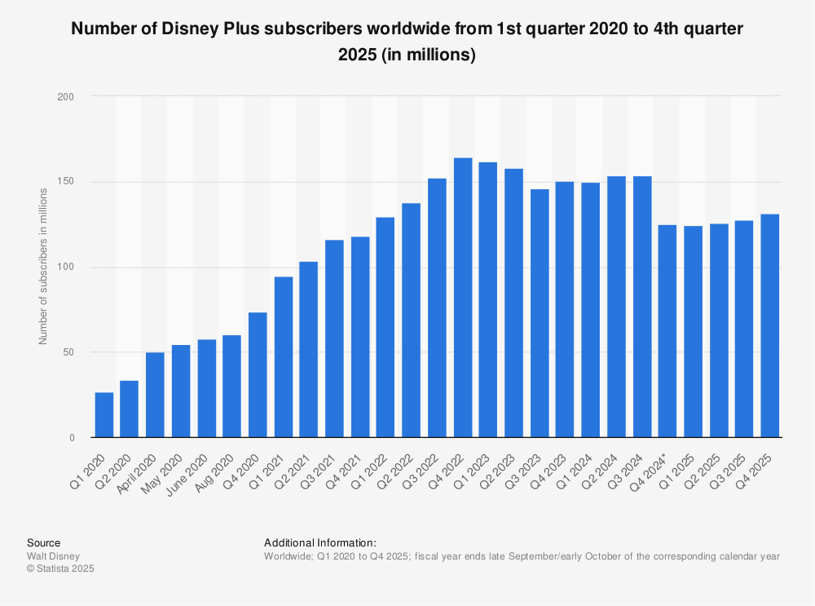
Figure 5: Disney+ Subscribers
(Source: Statista, 2025)
- Social factor: Benefits of changing the way consumers experience visual media. Netflix uses personalised recommendations to enhance the level of user interaction and gained 18.9m net subscribers in 2024 (Jones, 2025). Disney+ viewers are drawn towards brand loyalty founded on family-related material ad also gained around 130+ subscribers in Q4 2025 (Statista, 2025). As a result of changing watching patterns, social trends indicate that its numbers have over 325 million members all around the globe (Spangler, 2026).
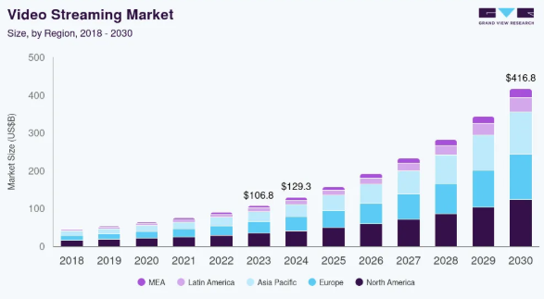
Figure 6: Video Streaming Market Prediction
(Source: GVR, 2023)
- Technological factor: Recommendations in the content created by artificial intelligence. The video streaming market was placed at $129.3 billion in 2024 ad expected to grow to $416.8 billion by 2023 (GVR, 2023). Netflix gains an effective algorithmic competitive advantage. Disney+ requires more investment in technological infrastructure. According to the research, AI-based recommendation systems can enhance the level of engagement by up to 80 percent (Arshad et al., 2025).
- Legal factor: Online regulation and implementation of copyright control. Netflix follows laws which regulate global licensing. Disney+ experiences reduction in licensing due to its intellectual property ownership. The pressure of laws is also increasing as more than 30 countries develop stricter digital content rules (Europa, 2025).
- Environmental factor: Digital infrastructure energy consumption. Netflix makes smart investment in effective cloud infrastructure. Disney+ faces similar struggles in operations.

2.2 Analysis of Macro Factor 1: Technological Environment

2.2.1 Impact on Netflix (Pioneer)
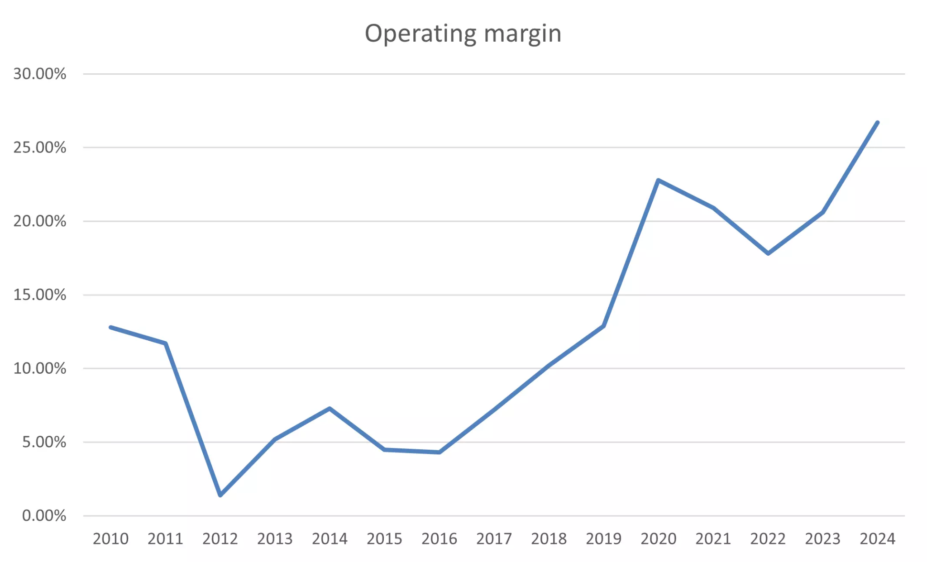
Figure 7: Netflix Operating Margin
(Source: Singh, 2025)
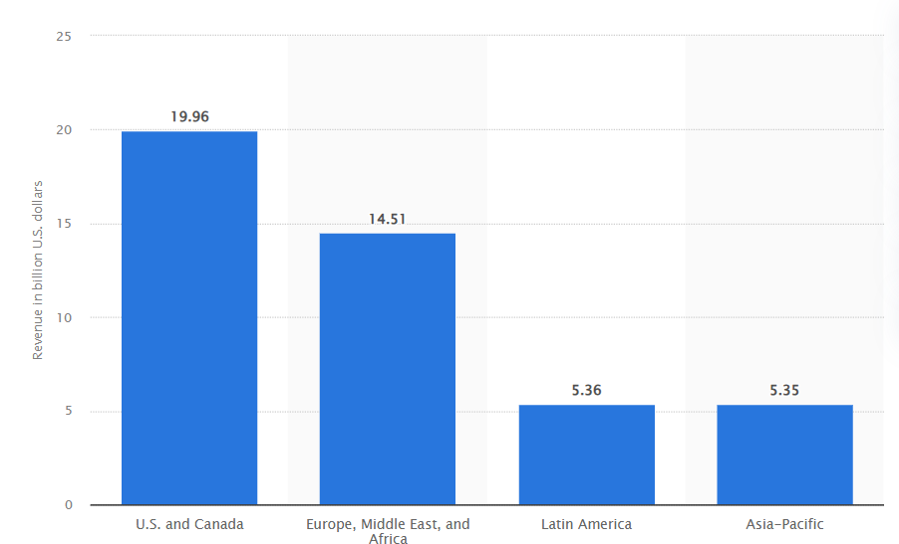
Figure 8: Netflix Revenue
(Source: Stoll, 2025)

Technological innovation has been noted to have greatly contributed to the rise of Netflix to the top of the streaming industry. As per the above graphs, Netflix recorded remarkable financial performance with content attack and technical effectiveness as the company sold approximately 45.18 billion and had an operating margin of around 27% in the year 2024 (Stoll, 2025; Singh, 2025). As the literature describes, algorithmic recommendation systems have a huge effect on the consumption of media and contact with the streaming services by citizens (Yu, 2023).
Data analytics systems of high sophistication are employed to process large audience segments of user data, the backbone of these algorithms. Machine-learning technologies make streaming services optimise content discovery and increase the watching time, which is recorded in the studies of recommendation technologies (Harichandan, Nayak, and Lenka, 2025). Other works show the impact of algorithmic systems on the viewer choices on streaming platforms and customer preferences (Pajkovic, 2021). Another technological advancement that Netflix has made is its membership portfolio, which includes ad-supported subscription tiers where users can engage and stream without ads.

2.2.2 Impact on Disney+
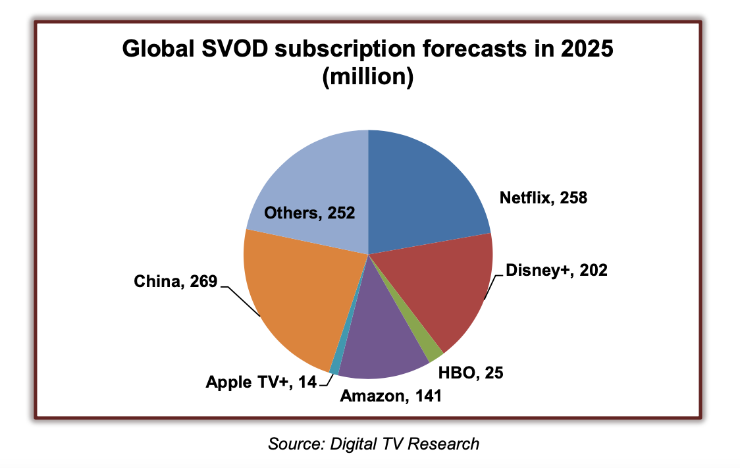
Figure 9: Global Disney+ subscribers forecast
(Source: Frankel, 2025)
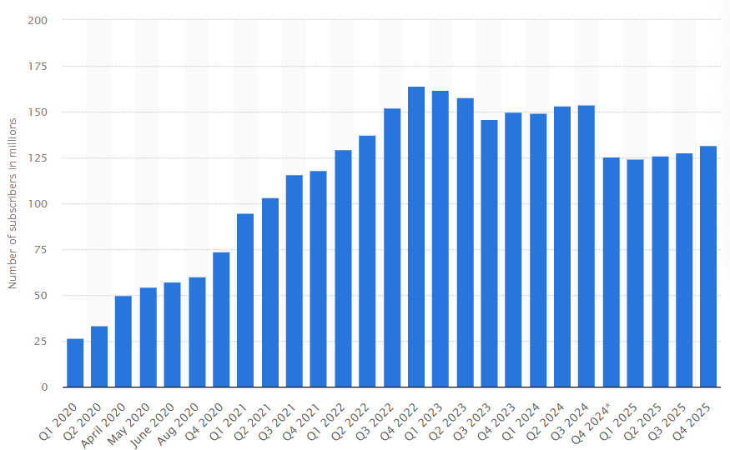
Figure 10: Disney+ subscribers forecast till 2025
(Source: Stoll, 2025b)
Opportunities and challenges of Disney+ with regard to technological advancement are presented. As per the graphs above, the viewership of Disney+ is likely to top 202 million users by 2025 across the globe with the unstoppable growth and increased online activities (Frankel, 2025; Stoll, 2025). Being a follower organisation, Disney+ has to exist in an environment where the giants of the industry have already set methodological standards in terms of technological advancement. The research on streaming platforms shows that data-based recommendation systems have a prominent effect on viewing behaviour and user engagement (Milosaljevic, 2025).
However, Disney+ mostly thrives on its strong brand portfolio to attract audiences. The influence of emotional attachment on entertainment brands on the engagement of customers and choice of subscription is significant, as digital consumer behaviour studies demonstrate (Nations, 2022). Based on the studies on digital commerce, streaming and live media enable the increase of customer engagement and buying behaviour (Li, Garcia-de-Frutos and Ortega-Egea, 2025). These results depict the digital media influencing consumer interactions with entertainment materials.

2.3 Analysis of Macro Factor 2: Legal and Regulatory Environment

2.3.1 Impact on Netflix
Legal and regulatory frameworks have a significant influence on the way in which streaming services are provided in foreign jurisdictions. States are growing stricter regulations to protect cultural industries and ensure that digital market competition is healthy.
Netflix has to maintain a significant legal framework to address the issues of copyright laws and regulations of digital platform governance. According to the Q4 shareholder letter, Netflix has emphasised the need to invest in foreign content and work within the regulations as part and parcel of its growth strategy (Netflix Forecast, 2025).

2.3.2 Impact on Disney+
Due to its ability to dominate a large market share of its entertainment content, it has different regulatory consequences. As a part of its larger digital entertainment plans, Disney is still allegedly pouring more resources into streaming (The Hollywood Reporter, 2019). Additionally, the studies conducted on the international streaming market also suggest that the consolidated entertainment ecosystem of Disney creates the opportunity to maintain the growth of the digital media market (Aleksandrov, 2025).

3. Task 2: Strategic Responses of Pioneering and Follower Organisations

3.1 Netflix Strategic Responses

Ansoff Strategy | Key Element | Netflix Example
Market Penetration | Increase the use of existing markets. It’s supported by being in over 190 countries, and spends over 20 billion annually on its content, demonstrating its product development plan (Netflix, 2025) | Personalised recommendations and stricter rules for sharing passwords.
Product Development | New content for existing users. | Originals such as Netflix's original series, such as Stranger Things.
Market Development | Expansion into other market territories. | Mobile-only subscription and information in local languages in countries such as India.
Diversification | New business areas beyond streaming. | Netflix games and ad subscription packages.

Table 1: Netflix Strategy Using Ansoff Matrix
(Source: Created by Author)
Ansoff Growth Matrix, a four-focal growth strategy, can be used to evaluate Netflix and its strategic growth. To begin with, Netflix utilises high-level consumer activation and retention strategies to expand its market share. It boosts viewer interaction and strengthens customer loyalty as a result of algorithmic personalisation. Second, Netflix takes the path of product development in creating original movies and TV shows that attract the attention of a wide audience; indeed, the competition strategy continues to focus on investing in content. Third, Netflix plans to enter foreign markets, which will allow the development of these markets. The study of Ansoff suggests that Netflix has been contributing to the market development, in that it is supported by being in over 190 countries, and spends over 20 billion annually on its content, demonstrating its product development plan (Netflix, 2025).
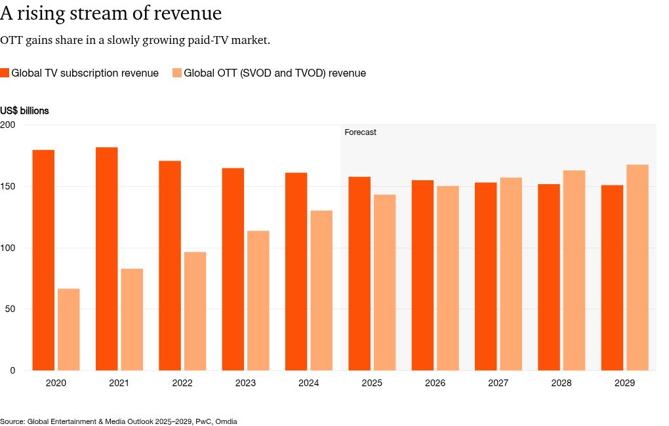

Figure 11: OTT gains
(Source: Media Outlook, 2025)
By 2029, streaming ad income is predicted to increase dramatically. The report uses Porter's Generic Strategies and the Growth Matrix by Ansoff to evaluate how Netflix and Disney+ are able to strategically change to these shifts in the environment. The macro marketing environment is composed of external factors, which affect the industry structures but are mostly beyond the immediate control of organisations.

3.2 Disney+ Strategic Responses
Disney+ has grown its number of subscribers at a very remarkable rate as one of the main rivals in the market, owing to its famous entertainment brands like Marvel, Pixar, and Star Wars (U.S. Securities and Exchange Commission, 2025). Brand and exclusive intellectual property are the bases that Disney+ uses to implement the differentiating strategy. The service provides unique value that cannot be differentiated from the competitors through the use of internationally known entertainment properties. The Walt Disney Company's annual report highlights the significance of the combination of intellectual property in the company, making the content more engaging and promoting the streaming approach of the company (Disney, 2025). The Disney + brand-based differentiation strategy helps it to compete effectively with advanced streaming services like Netflix.

Porter Strategy | Key Element | Disney+
Cost Leadership | Reasonable prices to attract a large audience. | Lower membership prices in some of the countries versus some of the streaming competitors.
Differentiation | Unique, high-quality content that is unavailable in other places. | The examples of exclusive franchises are Pixar, Marvel, and Star Wars.
Focus Strategy | Targeting a specific group of the audience. | Good family fun and attracting parents and children of the Disney brand.

Table 2: Disney+ Strategy Using Porter’s Generic Strategy
(Source: Created by Author)

The generic strategy adopted by Disney+, a streaming business follower of Porter, according to his General Strategies, has been based primarily on distinctiveness. Differentiation is when consumers have access to unusual value in the form of unique goods and brand identities or special talents that competitors cannot easily compete with. The key ways that Disney+ is competitive in the streaming industry have to do with its high-quality IP portfolio, brand loyalty, and entertainment ecosystem that cuts across platforms.
The strategy of Disney + greatly depends on the application of skeleton content distinction and brand value. The brand recognition and perceived brand importance significantly affect subscription intentions and repurchase intentions of the customers, as the study of brand equity in streaming services has shown (OZTEP and KAYA, 2026). Known as popular franchises such as Marvel, Pixar, and Star Wars of Disney create a strong emotional connection with the audience, improving retention of subscriptions and loyalty of buyers in the long-term. The perception of brand awareness, perceived quality, and brand associations are the significant determinants of digital subscription decisions and platform use, according to research on brand equity (OZTEP and KAYA, 2026).
Also, good emotional brand relationships with the customers help Disney in strategic positioning. One-to-one experiences and emotional product attachment are also assets required to maintain the competitive advantage in the digital entertainment market, as researchers on brand loyalty and consumer activism in streaming services concluded (Wen, 2025). The ability of Disney to integrate an emotive brand experience with a story makes it more engaging to customers and creates better customer loyalty.

Strategic Dimension | Disney+ Implementation | Supporting Evidence
Brand Equity | Close emotional attachment through international franchising. | Brand equity affects subscription loyalty (OZTEP and KAYA, 2026).
Brand Loyalty | Emotional storytelling improves the connection with the audience. | Literature on streaming brand engagement (Wen, 2025)
Table 3: Disney+ Differentiation Strategy within Porter’s Generic Framework
(Source: Created by Author)

Overall, Disney+ demonstrates how follow companies can successfully fight in the realm of technologically advanced industries through integrated entertainment ecosystems, unique intellectual property, and brand loyalty. Differentiated initiatives supported by well-developed contact with customers and franchise narratives have made Disney+ one of the leading competitors in the streaming sector worldwide within a short period. Companies with successful analysis of these external forces are in a better position to develop competitive responses, which can maintain the long-term competitive advantage. In this respect, Netflix has already become a pioneer, setting the subscription-video-on-demand (SVOD) model and radically changing the process of media consumption.

4. Conclusion
The research paper has proven that the technologies and the regulatory environment have a significant impact on defining the competition in the streaming industry. Technological progress can now be applied by streaming platforms to individualise user experiences and enhance customer interactions through new technology innovations like recommendation algorithms and artificial intelligence. Netflix has earned its dominant position in the streaming market due to the competent use of technical improvements; its popularity is supported by the data analytics approach, algorithmic data recommendation algorithms, and internationalisation strategies. Being a follower, Disney+ is more focused on intellectual property and brand equity. It has developed a powerful differentiating strategy that brings on board loyal viewers by adding popular entertainment properties to its streaming service. On the whole, the streaming industry demonstrates the need to monitor the environment constantly and be strategically flexible; companies that effectively measure the macro-environmental conditions and implement the strategic response are in a better position to maintain leverage in the fast-changing digital markets.

5. Reference
Aleksandrov, M. (2025) A systematic literature review on live-streaming commerce: trends, consumer behavior, and..., Access-bg.org. Available at: https://journal.access-bg.org/issue-6-2-2025/a_systematic_literature_review_on_live-streaming_commerce-trends (Accessed: 07 March 2026).
Alphastreet (2025) Netflix Q2 earnings jump on strong revenue growth; results beat estimates, AlphaStreet. Available at: https://news.alphastreet.com/netflix-q2-profit-jumps-on-strong-revenue-growth-results-beat-estimates/ (Accessed: 7 March 2026).
Arshad, M. et al. (2025) ‘Big data analytics and AI as success factors for online video streaming platforms’, Frontiers in Big Data, 8(1). Available at: https://doi.org/10.3389/fdata.2025.1513027.
Disney (2025) Redirecting, Google.com. https://www.google.com/url?q=https://investors.thewaltdisneycompany.com/files/doc_financials/2025/ar/2025-Annual-Report.pdf&sa=D&source=docs&ust=1773217622781099&usg=AOvVaw26aTAFmjEhPRxb_Jhtr3P3. Available at: https://www.google.com/url?q=https://investors.thewaltdisneycompany.com/files/doc_financials/2025/ar/2025-Annual-Report.pdf&sa=D&source=docs&ust=1773217622781099&usg=AOvVaw26aTAFmjEhPRxb_Jhtr3P3 (Accessed: 07 March 2026).
Europa (2025) Digital Services Act: keeping us safe online, European Commission. Available at: https://commission.europa.eu/news-and-media/news/digital-services-act-keeping-us-safe-online-2025-09-22_en (Accessed: 07 March 2026).
Frankel , D. (2025) Disney Plus and Netflix will Dominate Two-Horse Global SVOD Market in 2025, Research Company Predicts, NextTV. Available at: https://www.nexttv.com/news/disney-plus-and-netflix-will-dominate-two-horse-global-svod-market-in-2025-research-company-predicts (Accessed: 07 March 2026).
GVR (2023) Video Streaming Market Size, Share, Analysis | Industry Report, 2025, Grand View Research. Available at: https://www.grandviewresearch.com/industry-analysis/video-streaming-market (Accessed: 07 March 2026).
GVR (2023) Video Streaming Market Size, Share, Analysis | Industry Report, 2025, Grand View Research. Available at: https://www.grandviewresearch.com/industry-analysis/video-streaming-market (Accessed: 7 March 2026).
Harichandan, L., Nayak, S.K. and Lenka, S. (2025) ‘A Comprehensive Review on Video Recommendation System: Models, Challenges, and Applications’, Journal of Engineering Science and Technology Review, 18(3), pp. 207–225. Available at: https://doi.org/10.25103/jestr.183.21.
Jones, T. (2025) Netflix added 18.9 million subscribers, the company’s best-ever quarter, Sherwood News. Available at: https://sherwood.news/business/netflix-added-18-9-million-subscribers-companys-best-ever-quarter/ (Accessed: 7 March 2026).
LI, X. et al. (2024) ‘Why consumers have impulsive purchase behavior in live streaming: the role of the streamer’, BMC Psychology, 12(1). Available at: https://doi.org/10.1186/s40359-024-01632-w.
Li, Y., García-de-Frutos, N. and Ortega-Egea, J.M. (2025) ‘Impulse buying in live streaming e-commerce: A systematic literature review and future research agenda’, Computers in Human Behavior Reports, 19(1), p. 100676. Available at: https://doi.org/10.1016/j.chbr.2025.100676.
Media Outlook (2025) Perspectives: Global Entertainment & Media Outlook 2024–2028, PwC. Available at: https://www.pwc.com/gx/en/issues/business-model-reinvention/outlook/insights-and-perspectives.html (Accessed: 07 March 2026).
Milosaljević, I. (2025) ‘How Netflix’s Recommendation Algorithms Function in Small Markets – The Case of Serbia’, AM Journal of Art and Media Studies, 1(36). Available at: https://doi.org/10.25038/am.v0i28.612.
Nations, U. (2022) ‘Marine litter, an analytical overview’, Unep.org, 2(1). Available at: https://doi.org/N/A.
Netflix (2024) Netflix - Financials - Annual Reports & Proxies, ir.netflix.net. Available at: https://ir.netflix.net/financials/annual-reports-and-proxies/default.aspx (Accessed: 07 March 2026).
Netflix Forecast (2025) Netflix Q4 Results and Forecast, https://s22.q4cdn.com. Available at: https://s22.q4cdn.com/959853165/files/doc_financials/2025/q4/FINAL-Q4-25-Shareholder-Letter.pdf (Accessed: 07 March 2026).
OZTEP, M. and KAYA, H.F. (2026) ‘The role of customer-based brand equity in influencing Netflix subscribers’ repurchase intentions’, Gazi Journal of Economics and Business, 12(1). Available at: https://doi.org/10.30855/gjeb.2026.12.1.007.
Pajkovic, N. (2021) ‘Algorithms and taste-making: Exposing the netflix recommender system’s operational logics’, Convergence: the International Journal of Research into New Media Technologies, 28(1), pp. 214–235. Available at: https://doi.org/10.1177/13548565211014464.
PwC (2025) Perspectives: Global Entertainment & Media Outlook 2024–2028, PwC. Available at: https://www.pwc.com/gx/en/issues/business-model-reinvention/outlook/insights-and-perspectives.html (Accessed: 07 March 2026).
Senftleben, M. and Izyumenko, E. (2025) ‘Author remuneration in the streaming age – exploitation rights and fair remuneration rules in the EU’, Journal of Intellectual Property Law & Practice, 2(1). Available at: https://doi.org/10.1093/jiplp/jpaf071.
Singh, S. (2025) Netflix Subscribers Statistics (2025) — Users & Revenue, Demandsage. Available at: https://www.demandsage.com/netflix-subscribers/ (Accessed: 07 March 2026).
Spangler, T. (2026) Netflix Tops 325 Million Subscribers, Plans to Boost Content Spending 10% to $20 Billion in 2026, Variety. Available at: https://variety.com/2026/tv/news/netflix-q4-2025-financial-earnings-subscribers-1236635615/ (Accessed: 07 March 2026).
Statista (2025) Global number of Disney+ subscribers 2025| Statista, Statista. Available at: https://www.statista.com/statistics/1095372/disney-plus-number-of-subscribers-us/?srsltid=AfmBOopCoRC-c6EufoA5K31rjvbovr82nVaot6ZzX0d-25TtrfozU5Uv (Accessed: 7 March 2026).
Stoll, J. (2025a) Netflix global revenue by region 2020, Statista. Available at: https://www.statista.com/statistics/1090098/netflix-global-revenue-by-region/ (Accessed: 07 March 2026).
Stoll, J. (2025b) Number of Disney Plus subscribers worldwide from 1st quarter 2020 to 1st quarter 2022, Statista. Available at: https://www.statista.com/statistics/1095372/disney-plus-number-of-subscribers-us/ (Accessed: 07 March 2026).
The Hollywood Reporter (2019) Hollywood Reporter | Entertainment News, The Hollywood Reporter. Available at: https://www.hollywoodreporter.com/ (Accessed: 07 March 2026).
UNITED STATES SECURITIES AND EXCHANGE COMMISSION (2025) https://investors.thewaltdisneycompany.com. Thewaltdisneycompany. Available at: https://investors.thewaltdisneycompany.com/files/doc_financials/2025/ar/2025-Annual-Report.pdf (Accessed: 07 March 2026).
Wang, C. et al. (2025) ‘Streamer interaction and consumer impulsive buying in live-stream commerce: the mediating roles of trust and emotional arousal with anticipated regret as boundary condition’, Frontiers in Communication, 10(1). Available at: https://doi.org/10.3389/fcomm.2025.1547639.
Wen, Y. (2025) ‘Brand Loyalty and Consumer Behavior in Streaming Services: A Case Study of Netflix’s Marketing and Engagement Strategies’, Proceedings of the 2nd International Conference on Applied Psychology and Marketing Management, 1(1), pp. 74–79. Available at: https://doi.org/10.5220/0014074200004942.
Yu, Z. (2023) ‘Netflix recommends: algorithms, film choice, and the history of the taste’, Information, Communication & Society, 1(1), pp. 1–3. Available at: https://doi.org/10.1080/1369118x.2023.2252485.

