

Assessment 1 – Reading Task Template
Upload your photo of your A3 in-class notes here:
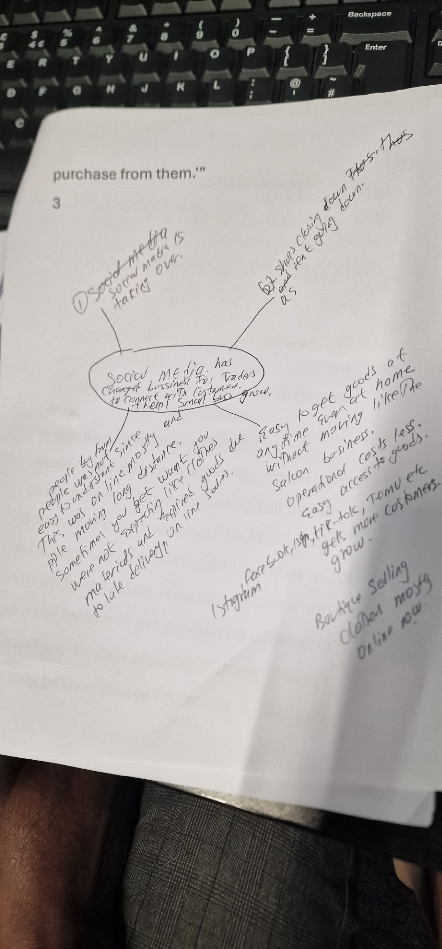

1. Answer these questions using the sentence starters below
a. What is the main idea of the text?
The main idea is that social media has changed business for traders to connect with customers.
b. What are two key points?
One key point is social media is taking over.
Another key point is most shops are closing down and market vendors are loosing business so landlord loosing clients.
c. What part of the text did you find most important? Why?
The most important part is some customers drive four/ five hours to came for sandwich and the saloon business.
d. Was anything unclear or difficult to understand?
I was not sure about the quote people buy from people. Yet people were buying on line without meeting customers on some goods. e. How did your group help you understand the text better?
My group helped me by discussing at the different ideas being sold like the sandwihch wre customers had to meet the seller and the saloon business as well.
2. One sentence reflection” people buy from people”
Question: What did you find challenging about this task?
The hardest part was gathering information from four different business with different ideas and different type of customers from different sources but almost with the same idea of looking for customers.

