Promoting
Rolling Snack to
Early Years Practitioners
in the Early Years.
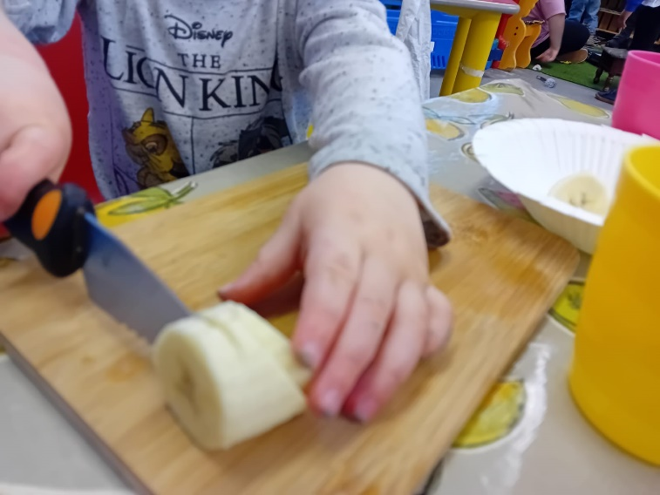
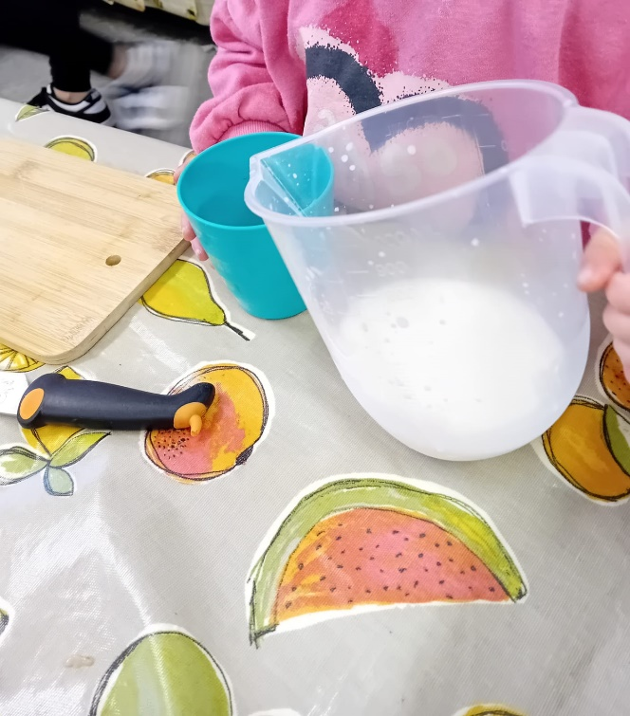

Contents
Introduction Page 3
What is a rolling snack? Page 3
Benefits of a rolling snack Page 4
Challenges of a rolling snack Page 6
Market research and Feedback Page 6
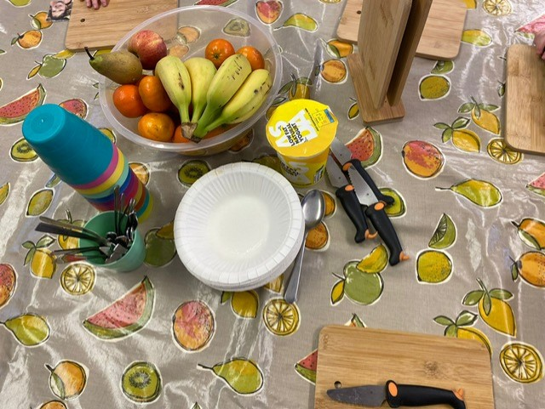
Support package for the rolling snack Page 6

Introduction
I have been working in childcare since 2002 and have been a manager in the same setting which is a breakfast club, wraparound, full day care and after school club since 2004.
Rolling snack has been implemented in our setting in the last twelve months and I would like to promote and introduce it to other Early Years settings and explain the positive effect that it has on young children. It supports the new curriculum encouraging the children to be ambitious, capable learners and healthy, confident individuals which are two of the four Purposes in the new Curriculum.
What is a rolling snack?
A rolling snack allows children of all ages to prepare their own snacks from a young age. We have children in our setting from age 2 years and they make their own snacks with little or no assistance. Children are provided with nutritional foods, chopping boards and dog knives. It works well as it allows the children to have their snacks when they want it and causes less disruption to their playing and learning. The children carry on playing until there is a seat at the snack table instead of sitting and waiting for all the children to wash their hands and the snack be delivered one by one to each of them. When the children have their snack they take the knife, a chopping board, choose their snack and then prepare it. We have noticed how behaviour has improved since the rolling snack was introduced in our setting. Rolling snack should only be limited to be open for about 30 minutes to one hour maximum.
Snack times in early years settings tend to be mid-morning, mid-afternoon and an optional evening snack. Having these snack times enables the children to keep their energy levels as well as supporting their development, growth and learning with the important nutrients provided.

Benefits of a rolling snack
These include:
Development – Making their own rolling snack requires grasping and manipulation which helps the children develop fine motor skills and hand-eye coordination as they learn to pick up and manipulate small items.
Independence – Rolling snack encourages self-feeding, fostering independence, promoting confidence and autonomy in young children, as they learn to feed themselves. Children choose what they want rather than what the Early Years Practitioner thinks they want which results in less waste.
Social interaction – Children can take their time and chat with their friends and the staff. They can be encouraged to talk about their likes and dislikes including any allergies they may have. Talking about their allergies makes the other children aware and also helps them to understand why they may be able to have a food or drink and another child cannot. With staff sitting with the children and showing by example, they are role-modelling and encouraging healthy eating habits.
Exploration and sensory development – Children can explore different textures, tastes, flavours and shapes, which can expand their palate, willingness to try new foods and it allows them to explore different sensory experiences. Rolling snack is a fun and educational experience. In our setting we have a rolling menu which means that the food changes each day on a rolling two week period to offer more choice and variety.
Nutrition – Nutrition is important and this needs to be stressed to Early Years Practitioners as to how the rolling snack promotes this. This is done by promoting a healthy, balanced menu offering essential, nutritious options like fruits, vegetables and whole grains which support children’s health and well-being. These nutritious foods contribute to a balanced diet, promoting health and development. The importance of nutrition in early years is vital to enhance the children’s physical and cognitive development. Welsh Government’s Early Childhood play, learning and care developmental pathways 0 to 3 emphasises the five developmental pathways. These include wellbeing, communication, exploration and physical development which are all promoted with the rolling snack.
Convenience – Rolling snacks are easy to prepare and serve, making them a convenient option. Early Years Practitioners can prepare the food quickly and easily. It does not need full preparation and saves time so our staff spend less time in the kitchen and more time with the children.
Team collaboration – encourages the Early Years Practitioners to brainstorm ideas and share recipes for the rolling snack amongst the team, fostering teamwork and collaboration within the childcare facility and with other childcare facilities.
Parental satisfaction – Early years staff need to be reminded that offering a healthy and engaging snack can enhance parental satisfaction and trust in the childcare program.
Challenges of a rolling snack
I have also considered some disadvantages but I feel and the other early years practitioners who are also delivering the rolling snack feel the same way that the advantages outweigh the disadvantages significantly.
A disadvantage is that the children do not have a routine so affects their sense of structure and predictability. However the children soon get used to the change and benefit from being child-led so they have the snack when they are ready for it not when the early years practitioners decide they should have it.
Market research and Feedback
It has been found that parents and carers appreciate the emphasis on healthy eating habits and the children doing the preparation themselves. The children respect the equipment and don’t throw it about or onto the floor. This is how they treat the authentic kitchen in the playroom with respect whereas they treat the areas which has a plastic kitchen and plastic food and utensils as toys they can just throw about.
Having a rolling snack encourages a child’s ability to focus, concentrate and engage in learning activities whilst contributing to their behaviour, mood and overall well-being.

Support package for the rolling snack
I am here to offer training and support to Early Years Practitioners. I will deliver the advantages and disadvantages as I have described earlier. I will answer any questions that anyone may have, help with any objections and put any worries and concerns at ease.
Basically after seeing the success the rolling snack is having on our settings I would like to be able to deliver and promote rolling snacks to other settings so all children have the same opportunities.
Overall rolling snacks play a valuable role in early childhood development and nutrition. By highlighting these benefits, I am confident that I can motivate early years staff into incorporating rolling snacks into their routines, creating a positive and enriching environment for the children under their care.
I would like to offer a package to support the rolling snack and offer training to staff in early years settings. From speaking to managers at a selection of early years settings it can be seen that some staff are keen to try out new ideas when they understand the reasoning behind them. Other staff are not quite so willing and are often set in their ways and this I would like to help change.
I offer 4 sessions. These I would carry out in person at early years settings within travelling distance. I can do via Teams meetings however I feel that delivering the package in person will have more impact.
- Session 1 – To explain to Early Years Practitioners the purpose and benefits of the rolling snack to the children and childcare setting. We would discuss ages of the children attending the setting, allergies and food intolerances and how to deliver the rolling snack in the setting.
- Session 2 – Once happy with the content of Session 1 and the setting feels ready to deliver the rolling snack I would visit the setting to supply chopping boards, dog knives and a starter kit of a selection of snacks. Then I would carry out a demonstration with children doing the rolling snack. I have photographs showing how we prepare for the setting up for rolling snack and how the children do it. The children pour their own milk and water as well as chopping up, preparing and eating food.
- Session 3 – Return to the early years setting after a month to evaluate. Here we can address any problems the staff and children have encountered and do our best to iron out the problems.
- Session 4 – Optional visit of me returning to the setting to hold a session with parents and carers. This gives the parents and carers the opportunity to watch the demonstration and then have a chat about how we do rolling snack. The session will give them ideas as to how they can prepare some foods at home with their child allowing their child to investigate with food.
Finance
Before coming today on checking the diary I have 15 early years settings booked in with me. I will be visiting these settings over the next month.
I have put advertising posters on Facebook and Instagram to offer the service of going to early years settings to deliver the rolling snack program. As a result of this I am expecting many more bookings.
The cost for the package which is 4 sessions, each 1 hour long is £250.00. This includes chopping boards (£13.99 per set of 6, dog knives @ £7.95 each and a selection of snacks £10.00.
I am looking for an investment of £10,000 and in return would offer a 20% return.

Part 2
Rolling snack allows children of all ages to prepare their own snacks from a young age. It supports the new curriculum encouraging the children to be ambitious, capable learners and healthy, confident individuals, which are two of the four Purposes in the new Curriculum. (Welsh Government, 2022)
Children from as young as 2 years old are able to make their own snacks with little or no assistance. They need to be provided with nutritional foods, chopping boards and dog knives. It works well as it allows the children to have their snacks when they want it and causes less disruption to their playing and learning. (Welsh Government, 2022) The children carry on playing until there is room at the snack table instead of sitting and waiting for all the children to wash their hands and the snack be delivered one by one to each of them. When the children have their snack they take the knife, a chopping board, choose their snack and then prepare it. Through research and feedback it has noticed how much behaviour has improved since the rolling snack was introduced in settings. Rolling snack should only be limited to be open for about 30 minutes to one hour maximum. (Welsh Government, 2019)
According to Pinnington (2019), rolling snack should be during the morning, after breakfast and before lunch, in the afternoon, after lunch and before tea and an optional evening snack. Having these snack times enables the children to keep their energy levels as well as supporting their development, growth and learning with the important nutrients provided.
As stated in the National Minimum Standards for Regulated Childcare, Standard 12, babies and children are to be provided with regular food and drinks in suitable amounts for their individual needs and therefore rolling snacks would be ensured this was abided with. (Welsh Government, 2022)
There are many benefits to having a rolling snack. One benefit is to help and encourage development. Making their own rolling snack requires grasping and manipulation which helps the children develop fine motor skills and hand-eye coordination as they learn to pick up and manipulate small items. (Welsh Government, 2019)
Rolling snack encourages fostering independence including self-feeding, promoting confidence and autonomy in young children, as they learn to feed themselves. (Welsh Government, 2019) Children choose what they want rather than what the Early Years Practitioner thinks they want which results in less waste.
Rolling snack encourages social interaction. Children can take their time and chat with their friends and the early years practitioners. (Welsh Government, 2019) They can be encouraged to talk about their likes and dislikes including any allergies they may have. Talking about their allergies makes the other children aware and also helps them to understand why they may be able to have a food or drink and another child cannot. With staff sitting with the children and showing by example, they are role-modelling and encouraging healthy eating habits.(Welsh Government, 2022) It is important that enabling adults take the opportunities throughout the sessions to recognise engaging experiences. These include during snack times where different teaching moment opportunities will arise. (Welsh Government, 2023d) It is useful to record these teaching moments and they can be added to the focus child sheets when staff have a free moment.(Welsh Government, 2022)
Exploration and sensory development skills are developed through the rolling snack. Children can explore different textures, tastes, flavours and shapes, which can expand their palate, willingness to try new foods and it allows them to explore different sensory experiences. Rolling snack is a fun and educational experience. (Welsh Government 2023d) Also having variety with the snacks such as a rolling two week menu which is changed daily and works well and this allows the children who do not go to the setting every day to have the opportunity to try the different foods. Also different cultures can be celebrated during rolling snack so that the children can get to experience the different foods. They can also talk to each other and learn from each other about each others cultures. (Welsh Government, 2022)
Nutrition, according to Welsh Government (2023a) is important and the rolling snack promotes this. This is done by promoting a healthy, balanced menu offering essential, nutritious options like fruits, vegetables and whole grains which support children’s health and well-being. (Russell, 2022) These nutritious foods contribute to a balanced diet, promoting health and development. (Welsh Government, 2023a) The importance of nutrition in early years is vital to enhance the children’s physical and cognitive development. Welsh Government (2023c) emphasises the five developmental pathways. These include wellbeing, communication, exploration and physical development which are all promoted with the rolling snack.
Teaching moments happen during rolling snack. These could include cutting the fruits into halves and understanding the concept of half aswell as using hand-eye coordination and fine motor skills while they manipulate the tools and also their social interaction by speaking to each other and the early years practitioners. During the snack time many teaching moments can happen from watching the child cutting up a piece of fruit to discussing the colours of the fruit and the textures of the fruit.(Pinnington, 2019)
Rolling snacks are easy to prepare, making them a convenient option. Early Years Practitioners can prepare the food quickly and easily. It does not need full preparation and saves time so our staff spend less time in the kitchen and more time with the children. (Welsh Government, 2022)
Team collaboration encourages the Early Years Practitioners to brainstorm ideas and share recipes for the rolling snack amongst the team, fostering teamwork and collaboration within the childcare facility and with other childcare facilities. (Welsh Government)
Parental satisfaction is important and Early years practitioners need to be reminded that offering a healthy and engaging snack can enhance parental satisfaction and trust in the childcare program. (Kimberley, 2017)
There are also some disadvantages which have been considered by a number of early years practitioners who are also delivering the rolling snack and all feel the same way that the advantages outweigh the disadvantages significantly.
One disadvantage is that the children do not have a routine so affects their sense of structure and predictability. However the children soon get used to the change and benefit from being child-led so they have the snack when they are ready for it not when the early years practitioners decide they should have it. (Ephgrave 2018, 2020)
However, there is concern that children tend to eat more sugar foods than is advised. This then has a negative effect on the children when it comes to rolling snack in their early years setting. They will not want to healthy food that is being provided. If the settings can inform the parents and carers that this is happening and encourage them to give their child a healthier option when at home then the children will eat healthier when in the setting. (HM Government, 2016, Revel and Leech, 2017)
Furthermore, the rolling snack should not be extended over a longer time as this can have an effect on the main meals the children are having. If the rolling snack is late then the children will not have an appetite. (Revel and Leech, 2017)
It has been noted that parents and carers appreciate the emphasis on healthy eating habits and the children doing the preparation themselves. (Welsh Government, 2019) The children respect the equipment which is real and do not throw it about or onto the floor. From research it is proving that children treat the authentic kitchen in the playroom with respect whereas they treat the areas which have a plastic kitchen and plastic food and utensils as toys they can just throw about the room.
Having a rolling snack encourages a child’s ability to focus, concentrate and engage in learning activities whilst contributing to their behaviour, mood and overall well-being. (Welsh Government, 2022)
Overall rolling snacks play a valuable role in early childhood development and nutrition. By highlighting these benefits, it can be confidently stated that if early years staff into incorporating rolling snacks into their routines, creating a positive and enriching environment for the children under their care. (Welsh Government, 2022)
To conclude it is clear that the rolling snack is proving to be a success and it needs to be promoted in all early years settings. Once early years practitioners are confident that the rolling snack will work and understand the reasons as to why it is being done in settings then it will be a success across all settings.

Reference List
Ephgrave, A. (2018) Planning in the Moment with Young Children: a Practical Guide for Early Years Practitioners and Parents. Oxon: Routledge
Ephgave, A. (2020) Planning in the Moment with two and three year olds. Oxon: Routledge
HM Government. (2016) Childhood Obesity ‘A Plan for Action’. Available at: www.gov.uk/government/uploads/system/uploads/ (Accessed: 27 February 2024)
Kimberley, E. (2017) Early Years Careers - Introducing Rolling Snack https://www.earlyyearscareers.com/eyc/learning-and-development/introducing-rolling-snack/amp/ (Accessed: 28 February 2024)
Pinnington, H. (2019) EYFS: How to maximise the potential of snack time. Available at: https://www.tes.com/magazine/archive/eyfs-how-maximise-potential-snack-time (Accessed: 28 February 2024)
Revel, E. and Leech, G. (2017) Nutrition and mealtimes: Food for in-between times. Available at: https://www.earlyyearseducator.co.uk
(Accessed: 26 February 2024)
Russell, M. (2022) Health and Nutrition – What makes a healthy snack. Available at: https://www.nurseryworld.co.uk/features/article/health-nutrition-what-makes-a-healthy-snack (Accessed: 28 February 2024)
Welsh Government. (2018) Food and Nutritional Guidance for Childcare Providers. Available at: https://www.gov.wales/food-and-nutrition-childcare-settings-full-guidance (Accessed: 25 February 2024)
Welsh Government. (2019) Skills building at snack time. Available at: https://www.estyn.gov.wa.les/effective-practice/skills-building-snack-time (Accessed: 26 February 2024)
Welsh Government (2022). National Curriculum for funded non-maintained nursery settings. Available at: https://hwb.gov.wales/curriculum-for-wales/curriculum-for-funded-non-maintained-nursery-settings (Accessed: 25 February 2024)
Welsh Government (2023a). Early Childhood Play, Learning and Care: Reflective Practice Toolkit. Available at: https://hwb.gov.wales/api/storage/a8d10028-25ae-4d94-ad18-0247286ce822/early-childhood-play-learning-and-care-reflective-practice-toolkit-v1.pdf (Accessed: 25 February 2024)
Welsh Government (2023b). National minimum standards for Regulated Childcare in Wales. Available at: https://www.gov.wales/national-minimum-standards-and-guidance-regulated-childcare. (Accessed: 25 February 2024)
Welsh Government (2023c). Early childhood play, learning and care: Developmental pathways 0 to 3. Available at: https://hwb.gov.wales/curriculum-for-wales/early-childhood-play-learning-and-care-in-wales (Accessed: 25 February 2024)
Welsh Government (2023d). A Quality Framework or Early Childhood Play, Learning and Care in Wales. Available at: https://www.gov.wales/written-statement-publication-quality-framework-early-childhood-play-learning-and-care-in-wales (Accessed: 25 February 2024)

