Marketing Plan
(Tara! Pop-up Kitchen)

Student Name: Mark Jeffrey Pascual
Student Number: 2229176
Module: Marketing and Promoting Restaurant Facilities BMGM6002
Lecturer: Ruth Taylor-Davies

Introduction
Marketing is essential in guiding a business's strategy by enabling the creation and exchange of value between companies and customers. It involves identifying customer needs, analysing competitors, and utilising the organisation’s strengths to meet customer demands effectively and profitably. For marketing to be successful, it requires a thorough understanding of customers, competitors, and partners, as well as the ability to use resources strategically to achieve business objectives (Harvard Business Review and Silk, 2015). A well-executed marketing strategy not only drives business growth but also enhances brand positioning and customer engagement. By integrating insights from consumer behaviour, market trends, and promotional tactics, businesses can develop strong relationships with their target audience and sustain a competitive advantage in the marketplace.
Purpose of the Marketing Plan
This marketing plan aims to define the strategy for launching and promoting Tara! Pop-Up Kitchen, an experimental dining concept. The plan will outline the marketing tactics to introduce the pop-up kitchen to the target market, position it within the competitive landscape, and generate sustainable revenue while testing innovative approaches to dining. It is being prepared for stakeholders such as potential investors, the management team, and marketing professionals who will execute the strategies. This plan serves as a key step in evaluating the viability and growth potential of the pop-up concept before potentially expanding into a permanent establishment.
Pop-ups
The concept of pop-ups has existed since colonial times, initially seen through traveling salespeople and entertainment stages. Over time, this evolved into temporary, local establishments such as lemonade stands, barber shops, food carts and stalls, and even circus attractions and festivals (Milwood et al., 2022). Pop-ups have always reflected a temporary nature, and more recently, they have expanded to incorporate diverse elements such as art, music, wine, and gastronomy, creating unique experiences (Pret a Diner, 2013).
Pop-ups also used to introduce new chefs or highlight seasonal ingredients, offering an exciting opportunity to experiment with flavours and themes (Aaltojärvi, Kontukoski, and Hopia, 2017). Tara! Pop-Up Kitchen brings this concept to life by offering a unique culinary experience that blends traditional Filipino flavours with locally sourced Welsh produce. This combination celebrates not only the rich heritage of Filipino cuisine but also the vibrant food culture of Wales.
The name "Tara!" embodies the Filipino warmth and hospitality, inviting guests to come together and enjoy a shared experience. The Welsh "Ta ra" adds a heartfelt farewell, fostering camaraderie and a sense of connection with every meal. Tara! Pop-Up Kitchen is more than just a temporary establishment; it is a journey of cultural connection through food, inviting guests to experience and savour the flavours of both cultures.
Key Frameworks
Marketing Mix (7P’s)
The marketing mix is a fundamental concept in marketing that involves key elements crucial for creating a successful strategy: product, price, place, and promotion (McCarthy, 1964). Initially derived from the single P (price) of microeconomic theory (Chong, 2003), McCarthy expanded this into the "4 Ps" as a framework for translating marketing planning into practice, which was later elaborated by Bennett (1997).The marketing mix has been expanded to include three additional Ps—People, Process, and Physical Evidence—addressing the unique challenges of marketing services (Booms & Bitner, 1982). These seven components work together to create a well-rounded strategy that meets customer expectations and provides a competitive edge.
Ansoff’s Matrix
According to Loredana (2017), this concept continues to recognise as one of the most essential tools for business development and market entry. Studies indicate that entrepreneurs successfully implement Ansoff's Matrix as an effective growth strategy. This model, introduced by Ansoff (1957), will evaluate growth strategies through market penetration, market development, product development, and diversification.
Segmentation, Targeting, and Positioning
Marketing strategies enable companies to identify and create specific customer groups within their target markets (segmentation). These strategies also encompass the decision-making process of selecting which customer groups to serve (targeting) and determining the best way to position products or services in the minds of target consumers (positioning).A framework for defining customer segments, targeting specific audiences, and positioning the restaurant in the minds of consumers (Anozie, 2013).
Product
Tara! Pop-Up Kitchen embodies the essence of the modern pop-up dining movement by offering a dynamic and immersive culinary experience. The concept is deeply rooted in the increasing consumer demand for creativity, sustainability, and exclusivity in dining (Metro, 2024). Unlike traditional restaurants with fixed locations and menus, Tara! embraces the flexibility and innovation that pop-up restaurants are known for, allowing it to experiment with seasonal ingredients, diverse locations, and evolving menu offerings (King, 2024).
The motivation behind Tara! Pop-Up Kitchen aligns with key factors driving the success of pop-ups, freedom, creativity, and the pursuit of uniqueness (Leirdal et al., 2024). By operating in rotating locations and focusing on locally sourced produce, the brand not only adapts to changing consumer preferences but also enhances engagement with customers who seek novel and socially interactive dining experiences. Research suggests that pop-ups serve as an experimental space for restaurateurs, enabling them to refine their concepts and gauge market response before committing to permanent ventures (King, 2024). This strategy is particularly beneficial for Tara! as it explores its positioning within the competitive food industry.
Furthermore, the rise of open kitchens plays a crucial role in Tara!’s identity. The demand for food transparency and ethical dining practices has increased significantly, with customers seeking assurance about ingredients, preparation methods, and overall food quality (Basu, 2022). By incorporating an open kitchen concept, Tara! fosters trust and engagement, allowing guests to witness the preparation of their meals firsthand. This transparency aligns with consumer expectations for clean-label and plant-based foods, reinforcing the brand’s commitment to sustainability and authenticity (Basu, 2022).
Tara! Pop-Up Kitchen is more than just a dining experience, it reflects evolving industry trends and consumer preferences. Through its seasonal, sustainable approach, open kitchen concept, and immersive atmosphere, Tara! capitalises on the core principles that make pop-up restaurants a thriving and innovative business model.
Customer Profile for Tara! Pop-Up Kitchen
Target Audience
Tara! Pop-Up Kitchen caters to a diverse yet niche market of food-conscious consumers who value sustainability, authenticity, and unique dining experiences. The primary target segments include:
1. Young Professionals (Ages 25-35)
This demographic seeks trendy, convenient, and socially engaging dining experiences. They prefer sustainable food options and are highly influenced by social media when choosing where to dine. Studies show that 63% of young consumers are driven by experiences, making them more inclined to participate in unique dining events (Currie, 2023). Additionally, 52% of 18-34-year-olds are willing to pay more for sustainable dining options (TWC Group, 2023).
2. Health-Conscious Diners (Ages 30-45)
Health-conscious diners prioritise plant-based and fresh ingredients, appreciating food that is both nutritious and environmentally friendly. The increasing demand for sustainability and locally sourced produce aligns well with Tara! Pop-Up Kitchen’s concept (Bidfood, 2025).
3. Food Enthusiasts (Ages 35-50)
Passionate about exploring new culinary trends and exclusive dining experiences, food enthusiasts seek authenticity and quality. They are willing to spend more on immersive dining events, making them an ideal audience for pop-up concepts. The rise of pop-up restaurants caters to their desire for novel and immersive culinary events, such as those seen in The Pop-Up Club, which transforms spaces into vibrant markets(O’Brien, 2025).
Market Demand & Consumer Behaviour
The Rise of Experiential and Sustainable Dining
- Foodies drive demand: 56% of UK consumers identify as "foodies," and 53% are eager to explore new dining trends, indicating strong interest in innovative culinary experiences (Bidfood, 2025).
- Younger consumers favour experience-driven dining: Two-thirds of Gen Z and Millennials are likely to participate in chef’s table or tasting dinners, compared to half of Gen Xers and only a third of Boomers (National Restaurant Association, 2023).
- Sustainability is a key driver: Consumers increasingly favour restaurants that implement environmentally friendly and sustainable practices (Mintel, 2025).
Pop-Up Dining & Consumer Preferences
- Pop-up restaurants are rapidly growing in popularity due to their ability to provide exclusive, immersive, and authentic food experiences (Eventflare, 2024).
- A sizeable proportion of UK diners eat at sit-down restaurants regularly, with 25% of 18-24-year-olds dining out a few times a month, while 6% dine out weekly (Statista, 2020).
- Younger consumers are more open to ordering multi-course meals for takeout, using meal kits, subscribing to restaurant meal plans, and purchasing restaurant-branded merchandise (National Restaurant Association, 2023).

Place
Place, also known as distribution, involves decisions about where and how services are delivered to consumers. It encompasses both physical and electronic distribution channels, ensuring that the product is easily accessible (Jain & Jain, 2022). Traditionally, markets have been designed for easy access, bringing products and services closer to consumers (Saha, 2020). For Tara! Pop-Up Kitchen, the place strategy is essential in determining where and how the brand will operate, maximising reach and engagement with its target audience.
Dynamic Locations
Tara! Pop-Up Kitchen will strategically set up in high-traffic areas such as local markets, food festivals, and collaborations with established venues. This aligns with the principle that distribution decisions focus on making the product available where customers are most likely to engage with it (Sadq et al., 2019). These locations ensure visibility, foot traffic, and accessibility, allowing Tara! to build brand awareness while catering to food enthusiasts seeking unique dining experiences.
Pop-Up Flexibility
Each new venue will offer a distinct dining experience while maintaining Tara!’s core brand identity. This strategy reflects the modern trend of pop-up restaurants, where mobility and exclusivity drive consumer interest (King, 2024). The flexibility to adapt ambiance, layout, and service style based on location further strengthens Tara!’s appeal to an audience looking for fresh and engaging dining experiences.
Accessibility
Ensuring easy access to Tara!’s pop-up locations is a critical part of its distribution strategy. Research emphasises that location plays a fundamental role in customer reach and satisfaction, particularly in service-based industries (Abdullah et al., 2019). Tara! will prioritise events and spaces that align with its target demographic young professionals, food enthusiasts, and health-conscious diners by setting up in urban centres, cultural events, and community gatherings. This approach increases the likelihood of repeat visits while also attracting new customers through strategic positioning.
By integrating a well-planned place strategy, Tara! Pop-Up Kitchen maximises exposure and accessibility while embracing the essence of pop-up dining: a dynamic, immersive, and ever-evolving culinary experience. This approach aligns with the broader marketing plan by ensuring that the brand reaches the right audience at the right time and place, strengthening its market presence.
Physical Evidence
Physical evidence refers to the tangible elements that shape the overall customer experience, fostering a stronger emotional and sensory connection with the brand (Janakiraman, 1998). In a pop-up setting, where permanence is absent, the physical environment plays an even more critical role in delivering a memorable and immersive dining experience (Booms & Bitner, 1981). Research highlights that the service environment significantly impacts customer satisfaction, influencing not just purchasing decisions but also brand loyalty (Duncan & Elliott, 2004).
Service (Professionalism and Engagement)
At Tara! Pop-Up Kitchen, all staff, including chefs and front-of-house members, will wear a uniform to ensure a consistent and professional brand image. Uniformity in appearance has been shown to increase consumer trust and perception of service quality in hospitality settings (Murray et al., 2017). The service approach will be friendly, interactive, and engaging, with well-trained staff knowledgeable about the ingredients, origins, and cultural significance of each dish. This aligns with experience-based dining trends, where guests seek deeper engagement beyond just consuming food (King, 2024).
Internal Ambience (Open Kitchen Concept)
Tara! will adopt an open kitchen model, allowing guests to see the food preparation process, reinforcing transparency and authenticity—key factors in modern dining experiences (Basu, 2022). An open kitchen fosters trust and interaction, enhancing customer satisfaction by making them feel involved in the experience (Duncan & Elliott, 2004). The interior design will integrate Filipino warmth with contemporary Welsh aesthetics, using reclaimed wood, bamboo, and greenery to establish a natural, inviting setting. The blend of organic materials with minimalist Welsh design aligns with the growing demand for sustainable and experience-driven dining environments (Sadq et al., 2019).
External Ambience (Attracting Attention)
A well-designed external setup enhances customer engagement and draws attention, an important aspect for temporary dining spaces like pop-ups (Ogiemwonyi et al., 2019). Tara! will feature eye-catching signage, fresh flowers, and natural lighting, seamlessly blending vibrant Filipino cultural aesthetics with modern Welsh simplicity. This combination will create an inviting and aesthetically appealing atmosphere, making it stand out in high-footfall areas.
Menu Design (Visual Appeal and Brand Storytelling)
A well-designed menu enhances customer experience by making ordering simple and engaging (Aljaf et al., 2017). Tara!’s menu will highlight Welsh produce and Filipino flavours, catering to food enthusiasts and health-conscious diners. Clear visual elements and a plant-based section will highlight sustainability and inclusivity, appealing to modern dining preferences (King, 2024).
Branding and Décor (Cultural Depth with a Modern Twist)
The branding of Tara! will extend beyond logos and signage to include tableware, packaging, and interior décor, reinforcing the brand identity. Sustainable, locally sourced materials will be used, aligning with research that shows eco-conscious restaurant environments enhance customer satisfaction and brand loyalty (Ping et al., 2019).
Technology and Customer Interaction (Enhancing Engagement)
Tara! will implement digital ordering options, such as QR codes and a dedicated app, while maintaining traditional ordering methods via a POS system. This hybrid approach ensures accessibility and convenience, aligning with modern consumer expectations for seamless service (Othman et al., 2020). Research shows that real-time feedback collection through social media and in-person interactions is crucial for service refinement and customer retention (Gan et al., 2011).
By prioritising these tangible and sensory elements, Tara! Pop-Up Kitchen will enhance customer satisfaction, reinforce its brand message, and create an impression on guests. The integration of cultural authenticity, sustainability, and interactive experiences aligns with contemporary dining trends, positioning Tara! as a dynamic and engaging pop-up concept that meets modern consumer expectations (Kotler, 2008).
People and Process
The people element of the marketing mix refers to all staff members who interact with customers, shaping their overall dining experience. Employees are at the forefront of customer interactions, handling inquiries, orders, and complaints in person, through online platforms, and via social media. As the "face" of Tara! Pop-Up Kitchen, the staff must reflect the brand’s values and vision (Oxford College Marketing, 2023). Their knowledge of Asian Filipino cuisine, enthusiasm, and ability to build relationships with customers will be key differentiators in a competitive market. Proper training, empowerment, and motivation will ensure that staff deliver exceptional service and uphold the brand’s commitment to quality and engagement.
Tara! will emphasise a friendly, engaging, and interactive service style. Staff members will be well-versed in the ingredients, origins, and stories behind each dish, fostering a deeper connection between guests and the brand. This approach aligns with the concept that customer satisfaction relies heavily on the people delivering the service. A well-trained and motivated team enhances.
A well-designed service process is crucial for ensuring efficiency and customer satisfaction. Tara! Pop-Up Kitchen will implement streamlined procedures to create a seamless customer journey from ordering to payment and service delivery. Service processes involve a sequential method that creates the value proposition promised to customers (Lovelock, Patterson, & Walker, 2001; Salloum & Ajaka, 2013). Poorly designed processes can frustrate customers due to inefficiencies, while well-structured processes ensure speed, consistent quality, and ease of service (Zeithaml, et.al., 2008).
To enhance operational efficiency, Tara! will implement a Point of Sale (POS) system that integrates multiple restaurant services. This technology will streamline order processing, track inventory, and improve transaction speed, ensuring a smooth experience for both staff and customers. A well-integrated POS system significantly enhances service efficiency while reducing operational costs, making it an essential tool for modern restaurant management (Shreeja & Vigneshwar, 2019).
The rapid growth of technology has led to increased demand for innovations that make transactions faster and easier. In the food industry, adopting new techniques to improve business functions results in higher revenue and customer satisfaction. Enhancing ordering, billing, and payment processes is essential to improving customer satisfaction. To address these needs, researchers have proposed web-based systems with Quick Response (QR) code functionality, which are easy for mobile users to navigate and enhance customer convenience (Intal et al., 2020). Tara! will incorporate digital engagement touchpoints, such as QR codes for menu access and app-based ordering, while maintaining traditional ordering options for customers who prefer face-to-face interactions. Real-time customer feedback will be collected via social media and direct interactions, allowing for continuous service improvement.
By focusing on the People and Process elements, Tara! Pop-Up Kitchen will create a service environment that is both efficient and customer centric. The combination of well-trained staff and streamlined operational processes will ensure a high-quality dining experience that aligns with the brand’s mission and values.
See Appendices 1.
Price
Price is a critical element of the marketing mix, as it not only determines the cost a customer pays for a product or service but also reflects the value of the exchange. According to Kotler and Armstrong, price is defined as the amount of money customers must pay to acquire a product or service. Experts, including Ehmke, Fulton, and Lusk (2016), emphasise that a fair price should match the quality of the product. Price plays a key role in driving profitability and market share, and it is also one of the most flexible elements of the marketing mix, capable of adapting quickly to market changes. As the only component that directly generates revenue, price is crucial for customer satisfaction and loyalty (Išoraitė, 2016). Pricing is a crucial factor in determining Tara! Pop-Up Kitchen’s market position, competitiveness, and profitability. A well-structured pricing strategy ensures that the brand remains accessible while maintaining financial sustainability.
Market Positioning
Tara! Pop-Up Kitchen will be position as a premium casual dining experience, blending Filipino and Welsh influences while using high-quality, locally sourced ingredients. Its price above street food vendors and casual fast dining but remains below fine dining establishments, offering a balance between affordability and quality.
Competitive Pricing Analysis
A price-benefit positioning map allows you to visualize, from your customers' perspective, how your product compares to its competitors in the market. This map can be created quickly and objectively, without the need for expensive, time-consuming consumer surveys or subjective evaluations of your product’s strengths and the weaknesses of others (D'Aveni, 2007). Below is a positioning map comparing price and quality perception, illustrating where Tara! Pop-Up Kitchen will be positioned in relation to its competitors.
A comparison of similar concepts in the UK market:
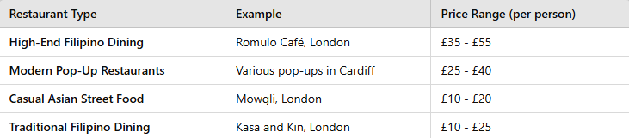

Pricing Strategy for Tara! Pop-Up Kitchen
Tara! will adopt a value-based pricing strategy, ensuring that prices reflect the quality, unique flavours, and overall customer experience. The menu pricing will be positioned in the mid-to-premium range:
- Starters: £6 - £9
- Mains: £14 - £22
- Desserts: £6 - £9
- Signature Drinks: £4 - £7
This pricing structure ensures that Tara! remains competitive while maintaining the perception of value and quality.
Positioning Map
Below is a positioning map comparing price and quality perception, showing where Tara! Pop-Up Kitchen sits in relation to competitors.
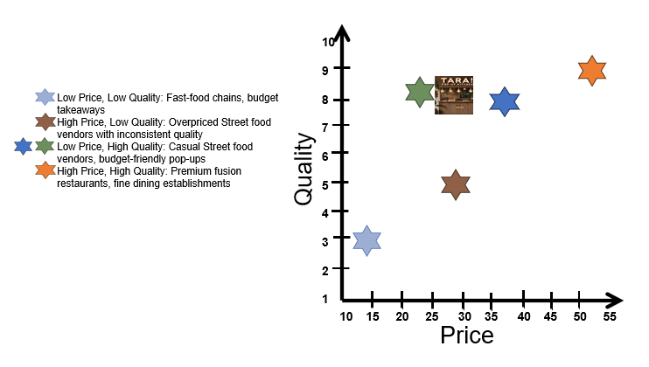
Tara! Pop-Up Kitchen sits between high-end Filipino dining and modern pop-up restaurants, offering premium quality at an accessible price.
By adopting this pricing strategy, Tara! ensures a strong competitive edge, balancing affordability with premium-quality dishes.
Promotion
Promotion is a continuous communication process between a business and its customers to foster positive attitudes toward its products and services, which influences consumer purchasing behaviour (Novak, 2011). The key promotional goal for Tara! Pop-Up Kitchen is to increase brand awareness, attract food enthusiasts (ages 25-50) eager to explore Filipino cuisine with a modern twist, and build customer engagement around the unique use of locally sourced Welsh ingredients in traditional Filipino dishes. This approach aligns with Novak’s (2011) view that promotion helps create favourable perceptions, driving customers toward the product.
Promotion also plays a significant role in assisting sales teams and traders in representing products to consumers effectively, inducing them to make a purchase (Singh, 2012). To this end, Tara! Pop-Up Kitchen will use various promotional tactics to ensure that its Filipino-inspired dishes, made with Welsh produce, are introduced to the target audience in an appealing manner. These tactics will include engaging content on social media, collaborations with local influencers, and hosting immersive pop-up events that highlight the unique cultural fusion of the brand.
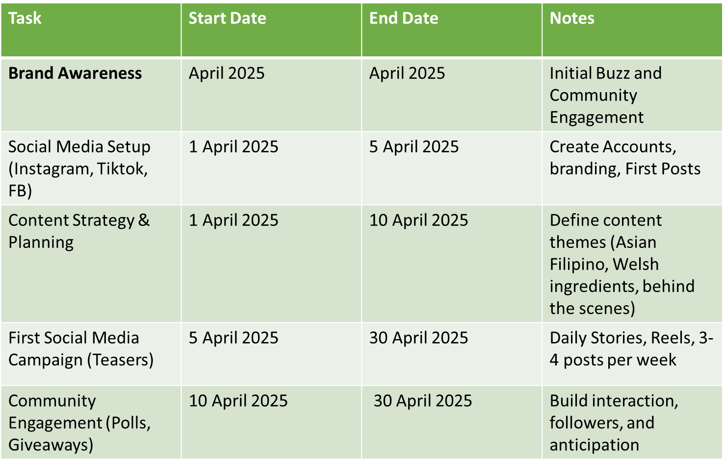
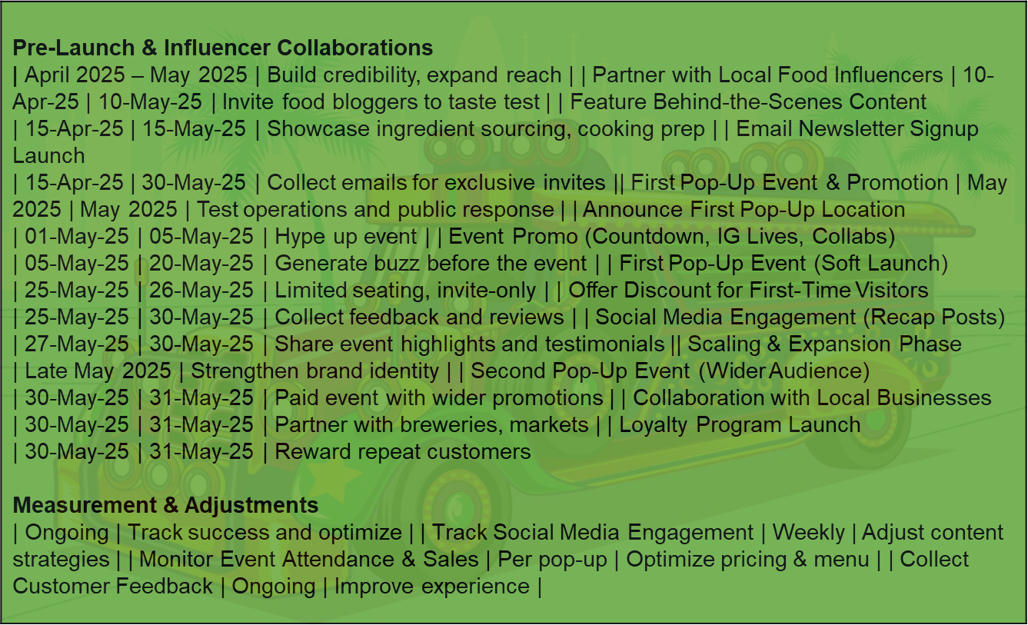
Sample Approach for Tara! Pop-up Kitchen
- April builds hype and online engagement.
- May focuses on pop-up execution and growing the audience.
- Low-cost, high-impact strategy using social media, influencers, and community engagement.
- Scalable—if the first pop-up succeeds, you can expand quickly.
Conclusion
Tara! Pop-Up Kitchen, with its unique blend of Filipino cuisine and Welsh produce, presents a promising culinary concept. However, as with any new business venture, it faces challenges in developing a marketing plan that resonates with the target audience while ensuring operational success. These challenges range from defining the brand and creating the right ambiance to effectively engaging the target audience and managing planning and finances. To address these hurdles, several strategic recommendations can help overcome the obstacles and set Tara! Pop-Up Kitchen on the path to success.
One of the primary challenges lies in brand development and positioning. Tara! Pop-Up Kitchen aims to stand out by offering adventurous and locally sourced dishes that combine Filipino culinary traditions with Welsh ingredients. However, finding the right balance between staying authentic to Filipino flavours while incorporating modern Welsh influences can be a delicate task. The brand must communicate its unique identity clearly to its audience while avoiding confusion over its cultural roots. To address this, it is recommended to focused on brand storytelling, highlighting the narrative behind the concept, including the cultural fusion and the importance of sourcing ingredients locally. This can help create an emotional connection with potential customers, reinforcing Tara! Pop-Up Kitchen’s identity.
Another challenge lies in creating the right ambiance that reflects both Filipino culture and modern Welsh style. This task requires careful planning in terms of design, decor, and atmosphere to ensure authenticity and contemporary appeal. A solution to this challenge would be to integrate Filipino aesthetics through colour schemes, materials, or design elements that are emblematic of the Philippines, while incorporating sleek, modern Welsh influences. This balance will not only create an inviting atmosphere but also enhance the dining experience, offering customers a memorable environment in which to enjoy their meals.
Engaging the target audience, foodies interested in new, bold, and locally sourced dishes presents another obstacle. Since Tara! Pop-Up Kitchen is a new concept, attracting the right audience and creating a community around it can be challenging. Effective social media marketing is essential here, and leveraging platforms like Instagram and TikTok can be particularly impactful for a pop-up kitchen. It is recommended to collaborate with local influencers and food bloggers who share an interest in unique and adventurous dining experiences. Their endorsement can help build credibility and spread the word about the kitchen’s offerings. Additionally, interactive content such as behind-the-scenes videos, cooking demos, and customer testimonials can keep the audience engaged and excited about the brand.
From an operational standpoint, managing a pop-up kitchen comes with the challenge of logistical operations. Sourcing fresh, local produce and ensuring consistent quality in a temporary setup can be difficult. To navigate this, Tara! Pop-Up Kitchen should develop strong partnerships with local producers and suppliers, ensuring that the kitchen has access to high-quality ingredients while supporting the local community. This will also help to maintain the authenticity of the dishes, as well as reinforce the kitchen’s commitment to using Welsh produce. Establishing streamlined planning for ingredient delivery and storage will also minimize potential challenges in maintaining the flow of service.
Finally, one of the most pressing concerns for any business is the financial aspect. Budgeting for ingredients, labour, and marketing efforts, while ensuring profitability, can be particularly tricky for a pop-up business with limited resources. To tackle this, I recommend a flexible financial plan that allows for adjustments as the business grows. Running smaller-scale pop-up events initially will help gauge customer demand, optimize operational efficiency, and fine-tune the menu. Keeping tight control over expenses, especially during the initial stages, while being open to adjustments based on customer feedback will help keep Tara! Pop-Up Kitchen financially sustainable.
Tara! Pop-Up Kitchen has exciting potential, but the challenges of establishing a strong brand, creating the right ambiance, engaging the target audience, and managing planning and finances must be addressed. By focusing on brand storytelling, refining the ambiance, leveraging social media for customer engagement, partnering with local producers, and being adaptable with finances, Tara! Pop-Up Kitchen can successfully overcome these challenges. With careful planning and strategic execution, Tara! Pop-Up Kitchen will be well-positioned to thrive in the competitive food scene.
References
Aaltojärvi, I., Kontukoski, M., & Hopia, A. (2018). Framing the local food experience: a case study of a Finnish pop-up restaurant. British Food Journal, 120(1), 133-145.
Abdullah, F., Abdullah, T. F., & Abdullah, M. F. (2016). Effects of marketing mix on customer satisfaction : empirical study on tourism industry in Malaysia. International Journal of Applied Research, 2(2), 357–360.
Anozie, U. (2013). SEGMENTATION, TARGETING AND POSITIONING. Principles of Marketing: A Value-Based Approach.
Ansoff, H. I. (1957). Strategies for diversification. Harvard business review, 35(5), 113-124.
Basu A., (2022). Pros and Cons of Open Kitchens in the Restaurant Industry Available at: https://modernrestaurantmanagement.com/pros-and-cons-of-open-kitchens-in-restaurant-industry/ (Accessed on 18 February 2025)
Bennett, A. R. (1997). The Five Vs - A Buyer’s Perspective of the Marketing Mix. Marketing Intelligence & Planning,15(3), 151-156.
Bidfood, (2025). Food and Drink trends 2025. Available at: https://www.bidfood.co.uk/food-and-drink-trends-2025/ (Accessed on 25 February 2025)
Bitesize, (n.d). People. Available at: https://www.bbc.co.uk/bitesize/guides/z6jwhbk/revision/1 (Accessed on 2 March 2025)
Bitner, M. J. and Booms, H. (1981). Marketing Strategies and Organization: Structure for Service Firms. Donnelly, J. H. and George, W. R. (eds). Marketing of Services, Conference Proceedings. Chicago, IL. American Marketing Association.
Chong, K. W. (2003). The Role of Pricing in Relationship Marketing - A Study of the Singapore Heavy Equipment Spare Parts Industry, PhD Dissertation, International Graduate School of Management, University of South Australia.
Currie H., (2023). Want to get down with the kids? The answer is experiential dining. Available at: https://www.restaurantonline.co.uk/Article/2023/11/06/Young-consumers-like-social-occasions-and-experiential-dining/ (Accessed on 18 February 2025)
D'Aveni, R. A. (2007). Mapping your competitive position. Harvard Business Review, 85(11), 110-120, 154. Available at: https://europepmc.org/abstract/MED/18159791 (Accessed on 4 March 2025)
Duncan, E., & Elliott, G. (2004). Efficiency, customer service and financial performance among Australian financial institutions. The International Journal of Bank Marketing, 22(5), 319- 342.
Ehmke, C., Fulton, J., Lusk, J. Marketing’s Four P’s: First Steps for New Entrepreneurs. Department of Agricultural Economics. Available at: https://www.extension.purdue.edu/extmedia/ec/ec-730.pdf (Accessed on 4 March 2025)
Eveentflare, (2024). Pop-up Dining Experiences: The Hottest Catering Trend. Available at: https://eventflare.io/journal/why-pop-up-dining-experiences-are-the-hottest-catering-trend (Accessed on 18 February 2025)
Gan, C., Clemes, M., Wei, J., & Kao, B. (2011). An empirical analysis of New Zealand bank customers’ satisfaction. Banks and Bank Systems, 6(3), 63-77.
Gronroos, C. (2011, February). A Service Perspective on Business Relationships: The Value Creation, Interaction and Marketing Interface. Industrial Marketing Management, 40(2), 240-247.
Helm, R., & Gritsch, S. (2014). Examining the Influence of Uncertainty on Marketing mix Strategy Elements in Emerging Business to Business Export-Markets. International Business Review, 23, 418-428.
Intal, G. L., Payas, J. D., Fernandez, L. M., & Domingo, B. M. (2020). Restaurant Information System (RIS) with QR Code to Improve Service Operations of Casual Fine Dining Restaurant. In 2020 IEEE 7th International Conference on Industrial Engineering and Applications (ICIEA) (pp. 1054-1059)
Jain, R., Jain, S., & Jain, S. (2022). Analyzing and exploring the effectiveness of each element of 7Ps of marketing mix. International Journal of All Research Education and Scientific Methods (IJARESM), 10(1), 2455-6211.
Janakiraman, M. (1998). Marketing mix in the context of library & information products & services. DESIDOC Journal of Library & Information Technology, 18(3).
Khorsheed, R. K., Abdulla, D. F., Othman, B. A., Mohammed, H. O., & Sadq, Z. M. (2020). The Role of Services Marketing Mix 7P's on Achieving Competitive Advantages (The Case of Paitaxt Technical Institute in Kurdistan Region of Iraq). TEST Engineering and Management, 83, 15947-15971.
King, M., (2024). 15 Pop-Up Restaurant Ideas You Can Try + Examples. Available at: https://www.therestauranthq.com/startups/pop-up-restaurant-ideas/ (Accessed on 18 February 2025)
Kushwaha, G. S., & Agrawal, S. R. (2015). An Indian customer surrounding 7P׳ s of service marketing. Journal of Retailing and consumer services, 22, 85-95.
Leirdal, K. N., Kwiatkowski, G., & Dragin-Jensen, C. (2024). Cooking Up Prosperity: Pop-Up Restaurants, Innovation, and Lifestyle Entrepreneurship. Gastronomy and Tourism, 8(1), 35-47. Available at: https://doi.org/10.3727/216929722X16354101932438 (Accessed on 18 February 2025)
Loredana, E. M. (2016). The use of Ansoff matrix in the field of business. In MATEC Web of Conferences (Vol. 44, p. 01006). Les Ulis, France: EDP Sciences.
Lovelock, C., Patterson , P., & Walker, R. (2001). Services Marketing. Sydney, Australia: Pearson Education.
McCarthy, E. J. (1960). Basic Marketing, A ManagerialAapproach. IL: Richard D. Irwin.
McCarthy, E. J. (1964). Basic Marketing, IL: Richard D. Irwin.
Metro, (2024). The Rise of Pop-Up a Concept Restaurant and What Sets Them Apart. Available at: https://metroxp.com/the-rise-of-pop-up-a-concept-restaurant-and-what-sets-them-apart/ (Accessed on 18 February 2025)
Milwood, P., Hartman-Caverly, S., & Murray, S. (2022). A Pop-up Restaurant Business Guide for Capstone Hospitality Entrepreneurship Education. Pennsylvania State University.
Mintel, (2025). UK Eating Out Review 2025. Available at: https://store.mintel.com/report/uk-eating-out-review-market-report (Accessed on 25 February 2025)
National Restaurant Association, (2023). Restaurant expectations vary with different age groups Available at : https://restaurant.org/education-and-resources/resource-library/restaurant-expectations-vary-widely-with-different-age-groups/ (Accessed on 25 February 2025)
Niroo, F. (2020). Exploring the Culinary Experiences of Visitors in Temporary Settings – The Case of Pop-up Restaurants (Master's thesis, University of Manitoba). Faculty of Graduate Studies, University of Manitoba. Winnipeg. Available at: http://hdl.handle.net/1993/35156 (Accessed on 18 February 2025)
Novak, D. (2011). Promotion as instrument of marketing mix. Engineering Management And Competitiveness, 510.
O’Brien J., (2025).MARKET SHIFT I left home aged 14 and lived in a bedsit above a shop – now my pop-up business turns over £700k. Available at: https://www.thesun.co.uk/fabulous/32972179/pop-up-club-tillie-peel-essex/?utm_source=chatgpt.com (Accessed on 18 February 2025)
Othman, B., Harun, A., Rashid, W., & Ali, R. (2019). The impact of Umrah service quality on customer satisfaction towards Umrah travel agents in Malaysia. Management Science Letters, 9, 1763–1772.
Oxford College of Marketing, (2023). Understanding The 7Ps of The marketing Mix. Available at: https://blog.oxfordcollegeofmarketing.com/2020/10/08/understanding-the-7ps-of-the-marketing-mix/ (Accessed on 25 February 2025)
Pret a Diner. 2013. “Pret a Diner Berlin—Backstage, Pt. 2.” Last modified February 22, 2013. YouTube video, 3:11.https://youtu.be/oFSbwCNxfcc.(Accessed on 1 March 2025)
Review, H. B., & Silk, A. J. (2015). What Is Marketing?. Harvard Business Review Press.
Rowlands E., (2023). The rise of Cardiff's food pop-up scene and the ones that need to be on your radar. Available at: https://www.walesonline.co.uk/whats-on/food-drink-news/rise-cardiffs-food-pop-up-26817295 (Accessed on 3 March 2025)
Sadq, Z. M., Ahmad, B. S., Sulaiman, V., Saeed, H., Othman, B., & Mohammed, H. O. (2020). The relationship between intellectual capital and organizational trust and its impact on achieving the requirements of entrepreneurship strategy ( The case of Korek Telecom Company , Iraq ). International Journal of Advanced Science and Technology, 29(02), 2669–2682.
Saha, M. (2020). Customer engagement with 7 PS of Marketing. Available at SSRN 3540310.
Salloum, C., & Ajaka, J. (2013). CRM Failure to Apply Optimal Management Information Systems: A Case of Lebanese Financial Sector. Arab Economics & Business Journal, 8, 16-20.
Singh, M. (2012). Marketing mix of 4P’s for competitive advantage. IOSR Journal of Business and Management (IOSRJBM, 3(6), 40-45
Sqauremeal, (2025). Romulo Café. Available at: https://www.squaremeal.co.uk/restaurants/romulo-cafe_10993 (Accessed on 3 March 2025)
Statista, (2025). How often do you eat at a restaurant with table service?* . Available at: https://www.statista.com/statistics/1135418/eating-at-full-service-restaurants-frequency-by-age-united-kingdom/ (Accessed on 25 February 2025)
T H, Shreeja and S, Vigneshwar, Integrated Restaurant Service Using POS System (October 30, 2019). International Journal of Emerging Technology and Innovative Engineering Volume 5, Issue 10, October 2019 (ISSN: 2394 – 6598), Available at SSRN: https://ssrn.com/abstract=3477725 ( Accessed on 2 March 2025)
Tripadvisor, (2025). Kasa and Kin Contemporary Restaurant. Available at: https://www.tripadvisor.co.uk/Restaurant_Review-g186338-d23758737-Reviews-Kasa_Kin_Contemporary_Restaurant-London_England.html (Accessed on 3 March 2025)
Tripadvisor, (2025). Mowgli Street Food. Available at: https://www.tripadvisor.co.uk/Restaurant_Review-g186460-d17740957-Reviews-Mowgli_Street_Food-Cardiff_South_Wales_Wales.html (Accessed on 3 March 2025)
TWC, (2022). YOUNGER CONSUMERS ARE MORE LIKELY TO PAY EXTRA FOR SUSTAINABLE CHOICES WHEN EATING OUT. Available at: https://twcgroup.net/younger-consumers-are-more-likely-to-pay-extra-for-sustainable-choices-when-eating-out/ (Accessed on 18 February 2025)

Appendices
1.


