Name: Abubarkar DEMBELE.
Student number: 2128085.
Module name: Learning in the Digital Era.
Assignment Title: Assignment component 1: E-Portfolio

- Essential skills

Employment skills are transferable skills that are important in a person to make them capable to perform at a job. This skill includes different personal and professional skills in addition of technical and academic skills.
You also achieve these skills through team activities and a personal development plan (PDP).
Team activity is essential to develop different skills from others and it is important for getting a job.
Team working skills are one of the basic requirements for employment through the team working you can gain experiences and skills facing different issues and situations.
You also need communication skills because is the most important to work in a team, you need communication skills for transferring and exchanges of information it is very important to listen to others before answering them, you need to adapt with your communication skill it will make you ready for face-to-face exchanges if you introvert.

Study skills are the variety of techniques and behaviour you need for effective learning, with time and experience you master most of them some are very hard that is the point in life the hardest thing takes time to master it but ones you master them you will find it easier to study.
Succinctness is useful for taking notes and essays.
Organisation is important for effective studying.
Self-disciplined is needed to meet deadlines and achieve academic goals.
Writing-skill is needed to write essays, reports and is the most common and difficult skill to master.

- Technical skill, Communication skill, Self- Discipline and Digital skills will support you in your chosen career after graduation.
Spending time on improving your skills will help you a lot achieving your career goal in computing after graduation, it will also help you to progress as a student and getting a job. You will need to combine your abilities, qualities and experience including soft skills, organization and leadership skills as well, you will also need technical skills for research, computer programming, accounting and more.

- My score on the Turnitin draft similarity check is 32% to improve this I will need to start my assignment earlier and have time to rewrite properly everything, this is my first year and been out of education more than 10 years, I am starting to get into it and with more motivation and perseverance I am sure I will improve it and dedicate all my time in to studying.

- I think my score will be GOOD 50-59%, I am sure that I can do better will dedicate my time to this course because its what I wanted long time and now had the chance so I will not throw it away

- My E-Portfolio and Video Presentation

YouTube Link:
https://youtu.be/uhVUtvTA5-c

PowerPoint Link:
Presentation of E-Portfolio.pptx

- Mendeley automatic referencing tool user guide

An automated referencing software is a tool to manage citations.
In figure 1, the screenshot of Mendeley’s main screen

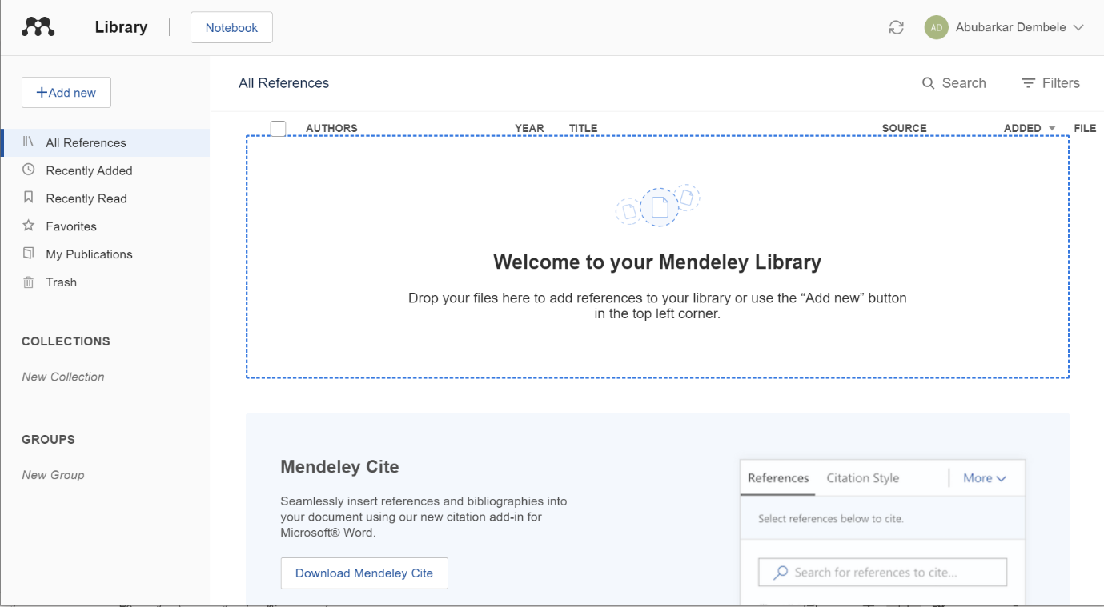

In figure 1, the title menus are shown on the top left corner
This is Mendeley desktop first thing that you need to do is to install all add-ons, to do that you will go to the tool’s menu, and you will click on web importer and install MS-Word Plugin. Once does are installed you are ready to go.
And afterward, first thing you do is populate your reference management tool, in this case is “Mendeley”, like much any software you are always going to have to populate first before you can go and drop citation into a document.
Thankfully, Mendeley has a few ways to do this and some of them are easy.
The first option you have into terms of bringing your citation or bringing you literature into Mendeley is quite simple just drag and drop the PDF file that you have into the interface. It will be listed, and it is fully populated it is on the right side of the interface it includes the year, the volume, the issue, abstract etc.
This is handy and can save you time. There is however a massive limitation, and it works for journal articles. If you are importing anything other than a journal article, like a chapter of a textbook it probably will not be as good because it might not have the right information, what is good about dropping PDF files straight in to Mendeley is that it goes and saves that you will see it down at the bottom right in the interface it will save it into software.

- Becoming an effective Team Member

You cannot be selfish if you are working in a team for example, you cannot play alone against 11 players in a football match, everyone got a role and need to be committed to it. Everyone needs to support each other and understand help each other having a good team means you will always have a positive result. The hardest part is to make everyone listening and accepting they are roles but with experience and leadership skills you can always make it work.
You can learn a lot from other people, and you might not have any idea for solutions, you need others to make a good job by challenging yourself and trying to bring the best ideas on the table you also inspire others to be like you so its good to be competitive especially when you work in with a team.

Working with a team boosts creativity and performance while working individually might sound more comfortable it will not help for your career or academic life, do not be selfish surround yourself with diverse teammates you might learn a lot from it.

Working as a team is beneficial and require a manager for rewarding the team.

To become a good Team Player, you need a set of skills and adapt with others and here are teamwork skills that are essential for your academic and professional success:

Communication: is one of the basic skills needed for working with a team, when you will be working on a presentation with classmates you will need to talk openly and honestly with your group members about your expectations, deadlines and responsibilities.
When disagreement occur, you will need to be upfront and respectful in your communication with other team members to solve the issue.

Time management: Managing your time, keeping track of your responsibilities and being accountable are qualities you need for your career and academic life.
You will need to set up manageable goals for yourself and your team for that you will need a good organizational skill.
For example, nurses need a good time management skill because they need to organise their tasks and have time for patients who needs extra attention.
If you can learn how to balance deadlines and assignments in your academic life, you will be prepared to cope with the fast-paced at work in future.

Problem solving: To become a good problem solver you need to think outside the box when you are faced with challenges and issues, you will need to stay calm and not focus on the negative outcome that way you will be able to see anything that is negative and that blokes the success of yourself and your team.

Listening: It is important to be open minded when you are working with a group, you need to understand that people see things differently it means you need to listen to them, and by listening you can solve a problem that you never faced before or knowing how to solve it.
Listening allows you to know everyone needs and challenges in advance so you can anticipate and respond effectively to them.

Critical thinking: You can make better decisions when you use critical thinking. It is easier to follow the group’s decisions or a team member’s ideas, but it is better to have a different or new approach it can deliver better results for the team.
When you examine all side of a situation reflect on past-experience and listen to opinions of others, it will be easier for you to come prepare a best plan that will move your team forward to a new best direction.

Collaboration: Working in a team can de challenging sometimes, but it is the best way to get new ideas, share different perspectives and develop your own skills. Teamwork can be improved if you treat each group project as a learning experience.
Willing to learn and explore new approaches will make you a better manager, supervisor, or leader.

Leadership: When a leader works with others, he or she spread knowledge and resources develops, new leader and it is important for the team and the organization. By encouraging, collaborating and motivating others to learn, grow and advance, a leader can demonstrate a strong teamwork skill.
Team identity: Getting individuals to work together, you need to encourage them to think of themselves as a unit with a clear identity, accepting responsibility for, ownership of, the task at hand and holding each other accountable for delivering the solution.
This will increase the level of commitment to a common goal on the part of individuals.
You need to encourage regular contact among team members by holding team building lunches, social events, and use electronic mailing systems so every team member has access to all information.

Shared vision: A clear shared vison of the future as the focus of one’s efforts helps most people perform better. In the same way a team that takes time to develop a shared vison, it will perform better.
The vison motivates and inspires team members, commit them to the task and convince them that working together rather than individually will make them succeed.

It is also important to have a reflection and self- assessment of the team members because they need to know what teamwork means. You need practical steps to promote reflection and self-assessment.
Try to make sure everyone is honest int the feedback reviews and review the teamwork process regularly, potentially at every meeting.
You need to be sure team members see themselves as a part of a single unit with joint responsibility for any task in hand and if the team identify for itself a challenging shared vison and is it committed to its delivery?

Link of the A3 poster:

Life is a Team Sport A3 poster.docx

Appendix:

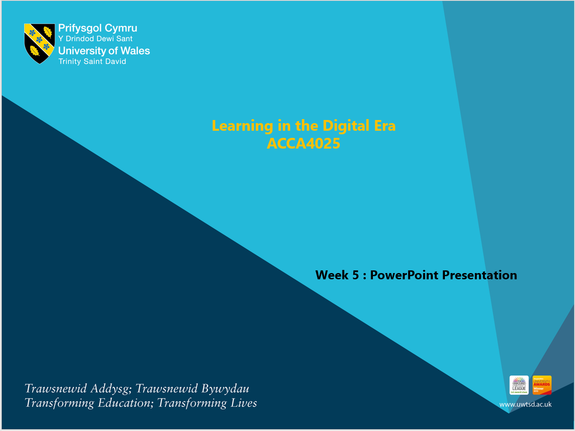

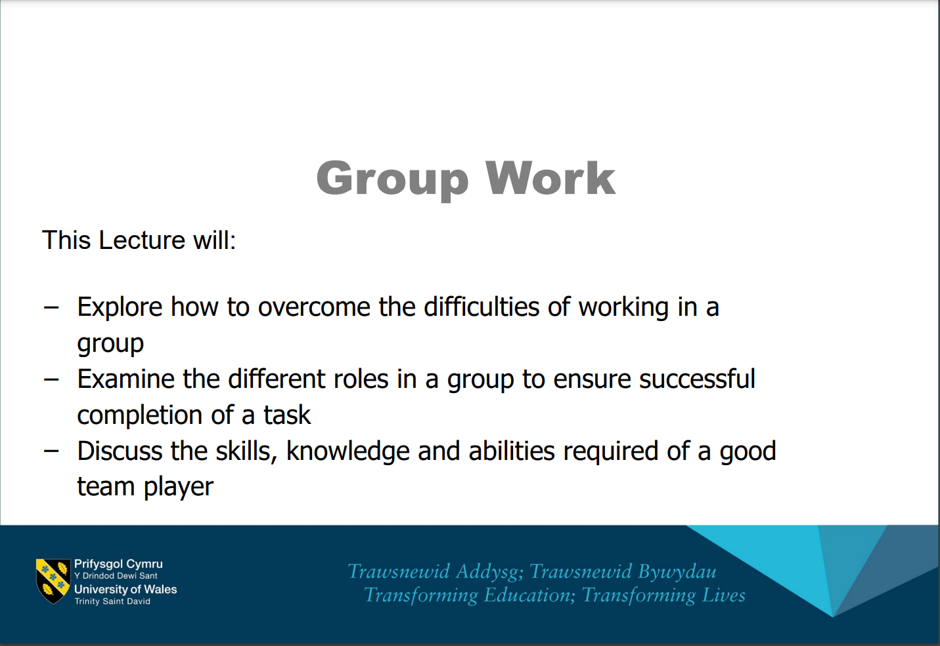

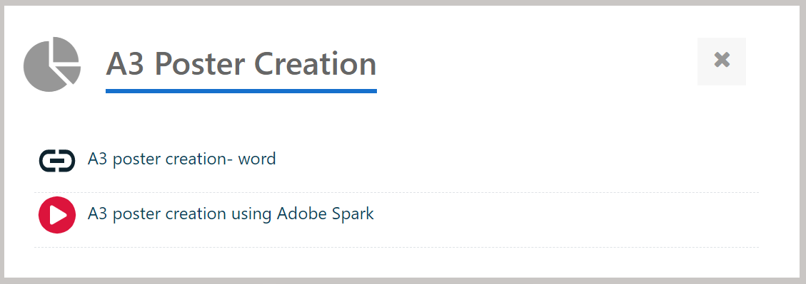

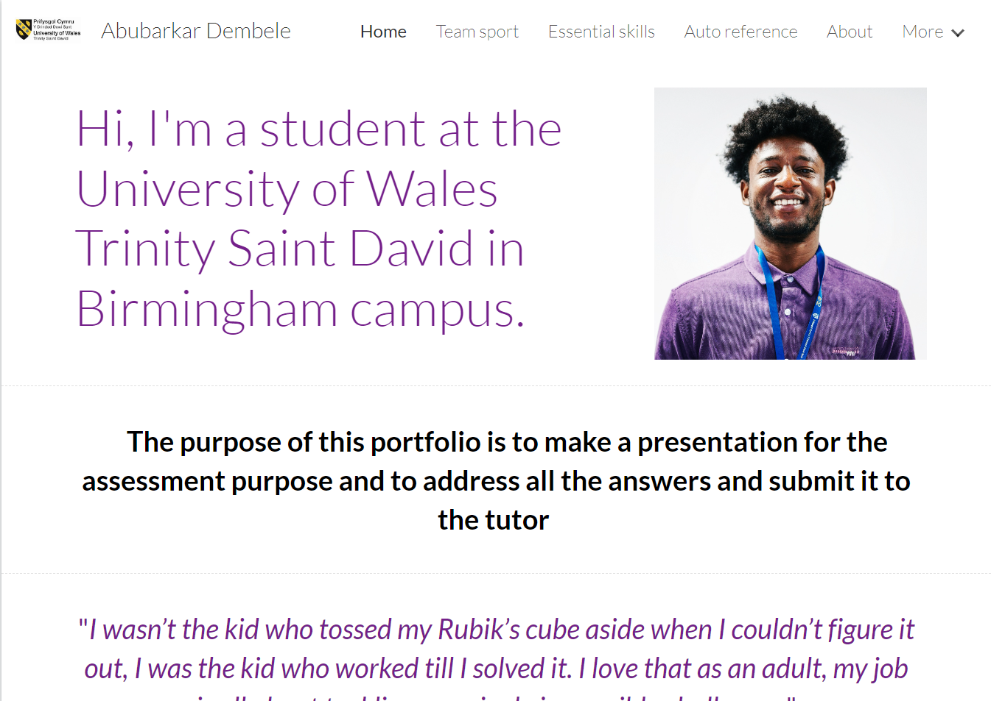

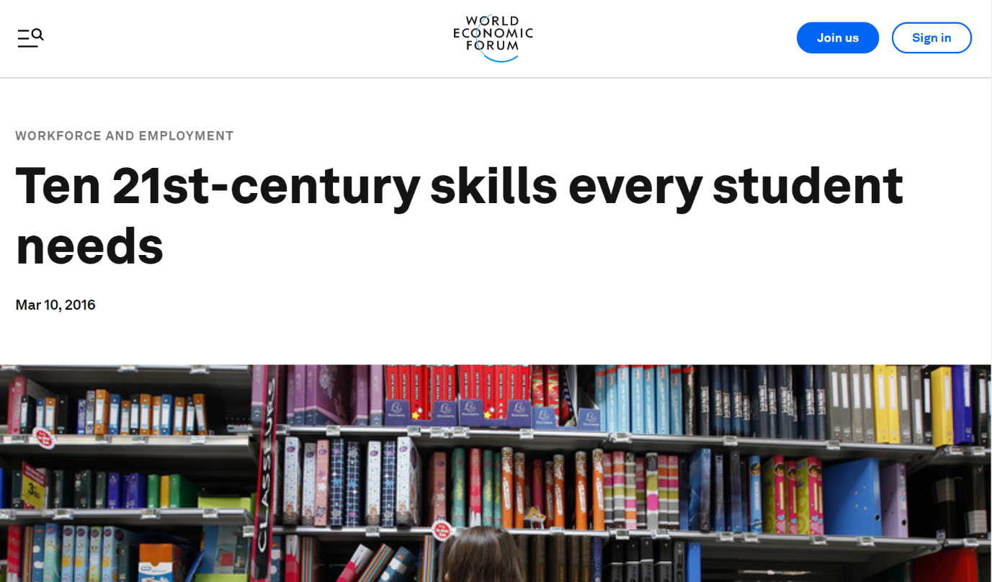

References:
- Desklib.com, “Essential Study and Employment Skills (pdf),” https://desklib.com/document/essential-study-and-employment-skills-83iz/
- Essayzone.co.uk,” 26 essential study skills « Essay writing help and study advice,” http://www.essayzone.co.uk/blog/26-essential-study-skills/
- Indeed Career Guide,” How to Develop Your Skill Set to Advance Your Career | Indeed.com,” https://www.indeed.com/career-advice/career-development/how-to-develop-your-skill-set
- Herzing University,” 7 Important Teamwork Skills You Need in School and Your Career,” https://www.herzing.edu/blog/7-important-teamwork-skills-you-need-school-and-your-career
- 2022. [ebook] Available at: <https://constructingexcellence.org.uk/wp-content/uploads/2015/03/Teamwork_Guide.pdf> [Accessed 1 August 2022].
- Foundr,” The Importance of Teamwork in 2022 (As Proven by Data),” https://foundr.com/articles/leadership/teamwork (A3poster)
- K.M. Bartol, L.L. Hagmann
Team-based pay plans: A key to effective teamwork
Compensation and Benefits Review, 24 (6) (1992), pp. 24-49

