Case Study Comparing and Contrasting Both a Concrete Frame Building and Steel Frame Building

Introduction:
This case study will compare and contrast a concrete frame building and a steel frame building. It will demonstrate the properties of both materials and how durable and sustainable they are in their given locations. Analysis of the impact of the frames original production processes on the environment will also be undertaken. In addition, the ease of assembly of each frame together with ease of adaptation (if required) throughout the buildings’ life cycles will be determined.

Having considered numerous steel frame buildings such as the Willis Tower Chicago, America and the Burj Khalifa, Dubai, United Arab Emirates, I have decided to research Lake Shore Drive Apartments, Chicago, Illinois, USA. Having considered numerous concrete buildings such as Villa Saitan, Kyoto, Japan and, Habitat 67, Montreal, Canada, I have decided to research Unitè d’habitation, de Marseille, France.

Steel Construction – Lake Shore Drive Apartments
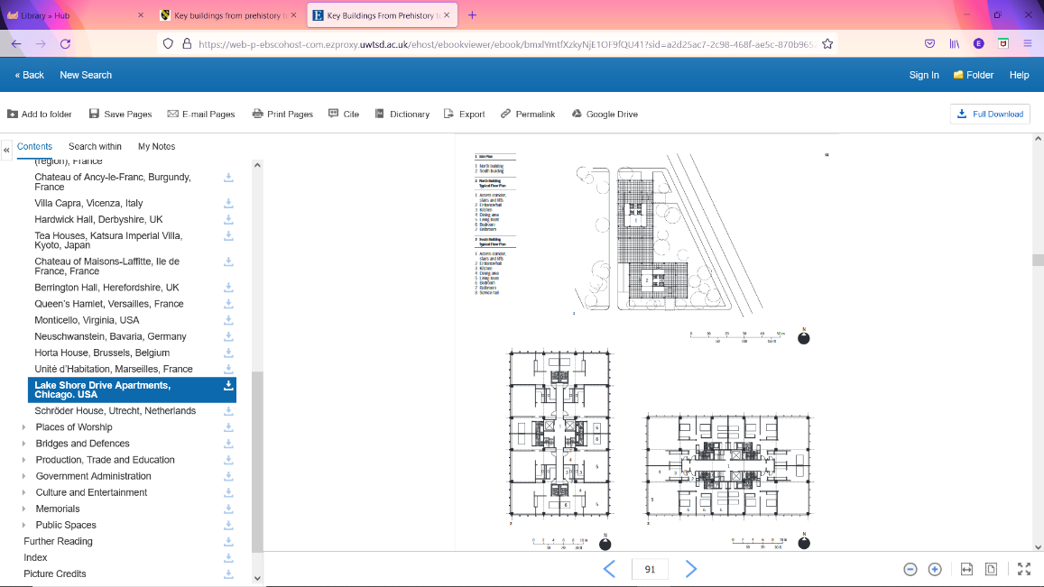
Lake Shore Drive Apartments, designed by Ludwig Mies van der Rohe was built between 1949 and 1951. The frame is constructed from steel rather than the steel being hidden behind brick or stone, it has been left for architectural affect, with glass between the steel frame members (Ballantyne, 2012, p. 90).
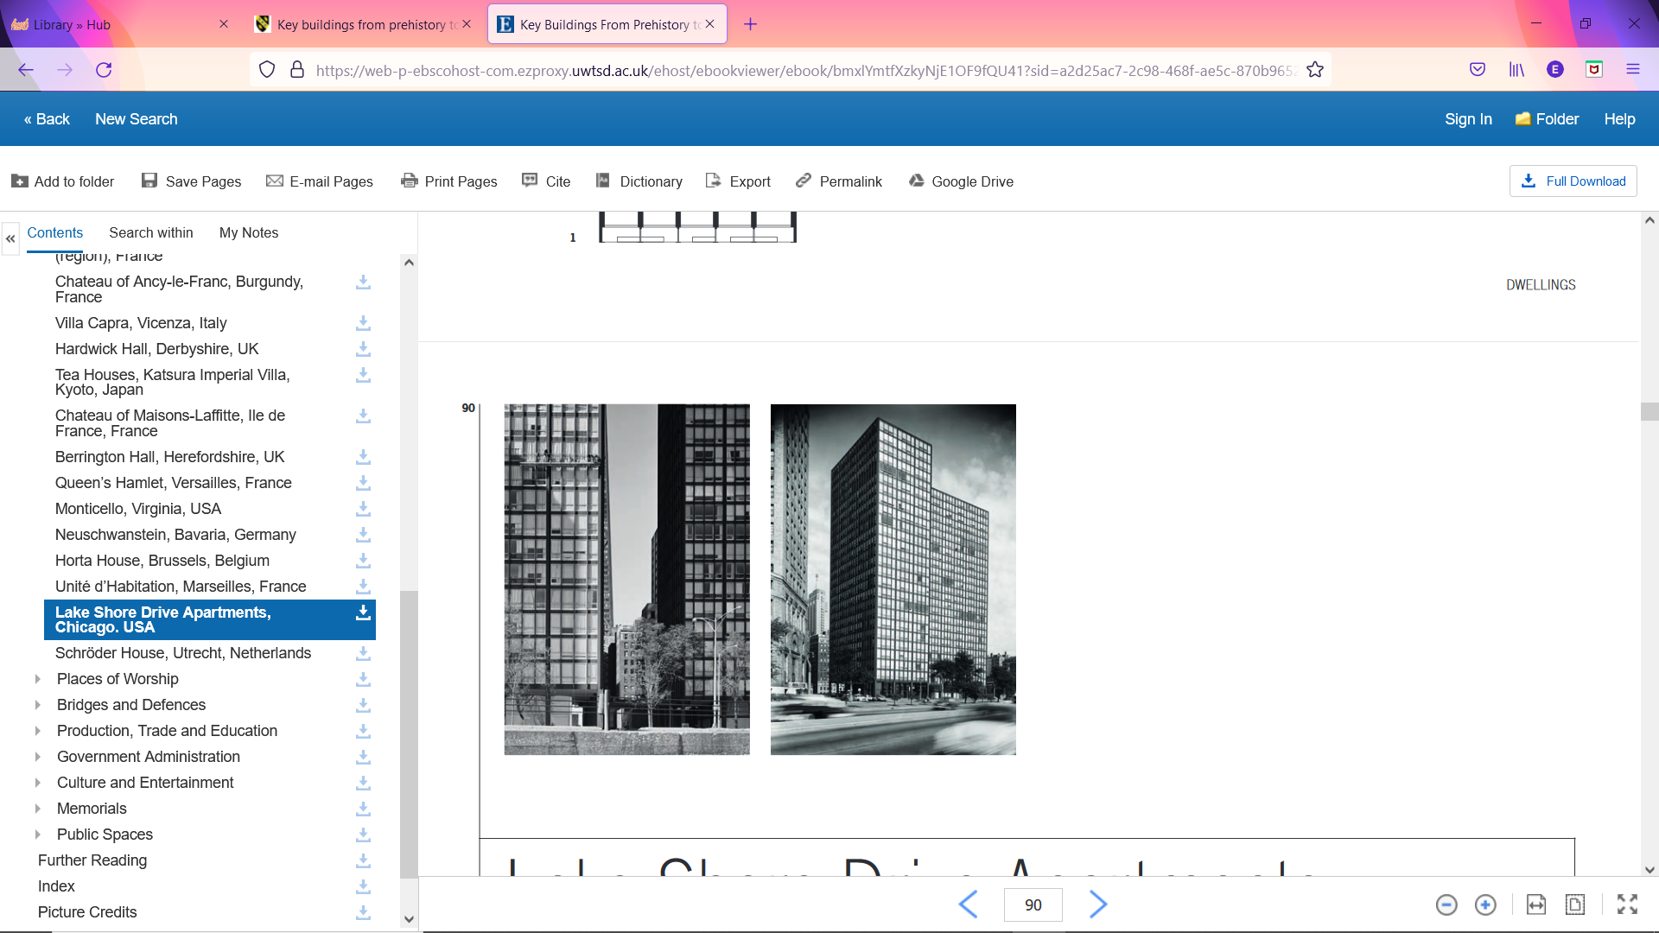
Fig. 1
Fig. 2
Fig. 1 & 2 (Ballantyne, 2012)
Concrete Construction – Unitè d’habitation
Unitè d’habitation, designed by Le Corbusier (Charles-Edouard Jeanneret) was built between 1947 and 1952. The frame is constructed from flat concrete slabs supported by concrete posts. The apartments are also cast in concrete and were cast at ground level and hoisted into position within the frame (Ballantyne, 2012, p. 88).
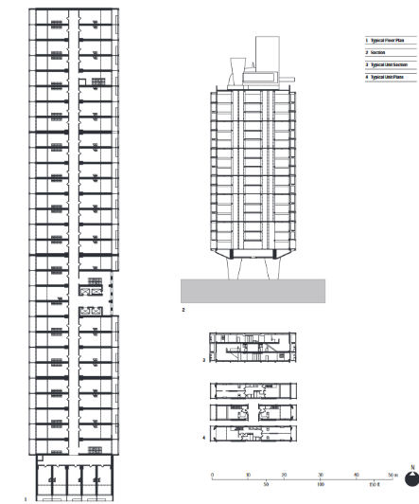
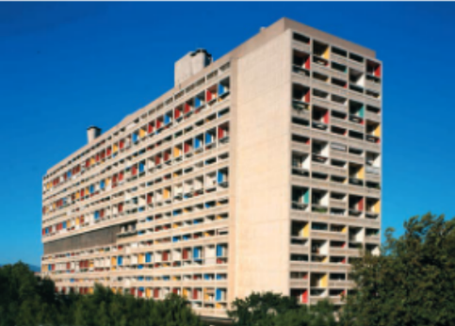

Fig. 3
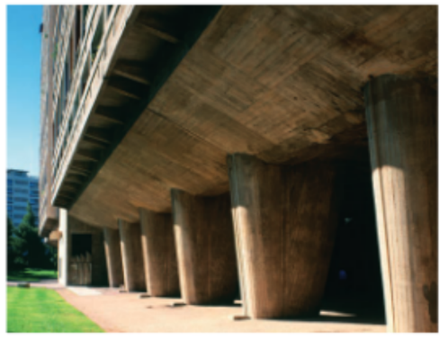

Fig. 4 Fig. 5

Fig. 3,4 & 5 (Ballantyne, 2012)

Durability and Climatic Resistance:

Chicago, Illinois has a similar weather system to Marseille, France however Lake Shore Drive Apartments is next to Lake Michigan which is an additional factor affecting the weather system. “The larger thermal mass of the lake tends to moderate temperatures, causing cooler summers and warmer winters.” (Angel, 2021). The lake also causes a breeze and lake-effect snow. Lake Shore Drive Apartments is also subject to a large number of storms and sees moderate variations in the type and amount of precipitation. Due to the weather conditions in this area, steel is a very good choice of material, and as such should lessen the risk of structural faults within the building.


Fig.6

Fig. 6 (Anon., n.d.)

Figure 6, show shows a generic week of the weather in Chicago, Illinois. The temperature and precipitation varies widely on a day by day basis. Due to changeable weather conditions, the use of steel in buildings is well suited as a material of choice. This is due to “Steel being the most ferrous metal in building construction (Taylor, 1994).” This means that steel is a very strong material. It has many properties such as its incredible durability. It can withstand bad weather conditions due to its molecular make up, which includes strong raw materials such as strong metals like iron.


Fig. 7

Fig. 7 (Anon., n.d.)
Figure 7 demonstrates Unitè d’habitation has a similar weather forecast in terms of precipitation to the Marseille, France, however, the temperatures does not vary as widely. Therefore, implying that the temperature is more consistent over a period of time.

As Unitè d’habitation is constructed of concrete the cold weather could have an effect on the buildings infrastructure. Cold temperatures slow down the curing process of making concrete. If the curing process is slowed it means that time scale of the construction project will be extended therefore adding cost to the project. Also due to weather conditions if there is rainfall, it could affect the shape of the concrete pour. During high spells of rain, no concrete will be able to be poured. This would be due to the rain integrating with the concrete mix. In high heats concrete could crack. If a crack grows it could lead to a structural fault and this could result in either a partial or complete collapse of the building.

Given the durability of steel, construction can be undertaken under most weather conditions. Steel can withstand rain and hot weather. Wind however, may pose a danger, this would be due to the wind causing steel beams to move more freely while using machinery such as cranes. Due to its ductility, steel can also take on many shapes and is easily adaptable.

Framing Material Impact on the Environment
Lake Shore Drive’s pre-fabricated components were constructed in a controlled environment using “8 inch wide-flange steel” (Perez, 11 May 2010). This construction process allows for minimal error during production. Less waste is generated in this type of process, which reduces the environmental impact. When steel is made in factories, machines have to be used which generate large amounts of smoke which is the emitted into the atmosphere, “ its environmental impact has always been substantial” (Costa, 1990). With many factories worldwide creating steel various amounts of smoke is generated increasing global warming and damaging the environment.

An alternative source of power would be to use electrical powered machines which would not pose harm on the environment. As time progresses more electrical tools and machines are being introduced, to limit the damage of global warming. There are some machines that can dispose of smoke safely and efficiently, therefore reducing the amount of environmental damage.

As the construction industry progresses and grows so does modern technology and sources of power. Having access to modern technology allows for more efficient and eco-friendly machines to be used to produce steel. Currently, “The total quality of by-products… with non-phosphorous iron ore is about 700 kg/t of steel” (Costa, 1990). With advancing technology this number can be reduced and help protect the environment and prevent waste of material and damage on the environment.

During the production of steel, biproducts such as slag is created. The slag can then be sold back into the construction industry to be used in the production of concrete. Using this method of recycling, environmental pollution is reduced and the slag which was to be disposed of, creates a cycle of production, keeping the construction industry going. Also, by reusing materials, less materials need to be made, allowing for more storage, thereby causing less impact on the environment and only one process would need to be undertaken. As more materials can be stored less transport journeys would be needed, preventing more unnecessary journeys and therefore reducing pollution from harmful gases in the atmosphere. If this cycle of large shipments continue global warning will stay on an incline and will always be a danger to the environment.

Unitè d’habitation’s frame was built from a structural system of flat concrete slabs supported by concrete posts, which meant that the external walls were not required to carry out a loadbearing function (Ballantyne, 2012, p. 88). Large amounts of concrete were required to build Unitè d’habitation. When making concrete, dust is created which is emitted into the atmosphere causing environmental damage. The more concrete that is required means more dust would be generated adding to the economic damage. An example would be using a large concrete mixer on a site which would create large amounts of dust which would then be emitted into the atmosphere causing harm. This on a small scale would have little affect although on a large scale it would have a massive effect on the environment. Creating steel and concrete both pose harm on the environment. Both processes create a bio-product damaging the environment. Every time that steel or concrete is form then there is an environmental impact. As the construction industry grows, there will be constant need for both materials and therefore the likelihood of additional environmental damage.

In modular buildings, steel would be commonly used due to its adaptivity and durability. Although concrete has a better constructed infrastructure ensuring that all components of the building are stable and secure. Also, with the use of concrete, large surfaces can be constructed faster, as the concrete can be poured into position.

Ease of Frame Assembly and Ease of Adaptation
Sections of the Lake Shore Drive Apartments were built using prefabricated components, making the frame more efficient and easier to construct. “Standard steel sections were manufactured for general use … they simply attached to the exterior frame” (Perez, 11 May 2010). As components in this type of construction were general, rather than bespoke, it means that they would have been easily accessible. Also, by using general components means that large amounts of material would be available to be transported in one shipment. Undertaking this method means that the groups of materials would be accessible at one given time, therefore construction can be continued in a continuous system. Having this system also allows for minimal error as all the materials would be provided, so there would be less chance of confusion within the site team. Due to using prefab construction the build would be quick and reduced delays due to the ease of assembly. Also, a less skilled workforce would be needed to erect a prefabricated building as less technical knowledge is needed.

Lake Shore Drive Apartments could have a various change during its life cycle. Re-using a building reduces the environmental impact. The buildings could be used for many different purposes such as offices and storage and would be an easy adaptation with minimal work to be carried out. By using prefabricated components in the current build it would allow for parts to be removed or remain in place. “Such sections are invariably hot rolled, taking advantage of the much greater ductility of steel at red heat” (Taylor, 1994). Re-using buildings can be the only chance for a renewed build to commence. In highly populated areas it is common for buildings to be renewed and recycled as they have a high-density population. Also, by adapting buildings it would mean that most of the common supplies are already in place, such as electricity and sanitary requirements. This would save time during conversion as less work would need to be undertaken. Although when converting buildings for different occupancies there may need to be a removal of services which could lead to more work being discovered. Some old services may need replacing or fixing depending on the date of installation and insurance cover.

Unitè d’habitation’s assembly was constructed by “ a structural system of flat concrete slabs supported by concrete posts” (Ballantyne, 2012, p. 88). This type of construction would be simple to erect. This method compared to building with steel would be relatively similar in terms of assembling the structure. Concrete can be premade in factories in a controlled environment ensuring that all measurements are correct, and the quality is precise. Also, concrete can be cast on site and filled into the correct position straight away. This would depend on what component of the structure is being made and how easy it would be to pour the mix into that shape.

Making the concrete components on site means that no storage space would be required, therefore saving the construction company money. The disadvantage of pouring concrete on site is that concrete needs to cure for a long period of time and during the process it may be weathered. Conditions such as rain could enter the concrete mix causing the shape of the mold to differ to the original shape. Also, by making the concreate mix on site there would be a higher risk of it not being precise compared to a pre-made cast.

By manufacturing concrete in a factory, it will be in a controlled environment. Having a controlled environment means that it will have a suitable place to go through the curing procedure. This would include a length of time for the components in the concrete mix to bind together. During the curing procedure the concrete sets and then hardens. It is important that this is undertaken in a dry, ambient area. If the temperature is too cold, the curing process may take longer to cure or may crack. After the hardening procedure the concrete can then be transported to the designated site. Once the concrete arrives on site it will then need to be situated in a suitable position. Large amounts of concrete components can be placed in situ and then joined together to form a structure.

If the building were to be adapted there could be a risk of the concrete cracking and the whole building collapsing. If the concrete structure was made with the correct mix and cured properly then there may not be an issue with adaptation. Adapting a concrete structure would be more challenging than a steel structure, this is because steel structures bolt together and can be removed more easily, although steel can corrode over time and the bolts may be difficult to undo, so may need to be cut apart, causing the whole structure to collapse.

With adapting steel structures, the main components could be taken apart and replaced with new ones. Adapting the inside of a steel building would be easier than a concrete building due to that the components can be taken out and replaced easier.

References
Angel, D., 2021. Climate of Chicago - Description and Normals. [Online]
Available at: https://www.isws.illinois.edu/statecli/general/chicago-climate-narrative.htm
[Accessed 24th October 2021].
Anon., 2021. Modern Trends in Research on Steel, Aluminium and Composite Structures : PROCEEDINGS OF THE XIV INTERNATIONAL CONFERENCE ON METAL STRUCTURES (ICMS2021), POZNAŃ, POLAND, 16-18 JUNE 2021. s.l.:Routlege.
Anon., n.d. marseille france weather, s.l.: https://www.google.com/search?q=marseille+france+weather&client=firefox-b-d&bih=995&biw=1920&hl=en-GB&sxsrf=AOaemvKk4jBCqtP8EmfI4cyzTHgrnR6g3Q%3A1638826936341&ei=uIOuYfmLFMqTxc8P7qeIuAg&oq=mar&gs_lcp=Cgdnd3Mtd2l6EAEYATIECCMQJzIECCMQJzIECCMQJzIECAAQQzIECAA.
Ballantyne, A., 2012. Key Buildings From Prehistory to the Present: Plans, Sections and Elevations. London: Lauence King Publishing.
Costa, E. d., 1990. https://www.researchgate.net/publication/327633282_By-products_and_waste_materials_in_steelmaking. [Online]
Available at: https://www.researchgate.net/publication/327633282_By-products_and_waste_materials_in_steelmaking
[Accessed 31 October 2021].
Kumar Mehta P., 2001. Reducing the Environmental Impact of Concrete. Concrete International, October, p. 66.
Perez, A., 11 May 2010. archdaily.com. [Online]
Available at: https://www.archdaily.com/59487/ad-classics-860-880-lake-shore-drive-mies-van-der-rohe
[Accessed 30 October 2021].
Taylor, G., 1994. Materials in Constrcution. s.l.:s.n.

