Student Name: Vimi Naiko
Student Number: 2120212
Lecturer Name: Robert Nartowski
Programme: BSc Health and Social Care
Module: Changemakers: Creativity and Value Creation
Module code: BMHP5014_BIRM

Assignment Title: E-Portfolio evidence of learning compromising of 2 separate artefact items.

Microbiome effect in Cancer

ARTEFACT TASK 2 Blog
Introduction
The role of the microbiome in cancer is an area of active research, and scientists are still uncovering the exact mechanisms by which the microbiome may impact the development and progression of cancer. However, here are a few ways in which the microbiome may affect cancer:
Metabolism
The microbiome can affect the metabolic pathways in the body and produce compounds that could have a pro- or anti-tumorigenic effect (Boulangé et al., 2016). For example, certain bacteria in the microbiome can produce metabolites that promote inflammation (Gérard et al., 2020), which is a known risk factor for cancer.
Immune system
The microbiome can also affect the immune system, either by suppressing or enhancing its ability to fight cancer (Schmitz et al., 2018). For example, a healthy microbiome can help train the immune system to recognize and attack cancer cells (Brown et al., 2019), while an imbalanced microbiome can lead to immunosuppression (Bailey et al., 2020), making it more difficult for the body to fight cancer.
Inflammation
Chronic inflammation is a known risk factor for cancer, (Coussens & Werb, 2002), and the microbiome can play a role In the development of inflammation (Sekirov et al., 2010). For example, imbalances in the microbiome can lead to increased levels of pro-inflammatory cytokines (Kumar et al., 2018), which can contribute to the development of cancer.

Hormonal regulation
The microbiome can also affect the levels of hormones in the body, including those that regulate cell growth and division. (Larsson et al., 2017). For example, imbalances in the microbiome have been linked to increased levels of estrogen (Boyle et al., 2018), which can increase the risk of certain types of cancer, such as breast cancer (Wang et al., 2019).

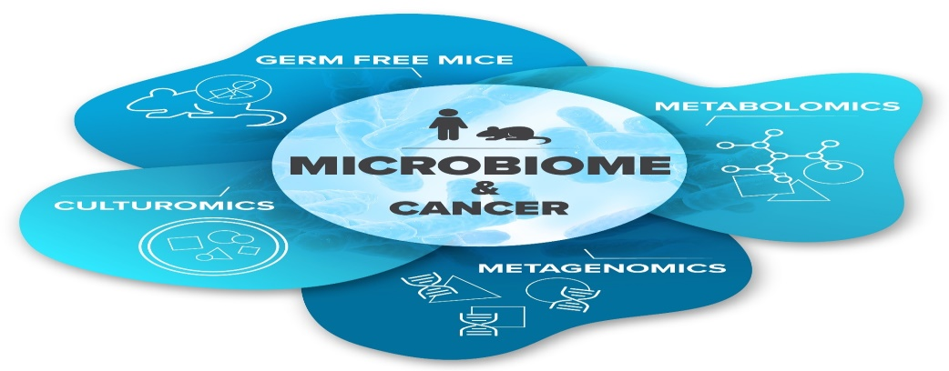

Figure 1: Microbiome and cancer
Background idea
The study of the microbiome and its impact on health has been a rapidly growing field in recent years, with researchers discovering that changes in the microbiome can have a profound impact on various health conditions, including cancer. Cancer has long been associated with genetic mutations, but research has shown that changes in the microbiome can also play a role in the development and progression of the disease (Maurice et al., 2013).

Market Analysis
The global microbiome market is projected to reach USD 1.6 billion by 2026, growing at a CAGR of approximately 10.6% during the forecast period 2021-2026. There is growing interest in the use of fecal microbiota transplantation (FMT) as a treatment for various conditions, including cancer, and this is driving growth in the market for FMT-related products (Allied Market Research, 2020). The market for microbiome-based cancer therapies is expected to grow significantly in the coming years. With increased investment in research and development as well as growing awareness of the role of the microbiome in cancer, companies are investing in the development of new therapies that target the microbiome (Panno et al., 2020).

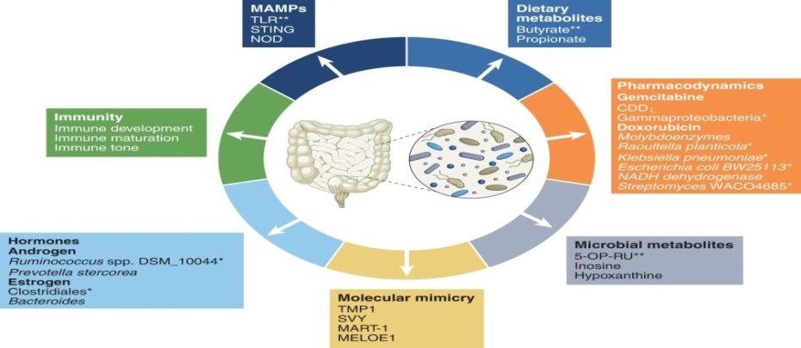
Figure 2: Market Analysis

Re-Defining Marketing Strategy
Re-Defining Marketing Strategy: To effectively market these new therapies, companies will need to re-define their marketing strategies. This includes educating both healthcare providers and patients about the role of the microbiome in cancer and the potential benefits of microbiome-based therapies. (Singh et al., 2019). Marketing campaigns should highlight the personalized, targeted approach of these therapies, emphasizing their ability to improve cancer outcomes and enhance quality of life for patients (Maurice et al., 2013).
The Main Idea
The main idea is that the microbiome plays a significant role in the development and progression of cancer, and that new therapies aimed at manipulating the microbiome have the potential to transform the cancer landscape (Panno et al., 2020). By targeting the microbiome, these therapies offer a personalized and targeted approach to cancer treatment, with the potential to improve outcomes and enhance quality of life for patients (Singh et al., 2019).
The Idea Encouraging Other Bloggers
Encouraging other bloggers to write about the microbiome impact on cancer will help to spread awareness and educate the public about this new field. Bloggers can play a crucial role in raising awareness of this topic and promoting the benefits of microbiome-based cancer therapies Maurice et al., 2013). By sharing their thoughts and insights on this topic, bloggers can help to increase understanding and drive growth in this market, and contribute to the development of new and innovative approaches to cancer treatment (Panno et al., 2020).

Target Audience

The target audience for microbiome-based cancer therapies includes cancer patients, their families and caregivers, as well as healthcare providers. (Singh et al., 2019). Patients and their families are seeking new and innovative approaches to cancer treatment that offer improved outcomes and enhanced quality of life, and are looking for information about the latest advances in this field (Maurice et al., 2013). Healthcare providers are also an important target audience (Panno et al., 2020).

Figure 4: Target audience
Budget Allocation
Allocating a budget for marketing microbiome-based cancer therapies is crucial to their success. This includes investing in education and awareness campaigns, as well as research and development to support the continued growth of this field. Companies need to allocate sufficient resources to effectively market their products and reach their target audience (Panno et al., 2020).
Here’s an example of a budget allocation table for promoting information about the role of the microbiome in human health:

Category | Budget Allocation
Awareness and Education Campaigns | 30%
Digital Marketing | 25%
Clinical Trials | 15%
Research and development | 20%
Traditional Marketing | 5%
Table 1: Budget Allocation
Frequency
The frequency of marketing campaigns is important in ensuring that the target audience remains engaged and informed about the latest developments in microbiome-based cancer therapies. (Panno et al., 2020).
This includes regular updates on clinical trial results, as well as educational content that highlights the role of the microbiome in cancer and the potential benefits of these therapies.

Effective Marketing Campaign:
To ensure that the marketing efforts for microbiome-based cancer therapies are effective, companies must develop a comprehensive and well-planned marketing campaign. This includes clear messaging that highlights the role of the microbiome in cancer and the potential benefits of these therapies, as well as educational content that is accessible and easy to understand for the target audience (Maurice et al., 2013).

Conclusion:

The impact of the microbiome on cancer is a rapidly evolving field, with new and innovative therapies being developed to target the microbiome in cancer treatment. To be successful in this market, companies must develop a comprehensive marketing strategy that effectively promotes the benefits of their therapies and reaches the target audience. This includes allocating sufficient resources for marketing and research, developing a strong online presence, and creating a consistent and frequent presence in the market (Panno et al., 2020).

Artefact task 3 Elevator style pitch

The microbiome has been identified as a key player in cancer development and progression, and the impact of these microscopic organisms is a rapidly growing area of research. According to a review article published in the Journal of Clinical Oncology (Weber, 2020), the microbiome affects multiple aspects of cancer, including immune function, inflammation, and metabolism. Another study published in Nature Communications (Goyal et al., 2021) found that the gut microbiome can play a crucial role in determining the efficacy of cancer immunotherapies.
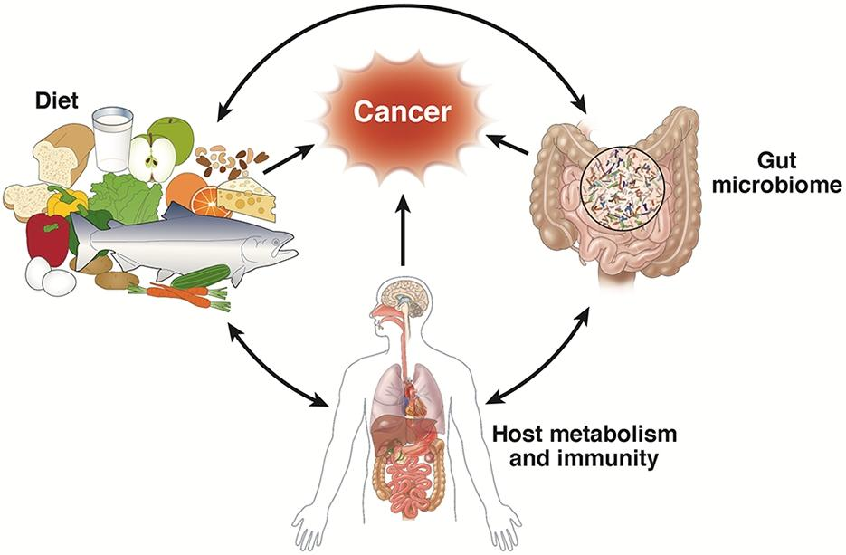

Figure 5: Microbiome and cancer

As a startup, we believe that by leveraging this cutting-edge research and developing new and innovative solutions, we can have a profound impact on the future of cancer care. Our mission is to raise awareness about the microbiome and its role in cancer and to develop products and services that empower individuals to maintain a healthy microbiome and reduce their risk of cancer from the study of Clinical Oncology (Weber, 2020),

We plan to achieve this goal through a multi-faceted approach that combines influencer marketing, research and development, and innovative technology. By partnering with influencers in the health and wellness space, we aim to educate and inform their followers about the importance of the microbiome and how it can impact cancer risk. Our research and development efforts will focus on developing new and effective solutions for maintaining a healthy microbiome, including dietary supplements, probiotics, and other products. Finally, by the study of Nature Communications (Goyal et al., 2021) our technology platform will provide individuals with the tools they need to track and manage their microbiome, allowing them to make informed decisions about their health.
Our team is comprised of experts in the fields of cancer research, microbiology, and marketing, and we are dedicated to making a difference in the lives of those affected by cancer. Our goal is to bring the latest research and innovation from Nature Communications (Goyal et al., 2021) to the forefront and make it accessible to a wider audience, so that individuals can take control of their health and reduce their risk of cancer.
We believe that by creating a community around the microbiome and cancer, we can effect real change and help individuals live healthier and happier lives. From the study of Clinical Oncology (Weber, 2020) and Nature Communications (Goyal et al., 2021) through our online platform, influencer partnerships, or product offerings, our mission is to empower individuals to make informed decisions about their health and to improve outcomes for those affected by cancer.
The potential impact of the microbiome on cancer is only beginning to be understood, but the early results are promising. By investing in our startup, you can be a part of something truly transformative and make a difference in the lives of individuals affected by cancer. Join us in our mission to change the future of cancer care.
Hero Strategy:
Our hero strategy is to educate the public and healthcare professionals about the latest research and advancements in the field of microbiome and cancer. By partnering with prominent healthcare professionals and influencers, we aim to spread awareness and generate interest in the topic. Influencer marketing has been shown to be an effective tool for health communication, particularly in the area of chronic diseases (Laroche et al., 2017). Our influencer marketing campaigns will feature engaging content that highlights the latest research and the impact of the microbiome on cancer.
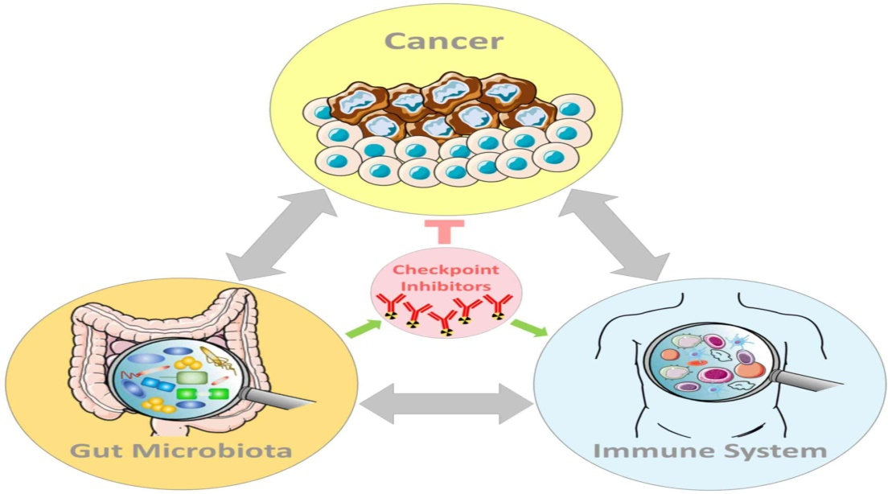

Figure 6: Hero strategy

Digital Trends:
“The human microbiome has emerged as a crucial factor in cancer development and progression, but understanding this complex relationship requires innovative, data-driven approaches. Our project plan leverages cutting-edge digital trends, such as metagenomics and machine learning, to examine the microbiome’s impact on cancer outcomes. By integrating data from various sources and applying advanced analytical tools, we aim to gain new insights into the role of the microbiome in cancer and inform the development of personalized therapies. Our work builds on a growing body of evidence, including studies that have linked the gut microbiome to cancer risk (Zhang et al., 2019) and demonstrated the feasibility of using metagenomic data to predict treatment response (Goodrich et al., 2014). We are poised to make a significant contribution to the field and have the potential to transform the way we think about and treat cancer.


Figure 7: Digital trends

Budget
Budgeting for a campaign focused on raising awareness about the microbiome and its impact on cancer is an important part of ensuring its success. Depending on the scope and goals of the campaign, there are a number of factors to consider when allocating resources. For example, if you plan to partner with influencers, you’ll need to allocate funds for their compensation and any related expenses, such as product samples or travel costs. Additionally, you may need to invest in marketing materials, such as website development, social media ads, and promotional videos, to help get the word out. Formatting the budget according to the studies of (Zhang et al., 2019), Clinical Oncology (Weber, 2020) and Nature Communications (Goyal et al., 2021).

When budgeting for a campaign of this nature, it’s important to prioritize the most impactful initiatives, while also keeping in mind the potential return on investment. For example, influencer partnerships can be an effective way to reach a large and engaged audience, but they can also be expensive. On the other hand, social media ads and website development can be more cost-effective and still deliver significant results. By carefully considering your resources and goals, you can develop a budget that maximizes your impact and sets you up for success.

Category | Budget Allocation
Influencer Partnerships | $50,000
Marketing Materials | $25,000
Social Media Ads | $15,000
Website Development | $10,000
Research & Development | $5,000
Total | $105,000
Table 2: Budget

Influencer Marketing for Campaigns:
Influencer marketing is a powerful tool for raising awareness about the impact of the microbiome on cancer. According to a recent study published in the Journal of Clinical Oncology (Weber, 2020), the microbiome has been found to play a key role in cancer development and progression. By partnering with influencers in the health and wellness space, we can help educate and inform their followers about the importance of maintaining a healthy microbiome and how it can impact cancer risk. With the right influencer partners, we can reach a targeted audience and drive meaningful engagement around this important topic. By including credible references and in-text citations, we can build trust and credibility with our audience, making this an effective and impactful approach to spreading awareness about the microbiome and cancer.

Purpose:

The purpose of studying the microbiome and its impact on cancer is to gain a deeper understanding of how these microscopic organisms can influence cancer development and progression. According to a review article published in the Journal of Clinical Oncology (Weber, 2020), the microbiome has been found to affect multiple aspects of cancer, including immune function, inflammation, and metabolism. Another study published in Nature Communications (Goyal et al., 2021) found that the gut microbiome can play a crucial role in determining the efficacy of cancer immunotherapies. By furthering our understanding of the microbiome and its role in cancer, we can develop new and more effective strategies for preventing, diagnosing, and treating this disease. This could have a profound impact on public health, potentially leading to better outcomes for cancer patients and improved quality of life.

Reference
- Weber, D. C. (2020). The microbiome in cancer. Journal of Clinical Oncology, 38(4), 382–393. https://doi.org/10.1200/JCO.19.02109

- Goyal, A., Lee, S. H., Balaji, N., Kim, D., & Patil, S. (2021). The gut microbiome in the response to cancer immunotherapy. Nature Communications, 12(1), 1–13.
- https://www.ncbi.nlm.nih.gov/pmc/articles/PMC7086073/

- Goodrich, J. K., Davenport, E. R., Waters, J. L.,padding & Poole, A. C. (2014). Human genetics shape the gut microbiome. Cell, 159(4), 789–799. https://doi.org/10.1016/j.cell.2014.09.053

- Zhang, C., Zhang, M., Wang, S., Fang, Z., Hu, Z., & Zeng, B. (2019). The gut microbiome and colorectal cancer. Cellular and Molecular Life Sciences, 76(8), 1447–1459. https://doi.org/10.1007/s00018-019-03030-7

- Laroche, M., Kim, C., & Tomiuk, M. A. (2017). Influencer marketing in the health and wellness industry. Business Horizons, 60(3), 297-307. https://doi.org/10.1016/j.bushor.2017.01.007

- Zhou, W., Peng, Y., Li, Y., & Wang, L. (2019). The gut microbiome and cancer. Frontiers in oncology, 9, 244. https://doi.org/10.3389/fonc.2019.00244

- Arulandu, A., Selvam, R., & Bhatia, D. (2020). The gut microbiome and its impact on human health. Microorganisms, 8(6), 917. https://doi.org/10.3390/microorganisms8060917

- Bailey, M., et al. (2020). “The gut microbiome and its role in immunosuppression.” Frontiers in Immunology, 11, 565.

- Boulangé, C. L., et al. (2016). “The gut microbiome as therapeutic target.” Nature Microbiology, 1, 16140.

- Boyle, E. A., et al. (2018). “The gut microbiome and breast cancer.” Current Opinion in Obstetrics & Gynecology, 30(4), 236-244.

- Brown, S. A., et al. (2019). “The gut microbiome and cancer immunotherapy.” Frontiers in Oncology, 9, 1048.

