Workbook
Elanor Alun
UWTSD
Lab Practical – Phase 1 Master Map in QGIS
Field and Laboratory Skills

Section 1: A QGIS Introduction – Setting Up

Exercise 1.1: Setting Coordinate Reference Systems (CRS)
Video: https://youtu.be/YZHWZ-7Hsiw
Coordinate systems are critical for GIS. A coordinate system is a reference framework that allows us to project coordinates in geographical space. Depending on the scale and geographical location of project data different coordinate systems might be used. In this exercise we will set the coordinate system for our project and ensure that any data being brought into our project will be projected “on-the-fly” to our desired coordinate reference system (CRS).
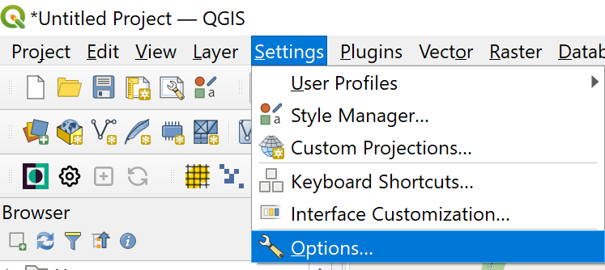
Note: On the fly re-projection is the default in QGIS 3 and there is no way to change this behaviour.
- Open QGIS
- From the main menu select: Settings> Options
- In the left-hand Dialogue window select: CRS
- Default CRS for new project options:
  - For “Default CRS for new projects:” choose EPSG: 27700 – OSGB 1936 (British National Grid)
  - Click OK

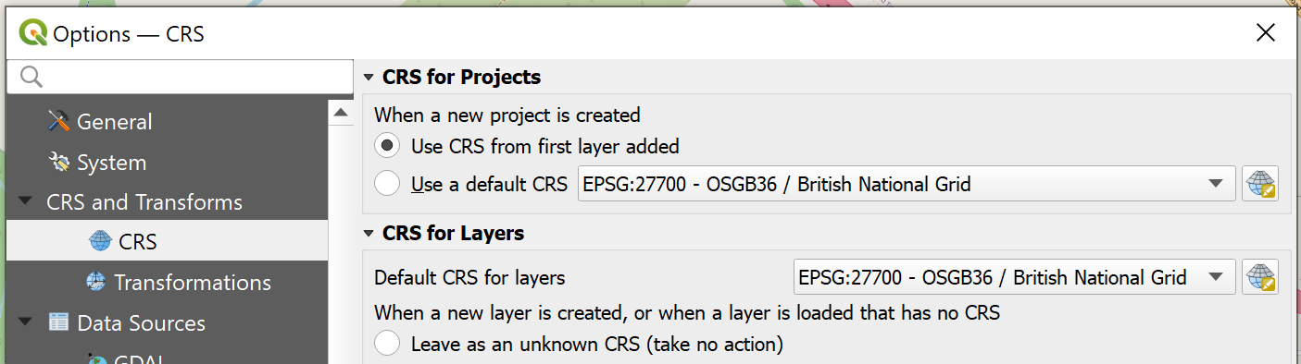
Be aware that this will set all future projects to begin in EPSG: 27700. If you are working on other projects not in the UK you should change this.

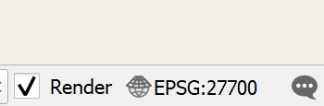
- Note the CRS in the bottom right corner of the Status Bar at the bottom of the map canvas window should show EPSG: 27700
If it doesn’t try starting a new project
- Look at some of the other settings for your information, including map tools and digitising, and note the measurement units. Don’t change any of the defaults for the exercises

In this exercise we have chosen a suitable CRS for our project. Any new project will default to this CRS. Project CRS can be changed using the project settings or the CRS widget in the bottom right of the main window.

Exercise 1.2: Base Maps
Currently, you probably still have a white screen and not much else. Time to change that!
Video: https://www.youtube.com/watch?v=mVVcxtBFZkA
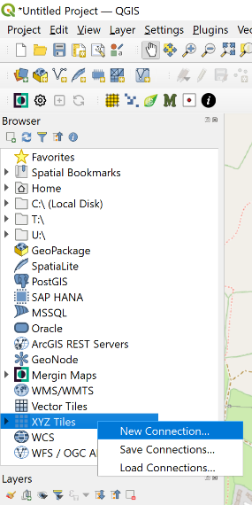
There are various places you can get base maps from for QGIS, two of which are shown here. For this session we’ll use Google Maps, and Ordnance Survey Maps.
Google Maps:
- On the left of the screen, you should have two panels: Browser, and Layers. Go to Browser > XYZ.
- Right click on XYZ Tiles, and choose New Connection.
- Name the connection something appropriate (in this case, either Google Maps, Google Satellite, or Google Hybrid depending on which you’re uploading), and then paste in the corresponding URL. These are listed below, and also on Moodle. Then click OK.

Map | URL
Google Maps | https://mt1.google.com/vt/lyrs=r&x={x}&y={y}&z={z}
Google Satellite | http://www.google.cn/maps/vt?lyrs=s@189&gl=cn&x={x}&y={y}&z={z}
Google Hybrid | https://mt1.google.com/vt/lyrs=y&x={x}&y={y}&z={z}

- To add these, click the little arrow next to XYZ Tiles to get the drop down menu of possible layers. Right-click the one you want, and select Add Layer to Project.

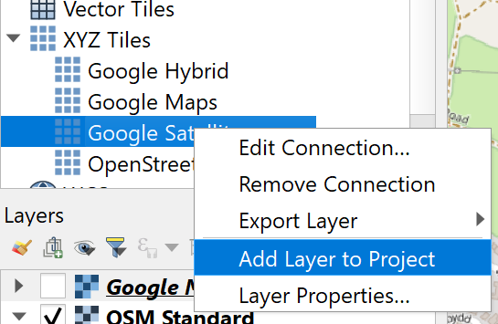
Ordnance Survey Maps:
- Go to Plugins > Manage and Install Plugins
- Scroll down to – or search for – QuickMapServices. Click Install Plugin
- This will give you access to the OSM. To use it, go to Web > QuickMapServices > OSM. This will load it into the workspace.

Note: occasionally, you might be prompted to ‘convert’ some of these into your project CRS. If this happens, simply make sure the ‘destination CRS’ is the one you’re using in your project – in this case, EPSG: 27700 – OSGB 1936 (British National Grid). The conversion method is not relevant at this level.

Exercise 1.3: Saving Your Project
GIS softwares are all very weird when it comes to saving, so it’s important to get this right early doors.
Firstly, you’ll need to choose an accessible place to save to. This place cannot be moved once chosen, or you will not be able to open the project again. So, in this case, choose your OneDrive; this will let you access it from any computer with QGIS installed and an internet connection. An alternative would be a memory stick.
Once that is done, and the project is saved, all subsequent layers will need to be saved below the workspace in the file directory. So, if you save the overall project into a folder called GIS, you then need to make a new folder next to the project – in the same GIS folder as it – and then save all subsequent data that will be uploaded into that.
You will need to practice good folder hygiene for this. Many people have a set up like this:

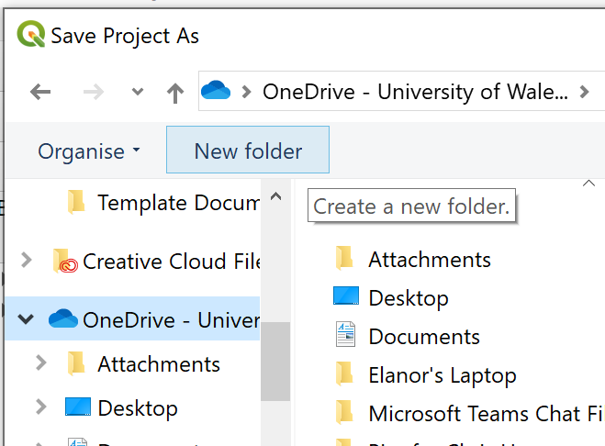
In this case:
- Go to Project > Save As
- In the left hand panel, select your OneDrive, and click New Folder. Call it GIS Projects.
- Click into this new folder. Name the Project Llys Nini Phase 1.
- Click Save.

Section 2: Adding Map Features

Exercise 2.1: Site Outline
Video: https://youtu.be/nrY7EjWKN-8
Here you’re creating your own GIS data, so in this exercise we will create a new point shapefile. A shape file can be a point, a line or a polygon, all of which you should recognise! These are also known as ‘vector layers’, which is how you’ll find them in QGIS.
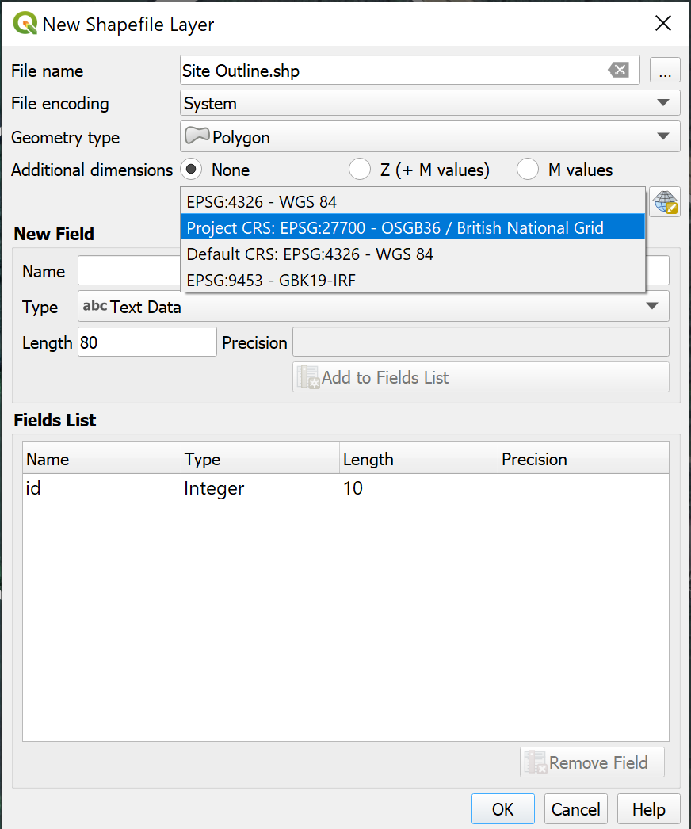
- Using our base map (Google satellite or hybrid are best here) we need to create a new layer so go to Layer> Create Layer> New Shapefile> New Vector Layer
- For Geometry Type choose Polygon
- Leave file encoding as System
- For CRS select “Project CRS”
- We will need to save our file somewhere. Click the three little dots in the top right after File Name, and navigate to the folder where you saved the overall project (Exercise 1.3). Save it in a new folder called Shapefile layers (or something similar), and give it a suitable name (e.g. Site Outline).
- Click OK
- Your new file should appear in the Layer Panels
- Currently there is no polygon in this file so nothing can be displayed, but we can add a polygon using the Edit mode
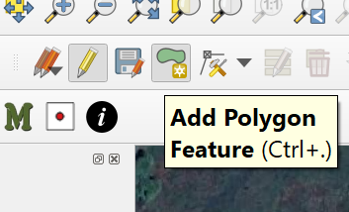
- Click the pencil to start editing and then click the “add feature” tool
- Draw a polygon to be Llys Nini’s site outline. This is done by clicking on the map to place points (or vertices) at the corners; if you want to delete one you just placed, click backspace. Once you’re done and ready to finalise it, right-click.
- Change the style (see below).
- Click the pencil again to finish editing and save your edits

When your polygon is first created, it will probably look something like this:
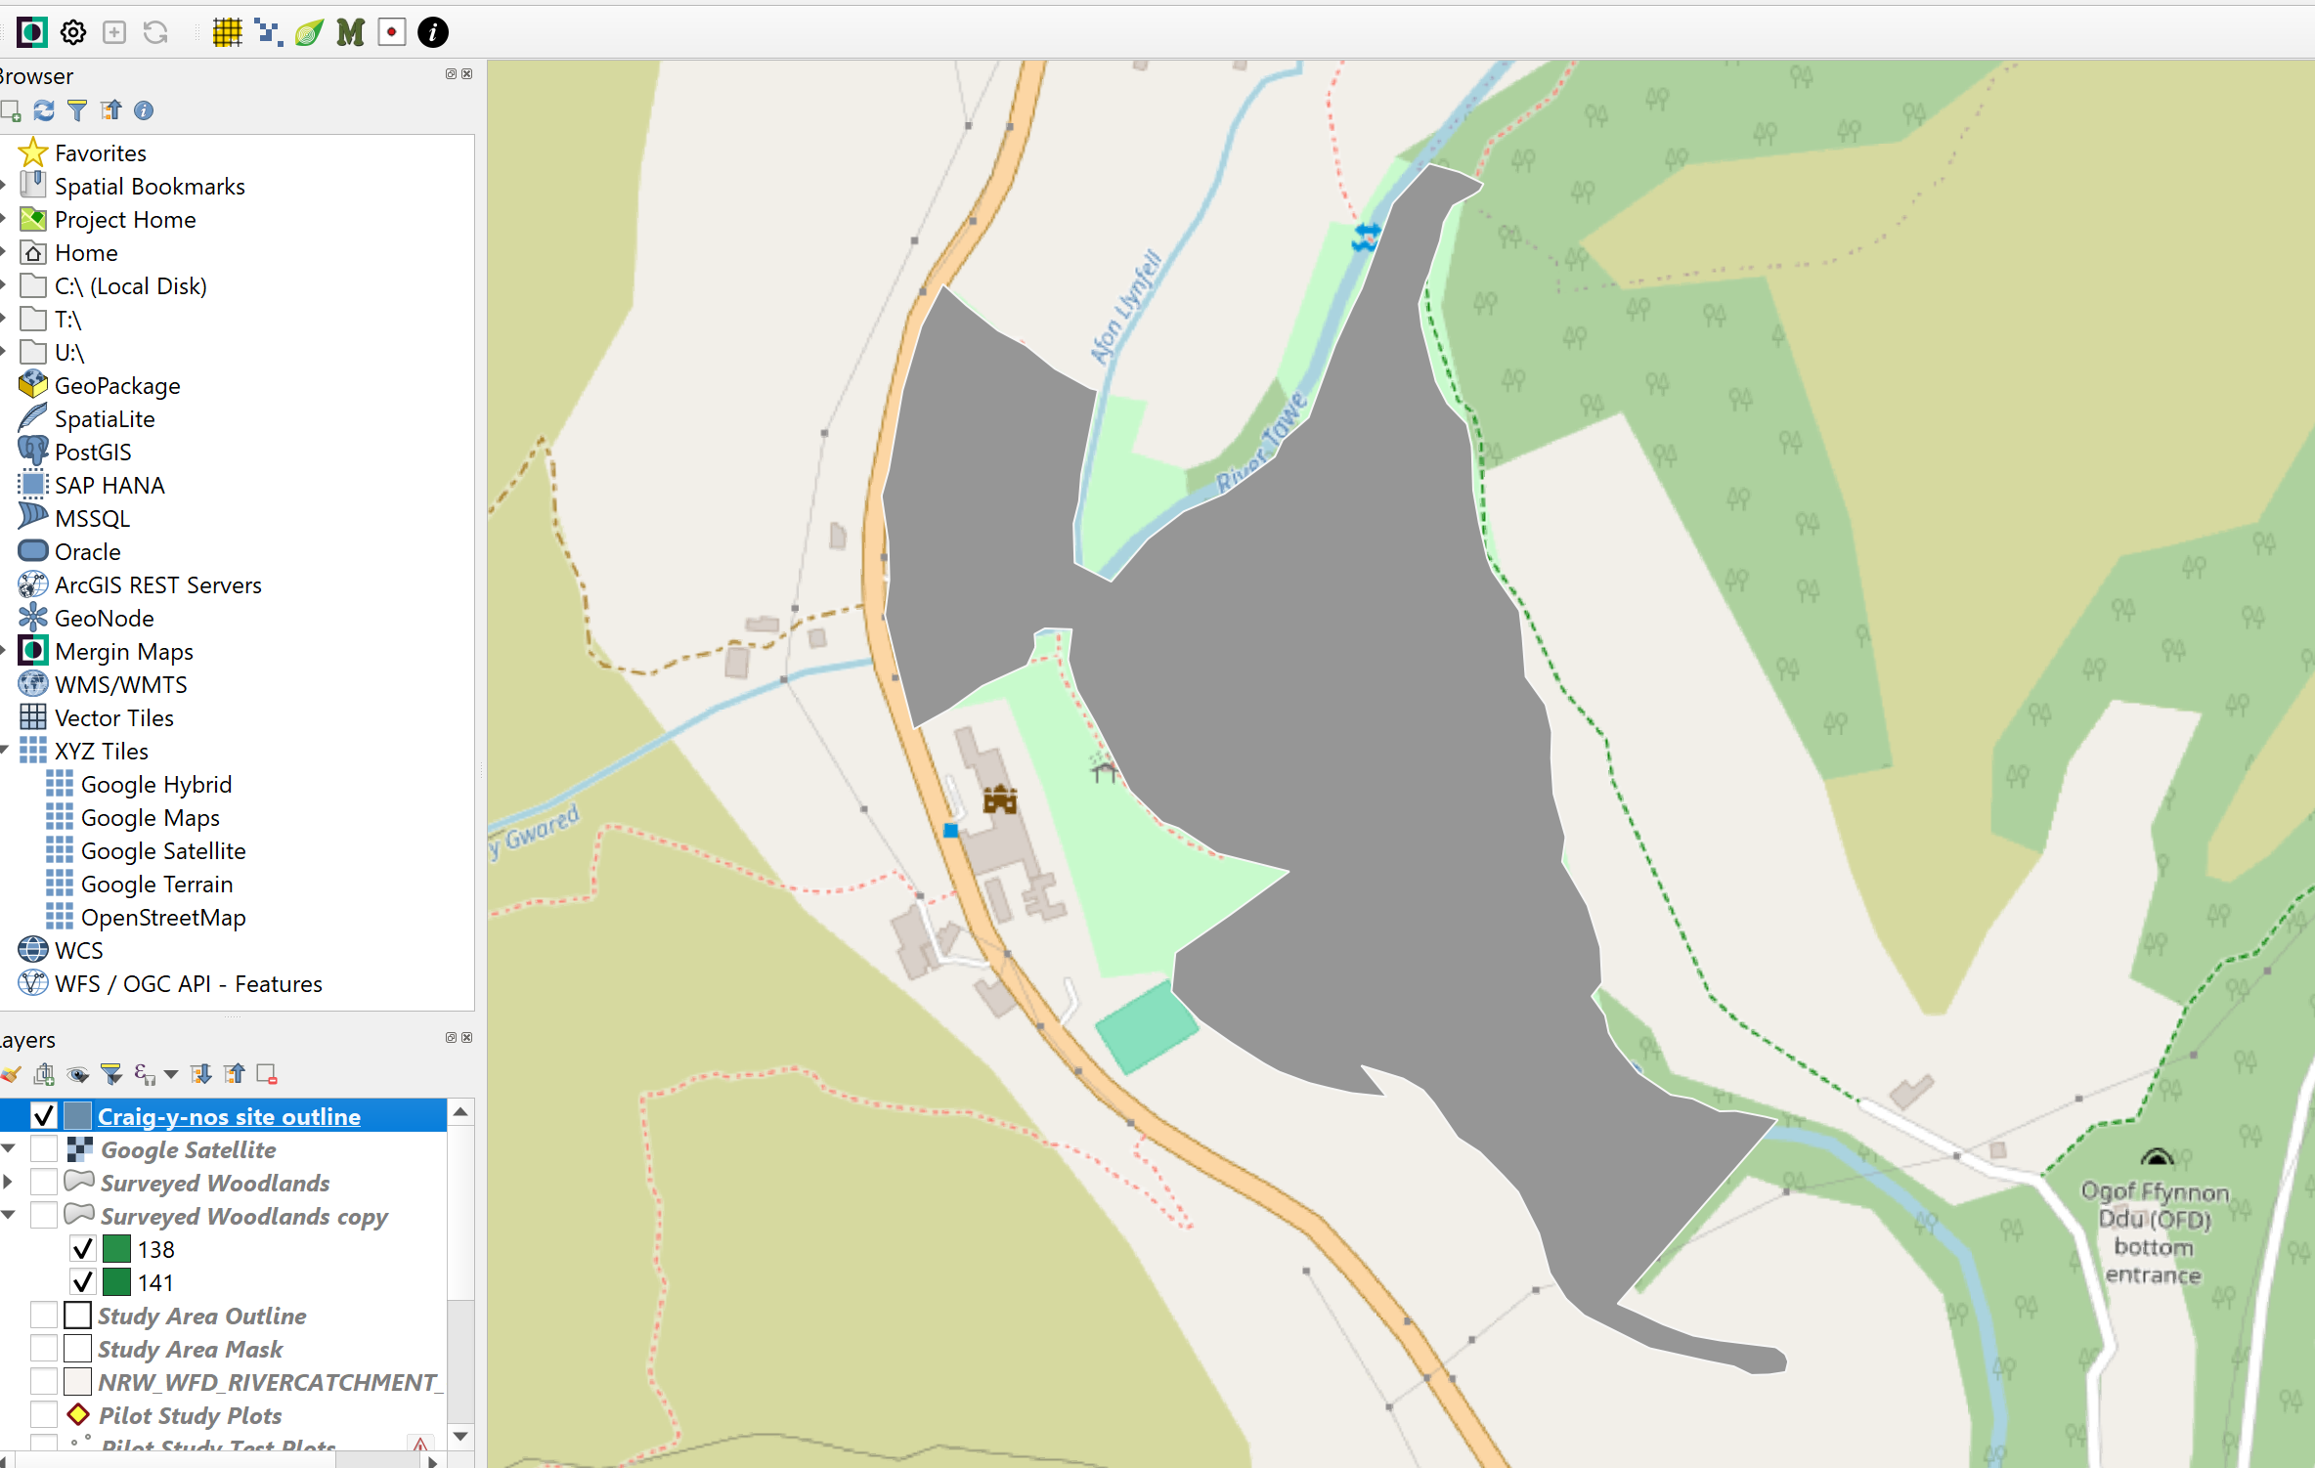

QGIS comes with a range of options to change the appearance of the features you place, and we’ll use one now.
To open the Style tab, you have a choice. Either:
- double click the layer’s name in the Layer Panel on the left and select Symbology, or
- right click the layer’s name in the Layer Panel and select Styles > Edit symbol
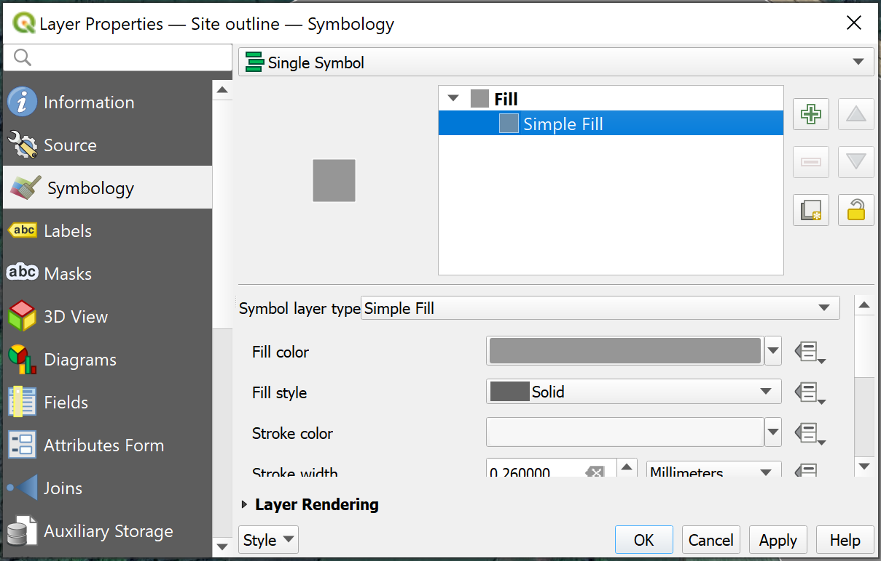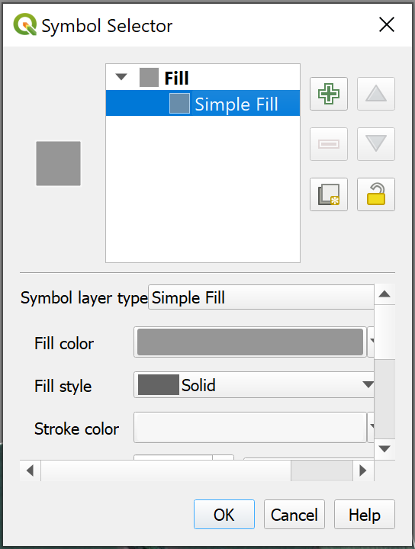
The latter is better, it lets you view more stuff. Either way, select the words “Simple Fill”. Clicking on the fill colour will let you reduce the opacity to 0%. “Stroke” refers to the shape outline – here, set it to white and make it a little wider. Clicking ‘apply’ will let you see it without having to leave the box and re-enter if you want to keep changing it.
Once you’re ready, click ‘OK’.

Your final outline should look something like the following:
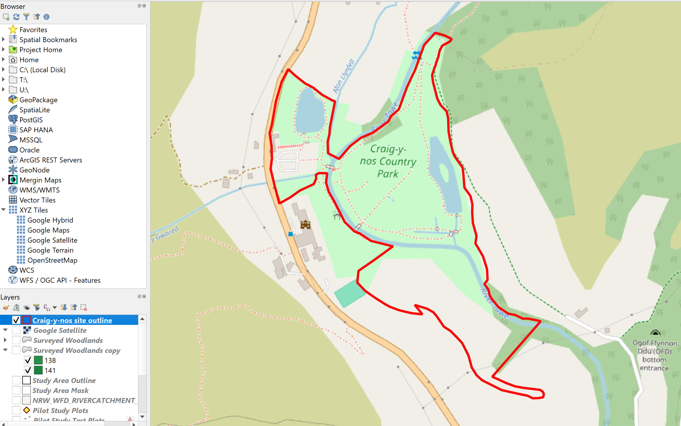

Exercise 2.2: Adding Habitat Compartments
Time to make the whole map!
You will now be adding polygons to display the different habitat compartments; some of which you can copy here, some of which you gathered on the field trip to Craig-y-nos. The procedure is largely the same as in steps above, but with a couple of tweaks:
- Create a new layer - go to Layer> Create Layer> New Shapefile> New Vector Layer
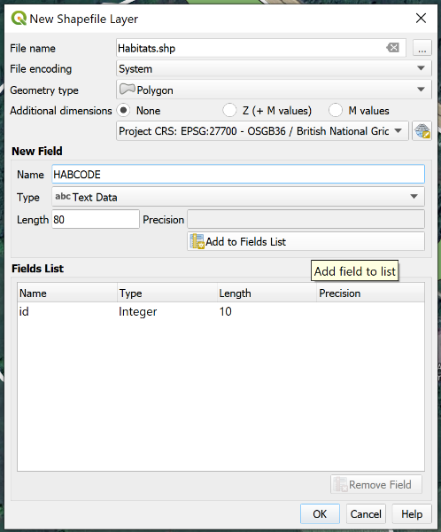
- For Geometry Type choose Polygon
- Leave file encoding as System
- For CRS select “Project CRS”
- We will need to save our file somewhere. Click the three little dots in the top right after File Name, and navigate to the folder where you saved the site outline. Give it a suitable name (e.g. Habitats).
- To add an attribute field to the table (more on these in a bit!) type a suitable name (e.g. HABCODE)
- Click Add to fields list
- Click OK
- Your new file should appear in the Layer Panels

Before you start adding polygons! We need to make sure they connect seamlessly to each other, so there’s no blank space between them when you zoom in or out.
To do this, we do the following:
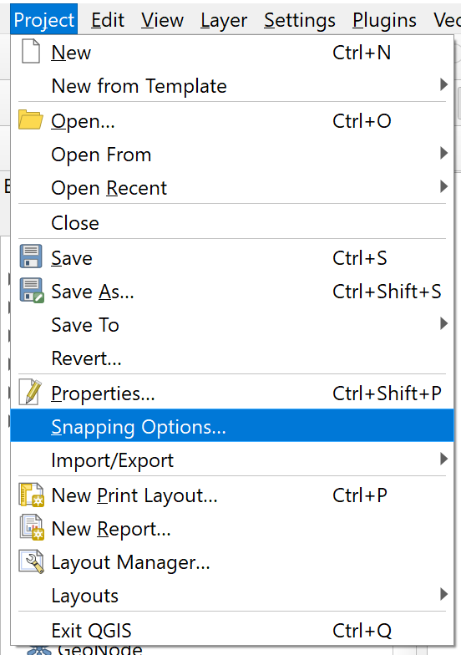
- Go to Project > Snapping Options.
- In the new table, look to the left; there will be a little magnet icon. Click this, and it will enable snapping.

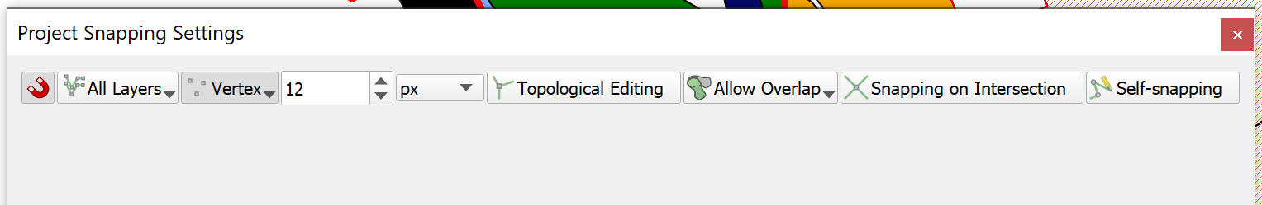

Currently there is no polygon in this file so nothing can be displayed, but we can add a polygon using the Edit mode.
- Click the pencil to start editing and then click the “add feature” tool
- Draw your polygons. This is done by clicking on the map to place points (or vertices) at the corners; if you want to delete one you just placed, click backspace. Once you’re done and ready to finalise it, right-click. THERE IS NO NEED TO MAKE A NEW LAYER EACH TIME.
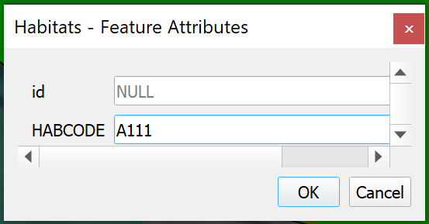
- For each polygon, put the Phase 1 Habitat code in (see below)
- Click the pencil again to finish editing and save your edits

Note on Habitat Codes:
We will be using these to colour code these habitat compartments correctly in the next exercise; but, to work, they have to be exact. You can go back and change them, but this is obviously more hassle. Try to format them right first time (i.e. spaces, decimal points, etc). See below.
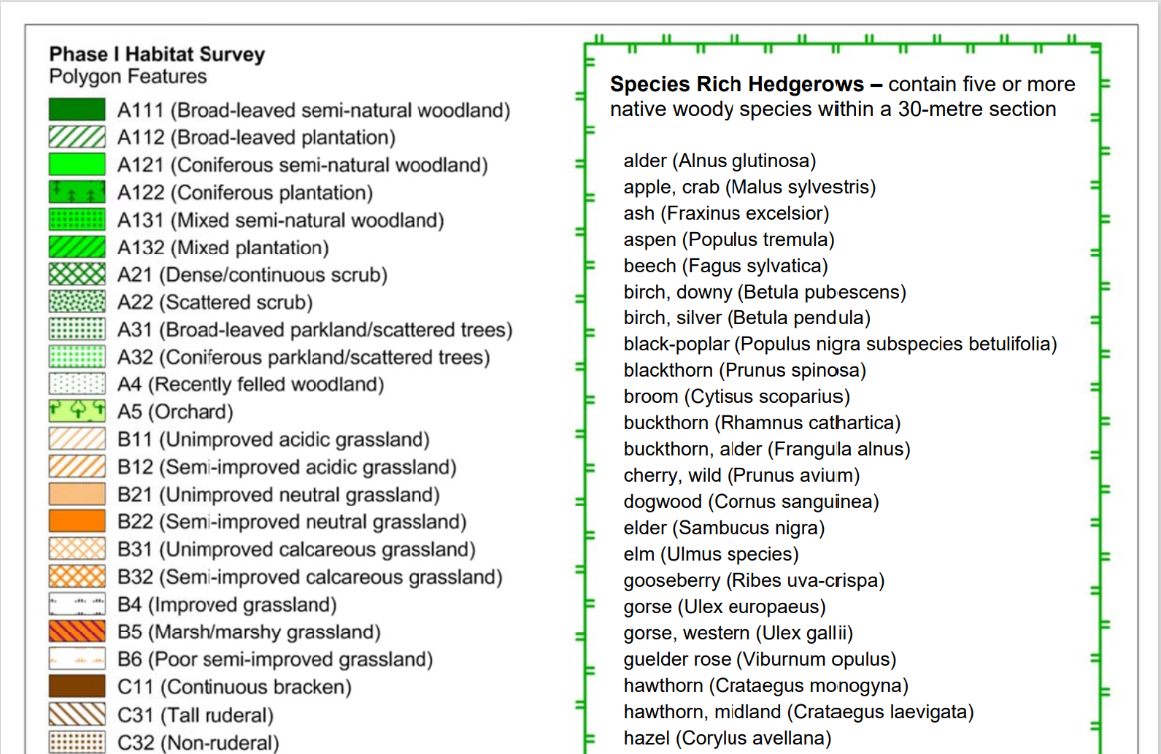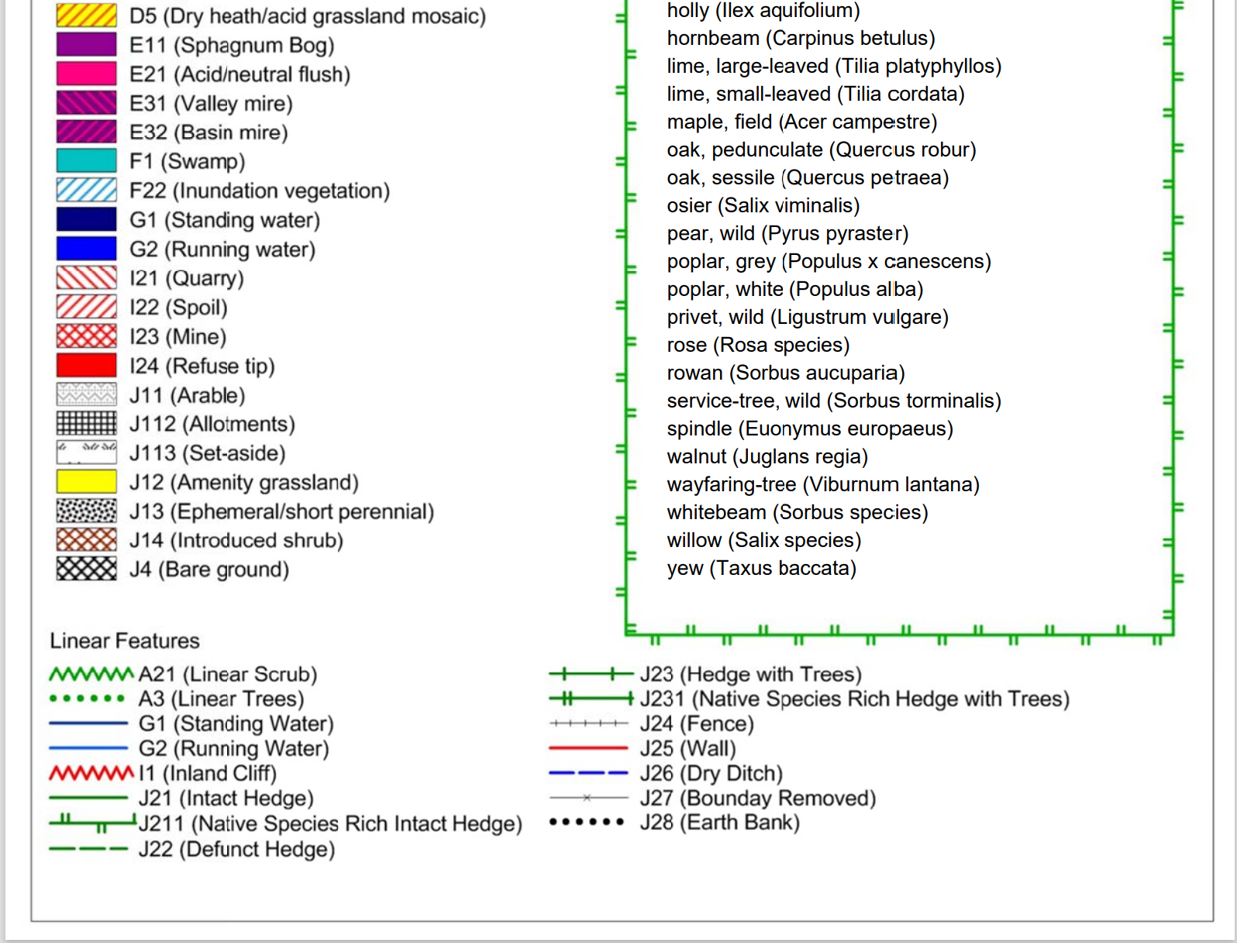

Exercise 2.3: Linear Features
So far you’ve added lots of polygons, but now you add linear features. These are any hedges, streams, ditches, banks, roads, etc that you marked in your survey.
The procedure is exactly the same here as it was for the polygons, but when you make your new vector layer, in Step 2 you change the Geometry Type to “LineString” instead of “polygon”. Do add a habitat code attribute like you did for the habitat compartments, however.
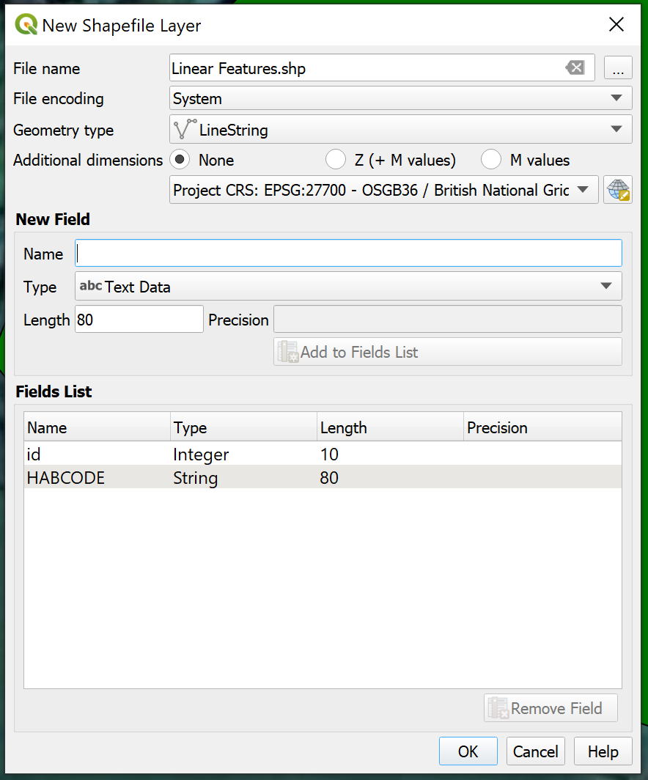

Exercise 2.4: Styles
So! You’ve made a map. It’s probably fairly ugly at the minute though – and it certainly doesn’t have the correct colours right now.
Firstly, you’ll need to download the colour palettes. They’re currently on Moodle for you – download those, and save them into their own new folder (Call it Phase 1 Style Sheets) in your GIS folder. You should have three different files.
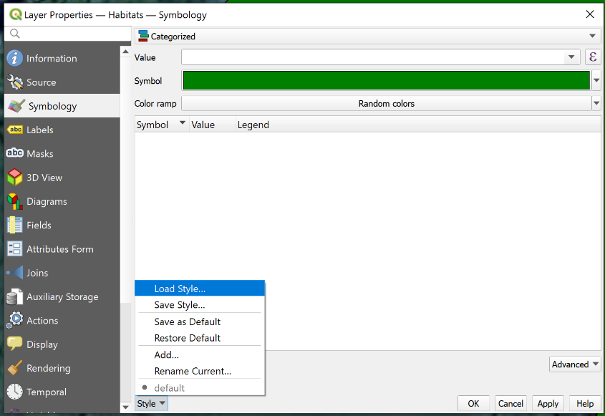
- Double click on your Habitat Compartment layer and open the Symbology tab.
- At the top, where it says “Single Symbol”, change this to Categorised.
- Click Style, and select Load style
- Browse for the style sheets you downloaded by clicking the three dots
- Select the Phase 1 style sheet, and click load style.
- Set the Value box to your HABCODE category.
- Click OK.

This will now change all of your polygons to their correct colours – providing you filled in the HABCODE box with the correct codes.
You can repeat this process for your linear features layer (selecting the style sheet for linear features), and your target note sheet (see below).

Exercise 2.5: Editing Lines and Polygons
Video: https://youtu.be/bQ15OmFVsgc
In this exercise we will import a comma separated values (CSV) file. You can create CSV files from Excel (save as… csv) and they are a common format for uploading data into QGIS. Similar files to CSVs include TAB and TXT files (tab separated and space separated files respectively).
In this exercise we will list our target note data. First, make an Excel file laid out in the following configuration:
Target Note No. | X | Y | Notes
1 | 260680.652 | 199738.666 | Ancient woodland, primarily p. oak, alder and willow. Wet; two ponds needing clearing. Potential for bats, newts and dormice

Name this file Craig y Nos target notes, and save it in a new folder called Field Data in the GIS folder. Save it as a CSV rather than as an Excel file.

- From the main menu go to Layer> Add Layer> Add Delimited Text Layer
- Browse to the CraigyNosTargetNotes.csv file
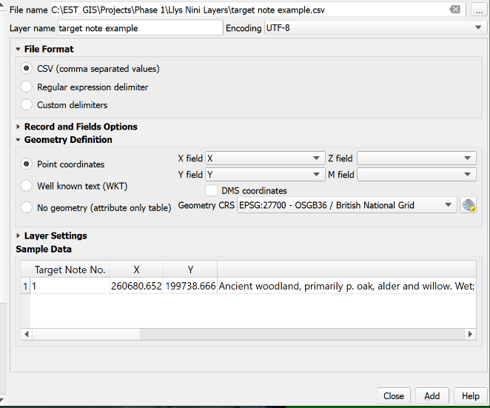
- Use the following settings in the dialogue window
  - File Format: CSV
  - Encoding: UTF-8
- Set the Geometry definition to point coordinates and make sure the x and y fields are correct
- Make sure you specify the CRS as EPSG 27700 British National Grid
- Once the settings are correct, click Add
- Your points will appear on the map
- To change the style, it’s pretty much the same procedure as before, except you can do it in the Single Symbol tab. Style > Load Style > Phase 1 target notes. This will change the symbol to the official target note symbol.

Note: if your points appear in the middle of nowhere – or don’t appear at all – it may be because your coordinates were recorded using a different system. In this case, the best thing to do is to use an online converter to convert them into EPSG 27700 British National Grid.

If you need to add/change anything:
At this point the data is being read directly from the CSV. This means we can browse the data points, style them, and overlay them with other layers, but they cannot be changed or edited. In order to make the CSV layer editable we need to convert it to a shapefile.
- Select the layer in the layers panel
- Right click and choose “Export> Save features as…”
- Save the shapefile somewhere sensible with a meaningful name
- The new shapefile is now ready for editing

Note for Mac users: Importing text files like CSV, TAB, TXT or ASC into QGIS
In general the difference between all these files is the delimiter character. That is the character separating each entry. For CSV it is a comma, for a TAB file it is a 'tab', for a TXT or ASC file it could be either a tab, comma or single or double quotes.
It is important to note that if you create a table of data in Excel then to import it as a CSV file to QGIS you must make sure that it is saved-as in the correct Unicode (UTF-8) style and not a DOS type CSV style. (The difference is DOS uses ASCII characters CR+LF and Unix/Linux just LF for new lines.)
Alternatively: Prepare the data in Excel, then copy to 'numeric' then export from this to CSV and to XLS files. Use these exported files and then the delimited text file import will work.

Section 3: The Final Map
Video: https://youtu.be/UBpz7Z3Hy-s
Now that we have made an awesome map it would be nice to share it. QGIS’ Print Layout (formerly print composer in QGIS 2.x and earlier) allows us to output our maps in many different formats so we can share them with others, insert them into word documents etc.
In this exercise we’ll look at creating a new print layout, adding some cartographic elements and outputting the result to a jpeg image. Keep in mind that print layout can be quirky; it is always a good idea to build in extra time to your projects to allow for print layout issues.
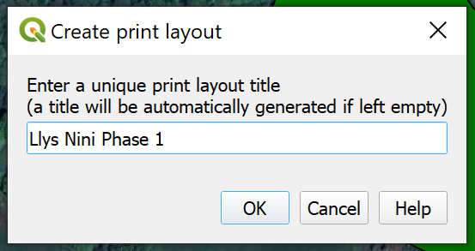
- Save your Llys Nini Phase 1 Map to the GIS folder giving it a suitable name if you haven’t already (it is always a good idea to save a project again before starting a print layout; but, you should have saved it many times by now)
- In the main menu go to Project> New Print Layout
- For the layout title type “Craig-y-nos Phase 1” and hit OK

This will open a new print layout window which looks similar to the normal QGIS window. It is important to remember that the large white space is equivalent to a sheet of paper and we will lay our map out on this sheet.
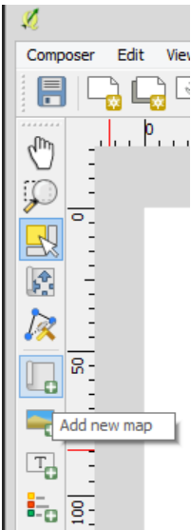
- Start by adding a new map to the print layout window (Left click and drag a rectangle to specify the map area)
- Your Llys Nini Phase 1 map should appear in the layout window
- Using the buttons to the left of the layout screen add the following
  - Title (label text)
  - Scalebar
  - Legend
  - North arrow (see if you can find preloaded north arrows!)
- These elements can all be altered on the right. You will probably have to remove some legend entries.
Now you can save and export using Layout> Save project or Layout> Export as
Print layout has other options that should be taken into consideration. Page set up allows you to select paper size and orientation. Export resolution (dpi) may also be of importance especially if printing very detailed data or printing at larger page sizes (such as A1 or A2 for posters).
Print layouts can also be saved as templates for future maps using Layout> Save as template.
For detailed descriptions of these and other features please see the QGIS docs at https://docs.qgis.org/3.16/en/docs/user_manual/print_composer/overview_composer.html


