Daniel Bridgewater (2218703)
May 2025
Abstract
This report aims to investigate performance relating to various types of radio-frequency antenna using simulations, designed with a mix of theoretical calculations and automatically generated using MATLAB. The types of antennae tested include patch, cylindrical dipole, folded dipole, horn, helical, and helical array. Discrepancies between theoretical calculations of resonant frequency and what was simulated were discovered, highlighting the need to test antenna designs in the real world.
This report also evaluates the trade-offs between antenna complexity and directivity, as well as the wider impacts of antenna choices to society and the environment. Recommendations for selecting the appropriate antenna design are given, so that efficiency is maximised to reduce necessary power usage.
Design and Analysis of RF Antennas
ACDA6019

Contents
Introduction 3
Methodology 3
Patch Antenna 3
Cylindrical Dipole Antenna 4
Folded Dipole Antenna 5
Horn Antenna 6
Helix Antenna 6
Helix Array Antenna 6
Results 8
Discussion 24
Conclusion 25
References 25

Figure 1: Patch antenna modelled in CST Studio 4
Figure 2: Cylindrical dipole 5
Figure 3: Cylindrical dipole calculated dimensions 5
Figure 4: Folded Dipole 5
Figure 5: Folded dipole dimensions 5
Figure 6: Horn antenna 6
Figure 7: Horn antenna dimensions 6
Figure 8: Graph of antenna element distances (in metres) and forward directivity 7
Figure 9: Zoomed graph of close antenna spacing impacting directivity, measuring distances between 70mm to 3cm. 7
Figure 10: Helical antenna array with elements spaced 1.7cm apart 8
Figure 11: Patch Antenna directivity in dBi (azimuth cross-section, top-down) 8
Figure 12: Patch Antenna directivity in dBi (elevation cross-section, side-on) 9
Figure 13: Patch Antenna directivity in dBi (3D view) 9
Figure 14: Patch antenna impedance Smith Chart 10
Figure 15: Patch antenna S Parameters, from 1 to 8GHz 10
Figure 16: Cylindrical Dipole directivity in dBi (azimuth cross-section, top-down) 11
Figure 17: Cylindrical Dipole directivity in dBi (elevation cross-section, side-on) 11
Figure 18: Cylindrical Dipole directivity in dBi (3D view) 12
Figure 19: Cylindrical Dipole impedance graph 12
Figure 20: Cylindrical Dipole S Parameters at nominal 50-ohm matching 12
Figure 21: Folded Dipole directivity in dBi (azimuth cross-section, top-down) 13
Figure 22: Folded Dipole directivity in dBi (elevation cross-section, side-on) 13
Figure 23: Folded Dipole directivity in dBi (3D view) 14
Figure 24: Folded Dipole impedance graph 14
Figure 25: Folded Dipole S Parameters at nominal 50-ohm matching 14
Figure 26: Horn antenna directivity in dBi (azimuth cross-section, top-down) 15
Figure 27: Horn antenna directivity in dBi (elevation cross-section, side-on) 15
Figure 28: Horn antenna directivity in dBi (3D view) 16
Figure 29: Horn antenna impedance graph 16
Figure 30: Horn antenna S Parameters at nominal 50-ohm matching 17
Figure 31: Helical antenna directivity in dBi (azimuth cross-section, top-down) 17
Figure 32: Helical antenna directivity in dBi (elevation cross-section, side-on) 18
Figure 33: Helical antenna directivity in dBi (3D view) 18
Figure 34: Helical antenna impedance graph 19
Figure 35: Helical antenna S Parameters at nominal 50-ohm matching 19
Figure 36: Cylindrical Dipole S Parameters mismatched at 30-ohms 20
Figure 37: Folded Dipole S Parameters mismatched at 30-ohms 20
Figure 38: Helical antenna S Parameters mismatched at 30-ohms 20
Figure 39: Horn antenna S Parameters mismatched at 30-ohms 21
Figure 40: Helical antenna array directivity in dBi (azimuth cross-section, top-down) 21
Figure 41: Helical antenna array directivity in dBi (elevation cross-section, side-on) 22
Figure 42: Helical antenna array directivity in dBi (3D view) 22
Figure 43: Helical antenna array centre element impedance graph 23
Figure 44: Helical antenna array S Parameters at nominal 50 ohm matching 23

Equation 1: Patch antenna frequency 3
Equation 2: Equations for calculating theoretical patch antenna dimensions, provided by [1] 4
Equation 3: Cylindrical dipole frequency 4
Equation 4: Folded dipole frequency 5
Equation 5: Horn antenna frequency 6
Equation 6: Helix antenna frequency 6
Equation 7: Helix antenna array frequency 6
Equation 8: Calculation of mismatching impact on cylindrical antenna performance 25

Introduction
Different antenna shapes exhibit different behaviours, useful in different situations at different frequencies. This report aims to calculate then simulate some common antenna performances, evaluating their traits and suitable use-cases.
The antennas simulated include a patch antenna, cylindrical dipole, folded dipole, horn, helical, and helical array. Patch antennas are uniquely capable of being embedded directly into a circuit board, enabling low-cost production of high-frequency antennas which can fit directly inside the device. Dipoles are one of the most common types of antenna, being extremely simplistic. Both cylindrical and folded types of dipole will be tested so their differences may be compared. For microwave frequency communication, horn and helical antennas will be tested, along with a helical array so the benefits of adding extra elements can be compared against a single element antenna.
Finally, the impacts of the antenna types to human society and the environment will be considered, along with recommendations for reducing such impacts. This will include compliance with appropriate regulatory standards and long-term sustainability of the equipment.

Methodology
All operating frequencies were derived from varying digits in the author’s student ID.
The patch antenna was modelled in CST while all other antennas were created using MATLAB Antenna Designer. MATLAB is preferred where possible as it’s capable of automatically determining the dimensions for common antenna types, given some operating frequency, reducing the chance for human error to influence the results.

Patch Antenna
CST Studio Suite 2024 (Learning Edition) was used to model the patch antenna, chosen for its granular control over the antenna’s construction. MATLAB’s Antenna Designer does not allow creating an antenna as if it were on a printed circuit board (PCB). The antenna will be designed for 2.2GHz, derived from the author’s Student Number.
$$Operating Frequency =2.2 GHz$$
Equation 1: Patch antenna frequency
The ground plane and patch antenna element are modelled as perfect electrical conductors (PEC), while the dielectric is modelled as a lossy FR-4 material, commonly used in PCB. 1.6mm is a typical thickness for PCBs, and CST’s dielectric constant for FR-4 is 4.3.
Given the antenna’s target frequency ($f_{o}=2.2×{10}^{9}Hz$) along with the dielectric’s thickness ($h=1.6mm$) and permittivity ($ε_{R}=4.3$), it is possible to directly calculate the theoretically optimum size for the patch antenna, shown in Equation 2.
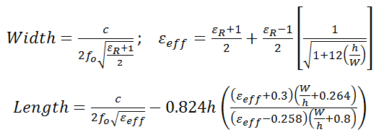
Equation 2: Equations for calculating theoretical patch antenna dimensions, provided by [1]
This yields a theoretical width of 41.85 mm and a length of 32.51 mm. However, when the patch antenna was built to these measurements in CST, the simulated resonant frequency was slightly low, at 2.1GHz instead of 2.2. To correct this, the length of the antenna was shortened to 31.3mm.
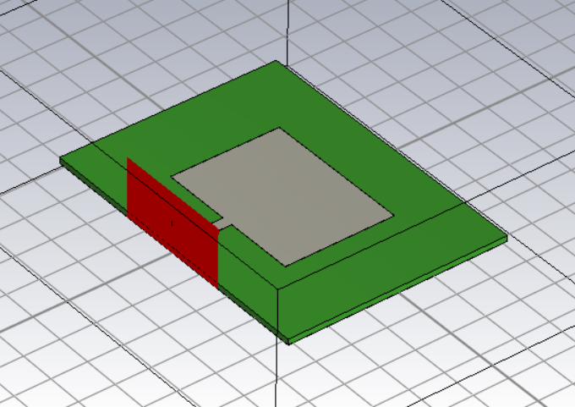
Figure 1: Patch antenna modelled in CST Studio

Cylindrical Dipole Antenna
$$Operating Frequency =2 GHz$$
Equation 3: Cylindrical dipole frequency
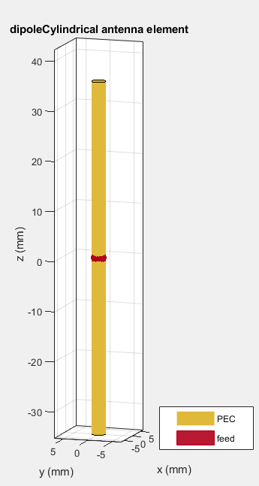  Figure 2: Cylindrical dipole | 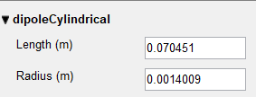  Figure 3: Cylindrical dipole calculated dimensions

Folded Dipole Antenna
$$Operating Frequency =\frac{221}{2} MHz \\ =110.5 MHz$$
Equation 4: Folded dipole frequency
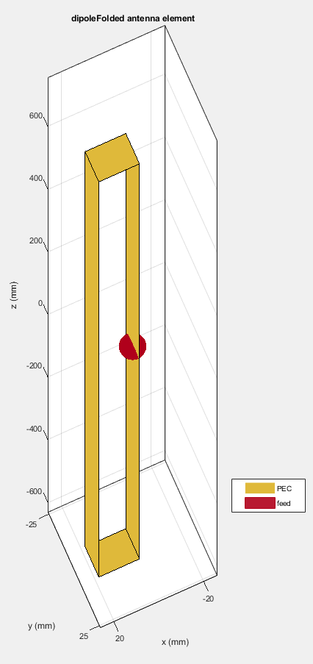  Figure 4: Folded Dipole | 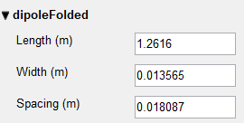  Figure 5: Folded dipole dimensions

Horn Antenna
$$Operating Frequency =\frac{18}{2} GHz \\ =9 GHz$$
Equation 5: Horn antenna frequency
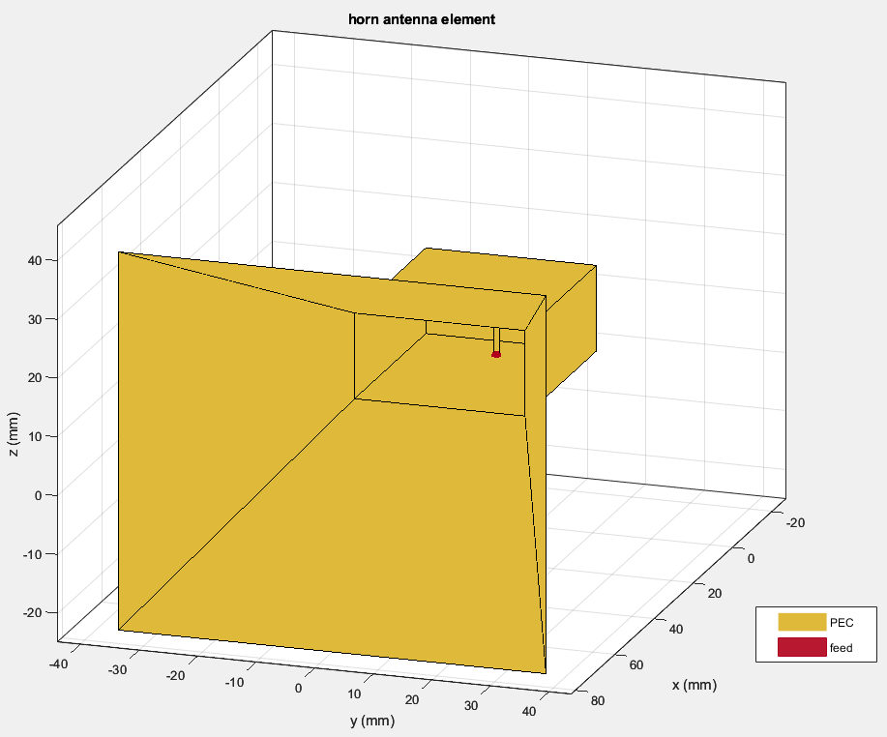  Figure 6: Horn antenna | 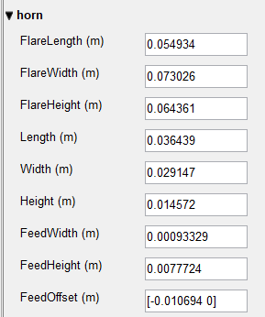  Figure 7: Horn antenna dimensions

Helix Antenna
$$Operating Frequency = 21 GHz$$
Equation 6: Helix antenna frequency

Helix Array Antenna
$$Operating Frequency = 21 GHz$$
Equation 7: Helix antenna array frequency
When creating an antenna array, there is a variable which MATLAB cannot calculate automatically, that being the distance between each antenna element. This variable is important, as changing it can affect how the radio waves from each element interfere with each other, either constructively or destructively. To find the optimum spacing for constructive interference, the author simulated a wide range of distances and created a graph to show the impact on directivity (Figure 8). Distances shorter than 0.007 metres were not tested, as that would place the helical elements inside each other.
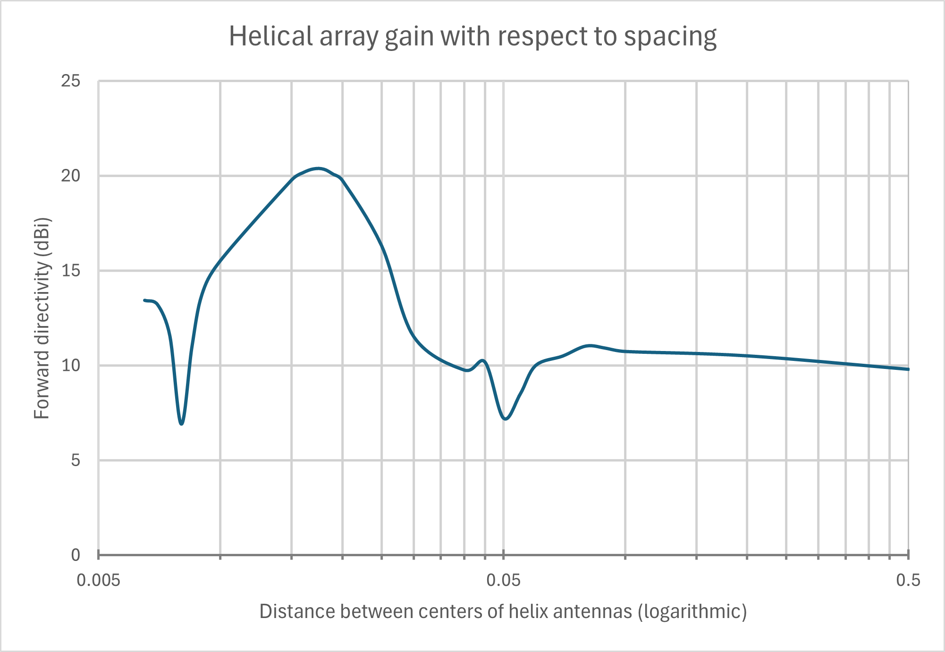
Figure 8: Graph of antenna element distances (in metres) and forward directivity
This revealed an optimum distance between 1 to 3 centimetres where the waves interfered constructively. Figure 9 was created to focus on this region, along with the thin band of destructive interference occurring when the elements were spaced at 80mm. This approximately coincides with $0.5λ=73.5mm$, where the phase difference between elements would equal 180°.
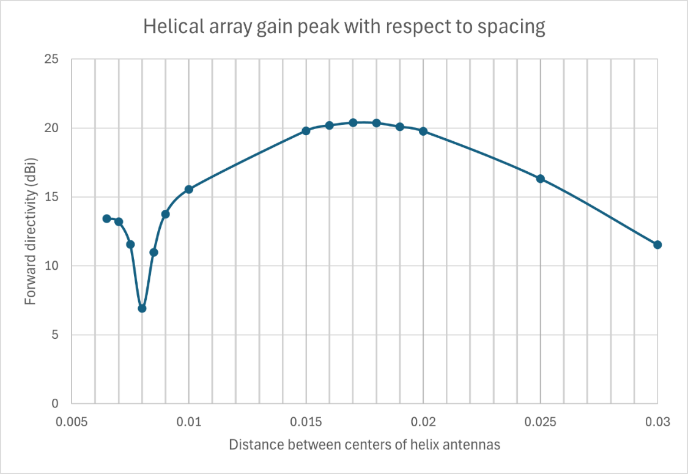
Figure 9: Zoomed graph of close antenna spacing impacting directivity,
measuring distances between 70mm to 3cm.
Figure 9 shows forward directivity can be maximized when the centres of all elements are spaced 1.7cm apart (shown in Figure 10). This distance was used during all measurements of the helical antenna array, to fairly evaluate the performance of well-tuned arrays.
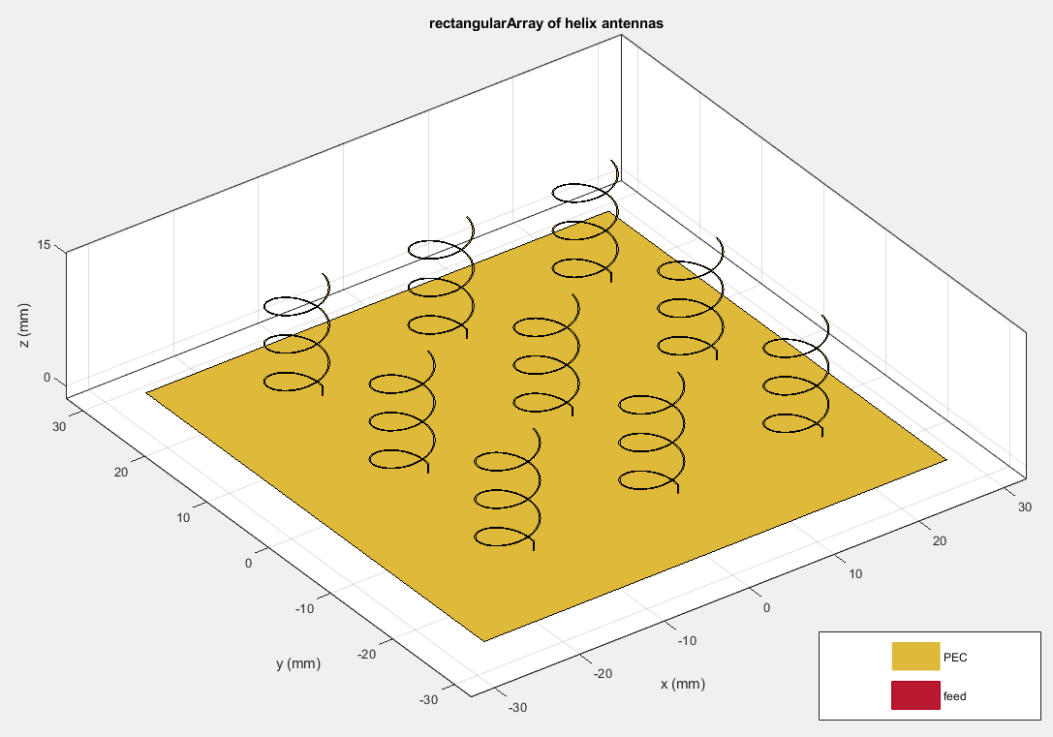
Figure 10: Helical antenna array with elements spaced 1.7cm apart

Results

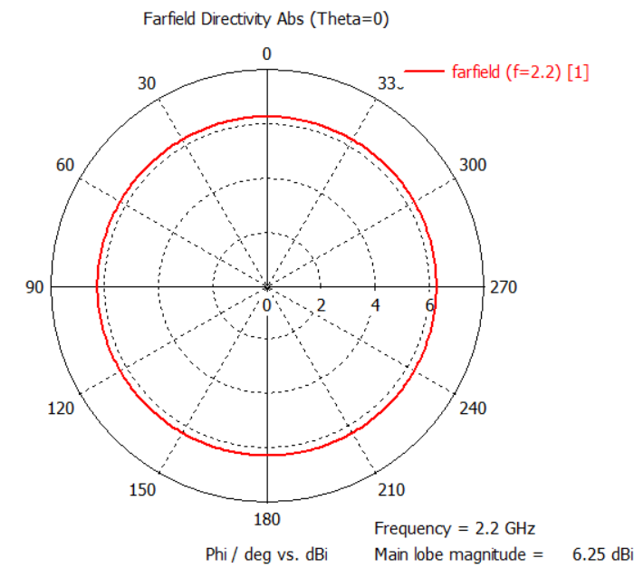
Figure 11: Patch Antenna directivity in dBi (azimuth cross-section, top-down)
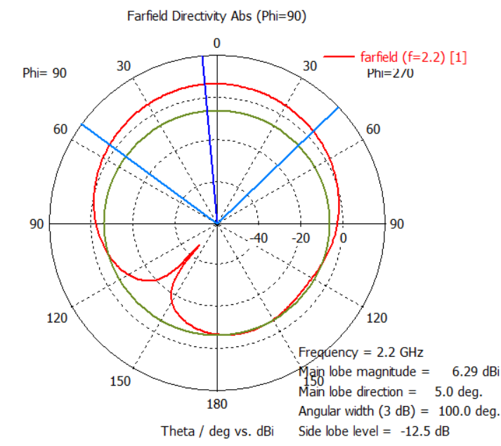
Figure 12: Patch Antenna directivity in dBi (elevation cross-section, side-on)

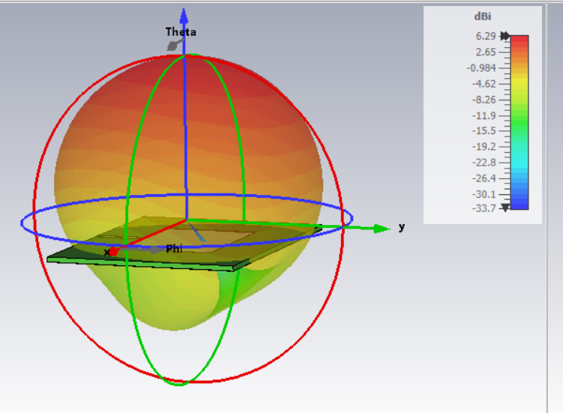
Figure 13: Patch Antenna directivity in dBi (3D view)
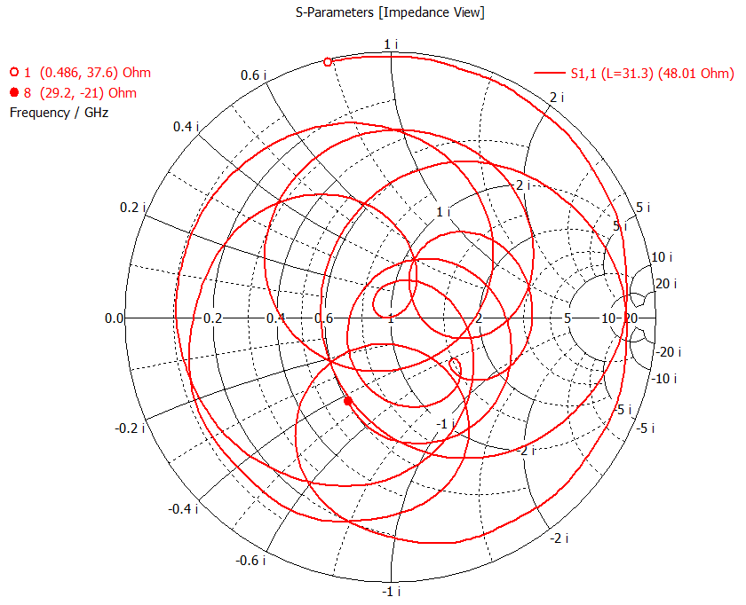
Figure 14: Patch antenna impedance Smith Chart
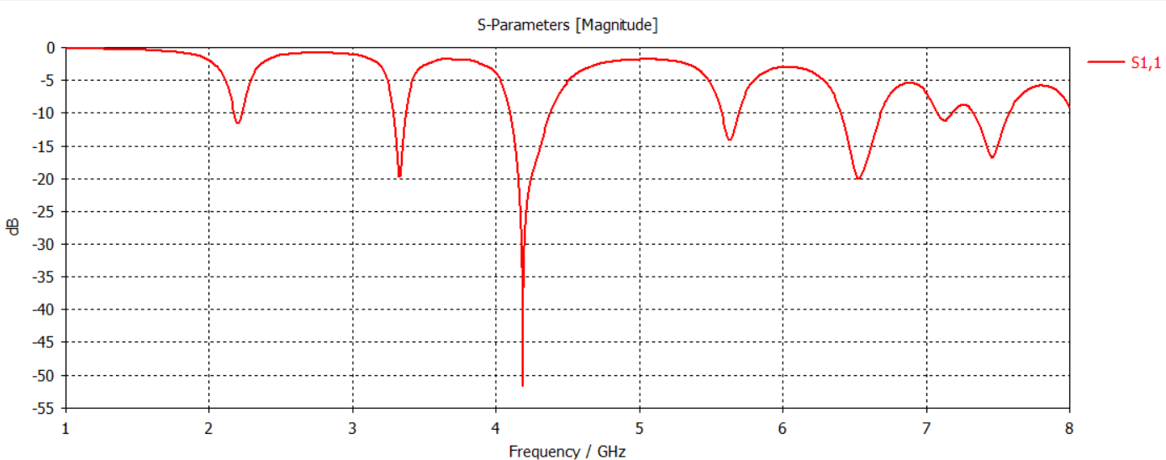
Figure 15: Patch antenna S Parameters, from 1 to 8GHz

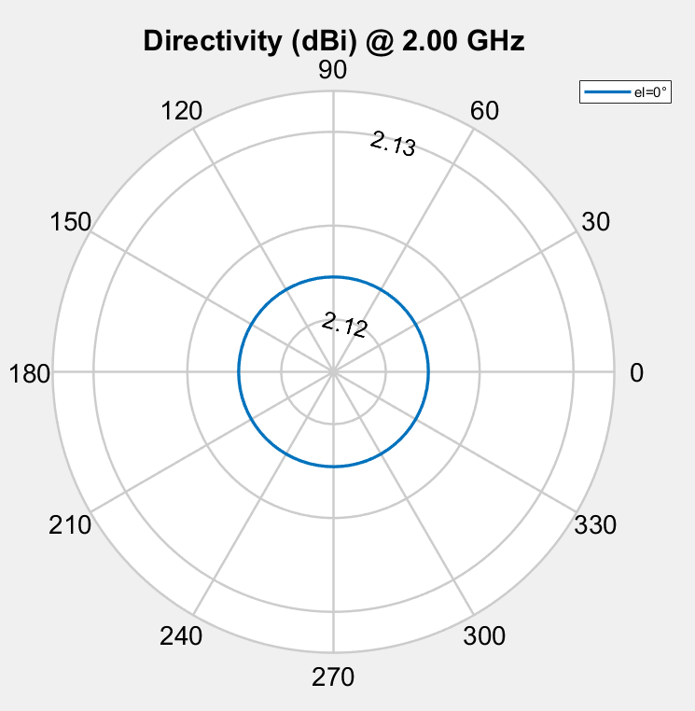
Figure 16: Cylindrical Dipole directivity in dBi (azimuth cross-section, top-down)
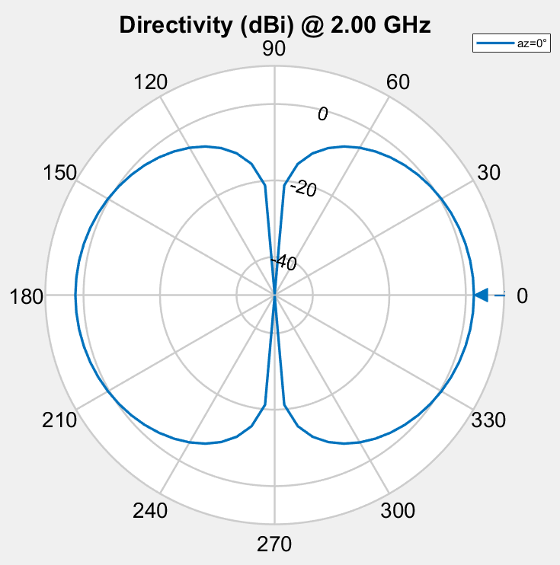
Figure 17: Cylindrical Dipole directivity in dBi (elevation cross-section, side-on)
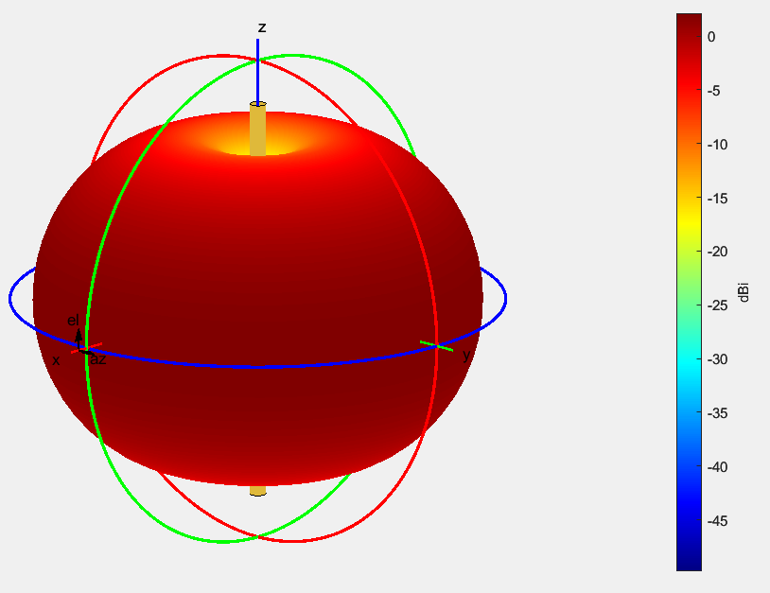
Figure 18: Cylindrical Dipole directivity in dBi (3D view)
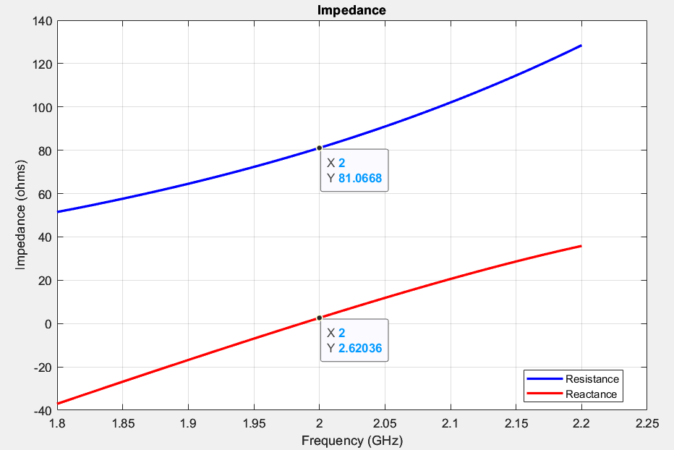
Figure 19: Cylindrical Dipole impedance graph
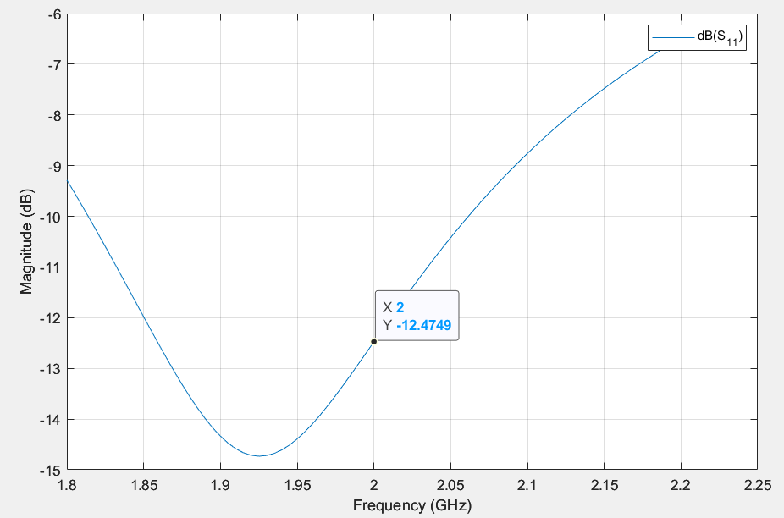
Figure 20: Cylindrical Dipole S Parameters at nominal 50-ohm matching

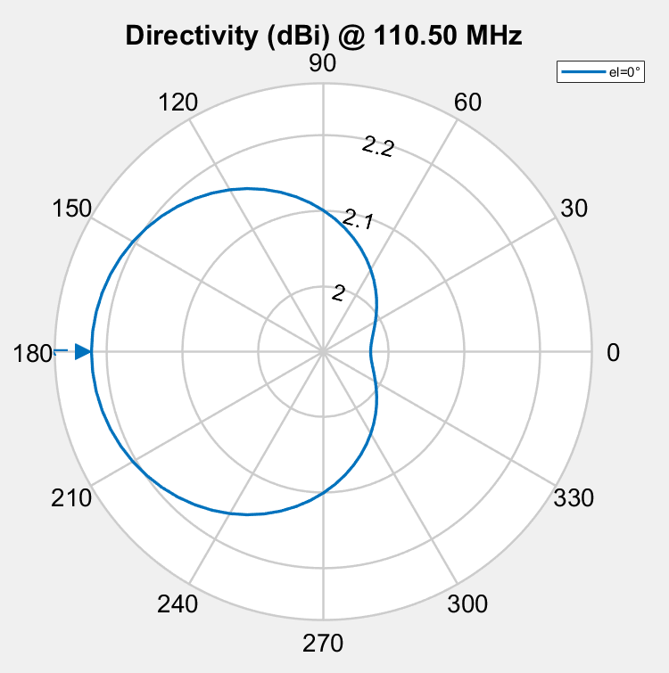
Figure 21: Folded Dipole directivity in dBi (azimuth cross-section, top-down)
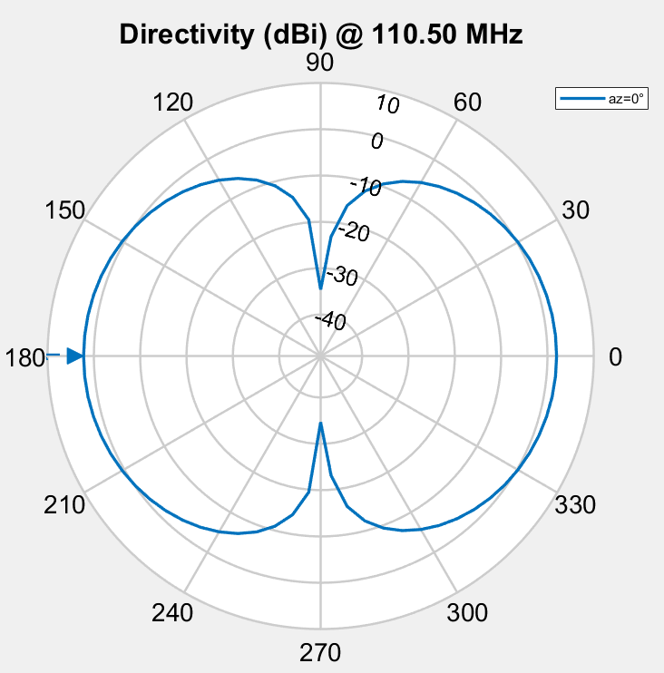
Figure 22: Folded Dipole directivity in dBi (elevation cross-section, side-on)
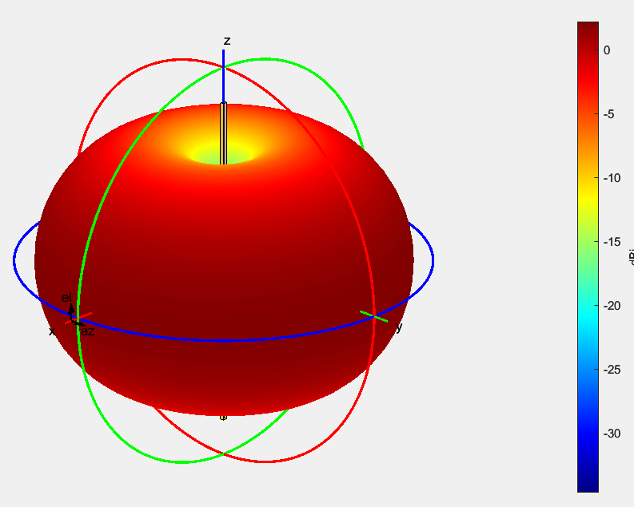
Figure 23: Folded Dipole directivity in dBi (3D view)
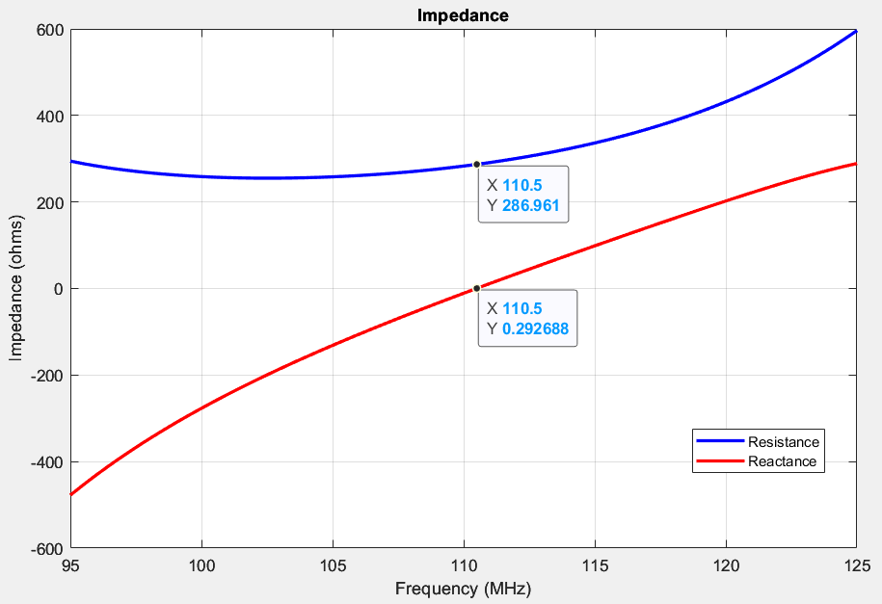
Figure 24: Folded Dipole impedance graph
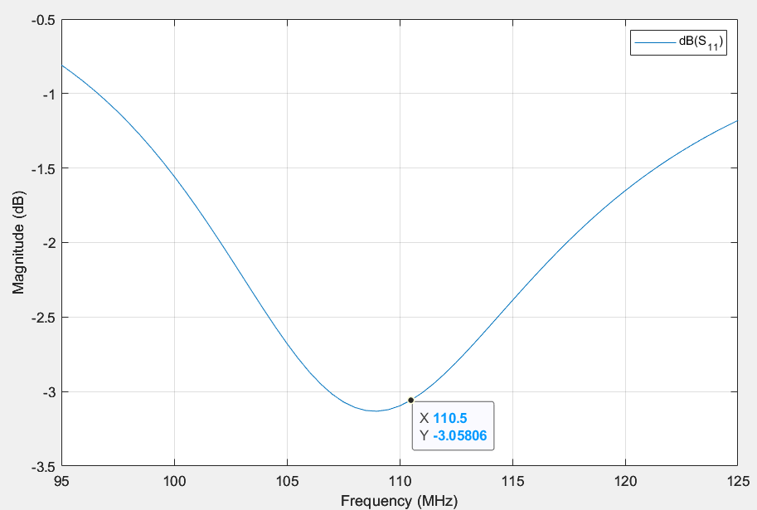
Figure 25: Folded Dipole S Parameters at nominal 50-ohm matching

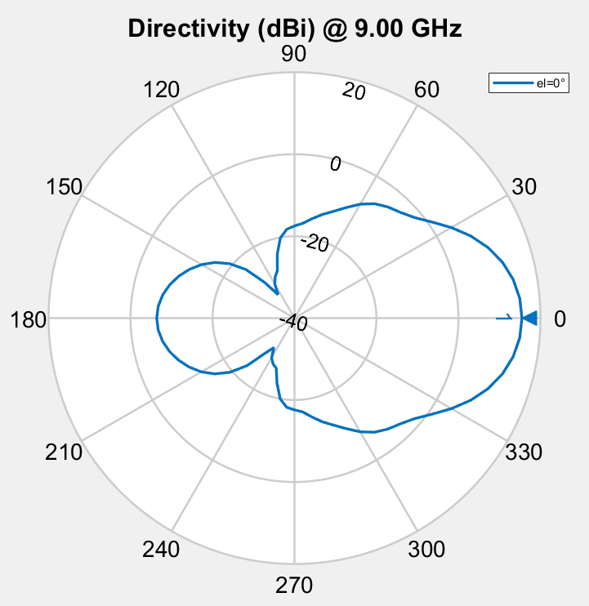
Figure 26: Horn antenna directivity in dBi (azimuth cross-section, top-down)
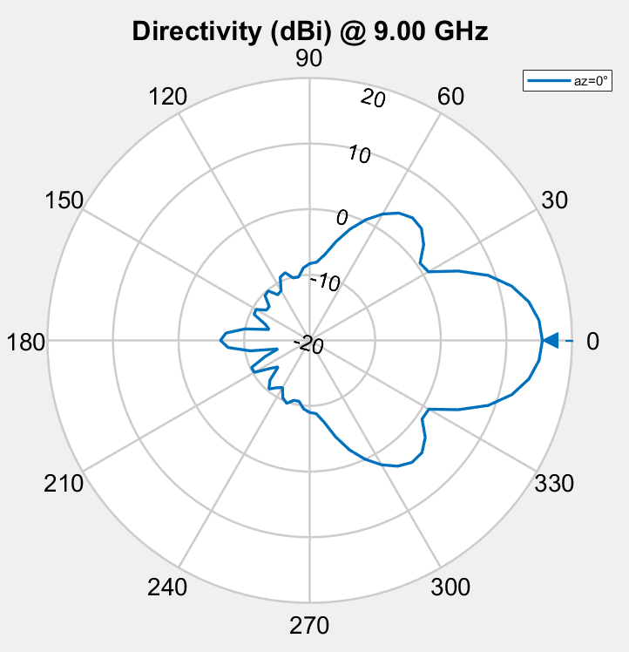
Figure 27: Horn antenna directivity in dBi (elevation cross-section, side-on)
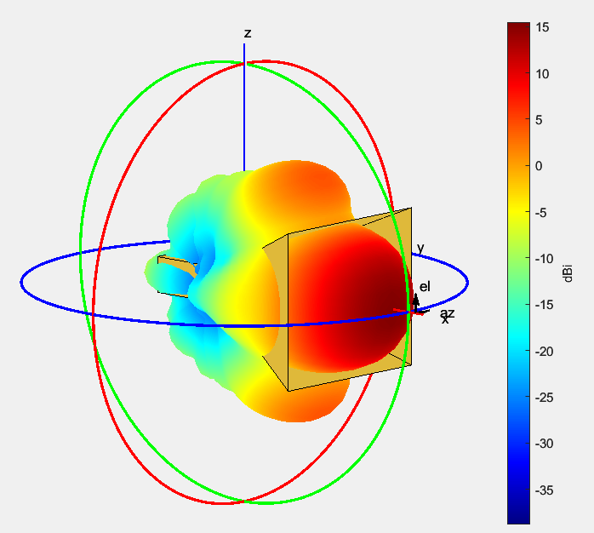
Figure 28: Horn antenna directivity in dBi (3D view)
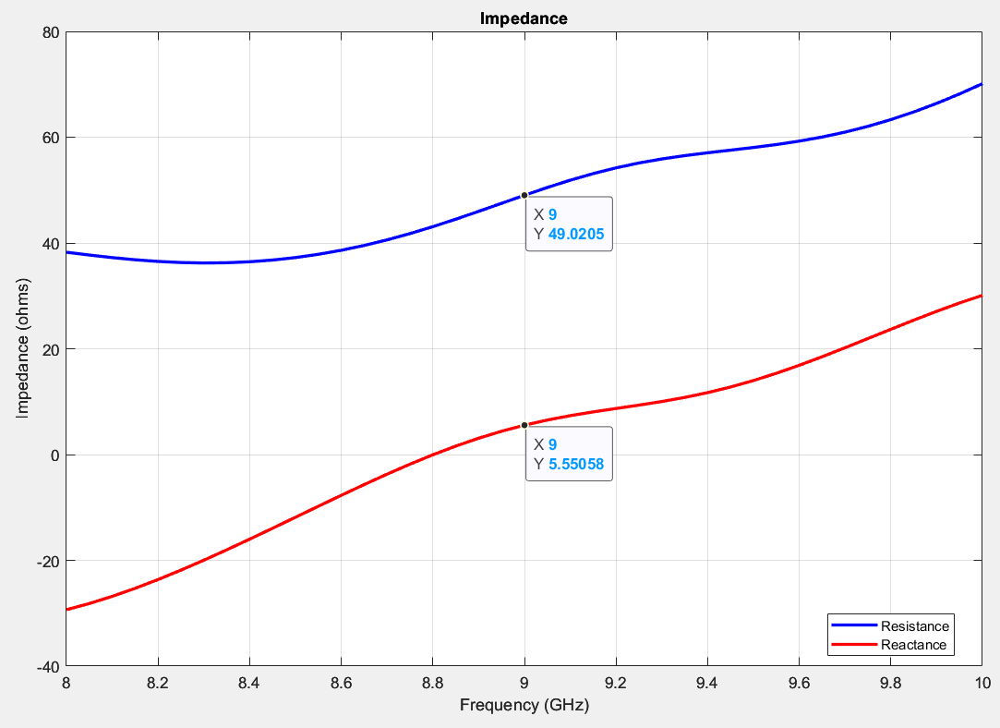
Figure 29: Horn antenna impedance graph
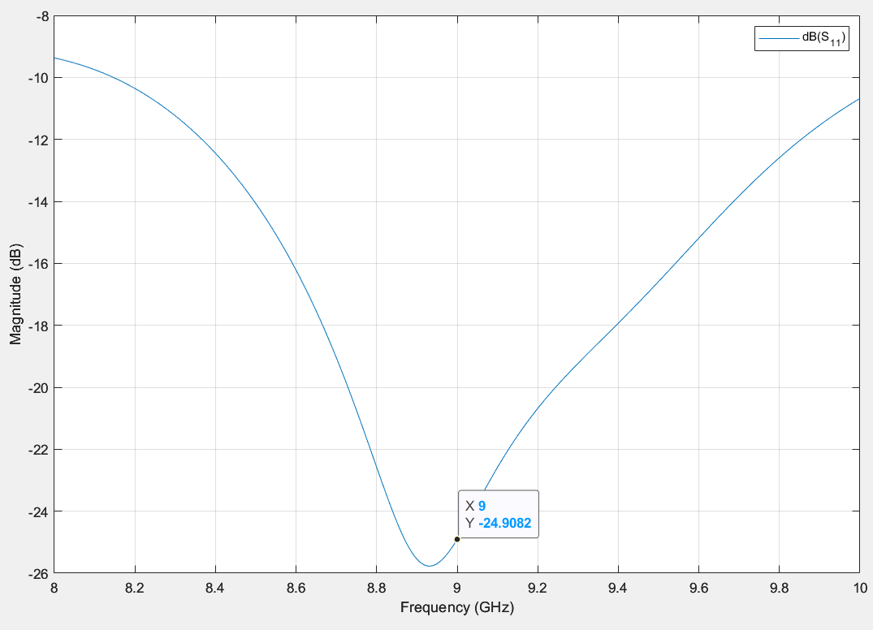
Figure 30: Horn antenna S Parameters at nominal 50-ohm matching

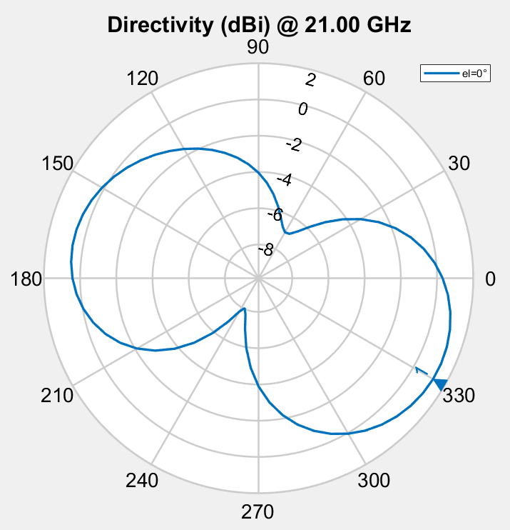
Figure 31: Helical antenna directivity in dBi (azimuth cross-section, top-down)
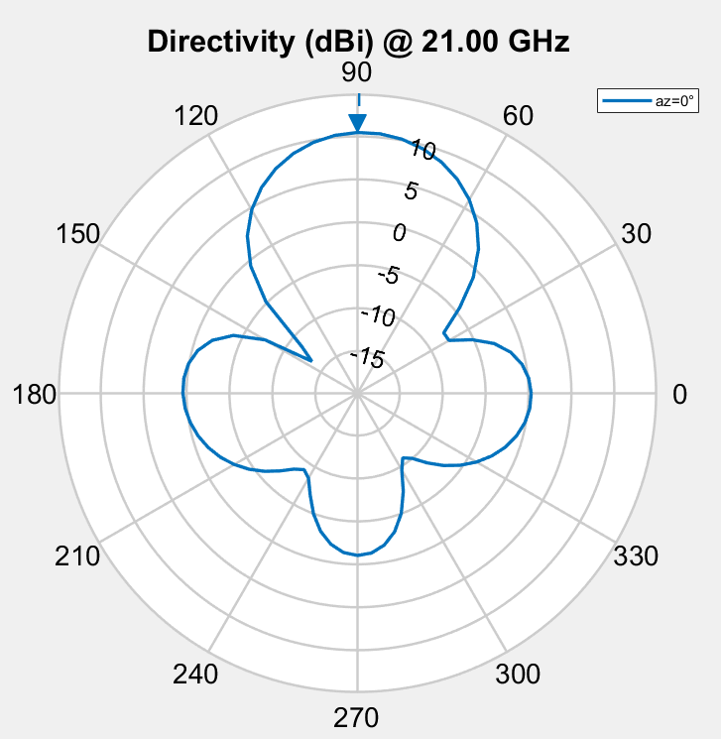
Figure 32: Helical antenna directivity in dBi (elevation cross-section, side-on)
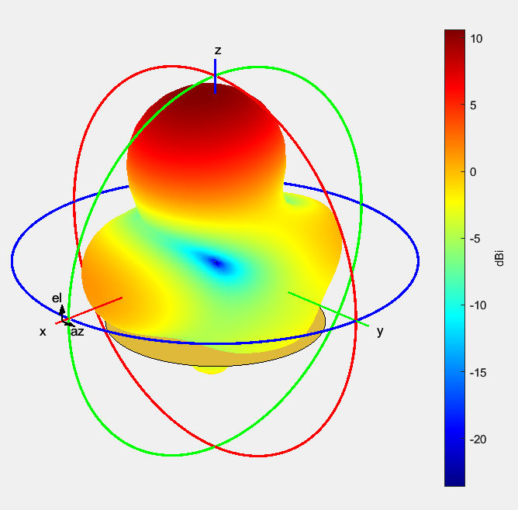
Figure 33: Helical antenna directivity in dBi (3D view)
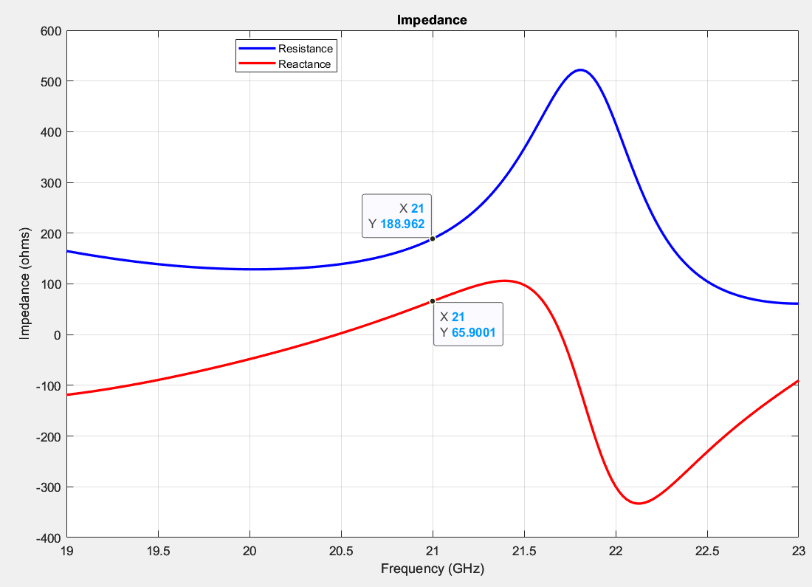
Figure 34: Helical antenna impedance graph
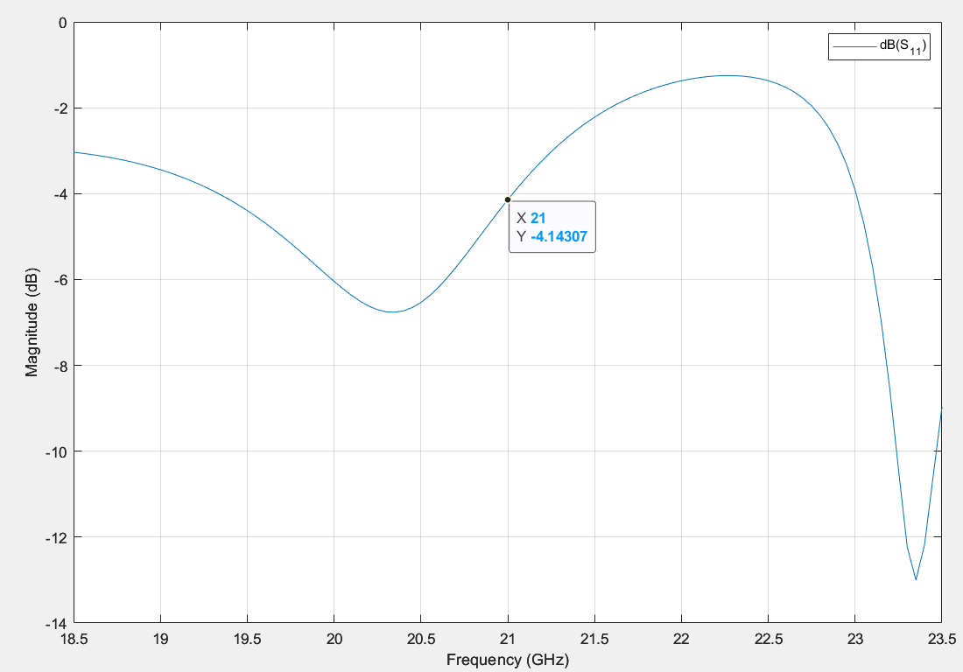
Figure 35: Helical antenna S Parameters at nominal 50-ohm matching

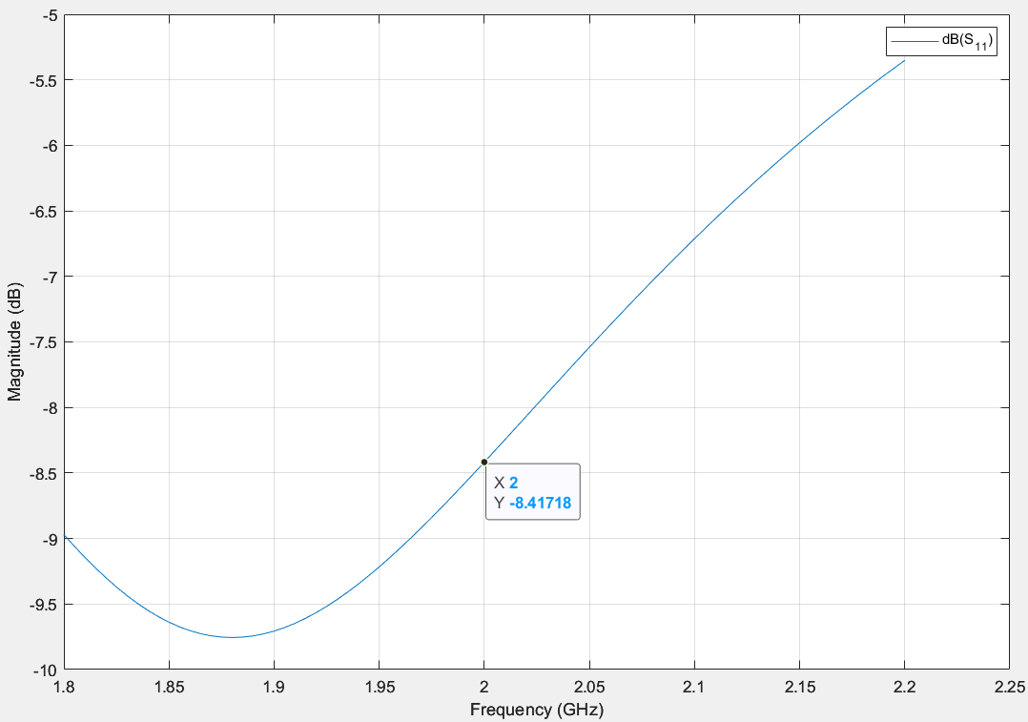
Figure 36: Cylindrical Dipole S Parameters mismatched at 30-ohms
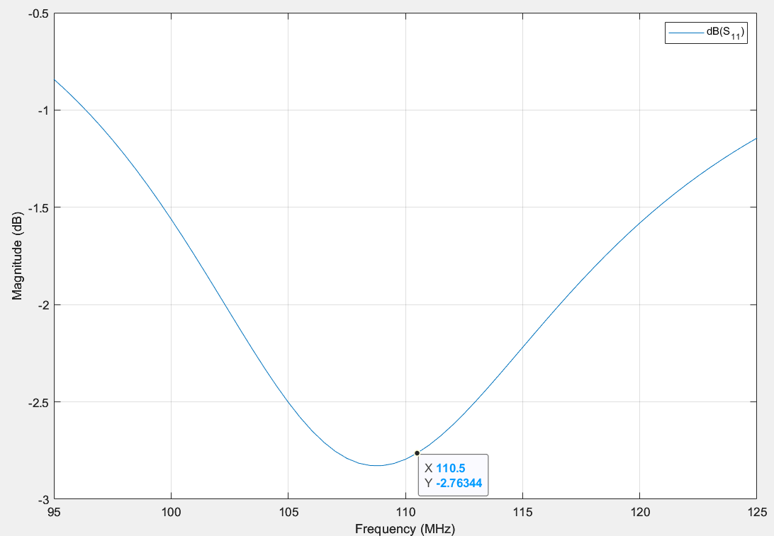
Figure 37: Folded Dipole S Parameters mismatched at 30-ohms
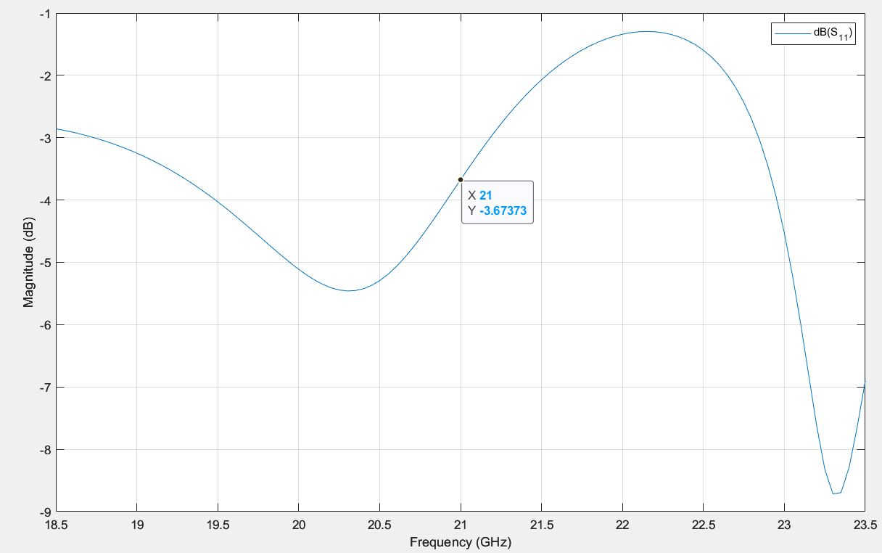
Figure 38: Helical antenna S Parameters mismatched at 30-ohms
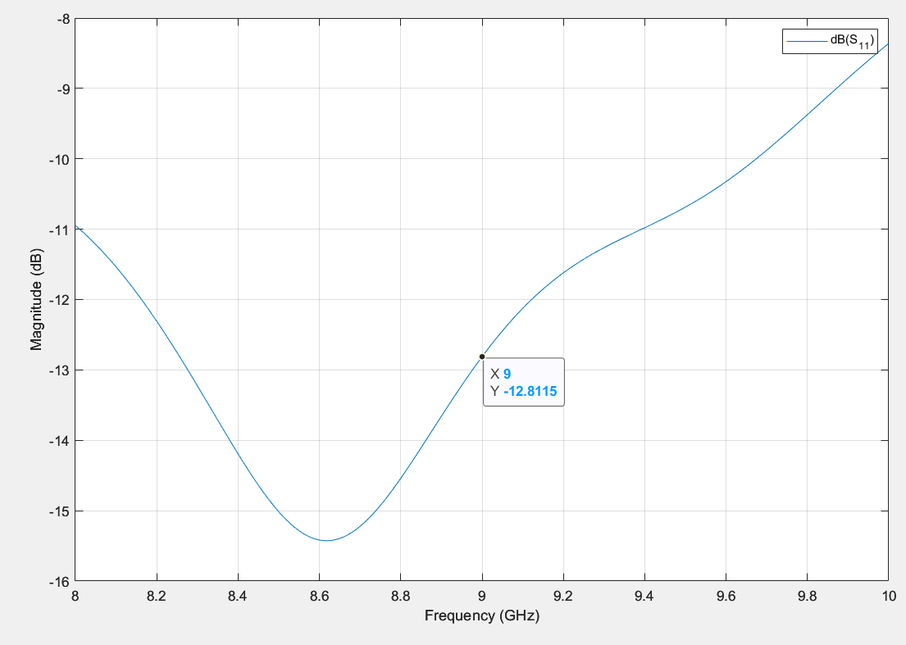
Figure 39: Horn antenna S Parameters mismatched at 30-ohms

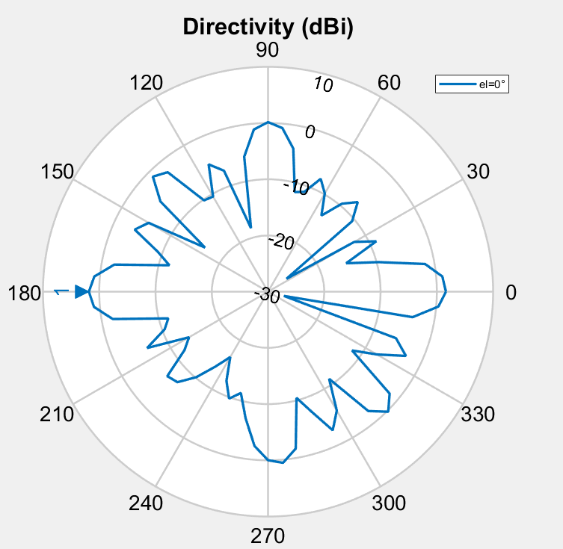
Figure 40: Helical antenna array directivity in dBi (azimuth cross-section, top-down)
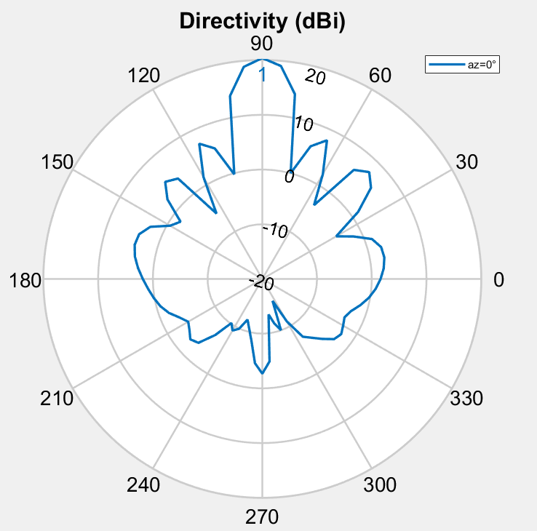
Figure 41: Helical antenna array directivity in dBi (elevation cross-section, side-on)
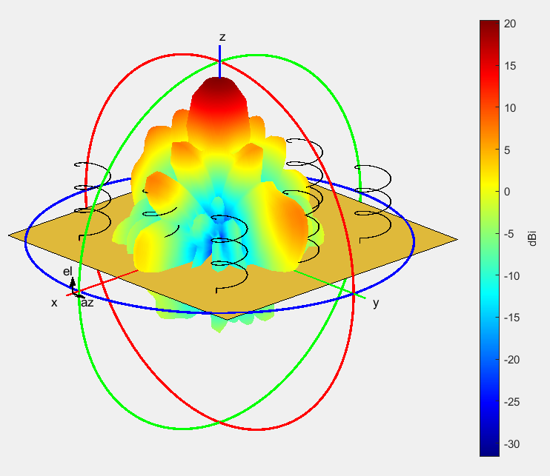
Figure 42: Helical antenna array directivity in dBi (3D view)
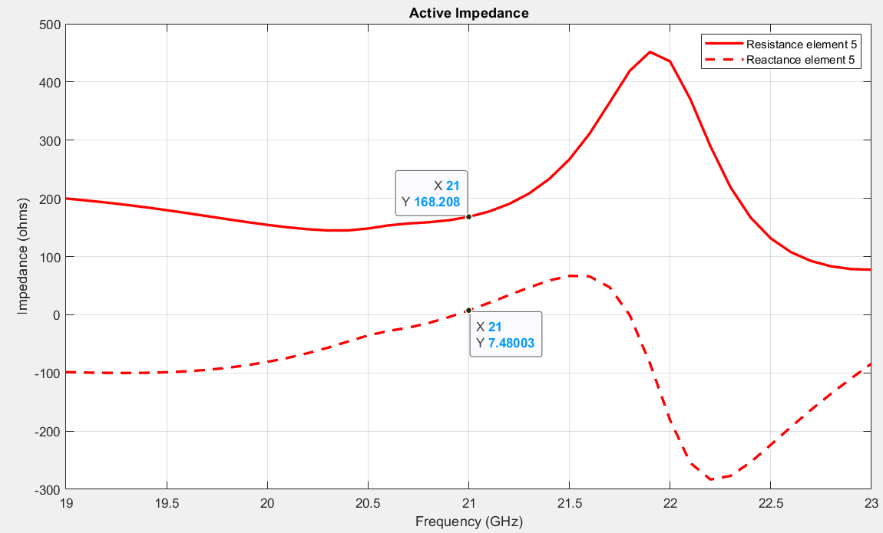
Figure 43: Helical antenna array centre element impedance graph
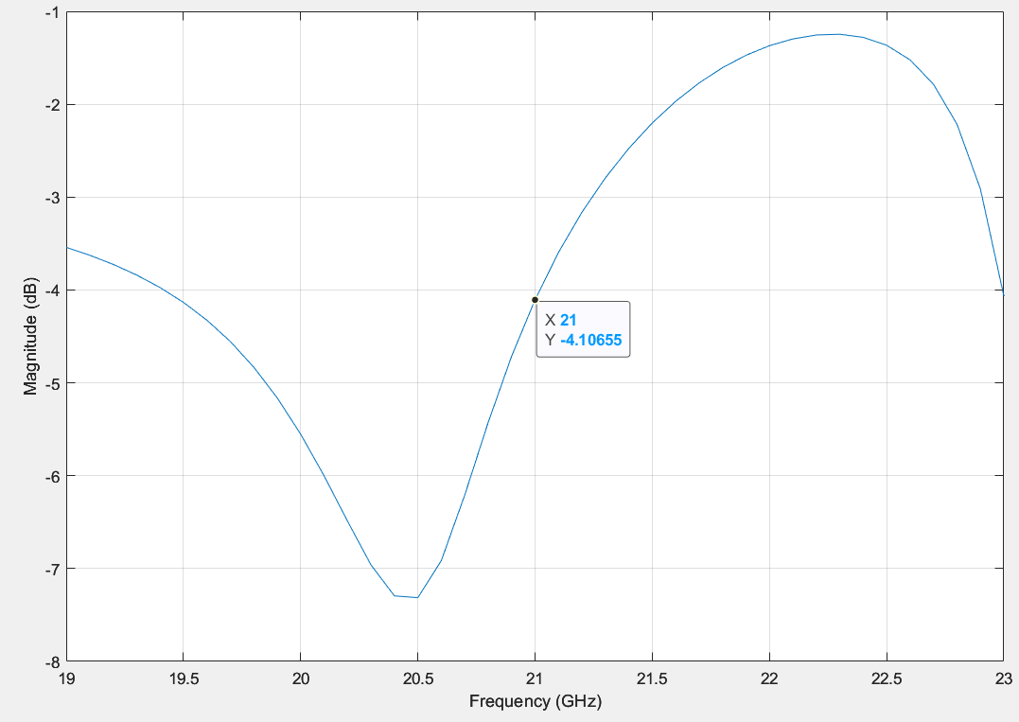
Figure 44: Helical antenna array S Parameters at nominal 50 ohm matching

Discussion
The patch antenna’s size was calculated using Equation 2, given a frequency and information about the dielectric. However, creating the antenna using the calculated dimensions led to the resonant frequency being slightly lower than expected. Correcting this required adjusting the length in CST until the simulated antenna resonated at the desired frequency, shown in Figure 8. This highlights an important consideration when calculating theoretical antenna parameters; there are additional unknowable variables which impact antenna performance in the real world, so simple calculations can only find approximate values. Fine-tuning the antenna will require some degree of experimentation. This was only done for the patch antenna as CST permits directly altering the antenna’s length. MATLAB only allows changing the target frequency, so all other antennas are unaltered.
Cylindrical and Folded Dipoles behave similarly, both being omnidirectional. However, there is a subtle difference in their radiation patterns, observable when comparing Figure 17 and Figure 22. The folded dipole has slightly higher emissions at the top and bottom compared to the cylindrical dipole, potentially allowing reception even when the antenna is not pointed in the correct direction.
Comparing the target frequency of each antenna modelled in MATLAB versus the actual resonance frequency shown in the S Parameter chart (see Table 1) reveals a peculiar pattern. Every time, MATLAB created an antenna which resonated below the target frequency, with discrepancies as high as 700MHz. The exact reason for this is unknown; only those who wrote MATLAB’s Antenna Designer could explain the software’s behaviour. However, the author speculates that the equations used by MATLAB are similarly imprecise to theoretical calculations, so both options must not be trusted blindly when creating an antenna where precision is required.
Antenna type | Target frequency | Resonant frequency | Difference MHz
Cylindrical Dipole | 2 GHz (Equation 3) | 1.93 GHz (Figure 20) | -70 MHz
Folded Dipole | 110.5 MHz (Equation 4) | 109 MHz (Figure 25) | -1.5 MHz
Horn | 9 GHz (Equation 5) | 8.93 GHz (Figure 30) | -70 MHz
Helix | 21 GHz (Equation 6) | 20.3 GHz (Figure 35) | -700 MHz
Helix array | 21 GHz (Equation 7) | 20.4 (Figure 44) | -600 MHz
Table 1: Comparison of antenna target resonance vs simulated resonance
Impedance matching is important, as properly matched antennas will perform better compared to incorrectly matched ones. This is because it minimises the power reflected back towards the RF hardware from the antenna, instead allowing it to be radiated usefully [2]. This is shown in Figure 36 through Figure 39, where mismatching the impedance to 30 ohms instead of the nominal 50 ohms causes the antenna's S Parameter to increase. Comparing Figure 20 and Figure 36, the Cylindrical Dipole S Parameter increased from -12.5dB to -8.4dB, representing a drop in performance by 32.8%. All antennas exhibited a noticeable drop in performance.
$$\frac{-8.4dB- -12.5dB}{-12.5dB}=-32.8\%$$
Equation 8: Calculation of mismatching impact on cylindrical antenna performance
There is an inherent trade-off between directivity and antenna complexity. Antennas with highest directivity (horn and helix, with relatively high directivities of 15dBi and 20dBi respectively, as shown in Figure 27 and Figure 32 respectively) will interfere less with surrounding electronics, thereby minimizing radio interference, as is required by UK law [3].
Cylindrical and Folded Dipole are the easiest to build, at the cost of being omnidirectional (shown in Figure 16 and Figure 21) and therefore less targeted. In some applications this is desirable, such as in consumer radios where the direction to the transmitter should not affect reception.
Antenna arrays provide an effective way to dramatically increase directivity by adding more elements. In testing, adding 8 elements positioned around the centre element (Figure 42) increased directivity substantially, approximately from 10 dBi (Figure 32) to 20 dBi (Figure 41), which is equal to 10 times greater.
Taking this into the context of societal and environmental factors, it is therefore important to choose an appropriate antenna for an RF system. If possible, it should be directed towards its receiver, so a minimum amount of power is required for the signal to be received. This also reduces emissions of stray RF into unwanted directions, helping to keep the electromagnetic spectrum free for other users. Furthermore, transmitting RF requires some amount of electricity to power the transmitter. If this usage can be reduced, it will be beneficial for the environment as less fossil fuels are required to power the equipment.

Conclusion
In conclusion, choosing the correct antenna type is crucial for optimal performance of the system, as choosing incorrectly can cause energy to be wasted if it is transmitted in the wrong direction. It is important to model the antenna in calculations and/or software so expectations of how it will perform can be verified. Furthermore, it is highly recommended for the system’s impedance to be correctly matched, to avoid damaging the radio hardware with signal reflections and maximise antenna performance.

References

[1] | Pasternack, “Microstrip Patch Antenna Calculator,” [Online]. Available: https://www.pasternack.com/t-calculator-microstrip-ant.aspx. [Accessed 12 05 2025].
[2] | D. A. Govind, “Antenna Impedance Matching – Simplified,” [Online]. Available: https://abracon.com/uploads/resources/Abracon-White-Paper-Antenna-Impedance-Matching.pdf. [Accessed 19 05 2025].
[3] | Wireless Telegraphy Act 2006, Part 3 Regulation of Apparatus (54)(4)(a).

