Name: Group business plan
Business Plan for: Tent Haven Events

Lecturer: | Neil Dyer
Date:  Words: | 04/03/2024  2737
Team members: | Alina Grigore (2209836)  Anat Dranciuc Georgescu (2125394)  Cecilia Maria Cojocaru (1816288)  Ionela Beatrice Hulub (2214483)

Business plan contents
Executive Summary…………………………………………………………………………………………………………….3
1 Executive summary 3
2 Business details 4
3 Key personnel 5
Vision 6
4 The business idea 6
5 Business goals 6
6 What the business does 7
7 What makes the business different 7
8 Legal requirements 7
Marketing 8
9 Market research 8
10 Profiling customers 8
11 Profiling competitors 9
12 Managing market risks 9
13 Pricing 9
14 Promotion and advertising 10
Running the business 11
15 Staff 11
16 Premises 11
17 Suppliers 11
18 Equipment 12
19 Managing operational risks 12
Finance 13
20 Start-up costs 13
21 Profit and loss forecast 15
22 Sourcing Finance 16
23 Managing financial risks 16
24 Cash flow forecast 17

1 Executive summary

Our project Tent Haven Events started from a very small idea from a previous assignment of one of the group members and suffered a lot of constructive modifications this week to achieve all the new ideas of the group members. Initially, the business was focused on hiring tents for small events and after group discussion, we were transformed into an entirely sustainable and eco-friendly business. Providing a comprehensive service that includes tent setup, breakdown, lighting, sound systems, full decorations, and catering, enhances customer convenience and experience.
Our tents are made from recycled materials, the BBQ catering offers a good start in the hospitality area which we cover (and which will be in a couple of years transformed into an eco-friendly restaurant) and is made from fresh meat directly from our farm collaborations, the way we do the decoration from recycled materials and repurposing old furniture it’s a way we use to protect the nature and also created public relationships with our workshops in primary schools.
As for our competitors, they are more focused on extending their business and less worried about sustainability. Others may have good marketing positions but the distance and offers that they give are limited to either one or two types of customers and do not have as much influence in our business area of choice.
Our main goal is to satisfy our customers’ needs so before we go and build our first tent, we discuss with our client, taking notes of their space, explaining our tent capacity, making sure that we can fit the tents they require plus our barbeque setting that we offer if needed and of course the payment options.
Part of our plan is to extend| an international area, transform the BBQ Catering into an eco-friendly restaurant and collaborate with colleges and universities to offer placement for students who study sustainability and environment preservation courses.
In conclusion, because our business is a social enterprise, the most important for us is to find a better way to implicate the community in our business and in this way to create a brand from our business, which in the future can also generate more profit and satisfaction.

2 Business details

Company name: Tent Haven Events

Address:
Unit 8 Millersdale Close, Euroway Industrial Estates, Bradford, BD6 6RX

Primary contact method
Phone: +447504235891 Email: tenthavenevents@gmail.com Site: tenthaven.events.co.uk

The business will:

Provide hire tents for events (summer and winter tents) made from recycled material, a various package of BBQ catering, lights, music system, decoration, and eco-friendly transport by electric car. The business offers customers the possibility to pick up from our packs everything they need to have their events ready uniquely and sustainably.

3 Key personnel

Details of owner(s):
Name: Alina Grigore
Position/main responsibilities: Business Admin
Experience and knowledge of our industry: Business Administration
Previous employment: BMP Cleaning Service
Key skills brought to the business: Founder of the vision of Tent Haven
Business experience and any training undertaken: human resources, business administration
Academic/professional qualifications: Lev 3 Business Administration, London Professional College
Salary expectations £ 30.000

Name: Anat Dranciuc-Georgescu
Position/main responsibilities: Site instructor and maintenance
Experience and knowledge of our industry: Caregiver, Personal assistant
Experience and knowledge of our industry:
Previous employment: Amazon
Key skills brought to the business: Language barrier, process knowledge, be a good listener.
Business experience and any training undertaken: Been through several trainings in health and safety and hazard precautions trainings.
Academic/professional qualifications:

Salary expectations 23000 £

Name: Cecilia Maria Cojocaru
Position/main responsibilities: Marketing and Sales
Experience and knowledge of our industry: Premier Inn, Sports Direct, Telemarketing.
Previous employment: Premier Inn
Key skills brought to the business: Digital Skills, Sales experience, well organized.
Business experience and any training undertaken: Telemarketing and sales training, can cover the main instructor in case of sick days due to training in safety and other parts of the industry.
Academic/professional qualifications: Level 3 course of Skills in Human Resource; Level 2: Diploma in working with vulnerable person; Level 2: Diploma in Skills of Team Leader.

Salary expectations £ 25000
Name: Ionela Beatrice Hulub
Position/main responsibilities: Health and Safety on the field and First aider on site.
Experience and knowledge of our industry:
- Housekeeping.
- Health and Safety regulations in the hotel
- Health care assistant
Previous employment: Gloucestershire Foundation Trust
Key skills brought to the business:
- Proficient in health and safety regulations
- Experience in providing first aid on-site.
- Excellent communication and interpersonal skills
- Ability to effectively manage emergencies and prioritize tasks
Business experience and any training undertaken: First Aid Training
NVQ Level 2
Academic/professional qualifications:
Post Secondary School
Salary expectations £ 32000

Vision

4 The business idea

Sum up your business idea:

Tent Haven Events is an innovative idea that merges the business model canvas for Tent Haven events business (Appendix 2) and improved from Event in a Tent (n.d.) the business concept specialising in hosting events such as Weddings birthdays, teamed parties or even corporate meeting or events such as yearly reward business events. The Tent Haven Events is an environmentally conscious business which uses recycled material to create tents in partnership with Robert’s Recycling (2024) and refurbishes old furniture and objects to create event decoration by repurposing the furniture and items to breathe new life into them, distinctive venues decoration. The business is a Social Enterprise business which in collaboration with Atlas Primary (2019) school creates workshops for children to attend and learn how to develop the skills of repurposing existing materials to create the decoration, the business is due to be known in local areas by leveraging public relationships trough inviting newspapers and television to document some of the workshops as an environmentally friendly business which implicates in social events to create brand awareness in the Bradford without spending a vast amount of revenue on marketing. The business owns winter and summer tents, Winter tents are equipped with external heating for cool seasons, and custom lighting, decorative furniture, tables, seats, a music system, and transportation are included with the tents. The size ranges from small to extra-large event tents created from impenetrable material with a full-service package that includes tent setup and breakdown lighting, sound stereos hired for the best parties, event planning and decoration inspired by All Occasion Venue stylist (2024) and food and drinks catering trough a dedicated team which during the event is selling BBQ cooked food inspired by BBQ and Buffet (2024). The barbeque food was supplied by Land End Farm Shop (2024) with a request to use environmentally friendly food transport packages such as plastic-free or reusable containers. The beverage of events is supplied by HB Clark
(2022) and for fruits and vegetables, a partnership with First Choice Products (2024) with the request to deliver in wood reusable boxes to reduce environmental impacts.
Tent Heven tent events competitors are Hotel Bell Tent (2021) and Honey Bell Tents & Events (RS Leisure LTD, 2024) as their principal rivals. Haven Tent plans to use public relations, social media and web marketing created by Pixel Digital (2022), internet booking, word-of-mouth, and local marketing initiatives as part of their multifaceted marketing strategy.
Leasing tents and selling food during the events are the business's main sources of income, fix costs include electric vans buying, employee wages, warehouse, and office space rent to store the equipment for the food catering. Flexible costs are the food and drinks supplies, uniforms, bills, decorations creation tools and accessories, and workshop hosting events. Tent Haven Events is positioned as a one-stop shop for all event tent needs that covers all these aspects in addition to these comprehensive services.

5 Business goals
- What do you want to achieve in your first year of business?
Objectives for Haven Tent’s business are to archive a 100% gross profit in the first year invest in decorations and cover the vans buying costs (Appendix 4).

- Where do you see your business in 3-5 years?
Current scoring for the business idea is a bit low (Appendix 4) which in time is expected to grow in awareness and be able to include in the workshop's collaborations with colleges and universities to offer placement for students who study sustainability and environment preservation courses (Appendix 5).

6 What the business does

Product/service | Features | Benefits
Even tents | Venue space for any occasion | Custom sizes ready to be built on any location
Different sizes | XS, S, M, L, XL | Cater to customer needs
Outdoor decorations | Themed decorations | Visually appealing
Lights | Different designs and styles | Brings the mood after the sun is down
Sound system | Ready to deliver sound for any size party | Creates atmosphere
Air curtain warmer | Warm up the tents to be able to operate out-of-season | Customises the tents for cold seasons
Transport  Partnerships  Specialised team  Food &Beverages catering  Eco toilets | Environmental and fast transport  All in one package  Building up and down the tents with care for the product  BBQ, salads, fruit dishes hot or cold food and drinks for the event.  Offering eco-toilets for the events to supply the needs of events (depending on capacity events can be 2 -5 toilets) | No worry for the customer  Customers have everything taken care of  Reducing stress for customers  Customers have everything taken care of  Eco way to the facility of outdoor events

7 What makes the business different (Value Proposition)

Offering eco-friendly, customisable tents made from recycled materials provides a strong differentiator in the event space market, focusing on sustainability appeals to environmentally conscious consumers and can leverage growing trends towards eco-friendly event solutions.
Providing a comprehensive service that includes tent setup, breakdown, lighting, sound systems, full decorations, and catering, enhances customer convenience and experience.

8 Legal requirements

Our business will include a series of standards and regulations which we were studying very much on the GOV site, and they are classified into two parts 1. Before launching and setting up the business: Business Registration and Tax Registration, Health and Safety, Insurance Policies, Environmental Permits, Food and Alcohol Licensing (for BBQ & Buffet), Fire Safety Regulations, Music Licensing, Equipment Safety and Compliance and 2. During the operations and Ongoing Basis: Event Permits, Transportation and Vehicle Licensing, Building Regulations, Waste Management, Regular Updates and Renewals, Insurance Policies, Health and Safety and Licenses and Permit (GOV, n.d.).

Marketing

9 Market research

Trends in your chosen market are:

The more efficient by offering a variety of services like food and beverage and the more colourful the tents it helps to outstand competitor demands According to ATA the most requested ones are the clear top tents and Black tents (ATA, 2024). When it comes to tent trends is also important the structure of the tent as it can come in a variety of structures such as frame tents. Pole tents, pop-ups or even inflatable (Pacific Dome, 2024). The tent event hosting is a relatively new hospitality ramification but including the food catering into the business and the full planning for an event therefore is leaning into hospitality even more. Regarding the food and Beverage services for events outdoors such as tent venues food trucks and catering businesses which offer a variety of services like BBQ, Fine dining, Salat and fruit bars, Cocktails, deserts, and other beverages (Keramu 2024).

How you know this:

After thorough research on competitive businesses website is clear that the tent hire business in more than pop-up and down a tent some organisations have a very well-done booking system (Event in a tent, 2024) which not only allows the customer to plan the size and the decorations for the venue through the tent hire company website (Appendix 10) The trend of the tents is not simply limited to 4 wall room structured tents but it varies from Tipi Tents, Stretch tents, Stages, Dome and quad tents to fulfil any need or requirement but also fully caters to the event planning to deliver services such as preparing the event and delivering food and Beverage services during the customer events. However catering companies like Big Bear, Meat Outdoors, and By Molly are the strongest competitors as they offer not just BBQ, but a wide range of foods Just Graze is a strong competitor in the Bradford area according to Keramu (2024).

10 Profiling customers

The customer groups you will be selling to are:

According to Similar Web (2024),(Appendix 9) the highest interest in outdoor activity is shown by men aged 25-34 however the higher interest in tent events is shown by women of the same age group therefore to attract both it must Cather to both preferences another spike on the activities are man and woman’s ages 35 to 44 and 45 to 54 to attract all these demographics the marketing must focus on the following.
- Customer Segment 1:
- For men Aged 25-34 see Appendix 11
- Customer Segment 2: Women Aged 25-34 see Appendix 12
- Customer Segment 3:
- Men and Women Aged 35-44 See Appendix 13
- Customer Segment 4:
- Men and Women Aged 45-54 See Appendix 14

How you know this:

According to Similar Web (2024), these are the demographic most interested in outdoor events and tent events (Appendix 9) (Faroog, 2019).

Number of customers you expect to win in each group and what they might pay:
Group | Number of customers | The price they might pay per unit
Segment 1 | 8 | £120
Segment 2 | 6 | £140
Segment 3 | 8 | £180
Segment 4 | 4 | £200

11 Profiling competitors

Competitor name | Strengths | Weaknesses
Pop Top | Strong market awareness on Similar Web (2024) | Not environmentally friendly
Xclusive Party tent hire | Search engine presence in Bradford | Poor website presentation and limited number of tents
Event in a tent | Good website presentation large range of services and is sustainable friendly | Low UK presents
Bell tent boutique | Good presence in the Nottingham area | Far from Bradford may be difficult to book events
Honey bell Tents  By Molly  Big Bear BBQ Pizza & Grill | Strong market presence in Dorset  Fine dining food created by a private chef.  Popularity in Bradford area affordable food | Significance distance from Bradford may lose out on transport.  Limited capability to take orders.  Is limited to fast food no servicing team to deliver for Higy end events.

How you can improve on their offer and/or price(s) unique offerings:

Place a high importance on online presence to create awareness in the Bradford area and increase website quality to appeal to customers' first impressions of the business and offerings.
Becoming environmentally aware and increasing their approach to sustainability can bring up a new demographic of customers inclined to eco practices. Competitors which seem to be too far away may benefit from opening branches in other places in the country to better cover the areas and create a presence to generate business.

12 Managing market risks

Write down the risks you have identified:

- Market Saturation: The presence of multiple competitors within the event tent rental space indicates a potentially saturated market. This could lead to intense competition, price wars, and difficulty in gaining market share.
- Local food catering: companies can create competition and prices must be adjusted accordingly.
- Food vans: food vans can be hired by guests to cater for them instead of choosing the Haven tent event full package.
- Competitor Imitation: If Tent Haven's eco-friendly approach and comprehensive service package are successful, competitors may quickly adopt similar strategies, reducing Tent Haven's competitive edge.
- Geographic Expansion of Competitors: Competitors such as Honey Bell Tents and Bell Tent Boutique could decide to expand closer to Bradford, directly threatening Tent Haven's local market.
- Search Engine Dominance: Competitors like Xclusive Party Tent Hire with a strong search engine presence in Bradford could capture potential customers before they even discover Tent Haven.
- Brand Recognition: Established competitors with strong market awareness, such as Pop Top, might overshadow Tent Haven's marketing efforts, making it harder for Tent Haven to become a recognised name.
- Technological Advancements: Competitors with the ability to invest in advanced booking systems and digital marketing may outpace Tent Haven in customer convenience and acquisition.
- Economic Scale: Larger competitors may have the advantage of economies of scale, allowing them to offer lower prices or higher discounts that Tent Haven may not be able to match.
- Logistics and Supply Chain: Competitors with a well-established supply chain and logistics might be more efficient in tent delivery and setup, offering faster and potentially more reliable services.
- Website Quality and Customer Experience: Competitors with superior website design and online customer experience could attract more clients, especially if Tent Haven's online presence does not meet customer expectations.
- Environmental Trends: While Tent Haven's eco-friendly approach is a strength, competitors can also enhance their sustainability practices, and Tent Haven could lose its unique market position.
- Customer Loyalty Programs: some competitors have implemented strong customer loyalty programs that encourage repeat business, which could be a challenge for Tent Haven to counteract without similar incentives.

(Appendix 8).

How will you manage these risks so that they become less of a threat:
To manage the Risk from these competitors Tent Haven will create strong public relations to increase social and online presence and invest in creating Brand awareness, another approach is to place significant energy in delivering exceptional services and full packages for the guests to cross-sell both the tents and the F&B services, create a serving team to service the food for better satisfy guests and partner whit Trustpilot (2024) to help create credibility of the services and business. For detailed details of competitors' Opportunities and Threats see Appendix 15

13 Pricing

How you can calculate your prices:
in comparison with the demand the price can be set if demand increases price can increase if demands drop price drops to help break even, for starters the prices will be set according to the competitor's price depending on the design and the size of the tent.
Therefore, tent heaven prices will be around as follows.

How your prices compare with the competition:
Product/service | Your price(s) | Range of competitor prices (per unit)
Small tents | £150-250 | £75-300
Medium Tents | £300-450 | £230-550
Large tents | £500-750 | £432-1152
BBQ Food | £8-16 | £8-15
Cold food | £2-14 | £4-10
Alcohol | £3.50-7 | £ £3.70-£7.50
Coffee/Tea | £2.40-3.70 | £3.20-4.80

According to Bell Tents (2024), the price range is shown.

Reasons for the difference between your price(s) and your competitors’ price(s):

The cost must cover the expenses for the setup therefore The Haven tent event is a start-up business and still needs to grow and supply more decorations and features to increase the price in the first year is important to create a good brand awareness.

14 Promotion and advertising

How and where will you promote your product/service?

Public relations are the main plan for the advertisement for Tent Haven events to promote the business's environmentally friendly approach to create awareness through workshops and rising interest in reutilising objects.
Furthermore, Search Engine Optimization (SEO) Optimise the website for relevant keywords to improve organic search rankings.
Offer discounts for off-peak seasons to attract customers planning for events.
Implement a referral program that incentivises current customers to refer new clients.
Ensure listings on online directories and event planning portals, complete with customer reviews and photos of past events.
Encourage satisfied customers to leave reviews on platforms like Trustpilot and Google My Business.
Search Engine Marketing (SEM) Run paid search in peak time to campaigns for quick visibility in high demand periods for keywords with high commercial intent.

Running the business

15 Staff

Role | Total cost | Necessary experience | Specialist skills and/or qualifications
Business Admin | £ 40.000 | Experience in business administration | Proficiency in office control, file-keeping, monetary management, and communication capabilities.
Site instructor and maintenance | £ 30.000 | Experience in site management and maintenance | Ability to interpret manufacturer instructions for the tent
Marketing and Sales | £ 32.000 | Experience in marketing and sales | Communications skills  Customer relationship management
Health and Safety on the field and First Aider on-site | £ 29.000 | Training in health and safety procedures  First aid certification | Health and Safety Training  First Aid Certification
Year 3; driver assembly  Grill Chef | £30.000  £25.000 | Driving licence minimum 2 years  Experience in preparing and cooking BBQ menu | marque installer/training provided.  NVQ Level 3 in Advanced Professional Cookery

16 Premises

 | Cost £
Premises required at start-up: location | £114.000 annual rent
Premises required in the future (if different): | £0

17 Suppliers

Your key suppliers and their credit terms
Supplier | What you’ll buy from them | Number of days’ credit
Robert’s recycling (2024)  Lane End Farm Shop | Tents  BBQ meats. | 30-60 days  30-60 days
Ford Drive | Electric van | 45 days
Thermoscreens.com  www.Alivenetwork.com | Air curtains  Dance Floor | - days  30-45 days
Ultra Event Production  www.willpoweltd.co.uk | Lighting  Generators and power distribution | - 30 days  - 45-60 days
 | Ecological Toilets | - 30 days
Vodafone | Phone/broadband | - 30 days
www.bicplc.co.uk | Cleaning and maintenance suppliers | - 30-days
Currys.co.uk  Amazon | PC, fridge,  Office Supplies | - 30 days  - 3-5 days

18 Equipment
Resource | When | How funded | Cost £ per unit
- Tents | - At start-up | - Start-up capital | £75
- BBQ Grill  - BBQ Utensils  - Chef uniform and shoes | - At start-up | - Start-up capital | £ 429.99  £ 136.98  £ 32.95
- Fridge | - At start-up | - Start-up Capital | £649.00
• Office table and chairs | - At start-up | - Credit  - Credit | £ 984.00
- PC  - Phone | - At start-up | - Credit  - Credit | £449.00  £ 399.00
- Fire Extinguisher  - First Aid Kit | - At start-up | - Start-up Capital  - Startup Capital | £ 281.95  £96.00
- Cleaning products | - At start-up | - Credit | £149.27
- Electric vans | - At start up | - Credit | £1325/month
- Tools kit | - At start up | - Start-up capital | £ 40.09

19 Managing operational risks.

Risk | Solution
- Staff  - Resignations  - Sickness  - Holidays | - Covered by agency staff or a team member.  - Cover by a team member when possible or an agency.  - Recruitment Agency covered.
- Suppliers  - Unavailable farm products.  - Contracted unreliable supplier. | - A secondary contract with another farm shop.  - Diversify supplier base

Finance

20 Start-up costs

Calculate how much money you need before you start trading.

21 Profit and loss forecast.

22 Sourcing finance

Total borrowing requirement for the business

23 Managing financial risks.

The risks that you have identified for your financial forecast are:
The main risks identified by the company would be to not have as many customers as the prediction of the forecast, in this situation the company would lose considerable amounts of money.
Second would be that the company is refused the cash grants that it applied for, and then the business would not have a successful start-up.

How you will minimise their impact:

Assuring that the company is already known in the market area of its location, saving as much of the cash it already has before actually getting the grand necessary to boost its performance.

24 Cash flow forecast (Click on the tabs within the Microsoft Excel sheet to view the second 6 months and summary)

25 Conclusion.
The main objective of the company is to access the grands necessary to support the company’s start-up, as such Gov.UK (2024) is offering grants for different entrepreneurs to help sustain the less fortunate area of the United Kingdom by boosting the companies to support the local economy and population with either jobs or opportunities to grow.
On another note, Future Learn (2024) gives a list of several different companies and trusted charities that support and sustain local business and their communities and Tent Haven is focused on these main objectives to help and support the local talents.

References
All Occasion Venue stylist (2024) Facebook page. [online] www.facebook.com. Available at: https://www.facebook.com/Alloccasionsworksop [Accessed 16 Feb. 2024].
ATA (2024) Tent and Event Trends for 2024. [online] InTents. Available at: https://intentsmag.com/2024/01/03/tent-trends-2024 / [Accessed 16 Feb. 2024].
Atlas Primary (2019) Contact – Atlas Community Primary School. [online] Available at: https://atlasprimary.co.uk/contact / [Accessed 25 Feb. 2024].
BBQ and Buffet (n.d.) Catering Bradford. [online] BBQ and Buffet Catering. Available at: https://bbqsandbuffets.co.uk/areas-we-cover/catering-bradford / [Accessed 14 Feb. 2024].
Conor Hourihan (2020) Why Festivals are More Popular than Ever. [online] https://www.gallowglass.com/our-blog/festival-crewing/why-festivals-are-more-popular-than-ever/. Available at: https://www.gallowglass.com/our-blog/festival-crewing/why-festivals-are-more-popular-than-ever / [Accessed 16 Feb. 2024].
Event in a Tent (n.d.) Tipi Rental for Weddings, Parties & Festivals. [online] Event in a Tent. Available at: https://www.event-in-a-tent.co.uk/ [Accessed 16 Feb. 2024].
Farmington & Co (2024) Buy Meat Online From The UK’s Best Online Butcher. [online] Farmison & Co. Available at: https://www.farmison.com/?msclkid=e9a78ffbea121e5e734eea23905f5801&utm_source=bing&utm_medium=cpc&utm_campaign=SEB%20-%20Farmison%20Brand%20BROAD%20%5BUK%20SRCH%20MaxConvValue%5D%20-%20Brand%20Rstrct&utm_term=farmison&utm_content=farmison%20uk%20BROAD [Accessed 25 Feb. 2024].
Farooq, U. (2019) StackPath. [online] Marketingtutor.net. Available at: https://www.marketingtutor.net/what-is-consumer-behavior/ [Accessed 16 Feb. 2024].
First Choice Products (2024) First Choice Produce. [online] firstchoiceproduce.co.uk. Available at: https://firstchoiceproduce.co.uk / [Accessed 25 Feb. 2024].
GOV (n.d.) Licences and licence applications - GOV.UK. [online] www.gov.uk. Available at: https://www.gov.uk/browse/business/licences [Accessed 14 Feb. 2024].
Hotel Bell Tent (2021) Hotel Bell Tent. [online] Hotel Bell Tent. Available at: https://www.perfectlypitchedproductions.com/#connect-index [Accessed 14 Feb. 2024].
Keramu LTD (2024) Big Bear’s BBQ Pizza & Grill - Wood-Fired Pizza or Great BBQs - Book on Together. [online] Together. Available at: https://togather.com/suppliers/big-bears-bbq-pizza-and-grill [Accessed 25 Feb. 2024].
MyMolly (2024) by Molly private chef. [online] by Molly private chef. Available at: https://bymolly.uk/ [Accessed 25 Feb. 2024].
Pacific Dome's (2023) Event Tent Types: Exploring Shelter Options for Event Venues. [online] Pacific Domes. Available at: https://pacificdomes.com/event-tent-types-exploring-shelter-options-for-event-venues/ [Accessed 16 Feb. 2024].
Pixel Digital (2022) Website Design Bradford. [online] PIXXEL DIGITAL. Available at: https://pixxeldigital.co.uk / [Accessed 14 Feb. 2024].
Pop Top (n.d.) Affordable Party Tents in Bradford for Hire, Instant Rental Prices & Availability. [online] www.poptop.uk.com. Available at: https://www.poptop.uk.com/bradford-city/suppliers/marqueetent/partytent/ [Accessed 16 Feb. 2024].
R S Leisure LTD (2024) Luxury Bell Tent Hire from Honeybells. [online] Honeybells Tents & Events. Available at: https://www.honeybells.co.uk/ [Accessed 14 Feb. 2024].
Robert’s Recycling (2024) Recycling. [online] Roberts Recycling Ltd. Available at: https://www.robertsrecycling.co.uk/recycling-operations/recycling/ [Accessed 14 Feb. 2024].
SimilarWeb (2023) Similar Web Identity. [online] Similar web. Available at: https://pro.similarweb.com/#/digitalsuite/websiteanalysis/audience-demographics/ [Accessed 18 Feb. 2024].
Trustpilot (2024) Technology Partners - Trustpilot API Documentation. [online] developers.trustpilot.com. Available at: https://developers.trustpilot.com/partners#:~:text=Building%20an%20Integration%201%201.%20Get%20your%20partner [Accessed 16 Feb. 2024].
Xclusive party tent hire (2024) Marquee, Gazebo and Party Tent hire in Leeds. [online] Xclusive Party Tent Hire. Available at: https://www.xclusivepartytenthire.co.uk/ [Accessed 16 Feb. 2024].
Lane End Farm Sho(2024)p. Available at: http://www.laneendfarmshop.co.uk/ (Accessed: 25 February 2024).
KitWave (2022) Beverage supplies, HB Clark. Available at https://www.hbclark.co.uk/ [Accessed on 25 Feb. 2024]
Thermoscreens (n.d.). Air Curtain | Air Curtain Heater Manufacturer. [online] Available at: https://thermoscreens.com/ [Accessed 26 Feb. 2024].
Pretty Little Party Shop. (n.d.). Eco-Friendly Decorations | Biodegradable, Recyclable, Reusable Party Decorations. [online] Available at: https://prettylittlepartyshop.co.uk/collections/eco-friendly-decorations [Accessed 26 Feb . 2024].
Indeed (2023). Job Search | Indeed. [online] uk.indeed.com. Available at: https://uk.indeed.com/. [Accessed 26 Feb . 2024].
Nisbets.co.uk. (2019). Nisbets Catering Equipment – Catering Supplies & Kitchen Equipment. [online] Available at: https://www.nisbets.co.uk/ [Accessed 26 Feb . 2024].
National Office Furniture Supplies. (n.d.). Office Furniture: Desks, Chairs & Storage Up To 65% Off. [online] Available at: https://www.nationalofficefurnituresupplies.co.uk/ [Accessed 26 Feb . 2024].
Currys (2023). Currys | Washing Machines, Laptops, TVs, Consoles. [online] www.currys.co.uk. Available at: https://www.currys.co.uk/ [Accessed 26 Feb . 2024].
www.forddrive.co.uk. (n.d.). Flex your business fleet | Ford Drive Commercial. [online] Available at: https://www.forddrive.co.uk / [Accessed 25 Feb 2024].
Simply Extinguishers. (n.d.). Simply Extinguishers | Simply Low Prices, Highest Quality. [online] Available at: https://simplyextinguishers.co.uk/ [Accessed 28 Feb. 2024].
BLOSTM Multi Tool Kit 100 piece (no date) DIY at B&Q. Available at: https://www.diy.com/departments/blostm-multi-tool-kit-100-piece/5060914440328_BQ.prd (Accessed: 29 February 2024).
ASPLI Safety Specialist since 1978 (2024). PPE Personal Protection. Available at: https://www.aspli.com/ppe-personal-protective-safety-equipment/?page=1 (Accessed: 3 March 2024).
Amazon (2024) Amazon Fresh Shopping Baske. Available at: https://www.amazon.co.uk/cart/localmarket?ref_=cart_go_cart_btn_fresh&almBrandId=QW1hem9uIEZyZXNo (Accessed: 3 March 2024).
City of Bradford Metropolitan District Council (2024). Planning Fees. Available at: https://www.bradford.gov.uk/planning-and-building-control/planning-applications/scale-of-planning-fees/ (Accessed: 3 March 2024).
Lubna Khan (2024). Cost and Services – Woodhall Solicitors. Available at: https://woodhallsolicitors.co.uk/cost-and-services/ (Accessed: 3 March 2024).
HISCOX (2024) How much does business insurance cost? Available at: https://www.hiscox.co.uk/business-insurance/faq/how-much-does-business-insurance-cost (Accessed: 3 March 2024).
Gov.UK (2024) Social Enterprise Boost Fund. Available at: https://www.gov.uk/guidance/social-enterprise-boost-fund-local-areas-of-delivery (Accessed: 4 March 2024).
Future Learn (2024) Funding for Social Enterprise. Available at: https://www.futurelearn.com/info/courses/social-enterprise-idea-action/0/steps/146050 (Accessed: 4 March 2024).

27 Appendix

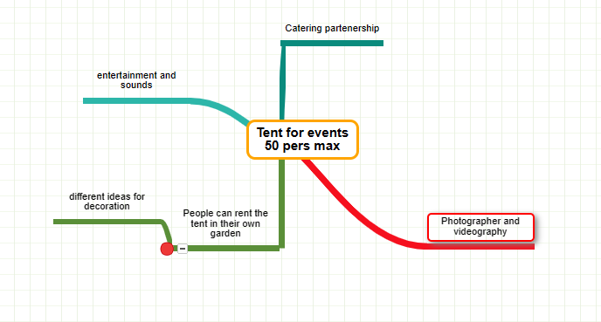

Appendix 2

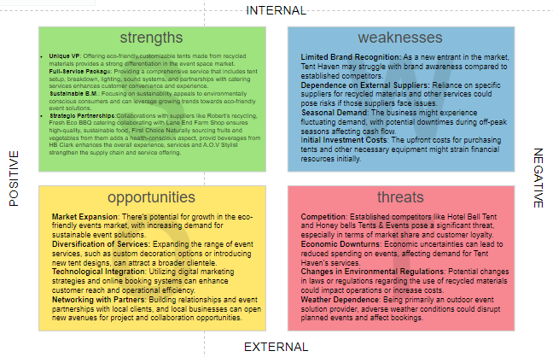
Appendix 3

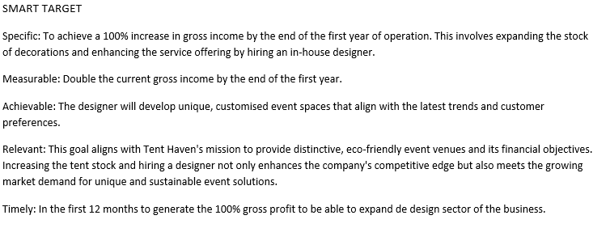
Appendix 4
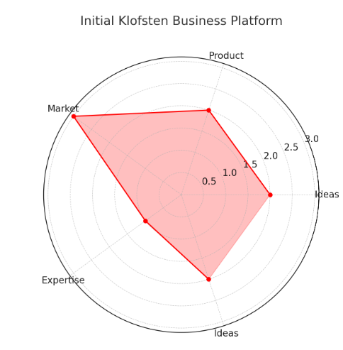

Appendix 5
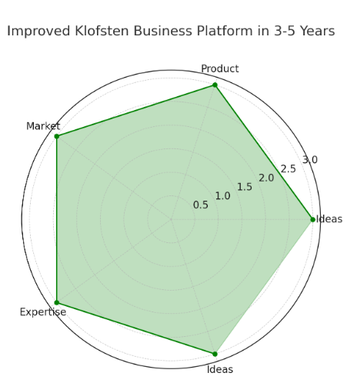

Appendix 6

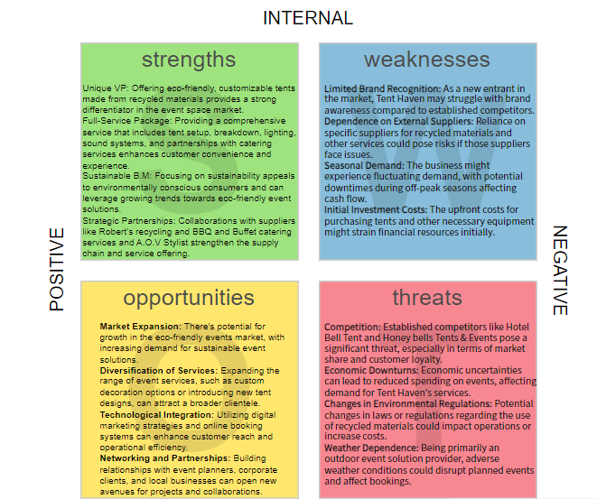

Appendix 7
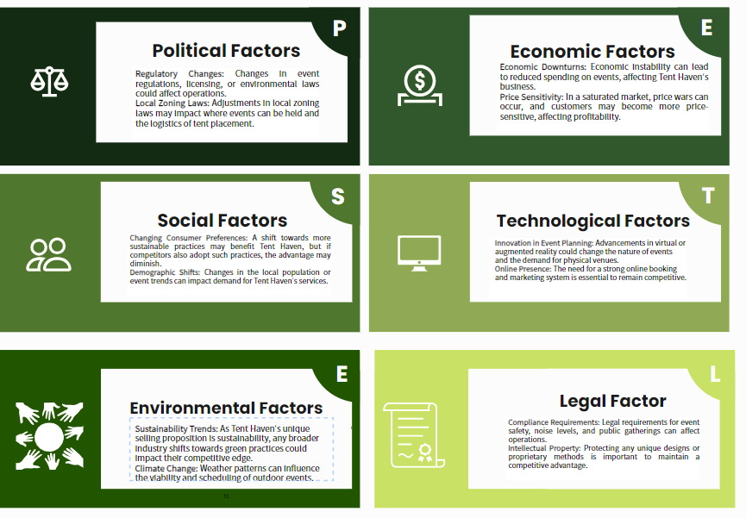
Appendix 8
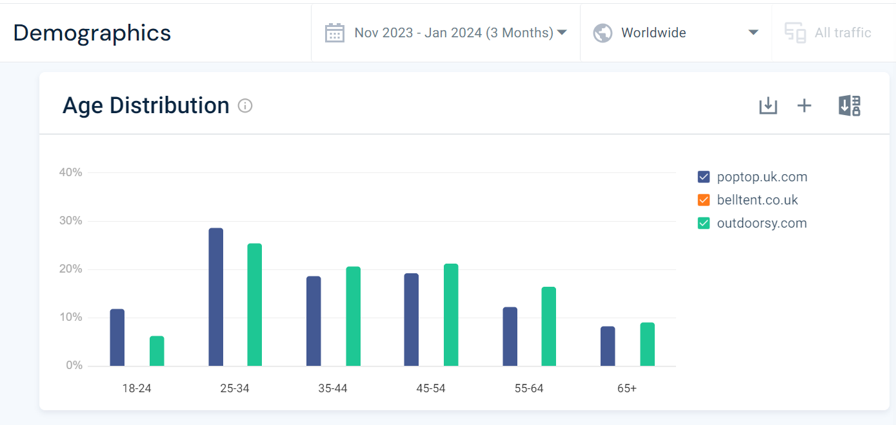
Appendix 9
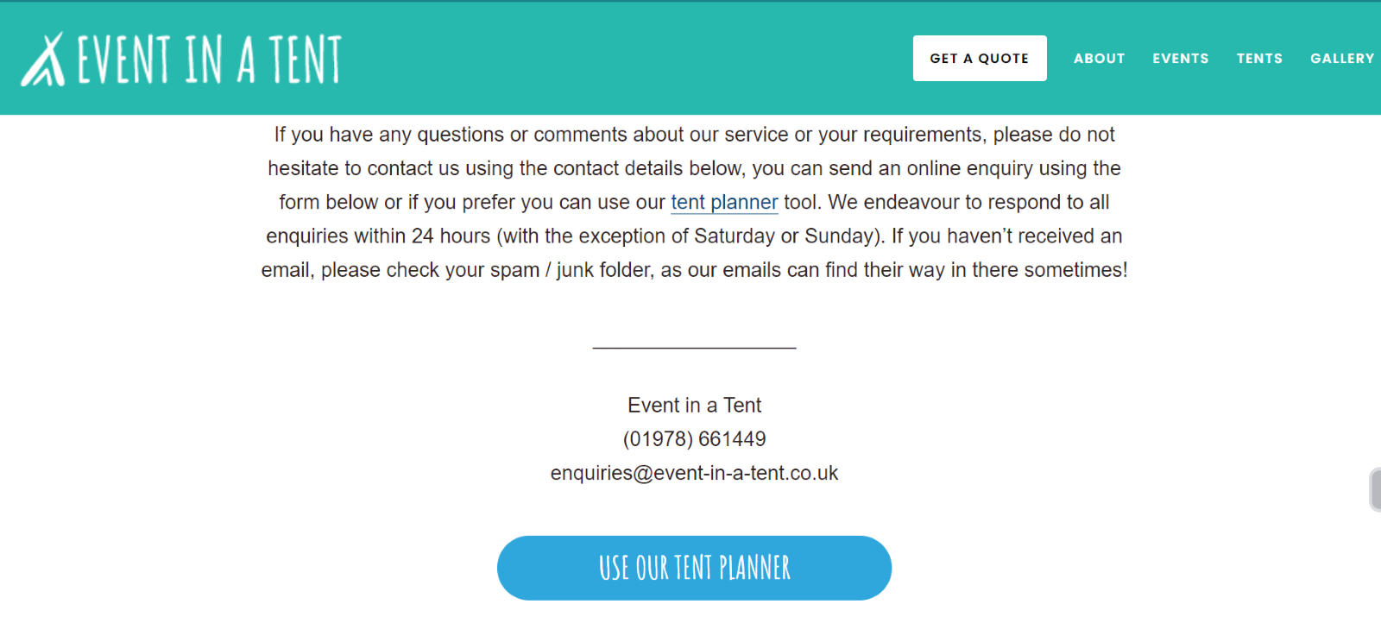

Appendix 10
BBQ Grill
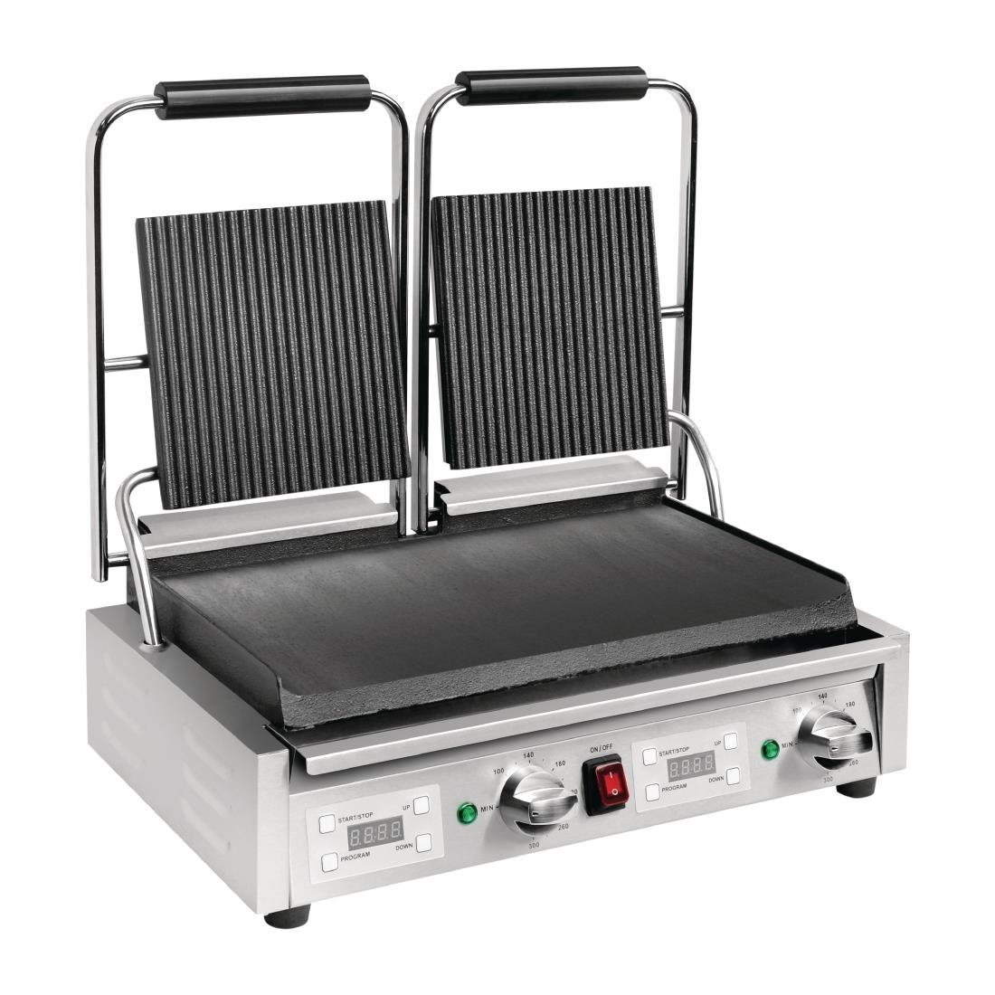

BBQ Utensils

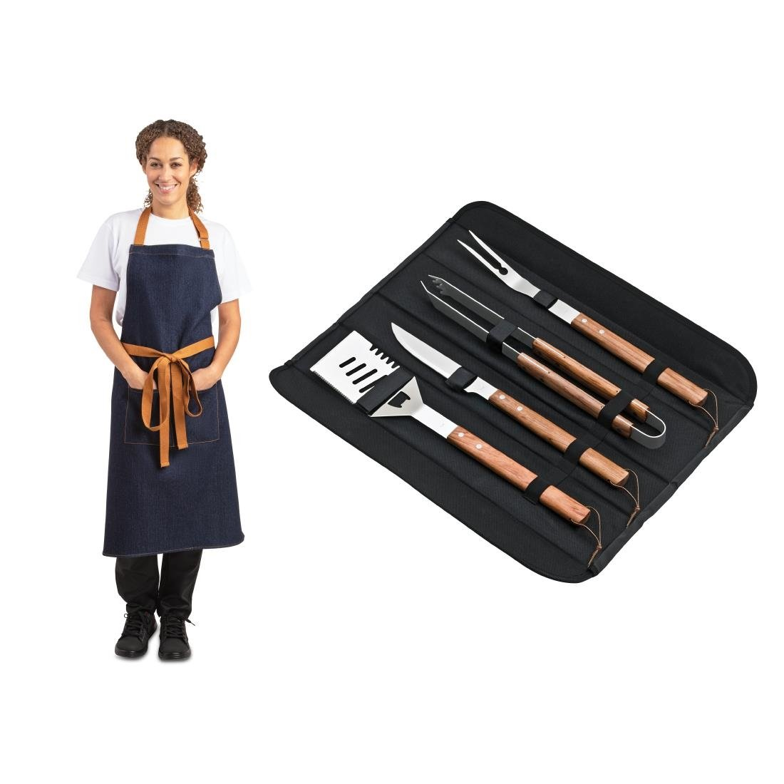
BBQ gloves

Chef uniform and shoes
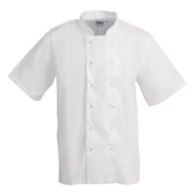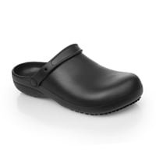

Fridge

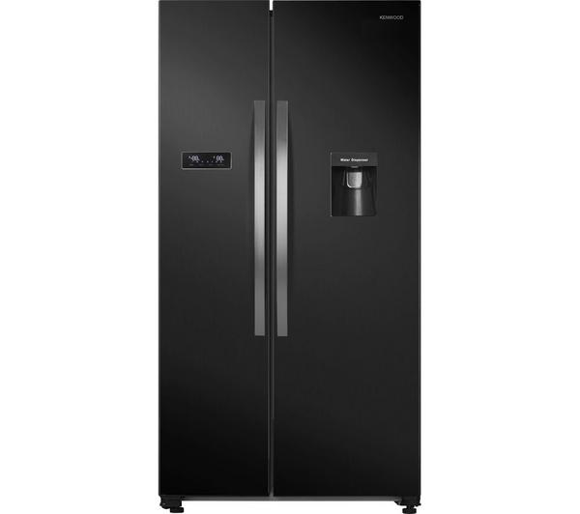

Office table and chairs


Phone
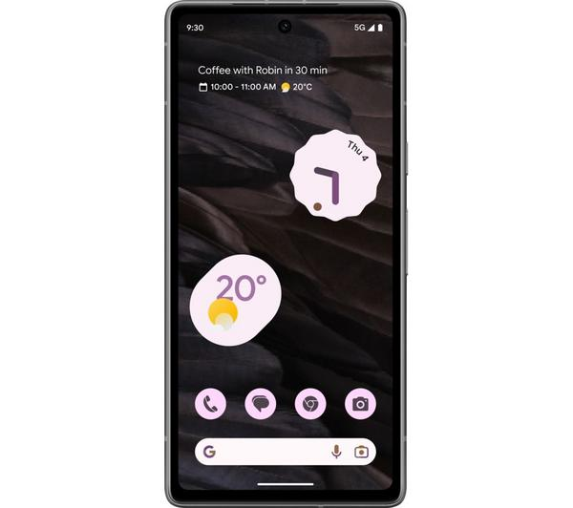
Electric Van

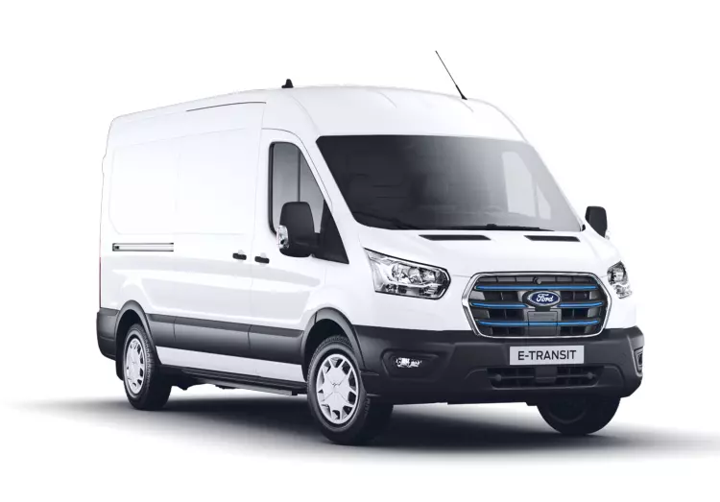
Fire estimator and first aid kits
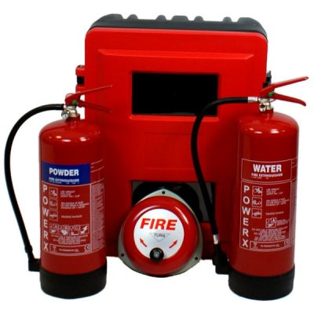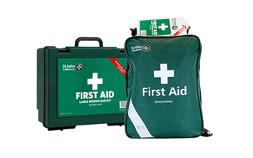

Cleaning Product
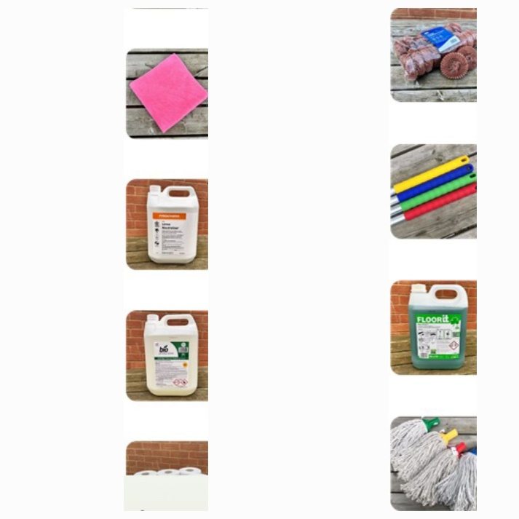
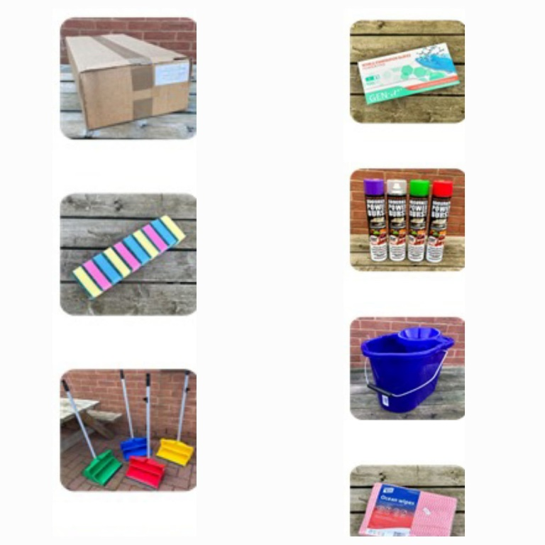

Appendix 10
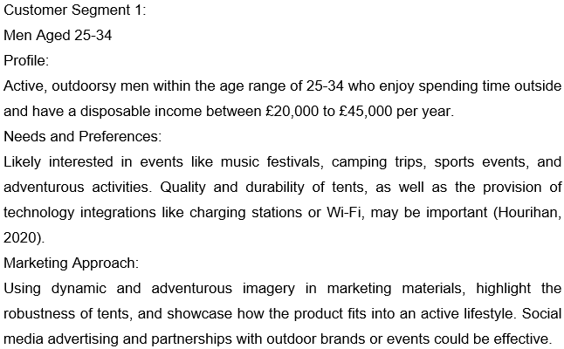

Appendix 11
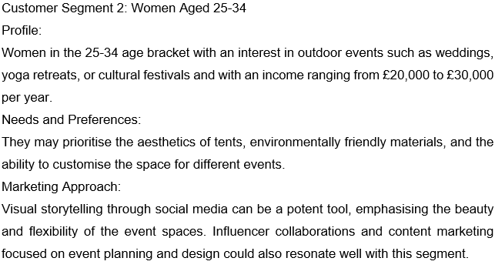

Appendix 12

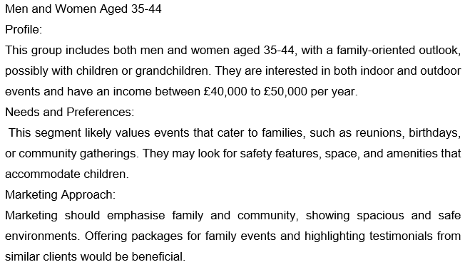
Appendix 13
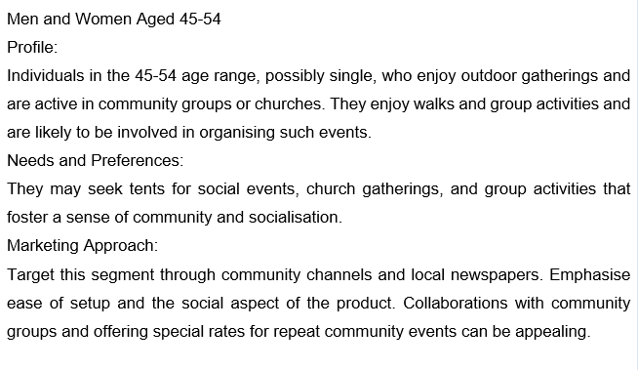
Appendix 14
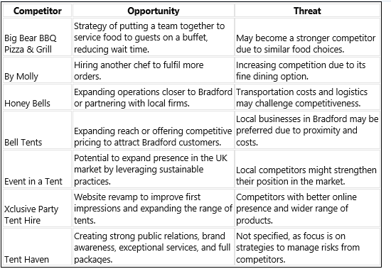
Appendix 15
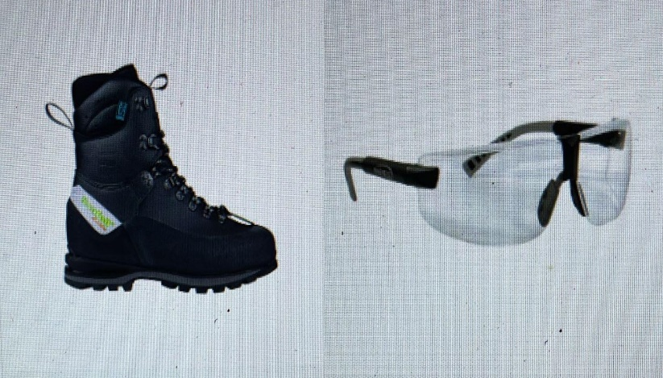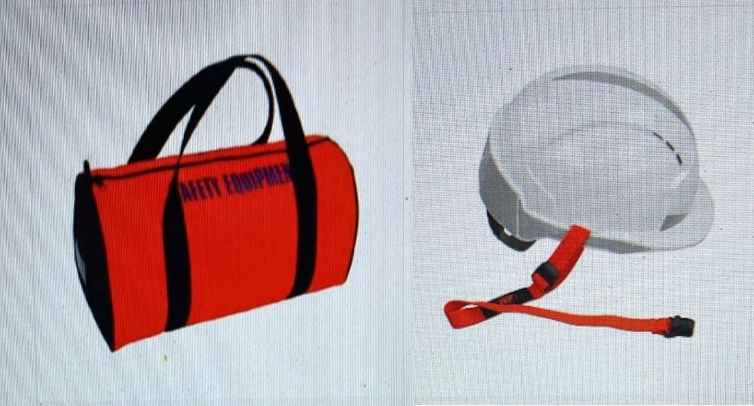
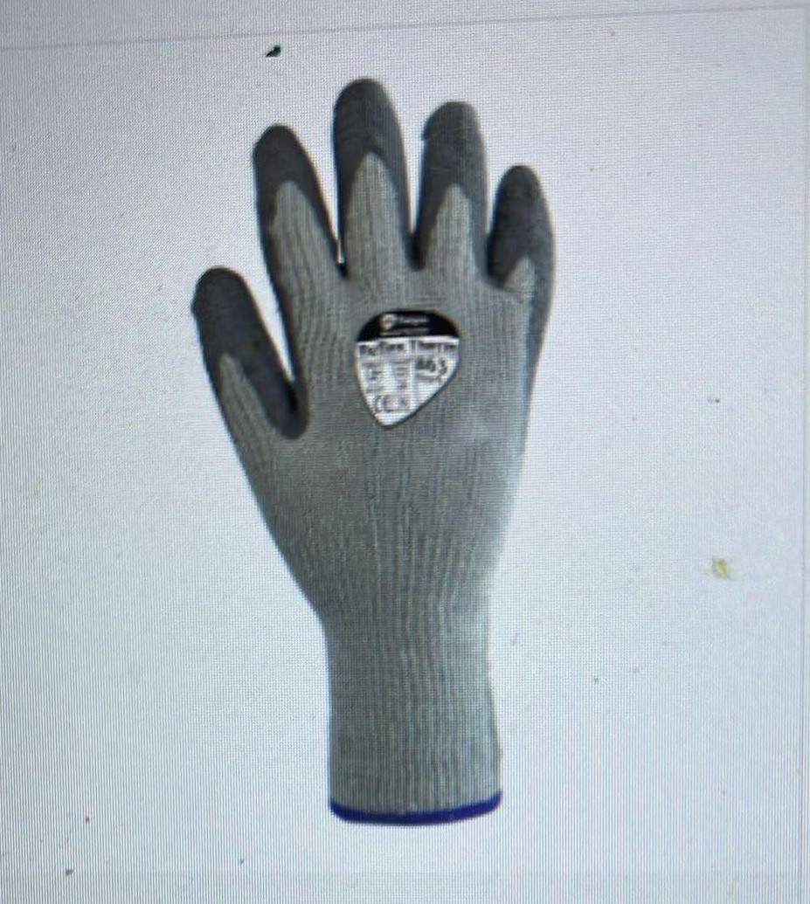 ASPLI Safety specialist since1978(2024)
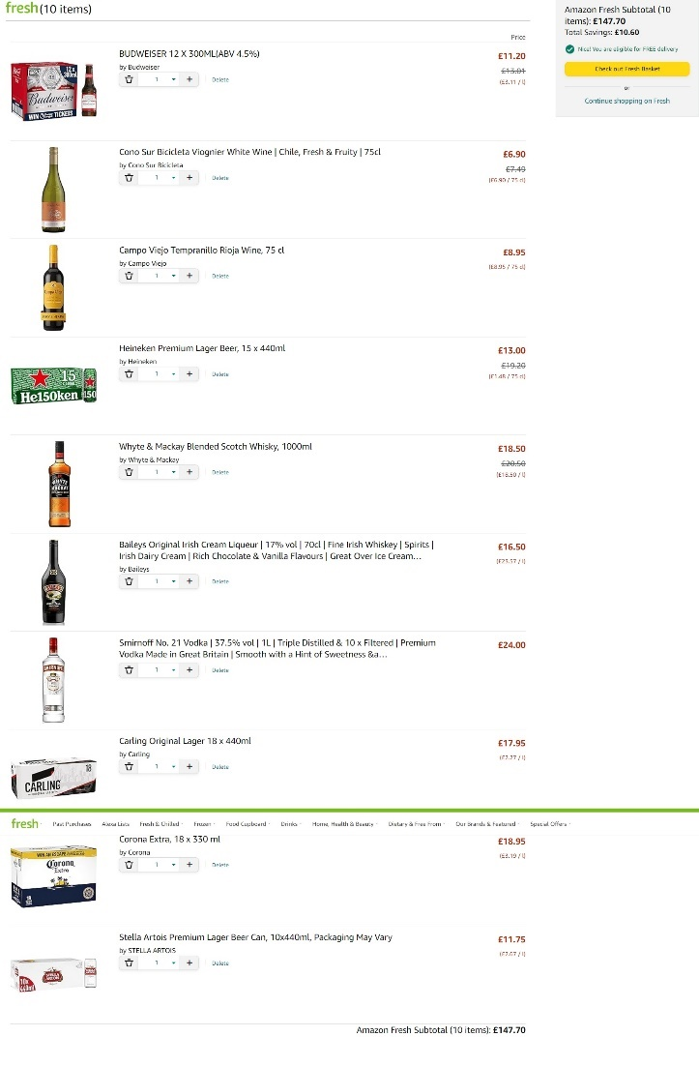
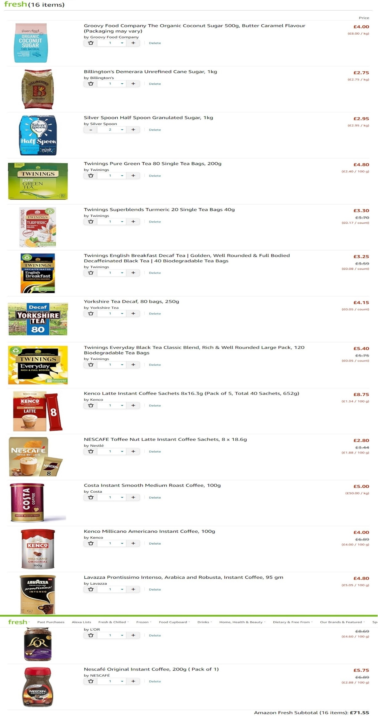 Amazon (2024).

