Student Name: Saeed Ahmad
Student ID: 2027769
Module: Knowledge and Information Management Skills for the Workplace
Module Code: BMSW5106
Lecturer: Dr Oluwaseun Adegbite

Executive summary
The effective management of information and knowledge is regarded as a key component of the smooth operation of a major organization. The process of managing information as a vital resource to increase managerial effectiveness is known as information and knowledge management in organizations. This report aims to gather a set of knowledge and information system from the field of two organizations, namely, Amazon and eBay. Here, analyzed the idea and significance of knowledge management in terms of an organization's knowledge assets and their management. Also comprehended the essential knowledge management procedures necessary for organizational development. Also covered were Amazon's and eBay's knowledge management strategies for creating a culture of knowledge management. During the covid pandemic, Amazon and eBay performed many systematic and beneficial supports for their workers and consumers considering their harmful effects which are also described. The findings of this report are about the knowledge management process which evaluates the process of how a company can run and how a company will be greater positioned systematically. Developing an effective KM strategy requires more than just expressing general goals like "being a knowledge-enabled organization." The strategy must instead identify the most critical needs and issues facing the company and give a framework for addressing them.

Contents
Introduction 3
Knowledge and Knowledge Management process 4
The main organizational activities of Amazon and eBay are based on KM 6
Amazon 6
eBay 7
SWOT analysis in relation to their KM system and similarities and differences 8
Similarities between Amazon and eBay 10
Differences between Amazon and eBay 10
KM value chain and a discussion of the various supporting systems interact with the Knowledge Management System 11
How individual organizations deploy knowledge Management systems in their respective businesses 12
Conclusion 15
Recommendation 15
Reference 16

Introduction
This report discusses the knowledge and knowledge management process which evaluated a company that is effective or will be effective in its purpose. The knowledge management process derives a person’s experiences and knowledge. The two types of knowledge and knowledge management processes are discussed in this report. Amazon and eBay are the companies of which KM processes are described here. Also, SWOT analysis for both Amazon and eBay based on a knowledge management system has been shown in this report. Amazon and eBay's knowledge management systems are examined, along with the value chain for KM and a description of the many supporting systems, such as information technology systems.

Knowledge and Knowledge Management process
What is knowledge? Knowledge may be viewed as the end consequence of a person's experiences and knowledge. Knowledge can be described as explicit and tacit knowledge.
Explicit knowledge: The most fundamental type of knowledge is called explicit knowledge, which may be communicated through data in the form of words and numbers. It is easily articulable, accessible, and may be officially and methodically shared between people. Explicit knowledge may be expressed in both verbal and written form. The key characteristics of explicit knowledge are objective, logical and technical (Hota et al., 2015). Explicit knowledge is codified and easily transferable and it can be recorded and stored in physical and electronic forms.
Tacit knowledge: Unexplained, intensely personal, and challenging to codify information is referred to as tacit knowledge. Perceptions, beliefs, values, intuition, and experience are some of the elements that make up tacit knowledge. Because it is all internal knowledge, it is challenging to capture, see, communicate, or express. It frequently comes from personal experiences and is casual. The key characteristics of tacit knowledge are subjective, cognitive, and experimental. Tacit knowledge is non-codified and difficult to transfer. Tacit knowledge often needs face-to-face communication and teaching.
What is knowledge management? The set of processes an organization uses to create, share, use, and manage knowledge and information is known as knowledge management. It alludes to a multidisciplinary strategy for achieving corporate goals by utilizing information to its fullest potential (Masrek et al., 2015). A change has taken place where "knowledge" is at the forefront, according to academics and observers from fields as diverse as sociology, economics, and management science. In both the public and commercial sectors, knowledge management is regarded as a requirement for increased productivity and flexibility. Information management involves gathering (eliciting) and codifying knowledge so that it may be disseminated throughout the organization. The collection of implicit knowledge and its transformation into explicit knowledge is a crucial step in this process.
There are four processes of knowledge conversion namely, socialization, capture, dissemination, and internalization.
Socialization: Transferring personal knowledge from one person to another is what socialization is all about. One way to do this is by interacting with an expert and learning from their methods (Masrek and Zainol, 2015). You will get experience and improve your abilities by taking on tasks on your own, which will enable the expert to oversee situations or confirm "on the fly." Observation, imitation, and practice-based experience exchange. The water cooler is usually where everything happens, along with conferences, seminars, apprenticeships, and workshops. Traditional apprenticeships are where socialization usually takes place, and through practical training, apprentices gain the tacit knowledge necessary for their trade.
Capture: The process of turning workshop information from implicit to explicit into a written report.
Dissemination: The dissemination and replication of explicit information.
Internalization: Internalization is the process of transforming explicit knowledge into tacit knowledge. It might take the form of practices and acts, allowing the person learning the knowledge to relive the experiences of others (Masrek and Zainol, 2015). Process of gaining knowledge from an explicit source, whereby one may incorporate past experiences with the reading of the workshop report.
Theory of knowledge creation:
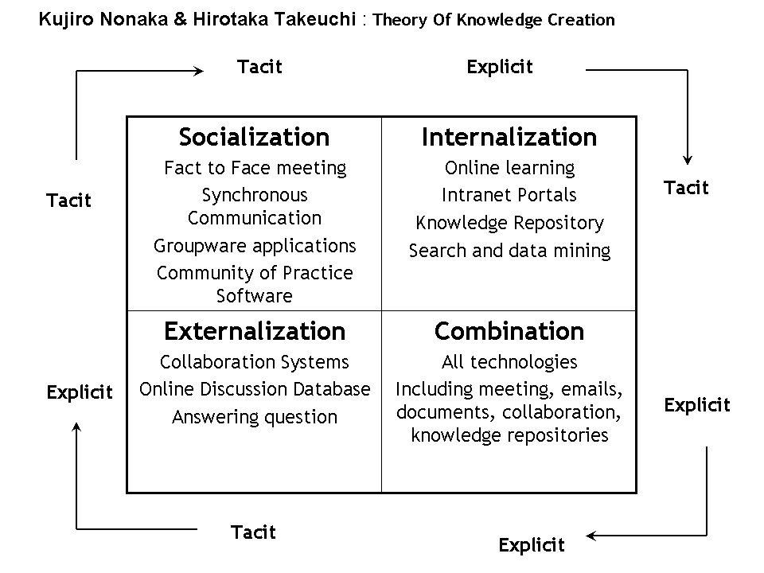
Figure 1: Modes of knowledge conversion which derives the cycle of knowledge conversion
Source: Masrek and Zainol, (2015)

The main organizational activities of Amazon and eBay are based on KM

Amazon

Figure 2: Amazon
Source: Md Masudur Rahman, (2021)
In the United States, Seattle, Washington, is home to Amazon, an electronic commerce firm. It is America's biggest retailer with an online presence. Although Amazon started as an online book retailer, it rapidly expanded its product offerings to include DVDs, VHS, CDs, video and MP3 downloads and streaming, software, video games, electronics, apparel, furniture, food, toys, and jewellery (Lopez et al., 2021). Amazon is the biggest and most famous online retailer and cloud provider in the world. Consumers can purchase all kinds of products including household goods, furniture, toys, electronic things, jewellery, books, movies, clothes, etc.
In the covid pandemic, countries are locked down, people are working by staying at home, and shops are closed. These are the general effects of the covid pandemic. The pandemic affects business by a big hand. In amazon, there are huge effects on sales and prioritize and categories. Except for one product, the UK's top 10 scarcely altered from February to March 24. Pasta made an appearance in the top 10 search phrases on Amazon in the UK for the week of March 15 (Hunter and Nida, 2021). This was the only food mentioned in the top 10 when compared to the other nations. Through increased safety precautions and compensated time off, Amazon is highly committed to helping employees, clients, and communities throughout the epidemic (Amazon.com). Here are a few instances:
- In 2020, they gave our staff throughout the world bonuses and incentives totalling more than $2.5 billion.
- They established a $25 million assistance fund for colleagues, such as seasonal workers and delivery drivers, who were placed in a difficult financial situation or who were subject to quarantine.
- Amazon actively fights price gouging to maintain fair pricing and to stop organizations from making money off the COVID-19 situation while keeping an eye on the needs of its consumers.

eBay

Figure 3: what are eBay and their activities
Source: Ecommerce Platforms, (2022)
A global firm based in the United States, eBay Inc. engages in online retail sales between businesses and consumers. San Jose, California, is home to the organization's headquarters. The renowned company is eBay for its auctions and direct-to-consumer sales and it is an online retail platform (O’Regan, 2015). Therefore, it uses a sales channel which is very common among internet retailers. eBay is accessible and available to many different nations. People can look for goods available nationally or internationally.
The impacts of Covid, according to eBay, are being felt by the company. As more vehicle dealers shuttered their doors and advertising slowed down more generally, its marketplaces experienced a boom in demand, but its classified advertising platforms were affected. To maintain the security and reliability of its platform, eBay also claims to have restricted or erased more than 15 million listings. Listings that made fraudulent health claims or demanded exorbitant prices for goods were among those that were banned. According to (Chloe Rigby, 2020), eBay has also aided its employees, communities, and consumers totalling more than $100 million. Many sellers have been given the option of delaying eBay fees to sustain their financial flow. And to (Seufzer, 2022), users of eBay shops have had access to up to 100,000 free listings.

SWOT analysis of their KM system and similarities and differences
Strengths of Amazon and eBay based on the KM system:
Amazon | eBay
Globally recognized brand. | Status of the brand.
Fast technical innovation capacity. | Scale economies
Moderate and expanding business diversification. | No fierce direct rivalry.
Superior systems for logistics and distribution. | The greatest online market worldwide.
Several goods are available. | Easy system of payment.
Customer Faith. | Localization.

Weaknesses of Amazon and eBay based on the KM system:
Amazon | eBay
Adaptable business strategy. | No more growth tactics.
low commercial penetration in undeveloped countries. | High costs.
Only a small amount of physical locations. | The things on eBay cannot be handled or felt by the buyers.
Cloned business strategy. | C2C business models can be abused by dishonest people.
Due to the desire for quick deliveries, changes in inventory store restrictions, and an increase in competition from Amazon's private label items, sellers on Amazon are angry. | The suspicion between customers and sellers is because of the possibility of fraud.

Opportunities of Amazon and eBay based on the KM system:
Amazon | eBay
New business collaborations, especially in emerging markets. | Create more international online retailers.
Development of brick-and-mortar operations. | Boost services and product offerings through acquisition.
Increased market penetration in developing countries for a stronger global footprint. | increasing numbers of customers using mobile devices.
Support for small enterprises. | Take up retailing.
Podcasting has caught Amazon's attention recently. With the help of Alexa and the favourable reception from the public, the corporation may be able to dominate a new industry by utilizing its technology and invention. | The rising use of the Internet, the growth of e-commerce, and potential mobile commerce solutions. These variables will affect the number of people that trade on eBay and the frequency, duration, and living conditions of their transactions.

Threats of Amazon and eBay based on the KM system:
Amazon | eBay
Secure browsing. | Secure browsing.
Rules of the government. | Inflation levels.
Absence of reviews. | Amazon is becoming a bigger rival.
Counterfeiting of goods and business models | Local internet stores with lower prices.
Fierce competition from both online and offline businesses. | An unfair relationship between buyers and sellers on the trading platform, difficulties with fraud, or mistrust between buyers and sellers.

Similarities between Amazon and eBay
- Two of the most significant and enduring companies in the e-commerce industry are Amazon and eBay.
- The primary ways that Amazon and eBay draw users to their websites, provide them access to the marketplace, and enable them to explore and buy things are where they have the most similarities.
- Amazon depends on independent sellers to post their products on the website so that customers have a huge selection of products to browse (Kalia and Paul, 2021). Similar to other online auction sites, eBay depends on sellers to put their products for sale so that they might be sold at a later time.

Differences between Amazon and eBay
- The two businesses are different in that Amazon works like a typical retail store while eBay runs more like an auction house.
- Compared to eBay, Amazon is seller-oriented whereas eBay is buyer-oriented.
- The size of the markets on eBay is a tiny portion of those on Amazon.
- By (El-Ebiary et al., 2021), Amazon began by selling books, followed by additional products. It is currently also selling secondhand goods. On the other hand, eBay began with used goods and is now introducing new ones.
- eBay connects individuals and has a strong sense of community. only on products on Amazon.
- According to (Gizatulina and Gorelkina, 2021), physical goods are handled and owned by Amazon. When it comes to handling or owning actual goods, eBay only sells virtual goods.
- While Amazon helps with storage, packaging, and shipping, eBay helps with the transaction.

KM value chain and a discussion of the various supporting systems interact with the Knowledge Management System
The process of efficiently capturing, disseminating, and applying knowledge is streamlined by knowledge management, which offers a set of methodical methods. The knowledge management system gives the company a set of criteria that offer appealing and affordable services and aid in bettering the decision-making process, which increases productivity and makes the company more inventive and competitive in the market (Schniederjans et al., 2020). The knowledge management system includes certain knowledge management tools that are crucial for improving the productivity and efficiency of business operations. Because of these reasons, both organizations need the knowledge management process:
- Simple access to the organization's expertise and critical data.
- Raising the organization's expectations for communication.
- The provision of intellectual property security.
- It facilitates making decisions quickly.
Since it gives management the right information to make informed decisions, the notion of knowledge and information management has gained a lot of popularity in the current, competitive corporate climate.
Comparison | Amazon | eBay
Competencies | Competency in technology, usability, and delivery. | Expertise in technology and usability.
Core competencies | Product reviews, the catalogue website, and conversion rates. | A site that accepts bids and conversion rates.
Distinctive competencies | Crossing selling. | Peer assessment.

How individual organizations deploy knowledge Management systems in their respective businesses
Amazon’s KM systems in their respective businesses
The majority of people consider Amazon to be among the most successful global online retailers, and they are correct. From the start, Amazon understood that the user experience—the ability of its consumers to swiftly and easily locate what they want, when they want it—was crucial to success (Cepeda et al., 2019). But it wasn't sufficient. The experience would be much more valuable if the system could assist users in achieving their objectives in a simple and tailored manner. Amazon adds considerable value to its consumers in a variety of ways by utilizing KM ideas and practices, including:
Decreased servicing: Due to Amazon's intense efforts to make its website as user-friendly and thorough as possible, fewer people are calling the company's call centre (Posey, 2019). This significantly reduces costs for the business and improves client satisfaction. People frequently refer to the information on most things on Amazon even if they plan to purchase elsewhere since it is so good.
Feedback: One of the eCommerce sites that are most successful at persuading visitors to leave useful feedback is Amazon.
Crowdsourcing: According to (Cepeda et al., 2019), Amazon helps consumers become more knowledgeable and aware by offering elements like user-provided ratings, reviews, and photographs as well as an analysis of what customers "like you" previously purchased or purchased together. The model for many of these social aspects, Amazon, has been imitated by a large number of online retail companies.
Personalization that almost seems miraculous: The way the website seems to know its users is what most Amazon users find so remarkable.
Content production upstream that is distributed: Despite the impression that Amazon is in charge of everything we see, content is typically produced by the product producers, who have the best industry knowledge.
A single interface and gateway: The same gateway is used for all of our transactions with Amazon, including our purchases. It doesn't matter what you eat or wear: devices, literature, or food. shopping all at once. The user interface and portal both remain unchanged. As a result, consumers feel more at ease and at home when exploring new parts of the website, which reduces their anxiety. Just consider if Amazon's technology store and bookshop had distinct website addresses.
Regular presentation: By (Posey, 2019), present all information, from product specs to reviews, uniformly and sequentially if feasible. This is the result of excellent content management, where the material is created and consistently published to users. The capacity to trace and archive every information "nugget" is an additional advantage.
Contained in modules: Each page on Amazon is set up with parts that are simple to read. There are no complex PDF books to search through. Although they occasionally offer more information, they do so as an alternative rather than as a roadblock in the way of what you want.
Very helpful online: Click "Help" on the Amazon.com website. Easy to use, read, and comprehend. Once more, this improves the customer experience, boosts customer happiness and productivity, and reduces Amazon's expenses.
Mobile accessibility: Any device, anywhere, and at any time, you may access Amazon.com and the apps that are linked to it. There are no worrying business hours.
Results of knowledge management methods utilized by Amazon
Amazon has successfully established a competitive and cosy position within the international consumer market through the efficient use of knowledge management strategies (Posey, 2019). The following list contains some of the beneficial effects of knowledge management strategies employed by Amazon.
- By using excellent knowledge management to analyze demand, the firm has successfully expanded its commercial operations to emerging countries.
- Additionally, Amazon was able to effectively capture more than 50% of the US E-Commerce market by creating a user-friendly website through careful study of consumer demand.
- With the need for a wide range of goods and services increasing, Amazon has also recently filed more than 49 patents.
- Last but not least, The Organization was able to successfully grow its sales revenue by over 100 billion dollars and boost profitability by over 84% through real beneficial knowledge management that encouraged good decision-making.
eBay’s KM systems in their respective businesses
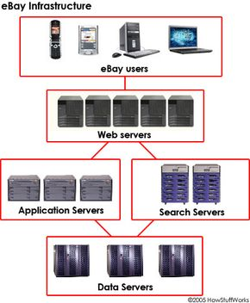
Figure 4: eBay infrastructure
Source: Julia Layto, (2022)
In 1999, eBay consisted of a single, sizable database server that ran the search feature on a few different platforms. eBay has 20 search servers and 200 database servers as of 2005 (Arbi et al., 2017). This grid computing design enables both mistake correction and growth. The whole eBay platform, including Web servers, application servers, and data storage systems, can be run on around 50 servers, except for the search feature. According to (Hota et al., 2015), each server contains six to twelve microprocessors. These 50 or so servers are independent yet communicate with one another, allowing everyone to be aware of any problems wherever they may be. If more servers are required, eBay can easily add them to the grid.
Even though the majority of the website can function on 50 servers, eBay has four times as many. In four different sites around the United States, there are sets of 50 servers each housing 200 servers (Arbi et al., 2017). All of those locations retain the same data, so if you use eBay, you might converse with any one of them. There are three more mechanisms to step in if one of them fails. This infrastructure enables millions of users to concurrently look for, purchase, and sell products. Everything runs smoothly for the user.

Conclusion
A comprehensive overview of knowledge management's general principles and how they apply to contemporary, large-scale commercial organizations are successfully provided by this assignment. The management takes wise decisions that provide the company with a competitive edge and allow it to start profitable and long-lasting commercial ventures thanks to the efficient use of knowledge management processes. For business organizations to successfully differentiate their goods and services in today's highly competitive business climate, it is crucial to effectively partner with suitable knowledge management. Additionally, it is important to make sure that the organization's unique selling proposition and knowledge management method support long-term, productive company operations. This assignment, therefore, makes it abundantly evident how crucial it is for contemporary commercial enterprises to successfully integrate KM systems into their company. Long-term positive business operations are ensured, and it aids in increasing revenue-generating capability.

Recommendation
Utilizing all of the knowledge a company has to offer is a terrific method to realize all of its potential. Untapped knowledge that is compartmentalized to certain employees or departments or lying dormant inside an organization's workforce. It is possible to locate, store, and make this information available to the larger workforce with the right organizational structures in place, providing real commercial benefits. It is also strongly should that the management of Amazon and eBay integrate a KM system that is openly equipped and controlled to address the areas that need improvement and ensure proper growth and development within corporate operations. Organizations are faced with a growing number of issues as a result of workplace dynamics or demands from the market. These difficulties are being addressed by many organizations by utilizing knowledge management (KM). Creating a knowledge management plan is a common place to start for such endeavours. A strong KM strategy must go beyond simply stating broad objectives like "becoming a knowledge-enabled organization". A framework for resolving them must be provided by the strategy, which must instead identify the organization's most important requirements and problems.

Reference
Arbi, K.A., Kausar, A.R. and Salim, I., 2017. Minimizing asymmetric information in online markets through knowledge management. International journal of management Excellence, 8(2), pp.924-931.
Baker El-Ebiary, Y.A., Ghanem, W.A.H., Saany, S.I.A., Rose, A.N.M., Jusoh, J.A. and Hassan, H., 2021, June. A Comparative Study of eBay and Amazon Electronic Commerce Platforms. In International Conference on Emerging Technologies and Intelligent Systems (pp. 371-380). Springer, Cham.
Crespo-Lopez, M.E., Augusto-Oliveira, M., Lopes-Araújo, A., Santos-Sacramento, L., Takeda, P.Y., de Matos Macchi, B., do Nascimento, J.L.M., Maia, C.S., Lima, R.R. and Arrifano, G.P., 2021. Mercury: What can we learn from the Amazon? Environment International, 146, p.106223.
Fonseca-Cepeda, V., Idrobo, C. and Restrepo, S., 2019. The changing chagras: traditional ecological knowledge transformations in the Colombian Amazon. Ecology and Society, 24(1).
Gizatulina, A. and Gorelkina, O., 2021. Selling “Money” on eBay: A field study of surplus division. Journal of Economic Behavior & Organization, 181, pp.19-38.
Hota, C., Upadhyaya, S. and Al-Karaki, J.N., 2015. Advances in secure knowledge management in the big data era. Information Systems Frontiers, 17(5), pp.983-986.
Chloe Rigby, 2020. eBay shows the effects of lockdown on its business. available now, https://internetretailing.net/covid-19/ebay-shows-the-effects-of-lockdown-on-its-business-21338/
Amazon Staff, (2022). Amazon Covid 19 blog. Available at https://www.aboutamazon.com/news/company-news/amazons-covid-19-blog-updates-on-how-were-responding-to-the-crisis
Hunter, R.E. and Nida, R.A., 2021. Compulsive shoppers flourish on amazon during Covid-19 pandemic. Journal of Medical Science and Clinical Research, 9(03), pp.87-93.
Kalia, P. and Paul, J., 2021. E-service quality and e-retailers: Attribute-based multi-dimensional scaling. Computers in Human Behavior, 115, p.106608.
Masrek, M.N. and Zainol, N.Z.M., 2015. The relationship between knowledge conversion abilities and academic performance. Procedia-Social and Behavioral Sciences, 174, pp.3603-3610.
O’Regan, G., 2015. eBay Inc. In Pillars of Computing (pp. 79-82). Springer, Cham.
Posey, D.A., 2019. Indigenous ecological knowledge and development of the Amazon. In The dilemma of Amazonian development (pp. 225-257). Routledge.
Schniederjans, D.G., Curado, C. and Khalajhedayati, M., 2020. Supply chain digitisation trends: An integration of knowledge management. International Journal of Production Economics, 220, p.107439.
Seufzer, S., 2022. eBay Investment Report.
Julia Layto, (2022). eBay insfrustucture. Available at https://computer.howstuffworks.com/internet/basics/ebay2.htm
Ecommerce Platforms, (2022). What is eBay and their activities. Available at https://ecommerce-platforms.com/glossary/what-is-ebay
Md Masudur Rahman, (2021). Amazon. Available at https://usapublisher.org/amazon-usa-buy-anything-from-home/

