
Module: International Marketing: Principles and Practices
Module code: LCMB7026

Assignment Title:
Assessment component: Individual report

Lecturer:
Tushara Balendran

Student Name: Md. Habibur Rahman
Student ID: 2432474
Word Count: 5016

AI acknowledgement

RESEARCH | For this assessment, you can use Generative AI to  support you in research, including searching for bibliography, using tools to summarise, compare and interrogate materials. | No
STRUCTURE | For this assessment, you can use Generative AI to  support you in structuring your submission, including creating a draft argument structure, identifying parts and headings, etc. | No
PROOFREADING | For this assessment, you can use Generative AI to  check your own text/creation for grammatical and syntactical mistakes, including rephrasing of your own work within specific standards. | Yes
WRITING | For this assessment, you can use Generative AI to  create text for submission. | No
CREATIVE | For this assessment, you can use Generative AI to  create creative materials, such as images. | Yes
PROGRAMMING | For this assessment, you can use Generative AI to  create and check code. | No
NONE | For this assessment, you are not allowed to use any  type of Generative AI support. This includes research support, structure support, writing/proofreading support and creative support. | No
Expectations: I acknowledge the use of Grammarly (https://www.grammarly.com/) on 20th April 2026 to check my work using the prompt(s): 1. Please check the following text for readability, grammar and syntax.

I confirm that I have not presented any AI generated text as my own work. I confirm I have copies of my drafts, notes, and other resources I used before, and after the use of AI tools which I may be asked to provide in evidence.

Table of Contents
Introduction 4
Section 1:International Marketing Report 5
About ZARA 5
Macro Environment Analysis of India and UK 6
Segmentation, Targeting and Positioning (STP) Analysis of ZARA in UK and India 13
Segmentation of ZARA 13
Targeting of ZARA 14
Positioning of ZARA 15
Marketing Mix (7Ps) of ZARA in the UK and India 17
Directional Development Strategy of ZARA in the UK and India 20
Ethical Issues in ZARA’s Marketing Mix in India 22
Ethical Practices of ZARA 22
Unethical Practices of ZARA 22
Recommendations 24
Section 2: Reflective Account 26
Conclusion 29
References 30

Introduction
In an increasingly globalised business world, businesses need to come up with strategies that can effectively address the various market conditions in different countries. Strategic management is a significant aspect that helps firms to attain and maintain competitive advantage in such rapid environment. Hitt, Ireland and Hoskisson, (2019) state that it helps organisations in analysing their internal capabilities and external environments effectively to develop strategies that generate value and guarantee long-term competitiveness. Furthermore, in the context of international marketing, this entails striking a balance between global standardisation and local adaptation in various markets (Hollensen, 2017). Therefore, this report will present a critical analysis of the international marketing strategy of ZARA. The analysis will be based on the company’s strategic approach in the UK, which is a mature and developed market, and India, which is an emerging market with a high growth potential. Based on the major strategic frameworks such as PESTLE, STP and 7Ps, the report will assess the ways in which the company modifies its strategies in these markets. Moreover, the report will discuss the directional development strategy of the company in terms of the Ansoff Matrix. It will also analyse the ethical aspects of the company’s marketing activities in India. Hence, by identifying similarities and differences between the two markets, the report aims to provide strategic insights and recommendations to enhance ZARA’s international marketing performance (Times of India, 2024). Furthermore, the report will also include a reflective report highlighting my experience during the report.

Section 1:International Marketing Report

About ZARA
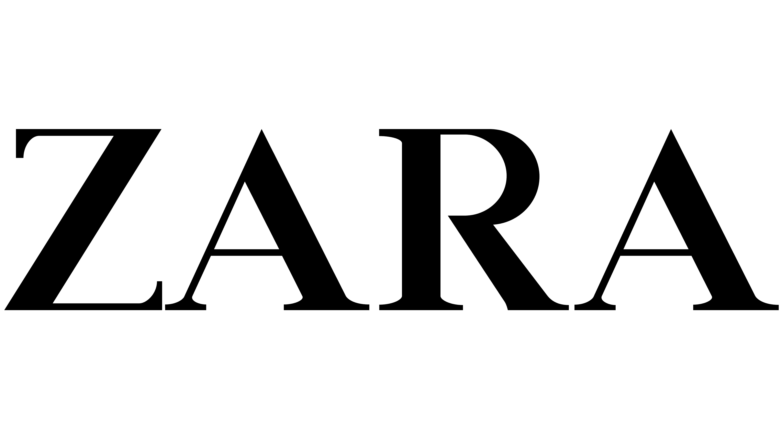
Figure 1. ZARA Logo
Source: Inditex, 2026a
ZARA is a large global fast-fashion retailer that was founded in 1975 by Amancio Ortega. The company currently has almost 3,000 stores in 96 markets and e-commerce in more than 100 markets (Forbes, 2026a). In 2024, it reported revenues of about €38.6 billion due to a robust sales growth in both online and offline channels (Inditex, 2025). This scale highlights its strong global positioning within the highly competitive fashion industry. According to Aftab et al. (2018), the company’s competitive advantage is driven by its fast-fashion business model, which emphasises speed, flexibility, and responsiveness to consumer demand. Moreover, the company’s capability to standardise its core brand identity while adjusting to the local market conditions has been a key to its long-term success in the global market (Józefowiak, 2023). For example, the company operates in the UK, a mature market where it has been present since 1998, through a more standardised efficiency-driven strategy. In contrast, its entry into India in 2010 through a joint venture (via Trent Ltd.) reflects a more cautious expansion strategy, enabling gradual adaptation to not only regulatory requirements but also distinct consumer preferences.

Macro Environment Analysis of India and UK
The macro-environmental analysis is defined as the systematic analysis of external forces beyond the control of an organisation that affect its strategic decisions (Hitt, Ireland and Hoskisson, 2019). The PESTLE framework is a strategic instrument that analyses these external dimensions of the wider business environment within which a company functions to aid strategic decision-making procedures (Eierle et al., 2022). Thus, the given section uses the PESTLE framework to compare the macro-environment of the fashion industry in the UK and India, pointing out the key similarities and differences to assess overall favourability to ZARA.

PESTLE Analysis of the UK and India
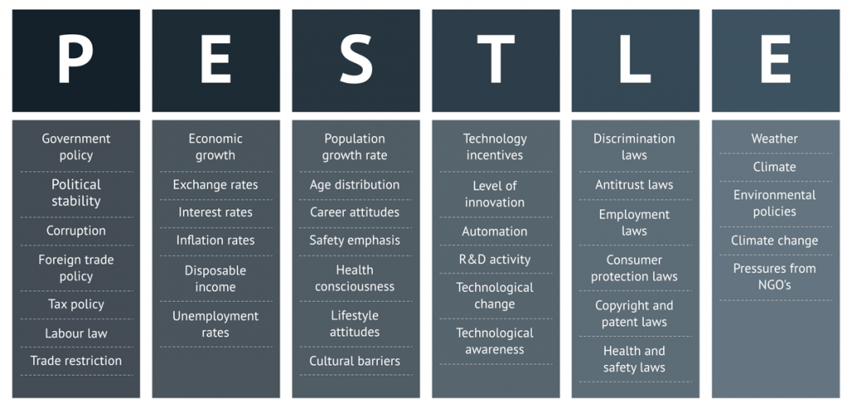
Figure 2. Elements of PESTLE
Source: Consulterce, 2026
Political Factors
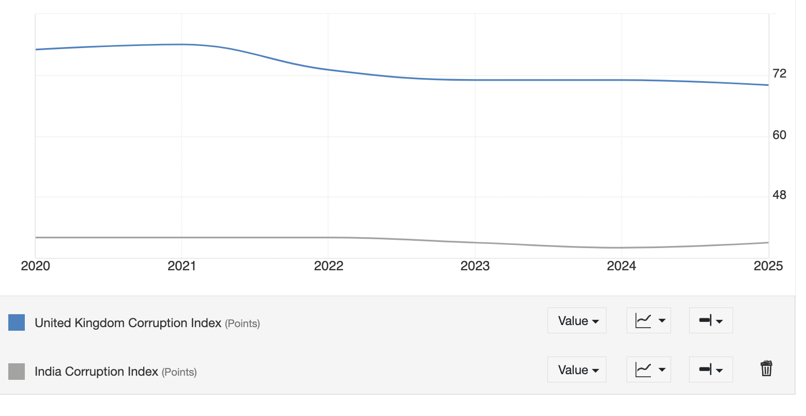
Figure 3. Comparison of Corruption Perceptions Index (CPI) in India and UK
Source: Trading Economics, 2026
In the UK, the political environment is generally stable, supported by transparent regulatory systems. In 2025, the country scored 70 out of 100 on the CPI, making it one of the least corrupt countries in the world (Trading Economies, 2026). This fairly high score provides a predictable business environment to international retailers by increasing investor confidence. However, India has a more complicated political environment, characterised by regulatory bureaucracy, political instability, vague regulatory systems. In 2025, the country scored 34 out of 100 on the CPI, indicating a high level of corruption (Trading Economies, 2026). This poses operational risks to multinational companies by reducing investor confidence. However, the government of the country has initiated reforms, such as liberalisation of investment policies, simplified taxation systems and changes in regulations to facilitate international business presence, to open up the country to FDI. These steps have attracted more than US$1 trillion in cumulative FDI inflows since 2000, indicating growing investor confidence in the market (White and Case, 2025).
Thus, the political climate in the UK is very favourable to ZARA because of the stable government, transparent regulations, and minimal corruption rates, which facilitate effective operations by minimising business risk. In contrast, the political environment in India is moderately favourable because of the regulatory complexity although continuous reforms of the government are taking place.
Economic Factors
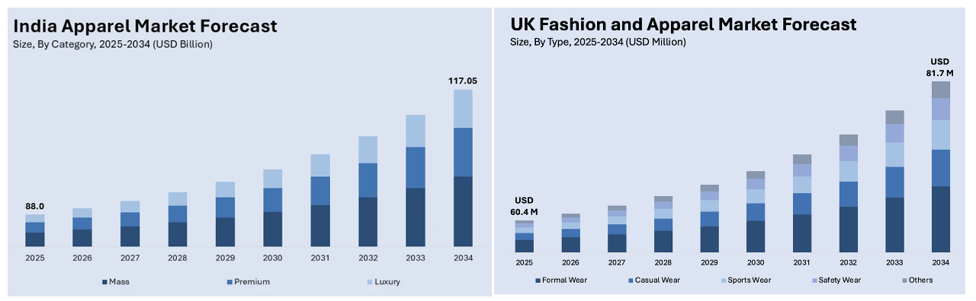
Figure 4. Comparison of UK and India Fashion Industry
Source: IMARC, 2026a; IMARC, 2026b
In the UK, the fashion industry is large and mature, with forecasts indicating growth from approximately $60.4 billion in 2025 to $81.7 billion by 2034, with a CAGR of 3.34% (IMARC, 2026). This is supported by a strong consumer purchasing power of over £1,000 per capita annually (Spring Fair, 2025). Nevertheless, the current economic trends (e.g., GDP growth of only 1.3% in 2025) suggest a reduced growth rate, resulting in decline in consumer confidence (The Guardian, 2026). In contrast, India’s fashion market demonstrates significantly higher growth potential, with forecasts indicating increase from approximately $88 billion in 2025 to $117.05 billion by 2034, with a CAGR of 3.16% (IMARC, 2026b). Moreover, the high number of consumers along with growing fashion consciousness is driving high demand of branded apparel, especially among the younger generation. However, despite this growth, fluctuations in demand exists due to economic challenges (e.g., inflation pressures at around 3.4% in 2026) (Reuters, 2026).
Hence, the UK has a stable yet matured economic environment, which is favourable to hold market share but constrained in terms of expansion. India, on the other hand, offers a high-growth but more volatile economic environment, which is very favourable to long-term growth despite short-term risks.
Social Factors
In the UK, consumer behaviour is strongly influenced by convenience, digitalisation, and changing lifestyles. It is estimated that online fashion sales in the country will be about 73 percent of the total fashion sales by 2025, indicating the supremacy of e-commerce in the industry (Spring Fair, 2026). This is an indication of a society that values speed, accessibility and efficiency in the consumer. India, on the other hand, has a different social set up with a fast digitalisation and traditional shopping habits. For instance, online retail is increasing in the country but physical retail is still dominant in the routine purchase, with social events like festivals playing a significant role in purchasing behaviour (IBEF, 2025).
Cultural Analysis of the Markets through Hofstede Framework
The social differences in the UK and India can be elaborated through the “Cultural Dimensions Theory of Hofstede” which gives a framework to analyse the impact of cultural values in determining consumer behaviour (Żemojtel and Piotrowski, 2023). Its primary strength is that it can reduce the complex cultural differences into similar indicators, which is especially applicable in international marketing strategy. Nevertheless, the model has its shortcomings, as it is prone to generalisation of national cultures that might not accurately represent regional diversity (Żemojtel and Piotrowski, 2023).

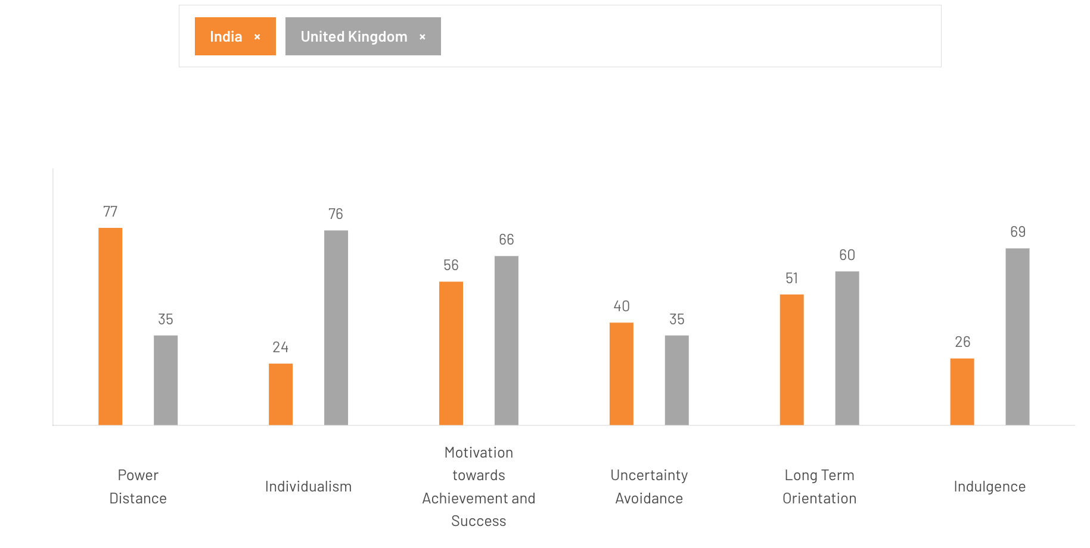
Figure 5. Cultural Dimensions Analysis of the UK and India using Hofstede
Source: The Culture Factor Group, 2026
Power Distance
The UK scores relatively low, which implies that consumers are not as affected by authority or status in purchasing. Conversely, India scores higher, implying that social status influence consumer preferences, especially in aspirational goods like fashion and luxury items.
Individualism vs Collectivism
UK is very individualistic, where purchases are made on the basis of individual needs. India, conversely, is more collectivist, with family, peer group and social expectations playing a huge role in buying behaviour particularly when it comes to cultural or social events.
Masculinity vs Femininity
India has a bigger masculinity score, meaning that it has a greater emphasis on success, status, and visible achievements, which can lead to demand of branded products.
Uncertainty Avoidance
The score is relatively low in the UK, implying that consumers are more receptive to innovation, new brands, and new trends. India also scores moderate to low, however, consumers can still be dependent on familiar brands because of social factors and risk perception.
Long-Term Orientation
The UK is more short-term oriented, indicating that consumers are interested in immediate satisfaction. India, however, is more long-term oriented where the purchasing behaviour is affected by the traditions, perseverance and future rewards.
Indulgence vs Restraint
The UK is termed as an indulgent society where consumers tend to spend more on leisure, fashion and personal pleasure. Conversely, India is less indulgent, where spending is usually held in by social pressures and cultural demands, resulting in more disciplined and goal-oriented spending patterns.
Thus, the social setting in the UK is quite favourable to ZARA because of its trend-following individualistic consumer behaviour. In contrast, India is moderately favourable, as strong growth potential is balanced by cultural complexity with the need for greater adaptation.
Legal Factors
The legal environment in the UK is highly structured, with legislations such as the Consumer Rights Act 2015, which requires all products to be of satisfactory quality, purposeful, and well-described (UK Parliament, 2015). India, on the other hand, offers a more challenging legal environment. The retail sector in the country is governed by several compliance policies in sourcing, labelling and taxation. This presents operational challenges to multinational retailers, particularly in the compliance assurance in different regional markets.
Therefore, the UK possesses highly regulated with transparent legal environment, which reduces uncertainty but contributes to the cost of operation. By comparison, the legal system in India is less uniform and more intricate, posing more compliance difficulties but also providing flexibility since reforms are ongoing.
Technological Factors
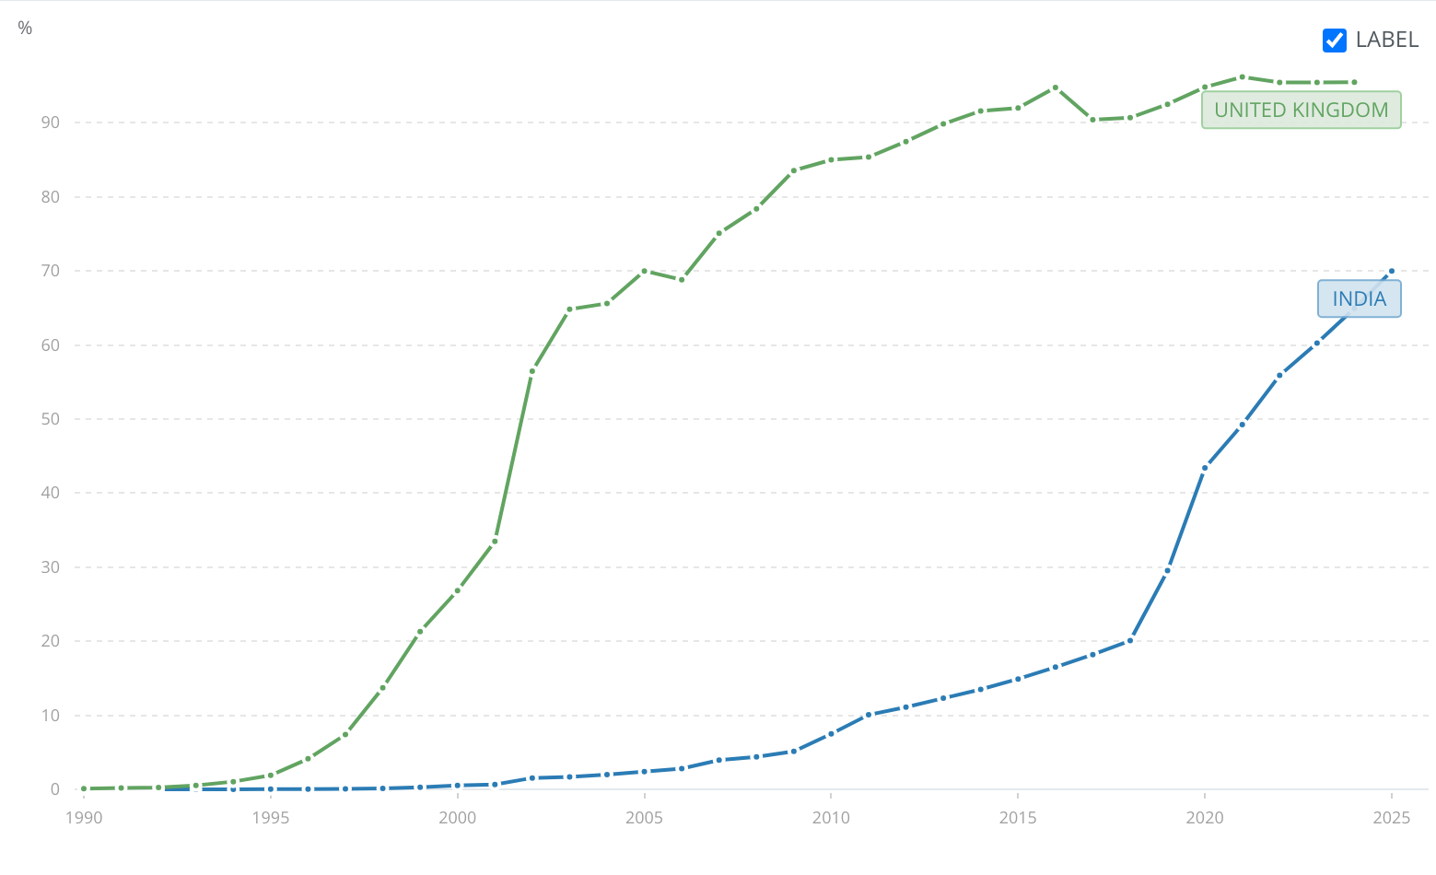
Figure 6. Internet Penetration in the UK and India
Source: World Bank, 2025
The UK has a highly developed technological environment that facilitates advanced digital retail ecosystem. The country’s internet penetration is about 97-98%, indicating its almost universal access to the internet (World Bank, 2025). Conversely, although India has one of the biggest digital markets in the world with more than 500 million internet users (World Population Review, 2026), the internet penetration is 70% (World Bank, 2025). This is because, technological infrastructure in the country is still uneven with disparities between the urban and rural regions.
Thus, the technological environment in the UK is highly favourable, with an advanced infrastructure. In contrast, India also presents a favourable technological environment driven by rapidly improving technological environment although strained by infrastructure challenges.
Environmental Factors
The fashion industry is becoming more influenced by environmental policies, with governments reacting to issues of climate change, waste, and sustainability. For instance, the UK government has introduced initiatives such as the Textiles 2030 programme, which aims to reduce the carbon footprint of textile products by 50% and water usage by 30% through industry collaboration and circular economy practices (WRAP, 2026). These policies are indicative of the growing government intervention to enhance sustainability levels in the fashion industry. Furthermore, the Indian government has also taken initiatives such as the NAPCC to minimise the environmental impact of industries including the textile industry (Government of India, 2008). Nevertheless, environmental policies in the country are not as enforced as in the UK. This provides more flexibility to the businesses but also poses a challenge in terms of long-term since consumer interest in sustainability is rapidly increasing.
Thus, UK environmental policies are more advanced and stricter, raising the compliance levels while promoting sustainable innovation. India, although improving, is less enforced, providing flexibility of operation but lower environmental control.

Evaluation of PESTLE in The UK vs India
According to the PESTLE analysis, the following is a clear synthesis of similarities and differences between the UK and India:
Similarities
The UK and India have some common characteristics as appealing markets to the fashion industry, especially regarding the rising consumer demand and rising digitalisation. In both nations, governments are also increasingly focusing on sustainability within the fashion sector.
Dissimilarities
There are major variations on the external dimensions of both countries. The UK offers a low corruption and transparent political environment, whereas India has greater corruption and complexity of the regulations that involve more business risk. Moreover, the UK is a mature market with slower growth whereas India is a high growth market with high volatility. In addition, the consumers in the UK are more individualistic and convenience-oriented, whereas the consumers in India are determined by collectivism, social conventions, and festivals. Hence, the UK presents a stable and predictable market, and India is a dynamic market with needs of more adaptation.

Segmentation, Targeting and Positioning (STP) Analysis of ZARA in UK and India
STP is a core marketing concept that helps companies to recognise and effectively cater to the most appropriate customer segments (Kotler et al., 2015). Using this framework, organisations are able to customise their marketing strategies more accurately, making them more aligned with the needs and preferences of customers. Furthermore, it leads to strategic success over the long term by enabling companies to concentrate on providing unique value propositions to particular market segments rather than competing with each other (Kotler et al., 2015).

Segmentation of ZARA
It is defined as the process of segmenting a large market into smaller segments of consumers with similar needs, characteristics or behaviours to enable more effective marketing strategies (Kotler et al., 2015). ZARA employs a standardised segmentation approach in all its stores worldwide, targeting young, urban, fashion-conscious customers, but tailors behavioural and psychographic factors in the UK and India to the income levels, culture and buying behaviour. Its market segmentation is depicted in the table below:
Type | UK Market | India Market
Demographic | Young adults (18–40) with medium disposable income. | Younger population with wider income variation.
Geographic | Urban cities (London, Manchester) with developed retail infrastructure. | Urban-focused expansion with presence in Tier 1 & Tier 2 cities (e.g.,Delhi, Mumbai).
Psychographic | Trend-driven fashion-conscious consumers. | Brand-conscious but price-sensitive consumers.
Behavioural | Frequent purchases driven by fast trend adoption. | Value-seeking customers with occasional purchases.

Targeting of ZARA
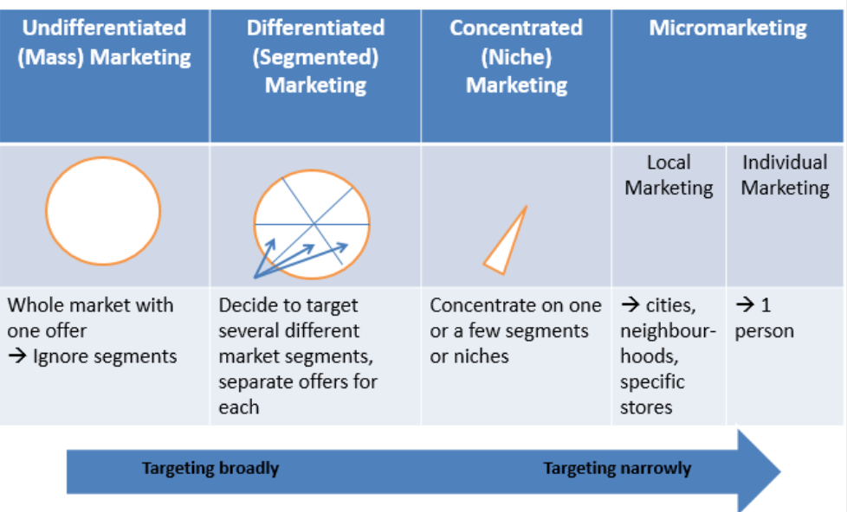
Figure 7. Different Targeting Strategies
Source: Kotler et al., 2015
It is defined as the process of choosing particular market segments to target them with marketing activities in order to create value (Kotler et al., 2015). Based on its segmentation strategy, ZARA adopts a differentiated targeting approach, focusing on consumers who are fashion-conscious, urban, and responsive to rapidly changing trends. Although the company primarily targets young adults aged between 18 and 40, as they are more likely to purchase frequently due to fast-changing fashion trends (McKinsey, 2025), it adapts marketing strategies slightly based on market conditions. For instance, it adopts a broader targeting strategy in the UK as the mature fashion market allow it to reach a wider segment of consumers, whereas in India it targets more selective consumers due to lower average income levels, higher price sensitivity and more collectivist culture. For instance, in 2024, the company launched its first-ever collaboration with an Indian artist during Diwali to addresses the behavioural segment in the India (IFAB Media, 2024).

Positioning of ZARA
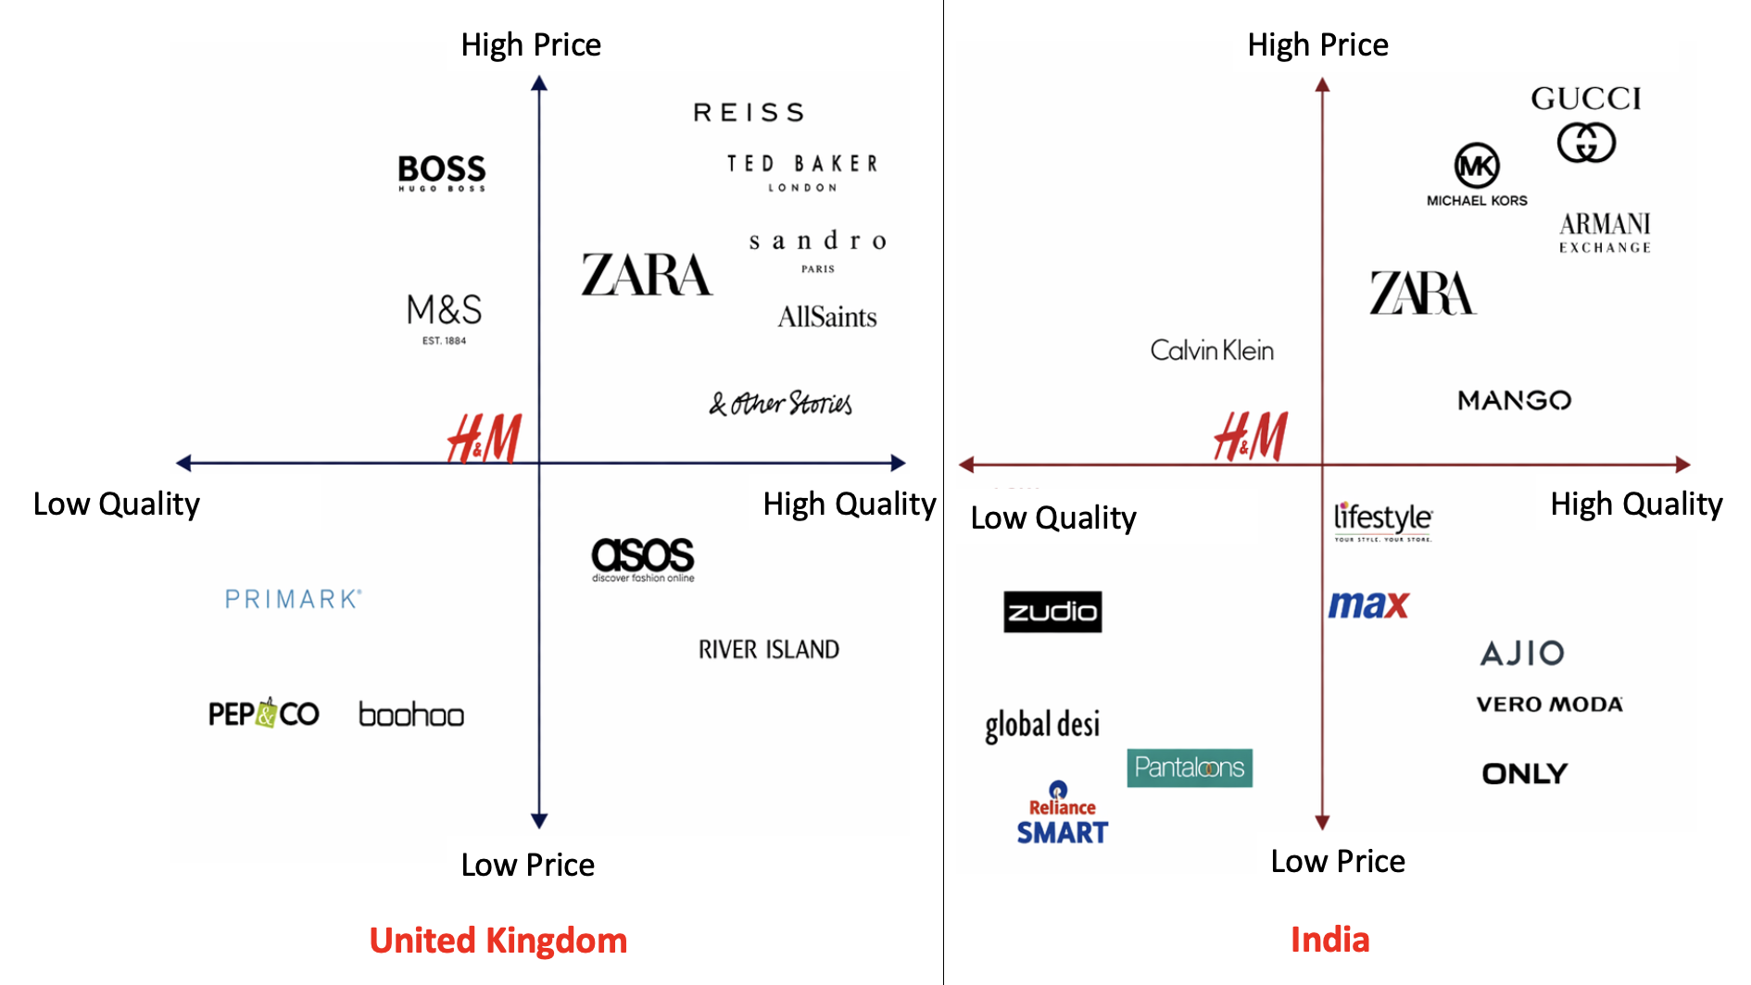
Figure 8. ZARA’s Positioning in the UK vs India
Source: Self-made, 2026
It can be defined as the perception of a brand in the mind of consumers compared to their competitors in terms of price, quality, and style (Kotler et al., 2015). ZARA markets itself as a fast-fashion retailer with trendy and high-fashion designs at relatively low costs, commonly known as an “affordable luxury” (Zhang, 2024). The difference in its market positioning in the two countries are depicted in the table below:
Factor | UK | India
Price perception | Mid-range | High/premium
Brand image | High-street fashion | Aspirational luxury
Accessibility | Broad market | Narrow, affluent segment

Evaluation of STP in The UK vs India
According to the STP analysis, the following is a clear synthesis of similarities and differences between the UK and India:
Similarities
ZARA uses a more or less standardised STP strategy in the UK and India as it targets the same segment in both markets. Such uniformity contributes to building a solid global brand and aligning with universal markets.
Dissimilarities
ZARA modifies its STP strategy slightly due to the economic conditions in the two countries. It is aimed at a wider market in the UK with medium disposable income, whereas it targets affluent consumers in urban areas in India due to higher price sensitivity. This creates a clear positioning gap, as the company is perceived as a mid-range high-street brand in the UK, while in India it is viewed as a high-end aspirational brand with limited accessibility.

Marketing Mix (7Ps) of ZARA in the UK and India
It is a strategic marketing model that defines the major components that a company employs to create value to the customers (Kotler et al., 2015). It enables companies to constantly analyse and adjust their strategies according to the evolving market conditions in dynamic industries, such as fashion.
Product

Figure 9. ZARA products in the UK
Source: Inditex, 2026a
UK: Provides a large selection of highly fashionable fast-fashion clothing, accessories and beauty products that appeal to the individualistic customer preferences.
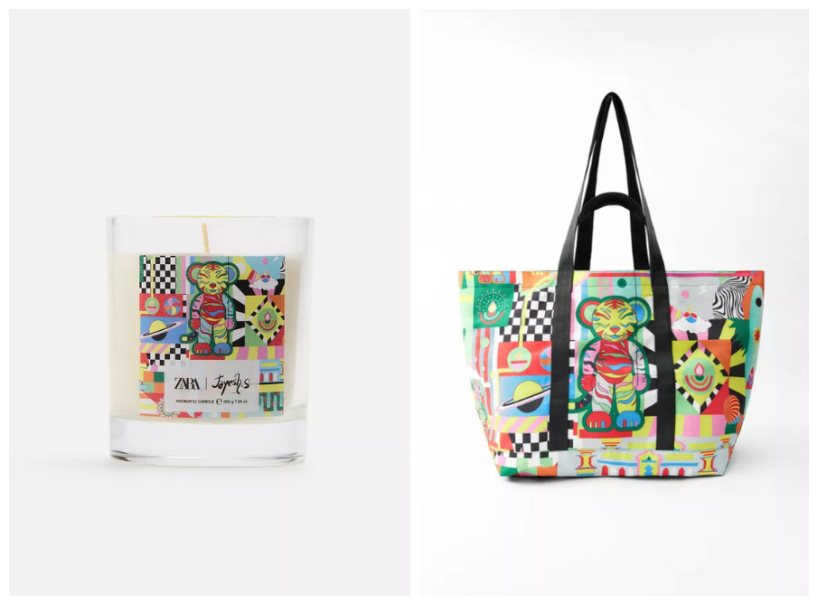
Figure 10. ZARA’s Product Localisation in India During Diwali
Source: In fashion, 2024
India: Offers the same core product assortment but tailors it to local demands, especially to the dressing habits of occasions and cultural inclinations.
Price
UK: A mid-to-premium high-street brand with relatively low-priced fashion relative to its luxury counterparts.
India: Positioned as a premium or aspirational brand because of lower average levels of income as the mass market cannot afford it (In fashion, 2024).
Place
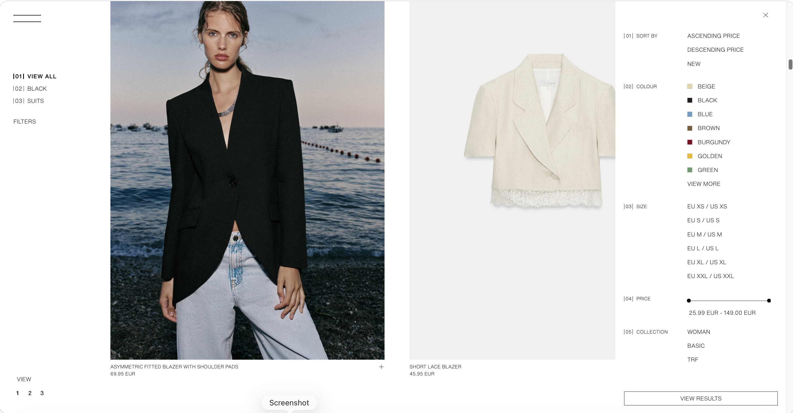
Figure 11. Product Placement at the ZARA Website
Source: Inditex, 2026a
UK: Significant physical presence with 58 stores in major cities, supported by vast online presence (Inditex, 2026a).
India: A more selective distribution approach with approximately 22 stores concentrated in large urban centres, like Mumbai, as well as online platforms (Inditex, 2026b).
Promotion

Figure 12. Visual Merchandising of ZARA
Source: Inditex, 2026a
UK: Adheres to a low-advertisement strategy which consists of the stores of the prime stores, visual merchandising, and social media interaction.
India: Similar to the UK but with a more aspirational brand image and word of mouth because of its premium positioning.
People
UK: A well-established workforce of more than 3,000 employees working in a well-organised retailing environment where customer service and efficiency are highly emphasised (The Retail Bulletin, 2026).
India: A joint venture with Tata Group, where it has approximately 1,454 employees who are more localised to meet the cultural diversity and consumer expectations (The Company Check, 2026).
Process
UK: A highly efficient and vertically integrated supply chain which allows the company to take 10-15 days to move the products through design to stores (Aftab et al., 2018).
India: Similar global supply chain model in India with a slight reduction on efficiency because of the infrastructure and logistical difficulties.
Physical Evidence

Figure 13. Premium Store Designs of ZARA
Source: Fifty, 2026
UK: Situated in the best high-street locations like Oxford Street, which strengthens its high-street premium image.
India: Located in high-end malls and other affluent areas, which boosts its image as a desirable global brand.

Evaluation of 7Ps in The UK vs India
According to the 7Ps analysis, the following is a clear synthesis of similarities and differences between the UK and India:

Similarities
ZARA has a fairly standardised 7Ps approach in the UK and India, ensuring global brand consistency. This standardisation strengthens its international brand name as a fast-fashion retailer that responds fast to fashion trends.
Differences
ZARA modifies its 7ps strategy slightly due to buyer behaviour differences in different countries. For instance, it is a convenient middle-range high-street brand in the UK, whereas in India, the relatively high relative pricing put it in a premium brand position, leading to a more selective distribution strategy in more affluent urban locations. Moreover, UK stores are more physical as they strengthen the accessibility of their store by placing it in high-street locations, whereas the Indian stores strengthen the exclusivity of their stores by placing them in up-market malls.

Directional Development Strategy of ZARA in the India
It is the long-term strategic path that a firm follows to attain growth and competitive advantage by using current or new products and markets (David, David and David, 2017). The Ansoff Matrix is a strategic tool often used in this analysis to identify and evaluate a firm’s growth strategies based on products and markets (Kotler et al., 2015). Therefore, this model is applied here to analyse ZARA’s entry in the Indian market.
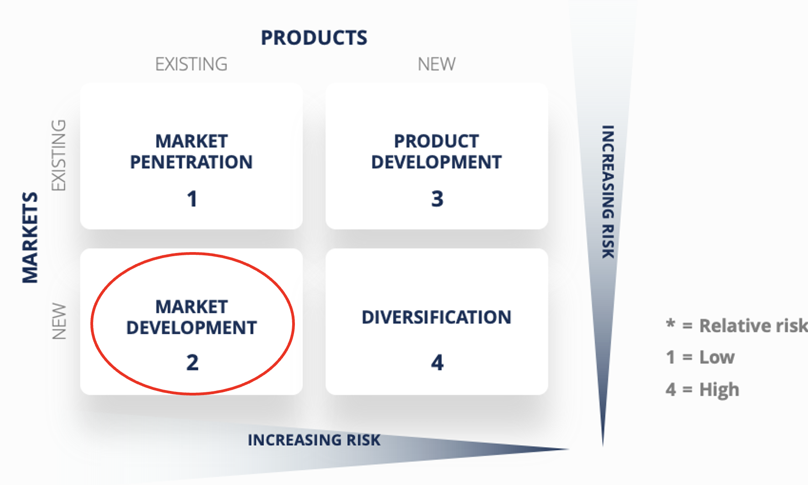
Figure 14. ZARA’s Developmental Strategy in India
Source: Self-made,2026
ZARA’s expansion into India can primarily be explained through a market development strategy. In 2010, it had entered the Indian market in a joint venture with the Tata Group (via Trent Ltd.), which allowed it to launch its existing fast-fashion products into a new geographic market (Times of India, 2024). This strategy is consistent with market development strategy because the company did not change its core product lines instead used its established global product lines. Moreover, the company has had a selective expansion policy in India, running about 20-25 stores in the large urban centres such as Mumbai and Delhi, instead of undertaking a mass-market expansion (ZARA, 2026b). This shows a conservative growth strategy whereby the company targets the urban consumers with high incomes instead of mass market penetration. Moreover, the company also exhibits a few aspects of market penetration as it enhances its online presence in India because of the shifting consumer behaviour that is influenced by rising digitalisation. Nevertheless, despite the fact that the company modifies its products to suit cultural preferences of the country slightly, it is not full product development, since the core fast-fashion model is retained.

Ethical Issues in ZARA’s Marketing Mix in India
Ethical marketing can be defined as the use of moral principles in business operations to promote fairness, transparency, and sustainability (Kotler et al., 2015). Ethical issues are important in the fast-fashion industry as they concern the labour conditions, environmental effects, and excessive consumption. Thus, this section evaluates ZARA’s ethical and unethical practices in relation to the 7Ps marketing mix in India.

Ethical Practices of ZARA
1. Sustainability Initiatives (Product/Process)
The company is devoted to ethical practices by implementing several sustainability measures. For example, it spends a significant amount of money on environmental and social programmes, contributing to over 1,182 projects that help over four million people around the world (Inditex, 2026c). This is an organised attempt to enhance environmental responsibility in the product and production processes of ZARA.
2. Supplier Code of Conduct (People/Process)
The company has an elaborate “Code of Conduct for Manufacturers and Suppliers” that outlines minimum standards on labour rights, health and safety, wages and environmental practices (Ethical Consumer, 2025). This shows a systematic ethical practice in the people and process aspects since it establishes clear guidelines on labour practices and tries to impose it globally.

Unethical Practices of ZARA
1. Labour Exploitation Risks in Supply Chain (People/Process)
The supply chain of the company has been criticised on labour practices especially in developing nations that are associated with production of textiles. For instance, according to a Business of Fashion (2025) report, some of the Indian cotton and textile sectors which provide fashion brands to the world, including ZARA, have been linked to child labour and poor working conditions. These concerns are further linked to systems such as the “Sumangali scheme,” where young women are employed under contracts that have been criticised for limiting rights and delaying wages (IMPRI India, 2025). Hence, despite the fact that the company has a developed supplier “Code of Conduct,” implementation in complex global supply chains is still inconsistent.
2. Environmental Impact of Fast Fashion (Product/Process)
The fast-fashion model of the company has been criticised extensively regarding its effects on the environment, especially overproduction and waste. For instance, approximately 10% of global carbon emissions and an annual generation of 92 million tonnes of textile waste is attributed to the global fashion industry, with fast-fashion retailers being a major contributor (UN, 2025). Furthermore, textile production is highly resource-intensive, with significant water usages, issues particularly relevant to manufacturing regions linked to India. Therefore, although the company has launched sustainability initiatives such as the “Join Life collection” that pledges to utilise more sustainable materials, these measures are not enough to counteract the environmental impact of its high-volume production model.
Thus, the marketing mix of ZARA in India is an indication of a partial adherence to ethical marketing, where official sustainability initiatives are intertwined with systemic problems of fast fashion. This implies that though there have been improvements, there is still a lot to be done to achieve truly ethical operations.

Recommendations
Following the discussion of the international marketing strategy of ZARA in the UK and India, several recommendations can be made to improve its performance, competitiveness, and ethical status in the two markets:
Recommendations for India
- Improving Localisation of Products: ZARA needs to enhance its product adaptation policy in India to suit cultural inclinations. While the company currently offers limited adaptations, greater localisation, such as culturally influenced styles (e.g., heritage designs ) would improve relevance among Indian consumers. This approach would enable the company to expand beyond its current urban segment given the country’s diverse cultural landscape along with occasion-based purchasing behaviour,
- Implementing a Tiered Pricing Strategy: ZARA needs to be more flexible in its pricing in India to counter high price sensitivity. A tiered pricing system, like the provision of entry-level product lines or region-based pricing would enable the company to appeal to a larger consumer base without watering down the brand image (Mintzberg, Ahlstrand and Lampel, 2008). This would enhance competitiveness with the international brands in the market such as H&M and local retailers that offer cheaper substitutes.
- Growing in the Emerging Indian Markets: ZARA should pursue a balanced expansion strategy in India by gradually increasing its presence in Tier 2 cities while maintaining its premium positioning. Although its existing selective strategy minimises risk, penetrating into new urban markets would enable it to tap into unexploited market potential. This expansion should be supported by data-driven analysis to ensure that store locations align with income levels and consumer demand.
Recommendations for the UK
- Strengthening Supply Chain Transparency: ZARA needs to improve its ethical behaviour by promoting transparency in its international supply chain. Despite the company having a supplier “Code of Conduct,” there are still unresolved issues of labour conditions that need to be resolved. Therefore, the company should release more comprehensive supplier data, enhance auditing processes, and work with independent organisations to make sure compliance.
- Expanding Sustainability in Business: ZARA needs to go beyond the narrow sustainability efforts by embracing a broader environmental responsibility strategy. This may involve the encouragement of circular fashion, such as recycling programmes, resale programmes, and life cycle extension of products. This would increase brand loyalty and reputation in the UK where consumers are becoming more environmentally conscious. On the other hand, in India, it would make ZARA a trend-setter international brand, which would help achieve long-term sustainability objectives.

Section 2: Reflective Account
This reflection will use Gibbs Reflective Cycle, that provides a systematic approach to reflection through six stages by analysing both positive and negative aspects of their experiences (Adeani, Febriani and Syafryadin, 2020).
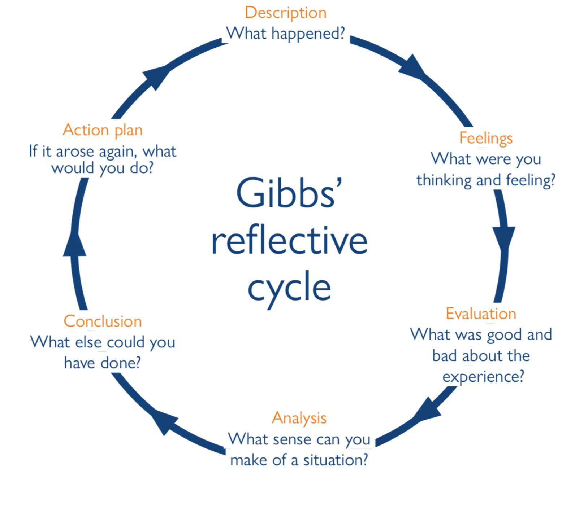
Figure 15. Elements of Gibbs Reflective Cycle
Source Adeani, Febriani and Syafryadin, 2020
1. Description
This assignment entailed the analysis of the international marketing strategy of ZARA, with a comparative focus on the UK and India. It involved the use of various strategic models, such as PESTLE analysis, the cultural dimensions of Hofstede, segmentation, targeting and positioning (STP), marketing mix (7Ps) and the Ansoff Matrix. In order to accomplish the task, I carried out secondary research with the help of diverse credible secondary sources. This was done by gathering information, contrasting the two markets and merging theory with evidence on the ground to generate a critical and systematic analysis.
2. Feelings
I felt uncertain about managing the volume of information required at the beginning. The necessity to refer to the credible sources while also securing the academic rigour at first appeared to be challenging. Nonetheless, as I continued, I became more assured of how to navigate pertinent information. The comparison of UK and India was also interesting to me, as it revealed obvious differences in economic, cultural, and market conditions. This made me more interested in the topic and more motivated to create a quality analysis. However, I was sometimes overwhelmed in my attempt to make sure that every section was critically analysed as opposed to being descriptive.
3. Evaluation
The research process proved to be successful in coming up with a holistic view of the international marketing strategy of ZARA. One of the strengths was the credibility and diversity of the sources used, which contributed to reliability of the analysis. However, there were restrictions as well. For instance, I initially made some parts of the analysis too descriptive rather critical. To illustrate, the initial versions of the PESTLE analysis were more about enumerating the factors than evaluating their implications to ZARA. Moreover, it was difficult to combine real-world data with academic theory because it involved a interpretation of sources. Furthermore, time management was also a significant constraint since it was time consuming to collect reliable data in each section.
4. Analysis
The experience demonstrated the importance of the integration of theoretical perspectives and empirical facts in the study of international marketing strategies. This assignment made me realise that it is not sufficient to determine just the strategic factors, but to evaluate how they affect the business. Furthermore, the process emphasised the role of critical thinking in academic work. For instance, analysing ZARA’s strategy in India required understanding of not only market opportunities but also challenges such as price sensitivity and cultural diversity. My research skills were also enhanced by the use of various sources, especially in the ability to differentiate between credible and less reliable information.
5. Conclusion
This assignment has helped me to gain a lot of knowledge about the use of analytical frameworks in international marketing strategy. I acquired better research skills, enhanced my capacity to combine theory and practice, and became more confident about my comparative analysis skills through this module. Nevertheless, the experience also brought up the areas of improvement, especially keeping the level of critical analysis consistent throughout the report. I feel that while the final outcome was comprehensive, a clearer structure could have improved efficiency and reduced pressure during the writing process.
6. Action Plan
I will embrace a number of strategies to enhance my performance in future. To start with, I will start assignments by developing a comprehensive plan that will include each part and the necessary sources. This will aid in time management and lessen the last-minute stress. Secondly, I will work on the development of critical analysis skills by always posing questions like “why does this matter” when presenting information. This will make my work go beyond description to greater assessment. Thirdly, I will further develop my research skills by focusing on high-quality academic and industry resources, including peer-reviewed journals and official reports. This will enhance the credibility of my work. Lastly, I will train myself to be more effective at combining theory with real-life examples to ensure that frameworks are not implemented as independent ideas. Through these strategies, I will be able to create more analytic, well-organised, and quality academic work in my subsequent works.

Conclusion
This report has critically analysed the international marketing strategy of ZARA across the UK and India, highlighting the importance of adapting strategies to different market conditions. The PESTLE analysis revealed that although the UK is a stable, technologically advanced, and high-income country, it is relatively saturated with low growth prospects. Conversely, India holds a great potential over the long-term, owing to the economic growth, urbanisation and the presence of the young population although with complexities such as regulatory challenges, cultural diversity, and infrastructural constraints. The analysis STP and marketing mix (7Ps) conducted has shown that ZARA uses a glocal strategy in which it standardises its central brand image globally. Additionally, the use of the Ansoff Matrix revealed that ZARA is expanding its operations in India on a market development basis with selective market penetration due to its conservative yet effective expansion strategy. Nevertheless, the analysis also revealed the ethical issues linked to labour practices and environmental impact, which means that the sustainability and supply chain transparency should be implemented more effectively. Therefore, the report concluded that ZARA is an effective international marketing company that needs to be more localised, more ethical and more digital especially in India to realise its full potential of growth and to remain competitive in the long-run.

References
Adeani, I.S., Febriani, R.B. and Syafryadin, S. (2020) Using GIBBS’reflective cycle in making reflections of literary analysis. Indonesian EFL Journal, 6(2), pp.139-148.
Aftab, M.A., Yuanjian, Q., Kabir, N. and Barua, Z. (2018) Super responsive supply chain: The case of Spanish fast fashion retailer Inditex-ZARA. International Journal of Business and Management, 13(5), pp.212-227.
Business of Fashion (2025) ‘Ethical’ cotton is being picked by child labourers in India, watchdog finds. Available at: https://www.businessoffashion.com/articles/sustainability/india-cotton-child-labour-investigation-ZARA-hm-amazon-gap/ (Accessed: 19 April 2026).
David, F.R., David, F.R. and David, M.E. (2017) Strategic management: concepts and cases: A competitive advantage approach (p. 127). Pearson.
Ethical Consumer (2026) ZARA (Inditex) company profile. Available at: https://www.ethicalconsumer.org/company-profile/ZARA-sa (Accessed: 19 April 2026).
Eierle, B., Hartlieb, S., Hay, D.C., Niemi, L. and Ojala, H. (2022) External factors and the pricing of audit services: A systematic review of the archival literature using a PESTLE analysis. Auditing: A Journal of Practice & Theory, 41(3), pp.95-119.
Forbes (2026a) ZARA company profile. Available at: https://www.forbes.com/companies/ZARA/ (Accessed: 19 April 2026).
Government of India (2008) National Action Plan on Climate Change (NAPCC). Available at: https://scopeclimatechange.scopeonline.in/wp-content/uploads/2025/11/Word1-NAPCC.pdf (Accessed: 19 April 2026).
Hitt, M.A., Ireland, R.D. and Hoskisson, R.E. (2019) Strategic management: Concepts and cases: Competitiveness and globalization. Cengage Learning.
Hollensen, S. (2017) Global Marketing: A Decision-Oriented Approach. 7th edn. Harlow: Pearson.
IFAB Media (2024) ZARA launches first-ever collaboration in India with artist Jayesh Sachdev. Available at: https://infashionbusiness.com/home/news_details/4143 (Accessed: 19 April 2026).
India Brand Equity Foundation (IBEF) (2025) Fashion forward: An analysis of India’s growing apparel market. Available at: https://www.ibef.org/blogs/fashion-forward-an-analysis-of-india-s-growing-apparel-market (Accessed: 19 April 2026).
IMARC Group (2026a) UK fashion apparel market: Size, share, trends and forecast. Available at: https://www.imarcgroup.com/uk-fashion-apparel-market (Accessed: 19 April 2026).
IMARC Group (2026b) India apparel market: Size, share, trends and forecast. Available at: https://www.imarcgroup.com/india-apparel-market (Accessed: 19 April 2026).
IMPRI India (2025) Gender, caste and labour: An overview of the Sumangali system. Available at: https://www.impriindia.com/insights/gender-caste-labour-sumangali-system/ (Accessed: 19 April 2026).
In Fashion (2024) ZARA launches first-ever collaboration in India with artist Jayesh Sachdev Available at: https://infashionbusiness.com/home/news_details/4143 (Accessed: 19 April 2026).
Inditex (2025) FY2024 results. Available at: https://www.inditex.com/itxcomweb/aq/en/press/news-detail/6f8d8db5-4d7a-43db-91b9-0c38065aec1e/fy2024-results (Accessed: 19 April 2026).
Inditex (2026a) ZARA store locator – India. Available at: https://www.ZARA.com/in/en/z-stores-st1404.html (Accessed: 19 April 2026).
Inditex (2026b) ZARA store locator – United Kingdom. Available at: https://www.ZARA.com/uk/en/z-stores-st1404.html (Accessed: 19 April 2026).
Inditex (2026c) Sustainability. Available at: https://www.inditex.com/itxcomweb/es/en/sustainability (Accessed: 19 April 2026).
Józefowiak, O., 2023. The Challenges of the Fast Fashion Industry Using the Example of ZARA–A Perspective of Modern Consumer Behaviour. Journal of Economic Literature, pp.59-72.
Kotler, P., Burton, S., Deans, K., Brown, L. and Armstrong, G., 2015. Marketing. Pearson Higher Education AU.
McKinsey (2025) Gen Z insights: December 2025 edition. Available at: https://www.mckinsey.com/~/media/mckinsey/email/genz/2025/12/2025-12-02a.html (Accessed: 19 April 2026).
Mintel (2025) UK clothing retailing market report. Available at: https://store.mintel.com/report/uk-clothing-retailing-market-report (Accessed: 19 April 2026).
Mintzberg, H., Ahlstrand, B., and Lampel, J. (2008) Strategy Safari: The Complete Guide Through the Wilds of Strategic Management. Harlow: FT Prentice Hall.
Reuters (2026) India’s March retail inflation quickens to 3.4% y/y. Available at: https://www.reuters.com/world/india/indias-march-retail-inflation-quickens-340-yy-2026-04-13/ (Accessed: 19 April 2026).
Spring Fair (2025) UK fashion industry 2025: Trends, stats and what’s next. Available at: https://www.springfair.com/news/uk-fashion-industry-2025-trends-stats-s-next (Accessed: 19 April 2026).
The Guardian (2026) UK GDP report: economy December Q4 2025 growth. Available at: https://www.theguardian.com/business/live/2026/feb/12/uk-gdp-report-economy-december-q4-2025-growth-rachel-reeves-budget-news-updates (Accessed: 19 April 2026).
The Company Check (2026) Inditex Trent Retail India Private Limited. Available at: https://www.thecompanycheck.com/company/inditex-trent-retail-india-private-limited/U74900HR2009FTC043768 (Accessed: 19 April 2026).
The Retail Bulletin (2026) ZARA news. Available at: https://www.theretailbulletin.com/retailers/ZARA-news/ (Accessed: 19 April 2026).
The Times of India (2024) How Ratan Tata started India’s romance with ZARA. Available at: https://timesofindia.indiatimes.com/life-style/fashion/buzz/how-ratan-tata-started-indias-romance-with-ZARA/articleshow/114105630.cms (Accessed: 19 April 2026).
Trading Economics (2026) United Kingdom corruption index. Available at: https://tradingeconomics.com/united-kingdom/corruption-index (Accessed: 19 April 2026).
UK Parliament (2015) Consumer Rights Act 2015Available at: https://www.legislation.gov.uk/ukpga/2015/15/contents (Accessed: 19 April 2026).
United Nations (UN) (2025) Rethinking fashion for a zero-waste future. Available at: https://news.un.org/en/story/2025/03/1161636 (Accessed: 19 April 2026).
White & Case (2025) Foreign direct investment reviews 2025: India. Available at: https://www.whitecase.com/insight-our-thinking/foreign-direct-investment-reviews-2025-india (Accessed: 19 April 2026).
World Bank (2026) Individuals using the Internet (% of population). Available at: https://data.worldbank.org/indicator/IT.NET.USER.ZS?contextual=min&locations=IN-GB (Accessed: 19 April 2026).
World Population Review (2026) Social media users by country. Available at: https://worldpopulationreview.com/country-rankings/social-media-users-by-country (Accessed: 19 April 2026).
WRAP (2026) UK Textiles Pact. Available at: https://www.wrap.ngo/take-action/uk-textiles-pact (Accessed: 19 April 2026).
Żemojtel-Piotrowska, M. and Piotrowski, J. (2023) Hofstede’s cultural dimensions theory. In Encyclopedia of sexual psychology and behavior (pp. 1-4). Cham: Springer International Publishing.
Zhang, E. (2024) Behind ZARA’s success: An analysis of brand marketing and management in fast fashion. In SHS Web of Conferences (Vol. 199, p. 02005). EDP Sciences.

