Name:Daniel Anghel
Student number:2224081
E-portfolio report
Learning in the Digital Era – BMPL4007/BMPS4009

Table of Contents

Task 1 – Written summary 2
Task 2 – Mind map 3
Task 3 – Presentation 4
Task 4 – Reflection 5
Reference list 6

Task 1 – Written summary
Preparing for higher education is a crucial step in the academic journey of an individual. It requires adequate planning and preparation to ensure a smooth transition from secondary education to higher education. The road to higher education can be challenging, but with the right mindset and approach, it can be an exciting and rewarding experience. One of the essential steps to prepare for higher education is to choose the right course and institution. Students must take the time to research various courses and institutions and choose the one that aligns with their interests and career goals. It is also essential to consider the reputation of the institution, the course structure, and the opportunities for practical experience and internships (Altbach, 2016).
Another crucial aspect of preparing for higher education is to develop good study habits. Students must learn to manage their time effectively, create study schedules, and prioritize their studies over other activities. It is also important to develop critical thinking and analytical skills, as higher education requires students to think deeply and analyze complex ideas. Preparing financially for higher education is also essential. Students must consider the cost of tuition, accommodation, and living expenses and plan accordingly. They can explore various funding options, such as scholarships, grants, and student loans, to help ease the financial burden (Cropley and Knapper, 2021). In addition to academic and financial preparation, students must also prepare themselves mentally and emotionally. Higher education can be overwhelming, and students may experience stress and anxiety. It is essential to develop good mental health habits, such as exercise, meditation, and social support, to cope with the demands of higher education.
Preparing for higher education requires a holistic approach. It involves academic, financial, and mental preparation to ensure a successful transition from secondary education to higher education. By choosing the right course and institution, developing good study habits, preparing financially, and taking care of their mental and emotional well-being, students can make the most of their higher education experience and achieve their academic and career goals.

Task 2 – Mind map
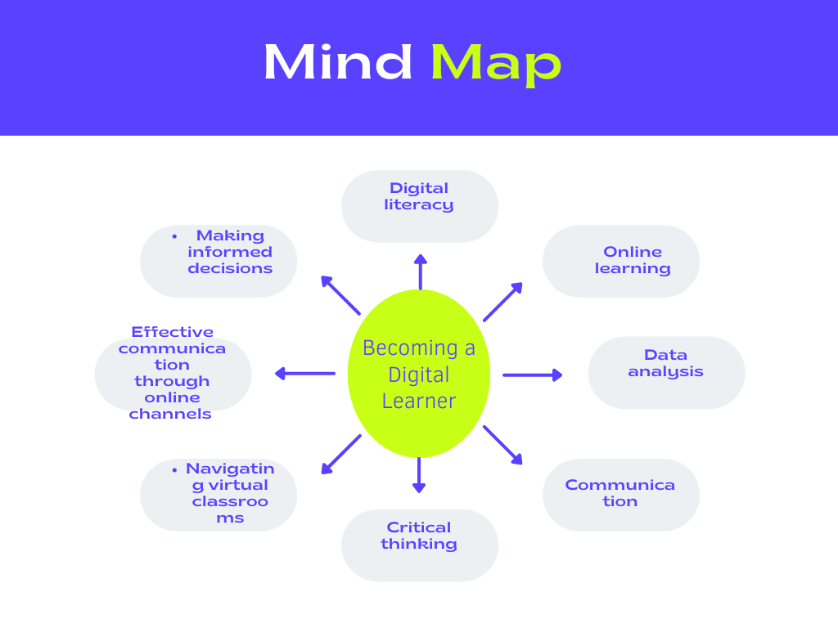
Becoming a digital learner is an essential skill for students pursuing a career in business. The following mind map illustrates how the main themes and concepts of this topic are interconnected and contribute to preparing students to work in their chosen discipline. The first theme of the mind map is digital literacy. This includes understanding basic computer skills, such as using Microsoft Office, and having knowledge of internet safety and security. Digital literacy is crucial for students as they will be required to use various software programs and online platforms in their future careers (Grand-Clement, 2017).
The second theme is online learning. With the rise of online education, students must learn how to navigate virtual classrooms and effectively manage their time while studying remotely. Online learning also includes taking advantage of digital resources such as e-books, articles, and webinars. The third theme is data analysis. As businesses increasingly rely on data to make decisions, students must have knowledge of data analysis tools such as Excel and Google Analytics. This skill is particularly relevant for those pursuing careers in marketing, finance, and business analytics (Sousa and Rocha, 2019).
The fourth theme is communication. In the digital age, communication has evolved, and students must learn how to effectively communicate through various online channels such as email, video conferencing, and social media. Communication skills are particularly relevant for those pursuing careers in marketing, public relations, and management. The final theme is critical thinking. With an abundance of information available online, students must develop critical thinking skills to analyze and evaluate sources to make informed decisions. This skill is particularly relevant for those pursuing careers in consulting, management, and entrepreneurship.
All of these themes are interconnected and contribute to preparing students to work in their chosen discipline. By becoming a digital learner, students can develop the skills necessary to succeed in a rapidly changing digital landscape. From data analysis and critical thinking to effective communication and online learning, these skills are crucial for students pursuing a career in business (Erdem, 2017).

Task 3 – Presentation

Please follow this link to view my presentation :
https://youtube.com/watch?v=l6u_s218_P8&si=EnSIkaIECMiOmarE

Task 4 – Reflection
Using Borton's reflective tool has helped me reflect on my experience of starting university during the pandemic, adapting to online learning, and writing my first assignments. Firstly, in the "What?" stage of the tool, I described the situation I faced. Moving onto the "So what?" stage of the tool, I reflected on the meaning and significance of my experience. I acknowledged that starting university during the pandemic was challenging but also an opportunity to develop new skills such as self-motivation, time management, and adaptability. I found online learning to be a convenient way to attend classes and access resources, but also noted that it requires a high level of self-discipline to stay focused and engaged.
Finally, the "Now what?" stage of the tool prompted me to identify actions or changes that need to be made in response to the experience. I recognized the importance of developing effective study habits, such as breaking down assignments into manageable tasks and creating a study schedule. I also acknowledged the need to seek support from tutors, classmates, and university services, such as the library and academic writing center, to improve my writing skills. Using Borton's reflective tool has allowed me to reflect on my experience of starting university during the pandemic, adapting to online learning, and writing my first assignments. The reflective process has highlighted the challenges, opportunities, and lessons learned from the experience. By identifying actions and changes that need to be made, I can improve my learning experience and achieve my academic goals.

Conclusion
In conclusion, this report has looked at the various aspects of preparing for higher education, such as selecting the right course and institution, developing good study habits, financing higher education, and mental and emotional preparation. Additionally, it has explored the importance of becoming a digital learner for those pursuing a career in business, and the various themes and concepts relevant to this topic, including digital literacy, online learning, data analysis, communication, and critical thinking. Finally, it showed how personal identity can help individuals become good team players, by fostering a strong sense of community, shared values, and a willingness to embrace different perspectives and ideas.

Reference list
Altbach, P.G., 2016. Global perspectives on higher education (p. 303). Baltimore: Johns Hopkins University Press.
Cropley, A. and Knapper, C., 2021. Lìelong Learning in Higher Education. routledge.
Erdem, A., 2017. Mind Maps as a Lifelong Learning Tool. Universal Journal of Educational Research, 5(n12A), pp.1-7.
Grand-Clement, S., 2017. Digital Learning: Education and Skills in the Digital Age. RAND Europe.
Lencioni, P.A.T.R.I.C.K., 2018. How to spot ideal team players. Servant leadership in action: How you can achieve great relationships and results, pp.1735-1760.
Sousa, M.J. and Rocha, Á., 2019. Digital learning: Developing skills for digital transformation of organizations. Future Generation Computer Systems, 91, pp.327-334.
Tannenbaum, S. and Salas, E., 2020. Teams that work: the seven drivers of team effectiveness. Oxford University Press.

