Mummification/Salt desiccation experiment:
Introduction:
In this experiment, orange segments are placed into sealed bags with different salts (Epsom, Table, Bicarbonate) and left for two weeks in order to study the effects that the different salts have and whether the salts can be used to desiccate the orange segments. Desiccation is a key part of the mummification process as it is important to ensure the preservation of the body. Mummification is artificial preservation of the body to ensure survival of the body after death. Mummification was key to the ancient Egyptians as the afterlife was regarded as ‘an extension of earthly existence’, therefore the body must remain intact. A main reason that the body had to remain intact was so that it was recognisable to the ‘Ba’ (part of the soul). Knowledge on Ancient Egyptian mummification techniques is mostly based on secondary literature, such as Herodotus, these texts describe the use of natron. Within the mummification process in Ancient Egypt, natron was used to desiccate the body. Natron is a naturally occurring sodium salt mixture. There have been modern experiments that have used artificial natron to test its desiccation ability. In this experiment, we used different salts to see the effect that each had on the orange segments.
Aims and hypothesis:
The aim of this experiment is to understand the effects that salt has as a desiccant on orange segments. It is likely that each salt will successfully remove some of the water from the segment, however the salts will most likely not desiccate the segments in two weeks.
Method:
Materials used for this experiment:
- Electronic Callipers
- Digital weighing scale
- Orange segments
- Sealable plastic bags
- Epsom salt
- Table Salt
- Bicarbonate
- Measuring beaker
- Plastic gloves
- Paper towels
- Wooden spoon
- Scraping tools

Procedure:
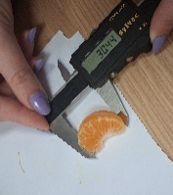
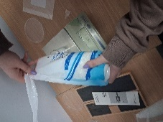
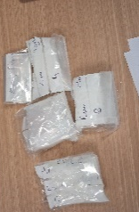
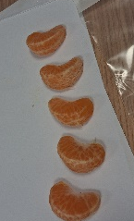
To begin this experiment, the orange was weighed before it was peeled or separated, it had a total weight of 83 grams, after peeling the orange was weighed again and now weighed 55.6 grams. For the experiment, the largest five segments were selected as it was believed that they would yield more accurate results and enable more accurate observations, it was also key to pick the segments most similar in weight in order to produce more accurate results. The specimen selected for the control was measured using the electronic callipers and had a length of 30.44 millimetres and a depth of 13.9 millimetres, it was then placed on a paper towel and weighed using the digital scales, it weighed 5.9 grams. The control specimen was placed into an empty bag and then sealed and the bag was labelled ‘Control'.
Figure 3 - Weighing the Epsom Salt
Figure 2 - Measuring the length of the control specimen
Figure 4 - The sealed and labelled bags
Figure 1 - The selected orange segments
Specimen A was measured with the electronic callipers, it had a length of 32.75 millimetres and a depth of 13.35 millimetres, it was then placed on to a paper towel and weighed using the digital scales, it weighed 6.2 grams. Specimen A was then placed into an empty bag. Then the digital scales were used to weigh 100 grams of Epsom salt using a beaker. This salt was then put into the bag and used to completely cover specimen A, the bag was then sealed, and the bag was labelled ‘A'.
Specimen B was measured with the electronic callipers, it had a length of 33.85 millimetres and a depth of 15.77 millimetres, the specimen was then placed on a paper towel and weighed using the digital scales, it weighed 6.2 grams. Specimen B was then placed into an empty bag. Then the digital scales were used to weigh 100 grams of table salt using a beaker. The table salt was then put into the bag and used to cover specimen B. The bag was then sealed and labelled ‘B'.
Specimen C was measured with the electronic callipers, it had a length of 32.28 millimetres and a depth of 15.77 millimetres. The specimen was then placed on a paper towel and weighed using the digital scales, it weighed 8.1 grams. Specimen C was then placed into an empty plastic bag. The digital scales were then used to weigh 100 grams of Bicarbonate in a beaker. This was then placed into the bag and used to cover specimen C. The bag was then sealed and labeled ‘C'.
Specimen D was measured using the electronic callipers, it had a length of 35.33 millimetres and a depth of 15.98 millimetres. The specimen was then placed on a paper towel and weighed using the digital scale, it weighed 7.9 grams. Specimen D was then placed into an empty plastic bag. The digital scales were then used to weigh 50 grams of Epsom salt, 25 grams of table salt and 25 grams of Bicarbonate in a beaker. This mixture was then placed into the bag and used to cover Specimen D. The bag was then sealed and labelled ‘D'. All of these bags were then labelled with the date and left in a classroom for a week.

After a week had passed, the specimens were removed from the bags and any excess salt was scraped off using the wooden spoon and the scraping tools, visual observations were taken and the specimens were measured once again. The control specimen was measured with the electronic callipers and had a length of 33.52 millimetres and a depth of 14.42 millimetres. It was then placed on to a paper towel and weighed on the digital scales, it weighed 5.78 grams. The specimen was then placed back into the bag.
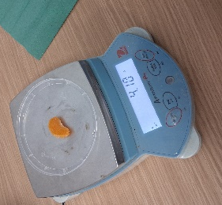
Specimen A was measured with the electronic callipers, it had a length of 30.47 millimetres and a depth of 13.01 millimetres. It was then placed on to a paper towel and weighed using the digital scales, it weighed 4.1 grams. The specimen was then placed back into the bag and covered with the Epsom salt and the bag was sealed.
Specimen B was measured with the electronic callipers, it had a length of 31.72 millimetres and a depth of 11.11 millimetres. It was then placed on to a paper towel and weighed using the digital scales, it weighed 3.39 grams. The specimen was then placed back into the bag and covered with the table salt.
Figure 5 - Weighing Specimen A
Specimen C was measured with the electronic callipers, it had a length of 33.39 millimetres and a depth of 15.95 millimetres. It was then placed on to a paper towel and weighed using the digital scales, it weighed 6.3 grams. The specimen was then placed back into the bag and covered with the Bicarbonate and the bag was sealed.
Specimen D was measured using the electronic callipers, it had a length of 35.56 millimetres and a depth of 13.61 millimetres. The specimen was then placed on a paper towel and weighed using the digital scales, it weighed 4.8 grams. The specimen was then placed back into the bag and covered with the salt mixture and the bag was sealed. The specimens were then left in a classroom for another week.
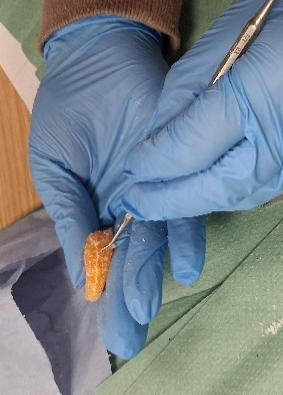
After another week had passed, the specimens were once again removed from the bags of salt and after any excess salt had been scraped off using the scraping tools, placed on to a paper towel in order to be measured and have visual observations taken. The control specimen was measured using the electronic callipers, it had a length of 33.26 millimetres and a depth of 13.16 millimetres. It was then placed on a paper towel and weighed using the digital scales, it weighed 5.53 grams. The specimen was then placed back into the bag and the bag was discarded.
Specimen A was measured using the electronic callipers, it had a length of 31 millimetres and a depth of 8.68 millimetres. It was then placed on to a paper towel and weighed using the digital scales, it weighed 2.75 grams. The specimen was then placed back into the bag and the bag was discarded.
Specimen B was measured using the electronic callipers, it had a length of 33.39 millimetres and a depth of 10.63 millimetres. It was then placed on a paper towel and weighed using the digital scales, it weighed 3.4 grams. The specimen was then placed back into the bag and the bag was discarded.
Figure 6 - Removing the salt from a specimen
Specimen C was measured using the electronic callipers, it had a length of 32.3 millimetres a depth of 15.03 millimetres. It was then placed on to a paper towel and weighed using the digital scales, it weighed 5.45 grams. The specimen was then placed back into the bag and the bag was discarded.
Specimen D was measured using the electronic callipers, it had a length of 36.11 millimetres and a depth of 12.44 millimetres. It was then placed on to a paper towel and weighed using the digital scale, it weighed 4.12 grams. The specimen was then placed back into the bag and the bag was discarded.
Week 1:
 | Weight (grams) | Length (millimetres) | Depth (millimetres)
Control | 5.9 | 30.44 | 13.9
A | 6.2 | 32.75 | 15.35
B | 6.2 | 33.85 | 15.77
C | 8.1 | 32.28 | 17.87
D | 7.9 | 35.33 | 15.98

Week 2:
 | Weight (grams) | Length (millimetres) | Depth (millimetres)
Control | 5.78 | 33.52 | 14.42
A | 4.1 | 30.47 | 13.01
B | 3.39 | 31.72 | 11.11
C | 6.3 | 33.39 | 15.95
D | 4.8 | 35.56 | 13.61

Week 3:
 | Weight (grams) | Length (millimetres) | Depth (millimetres)
Control | 5.53 | 33.26 | 13.16
A | 2.75 | 31 | 8.68
B | 3.4 | 33.39 | 10.63
C | 5.45 | 32.3 | 15.03
D | 4.12 | 36.11 | 12.44

Observations:
On week 1, the orange segments all appeared as normal, they were very orange in colour and had very little pith remaining.
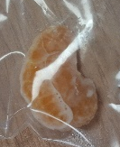
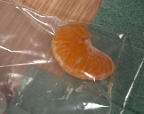
On week 2, the control specimen appeared to have a different texture to the previous week and was sticky to touch. Specimen A appeared to be more wrinkled than it had been the previous week. Specimen B appeared to be softer and smaller than it had been the previous week. Specimen C appeared to be browner than it had been the previous week, but it seemed as if it had not shrunk as much as the other specimens. Specimen D appeared to be very orange and felt hollower than it had been the previous week.
Figure 7 - Control Specimen in bag
On week 3, the control specimen had a layer of white moisture around it and was still sticky. Specimen A was very orange in colour and appeared to have shrank but felt fairly solid. Specimen B was soft and squishy. Specimen C had gone more of a brown colour, but the salt around it appeared to have an orange tinge. Specimen D was solid but had sunken in the middle and felt hollow.
Figure 8 - Control specimen in bag
Results:
By week 3, each of the specimens that had been covered in salt were more preserved than the control specimen, this therefore suggests that each specimen had at least been partially desiccated. A way of determining this is by looking at how the weight of each specimen changed. While the control specimen had a minor weight change (0.37 grams) from week 1 to week 3, some of the other specimens experienced more weight change. Specimen A had a weight change of 3.45 grams from week 1 to week 3. Specimen B had a weight change of 2.8 grams from week 1 to week 3. Specimen C had a weight change of 2.65 grams from week 1 to week 3. Specimen D has a weight change of 3.78 grams from week 1 to week 3. Therefore, specimen D experienced the largest weight change. Specimen D also appeared to have experienced the least visual change as it did not change in colour or texture.

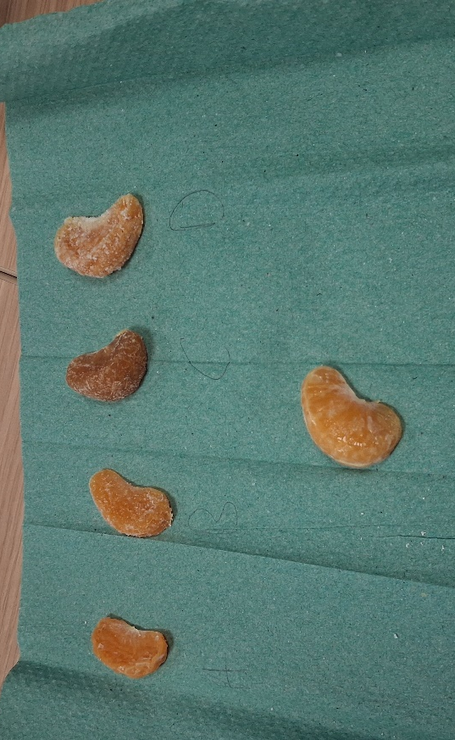
Figure 9 - The Orange segments at the end of the experiment

Conclusions:
The results for this experiment suggest that although each salt was able to remove salt from the specimens, the most successful was the mixture of 50% Epsom salt, 25% table salt and 25% bicarbonate.

Reference List:
Ikram, S. (2010). Mummification. https://escholarship.org/uc/item/0gn7x3ff (Accessed 19th March 2026)
Kaup, Y., Schmid, M., Middleton, A., & Weser, U. (2003). Borate in mummification salts and bones from Pharaonic Egypt. Journal of Inorganic Biochemistry, 94(3), 214–220. https://doi.org/10.1016/S0162-0134(03)00002-3 (Accessed 19th March 2026)
Loynes, R. (2015). Prepared for eternity; a study of human embalming techniques in ancient Egypt using computerised tomography scans of mummies. Archaeopress.
Öhrström, L., Tekin, A., Biedermann, P., Morozova, I., Habicht, M., Gascho, D., Bode‐Lesniewska, B., Imhof, A., Rühli, F., & Eppenberger, P. (2020). Experimental mummification—In the tracks of the ancient Egyptians. Clinical Anatomy (New York, N.Y.), 33(6), 860–871. https://doi.org/10.1002/ca.23568 (Accessed 19th March 2026)
Taylor, J. H. (2001). Death and the afterlife in ancient Egypt. University of Chicago Press.

Images:
Figure 1 – Stewart, R (2026). The selected orange segments. Photograph. Week 1
Figure 2 – Dabell, M (2026). Measuring the Depth of the control specimen. Photograph. Week 1
Figure 3 – Dabell, M (2026). Weighing the Epsom Salt. Photograph. Week 1
Figure 4 – Dabell, M (2026). The sealed and labelled bags. Photograph. Week 1
Figure 5 - Dabell, M (2026). Weighing Specimen A. Photograph. Week 2
Figure 6 – Dabell, M (2026). Removing salt from a specimen. Photograph. Week 3
Figure 7 – Dabell, M (2026). Control Specimen in bag. Photograph. Week 2
Figure 8 – Stewart, R (2026). Control Specimen in bag. Photograph. Week 3
Figure 9 – Dabell, M (2026). The Orange Segments at the end of the experiment. Photograph. Week 3

Ikram, S. (2010). Mummification. https://escholarship.org/uc/item/0gn7x3ff
Taylor, J. H. (2001). Death and the afterlife in ancient Egypt. University of Chicago Press. Page 13
Loynes, R. (2015). Prepared for eternity; a study of human embalming techniques in ancient Egypt using computerised tomography scans of mummies. Archaeopress.
Öhrström, L., Tekin, A., Biedermann, P., Morozova, I., Habicht, M., Gascho, D., Bode‐Lesniewska, B., Imhof, A., Rühli, F., & Eppenberger, P. (2020). Experimental mummification—In the tracks of the ancient Egyptians. Clinical Anatomy (New York, N.Y.), 33(6), 860–871. https://doi.org/10.1002/ca.23568
Kaup, Y., Schmid, M., Middleton, A., & Weser, U. (2003). Borate in mummification salts and bones from Pharaonic Egypt. Journal of Inorganic Biochemistry, 94(3), 214–220. https://doi.org/10.1016/S0162-0134(03)00002-3
Öhrström, L., Tekin, A., Biedermann, P., Morozova, I., Habicht, M., Gascho, D., Bode‐Lesniewska, B., Imhof, A., Rühli, F., & Eppenberger, P. (2020). Experimental mummification—In the tracks of the ancient Egyptians. Clinical Anatomy (New York, N.Y.), 33(6), 860–871. https://doi.org/10.1002/ca.23568

