Reflective Portfolio

BMSW4005-Professional Career Development

Lecturer: Kingsley Omeihe

student name: Ana Balteanu

Student number: 2132981

abstract
This reflective portfolio has examined my skills and competences using swot analysis, this analysis was crucial in helping me find my personal strengths and weaknesses, and what opportunities I should seek and threats I should avoid.
After the personal analysis I have discussed about the various learning styles assessed during the trimester and how each one of them could help students optimise their learning experience, making full use of their skills and capacities.
The personal learning style test has been addressed, as it was an activity that the lecturer has invited the students to complete in order to find each of our strongest features.
Gibbs reflective cycle was the next argument that I had assessed in this reflective report, applying it to my personal situation.

Table of contents
abstract 1
Table of contents 2
Introduction 3
SWOT ANALYSIS 4
Personal Development Plan 5
learning styles 6
Kolb 6
Honey and mumford 7
Neil Fleming 7
gibbs reflective model 9
REFERENCE 11

Introduction
In this reflective portfolio a detailed analysis on my personal abilities, skills and competences will be discussed.
A reflective portfolio is useful identifying one’s personal skills and reflections during a given period (am j pharm educ. 2007).This analysis will be made with the help of specific tools learnt during the whole year of studies, such as: SWOT analysis and Personal Development Plan.
Section one will assess personal skills, which will be made with the help of specific tools learnt during the whole year of studies, such as: SWOT analysis and Personal Development Plan. Section two will be a reflection on the numerous learning theories and styles, learned during the duration of the personal and business development plan Module, and how it has influenced my personal work ethic and life. Kolb honey and Mumford and Neil Fleming learning styles will be talked about. In section three Gibbs reflective cycle will be discussed and there will be an example on how this can be used in day-to-day basis, rather at work or during studies.

SWOT ANALYSIS
SWOT analysis is a framework that comes in handy when it is necessary to identify and analyse internal and external factors, that can influence the viability of a project, product, place or person (Gurel, 2017).
Within this portfolio, I have relied on a SWOT analysis to capture the aspects of my skills, competencies and areas where I can improve. The below diagram describes my personal SWOT analysis.
Table 1: SWOT Analysis
strengths  Interpersonal skills  Analytical skills  Technology skills  Time management skills  Organisation skills  Foreign languages knowledge  Confidence | weaknesses  Frist operation anxiety  Easily discouraged by criticism  Anger issues  Impatience  Distraction  Impatience  Low experience
opportunities  Progress in fashion industry  Continue studies  Gain knowledge in business and fashion | threats  Competition  Large domain  Big industry  Inability to be mobile
In terms of my strengths, I have very good interpersonal and analytical skills, this has been useful during my activity as a self-employed nail artist, I also have a very good knowledge on foreign languages, as I have studied 3 foreign languages during high school, in Italy. However, one weakness that comes hand in hand with the confidence that I own, is the fear of criticism, that discourages me and makes me take a few steps back and feel unsure about my potentiality.
Considering that I am at a really young age, I personally think that I have a lot of time to build my career and find a job that really suits my needs and makes me happy, that would mean progressing in the fashion industry and make my studying years as fruitful as possible. But the fashion industry is very vast, and it has already so many talented people working in it, so the competition is very big.

Personal Development Plan
A personal development plan is a plan to chart out the skills that one has, identifying and developing the skills needed and working out what one wants to achieve and how to achieve it (CMI Report, 2020).
During one of the lessons, us students were invited to think how we see ourselves in five years and what our plans are for the rest of our lives. This activity is useful because it makes students realize what their real goals are and what they are actively doing to achieve them.
The activity was split into two-time frames, long term and short term, and every goal set for each section had students figuring out what their success criteria would have to be, and what resources they possess or need to obtain, in order to check their objectives out.
Objectives | Time | Activities | Success criteria | Resources
Short term
Studies | 3-4 years | Learn communication, management, business | Graduate with diploma | UNI
Work | 1-2 years | Save capital for buying space | Open salon in January 2026 | Work
Technician certificate | 1-2 years | Complete professional courses | Professional/ master certificate | Practice
Long term
Open 1st salon | 2-3 years | Start work | Good profit | All the above
Employ 2-3 technicians | 3-4 years | Good environment  Known for good work | Increase profit | Beautician skilled
Expand, have employees | 5 years | Passive income  Management  Start other business | Extend family | Success
This chart explains my plan for the next five years, and what I see myself busy doing.
In the first 2 years my focus is on finishing my studies and graduate from university, so that I possess the needed paperwork to get into the work domain that will help me save the capital which I think is necessary to afterwards buy a space and start my small business, making it bigger and bigger with employees and then other beauty centres. Ultimately my goal is to only highly direct the beauty centres and then start my other business, which is in the real estate domain, and only afterwards, enlarge my family.

learning styles
Different learning styles were addressed during the course of this module, such as Kolb, Honey and Mumford and Neil Fleming’s ones.
Each of the before listed learning styles has differences in how the style is assessed, defined and categorized, but on the other hand, have a common denominator: the idea that human beings are classified by their way of learning.
Kolb’s (1984) learning style is a four-step process that involves concrete experience, meaning that for one person to be able to learn, it must be in the moment and feel and touch the sources.
Kolb describes the second phase as Reflective Observation, that is watching, understanding different situations with different points of view, and then creating their own opinion based on sight and thought, which is also the third part: Abstract Conceptualisation. At this stage, the students use their own theories and ideas to come at the base point of the problem and solve it. The last phase is called Active Experimentation, which is named as active stage, in fact the learners experiment by taking a practical approach to different situations and show active learning. This learning style is affective when the student progresses through each phase.

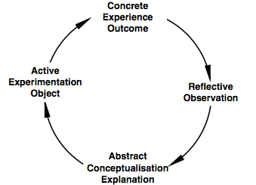
This Photo by Unknown Author is licensed under CC BY-SA-NC

Honey and mumford ‘s learning style describes students in four different ways based on some of their personal emotions and practical way of learning. (Denis, 2020)
This learning style describes one as an activist learner if he or she enjoy challenging activities and don’t hold back from getting their hands dirty, in fact, they learn best under pressure and through experience. The second description that is given is about one that best categorizes into a reflector, that feels most at ease when events are planned ahead of time, has clear backup plans and views things from different prospectives.
Honey and Mumford also describe Theorists, which are students that learn best when learning through models, theories or concepts.
The last category that we get is the pragmatists, that prefer learning through practical application of activities.

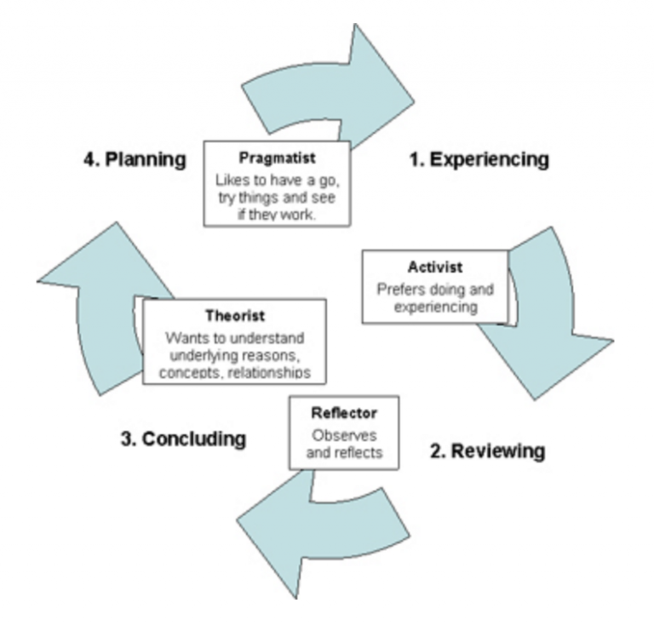

Neil Fleming’s learning style offers four categorizations of students: Aurals, Kinesthetics, readers and writers, and visuals. (Prithishkumar, Michael, 2014).

Aurals mostly find themselves as natural listeners, slow speakers, and prefer explanation rather than text.
Kinaesthetic learners are the slowest talkers and find it very difficult to settle on one decision they learn through trial and error.
Readers and writers prefer written text over vocal explanation and enjoy reading and writing, finding it to be the best way to memorize stuff.
Visual learners are described as being impatient, fast talkers, and find it as being the most useful way to memorize, seeing and visualizing.

The below listed picture shows a result of a test that all the students were invited to complete during one of the classes of this module. The tests include 20 questions that will ultimately help learners understand their most prominent feature that is most helpful in their study journey.
I personally got the result as being an Auditory learner, which means I would be the person to be more eager at learning and memorizing by hearing and listening. The way information is stored is by the way it sounds, and it is easier for auditory people to listen to instructions rather than reading them.
This test is really useful in giving students tips on how to better their studying time and optimizing their knowledge.
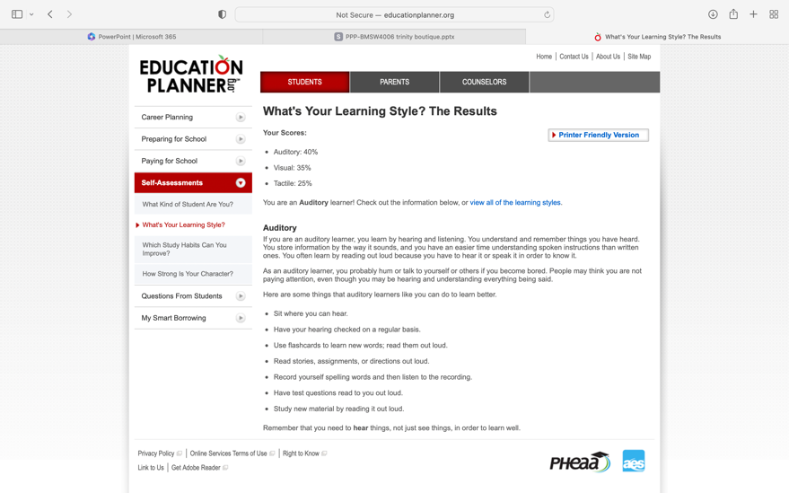

gibbs reflective model
Gibbs reflective model was structured to help students learn from personal experiences, in 1988.
I am going to use this model to reflect on the progress made from the start to the finish of this module.
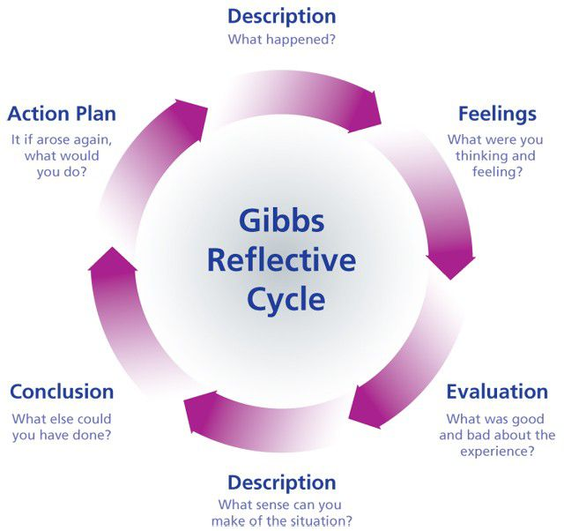
This model has 6 distinctive phases
- Detailed description of the situation, using questions such as: what happened, who was present, why were you there etc.
This module started after the Christmas vacation, at the university of Wales Trinity saint David in Quay Place, Birmingham, and it has lasted 10 weeks. The class is formed by 14 students at this point, and the lecturer Dr King
- Feelings: explorations of feelings and thoughts that one person has experienced in the specific situation
What were your feeling before and after the situation? What do you think other people feel about the situation now? What do you think about the situation now?
Us students were excited about the start of this new module, and the lecturer seemed to be very actively trying to make us feel at ease, and very friendly. Our task was to first get ready for an in class open book assessment, and the lecturer really prepared us to have an answer to whatever the question was, giving us lots of resources and material to work with. We then had a mock interview and needed to prepare our cv, cover letter and lastly face an interview with the lecturer, that again prepared us very well for it. The thing that surprised me most for the duration of this module, is how fast the time has passed, and not even one drop of anxiety was in me, as Dr King encouraged the whole class to do our best and not fear, explaining his experience and giving us a lot of stories on his career and life.
- Evaluation: what went well? What didn’t go so well? Are questions that help get the exact answer that will give the chance to evaluate what worked in the situation, and what did not. Total honesty and objectivity are required in the answers to these questions, for the model to work accordingly.
Considering that each of the activities were singular and no work group was necessary, I find that everything went well, and no discussions were started.

- Analysis/ Description: this is the step where the chance is given to make sense of the situation and extract meaning from the experience.
Helpful questions are: Why did things go well? Why did they not go well? What sense can you make of the situation?
I think that this experience went particularly well because the lecturer was really positive and included all the students, making clear any point that one might have not understood. There was a lot of communication both between the lecturer and students, and within the student group.
- Conclusion: this is the section where conclusions are being made, a summary of what has been learned is created and we are highlighting what actions must change in order to change the outcome in a future experience.
The highlight of this experience was in my opinion, the serenity that has covered the class and how everything was made really simple even if it maybe was not.
- Action plan: this is where the planning for a future situation happens. In a similar or related situation, what could be done differently? How will I develop the required skills?
I think this could be the blueprint, and example of the confidence that each of us must gain in life, to succeed in every business idea that we have. (University of Edinburgh, 2023).

REFERENCE
Denis, G., Minute Tools Content Team, Honey and Mumford Learning Styles, Minute Tools, (Oct 2020) https://expertprogrammanagement.com/2020/10/honey-and-mumford/
Gibbs reflective cycle, The University of Edinburgh (2023).
Gurel, E., & Tat, M. (2017). SWOT Analysis: A Theoretical Review. The Journal of International Social Research, 10, 994-1006.
Kolb, D., the Experiential Learning Theory (ELT), (1984).
Personal development planning, CMI, (2020).
Plaza CM, Draugalis JR, Slack MK, Skrepnek GH, Sauer KA. Use of reflective portfolios in health sciences education. Am J Pharm Educ. (2007 Apr )15;71(2):34. doi: 10.5688/aj710234. PMID: 17533443; PMCID: PMC1858617.
Prithishkumar IJ, Michael SA. Understanding your student: using the VARK model. (J Postgrad Med. 2014 Apr-Jun);60(2):183-6. doi: 10.4103/0022-3859.132337. PMID: 24823519.

