Connor Rossiter
1708658 | M6X02113
Treochy Park and Dare Theatre
Consultancy Project

Contents
Executive Summary 2
1.0 Project Justification 2
1.1 Background 2
1.2 Project Aim 2
1.3 Project Objectives 3
1.4 Rationale 3
1.5 Benefits 3
1.6 Possible Constraints and Assumptions 4
2.0 project Approach 4
2.1 Risk Management Strategy 4
2.2 Project Management Team Structure 5
2.3 Project Organisational Chart 5
3.0 Quality Management Strategy 6
4.0 Work Breakdown Structure 6
4.1 Project Plan Gantt Chart 6
5.0 Communication Plan 7
6.0 Appendices 7
7.0 Bibliography 8

Executive Summary

This consultancy project is extremely important to the theatre, as a developed and possibly new marketing strategy will be monumental for the predicted outcomes. The main goal is to potentially achieve more revenue for the theatre during non-event days.

Project Justification

1.1 Background

Treorchy Park and Dare Theatre is a theatre hall based in the village of Treorchy and is owned by Rhondda Cynon Taf County Borough Council. Treorchy has a population of 7,694, according to UK CENSUS 2011, and the theatre is seen as the pinnacle of the village.
The theatre has a capacity of 660 and plays host to a range of music, comedic, drama and community events while also housing a cinematic experience. The village of Treorchy is easily accessible by road from the M4 and has had its fair share of star power perform at the theatre, whether that be comedic giants such as Ed Byrne and Jason Manford or famous Welsh musicians such as, Max Boyce and Rhydian.

1.2 Project Aim

The aim of this project is to identify marketing strategies to allow the theatre to generate more revenue from their cinematic experience. It is very important that the theatres marketing strategy highlights the positives of what a good marketing strategy can deliver:
- To gather repeat business
- To gain trust with stakeholders
- To develop knowledge on the theatre’s competitors
- To improve the brand
- To target customers to gather a understanding on what they want

1.3 Project Objectives

- To evaluate how other theatres, operate regarding cinema.
- Compare prices with local cinemas.
- Conduct a questionnaire to see if locals want a change or not.
- To find a solution on improving the cinematic experience and recommend it to the council.

1.4 Rationale

The theatre aims to make a profit on every function or event they host, however, since the theatre is in a village so there is not a huge demand of events that take place. Park and Dare have like many other theatres introduced a cinematic experience that runs on non-event days to hopefully gain profit. Throughout this project the consultant will gather information to see if the cinema days are working and to develop a marketing strategy to hopefully help and gain the theatre, regarding revenue.

1.5 Benefits

As already stated, marketing can be used to develop mass interest from future stakeholders and help unite the business and the stakeholders which will allow the business to grow with a healthy relationship between one another resulting in repeat business. Throughout the project there are a range of benefits targeted to the theatre, for example, the consultant will gather research on what other theatres are doing to fill their seats on non-event days. The research will then be made into a questionnaire with Treorchy locals and theatre guests choosing or introducing improvements for the theatre. This allows the theatre to gain an understanding of what its stakeholders and future stakeholders want, brining awareness to the theatre.
Another benefit the project will bring is the possibility of targeting a desired target audience which could see the number in visitors increase, resulting in a more substantial revenue. This also allows room for exposure from the target audience which could see a possible rise in guests on non-event days, possibly creating a balanced revenue monthly.

1.6 Possible Constraints and Assumptions

When the marketing strategy is set in place the theatre may not have the time to help the consultant or provide feedback in developing the strategy further as the hierarchy of the theatre (the council) can be very difficult to catch free.
The only assumption that the consultant can suggest is that the staff and supervisors of the theatre can offer guidance and advice when possible during the project.

project Approach

This report will consist of the breakdown, steps and challenges of the project at hand in detail. The overall cost of the project is not a factor that has been taken in as the consultant is willing to pay for printing and petrol, the only costs that will affect them. However, if the theatre decides to use the marketing strategy proposed then economic factors will have to come into place for the strategy to work. This investment will possibly help create more revenue by bringing in more guests.
This report will highlight all the possible outcomes the project could result in:
- Brand Exposure
- A new marketing strategy
- More targeted specific events
- Relationship progress with stakeholders

2.1 Risk Management Strategy

There is always going to be conflicts and constraints when conducting a consultancy project. However, the consultant will offer efficient solutions and cover all costs to achieve the best strategy possible.
For instance, the consultant has found it hard assessing the current marketing strategy as management have other commitments which has slowed the development of the project down. However, to reduce the loss of time on waiting for replies, the consultant will review the project constantly and make all timings and objectives realistic and achievable. The consultant has 2 meetings booked with management and will use these dates as guidelines for when they can receive guidance.
The fact that the project will be heavily based around research findings, there are factors of which that must be taken into consideration. The main factor surrounding this would be the primary research that will be conducted in the form of questionnaires. The feedback given back to the consultant has a high probability of being biased from proud locals. Too prevent bias opinions the questions will be based on theatre in general and not a specific building.

2.2 Project Management Team Structure

For this project to become a success have set of roles and responsibilities is key. Even though the theatre has granted me access to conduct the project and gather the research, they are not needed in all factors of the project. However, guidance and information will be needed, along with the access to the theatre on an event day to hand out questionnaires.
Even though staff is limited at the theatre they will still play a key role within the project as the consultant will meet with them regularly for times and when management will visit
Another key team member will be the project co-ordinator who the consultant will have one to one session with every Tuesday to discuss progress and to ensure that the main operations of the project are being implemented efficiently.

2.3 Project Organisational Chart
Rhondda Council Managerial Staff
Project Co-ordinator
Key Resources
Key Stakeholders
Theatre Staff
Consultancy Manager

3.0 Quality Management Strategy

To ensure quality is achieved the Prince2 methodology method will be used. This method is used globally to control project developments. Using this method will allow the consultant to avoid and minimise risks for the theatre.
A quality plan will be taken, regarding methods, techniques and equipment needed for research, with everything going through managerial and being signed off.

4.0 Work Breakdown Structure

The breakdown of the project will result in a starting point that will benefit the future assignment and provide more in-depth. In this project timing requirements and resources will be the main breakdown focus. The project will begin from when the consultant first got in touch with the theatre spanning from December when the theatre as chosen to May the hand in date.

4.1 Project Plan Gantt Chart

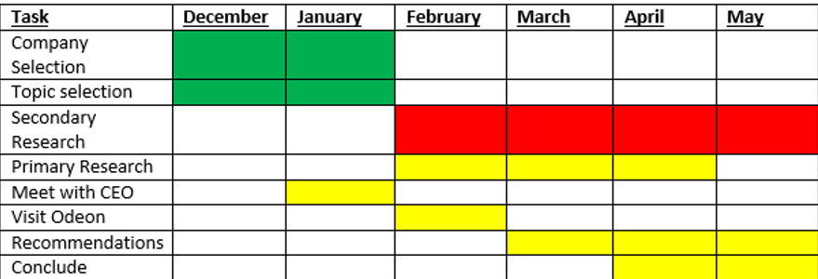

The first phase of the project was to decide on not only a company but a topic to work with. So, the current proposed project was decided with the backing of the theatre.
The second phase is currently in motion with a BID presentation of what the consultant wants out the project taken place along with the PID report that will be submitted to both the University and the theatre. This has entailed a mass depth of secondary research which has been displayed to the theatre. This phase has allowed the consultant to display all the findings to the theatre and what they can bring to the organisation.
The third phase will be when the consultant will gather all primary research, whether that be going to Treorchy and doing the questionnaires or going and comparing prices and events at other local theatres and cinemas. This will allow the consultant to feedback to the theatre what other initiatives their competitors are using, while also giving the consultant the research necessary to propose a successful marketing strategy. A meeting with the CEO of the theatre had taken place where the consultant was advised on what they should focus on.
The final phase would be presenting the marketing strategy to the theatre with the possibility of it being used. The final stage will involve recommendations from both the stakeholders and the consultant, along with the assignment submission date in May.

5.0 Communication Plan

It is the consultant’s responsibility to make sure that they stay communicated with all the project’s stakeholders. The consultant will arrange all meetings and e-mails with both the University and the theatre. As already stated, all meetings will be a deadline for work to be produced to the theatre.

6.0 Appendices

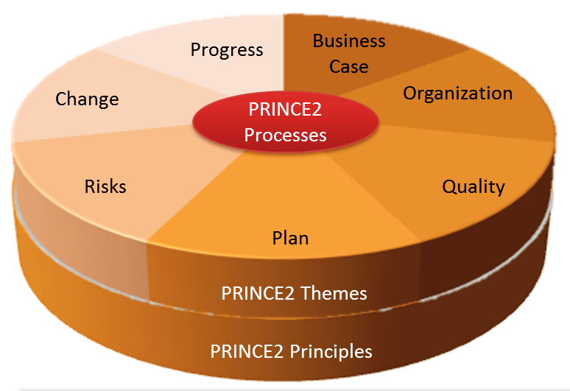
Appendix 1:

7.0 Bibliography

Hahn, D., & Robins, N. (2008). Treorchy. The Oxford Guide to Literary Britain & Ireland, The Oxford Guide to Literary Britain & Ireland.
https://rct-theatres.co.uk/park-dare
https://www.lucidchart.com/blog/what-is-prince2-methodology
Matos, S., & Lopes, E. (2013). Prince2 or PMBOK – A Question of Choice. Procedia Technology, 9(C), 787-794.
UK CENSUS DATA 2011. (2011). Treorchy Population. Available: https://www.citypopulation.de/en/uk/wales/wards/rhondda_cynon_taf/W05000701__treorchy/. Last accessed 01/03/2020.

