Outline the position of women in ancient Egyptian society.
Present your ideas with particular examples.

Women’s position in society in Ancient Egypt greatly varied with their social position (Khalil et al., 2017) as they were typically denied from higher-ranking jobs with the exception of the monarchy. The society was highly gendered with day to life often being heavily intertwined with your respective sex, and men were typically dominant, but it wasn’t patriarchal as women still had rights (own land for example (Fletcher, 2013)) and could also work in a variety of jobs like men. (Mark, 2017)

Focusing in on jobs some were split on a gender basis, for example, a scribe was a male-only job, (Figure 1, which shows three male scribes working). However, there are cases of this binary being broken in specific cases, like with female kings.

A lower job could be for example a servant. Usually, women would enter this around the age of 13 to earn a standard amount, this also covers jobs like cook and other forms of servitude. There was the opportunity to work up in some cases as well.
Other notable jobs involved brewing beer which could be done from the home, there was also another emphasis in crafts as women could hold jobs as weavers, which wasn’t available to men, instead, the men would likely work in workshops, as shown in Figure 2 (Scene depicting goldsmith men from the tomb of Nebamun at work.)
Or another popular grouping of jobs was working as an Entertainer, which incorporates musicians, dancers and singers to perform both publicly and in Temple ceremonies. (Mark, 2017)
This is shown in Figure 3, which was a painting from the Tomb of Nebamun, it shows women making music while the others in the image are dancing.

On the other hand, some of the higher examples of jobs women could hold are Seers or in some cases Queen. Seers were dream interpreters, dreams were important in ancient Egypt as they were often seen as a way to receive messages and omens from the gods and predict the future, (Encyclopedia.com, 2020)
Some female seers could interpret for both male and female clients which we can infer as the seer, in that case, being incredibly important. (Mark, 2017)

There’s still an emphasis on the fact that women did take care of the house and family, so most were technical housewives to a degree. (Fletcher, 2013) But despite these women did still have self-determinism as they could work and had equal opportunities to do so like men while also having much the same economic and legal rights as men. (Khalil et al., 2017)

So, on average, women’s jobs typically were excluded from the running of the government, as that was supposed to be men only. But asides from the government-connected jobs they had mostly the same job opportunities as men in this period. Where there was female excluded job positions it also can be said there were male excluded jobs, which highlights that usual working-class women had basically equal opportunities, as it’s only higher up in the government where it would be increasingly rare to have women in those roles.

To examine specific examples of women in high societal positions we can look at the women specifically from the Amarna period.
The Amarna period was a roughly 30 year-long time frames. This period lasted from the end of Amenhotep II until Horembab, with its imperial height being around Akhenaten's rule. A feature of this time centres on the Amun priesthood, they held control over aspects of politics and religion and who were trying to strip royal prerogatives. This 30-year period is dominated by this struggle of the king trying to reduce their power. It’s also one of the most well documented periods for women in antiquity, specifically those in power. (Amarnaproject.com, 2017)

The first of these queens to look at is Tiye, the wife of Amenhotep III. She was also dubbed the commoner queen as she wasn’t born into royalty, this was unusual as normally the Queen is from one of the elite circles. But this wasn’t to say she was particularly low class, her mother was a priestess of Min (an inherited religious title of a high-level God) and her father was commander Yuya, both of these titles are of a high-status which would make her background akin to aristocratic by our standards. (History Magazine, 2020)
Even after Amenhotep’s death, she was politically powerful, arguably more so than her son. Proof for this comes from the Amarna letters, a series of clay tablet diplomatic correspondence of the Eastern Meditatraian kings. Not only was Tiye mentioned in these letters, but she also wrote letters and would receive letters in return asking her to mediate for her son. In this correspondence she was dubbed the “Mistress of Egypt”, essentially calling her the female lord of Egypt. This correspondence and overt respect from other kings displays her political importance even without her husband and son clearly. (History Magazine, 2020)
Furthermore, Tiye was deified in her lifetime, an act unheard of even for kings. The evidence for this is that Amenhotep was worshipped as the sun and lord of Nubia at Soleb, and in addition to this, there’s further evidence showing Tiye was worshipped as the sun god’s consort Hathor. Hathor was a prominent goddess of women and fertility amongst other things in Ancient Egypt with a considerably large following and worship. (Ancientegyptonline.co.uk, 2020)
Another example of her clear importance is Tiye being shown as a sphynx, which usually only the kings can be displayed as. (Zinn, K. 2016)
Overall, Tiye was shown to be an incredibly powerful figure, her role in this period clearly having huge political influence due to her involvement in the Amarna letters and iconography even deifying or likening her status to that of the Kings.

The next woman from the Amarna period to examine is Nefertiti, chief wife of Akhenaten.
When it comes to Nefertiti, we know everything and nothing about her. In iconography, she’s shown with her own headdress (Figure 5, a bust of Nefertiti wearing the aforementioned headdress), a blue crown that was only previously worn by an early creation cycle goddess and Tiya in depictions (Zinn, K. 2016). This marker already brings her much closer to the role of kingship.
Nefertiti also had a distinctive role in cult scenes (Nefertiti | Biography, Reign, & Facts | Britannica, 2020), sometimes more equal to her husband but in some cases, she could be interpreted as the more dominant of the pair. An example of her potential dominance can be seen in Figure 6 which depicts her being the more emotionally strong of the duo in a mourning scene. Other notes for Nefertiti in cult scenes depict her worshipping the gods alone, or with her first daughter over the king himself. (Zinn, K. 2016)
Other special features of Nefertiti are that she has been depicted on the four corners of her husband’s sarcophagus as a safeguarding goddess, like Isis, Hathor or Selket for example. This possibly implies that she gives life to Akhenaten. (Nefertiti | Biography, Reign, & Facts | Britannica, 2020)
Overall Nefertiti is widely interpreted to have a huge religious role, this being supported through the depictions of her in iconography.

The final woman to examine from Amarna is Kiya, Akhenaten’s other wife.
She was rediscovered in the late 20th century, what we know is that she was a foreign queen who was honoured with a temple. She was referred to as the “greatly beloved wife of the King of upper and lower Egypt.”, her name also roughly translates to a monkey, which means it could be a nickname or abbreviation of her actual name. (Klimczak, 2016) Given the inscription as “greatly beloved,” it’s thought this marriage may have been a love marriage while the marriage to Nefertiti was more for political power. Kiya has been shown before in a purification ritual, but this image was later altered. (Zinn, K. 2016)
Unlike Nefertiti, it seems Kiya had a main everyday role over anything particularly religious or political, despite little being known about her she was still clearly well regarded in her position.

While these three women are specific case studies, they do highlight that despite the notion that while Egypt was a highly gendered society it wasn’t patriarchal as women could and did break into positions of power, where especially in cases like Nefertiti or Tiye they were arguably more important than their husbands. (Zinn, K. 2016)

Iconography can also display some of the standards women were under at the time to highlight their position.
One is that women’s position can still be heavily connected with staying indoors more. This is shown in iconography as women are depicted with paler skin or skin that’s more yellowish in tone (Figure 2, which shows men working in comparison to Figure 3 showing women entertainers, the males have a more reddish complexion.)
Higher-class women would also aim to stay indoors more to keep such a complexion, this it was a desirable standard to have paler skin from staying indoors over the implication of working out in the sun.
Another is women having more of a passive role in relationships, highlighted in statues where women are depicted with the feet together while men are mid-stride (Figure 7, a statue of Menkaure and the Queen), this identifier is really only ever challenged by women of a higher social status where there’s evidence to argue the contrary.

Iconography also helps us break down the contemporary view for femininity which can help establish what the basic beliefs around women and their role are. This can be roughly divided into three categories: physical, psychological and aesthetic. (Zinn, K. 2020)

Physical qualities were attributes such as breasts, wide hips, no facial hair, etc. This is displayed in a variety of iconographic images and statues and example being Figure 4 which is a statue of a woman nursing a child. The reason for the emphasis of such things can be linked to fertility, as large hips are often associated with childbirth and larger breasts with nurturing. These qualities were a social expectation for women, and the iconography means we can make a link between this and their role linking back to the idea of motherhood and the expectation to have children, which was a role shared across all women despite social status. This shows that there was still an expectation of one of the women’s roles to be biologically aligned with the aim to produce children.

Psychological traits were linked more with concern or sensitivity, so shows of softer emotions. This can only really be identified in paired images where you may have the women being comforting or in some cases comforting someone, an example of this is shown with Nefertiti as she is depicted to be comforting her husband in Figure 6, this is unusual typically it would be the other way around. The reason for this again comes back to the traditional values and beliefs of women, which link back to a more caring and kinder disposition as per more traditional values.

Aesthetics would usually consist of decoration or ornamentation of some kind, so jewellery or headdresses in some cases. This really can’t be said to just be a marker for femininity as it wasn’t uncommon for men to also wear necklaces or other ornamentation. But, it’s useful when examining the iconography of women as something like a headdress can give away social status, an example of this is Nefertiti’s crown (Figure 5, a bust of Nefertiti) in statues of her, the blue headdress gives away her high position as it likened her to more of a king in her depictions. So, ornamentation can help with analysing the role of women via iconography.

Marriage is also an interesting factor to look at when discussing the role of women at this time. Marriage was a social construct and a contract-based system. The contract was fairly equal for both parties, an example of this being a man binding himself and his property to the woman and in return, the woman is to pay damages should she despise him or fall in love with another man over him. In this, we can see that in this contract both parties know what they’re getting into and what’s expected of this, alongside it being a fairly equal exchange. (Edwards, 1887)
As marriage had no formal ceremony and was purely contract-based, it was only active after cohabitation and divorce essentially meant expulsion from this household. In most cases the term was to take someone as a wife, never to take a husband, or in some cases, it was a third party that was asked to sanction the marriage. (Edwards, 1887)

In marriage it was permitted for men to have affairs, not women and adultery could be a reason for divorce.‌ The wife should not have sexual intercourse for means out of reproduction but when unmarried it was perfectly fine. In short, marriage was the social recognition of couples, and sex was meant to be to produce children. (Robert Garland, 2020)
Marriage on a whole seemed equal asides from discrepancies around topics such as affairs, but women could also call grounds for divorce so the legal rights for both sexes were also pretty equal. On the position of women, it shows that there was an expectation around having children and a household position, but that asides marriage was mostly just a contract arrangement that both parties had a clear stake in. (Johnson, 2002)

Literature also suggests agency for women, an example of this being an Egyptian love poem. (Ucl.ac.UK, 2020) This poem in particular is not connected to marriage, which wasn’t uncommon. One interpretation of this poem is that it may be referring to a relationship between the feminine and masculine side, the poem also can be used for same-sex couples in this sense. But in short, it’s a poem told from both a male and female’s perspective about their feelings for one another.

The use of language in the poem such as “she has” suggests that the woman is acting of her own accord, and further suggests she has confidence in her own appearance when pairing this agency with lines about her physical attractiveness and how other men also have had feelings for her.
The poem also refers to the woman as “the One Goddess”, this is a reference to Hathor (Ancientegyptonline.co.uk, 2020) who had a prominent fertility cult which was highly sexual, this connecting to sex for enjoyment out of marriage over procreation. The reason this is interesting is that it’s used in a positive light in this poem, meaning there is no stigma around the sexual connotations of that goddess and her following.

Furthermore, in the second stanza from the woman’s point of view she calls him a “senseless man” this implies he’s equally as oblivious to the world and as sensitive as she is herself, leaving both on an equal level emotionally. Also, by comparing both points of view it’s clear to see that this poem highlights the importance of wanting a relationship for love as it seems there are no real clear other motives at play.

What this literature does show us is that women were in this case on equal footing with men in the pursuit of relationships, there was also a distinct lack of over-sexualization and instead was just genuine feelings from both parties, showing that women’s position wasn’t just reduced to that of sexualization nor did the poem objectify her at any point either.

In conclusion, there was a strict gender binary in Egyptian society, but this wasn’t patriarchal as it’s hard to argue that there was an overwhelming gap in the power dynamics which would negatively push women down to a lower position or role based on their sex.
While it was more the norm for men to hold positions of high power and for women to be more home centric that doesn’t mean it was impossible for women to hold those positions, as we can see through women like Nefertiti or Tiye, to get these roles all it usually entailed was the adoption of masculine aligned traits. An example of this being Nefertiti showing more emotional strength in Figure 6, which would go against the feminine aligned psychological trait of being more emotive.
Therefore, in general, while the position of women was still very much connected to basic gender expectations of looking after the family and the home, their role was able to be more, given the ability to have jobs and not being restricted to just their biological expectations.

Bibliography
- Amarnaproject.com. (2017). Amarna The Place - Amarna Project. [online] Available at: https://www.amarnaproject.com/pages/amarna_the_place/ [Accessed 20 Dec. 2020].
- Amelia Blandford Edwards(1887). The Social and Political Position of Woman in Ancient Egypt on JSTOR. [online] Available at: https://www-jstor-org.ezproxy.uwtsd.ac.uk/stable/25486220?seq=10#metadata_info_tab_contents [Accessed 19 Dec. 2020].
- Ancientegyptonline.co.uk. (2020). Hathor | Ancient Egypt Online. [online] Available at: https://ancientegyptonline.co.uk/hathor/ [Accessed 20 Dec. 2020].
- Encyclopedia.com. (2020). Seers | Encyclopedia.com. [online] Available at: https://www.encyclopedia.com/history/encyclopedias-almanacs-transcripts-and-maps/seers [Accessed 19 Dec. 2020].
- Fletcher, J. (2013). Women in ancient Egypt were more than just mummies. [online] the Guardian. Available at: https://www.theguardian.com/tv-and-radio/tvandradioblog/2013/mar/28/women-ancient-egypt [Accessed 19 Dec. 2020].
- Khalil, R., Moustafa, A.A., Moftah, M.Z. and Karim, A.A. (2017). How Knowledge of Ancient Egyptian Women Can Influence Today’s Gender Role: Does History Matter in Gender Psychology? Frontiers in Psychology, [online] 07. Available at: https://www.ncbi.nlm.nih.gov/pmc/articles/PMC5215293/ [Accessed 19 Dec. 2020].
- Klimczak, N. (2016). Kiya - The Most Mysterious Woman of Amarna. [online] Ancient-origins.net. Available at: https://www.ancient-origins.net/history/kiya-most-mysterious-woman-amarna-005092 [Accessed 20 Dec. 2020].
- Mark, J.J. (2016). Love, Sex, and Marriage in Ancient Egypt. [online] Ancient History Encyclopedia. Available at: https://www.ancient.eu/article/934/love-sex-and-marriage-in-ancient-egypt/ [Accessed 19 Dec. 2020].
- Mark, J.J. (2017). Women’s Work in Ancient Egypt. [online] Ancient History Encyclopedia. Available at: https://www.ancient.eu/article/1058/womens-work-in-ancient-egypt/#:~:text=Women%20in%20ancient%20Egypt%20had,seers%2C%20dentists%2C%20and%20doctors. [Accessed 19 Dec. 2020].
- Neel Burton M.D. (2017). Love, Sex, and Marriage in Ancient Egypt. [online] Available at https://www.psychologytoday.com/us/blog/hide-and-seek/201710/love-sex-and-marriage-in-ancient-egypt [Accessed 19 Dec. 2020].
- Nefertiti | Biography, Reign, & Facts | Britannica. (2020). In: Encyclopædia Britannica. [online] Available at: https://www.britannica.com/biography/Nefertiti [Accessed 20 Dec. 2020].
- Ucl.ac.uk. (2020). Love songs. [online] Available at: https://www.ucl.ac.uk/museums-static/digitalegypt/literature/lovesongs.html [Accessed 19 Dec. 2020].
- The British Museum. (2011). papyrus | British Museum. [online] Available at: https://www.britishmuseum.org/collection/object/Y_EA10683-1 [Accessed 20 Dec. 2020].
- The Great Courses Daily (Robert Garland. (2020). Marriage in Ancient Egypt: Egyptian Family System. [online] Available at: https://www.thegreatcoursesdaily.com/marriage-in-ancient-egypt-egyptian-family-system/ [Accessed 20 Dec. 2020].
- Uchicago.edu. Janet H. Johnson (2020). Women’s Legal Rights in Ancient Egypt. [online] Available at http://fathom.lib.uchicago.edu/1/777777190170/ [Accessed 20 Dec. 2020].
- Zinn, K. (2016). Women in Amarna: legendary royals, forgotten elite, unknown populace? In: S. Budin, J. Turfa (eds.). Women in antiquity: Real Women across the Ancient World. London: Routledge, 2016, 255-275.

Images list
- ‌Figure 1; TERRY/SCIENCE, S. (2019). Ancient Egyptian Scribes - Stock Image - C007/7582. [online] Science Photo Library. Available at: https://www.sciencephoto.com/media/140538/view/ancient-egyptian-scribes [Accessed 20 Dec. 2020].
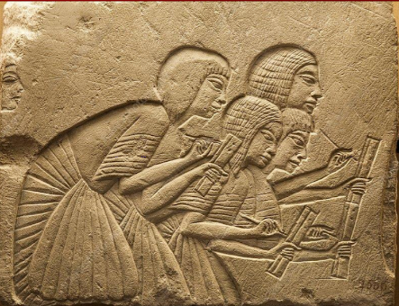
‌

- Figure 2; Goldsmiths at work, from the tomb of Nebamun and Ipuky. Courtesy of the Metropolitan Museum of Art. http://www.metmuseum.org/collection/the-collection-online/search/54856

‌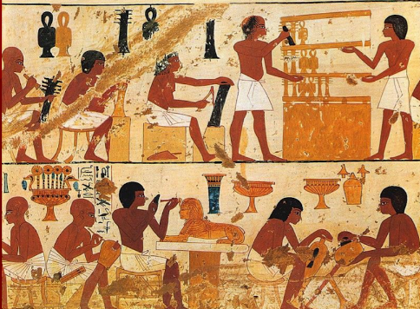
- Figure 3; Egyptian dancing, detail from a tomb painting from Shaykh ʿAbd al-Qurnah, Egypt, c. 1400 BCE; in the British Museum, London. Courtesy of the trustees of the British Museum
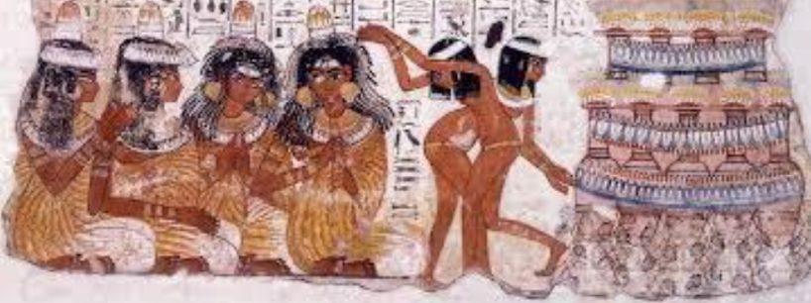

- Figure 4; Nursing Woman, ca. 1938-after 1630 B.C.E. Limestone, pigment, 4 9/16 in. (11.6 cm). Brooklyn Museum, Charles Edwin Wilbour Fund, 51.224. Creative Commons-BY (Photo: Brooklyn Museum, CUR.51.224_erg456.jpg)

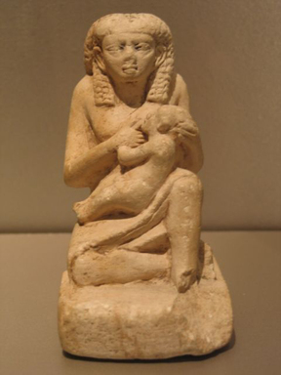

- Figure 5; Nefertiti, painted limestone bust, about 1350 BCE; in the New Museum, Berlin
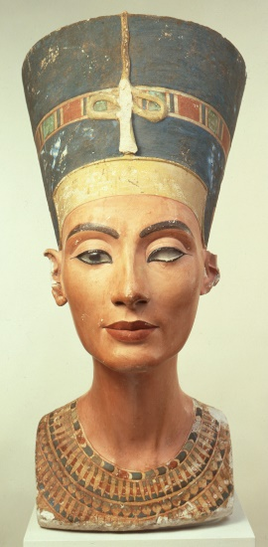

- Figure 6; Scenes of the royal family mourning the death of princess Meketaten. Amarnaproject.com. (2020). Royal Tomb - Amarna The Place - Amarna Project. [online] Available at: https://www.amarnaproject.com/pages/amarna_the_place/royal_tombs/index.shtml [Accessed 20 Dec. 2020].

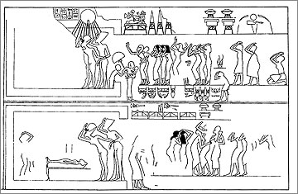

- Figure 7; Menkaure and Queen, 4th Dynasty 2548-2530 BCE
- NinaC (2016). Portraits of Husband and Wife from Ancient Egypt - Talaria Enterprises Museum Store. [online] Talaria Enterprises Museum Store. Available at: http://www.talariaenterprises.com/portraits-of-husband-and-wife-from-ancient-egypt/ [Accessed 20 Dec. 2020].





