Financial Management for the Hotel Industry

(M5X01922_BIRM)

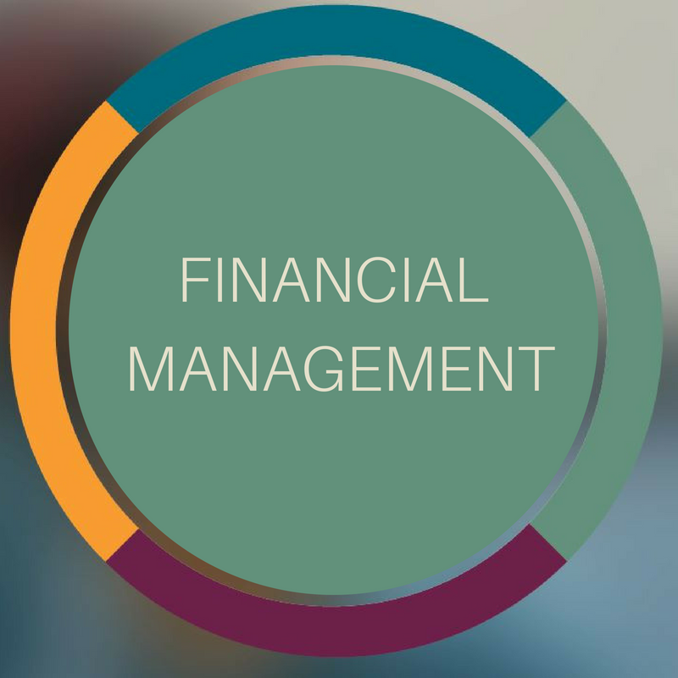

Lector: David Jenkins
Student name: Andreea Suciu
Student number: 1816340

Profit buget
 | Sales |  |  | 867,000
Cost of sale | Open inventory | 105,500
Purchases | Room toiletries | 22,998
 | Free room beverage | 12,000
 | Bedding bundles | 700
 | Complimentary | 24,000
 |  | 165,198
 | Close inventory | 98,000 |  | 67,198
 |  |  |  | 799,802
Other income | Food and beverages | 247,200 |  | 253,065
 | Rent | 5,700
 | Commission | 165
 |  |  |  | 1,052,867
Expenses | Depreciation
 | Minibus | 2000
 | Van | 2800
 | Other expenses | 636,452 |  | 641252
Net profit |  |  |  | 411,615

