Student number: 2224284

Student name: Liviu-Marius Postelnicu

Module title: Hospitality & Tourism Management

Module code : BMIH5006

Lecturer: Lisa Knight

Word count: 1953

I acknowledge the use of Microsoft Word Editor and Grammarly App on 15th November 2024 to check my grammar, syntax and misspellings.

Executive summary

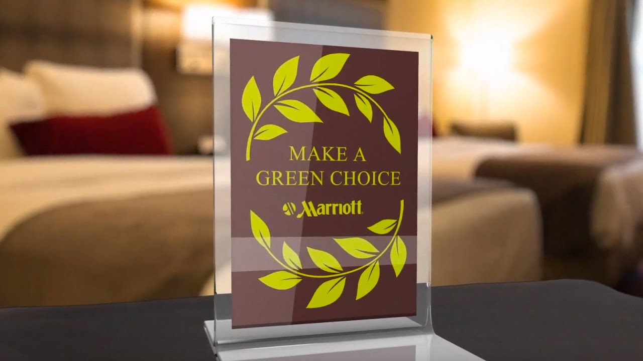This report evaluated Marriott’s “Make a Green Choice” program, which encourages guests to decline daily housekeeping services to minimise water, energy, and chemical consumption. While aligned with Marriott’s sustainability objectives, the program has faced criticism regarding its environmental impact and transparency. Critics contend that the initiative mainly lowers labour costs instead of providing substantial ecological advantages. Research indicates infrequent housekeeping leads to greater resource consumption during post-stay cleaning, compromising the program's intended savings. Furthermore, the reduced working hours for housekeeping staff have resulted in financial instability and heightened concerns regarding labour equity.
The program's insufficient transparent reporting on environmental outcomes reduces its credibility, particularly compared to competitors such as Hilton, which implements more extensive carbon reduction strategies. Case studies demonstrate that significant sustainability outcomes can be attained through comprehensive initiatives, including adopting renewable energy and implementing advanced water management systems.
Recommendations suggest that Marriott should prioritise investments in renewable energy, improve transparency by providing detailed reports on environmental metrics, and engage with labour unions to guarantee equitable treatment of employees. Implementing a comprehensive sustainability strategy that integrates advanced technologies and inclusive labour policies can improve Marriott's environmental and social responsibility, thereby establishing it as a leader in sustainable hospitality.

Introduction
Sustainability in the hospitality industry has emerged as a priority, with businesses aiming to reduce environmental impact while addressing consumer demand for environmentally friendly practices. Hotel green initiatives typically emphasise the reduction of water and energy usage, minimising waste, and boosting operational efficiency. Marriott’s “Make a Green Choice” program illustrates efforts to conserve resources and minimise the hotel’s environmental footprint by encouraging guests to forgo daily housekeeping services.
The program has faced criticism regarding its limited transparency and questioned effectiveness, especially compared to more comprehensive sustainability initiatives within the industry. Critics contend that, despite the appealing nature of environmental claims, the initiative mainly functions to lower labour costs instead of delivering substantial ecological advantages. This report assesses the environmental impact, labour implications, and feasibility of “Make a Green Choice,” offering actionable recommendations to improve its effectiveness and credibility in achieving sustainability objectives.

- Greener Practice Initiative: “Make a Green Choice” Program

Marriott’s “Make a Green Choice” program incentivises guests to decline daily housekeeping services in return for loyalty points to decrease water and energy consumption while minimising chemical use. The program indicates that by opting out of daily room cleaning, guests aid in water conservation, reduce energy consumption, and minimise chemical, environmental effects, corresponding with broader industry initiatives to strengthen hotel sustainability (Han et al., 2020).
Critics contend that the environmental advantages of these programs are frequently exaggerated. Reducing housekeeping frequency may not substantially decrease water or energy consumption as suggested, particularly if rooms necessitate more thorough cleaning following periods without service (Pharmawati et al., 2018). Research indicates that a significant reduction in hotel water usage typically necessitates comprehensive strategies, including greywater recycling or implementing advanced water-saving fixtures, rather than merely omitting fundamental housekeeping activities (Sayegh et al., 2020).
Employee feedback has identified additional challenges associated with the program. Housekeepers indicate a requirement for increased water and cleaning supplies to manage rooms that have remained uncleaned for prolonged durations, which may undermine environmental benefits (Dael and Saab, 2023). Furthermore, guests' perceptions and support for water conservation may not consistently result in measurable reductions unless underpinned by extensive, facility-wide sustainability initiatives (Verma & Chandra, 2018).
Research indicates that for green initiatives to effectively influence sustainability, it is essential to incorporate technological and behavioural elements that enable staff and guests to actively minimise resource consumption (Jackson, 2010). Marriott could improve the program's credibility and effectiveness by improving transparency regarding actual savings and potential benefits (Mills and Rudd, 2009).

2. Environmental Impact and Criticism
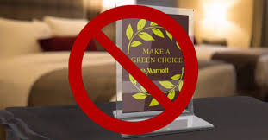
Marriott’s “Make a Green Choice” program, which promotes guest participation in opting out of daily housekeeping, has faced scrutiny from environmental organisations such as Sierra Club, 350.org, and the Union of Concerned Scientists. These organisations contend that Marriott’s initiative lacks transparency regarding measuring actual environmental impact, as data concerning reductions in water, energy, or chemicals achieved are not disclosed (Subbiah and Kannan, 2011). Critics argue that Marriott’s program primarily aims to lower labour costs rather than fulfil substantial environmental objectives, thus exemplifying greenwashing, where environmentally friendly assertions are utilised for marketing without considerable ecological effect (Chen, Bernard & Rahman, 2019).
Marriott's reporting practices lack transparency, reflecting broader industry criticisms regarding inadequate standardisation in environmental performance measurement in the hotel sector. Research shows that although certain hotels claim to implement sustainable practices, the approaches to collecting and analysing ecological data differ significantly, hindering property comparisons (Geerts, 2014).
The program has generated significant discussion regarding its labour implications alongside environmental concerns. Rooms that are not cleaned daily result in an increased workload for housekeepers, as they must address accumulated dirt. This often necessitates additional water, energy, and cleaning chemicals, undermining the intended environmental benefits (Han et al., 2020). The heightened workload and diminished working hours have resulted in financial difficulties for numerous employees, with some experiencing loss of healthcare coverage due to decreased hours (Amer, Mohamad and Roosli, 2023).
The phenomenon of greenwashing is notably pertinent considering Marriott's minimal investment in comprehensive sustainability initiatives relative to its industry peers. Marriott's sustainability claims are inadequate when compared to the ambitious environmental targets established by Hilton, which is dedicated to significant reductions in carbon emissions and has adopted energy-efficient technologies throughout its properties (Goel et al., 2022). Some analysts contend that Marriott's environmental impact is limited due to its emphasis on guest opt-out initiatives instead of prioritising infrastructure upgrades or renewable energy investments (Pereira et al., 2021).
Hotels implementing extensive water conservation and waste reduction strategies illustrate that substantial sustainability developments can be realised through targeted investment independent of guest-driven initiatives (Park et al., 2021). Research indicates that greywater recycling, solar energy utilisation, and comprehensive waste management programs significantly mitigate the environmental impact of hotels, in contrast to Marriott's strategy of minimal intervention (Tirado et al., 2019).
In conclusion, although “Make a Green Choice” is marketed as an environmentally friendly initiative, Marriott’s program has been criticised for its insufficient genuine environmental impact and lack of transparency. Comparative analyses indicate that authentic advancements in sustainability necessitate Marriott's adoption of more significant and transparent ecological practices, in accordance with wider hospitality standards and guest anticipations (Abdelrazaq et al., 2021).

3. Case Studies and Comparisons with Other Hotels
Marriott's "Make a Green Choice" program exemplifies a significant sustainability initiative, promoting guest participation in reducing water and energy consumption and minimising chemical usage by opting out of daily housekeeping services. This initiative has been criticised for its lack of transparency and minimal environmental impact, particularly compared to the more extensive sustainability strategies adopted by competitors like Hilton (Adams et al., 2022). Hilton has pledged to reduce carbon emissions by 61% by 2030 and systematically monitors its progress through comprehensive reporting on energy consumption and emissions (Bohdanowicz et al., 2011).
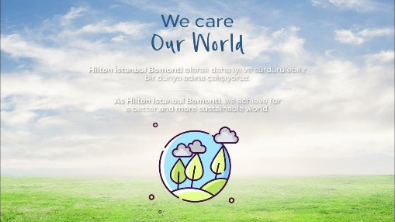
Hilton’s initiatives, exemplified by the “We Care!” program, integrate comprehensive strategies encompassing employee engagement, IT-based resource utilisation monitoring, and behavioural training to incorporate sustainability into routine operations. This approach allows Hilton to attain measurable outcomes, including notable water and energy consumption reductions across its properties (Bohdanowicz et al., 2005).
In comparison, although advantageous, Marriott's sustainability measures do not possess the comprehensive framework required for significant environmental impact. Research demonstrates that sustainability initiatives within the hospitality sector yield the best outcomes when accompanied by transparent reporting and well-defined carbon-reduction objectives (Wang, 2023). Marriott's emphasis on cost-saving strategies instead of a comprehensive approach to carbon reduction has prompted analysts' scepticism regarding its commitment to sustainability (Marcello and Rogovin, 2024).
In conclusion, Marriott’s “Make a Green Choice” program provides certain eco-friendly advantages; however, it is less effective than Hilton’s proactive carbon-reduction initiatives and transparent impact reporting, which contribute more significantly to sustainable hospitality (Matteucci, 2020).
4. Feasibility and Recommendations for Improvement
Marriott's "Make a Green Choice" program, although theoretically advantageous, exhibits considerable limitations in its practical application concerning environmental efficacy and labour implications. This program encourages guests to forgo daily housekeeping to minimise water, energy, and chemical consumption. Nonetheless, its actual efficacy in producing significant environmental outcomes remains uncertain. Studies indicate that water and energy savings from infrequent housekeeping are inadequate because the resources needed for post-stay cleaning are heightened, as unoccupied rooms necessitate more thorough maintenance (Sayegh et al., 2020). Without transparent data, the reported reductions by Marriott cannot be verified, which raises concerns regarding the program's effectiveness in actual resource conservation (Subbiah and Kannan, 2011).
The labour implications of the program are concerning. Housekeepers face increased workloads following missed days, resulting in higher consumption of water and cleaning products, which undermines the program’s environmental objectives (Han et al., 2018). Furthermore, reduced hours negatively impact employees' financial situations, resulting in a loss of wages and, in certain instances, health benefits associated with part-time employment status (Mbasera et al., 2016). This situation has led to union and employee advocacy, highlighting Marriott's need to address environmental and labour issues.
Marriott's renewable energy sourcing presents an opportunity for improvement. In contrast to competitors such as Hilton, which has committed to substantial carbon reduction efforts, Marriott's dependence on guest-driven conservation measures is insufficiently robust. Expanding into renewable energy could boost Marriott’s commitment to sustainability, as renewable sources have effectively reduced overall environmental impact (Mahachi et al., 2015). Marriott may consider investing in energy-efficient technologies such as HVAC systems and smart lighting, which directly impact sustainability more than guest opt-out programs (Zografakis et al., 2011).
Developing transparency would improve the program's credibility. Research indicates that effective communication of sustainability data develops trust and boosts guest participation in green initiatives (Yi et al., 2018). Marriott should consistently release comprehensive environmental impact data to assess the program's effectiveness, ensuring alignment with industry standards (Adams et al., 2022).
Marriott should engage with unions to develop sustainability programs that protect employee welfare in response to labour concerns. Flexible housekeeping options, including partial-service alternatives, may address environmental and labour requirements effectively. Studies demonstrate that policies integrating environmental objectives with equitable labour practices are effective and positively received by employees and patrons (Kularatne et al., 2019). Marriott may develop inclusivity and equity by incorporating employee feedback into sustainability planning (Shaikh and Bhautik, 2022).
In summary, Marriott’s “Make a Green Choice” program would improve through a holistic strategy that includes investments in renewable energy, better transparency in environmental reporting, and collaborative labour initiatives. These initiatives can potentially improve Marriott's commitment to sustainability and align its practices with established industry standards.

Conclusion and Recommendations
Marriott's "Make a Green Choice" program aims to decrease water, energy, and chemical consumption by encouraging guests to forgo daily housekeeping services. The program's environmental benefits are largely unsubstantiated, primarily due to insufficient transparent data and the unintended consequence of necessitating additional resources for post-stay cleaning. The program's negative effects on labour, such as decreased hours and financial instability for housekeepers, diminish its overall value as a sustainable initiative. In comparison, competitors like Hilton exhibit a more thorough commitment to sustainability, characterised by ambitious carbon-reduction targets and significant investments in renewable energy.
Marriott should adopt several essential recommendations to rectify these deficiencies. The company should prioritise sourcing renewable energy and invest in energy-efficient technologies, including HVAC systems and smart lighting. These initiatives have proven effective in decreasing carbon emissions and operational expenses. Marriott should improve transparency by releasing complete reports regarding the environmental effects of its sustainability initiatives. This action would improve trust and credibility among stakeholders. Finally, Marriott should engage with labour unions to guarantee equitable treatment of employees. Implementing flexible housekeeping options that align environmental objectives with employee well-being would reflect a true dedication to sustainability and social responsibility.
Implementing these measures will enable Marriott to improve its sustainability initiatives and establish a benchmark for the hospitality sector.

Reference List
1. Abdelrazaq, H., Aljaffal, T., Daruwalla, P., and Wardle, K., (2021). Business Sustainability Through Environmental and Operational Management in Five Star Hotels in Amman, Jordan. , 28, pp. 31-51. https://doi.org/10.31966/JABMINTERNATIONAL.V28I1.824.
2. Adams, S., Kageyama, Y., and Barreda, A., (2022). Sustainability Efforts in the Hotel Industry: A Systematic Literature Review. Journal of Tourism Management Research. https://doi.org/10.18488/31.v9i1.2921 .
3. Amer, A., Mohamad, D., and Roosli, R., (2023). THE IMPACT OF GREEN ENERGY & WATER PRACTICES ON THE DEVELOPMENT OF SUSTAINABLE TOURISM: A CASE STUDY OF 5-STAR HOTELS IN HURGHADA AND MECCA. PLANNING MALAYSIA. https://doi.org/10.21837/pm.v21i28.1335 .
4. Bohdanowicz, P., Simanic, B., and Martinac, I., (2005). Environmental training and measures at Scandic hotels, Sweden. Tourism Review International, 9, pp. 7-19. https://www.proquest.com/scholarly-journals/environmental-training-measures-at-scandic-hotels/docview/2780038466/se-2?accountid=130472
5. Bohdanowicz, P., Zientara, P., and Novotna, E., (2011). International hotel chains and environmental protection: an analysis of Hilton's we care! programme (Europe, 2006–2008). Journal of Sustainable Tourism, 19, pp. 797 - 816. https://doi.org/10.1080/09669582.2010.549566.
6. Chen, H., Bernard, S., and Rahman, I., (2019). Greenwashing in hotels: A structural model of trust and behavioral intentions. Journal of Cleaner Production. https://doi.org/10.1016/J.JCLEPRO.2018.09.168.
7. Dael, R., and Saab, R., (2023). Green Practices in The Hotel Industry: Proposed Implications to The Environmentally Appropriate Programs. British Journal of Multidisciplinary and Advanced Studies. https://doi.org/10.37745/bjmas.2022.0195.
8. Geerts, W., (2014). Environmental certification schemes: Hotel managers’ views and perceptions. International Journal of Hospitality Management, 39, pp.87-96. https://doi.org/10.1016/j.ijhm.2014.02.007
9. Goel, R., Singh, T., Sahdev, S.L., Baral, S.K. and Choudhury, A., (2022), October. Impact of AI & IOT in sustainable & green practices adopted in hotel industry and measuring hotel guests' satisfaction. In 2022 10th International Conference on Reliability, Infocom Technologies and Optimization (Trends and Future Directions)(ICRITO) (pp. 1-5). IEEE. https://ieeexplore.ieee.org/document/9965152/
10. Han, H., Chua, B., and Hyun, S., (2020). Eliciting customers’ waste reduction and water saving behaviors at a hotel. International Journal of Hospitality Management. https://doi.org/10.1016/j.ijhm.2019.102386.
11. Han, H., Lee, J., Trang, H. and Kim, W., (2018). Water conservation and waste reduction management for increasing guest loyalty and green hotel practices. International Journal of Hospitality Management. https://doi.org/10.1016/J.IJHM.2018.03.012.
12. Jackson, L., (2010). Toward a framework for the components of green lodging. Journal of Retail & Leisure Property, 9, pp. 211-230. https://doi.org/10.1057/RLP.2010.6
13. Kularatne, T., Wilson, C., Månsson, J., Hoang, V. and Lee, B., (2019). Do environmentally sustainable practices make hotels more efficient? A study of major hotels in Sri Lanka. Tourism Management. https://doi.org/10.1016/J.TOURMAN.2018.09.009 .
14. Mahachi, D., Mokgalo, L., & Pansiri, J., (2015). Exploitation of Renewable Energy in the Hospitality Sector: Case Studies of Gaborone Sun and the Cumberland Hotel in Botswana. International Journal of Hospitality & Tourism Administration, 16, pp. 331 - 354. https://doi.org/10.1080/15256480.2015.1090253 .
15. Marcello, J.M.B.A. and Rogovin, T.M.B.A., (2024). Sustainability and Cost Containment in the Hotel Industry: A Review of the Literature. THE CONSORTIUM, p.33. https://www.hospitalityhbcu.org/uploads/articlelink/1722243569.pdf#page=35
16. Matteucci, V., (2020). How can the hospitality industry increase corporate value aligned with sustainable development goals? Case examples from Hilton, Meliá and Sun. Worldwide Hospitality and Tourism Themes, 12, pp. 509-523. https://www.proquest.com/scholarly-journals/how-can-hospitality-industry-increase-corporate/docview/2625320978/se-2?accountid=130472
17. Mbasera, M., Du Plessis, E., Saayman, M. and Kruger, M., (2016). Environmentally-friendly practices in hotels. Acta Commercii, 16(1), pp.1-8. https://www.scielo.org.za/pdf/acom/v16n1/11.pdf
18. Mills, R. and Rudd, D., (2009). Going Green: How the Green Movement Impacts the Bottom Line in the Hospitality Industry. Economics and Organization of Enterprise, 5, pp. 2-9. https://access.portico.org/stable?au=phz2d88x1g1
19. Park, J., Park, Y., Yoo, J. and Yu, J., (2021). Can Hotel Companies’ Water Conservation Management and Waste Reduction Measures Influence Hotel Customers’ Willingness to Pay More and Intention to Revisit?. International Journal of Environmental Research and Public Health, 18. https://doi.org/10.3390/ijerph18179054 .
20. Pereira, V., Silva, G. and Dias, Á., (2021). Sustainability Practices in Hospitality: Case Study of a Luxury Hotel in Arrábida Natural Park. Sustainability, 13, pp. 3164. https://doi.org/10.3390/SU13063164 .
21. Pharmawati, K., Hidayatullah, D. and Wirasakti, P., (2018). Identification The Application of Water Conservation in Hotel. , 73, pp. 04019. https://doi.org/10.1051/E3SCONF/20187304019 .
22. Sayegh, M., Ludwińska, A., Rajski, K. and Dudkiewicz, E., (2020). Environmental and energy saving potential from greywater in hotels.. The Science of the total environment, pp. 143220 . https://doi.org/10.1016/j.scitotenv.2020.143220 .
23. Shaikh, P. and Bhautik, P., (2022). A comprehensive study on sustainable practices in the hotel industry: A review. ECS Transactions, 107(1), p.479. https://www.academia.edu/download/87114288/Shaikh_2022_ECS_Trans._107_479.pdf
24. Subbiah, K. and Kannan, S., (2011). The eco-friendly management of hotel industry. International Conference on Green technology and environmental Conservation (GTEC-2011), pp. 285-290. https://doi.org/10.1109/GTEC.2011.6167681 .
25. Tirado, D., Nilsson, W., Deyà-Tortella, B. and García, C., (2019). Implementation of Water-Saving Measures in Hotels in Mallorca. Sustainability. https://doi.org/10.3390/su11236880 .
26. Verma, V. and Chandra, B., (2018). Sustainability and customers’ hotel choice behaviour: a choice-based conjoint analysis approach. Environment, Development and Sustainability, 20, pp. 1347-1363. https://doi.org/10.1007/s10668-017-9944-6 .
27. Wang, L., (2023). Low Carbon Management of China’s Hotel Tourism through Carbon Emission Trading. Sustainability. https://doi.org/10.3390/su15054622 .
28. Yi, S., Li, X., and Jai, T., (2018). Hotel guests’ perception of best green practices: A content analysis of online reviews. Tourism and Hospitality Research, 18, 191-202. https://doi.org/10.1177/1467358416637251
29. Zografakis, N., Gillas, K., Pollaki, A., Profylienou, M., Bounialetou, F. and Tsagarakis, K., (2011). Assessment of practices and technologies of energy saving and renewable energy sources in hotels in Crete. Renewable Energy, 36, pp. 1323-1328. https://doi.org/10.1016/J.RENENE.2010.10.015 .

