Rhian Johnson - 2618859
Portfolio: The professional Practitioner.

Contents page
Part 1: Personal development plan (500 words) page 2-4
Part 2: Academic poster on reflection. (1000 words) page 5-6
Part 3: 1500 words on the professional practitioner (1500) page 7-10
Reference list: Page 11- 13

Basic Acknowledgement format of AI tool use
I confirm that I have not presented any AI generated text as my own work. I confirm I have copies of my draft’s notes, and other resources I used before and after the use of AI tools which I may be asked to provide in evidence.

Personal Development Plan
The thinking, knowledge, skills and behaviours that I will change and develop to achieve my vision and goals, adhere to my values and become as resilient as possible
No | Improvement and Development Goals | Success Criteria  (How I will know when I have made this change) | The actions I will take to achieve the goal | Timelines | What will this help me to achieve? | Achievements  (3 monthly review)
1 | To become confident in the Welsh language in my work environment and supporting children’s Welsh language development throughout the rhythm of the day. | Welsh language will be used confidently in the classroom by the teaching staff and children as part of our curriculum, for example, the names of fruit we prepare at snack time. | - Seek support from Welsh speaking staff to support me with the correct Welsh language for our part of Wales.  - CPD learning through - Learn Welsh Cymru courses for the education workforce (dysgucymraeg cymru, 2017). | Ongoing  Complete a refresher course by July 2027. | To help our workplace support the Welsh governments initiative for 1 million Welsh speakers by 2050 (Llywodraeth Cymru, 2025). | Review: January 2027
2 | Revisit the Professional standards for assisting teaching to continue consolidating my knowledge of the standards and support me in demonstrating the standards through my role as a HLTA.  To improve management of challenging behaviour within the classroom. To support a child with appropriate connection seeking techniques and strategies to support the child with behaviours linked to ACES. | I will demonstrate personalized to my role:  - Collaboration- Working collaboratively with my colleagues to source opportunities that implement family and community engagement.  - Professional learning- confidence using the Welsh language.  - Innovation- Establishing an IDP used to support the child with their difficult behaviours and taken part in conversations with parents and the team around the child to support our understanding of the potential underlying causes for the behaviour. The strategies being used by all staff for a consistent child centred approach.  - Pedagogy and leadership- An established planning document in line with the notice, analyse and respond method. (Education Wales, 2022). | Wild walks – Walks with families and children incorporating Eco- tots Cymru activities once a term.  - Connect with DP Road Church to donate our Harvest collection.  - Connect with Feed Newport to donate coats in November and Shoe boxes for their Christmas project.  - Develop Welsh language.  - Discuss the child with the team at NNS.  - Ask the ALNco to advise on professionals who can support the child and the school to be able to meet his needs.  - Develop an IDP with the ALNco.  - Use the non- maintained curriculum for Wales to support my understanding when planning for Nursery.  - Ensure it is clear and directional for staff. | October 2026 – December 2026.  October 2026. | This will support my professional practice and delivery of the non-maintained curriculum for early years.  As above in section 1.  An inclusive classroom. Behaviour management strategies and techniques. Equity.  A clear planning cycle. | Review each half term and in tune with the child’s progress.  Review each half term.  Ask for feedback from colleagues using the planning.
3 | Study skills: Including time management, Grammer and punctuation. | An improvement on marks received for grammar and punctuation and study routine template. | - Study skills by stella Cotterell.  - Read Collins Grammer and Punctuation. | October 2026. | Develop punctuation and grammar use and limit the loss of marks. | Ongoing. Use written feedback from lecturers to support further development.
4 | Seek careers advice:  Source information on resitting some of my GCSES. | I will know which qualifications I need to complete the salaried route PGCE offered. I will know where I can access the qualifications and exams. | - Book an appointment with career | July 2027 | Gaining teaching qualifications.

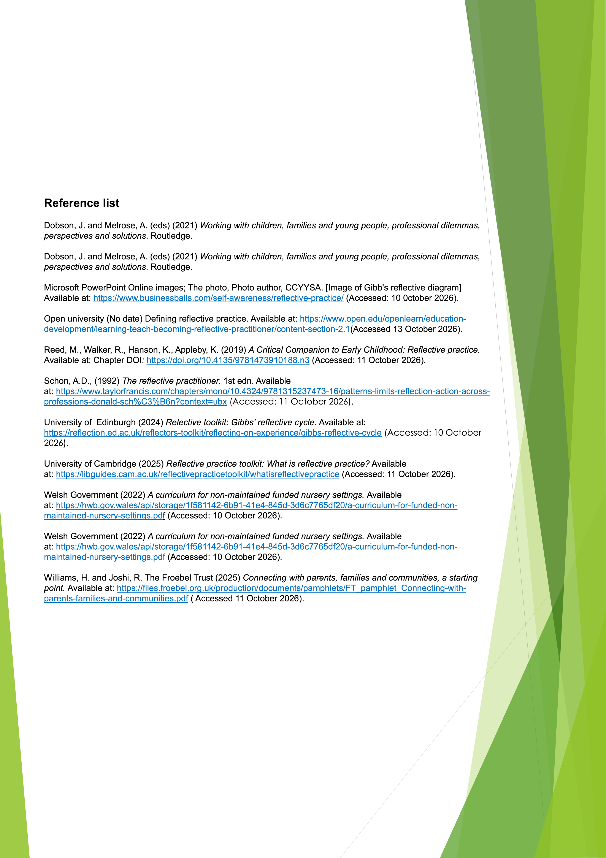
Part 3: Different aspects of professional practice and why are these important to meet individual and inclusive needs of children?
(Melrose, 2021, p.27) describes professionalism as a difficult subject to comprehend. She argues that understanding professionalism is dependent on the exact domain of professional practice, and how growth over time can be dependent on the individual's attitude and experiences. (Melrose, 2021, p.27) acknowledges that trying to find a definition and understanding of professionalism can be unsettling, because of its broad spectrum of characteristics. (Melrose, 2021, p.27) considers the traits that underpin the ‘quality’ aspect of being a professional; these include timekeeping, good social and communication skills and how we present ourselves in the workplace. (Melrose 2021, p.27) goes on to suggest that professionalism is much more profound and how becoming a professional is a journey that involves deep knowledge of a specific role, that then leads to analysis of how to best carry it out.
Like (Melrose, 2021) Reed, M., Walker, R., and Gasper M. (2015, p.254) agree with the complexity of defining what a professional is. The authors debate that the definition of a professional can superficially arise from a qualification, or a field of expertise and while these are beneficial to a professional role, they acknowledge the role of an early year's practitioner, and go on to consider how those aspects of professionalism alone would not compliment the role, a role which needs a person with specific values and principles that are underpinned with experience and knowledge. Reed, M., Walker, R. and Gasper M. (2015, p.257) Suggests an early year's professional is someone who would be mindful of children's needs and who will strive to meet those needs. The authors compared professional practice in this context to that of a servant.
These theorists both agree that it is simpler to look at aspects of professional practice than to describe what a professional is. For example, the Welsh Government (2025) published a consultation document that depicts the role of an educational professional as a person who supports and assists the development and learning of children and young people. The standards were created in 2018 to compliment the arrival and digestion of the new curriculum for Wales. When laying out the foundations of professionalism while working in education, the Welsh government (2025) suggests using the standards as a tool. The standards consist of 5 parts: Innovation, Collaboration, leadership, professional learning and pedagogy. Each standard has a range of descriptors describing ways to demonstrate competency in each specific role.
Mohammed (2023, Para. introduction) expresses the significance of early years education on the lives of children. He acknowledges how children's very foundations are developing rapidly at this stage, including their social and emotional skills. Mohammed (2023) explores the lifelong benefits of early childhood education academically, and how the opportunity to attend, explore and be a part of an early year's setting could be detrimental to positive foundational development. Mohammed (2023, Para.8) considers different theorists and their approaches to the early years, for example, Maria Montessori, Rustamova, Reggio Emilia (Louis Malaguzzi), and Waldorf. Mohammed (2023) suggests that parents and educators can look at the different models and choose an approach based on children's needs. Mohammed (2023) summarises the work of Quigley and hall, who recognise the different roles that early childhood professionals take on daily, these include the skilful development and delivery of a child centred curriculum, creating a warm, inviting, inclusive space for children. They go on to say that professionals are responsible for engaging children and managing classroom expectations, and for children's physical care needs. The professional needs to have strong communication skills to be able to establish effective relationships with parents and carers. An important range of skills and a depth of knowledge to be able to deliver important practice at a critical time in the development of a child.
Crow and Watson (2019, Chapter 6) explore safeguarding and have scrutinised safeguarding in this chapter to be able to write an in-detail guide to support students going into early years roles. They state that safeguarding is an essential part of the early years practitioner's role and discuss how the knowledge and understanding of safeguarding policies, and procedures are vital to be able to keep a child at the centre when safeguarding. The chapter put emphasis on how losing sight of the child has been a common indicator of error in past serious cases.
Bottrill (2022, Chapter 15, 02:30) Discusses parenting. He has an interesting, easy, relatable outlook stating that parenting is a major factor in the development of a child. He mentions how we don’t get lessons in school on how to be a parent, yet, when thinking about his own children, how they present with qualities from himself and their mother. Unconsciously, parents are conditioning their children, and unconsciously children are evolving into their parents, picking up characteristics and traits. This is one of the reasons why parents need to play a leading role in their child's life and education. They are the caregiver; they have the biological connection. Bottrill (2022) goes on to note that most of all, a child will crave ‘time’ from their parent, and parents can thrive with an understanding of what is ahead for the child, with the support of skilled early years practitioners and other professionals the families may come across. Bottrill (2022) worries that parents experience with their own parents could present as a wall to healthy relationships with their own children (attachment theory). This is why it is important to have effective communication between professionals and children's main caregivers. Bottrill (2022) stresses the importance of getting parents on board, but regrets that many parents are reluctant to get involved. Parents' own experiences, attitudes and outlooks on education can influence a child. He advises that we listen to parents and offer them guidance to support them in a job they were never trained for, so that they realise the impact of their own influence and actions effects on their child's outcomes and the value of working alongside others who also want what’s best for their child. We need to listen as professionals so that we can meet those individual needs but always being mindful that a parent knows their child best.
Doyla (2010, p.147) Discusses parents, the position they are in, and benefits of taking them on their child's educational journey because of the natural love they possess for their children. As result of this love, they know their child the best, have a natural urge to advocate for them and help them learn and while they are young, they want to be involved. Doyla (2010, p.147) expresses that even good parents may not know the importance of quality time at home, and valuable experiences like accessing the outdoors. Parents just need equipping with the knowledge to know how. As well as working alongside parents the (NSPCC, 2023) say that multiple agencies working around a child is paramount to be able to get the best available holistic insight into a child's life. The (NSPCC, 2023) maintain that this is an effective way of being able to meet a child's needs and to safeguard a child. This means professionals, can purposefully share important information, that gives different experiences and perspectives of the child which can then, support professionals in making decisions based on more accurate and detailed information.
In terms of education, the (Welsh Government, 2022) have developed a cycle of reflection called notice, analyse and respond. Used alongside knowledge of child development, this cycle can support us in understanding children. By using this cycle, the Welsh government (2022) intend for us to decode a child's behaviour, learning styles and interests to motivate them and engage them in learning.
The (Welsh government, 2022) model compliments the work of Loris Malaguzzi (1991) 100 hundred languages. The model allows educators to follow the lead of the child, wrap them up in their own interests and meet them where they are at individually, allowing for differentiation and promotion of inclusivity and equity.
Learn together Cambridgeshire (2026) describe inclusivity as something that must be at the very centre of early years practice. It states that one of the most important considerations is diversity in individuals, families and communities that they belong to. The principle of inclusion is to ensure, for example, that no matter where a child comes from, what culture or religion they belong to, their status in terms of wealth, their health and capabilities that these do not prevent or disadvantage a child obtaining their rights. The UNCRC (1991) state that all children have the same rights, it is an adult's responsibility to make sure a child knows what their rights are, and to advocate for children to ensure sure their rights are honoured. Firstly, the UNCRC (1991) say that the rights are about freedom for all. The freedom to live without fear and discrimination. They recognise the fragile nature of childhood and in article 3, layout that no matter what sector, all are required to respect the child's rights and honour the legislation. In article 19 of the UNCRC (1991) it states that the professionals around a child have the duty to safeguard children and work with others to achieve safety and the best outcomes for children.
In conclusion, defining the word professional is difficult because it has such a broad range of characteristics. To practice professionally underpins the word ‘professional’ a person practicing in a professional way would engage with information, guidance and legislation to support them in their roles when striving for inclusivity and the best outcomes for children.

Reference list
Crow, A. and Watson, L. (2019) ‘Safeguarding in practice’ in Mahon,S. And Dyer,M (eds), Advanced work-based practice in the early years. Routledge. Available at:https://www.taylorfrancis.com/reader/read-online/f9850f39-4e5f-4172-88fd-5f9260858075/book/epub?context=ubx (Accessed: 17 October 2026).
Education Wales, (January 2022) A curriculum for funded non- maintained nursery settings. Available at: https://hwb.gov.wales/api/storage/b1801d78-38c3-4320-9818-d9996c21aef8/220914-a-curriculum-for-funded-non-maintained-nursery-settings.pdf (Accessed: 03 October 2026).
Doyla, A. (2010) Vygotsky in action in the early years; Parent power, strategies for building a positive partnership. Routledge. Available at: https://research-ebsco-com.uwtsd.idm.oclc.org/c/onvpsy/ebook-viewer/pdf/lommfh5lhz/section/lp_C-2?location=https%25253A%25252F%25252Fresearch-ebsco-com.uwtsd.idm.oclc.org%25252Fc%25252Fonvpsy%25252Fsearch%25252Fdetails%25252Flommfh5lhz%25253Frequest-context%25253Dplink%252526db%25253Dnlebk&auth-callid=7709bfbe-17b3-4a71-ab4a-7ce520caf274 (Accessed 17 October 2026).
Greg Botrill (2022) Can I go play now? Partnership: Parents. Available at: https://www.audible.co.uk/pd/Can-I-Go-and-Play-Now-Audiobook/1529752396?source_code=ASSORAP0511160006&share_location=library_overflow (Accessed: 17 October 2026).
Learn together Cambridgeshire (2026) What is inclusive practice? Available at: https://www.cambslearntogether.co.uk/cambridgeshire-early-years-and-childcare/supporting-inclusive-practice/inclusion-without-labels/what-is-inclusive-practice (Accessed: 18 October 2026).
Llywodraeth Cymru, (2025) Closed consultation document. Revised professional standards for assisting teaching, teaching and leadership. Available at: https://www.gov.wales/revised-professional-standards-assisting-teaching-teaching-and-leadership-html (Accessed: 03 October 2026).
Llywodraeth Cymru, (2017) learnwelsh.Cymru. Available at: https://learnwelsh.cymru/education-workforce/. (Accessed: 03 October 2026).
Llywodraeth Cymru, (2025) Closed consultation document. Revised professional standards for assisting teaching, teaching and leadership. Available at: https://www.gov.wales/revised-professional-standards-assisting-teaching-teaching-and-leadership-html (Accessed: 16 October 2026).
Malaguzzi, L. (1991) ‘100 languages’ ‘No way the hundred is there’. Available at: https://www.reggiochildren.it/en/reggio-emilia-approach/100-linguaggi-en/ (Accessed 17 October 2026).
Melrose, A. (2021) ‘Professionalism in practice’, in Dobson, J. and Melrose, A (eds) Working with children, families and young people, professional dilemmas, perspectives and solutions. Routledge, p.27.
Mohammed, S.M. (2023) ‘Teacher and care giver roles’, in Recent perspectives on pre-school education and care (Online ed.). Intech open. Available at: DOI: 10.5772/intechopen.111745
Reed, M., Walker, R. and Gasper, M. (2015) ‘Professional Practice and Early Childhood Today’, In: A Critical Companion to Early Childhood. First Edition edn, SAGE Publications, Inc. pp. 254-268. Available at: <https://doi.org/10.4135/9781473910188.n22> (Accessed 16 Oct 2026).
United Nations (1991) Convention on the rights of the child. Available at: convention-rights-child (Accessed 17 October 2026).
Welsh Government (2025) Revised professional standards for assisting teaching, teaching and leadership. Available at: https://www.gov.wales/revised-professional-standards-assisting-teaching-teaching-and-leadership-html (Accessed: 16 October 2026).

Welsh Government (2022) A curriculum for funded non- maintained nursery settings. Available at: https://hwb.gov.wales/api/storage/b1801d78-38c3-4320-9818-d9996c21aef8/220914-a-curriculum-for-funded-non-maintained-nursery-settings.pdf (Accessed: 17 October 2026).

