

Assessment 1 – Reading Task Template
PART 1: Upload your photo of your A3 in-class notes here:
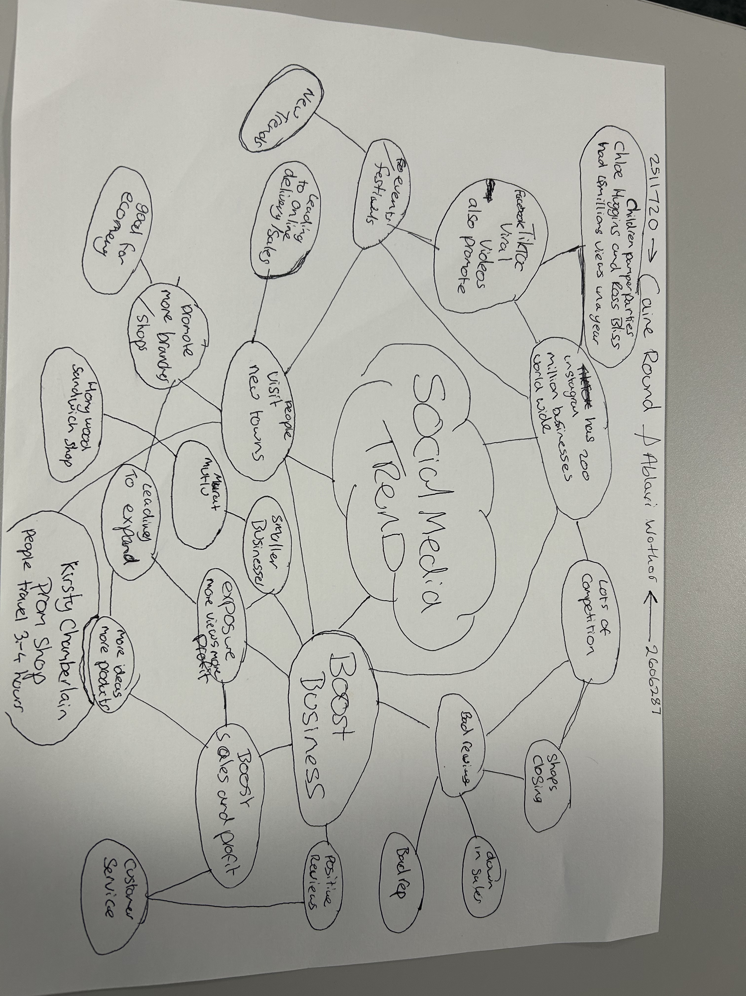

PART 2:
- Answer every question below in 1-3 full sentences.
- Use your own words. Do not use generative AI to answer these questions.
- Include a specific detail from the text when asked.
REMINDER
- The main idea is the overall message of the whole text.
- A key point helps to explain the main idea.
- A specific detail or example from the text shows that the key point is true.

- What is the main idea of the whole text?
The main idea of the text is to brainstorm ideas about social media and how it makes a impact on business. Positively and negatively.

- What is one key point that supports the main idea, and which specific example from the text shows this?

The brainstorm shows the exposure of social media stating facts which helps support smaller business.

- What is a different key point that supports the main idea, and which specific example from the text shows this?

Kirsty chamberlain prom shop had customers traveling 3-4 hour because of viral social media post which is evidence which supports the brainstorm.

- Which part of the text do you think is most important, and why?

I think the most important part of the brainstorm text is the “social media trend” in the centre, every bit of evidence or information all the leads back to it.

Reflection:
- What did you find difficult in this task (including in-class components), and why was it difficult?

I found finding the relevant information by scanning through the text. If I took my time to search for information, I would have more facts/evidence

- What helped you with this difficulty, and how did it help you?

Reading through the text properly and taking notes of smaller details that also make a impact

